Little Sponges AI Spanish Tutor
POC for Conference Demo — February 11, 2026
Hi Natalia! Here's a quick look at the Spanish tutor app for your conference demo. I just need two things from you to finalize it.

Current Prototype
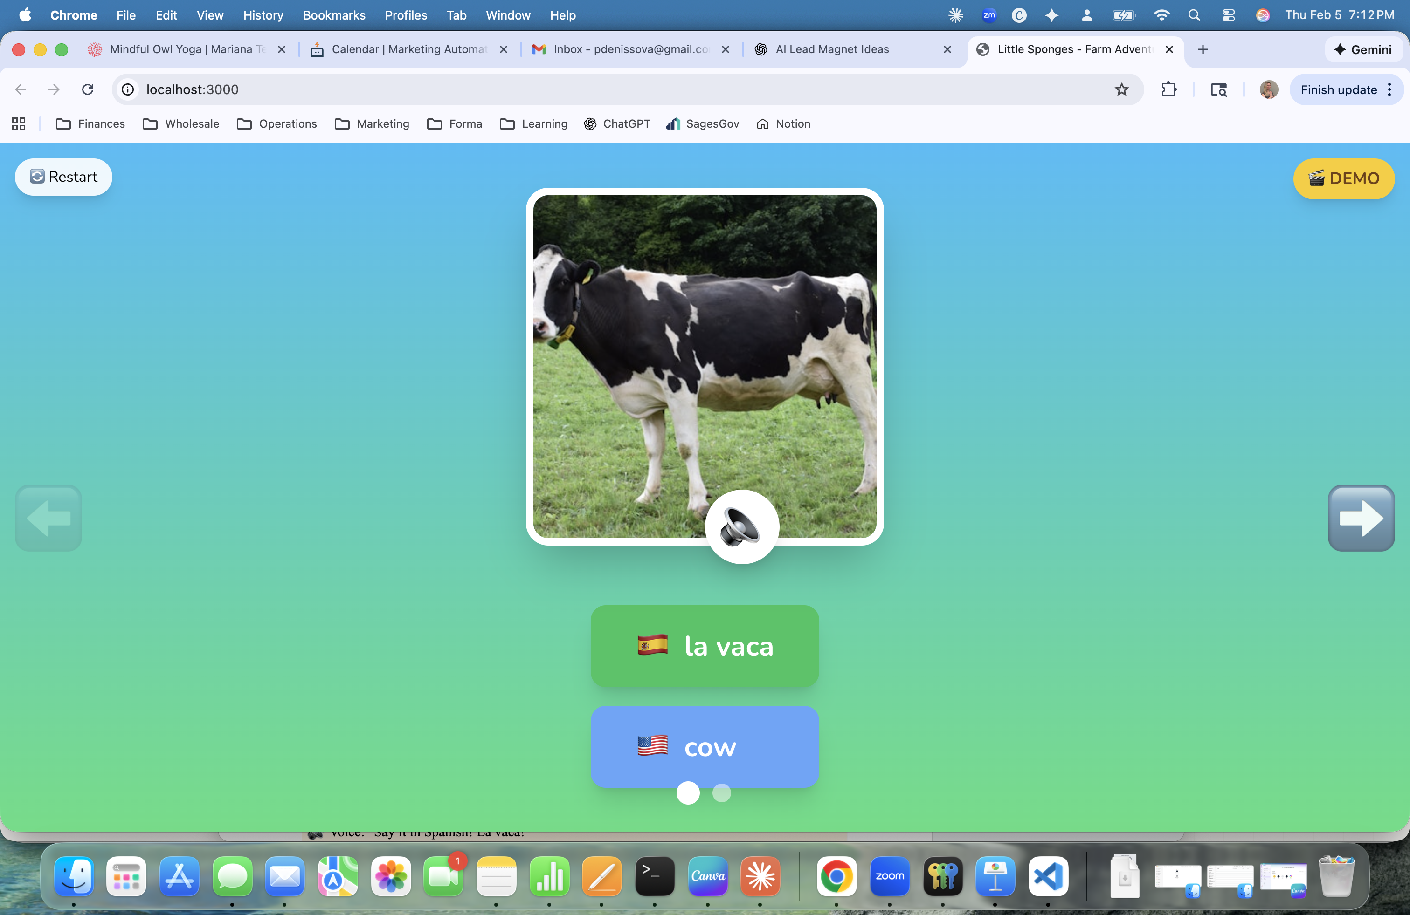
Demo showing chicken exercise with voice prompts

What the POC Includes
- 2 animals: cow and chicken (using your photos)
- Voice asks "What is this?" for each animal
- Child can tap Spanish answer OR speak it
- Correct answer: celebration voice + animal sound
- English answer: "Say it in Spanish!" prompt
- Female, warm AI voice
- Installed locally on your Mac for the conference

What I Need From You

1. Background Style
Which background would you prefer for the app?
☐ A) Simple green gradient (like the screenshot above)
☐ B) Illustrated farm scene
☐ C) Other idea: _______________
Your choice:

2. Animal Photos
Please send me the cow and chicken photos you use in the Little Sponges program. I'll replace the stock photos with your images.
☐ Photos attached / sent separately

Timeline
Now | You send background choice + photos
Feb 7-8 | I finalize the app with your assets
Feb 9-10 | Install on your Mac + test together
Feb 11 | Conference demo! 🎉

Questions? Just reply to this email!

