
MINISTRY OF EDUCATION, CULTURE AND RESEARCH
OF THE REPUBLIC OF MOLDOVA
Technical University of Moldova
Faculty of Computers, Informatics and Microelectronics
Department of Software Engineering and Automation

Clepicova Polina FAF-243

Report
Laboratory Works No.1–2
Operating Systems
Topics: The OS as a Resource Manager; Meet the OS You Will Build (xv6)

Checked by:
Reitman P., univ.assistant
FCIM, UTM

Chișinău – 2026
TABLE OF CONTENTS
PRE-LAB SETUP & ENVIRONMENT VERIFICATION 3
PART 1. FILES AND DIRECTORIES (FILE MANAGEMENT) 4
PART 2. PROCESSES (PROCESS MANAGEMENT) 8
PART 3. MEMORY (MEMORY MANAGEMENT) 12
PART 4. DEVICES AND STORAGE (I/O MANAGEMENT) 14
SYNTHESIS & CLOSING SUMMARY 16
LABORATORY WORK No.2. MEET THE OS YOU WILL BUILD (xv6) 17
LAB 2 · PART 1. BUILD AND BOOT XV6 17
LAB 2 · PART 2. USING XV6 AS A UNIX 18
LAB 2 · PART 3. READING THE SOURCE CODE 20
LAB 2 · PART 4. WRITING THE FIRST XV6 PROGRAM 24
LAB 2 · CLOSING SUMMARY 26

PRE-LAB SETUP & ENVIRONMENT VERIFICATION
To verify the working environment, basic system parameters were inspected in the Linux terminal:
whoami # Identifies the current active user
uname -a # Displays kernel and system architecture information
uptime # Shows machine running time and load average

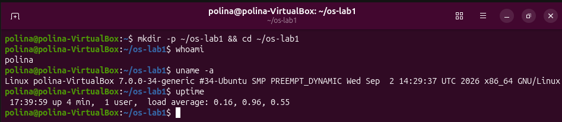
Figure 1.1 – Output of whoami, uname -a, and uptime commands
Results of execution is shown in output: The current active user is “polina”
Kernel and system architecture information is “Linux polina-VirtualBox 7.0.0-34-generic #34-Ubuntu SMP PREEMPT_DYNAMIC Wed Sep 2 14:29:37 UTC 2026 x86_64 GNU/Linux
And the machine running time and load average: 17:39:59 up 4 min, 1 user, load average 0.16,0.96,0.55.
Comment: I created the working folder and ran three basic commands to see who and what I am talking to. whoami asks the OS which user account my session belongs to; this matters because every permission check later in the lab is based on this identity. uname -a shows that the kernel (the core part of the OS that talks to the hardware) is Linux, running on a VirtualBox virtual machine with a 64-bit (x86_64) architecture. uptime shows that the system had been running for only 4 minutes, so it was freshly booted, and the load averages (0.16, 0.96, 0.55 for the last 1, 5 and 15 minutes) are low, which means the CPU was almost idle. The slightly higher 5-minute value is probably caused by the boot process itself.

PART 1. FILES AND DIRECTORIES (FILE MANAGEMENT)
In this section, the UNIX file tree, ownership, and permission levels were explored and modified.
Commands Executed:
pwd
ls -la /
ls -la ~
cd /etc && ls | head
cd ~/os-lab1
mkdir demo && cd demo
echo "hello operating system" > note.txt
cp note.txt copy.txt
mv copy.txt renamed.txt
ls -l
rm renamed.txt
ls -l note.txt
chmod 600 note.txt
ls -l note.txt
chmod 644 note.txt
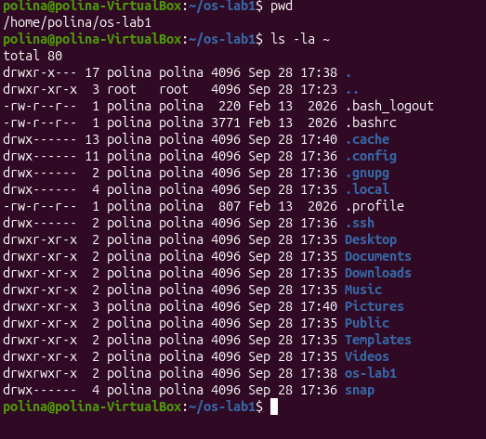
Figure 2.1 – Directory navigation and file operations
Comment: Here pwd confirmed that I am in /home/polina/os-lab1, and ls -la ~ listed everything in my home directory, including hidden files (names that start with a dot, such as .bashrc and .profile). Each line shows the file type and permissions, the owner, the group, the size and the modification date. All my files belong to polina:polina, and private folders like .ssh and .gnupg have drwx------, which means that only the owner can even enter them. The entry “..” is owned by root because it is /home, which belongs to the system, not to me.

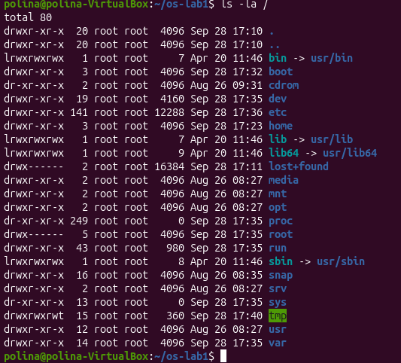
Figure 2.2 – Directory navigation and file operations
Comment: ls -la / shows the root of the whole file tree. As I understand it, the OS hides the physical disks and presents one single tree that starts at /. Almost everything here is owned by root, so a normal user cannot change it. Entries like bin, lib and sbin are symbolic links (shown with an arrow) to directories inside /usr, so old paths still work while the OS keeps only one real copy. The directories proc and sys have size 0 because they are not stored on the disk at all: the kernel generates them on the fly. The directory tmp has drwxrwxrwt, which means everyone can write there, and the final t (sticky bit) prevents users from deleting each other’s files.

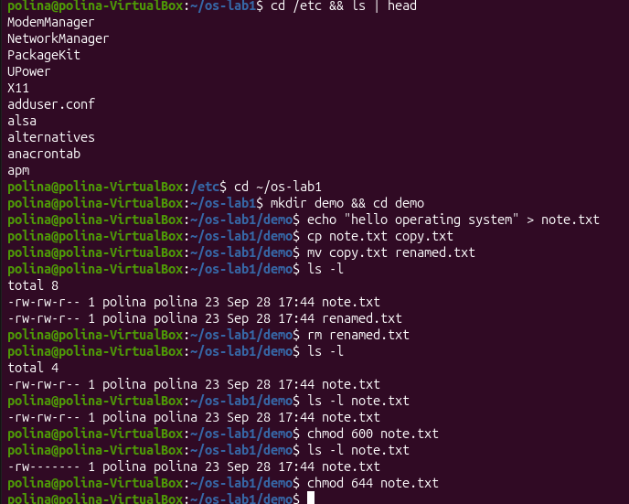
Figure 2.3 – Directory navigation and file operations (mkdir, cp, mv, rm).
Comment: With cd /etc && ls | head I looked at the beginning of the system configuration directory (it contains things like NetworkManager, adduser.conf and alsa). Then I created a demo folder and wrote a text file with echo and the > redirection. After cp I had two files, mv only changed the name of the copy (the content stayed the same), and rm deleted it, so ls -l shows two files first and then only one. Both files are 23 bytes, which is the 22 characters of the text plus the newline. Initially note.txt has -rw-rw-r--: the owner and the group can read and write, others can only read. After chmod 600 it becomes -rw-------, so only the owner has access. In the number 600 each digit is for owner, group and others, and 6 = read (4) + write (2). Finally chmod 644 restored the usual -rw-r--r--. This shows that the OS decides who may touch each file.
Observations & Answers:
- File Ownership and Group:
The files created in this lab (note.txt and its copy) are owned by my user account polina and belong to the primary group polina (shown as “polina polina” in the output of ls -l). Files in my home directory, such as .bashrc and the folder os-lab1, have the same owner and group.
- Permission Notation (chmod 600):
After running chmod 600 note.txt, the ten-character string at the beginning of ls -l shows -rw-------. The leading - indicates a regular file, rw- grants read and write permissions exclusively to the file owner, and ------ denies all read, write, and execute permissions to both the group and other users.
- Directories directly under /:
/etc: Contains system-wide configuration files and setup scripts for installed applications.
/bin: Holds essential command-line programs (e.g., ls, cp, bash). On this system it is a symbolic link to /usr/bin.

PART 2. PROCESSES (PROCESS MANAGEMENT)
This part focuses on observing process isolation, background job execution, process signals, and the /proc pseudo-filesystem.
Commands Executed:
ps aux | head
ps aux | wc -l
top
sleep 300 &
jobs
ps -ef | grep sleep
kill <PID>
sleep 300 &
PID=$!
ls /proc/$PID/
cat /proc/$PID/status | head -20
kill $PID

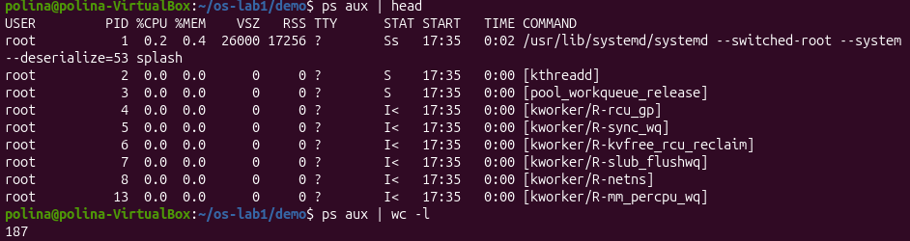
Figure 3.1 - Live system processes view using ps aux.
Comment: ps aux | head lists the first few processes. The very first one has PID 1 and is /usr/lib/systemd/systemd, started by root: it is the first process that the kernel launches at boot, and every other process descends from it. Names in square brackets, such as [kthreadd] and [kworker/...], are kernel threads, which means that the kernel itself also runs as a set of processes. The question mark in the TTY column means that these processes have no terminal. The command ps aux | wc -l printed 187; since the first line is the table header, there were about 186 processes on my idle VM.
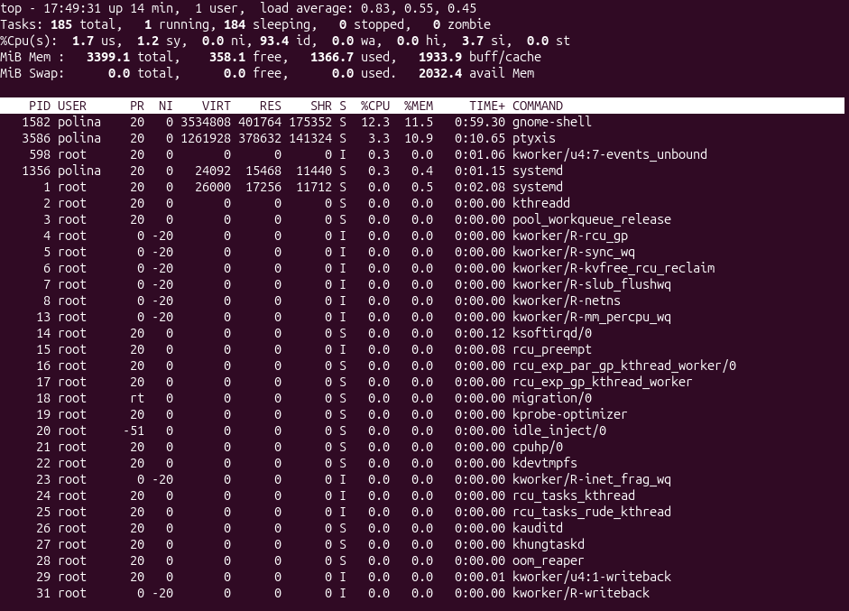
Figure 3.2 - Live system processes view using top.
Comment: top is a live version of the same information, refreshed every few seconds. In the header I see 185 tasks: 1 running (top itself), 184 sleeping and 0 zombie. So almost all processes are just waiting for some event, and the CPU is 93.4% idle. This is how the OS scheduler works: it gives CPU time only to the processes that actually need it. The memory line shows about 3399 MiB of RAM in total, and the swap line shows 0. The biggest consumers are gnome-shell (the graphical desktop) and ptyxis (the terminal I am typing in), which makes sense for a desktop system.
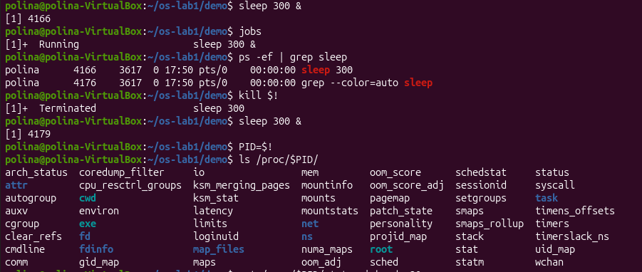
Figure 3.3 - Running a background sleep job, locating its PID, and sending a kill signal.
Comment: I started sleep 300 & ; the & symbol runs it in the background, so the shell immediately gave the prompt back and printed the job number [1] and the PID 4166. The jobs command shows that it is Running. In ps -ef | grep sleep there are two lines: the real sleep process and the grep command itself (grep finds itself because its own command line contains the word sleep). The PPID column is 3617, which is my shell, so I understand that sleep is a child of the shell that created it. Then kill $! sent the termination signal (SIGTERM) to the last background process, and the shell reported Terminated. After that I started a new sleep (PID 4179), saved its PID in a variable and listed /proc/$PID/, a directory the kernel creates for every running process.

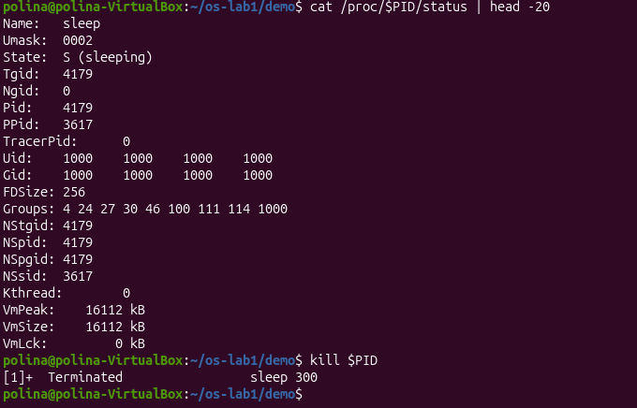
Figure 3.4 - Inspecting kernel process status from /proc/<PID>/status.
Comment: The /proc directory is a pseudo-filesystem: its files are not stored on the disk, the kernel creates them at the moment I read them, so they give a live window into the process. In status I see Name: sleep, State: S (sleeping), Pid: 4179 and PPid: 3617 (my shell, which matches the previous figure). Uid and Gid are 1000, my user, so the process runs with my privileges and not as root. VmSize is 16112 kB, which is the virtual memory address space of the process. After that kill $PID stopped it. This part shows well that the OS keeps a record for each process and controls its life from creation to termination.

Observations & Answers:
- Process ID 1 (PID 1):
The process with PID 1 is systemd (/usr/lib/systemd/systemd), as shown in the output of ps aux. It is the first process started by the Linux kernel during boot and it is responsible for starting and managing all other system services and daemons.
- Number of Running Processes:
About 186 processes were running on the idle Virtual Machine: ps aux | wc -l printed 187, and one of these lines is the table header; top also reports 185 tasks (1 running, 184 sleeping, 0 zombie).
- Sleeping Process State:
In /proc/<PID>/status, the State: line reads S (sleeping) (interruptible sleep), indicating that the process is waiting for an event or timer signal to wake up.

PART 3. MEMORY (MEMORY MANAGEMENT)
In this section, RAM allocations, swap usage, and physical memory footprints (VmRSS) were examined.
Commands Executed:
free -h
cat /proc/meminfo | head -6
sleep 300 & PID=$!
grep VmRSS /proc/$PID/status
kill $PID

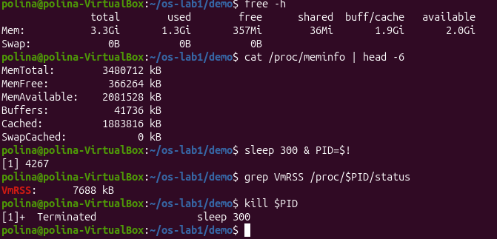
Figure 4.1 - Memory inspection output from free -h and /proc/meminfo,
Resident Set Size (VmRSS) measurement for a sleep process.
Comment: free -h shows 3.3 GiB of RAM in total, 1.3 GiB used, only 357 MiB free, 1.9 GiB in buff/cache and 2.0 GiB available. At first the small “free” number looked strange, but I understand that Linux uses unused RAM as a disk cache and can release it immediately when programs need memory, so the “available” column is the more honest number. The Swap line is 0B, which means that no swap space is configured on this VM. /proc/meminfo shows the same data in kilobytes (MemTotal is 3480712 kB), because free reads its numbers from there. For the sleep process, VmRSS (the part of its memory that is really in RAM now) is 7688 kB, about 7.5 MB. This is more than I expected for a program that does nothing; I think the reason is that the shared C library is loaded into RAM, and this library memory is shared with other processes, so the real extra cost of one more sleep is smaller.

Observations & Answers:
- Total and Free RAM:
The Virtual Machine has about 3.3 GiB of total RAM (MemTotal is 3480712 kB in /proc/meminfo). At the moment of measurement, only 357 MiB was completely free, but about 2.0 GiB was available, because 1.9 GiB was used as buffer/cache, which the kernel can release immediately when programs need memory.
- Swap Space:
Swap is a designated disk space used as virtual memory when physical RAM becomes fully saturated. On this system no swap space is configured: free -h shows 0B for swap, and top shows 0.0 MiB total swap.
- Resident Memory Usage (VmRSS):
The bare sleep process uses about 7.5 MB of resident memory (VmRSS: 7688 kB). This is more than I expected for a program that does nothing. The reason is that the process still has the shared C library and other shared pages mapped into RAM; these pages are shared with other processes, so the real additional memory cost of one more sleep is smaller.

PART 4. DEVICES AND STORAGE (I/O MANAGEMENT)
This part illustrates storage management, block devices, and the UNIX "everything is a file" philosophy.
Commands Executed:
df -h
lsblk
du -sh ~/os-lab1
ls -l /dev | head
mount | head

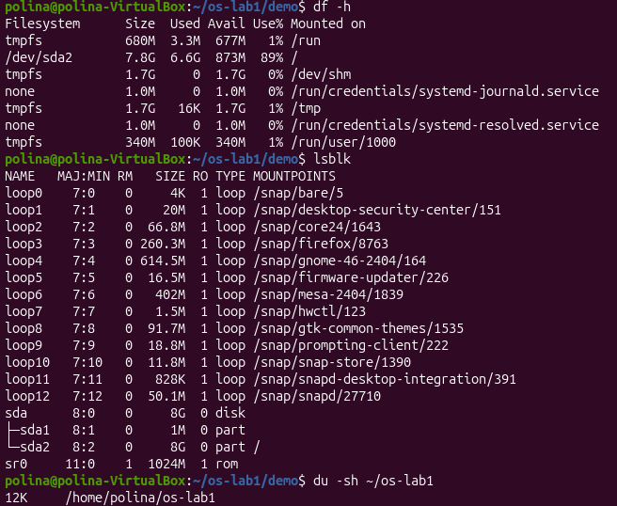
Figure 5.1 - Storage filesystems and block devices layout using df -h and lsblk.
Comment: df -h shows the mounted filesystems. The root filesystem / is on /dev/sda2: 7.8 GB in total, 6.6 GB used (89%) and only 873 MB available, so the virtual disk is almost full. Most of the other lines are tmpfs, which means they live in RAM and not on the disk (for example /run and /dev/shm). lsblk shows the real block devices: one 8 GB disk sda with two partitions, sda1 (1 MB, probably a small boot partition) and sda2 (mounted on /), plus sr0, a virtual CD drive. The many loop devices are snap packages, each one an image file mounted as a read-only filesystem. Finally, du -sh shows that my os-lab1 folder takes only 12 KB. The difference between the commands is that df looks at whole filesystems and du measures one folder.

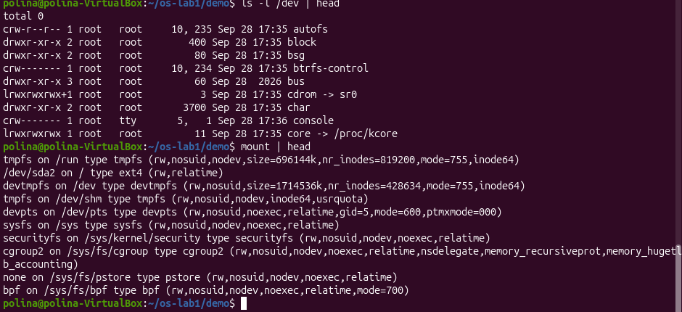
Figure 5.2 - Inspecting device files under /dev and active mount points.
Comment: In ls -l /dev the first letter of each line is the file type: c is a character device (autofs, console), d is a directory and l is a symbolic link (cdrom points to sr0, core points to /proc/kcore). They look like ordinary files, but each one stands for a kernel interface or a piece of hardware; for example console is the system console, and cdrom is the link to my virtual optical drive. The mount output lists what is attached to the tree and with which filesystem type: / is /dev/sda2 with type ext4, while tmpfs, sysfs, devpts and cgroup2 are virtual filesystems created by the kernel. So I understand that the same mount mechanism joins a real disk and purely virtual filesystems into one tree, and programs use the same file operations for all of them.

Observations & Answers:
- Root Filesystem Mount Point:
The root filesystem / is mounted on the partition /dev/sda2 (type ext4, 7.8 GB in size, 89% used), which is the second partition of the virtual disk /dev/sda.
- Device Entry under /dev:
The entry /dev/sda represents the 8 GB virtual hard disk attached to the virtual machine; /dev/sda1 and /dev/sda2 are its partitions. Another example is /dev/cdrom, a link to /dev/sr0, which stands for the virtual CD/DVD drive.
- "Everything is a file" Concept:
"Everything is a file" means that the operating system exposes hardware peripherals, storage drives, network interfaces, and kernel parameters as file paths, enabling applications to interact with devices using standard file operations (open, read, write).

SYNTHESIS & CLOSING SUMMARY
The operating system serves as a central resource manager controlling four key assets: files, processes, memory, and devices.
File management was inspected through file creation and permission utilities using the ls command.
Process isolation and scheduling were observed using ps (and the /proc filesystem), memory allocation was monitored using free, and storage/device abstractions were evaluated using lsblk and df.

LABORATORY WORK No.2. MEET THE OS YOU WILL BUILD (xv6)
In this laboratory work, the teaching operating system xv6 was built from source, booted in the QEMU emulator, used through its own shell, studied by reading its source code, and extended with a first user program. xv6 is a small Unix-like operating system written in C for the RISC-V architecture. Unlike Lab 1, where the Linux system could only be observed from the outside, here it was possible to look at both sides of the system: the programs that make requests and the kernel code that answers them.
The work was done on the provided Linux virtual machine, where the riscv64 cross-compiler and QEMU were already installed. The xv6 source tree was located in ~/xv6-riscv.

LAB 2 · PART 1. BUILD AND BOOT XV6
In this section, the xv6 kernel and its user programs were compiled from source and the system was started in the QEMU emulator.
Commands Executed:
cd ~/xv6-riscv 2>/dev/null || git clone https://github.com/mit-pdos/xv6-riscv ~/xv6-riscv
cd ~/xv6-riscv
ls
make qemu
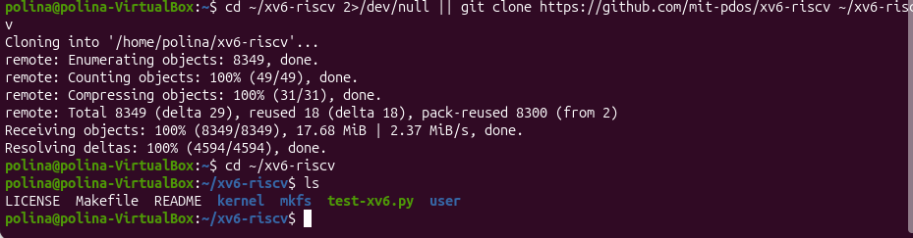
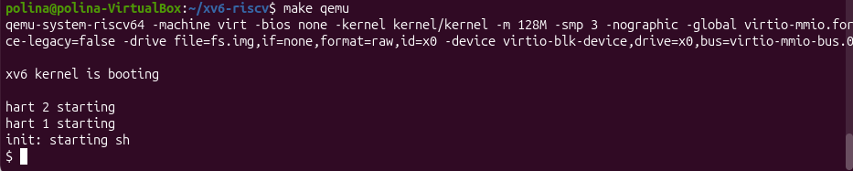
Figure 6.1 – Building xv6 with make qemu and booting to the shell prompt.
Comment: The first command enters the xv6 folder (or downloads it from GitHub if it is missing), and ls shows its main parts: the kernel/ and user/ folders, the Makefile and the README. The command make qemu compiles the kernel and all user programs with the RISC-V cross-compiler, builds a disk image that contains these programs, and starts the QEMU emulator. After that xv6 printed “xv6 kernel is booting” and “init: starting sh”, and I received the $ prompt of the xv6 shell. As I understand it, QEMU pretends to be a small RISC-V computer, and xv6 boots on it as if it were real hardware, so this is a computer inside a computer: VirtualBox, then Ubuntu, then QEMU, then xv6. The message “init: starting sh” shows the boot sequence: the kernel starts the first process, init, and init starts the shell. To leave xv6, the emulator is stopped with Ctrl-A followed by X; this is a QEMU shortcut, not an xv6 command.

LAB 2 · PART 2. USING XV6 AS A UNIX
This part shows that xv6 behaves like a miniature version of the Linux system used in Lab 1: it has files, a shell, standard programs and pipes.
Commands Executed:
ls
cat README
echo hello xv6
ls | grep c
wc README
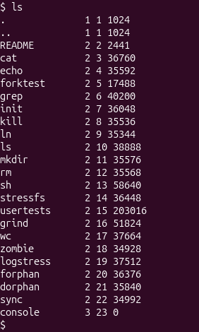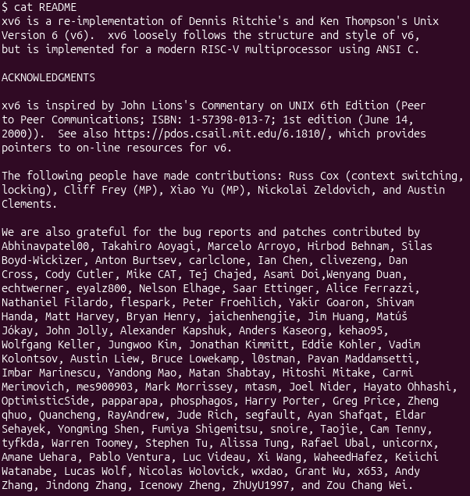
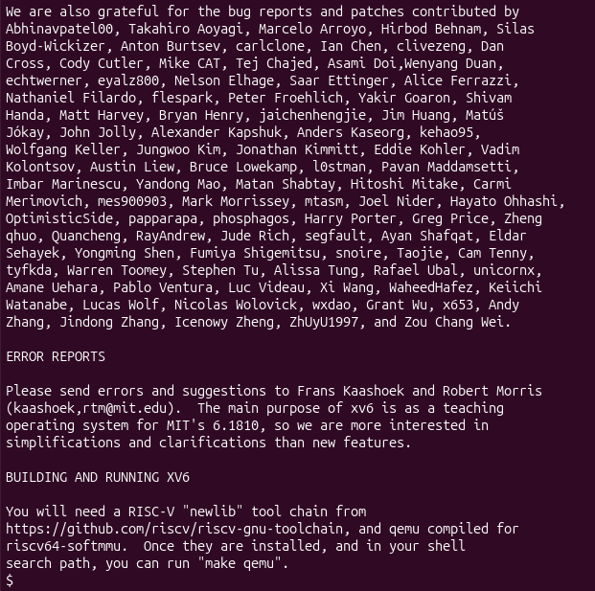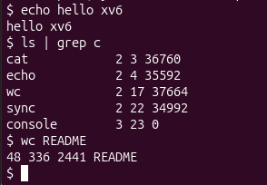
Figure 7.1 – Running built-in xv6 programs: ls, cat, echo, a pipe with grep, and wc.
Comment: The command ls lists the files on the xv6 disk: they are the user programs (cat, echo, grep, wc, sh and others) together with the README file. cat README prints that file, echo hello xv6 prints its arguments, and wc README counts the lines, words and bytes of the file. In the command ls | grep c the shell connected two programs: the output of ls became the input of grep, which kept only the lines that contain the letter c. As I understand it, each of these commands is a separate program stored as a file, and the shell starts it by asking the kernel to run it, so the shell itself is also just an ordinary program.
Observations & Answers:
- Programs shipped with xv6:
ls, cat and echo. The output of ls also shows grep, wc, mkdir, rm, kill, ln and sh.
Comment: These are ordinary programs stored as files on the xv6 disk. They are small, but they work on the same ideas as the Linux versions used in Lab 1.
- Features required for a pipe:
Processes and inter-process communication (IPC).
Comment: When ls | grep c was typed, the shell created two separate processes with the fork system call, one for ls and one for grep. The kernel also created a pipe (the pipe system call), which is a small buffer in kernel memory: ls writes its output into one end of it, and grep reads it from the other end. Without processes there would be nothing to connect, and without a communication mechanism the two processes could not exchange data, because every process has its own private memory.
- xv6 shell compared to the Linux shell:
The xv6 shell follows the same ideas as the Linux shell (running programs, pipes, redirection), but it is much simpler.
Comment: It has no command history, tab completion, variables or scripting. It is enough to show how a shell really works: it reads a line, creates a process for each command and connects them with pipes. In the xv6 source it is only one small file, user/sh.c.

LAB 2 · PART 3. READING THE SOURCE CODE
After leaving QEMU (Ctrl-A, then X), the source tree was studied. The system is split into two folders: kernel/ is the operating system itself (scheduler, memory management, file system and system-call handlers, running in privileged mode), and user/ contains the ordinary programs that run on top of it (ls, cat, echo, the shell).
Commands Executed:
sed -n "1,40p" user/ls.c
sed -n "1,30p" user/cat.c
cat user/user.h
grep -n "sys_read\|sys_write" kernel/sysfile.c | head
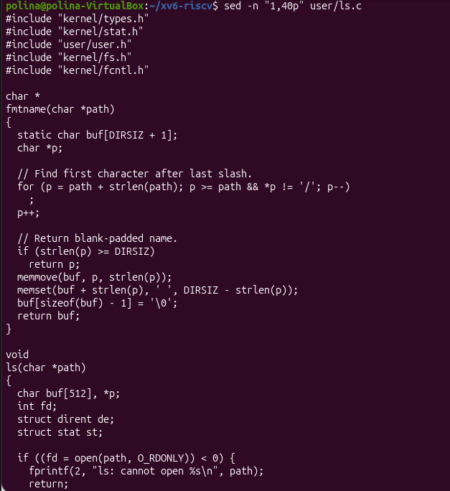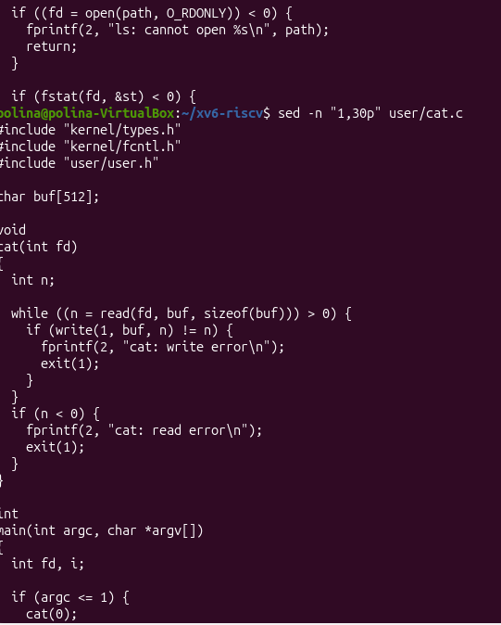
Figure 8.1 – Source code of the user programs user/ls.c and user/cat.c.

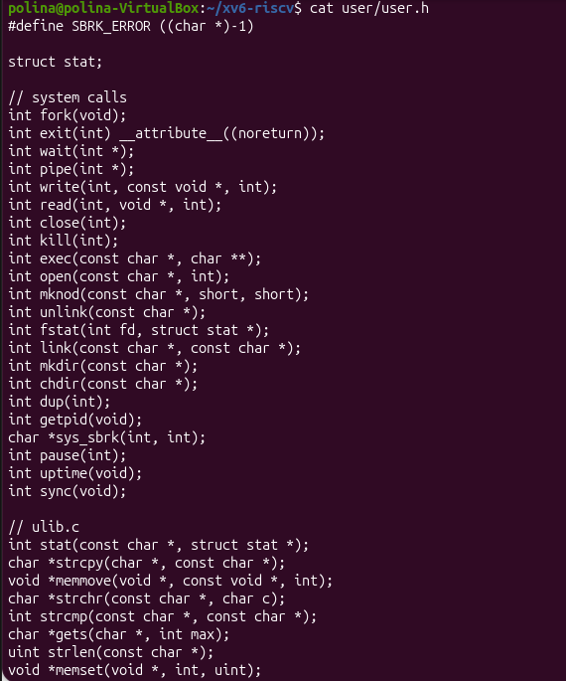
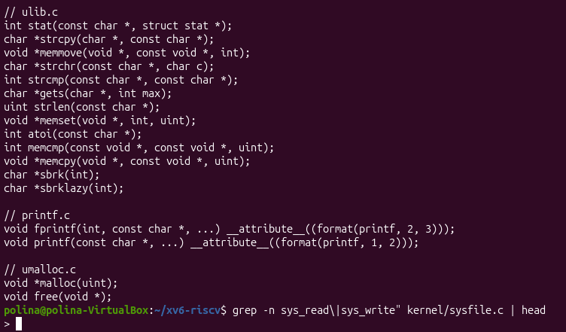
Figure 8.2 – System-call declarations in user/user.h and the handlers in kernel/sysfile.c.
Comment: The programs in user/ are short C programs with a main function, similar to the programs from ordinary C labs. In cat.c the functions open, read, write and close are not normal functions with their own code inside the program: they are declared in user/user.h, which is the list of system calls available to programs, and their real implementation is inside the kernel. The grep command found the handlers sys_read and sys_write in kernel/sysfile.c. As I understand it, this is the central idea of the lab: in xv6 both sides of a request can be read, the program that asks (user/) and the kernel code that answers (kernel/).
Observations & Answers:
- System calls used by user/cat.c:
open(name, O_RDONLY): asks the kernel to open the file for reading and to return a file descriptor, a small number that stands for the open file.
read(fd, buf, n): asks the kernel to copy up to n bytes from the open file into the buffer buf.
write(1, buf, n): asks the kernel to write n bytes to file descriptor 1, which is the screen (standard output).
close(fd): asks the kernel to release the file descriptor.
exit(status): asks the kernel to end the program.
Comment: cat does not touch the disk or the screen by itself: everything it does with the outside world goes through these requests to the kernel. The function fprintf that is also used in cat.c is a library function, not a system call, because it only prepares the text and calls write internally.
- Location of sys_read:
sys_read is implemented in the file kernel/sysfile.c, at line 69 (sys_write is at line 83 of the same file).
Comment: When cat calls read(), the processor switches into the kernel, which runs sys_read: it finds the open file and reads the data. The declaration int read(int, void *, int); in user/user.h only tells the user program that such a request exists, and the real work is done in kernel/.
- kernel/ versus user/:
The code in kernel/ is the operating system itself and runs in privileged mode with full access to the hardware and memory, while the code in user/ is ordinary programs that run without privileges and can only ask the kernel for services through system calls.
Comment: This split protects the system: a normal program cannot overwrite the memory of another process or write to the disk directly, so a bug in cat cannot break the whole OS. It also explains why the OS is called a resource manager: only the kernel is allowed to hand out the resources.

LAB 2 · PART 4. WRITING THE FIRST XV6 PROGRAM
In this part a new user program, sleep, was added to xv6. It pauses for a given number of clock ticks by calling a system call that already exists in the kernel.
Commands Executed:
nano user/sleep.c
nano Makefile # added $U/_sleep\ to the UPROGS list
make qemu
sleep 10
sleep

Source code of user/sleep.c:
#include "kernel/types.h"
#include "user/user.h"
int
main(int argc, char *argv[])
{
if(argc != 2){
fprintf(2, "usage: sleep <ticks>\n");
exit(1);
}
sleep(atoi(argv[1])); // system call into the kernel
exit(0);
}
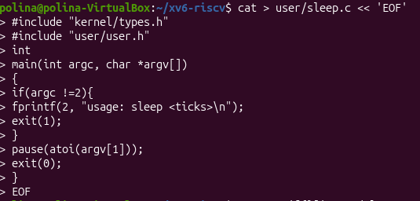
Figure 9.1 – The new program added to the UPROGS list in the Makefile.
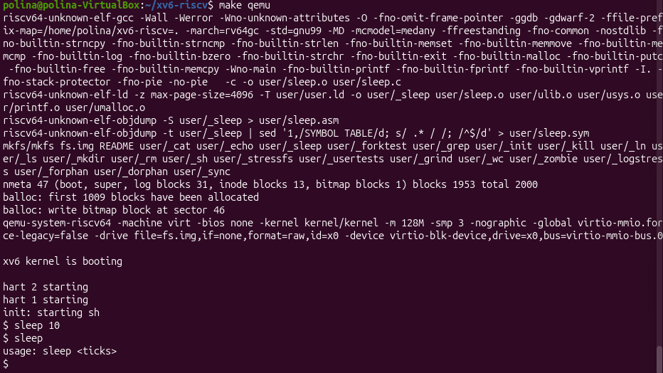
Figure 9.2 – Testing the sleep program inside xv6.
Comment: The program has two jobs: it checks the arguments and converts the text into a number with atoi, and the waiting itself is done by the kernel. If the number of arguments is not exactly two, the program prints the usage message to file descriptor 2 (standard error) and exits with status 1. The new line in the Makefile tells the build system to compile user/sleep.c and to put the resulting program _sleep on the disk image of xv6, otherwise the program would not exist inside the system. During the test, sleep 10 paused for a moment and then returned to the prompt, and sleep without an argument printed the usage message.

LAB 2 · CLOSING SUMMARY
xv6 was built from source, booted in QEMU and used as a small Unix system with files, processes, a shell and pipes. Reading the source showed the basic organisation of an operating system: kernel/ contains the OS that runs in privileged mode, and user/ contains ordinary programs that reach the kernel only through system calls such as open, read, write and fork.
Finally, the program user/sleep.c was written and tested. It makes a real system call into a kernel that was compiled from source on the same machine and runs on emulated hardware.

