Open-system quantum noise analysis in the vicinity of a quadrature-squeezing exceptional point

Polina Blinova^{1*} and Kai Wang¹
¹Department of Physics, McGill University, 3600 rue University, Montreal, QC, H3A 2T8, Canada
*Corresponding author: polina.blinova@mail.mcgill.ca
Abstract: Exceptional points (EPs) are often proposed for sensing enhancement. We analyze a quantum quadrature-squeezing EP sensor within an input-output framework, accounting for unavoidable linear dissipation. We show that loss separates the EP from the stability threshold, and the quantum Fisher information per photon is optimized near threshold instead of the EP.
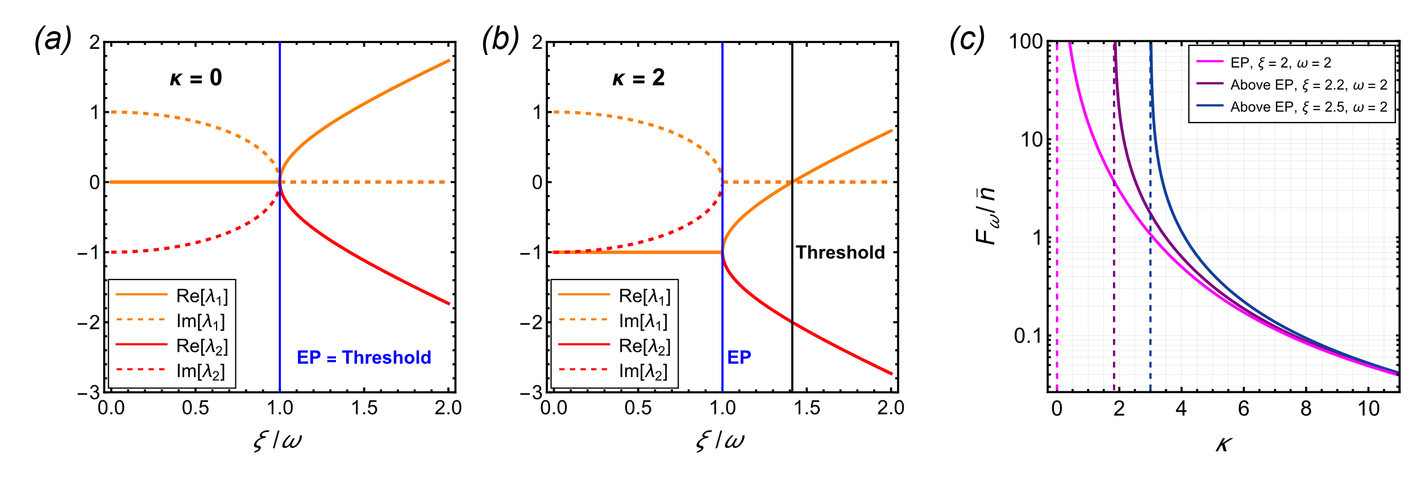
Exceptional points (EPs) in non-Hermitian dynamics have been widely discussed as potential operating points for enhanced sensing. EPs are found not only in classical systems with gain and loss [1], but also in quantum squeezing systems of bosons, where for such bosonic quadratic Hamiltonians, the Heisenberg equations are governed by a non-Hermitian dynamical matrix. Investigating EPs in such quantum systems, can be particularly interesting due to the lack of Langevin noise associated with incoherent gain and can provide a clean platform for studying whether EPs constitute a genuine sensing advantage. Recent work has emphasized that operating at such a quantum EP can produce polynomial scaling of the quantum Fisher information (QFI) in time and is thus considered the optimal sensing point before entering a dynamically unstable regime [2]. At the same time, it is also well understood, particularly from analyses of classical gain-loss EP sensors, that the sensitivity enhancement must be assessed in a fully open setting [1]. Hence, a natural question arises: in a realistic input-output system, where coupling to external ports is unavoidable, whether the quantum EP remains an optimal operating point for sensing.
Figure 1. Real and imaginary parts of eigenvalues $λ_{1,2}$ of the dynamical matrix $E-(κ/2 )I$ with no intracavity loss $κ=0$ in (a) and finite $κ=2$ in (b). Intracavity loss separates the EP from threshold. (c) QFI with respect to the detuning $ω$ for a single-mode squeezed state normalized to the mean intracavity photon number $\overline{n}$ in the case of EP (pink) and two points above the EP (purple, blue). Thresholds for each case are marked with dashed lines of the respective colors.
In this work, we address this question for the first time by analyzing a quantum EP sensor in an input-output formalism with unavoidable linear loss, using careful calculations of the QFI. We find that quantum EPs are not the optimal points for sensing in the presence of linear dissipation. Instead, we show that operating near the dynamical stability threshold [3], which generally does not coincide with a quantum EP in open systems, is the key factor enabling enhanced sensing. More specifically, once openness is included, the EP condition generically separates from the stability threshold: loss shifts the drift eigenvalues and places the system under an exponential envelope, so that the EP is no longer the boundary between stable and unstable dynamics.
We consider a parametrically driven single mode generated by a Hamiltonian $H=ω{\hat{a}}^{†}\hat{a}+(iξ/2)a^{2}+h.c.,$where $a (a^{†})$ is the annihilation (creation) operator, $ω$ is the resonance frequency of the mode in a properly chosen reference frame, and $ξ$ is the real-valued gain coefficient for single-mode squeezing. In the input-output formalism, the evolution of quadratures $R={\left(x,p\right)}^{T}$ for $x=(a^{†}+a)/\sqrt{2}$ and $p=-i(a-a^{†})/\sqrt{2}$ is guided by the non-Hermitian dynamical matrix $E$ [4]
$$\begin{aligned}∂_{t}R=\left(E-\frac{κ}{2}I\right)R+\sqrt{κ}R_{in},\#\left(1\right)\end{aligned}$$
where $R_{in}={\left(x_{in},p_{in}\right)}^{T}$, $κ$ is the intracavity loss rate and $I$ is the $2×2$ identity matrix. In a closed system with $κ=0$, the quadratures evolve as $R\left(t\right)=e^{Et}R$, and the QFI of a parameter $θ∈\left\{ξ,ω\right\}$ for a squeezed vacuum can be calculated as $F_{θ}=\frac{1}{4}\text{Tr}\left[{\left(Σ^{-1}∂_{θ}Σ\right)}^{2}\right]$, where $Σ_{mn}=\left\langle \{R_{m}-d_{m},R_{n}-d_{n}\}\right\rangle$ is the covariance matrix with $d=⟨R⟩$ the mean displacement vector. The eigenvalues $λ_{1,2}= ±\sqrt{ξ^{2}-ω^{2}}$ of $E$ define three distinct dynamical regimes shown in Fig. 1(a), with qualitatively different QFI scalings. In the dynamically stable regime ($ξ<ω)$, the exponential of the dynamical matrix is purely a phase (region before the vertical blue line), and the covariance matrix $Σ=e^{Et}e^{E^{T}t}$ oscillates in time. The dynamically unstable regime ($ξ>ω)$ is characterized by exponential amplification (region after the vertical blue line). An EP emerges at the dynamical stability threshold $ξ=ω$ (vertical blue line), where the quadratures evolve with $e^{Et}=I+tE$, leading to a polynomial time-dependence of $Σ$. Consequently, the QFI grows polynomially in time at the EP [2], which constitutes the most optimal long-time scaling in the lossless case.
In contrast, the EP no longer coincides with the threshold for finite coupling loss $κ$. As shown in Fig. 1(b), the eigenvalues $λ_{1,2}=-κ/2±\sqrt{ξ^{2}-ω^{2}}$ of $E-(κ/2)I$ now coalesce into $λ_{1,2}=-κ/2$at the EP. In the long-time limit, the system approaches a steady-state with covariance matrix $Σ≈κ\int_{0}^{t}{{e^{-κt'}e}^{Et'}e^{E^{T}t'}dt'}$, and the QFI is now calculated as $F_{θ}=\frac{1}{2}\frac{Tr{\left[{(Σ}^{-1} ∂_{θ}Σ\right)}^{2}]}{1+μ^{2}}+\frac{2{\left(∂_{θ}μ\right)}^{2}}{1-μ^{4}}$, where $μ=1/\sqrt{Det\left(Σ\right)}$ is the purity. In this limit, both the QFI and the QFI per photon are again maximized near threshold $ξ=\sqrt{ω^{2}+κ^{2}/4}$, where the steady-state ceases to exist. As a result, the squeezing gain $ξ$ can now exceed $ω$ while the system remains dynamically stable, which is demonstrated in Fig. 1(c), where the steady-state QFI $F_{ω}$, normalized to the mean intracavity photon number, is plotted against intracavity loss rate $κ$. The pink curve corresponds to the EP, while the purple and blue correspond to two parameter combinations between the EP and stability threshold. All curves diverge as their individual thresholds are approached (dashed veritcal lines), and we conclude that QFI enhancement originates from proximity to the dynamical stability threshold rather than from the exceptional point itself.
Our work clarifies the role of EPs in realistic quantum sensors and provides a direct design rule: the relevant optimization axis is proximity to dynamical stability threshold, not proximity to an EP per se.
References
- M. Zhang, W. Sweeney, C. W. Hsu, L. Yang, A. Stone, and L. Jiang, Physical Review Letters 123, 180501 (2019)
- C.-H. Liu, F. Li, S. Du, J. Wen, L. Yang, and C. Zhang, arXiv preprint arXiv:2404.03803 (2024)
- V. P. Flynn, E. Cobanera, and L. Viola, New Journal of Physics 22, 083004 (2020)
- Y.-X. Wang and A. A. Clerk, Physical Review A 99, 063834 (2019)

