# JavaScript for Front-End – DOM Manipulations

Your task is to write the Front-End part of an application which renders information into HTML.

There are a few simple tasks. Those little tasks will ultimately combine into the functionality you need for the application itself.

## Rendering Data in HTML – 30 pts

In order for the HTML to look tidy and well formed, CSS needs to be applied, which suggests some specific element hierarchy and classes. Check the template and make sure your function renders the object correctly. You can see input and output below.

Create your functions for this task inside the jquery-data.js file, and implement them so that they render the data inside the jquery-data.html file.

### Render Elements in HTML – 30 pts

#### Input

|  |
| --- |
| jquery-data.html |
| <!DOCTYPE **html**> <**html lang="en"**> <**head**>  <**meta charset="UTF-8"**>  <**title**>Title</**title**>  <**link rel="stylesheet" href="languages.css"**>  <**script src="https://ajax.googleapis.com/ajax/libs/jquery/3.2.1/jquery.min.js"**></**script**> </**head**> <**body**> <**div class="top"**>   </**div**> <**section**>  <**article class="first-article"**>    </**article**>  <**article class="second-article"**>    </**article**>  <**article class="last-article"**>    </**article**> </**section**> <**script src="languages.js"**></**script**> </**body**> </**html**> |
|  |

#### Output

|  |
| --- |
| jquery-data.html |
| <!DOCTYPE **html**> <**html lang="en"**> <**head**>  <**meta charset="UTF-8"**>  <**title**>Title</**title**>  <**link rel="stylesheet" href="calculator.css"**>  <**script src="https://ajax.googleapis.com/ajax/libs/jquery/3.2.1/jquery.min.js"**></**script**> </**head**> <**body**> <**div class="top"**>  <**div class="languages"**>  <**span id="bg"**>BG</**span**>  <**span**>/</**span**>  <**span id="en" class="hidden"**>EN</**span**>  </**div**>  <**h1 id="heading"**>The most used programming languages</**h1**> </**div**> <**section**>  <**article**>  <**h2 class="article-header"**>JavaScript</**h2**>  <**div class="js-container"**>  <**img class="js-logo" src="js.png" alt="js"**>  <**p class="js-info"**>  JavaScript, often abbreviated as JS, is a high-level, interpreted programming language.  It is a language which is also characterized as dynamic, weakly typed, prototype-based and  multi-paradigm.  Alongside HTML and CSS, JavaScript is one of the three core technologies of the World Wide Web.  It is used to make dynamic webpages interactive and provide online programs, including video games. The  majority  of websites employ it[citation needed], and all modern web browsers support it without the need for  plug-ins by means  of a built-in JavaScript engine. Each of the many JavaScript engines represent a different  implementation of JavaScript,  all based on the ECMAScript specification, with some engines not supporting the spec fully, and with  many engines  supporting additional features beyond ECMA.  </**p**>  </**div**>  </**article**>  <**article**>  <**h2 class="article-header"**>C#</**h2**>  <**div class="csharp-container"**>   <**p class="csharp-info"**>  C# is a multi-paradigm programming language encompassing strong typing, imperative, declarative,  functional, generic, object-oriented (class-based), and component-oriented programming disciplines.  It was developed by Microsoft within its .NET initiative and later approved as a standard by Ecma  (ECMA-334)  and ISO (ISO/IEC 23270:2006). C# is one of the programming languages designed for the Common Language  Infrastructure.C# is a general-purpose, object-oriented programming language. Its development team is  led  by Anders Hejlsberg. The most recent version is C# 7.2, which was released in 2017 along with  Visual Studio 2017 version 15.5.  </**p**>   <**img src="csharp.jpg" alt="csharp-logo"**>   </**div**>  </**article**>  <**article**>  <**h2 class="article-header"**>Java</**h2**>  <**div class="java-container"**>  <**img src="java-logoo.png" alt="java-logo"**>  <**p class="java-info"**>  Java is a general-purpose computer-programming language that is concurrent, class-based,  object-oriented,  and specifically designed to have as few implementation dependencies as possible. It is intended to let  application developers "write once, run anywhere" (WORA), meaning that compiled Java code can run on  all platforms that support Java without the need for recompilation. Java applications are typically  compiled to bytecode that can run on any Java virtual machine (JVM) regardless of computer architecture.  As of 2016, Java is one of the most popular programming languages in use, particularly for  client-server web applications, with a reported 9 million developers. Java was originally developed by  James Gosling at Sun Microsystems (which has since been acquired by Oracle Corporation) and released in  1995  as a core component of Sun Microsystems' Java platform. The language derives much of its syntax from C  and C++,  but it has fewer low-level facilities than either of them.  </**p**>  </**div**>  </**article**> </**section**> <**script src="calculator.js"**></**script**> </**body**> </**html**> |

If you do everything correctly, you should see this:

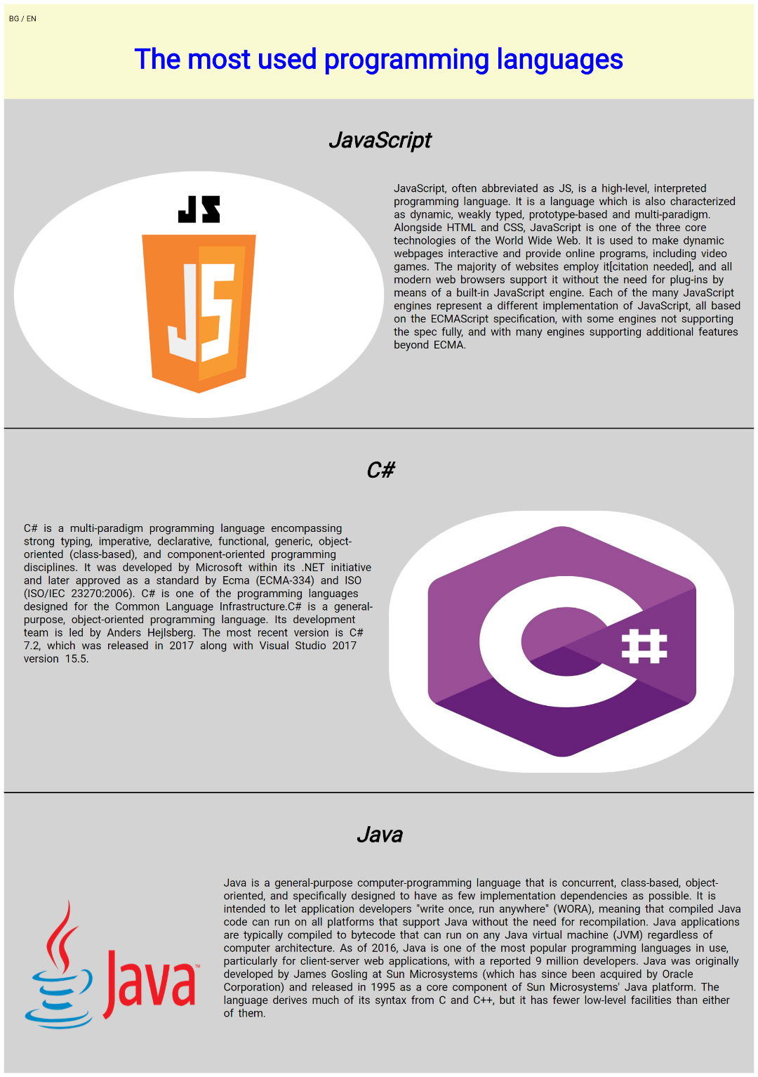

## Capture Click Event – 70 pts

Now let’s complete some tasks of handling click events.

### BG/EN Click Events – 40 pts

Your task is to **attach** a click event to **#bg and #en.** When you click on single element, **#bg** or **#en** become with italic style and purple color, when you click on the other оne of the elements its resets previous element styles:





### BG/EN Click Events part two - 30 pts

Your task is to **attach** a click event to **#bg and #en.** When you click on single element, **#bg** or **#en** your program should change the content in **#heading, .js-info, .csharp-info** and **.java-info** like the following:

**#bg** clicked:

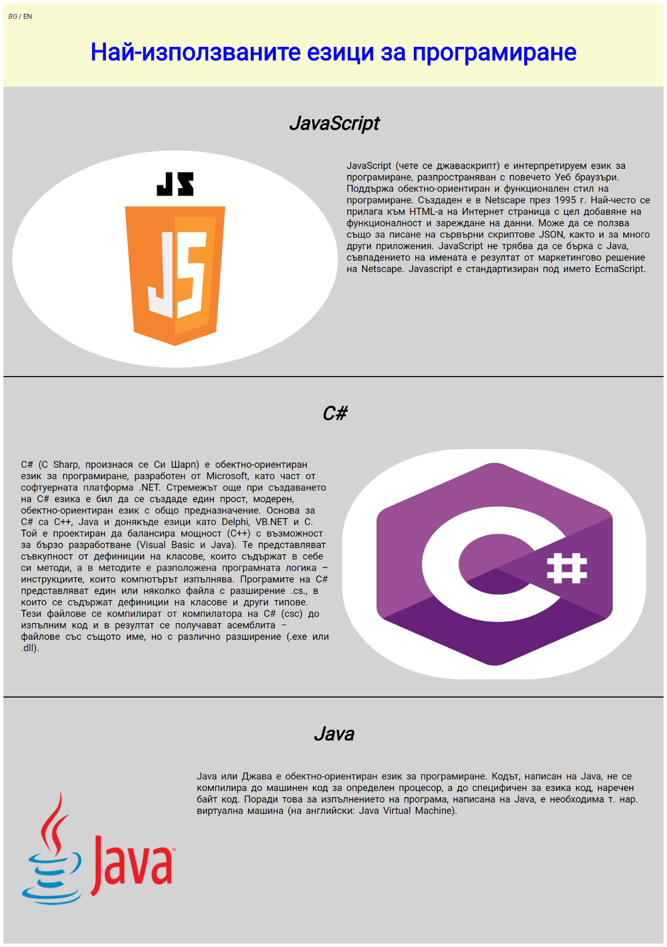

**#en** clicked:

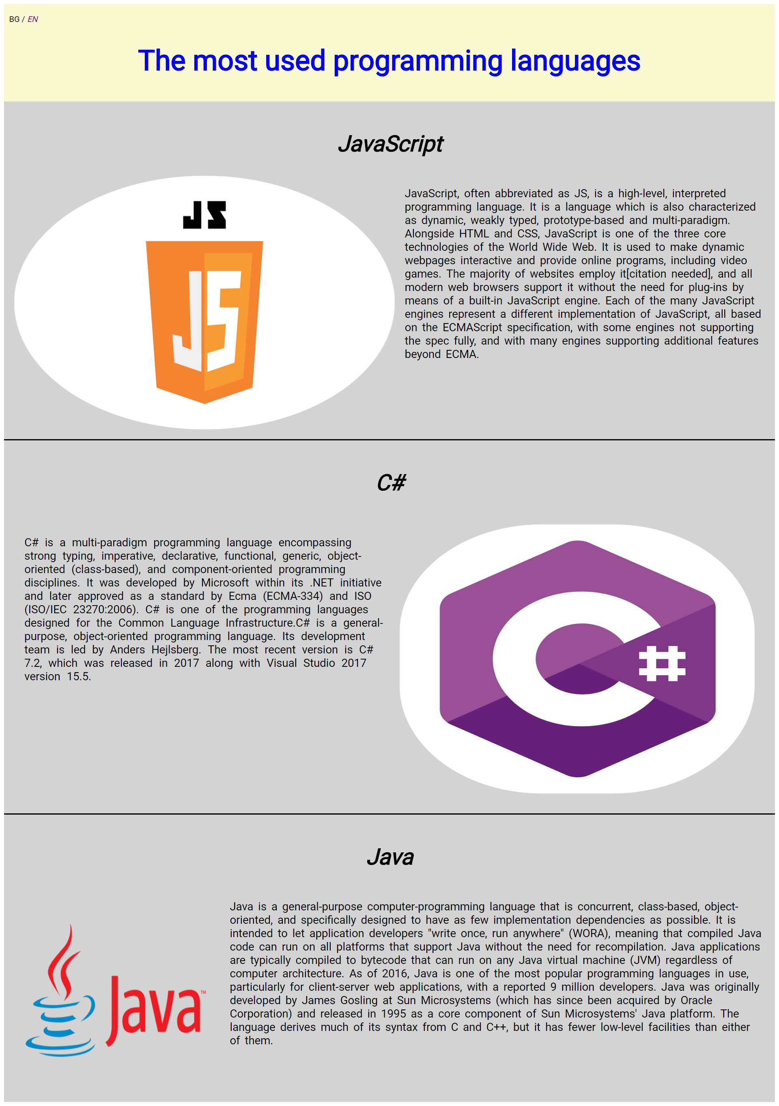

Be careful what you **click** and what you change, your task is to change the **styles** and **texts** on different elements.