Definitional Instability in Kinase Inhibitor Selectivity: An Empirical Characterization and Motivated Properties for a Well-Formed Measure
Polina Vinogradova
Independent Researcher
ORCID: 0000-0003-3271-3841 · polina.vino@gmail.com
Abstract
Kinase inhibitor selectivity is quantified using several competing definitions: S-score, selectivity entropy, Gini coefficient, and ratio-based measures, which are applied interchangeably without justification. Across four profiling datasets spanning three assay technologies (68-704 compounds each), we show these definitions split three to one, with the S-score, entropy and Gini agreeing closely while the fold-selectivity ratio agrees with none, and that rank instability is predictable from binding profile shape. We trace instability to three sources: definitional noise below the activity threshold, near-tied top targets, and distribution-ratio disagreement for promiscuous compounds with a dominant target. We motivate four properties that a well-formed selectivity measure should satisfy, and find that none of the four assessed satisfies all of them. We then propose a measure that does, recovering its full-panel ranking from about a third of a panel.
Keywords: binding selectivity, cancer drug discovery, cheminformatics, kinase inhibition, research methodology.

Introduction
Kinase inhibitors are among the most intensely investigated compound classes in drug discovery, with over 80 FDA-approved agents and several hundred in clinical development.^{[1]} Because the human kinome is comprised of more than 500 proteins sharing a highly conserved ATP-binding site,^{[2]} the design of inhibitors with controlled target profiles remains a central challenge. Selectivity is a primary criterion in lead optimization and a key determinant in the drug approval process.^{[3]}
Despite its importance, no single consistent definition of selectivity exists. The field employs at least four distinct quantitative measures: the S-score,^{[4]} selectivity entropy,^{[5]} Gini coefficient,^{[6]} and ratio-based measures, a family to which the field assigns the CATDS score.^{[7]} These definitions are applied interchangeably in the literature without systematic justification, and their parameter values (the activity threshold in the S-score, the baseline in the entropy and Gini coefficient, the reference off-target in ratio-based measures) are chosen by convention rather than principle. Standardizing them is a prerequisite for integrating selectivity data across laboratories and platforms.
Bosc et al.^{[8]} showed that these definitions can produce substantially different compound rankings on the same dataset, and the KInhibition platform^{[9]} explicitly acknowledged that conflicting results across metrics are common. However, the structural sources of this disagreement, such as “which binding profile properties determine when definitions agree or conflict, and why?”, have not been characterized.
The absence of a principled basis for selectivity measurement is not merely a practical inconvenience. Go/no-go decisions in lead optimization are made on the basis of selectivity assessments whose sensitivity to definitional choice is unknown. The lack of consistency across applications of selectivity definitions for different compounds makes comparison very challenging.
Our analyses suggest that existing selectivity definitions are, in some cases, measuring entirely different qualities of binding profiles, and therefore cannot be easily converted from one to another. In information theory, Shannon^{[10]} settled which function should measure entropy by writing down a few properties a sensible measure must have (e.g., that it should be maximal when all outcomes are equally likely) and showing that only one formula satisfies them. In this work, we follow this precedent, characterizing how the competing measures actually behave, stating the properties a good measure should have, and proposing a satisfactory formula.
We use four large profiling datasets for kinase inhibitor selectivity that span three assay technologies in our characterization. In service of the overarching goal of developing a principled, standardized formula for defining selectivity, our contributions are as follows:
- we show that the S-score, entropy and Gini agree closely with each other on every one of the four datasets (Spearman $0.72$–$1.00$), while the fold-selectivity ratio $R(k)$ agrees with none of them ($0.14$–$0.62$). We call the first group the distribution-based family, and $R(k)$ the ratio-based family. The split follows what each quantifies: how concentrated a compound’s activity is across the whole panel, against how large the gap is to one chosen off-target;
- we identify three sources of instability: definitional noise for compounds with no binding above the activity threshold, ratio-specific instability driven by near-tied top targets, and distribution-ratio disagreement for compounds with one dominant target and broad moderate off-target activity;
- we propose four motivated properties: (D1) a reliability threshold condition, (D2) bounded gap sensitivity, (D3) distributional consistency, and (D4) monotonicity under weak off-target addition. We then find that none of the four definitions assessed satisfies all four simultaneously;
- we propose a candidate measure: a gated, smooth-hinge effective-target number that satisfies all four properties and recovers its full-panel ranking from roughly a third of a typical panel.
We demonstrate that candidate measure we propose is neither unique as a measure satisfying the four properties jointly, nor is it guaranteed to perform better than existing measures in all cases.

Background

Existing Selectivity Metrics and Their Comparison
Several metrics have been proposed to quantify kinase inhibitor selectivity from profiling panel data. Karaman et al.^{[4]} introduced the selectivity score (S-score), defined as the fraction of panel kinases inhibited above a fixed concentration threshold. Uitdehaag and Zaman^{[5]} proposed the selectivity entropy, which treats the normalized binding profile as a probability distribution and computes its Shannon entropy. Low entropy indicates activity concentrated on few targets. Graczyk^{[6]} adapted the Gini coefficient from economics, treating the distribution of a compound’s activity across the panel as an inequality distribution. A value near 1 indicates activity concentrated on few kinases and near 0 indicates activity spread evenly. Klaeger et al.^{[7]} introduced the concentration- and target-dependent selectivity (CATDS) score, which quantifies the reduction in binding to a given target relative to the summed reduction across all detected targets at a specified inhibitor concentration (see Discussion for why we did not implement it as a fifth measure). Bosc et al.^{[8]} subsequently proposed two further metrics, the window score and ranking score, and compared them against four previously published metrics (the S-score, Gini coefficient, selectivity entropy, and a partition index) on the Davis and Anastassiadis datasets, showing that compound rankings differ substantially depending on the metric applied and that certain compounds cannot be scored under some definitions when threshold conditions are not satisfied. For example, ratio-based scores are undefined for a compound with no kinase above the activity threshold, since there is then no primary target or off-target to compare.
Reconciliation attempts have remained limited in scope. Bajorath et al.^{[11]} compared CATDS-based selectivity assessments from Klaeger et al. with activity data mined from ChEMBL for the same compounds, finding broad consistency between the two sources. The KInhibition platform^{[9]} explicitly acknowledged that multiple existing metrics yield conflicting results for the same compound, but addressed this by introducing its own composite score (combining on-target inhibition with an off-target inhibition penalty) rather than reconciling the disagreement among the existing definitions. More recently, the same group’s built a KIRHub resource^{[12]} on a new profiling campaign of 86 approved kinase inhibitors against 758 kinases and disease-associated mutant variants. This resource offers users a choice between a further named metric (the KISS score, an on-target/off-target balance) and a separate Gini-based score, thus proliferating named, ad hoc definitions.
Two further notable gaps surface in existing work. The first is that is that each metric is evaluated at fixed parameter values. Thus, the sensitivity of rankings to parameter choice has not been systematically characterized. The second i that the structural properties of binding profiles that determine when definitions agree or disagree have not been identified. The present work addresses both gaps.

Axiomatic Approaches to Ranking and Measurement
Precedent for an axiomatic characterization of measurement functions is established. Shannon^{[10]} demonstrated that the entropy of a probability distribution is uniquely determined, up to a multiplicative constant, by four requirements: continuity, maximality on the uniform distribution, expansibility, and additivity over independent subsystems. Khinchin^{[13]} subsequently strengthened this uniqueness result. The selectivity entropy of Uitdehaag and Zaman applies the Shannon formula to normalized binding profiles but provides no analogous axiomatic justification. The axioms that single out Shannon entropy, such as maximality on the uniform distribution and additivity over independent subsystems, characterize a measure of uncertainty rather than a measure of selectivity.
Arrow^{[14]} established that no social welfare function satisfies simultaneously the requirements of unrestricted domain, Pareto efficiency, independence of irrelevant alternatives, and non-dictatorship. The theorem is relevant here in two respects: it demonstrates that axiomatic analysis of a ranking concept can yield impossibility, and it shows that competing ranking functions reflect genuine tradeoffs between properties that cannot all be achieved simultaneously. Singleton and Booth^{[15]} applied this methodology to truth discovery, i.e. the problem of identifying true facts from conflicting reports of unknown reliability, posing it as a social choice problem, formulating candidate axioms, and proving that a subset cannot be jointly satisfied.
To our knowledge, this axiomatic style of analysis has not previously been applied to any selectivity or promiscuity measure in drug discovery. The present work proposes empirically motivated properties as a foundation for such an analysis.

Methods

Datasets
Our primary analysis uses two publicly available kinase inhibitor profiling datasets, described first. Two further datasets are added below to confirm the findings across additional assay technologies. The Davis dataset^{[16]} is comprised of binding affinities ($K_{d}$) for 68 small-molecule kinase inhibitors measured against 433 human kinase domains. Affinity values are reported as dissociation constants and were converted to $pK_{d}=−\log_{10}(K_{d}/{10}^{9})$ prior to analysis, following the convention of the DeepDTA benchmark.^{[17]} The resulting affinity matrix is complete ($68×433$, 29,444 entries), with all non-binding pairs assigned the detection-floor value $pK_{d}=5.0$ (corresponding to a $K_{d}$ of 10 $μ$M). This is the standard convention for the dataset^{[8,17]} and slightly underestimates true non-binding affinity.
Active entries (pKd $>6$, i.e. $K_{d}<1 μ$M) make up 17.9% of the Davis matrix. This cutoff answers “was binding detected above assay noise/floor,” the conventional boundary used in kinase profiling, rather than “is this target plausibly occupied at physiological drug concentrations,” a question affinity values alone cannot answer without exposure data (e.g. free-drug concentration) that neither dataset provides. A stricter cutoff ($pK_{d}≥7$, $K_{d}<100$ nM) leaves the agreement between selectivity definitions unchanged but shrinks per-compound active sets, pushing more compounds toward the zero/near-zero-active regime that Section [sec:results:instability] identifies as least rank-stable.
The Klaeger dataset^{[7]} is comprised of binding affinities for 243 clinical kinase inhibitors profiled against the human kinome using Kinobeads chemical proteomics. Apparent dissociation constants ($K_{d}^{app}$) were derived from dose–response curves across eight inhibitor concentrations in cancer cell lysates. Only high-confidence measurements (as annotated by the original authors) were retained, yielding 5,123 drug–target pairs for 222 drugs and 343 kinase targets. Affinity values were converted to $pK_{d}$ using the same formula as above. Missing entries, representing kinase–inhibitor combinations not detected in the assay, were assigned the background value $pK_{d}=5.0$. The resulting Klaeger matrix is $222×343$. Active entries (pKd $>6$) make up 3.6% of the Klaeger matrix, versus 17.9% for Davis above. The lower active fraction for Klaeger reflects the more stringent detection threshold of the chemoproteomic assay.
To test whether our findings depend on the assay technology, we added two further datasets that measure kinase inhibition by different means. The Anastassiadis dataset^{[18]} profiles 178 inhibitors against 300 kinases in a single-concentration ($0.5 μ$M) radiometric activity assay, reported as percent residual kinase activity relative to a solvent control. We converted these to percent inhibition ($100$ minus residual activity, clipped to $[0,100]$, where higher values denote stronger inhibition), with the $1.1\%$ missing entries set to zero inhibition. The Metz dataset^{[19]} reports $pK_{i}$ affinities for a large medicinal-chemistry campaign using the same negative-log scale as $pK_{d}$. The value $pK_{i}=4.0$ is the lowest value reported anywhere in the released data (only $0.17\%$ of measurements), so we assign it to unmeasured combinations as the assay’s own detection floor (the same convention used for the Davis $pK_{d}=5.0$ floor above). Coverage per compound is highly skewed (a median compound is measured against only 21 of the 172 kinases), so we restricted the dataset to the 704 compounds profiled against at least 50 of the 172 kinases, keeping profiles in which most entries reflect a real measurement rather than floor imputation while retaining a large enough compound set for the panel-size and instability analyses.
The four datasets span three assay technologies (competition binding, chemoproteomics, and functional activity) and two readout types (affinity and single-concentration inhibition). Each selectivity definition is computed on the native readout of its dataset, and our analyses concern rank correlations between definitions and rank instability. Figure 1 shows the definitions are not invariant to the choice of readout. In fact, two defensible operationalizations of the entropy rank compounds differently, and on Klaeger in reverse. Cross-dataset comparison here rests on rank correlations computed within each dataset, never on absolute scores compared across them. For the percent-inhibition and $pK_{i}$ datasets, the S-score threshold, and entropy/Gini baseline grids were shifted to span each dataset’s active range, while the ratio off-target index $k∈\{1,…,5\}$ was left unchanged (it is an index of off-targets and so needs no rescaling).
We excluded two additional candidate datasets. The Gao screen^{[20]} is a single-concentration functional inhibition assay of the same readout type as the Anastassiadis dataset already included, and its raw data are not openly redistributable. Including it would add a second instance of an assay type rather than a new assay technology. The Patricelli study^{[21]} profiles only a small number of inhibitors against native kinases as a proof of concept for the KiNativ platform. A ranking-stability analysis requires many compounds to produce a meaningful ranking, so this dataset is not suited to the present comparison.

Selectivity Definitions and Parameterization
We implemented four selectivity definitions, each including parameters whose values are not standardized in the literature. We discuss each definition below. Throughout, a compound’s binding profile is the vector of its affinities $pK_{d,i}$ across the $N$ panel kinases, with higher $pK_{d}$ denoting tighter binding.
S-score. Karaman et al.^{[4]} defined the selectivity score as the fraction of the panel that a compound inhibits: the number of kinases “bound” divided by the number tested, where a kinase counts as bound when the compound reduces its activity below a fixed cutoff at a single screening concentration (the original work reports $S(35)$, $S(10)$ and $S(1)$ for cutoffs of $35\%$, $10\%$ and $1\%$ of control activity). We implemented the same fraction, expressing the bound criterion as an affinity threshold $τ$ on $pK_{d}$:
$$S(τ)=\frac{1}{N}\sum_{i=1}^{N}{1}[pK_{d,i}>τ].$$
Sweeping $τ$ reproduces their family of cutoffs. We used $τ∈\{5.5,5.75,…,8.0\}$ (11 values), spanning $K_{d}$ cutoffs from approximately 3 $μ$M to 10 nM.
Selectivity entropy. Uitdehaag and Zaman^{[5]} treat the compound’s binding across the panel as a probability distribution and report its Shannon entropy. A profile concentrated on few kinases has low entropy and is selective. In the original definition, the weight on each kinase is its association constant $K_{a,i}=1/K_{d,i}$ (the share of compound that would be bound to kinase $i$ in an equimolar mixture), so pi=Ka,i/j​Ka,j. We implemented the entropy on the same log-affinity scale used by the other metrics, weighting each kinase by its affinity in excess of a baseline $β$:
H(β)=−i=1Npilog2pi, pi=max(pKd,i−β, 0)j​max(pKd,j−β, 0),
where $β$ is the affinity below which binding is treated as negligible. This makes $β$ an explicit parameter (its under-specification motivates property D3 below). We swept $β∈\{5.0,5.25,…,6.5\}$ (7 values), a narrower range than the S-score’s $τ$ sweep above. Both parameters key off the same threshold-crossing event, so sweeping either one far enough leaves a growing share of compounds with no kinase above the cutoff (on Klaeger, 7.2% of compounds at $pK_{d}=6.0$ versus 55% at $pK_{d}=8.0$), degenerating the S-score toward an uninformative 0 and the entropy and Gini weights toward an undefined 0/0 alike. The $τ$ range (whose S-score is not necessarily immune to this) is wider because it was chosen to reproduce Karaman et al.’s published cutoffs (approximately 3 $μ$M to 10 nM). $β$ has no equivalent published reference points and was kept closer to the $pK_{d}=6$ active threshold used elsewhere in this work. The association-constant and log-affinity weightings are distinct reasonable choices that can rank compounds differently, which is itself an instance of the definitional instability this paper characterizes. We quantify the difference below.
Gini coefficient. Graczyk^{[6]} adapted the Gini coefficient from economics: kinases are sorted by activity and the cumulative fraction of total binding is plotted against the cumulative fraction of kinases (a Lorenz curve). The Gini coefficient, which measures how unequally is binding distributed across the kinome, is twice the area between this curve and the diagonal of equal distribution. The original work computes it from percent-inhibition values. As with the entropy above, implemented the entropy on the same log-affinity scale for the same reason. We applied the standard discrete Gini formula to that baseline-subtracted log-affinity profile:
$$G(β)=\frac{2\sum_{i=1}^{N}{i}⋅x_{(i)}}{N\sum_{i=1}^{N}{x_{(i)}}}−\frac{N+1}{N}, x_{(i)}=max(pK_{d,i}−β, 0) \text{sorted ascending}.$$
We swept $β$ over the same range as for the entropy. A compound whose binding is concentrated on one kinase has a highly unequal distribution ($G$ is near 1), while a compound that binds many kinases equally has $G$ near 0. Higher values therefore indicate greater selectivity.
Ratio. Classical pharmacological selectivity is pairwise. It quantifies how much more tightly a compound binds its primary target than an off-target. We implemented this as the fold-selectivity, in log units, between the primary target and the $k$-th ranked off-target:
$$R(k)=pK_{d,(1)}−pK_{d,(k+1)}=\log_{10}\frac{K_{d,(k+1)}}{K_{d,(1)}},$$
where $pK_{d,(j)}$ is the $j$-th largest affinity in the profile and $k∈\{1,2,3,4,5\}$ selects the reference off-target. We capped $k$ at 5 because, on the sparser Klaeger panel, a large share of compounds already have fewer than five active kinases (median 5.5; $45\%$ have fewer than five). For those compounds, a larger $k$ would compare the primary target against the assay floor rather than a genuine off-target. $R(k)$ takes the affinity gap to a single chosen competitor, the $k$-th ranked off-target. The field also assigns the concentration- and target-dependent selectivity (CATDS) score of Klaeger et al.^{[7]} to this family, though we find that it does not behave like a member of it. CATDS divides each target’s concentration-dependent binding reduction by the sum of binding reductions over every target in the panel, rather than comparing to a single chosen competitor, which is a distributional construction. We therefore represent the ratio family by $R(k)$ alone and treat CATDS separately in the Discussion. We use the simpler fold-selectivity because the reference off-target index $k$ is then an explicit parameter whose effect can be studied directly. A larger affinity gap to the nearest competitor means greater selectivity, so higher $R(k)$ indicates greater selectivity.
Faithfulness to the original definitions. The S-score and the ratio are computed in the form given by their original sources (a panel-hit fraction and a primary-to-off-target affinity ratio, respectively). For the entropy and the Gini coefficient, we used the baseline-subtracted log-affinity profile in place of the original association constants (entropy) and percent-inhibition values (Gini), so that all four metrics operate on one common scale, and making baseline $β$ an explicit calculation parameter. To confirm that this choice does not implicitly determine our conclusions, we recomputed the entropy and Gini in forms closer to the originals (association-constant weighting) and compared the resulting rankings with the log-affinity forms. The two operationalizations differ substantially: for entropy, Spearman $r=0.42$ (Davis) and $−0.32$ (Klaeger), while for Gini, $r=0.11$ and $−0.45$ (Figure 1). This confirms that the operationalization of a named metric is a source of the definitional instability.
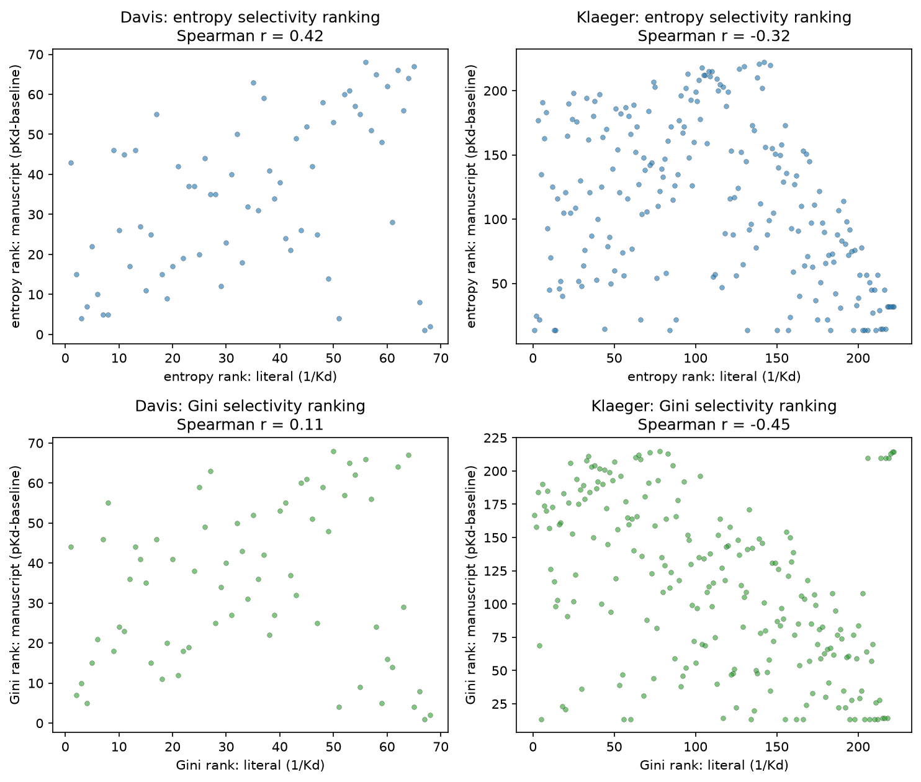
Figure 1. Operationalization sensitivity of the entropy and Gini coefficient. For each dataset, the compound selectivity ranking computed in a form close to the original publication (association-constant weighting) is plotted against the baseline-subtracted log-affinity form used in the main text. Top row: selectivity entropy; bottom row: Gini coefficient. The two operationalizations of the same named metric differ substantially, and the entropy ranking even reverses on Klaeger, confirming that the operationalization of a named metric is a source of the definitional instability.

Rank Stability Analysis
For each definition and each parameter value, compounds were ranked from most selective (rank 1) to least selective (rank $n$, where $n$ is the number of compounds in the dataset). Ties were broken by average rank. This yielded 30 rank vectors per dataset for Davis, Klaeger, and Metz (11 for the S-score, 7 for entropy, 7 for Gini, and 5 for ratio), and 28 for Anastassiadis, whose coarser native percent-inhibition scale supports only 9 S-score threshold values rather than 11.
For each compound, rank instability was quantified as the standard deviation of its rank across all configurations for that dataset (overall instability) and separately across parameter configurations within each definition family (within-family instability). Cross-definition-family agreement was assessed using Spearman rank correlation between the median rank vectors of each definition family. The median was taken across parameter values within each family, rather than the mean, because the median is less sensitive to the inclusion or exclusion of outliers than the mean.
Associations between rank instability and binding profile features were assessed using Spearman correlation, restricted to the Klaeger and Davis datasets. These are the two datasets on a $pK_{d}$ scale, so the same activity threshold and affinity-based features apply directly, allowing the predictor structure to be checked for replication across a second dataset. Profile features computed for each compound included: the number of active kinases ($pK_{d}>6$), the gap between the top and second-ranked affinities, the standard deviation and range of active affinities, and the absolute affinity of the second-ranked target. All correlations are reported with two-tailed $p$-values. Significance thresholds of $p<0.05$, $p<0.01$, and $p<0.001$ are denoted *, **, and *** respectively. Analyses were performed in Python 3.10 using NumPy, pandas, and SciPy.^{[22–24]} A secondary analysis relating selectivity rankings to clinical adverse-event outcomes (FAERS report rates and FDA-label discontinuation rates for the FDA-approved Klaeger compounds) is summarized in the Limitations section. The analysis code and full per-definition results are available in the code repository (see Data and Software Availability).

Results

Selectivity Definitions Cluster into Two Families
Across 30 parameter configurations (11 S-score thresholds, 7 entropy baselines, 7 Gini baselines, 5 ratio off-target indices), compound rankings were computed for all drugs in both datasets. Spearman correlations between the median ranking of each definition family reveal a consistent two-cluster structure (Table 1). On the Davis dataset, S-score, entropy, and Gini are mutually correlated ($r=0.95$–$0.999$), while ratio correlates substantially less with each ($r=0.34$–$0.46$). On the larger Klaeger dataset, the same structure is preserved but with lower within-cluster correlations ($r=0.72$–$0.90$), reflecting greater diversity of binding profiles among the 222 clinical compounds. The ratio definition is the consistent outlier in both datasets, with cross-family correlations of $r=0.22$–$0.62$.
Table 1. Spearman correlations between median rankings by definition family. Upper triangle: Davis ($n=68$). Lower triangle: Klaeger ($n=222$).
 | S-score | Entropy | Gini | Ratio
S-score | — | 0.946 | 0.952 | 0.456
Entropy | 0.901 | — | 0.999 | 0.343
Gini | 0.722 | 0.866 | — | 0.343
Ratio | 0.223 | 0.483 | 0.616 | —
This two-family structure reflects a fundamental difference in what the definitions measure. The S-score, entropy, and Gini all quantify the concentration of activity across the full kinase panel. They differ in functional form but respond to the same underlying property of the binding profile. The ratio definition, by contrast, quantifies the gap between the primary target and a specific off-target, ignoring the remainder of the binding profile entirely. A compound that strongly inhibits one kinase and moderately inhibits twenty others will be ranked as highly selective by ratio (large gap to the second target) but as moderately promiscuous by entropy and Gini (activity distributed across many targets).

The Two-Family Structure Replicates Across Assay Technologies
The Davis and Klaeger pattern of Table 1 extends to the two further datasets, across three assay technologies and both readout types (Figure 2). In all four, the S-score, entropy, and Gini remain mutually correlated (within-family Spearman $r=0.72$–$0.999$) while the ratio definition is the consistent outlier. Its correlation with the distribution-based family is $0.49$–$0.56$ on the Anastassiadis functional-activity dataset and only $0.14$–$0.19$ on the Metz $pK_{i}$ dataset. The degree of separation varies with the assay, but in every case the ratio definition measures something the distribution-based definitions do not.
The instability findings also replicate. Compounds with no active kinases (Type 1, below) are markedly more rank-unstable than active compounds wherever such compounds exist: mean rank $σ=36.8$ vs. $21.7$ on Anastassiadis and $178.5$ vs. $108.1$ on Metz, matching the $72.9$ vs. $31.3$ contrast on Klaeger (Davis contains no zero-active compounds). Within the distribution-based family, the number of active kinases negatively predicts entropy instability in every dataset ($r=−0.28$ to $−0.43$). The top$​_{1}$–top$​_{2}$ affinity gap predicts ratio instability on three of the four datasets, Davis, Klaeger and Metz ($r=−0.44$, $−0.34$, $−0.27$; all $p<0.001$), but not on Anastassiadis ($r=−0.104$, $p=0.23$), as detailed below.
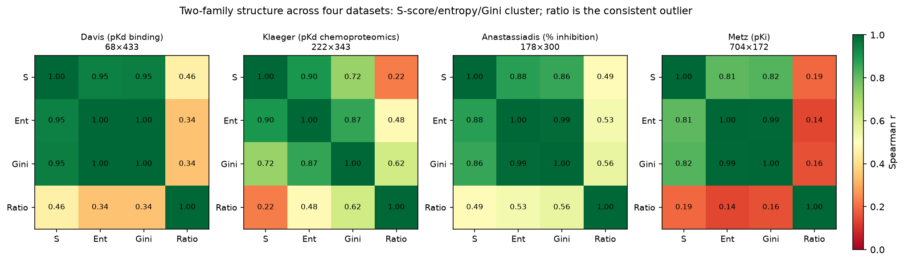
Figure 2. Spearman correlations between the median rankings of the four selectivity definitions, computed independently on each of the four datasets (compound $×$ kinase panel sizes shown). In every dataset the S-score (S), entropy (Ent), and Gini cluster together while the ratio is the consistent outlier (the ratio row and column are the least green throughout), confirming the two-family structure across competition-binding, chemoproteomic, and functional-activity assays.

Rank Instability Is Structured and Predictable
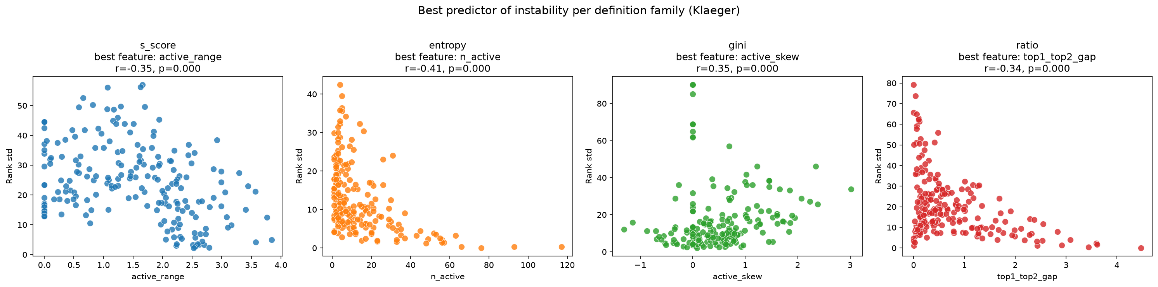
Figure 3. Best predictor of rank instability within each definition family (Klaeger dataset, active compounds, $n=206$). Ratio instability is best predicted by the top$​_{1}$–top$​_{2}$ affinity gap; entropy, Gini, and S-score instability are best predicted by features of the active affinity distribution.

Overall rank instability (measured as the standard deviation of a compound’s rank across all 30 configurations) varies substantially across compounds (Klaeger: mean $σ=34.3$, range $7.0$–$90.7$; Davis: mean $σ=8.5$, range $1.8$–$19.3$). Instability is not uniformly distributed: within each definition family, specific binding profile features predict which compounds receive unstable rankings (Table [tab:predictors]).
Within the ratio family, the gap between the top and second-ranked affinities (top$​_{1}$–top$​_{2}$ gap) is the strongest predictor of instability (Figure 3) ($r=−0.444$, $p<0.001$ on Davis, and $r=−0.341$, $p<0.001$ on Klaeger). Compounds with near-identical affinities for their two best-bound kinases receive highly variable ratio rankings because the choice of reference off-target ($k=1$ vs. $k=2,…,5$) determines whether the compound appears selective or promiscuous.
Within the entropy and Gini families, the number of active kinases ($pK_{d}>6$) negatively predicts instability ($r=−0.279$, $p<0.05$ for entropy on Davis, $r=−0.409$, $p<0.001$ on Klaeger). Compounds with many active kinases have well-defined broad profiles whose entropy and Gini scores are stable across baseline choices, while compounds with few active kinases are sensitive to the baseline because small changes can move targets in or out of the active set, altering the distribution substantially. The active affinity range is also a significant predictor for the S-score and entropy on Klaeger ($r=−0.35$ and $−0.27$, both $p<0.001$). Gini is not significantly predicted by this feature ($r=−0.10$, $p=0.15$). It is consistent with the interpretation that heterogeneous profiles (whose affinities span a wide range) yield more reproducible rankings across parameter choices than flat profiles (in which many near-equal affinities reshuffle as the parameter changes).
Gini instability’s strongest predictor in either dataset ($r=+0.346$, $p<0.001$ on Klaeger) is skewness, exceeding every other feature–family pairing in Table [tab:predictors] apart from the ratio’s top$​_{1}$–top$​_{2}$ dependence. Unlike the other features above, it targets what Gini measures directly, i.e. the shape of the active-affinity distribution’s inequality. The positive sign of this correlation is consistent with right-skewed active distributions being the least stable. Most active kinases bound only modestly above threshold, with one (or a few) much more potent outliers, concentrating mass near the baseline boundary. A small shift in $β$ moves that mass in or out of the active set. Left-skewed profiles (most active kinases tightly bound, few sitting near threshold) are comparatively insensitive to that choice. As with active affinity std/range above, the relationship does not replicate on Davis ($r=+0.043$, $p=0.73$).
Unlike the other families, the S-score’s instability is significantly predicted by every profile-shape feature except the top$​_{1}$–top$​_{2}$ gap (Table [tab:predictors]), and most strongly by the spread of active affinities. Compounds whose active affinities cluster near the threshold gain or lose panel hits under small shifts in $τ$, whereas those with a wide affinity range retain a stable hit count regardless of the exact cutoff. This S-score pattern is specific to Klaeger, however, on Davis, no profile feature significantly predicts S-score instability (all $|r|≤0.16$; Table [tab:predictors], right). A possible explanation is that a threshold count’s instability is governed by where each assay’s detection window falls relative to the cutoff, and the two assays place that window very differently: 3.6% of the Klaeger matrix is active versus 17.9% of Davis (Methods). Within Table [tab:predictors], the only pairing that holds on both pK$​_{d}$ datasets is the ratio family’s dependence on the top$​_{1}$–top$​_{2}$ gap, which compares two affinities directly rather than counting how many pass a cutoff. As reported above, that dependence also holds on Metz but fails on Anastassiadis, so it replicates on three of the four datasets and specifically not on the percent-inhibition readout. The entropy dependence on the number of active kinases replicates in direction but more weakly on the smaller Davis panel ($r=−0.409$ on Klaeger vs. $−0.279$ on Davis). Gini shows the reverse pattern in strength, reaching significance on Davis ($r=−0.300$) but not on Klaeger ($r=−0.093$).
Five additional candidates features were tested: two concentration measures from industrial-organization economics ((1) the top-target concentration ratio (CR$​_{1}$) and (2) the Herfindahl–Hirschman Index (HHI)). These were sourced from the same field as the Gini coefficient^{[6]}. We also tested (3) the raw primary-target affinity (top$​_{1}$ $pK_{d}$), (4) a near-tie count generalizing the top$​_{1}$–top$​_{2}$ gap, and (5) the active-affinity coefficient of variation. CR$​_{1}$ and HHI turned out to be near-collinear with $n_{active}$, which is already in the table ($r=−0.98$ to $−0.99$ and $−0.998$, respectively, on both datasets). The remaining three were uniformly weaker predictors than the features already included, in every family and both datasets (full numbers in the code repository).

Three Mechanistically Distinct Sources of Instability
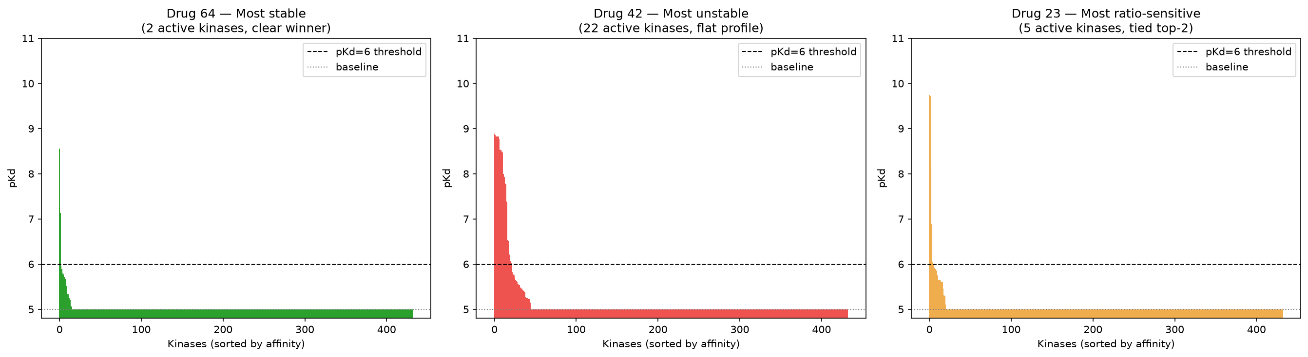
Figure 4. Representative binding profiles illustrating the three instability types. Left: Drug 64 (Davis), most stable ($σ=1.8$), two active kinases. Center: Drug 42 (Davis), most unstable ($σ=19.3$), 22 active kinases with no dominant target. Right: Drug 23 (Davis), most ratio-sensitive, five active kinases including two near-tied top targets ($ΔpK_{d}=0.023$). Dashed line: $pK_{d}=6$ activity threshold; dotted line: $pK_{d}=5$ assay floor.

Examination of the most and least unstable compounds in the Klaeger dataset reveals three structurally distinct sources of rank instability (Figure 4), each implicating a different aspect of how the definitions are constructed.
Type 1: Zero-active compounds. The five most unstable Klaeger compounds (AZD-8055, BMS-911543, Vatalanib, Filgotinib, ARRY-380; rank $σ>76$) all have zero active kinases at the $pK_{d}>6$ threshold. These compounds have no meaningful binding to any profiled kinase at sub-micromolar affinity, yet all four definitions still assign them numerical selectivity scores based on sub-threshold values. The resulting rankings are arbitrary: different parameterizations produce different orderings of compounds that are, in practice, indistinguishable from one another. Mean rank instability for zero-active compounds is $σ≈73$, compared with $σ≈31$ for compounds with at least one active kinase ($p<0.001$, Mann–Whitney $U$ test). Davis has no such compounds at all: every Davis compound has at least one active kinase, consistent with Davis’s fixed-concentration screening design, which reports a $K_{d}$ only when activity is first detected at 10 $μ$M. The same zero-active instability contrast reported here for Klaeger also holds on the two further datasets in Section 4.2.
Type 2: Near-tied top targets. When an active compound’s two best-bound kinases have near-identical affinities, the ratio is highly sensitive to which is designated the primary target and which the reference off-target, because a small parameter change can swap their roles (the top$​_{1}$–top$​_{2}$ gap is the strongest predictor of ratio instability, above). Drug 23 in the Davis dataset (top$​_{1}$–top$​_{2}$ gap $=0.023$ pKd units) is the extreme case: its two best-bound kinases are essentially indistinguishable, so it receives maximally unstable ratio rankings.
Type 3: Broad profiles with a dominant primary target. The largest entropy-ratio disagreements in the Klaeger dataset arise for compounds with high $n_{active}$ and a large top$​_{1}$–top$​_{2}$ gap (e.g. Dovitinib: $n_{active}=26$, gap $=1.935$; BMS-690514: $n_{active}=20$, gap $=1.985$). These compounds have one clearly dominant target but also bind many kinases at moderate affinity. The ratio definition scores them as highly selective (large gap between primary and secondary target), while the entropy and Gini definitions score them as moderately promiscuous (activity spread across many targets). Neither characterization is incorrect, as they reflect genuinely different questions about selectivity.
Conversely, the most stable compounds in both datasets (e.g. XL-228, $σ=7.0$; PF-03814735, $σ=7.8$) are highly promiscuous, with 55–57 active kinases. When a compound binds nearly the entire profiled kinome, all definitions rank it as non-selective regardless of parameterization, producing low instability.

Panel Size Dependence of Selectivity Rankings
To assess the stability of selectivity rankings as a function of kinase panel size, we performed a subsampling analysis on the two datasets with genuine sparse kinase coverage: Klaeger (343 kinases, chemoproteomic dose–response profiling) and Metz (172 kinases, a medicinal-chemistry campaign), in each of which compounds were tested against only a subset of the panel. The Davis and Anastassiadis datasets were not used for this analysis, because both are dense complete-matrix screens (every compound tested against every kinase by construction) rather than the sparse coverage of real profiling panels. Subsampling their kinases would also change the apparent number of active compounds in ways that confound the panel size effect with the zero-active instability characterized in the instability taxonomy above.
For each panel size (Klaeger $p∈\{50,80,…,320,343\}$; Metz $p∈\{50,80,…,170,172\}$), we drew 50 random subsets of $p$ kinases from the full panel, computed each selectivity definition on the subpanel, and measured agreement with the full-panel ranking using Spearman correlation. We call a panel size “recovering” the full-panel ranking once this mean correlation exceeds $0.90$, adopting the same numerical bar reliability conventionally sufficient to call a measurement “excellent”^{[25]}. Altering the choice of correlation cutoff changes the reported $p^{*}$ values, however, the ratio definition remains the slowest to recover and the Gini coefficient the second-slowest for any bar between $0.80$ and $0.95$. Only the relative order of entropy and the S-score is bar-dependent within this range (full numbers in the code repository).
On Klaeger, the four definitions differ substantially in their panel size requirements (Figure 5). Selectivity entropy and the S-score both reach mean $r=0.90$ against the full-panel ranking at approximately 110 kinases. The Gini coefficient requires approximately 290 kinases to reach the same threshold. The ratio definition does not reach $r=0.90$ at any subpanel size short of the full panel: it achieves only $r=0.888$ even at 320 kinases, just 23 below the full panel of 343, and attains $r=0.90$ only on the complete panel.
This result has a direct practical implication. Commercial kinase selectivity panels vary widely in size, from focused subpanels of a few dozen kinases to near-kinome panels of several hundred. On a 50-kinase subpanel, entropy- and S-score-based rankings are reasonably stable ($r≈0.78$–$0.82$), while Gini and ratio rankings are effectively uncorrelated with what would be obtained on a full kinome panel ($r=−0.09$ for Gini and $r=−0.08$ for ratio at $p=50$). The practical consequence is that the smaller the panel, the more the choice of definition determines the answer. Ratio rankings in particular are unreliable at any panel size commonly used in practice, because the identity of the reference off-target ($k$-th ranked kinase) changes substantially as panel composition changes.
To test whether these patterns generalize beyond a single assay, we repeated the analysis on Metz (172 kinases; Figure 5, right). The ordering of the definitions by panel-size requirement is preserved. The distribution-based definitions recover the full-panel ranking from a small fraction of the panel (S-score at approximately 50 kinases, entropy and Gini at approximately 80), while the ratio again lags, reaching $r=0.90$ only at 170 of the 172 kinases. We note that the ratio’s poor recoverability is universal, holding on both sparse datasets, which strengthens the case that it measures a distinct, panel-composition-dependent property. We also note that the Gini coefficient is the one measure whose recoverability is dataset-specific. It is slow on Klaeger ($p^{*}=290$), but fast on Metz ($p^{*}=80$), so its poor behavior on Klaeger should not be read as a general property. Entropy and the S-score are fast on both.
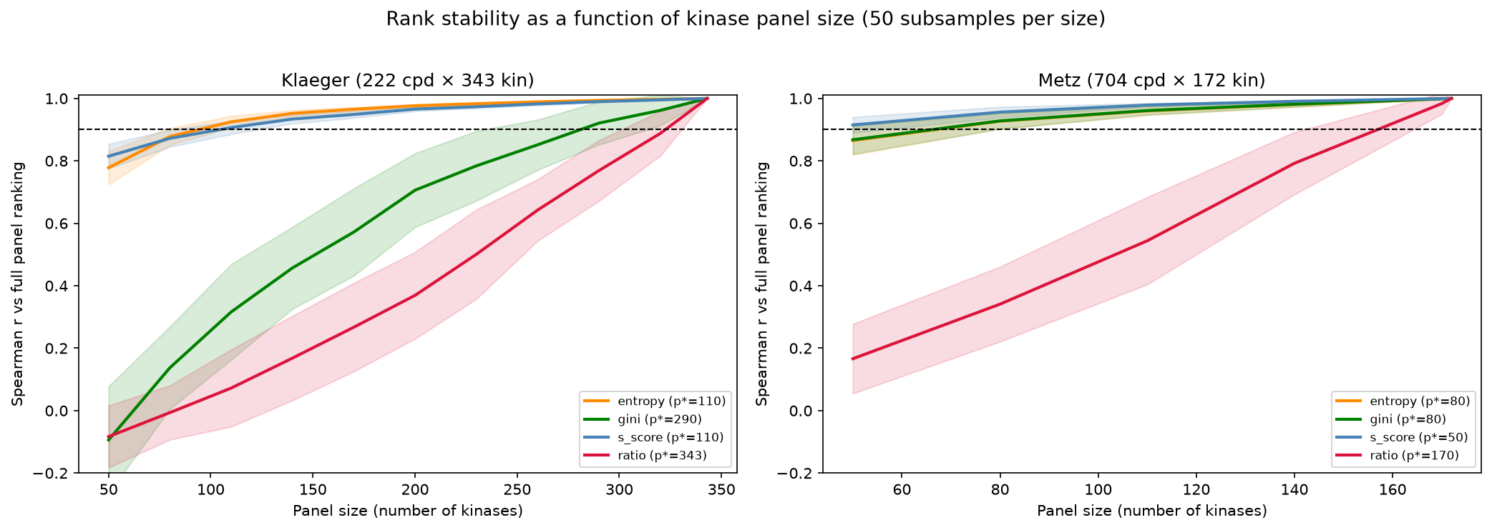
Figure 5. Mean Spearman correlation between rankings computed on random kinase subpanels and rankings on the full panel, as a function of subpanel size, for the two sparse-coverage datasets: Klaeger (left, 343 kinases) and Metz (right, 172 kinases). Shaded bands indicate $±1$ standard deviation across 50 subsamples; the dashed line marks $r=0.90$.

Motivated Properties for a Well-Formed Selectivity Measure
The empirical findings of the Results section motivate four properties that any well-formed kinase inhibitor selectivity measure should satisfy. Each property is stated below together with the observed failure mode that motivates it.
Let $x=(x_{1},…,x_{N})∈R^{N}$ denote a compound’s binding profile across $N$ kinases, where $x_{i}=pK_{d,i}$. $N$ is the size of the profiling panel, which varies across compounds within a dataset (Anastassiadis, Metz) and across datasets (Davis: $N=433$; Klaeger: $N=343$). A selectivity measure is a function $f:R^{N}→R$, where higher values indicate greater selectivity, defined for every panel size $N$. A selectivity ranking over a set of compounds is induced by ordering their $f$-scores.
D1: Reliability threshold. There exists a threshold $τ^{*}>0$ such that $f(x)$ is undefined, or explicitly flagged as unreliable, when $\max_{i}x_{i}≤τ^{*}$.
Motivation. Compounds with no binding above the $pK_{d}>6$ activity threshold receive arbitrary selectivity scores, producing rank instability with mean $σ=72.9$ pooled across the four definitions’ parameter sweeps, compared with $σ=31.3$ for active compounds ($p<0.001$, Mann–Whitney $U$ test; Type 1 instability, above; Figure 6, left). The pooled figure is not uniform across the four definitions, and we report the decomposition rather than claim that it holds for each. It is driven by Gini ($σ=86.1$ versus $15.9$) and by entropy ($17.1$ versus $12.5$), is marginal for the ratio ($24.0$ versus $20.7$), and reverses for the S-score ($18.5$ versus $24.3$), whose score is exactly $0$ for every one of these compounds and whose ranks are therefore stable by degeneracy rather than by reliability. A compound that does not bind cannot be meaningfully ranked relative to compounds that do. None of the four definitions assessed here incorporate an explicit reliability condition. In fact, both the S-score and selectivity entropy assign scores to compounds with no sub-micromolar binding, treating sub-threshold values as informative.
D2: Bounded gap sensitivity. For any compound profile $x$ satisfying D1, a small perturbation to the identity of the reference off-target should produce a bounded change in $f(x)$. Formally, if $f$ depends on the $k$-th ranked affinity $x_{(k)}$, then there should exist a function $g$ with $g(0)=0$ such that $|f(x;k)−f(x;k+1)|≤g(x_{(k)}−x_{(k+1)})$. This inequality states that “as the gap between the two ranked affinities shrinks to zero, the score’s dependence on which one is chosen as the reference off-target must shrink to zero as well”.
Motivation. Ratio-based definitions violate this property when $x_{(1)}≈x_{(2)}$. A compound with near-identical affinities for its top two kinases receives a near-zero ratio score when $k=1$ (the reference off-target is the tied second target, so the gap is negligible) but a large score when $k=2$ (the reference skips past the tie). On the 17 Klaeger compounds with a top$​_{1}$–top$​_{2}$ gap below $0.05$, mean $R(1)=0.02$ against mean $R(2)=0.42$. This produces the Type 2 instability identified in the instability taxonomy above, where top$​_{1}$–top$​_{2}$ gap is the strongest predictor of ratio instability ($r=−0.341$, $p<0.001$). Entropy and Gini satisfy D2 vacuously. Neither scores a specific ranked affinity $x_{(k)}$, so the if condition of D2’s formal statement (“if $f$ depends on the $k$-th ranked affinity, then …”) is never satisfied. However, they also satisfy the intent of D2. That is, both are symmetric, continuous functions of the full normalized profile, so swapping two exactly tied affinities leaves the score unchanged, and a near-tie changes it only by a vanishing amount. The S-score also has no $k$-th ranked term, but it is not continuous in the same way: it counts kinases against a fixed threshold $τ$, so whichever kinase’s affinity happens to sit nearest $τ$ plays the role of a reference off-target, and an infinitesimal perturbation that moves that affinity across $τ$ changes the score by a full $1/N$. This is a bounded, single-kinase version of the same instability, smaller in magnitude than the ratio’s unbounded swing but not the vanishing sensitivity entropy and Gini show, which is why it is graded $∼$ rather than $✓$ in Table 2.
D3: Distributional consistency. The ranking induced by $f$ should be stable under small perturbations to the activity baseline $β$ used to define the active binding distribution. Formally, for any two compounds $x,y$ and any $ϵ>0$, there exists $δ>0$ such that if $|β_{1}−β_{2}|<δ$ then the ranking of $x$ relative to $y$ under $f(⋅;β_{1})$ agrees with that under $f(⋅;β_{2})$.
Motivation. As we implement them, the entropy and Gini definitions are parameterized by a baseline $β$ that determines which affinities contribute to the binding distribution. Our $β$ is derived from the published forms’ own (implicit) choice of reference points, $K_{a}→0$ for the entropy and $0\%$ inhibition for the Gini. Compounds with few active kinases are sensitive to this choice because small changes in $β$ can move individual kinases in or out of the active set, substantially altering the distribution. The negative correlation between $n_{active}$ and entropy instability ($r=−0.409$ on Klaeger, $p<0.001$; weaker for Gini, see Table [tab:predictors]) reflects this sensitivity (Figure 6, right). D3 requires that the ranking be robust to the choice of $β$ within a reasonable neighborhood, which existing implementations do not guarantee. The ratio $R(k)$ compares two specific ranked affinities directly, so there is no $β$ for D3 to perturb. It therefore has no activity baseline at all. Unlike D2, D3’s formal statement is not phrased as a conditional. Instead, it presupposes a baseline $β$. Where that presupposition fails, as for the ratio, the property holds vacuously. This is why the ratio is graded $✓$ for D3 in Table 2.
The S-score’s threshold $τ$ plays the same active/inactive gating role as $β$. Its instability under $τ$ is, however, weaker and less consistent than entropy and Gini’s under $β$. This instability is predicted by every profile-shape feature except the top$​_{1}$–top$​_{2}$ gap on Klaeger, but by none of them on Davis (all $|r|≤0.16$; Table [tab:predictors]). The entropy’s $n_{active}$ dependence, on the other hand, replicates on both datasets. This inconsistent sensitivity is why the S-score is graded $∼$ rather than $×$ or $✓$.
D4: Monotonicity under weak off-target addition. If compound $x$ has a weak additional binding interaction added, i.e. if $x^{′}=(x_{1},…,x_{N},x_{N+1})$ where $x_{N+1}≤τ^{*}$, then $f(x^{′})≤f(x)$. Adding a sub-threshold binding interaction should not increase a compound’s selectivity score.
Motivation. The S-score and the Gini coefficient violate this property. Adding a kinase that the compound does not meaningfully bind increases the panel size without adding activity. This lowers the S-score’s fraction of hit kinases and raises the Gini coefficient’s inequality, in both cases inflating the apparent selectivity. A compound can therefore be made to look more selective simply by profiling it against more inactive kinases. This is a serious problem when panels differ in size or composition across experiments, as between Davis and Klaeger. The entropy and the ratio satisfy D4. This can be explained by the fact that a sub-threshold target adds negligible weight to the entropy’s normalized distribution and falls at or below the ratio’s reference off-target, so neither score increases.
Table 2 summarizes which definitions satisfy each property. The D1, D2 and D4 verdicts follow from the functional forms set out above. The D3 verdicts for the entropy and the Gini are empirical, and apply to the parameterized forms implemented here rather than to the published definitions, which leave the reference point implicit. None of the four definitions assessed satisfies all four properties, but the candidate measure introduced next does.
Table 2. Satisfaction of the four motivated properties by existing selectivity definitions and by the candidate measure introduced below. $✓$: satisfied (by construction, or verified empirically for the candidate). $∼$: partially satisfied or satisfied under additional assumptions. $×$: violated in general.
Property | S-score | Entropy | Gini | Ratio | Candidate
D1 (reliability threshold) | $×$ | $×$ | $×$ | $×$ | $✓$
D2 (bounded gap sensitivity) | $∼$ | $✓$ | $✓$ | $×$ | $✓$
D3 (distributional consistency) | $∼$ | $×$ | $×$ | $✓$ | $✓$
D4 (monotonicity, weak off-target) | $×$ | $✓$ | $×$ | $✓$ | $✓$

A Candidate Measure
The four properties can indeed be satisfied, and the selectivity entropy is the natural starting point. The goal is not to outrank the entropy, but to repair the two failure modes documented above (D1’s arbitrary scores for non-binders and D3’s baseline-driven instability) without giving up what it already gets right. Of the existing definitions it is the only one that already satisfies both D2 and D4 (Table 2). Because it scores the whole normalized profile rather than a single pairwise gap, it neither privileges a reference off-target (D2) nor rewards the addition of non-binders (D4). It, however, fails D1 and D3. It fails D1 due to having no reliability gate. The D3 failure comes from the hard active/inactive cutoff $max(x_{i}−β,0)$, which ties the boundary between active and inactive kinases to the baseline $β$. As $β$ moves, kinases enter or leave the active set and the ranking shifts.
The cutoff plays two roles: it excludes non-binders, which keeps the measure correctly oriented, and it sets the emphasis among the active kinases. The candidate separates these roles. It excludes non-binders with a gate fixed at the assay detection floor (a specified constant). It then applies a smooth softplus emphasis above the floor. The ratio cannot be repaired this way, as it fails D2 by construction. The S-score and Gini violate D4 by construction, as both are computed as a fraction or rank-weighted sum over the full panel of size $N$. A sub-threshold addition still shifts $N$ and moves the score. This differs from the entropy’s normalized weights, where a zero-weight addition drops out without changing the score. The entropy is therefore the one existing measure that can reach all four properties through local changes. The candidate differs from entropy in the following ways: (1) it adds the D1 reliability gate, (2) it fixes the non-binder gate at the assay floor, and (3) it replaces the hard cutoff above the floor with a smooth softplus emphasis.
All three changes are deliberately local, and it follows that on the compounds both measures score they should rank them almost identically. They do: the full-panel Spearman correlation between the candidate and the entropy is $+0.999$ on Klaeger and $+0.997$ on Metz. This is expected, since the four properties do not act by reordering the compounds in the body of the distribution. They act on which compounds receive a score at all, which is D1 and changes the status of 16 of 222 Klaeger compounds, and on whether the score survives a shift in the analyst’s baseline, which is D3. For a profile $x$ with $\max_{i}x_{i}>τ^{*}$ (and undefined otherwise, satisfying D1), define
wi=1[xi>x0] Tlog​1+e(xi−β)/T, pi=wij​wj, f(x)=i​pilog2pi,
where $x_{0}$ is the fixed assay detection floor, $β$ is the emphasis baseline (set to $x_{0}$ in the results below), and $T$ a smoothing width in $pK_{d}$ units. The indicator gates out kinases at or below the floor, so non-binders carry no weight. Without it, the non-binding kinases at the floor dominate the profile and the score inverts, rising with the number of active kinases ($r=+0.94$ on Klaeger). The score is the negative Shannon entropy of the smoothed, normalized profile, or, equivalently, the negative logarithm of the effective number of targets the compound binds. The weight gate sits at the detection floor $x_{0}$, while the D1 reliability gate sits at $τ^{*}>x_{0}$. A kinase with affinity between $x_{0}$ and $τ^{*}$ therefore contributes to the binding distribution. However, a compound whose strongest binding falls in that range is flagged unreliable by D1.
This measure satisfies all four properties. D1 holds by the explicit reliability gate. D2 holds because $f$ is a symmetric function of the full normalized profile and references no particular off-target. D3 holds because the candidate has no free activity baseline: the boundary between active and inactive kinases is fixed at the assay detection floor $x_{0}$. Entropy and Gini, as used in practice, leave this baseline free, so their rankings move as it is varied (the $n_{active}$ instability correlation of Table [tab:predictors]). Once $x_{0}$ is fixed, the sole free parameter left in the score is the softplus emphasis baseline $β$, and the ranking is essentially invariant to it over $[4.5,6.5]$ (worst-case pairwise Spearman $ρ=0.999$). Moving the floor across the same range shifts the ranking sensitively ($ρ≈−0.93$), as it does for any threshold-based activity call, including the entropy’s ($ρ≈−0.95$). D4 holds because the gated weight is zero at and below the floor and is monotone above it, so adding a sub-threshold target never raises the score (verified for $100\%$ of Klaeger compounds). The orientation, D3, and D4 checks were repeated on the other three datasets. The candidate stays correctly oriented and satisfies D3 and D4 on Davis, Anastassiadis, and Metz, with orientation between selectivity and the active-kinase count ranging from $−0.79$ to $−0.97$, D3 emphasis-robustness $ρ≥0.99$, and D4 for $100\%$ of compounds in every dataset (full numbers in the code repository).
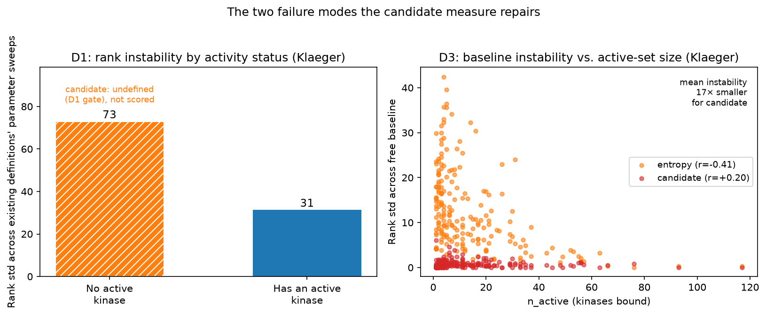
Figure 6. The two failure modes the candidate measure repairs (Klaeger). Left (D1): rank instability (std across the existing definitions’ parameter sweeps) for compounds with no binding above the activity threshold versus compounds with at least one active kinase. Right (D3): per-compound rank instability under the free activity baseline, against the number of active kinases, for the entropy and for the candidate.
A usable measure must also be recoverable from realistic panels. Applying the panel-size subsampling analysis above to the candidate (same grid, 50 random subpanels per size), the smallest panel reaching mean Spearman correlation $ρ>0.90$ with the full-panel ranking is $p^{*}=110$ kinases on Klaeger (Figure 7) and $p^{*}=80$ of 172 kinases on Metz, so it converges quickly on both datasets. On Klaeger, this matches the entropy and the S-score (all $p^{*}=110$) and is well ahead of both Gini ($290$) and ratio ($343$, the full panel). On Metz it again matches the entropy, but here the S-score converges faster ($p^{*}=50$ vs. $80$).
Those $p^{*}$ values score every compound, including ones the D1 gate would refuse to score, and that matters on a subpanel: a compound whose active kinases fall outside the drawn subset drops below $τ^{*}$ and becomes undefined. On Klaeger this affects $42\%$ of compounds at a 50-kinase panel, $27\%$ at 110 and $7\%$ at the full panel; on Metz, which is densely covered, at most $2\%$. Recomputing the convergence over only the compounds that are D1-defined on both the full panel and the subpanel, the candidate reaches $ρ>0.90$ at $p^{*}=80$ on Klaeger rather than $110$, and Metz is unchanged. Two cautions apply. The gated and ungated $p^{*}$ are not computed on the same set of compounds, since gating removes the least-bound ones, which are also the hardest to rank, so part of the improvement is selection rather than a property of the gate. And the same recomputation moves the Gini from $p^{*}=290$ to $p^{*}=80$, which bears on the panel-size recommendation in the Discussion. Raw convergence speed is not by itself a useful criterion, however: the S-score fails D1 and D4 outright (Table 2), so a smaller $p^{*}$ does not make it a viable alternative. Matching the bare entropy’s $p^{*}$ on both datasets, while adding the two properties it lacks, shows that the D1 gate and the smooth emphasis do not cost any convergence speed.
The candidate measure above (to which we will refer as the featured candidate measure) is one member of a family of measures satisfying D1–D4. Next, we consider three axes of variation within this family: the reliability floor, the Rényi order, and the smoothing width $T$. Replacing the fixed floor with a per-compound low-quantile reference gives a shift-invariant variant. It produces nearly the same ranking on both datasets (Spearman $r≈1.00$), is equally robust to the choice of quantile ($ρ≈1.00$ for D3), and continues to satisfy D4 exactly.
Generalizing the Shannon functional to any Rényi order $α>0$ gives another way to vary the candidate solution: −Hα(p)=1α−1log2i​piα, which recovers Shannon entropy as $α→1$. D1 holds for every $α$ since the $x_{0}$ gate is applied before the entropy is computed, independent of order. D2 and D3 hold by the same continuity and symmetry arguments used for Shannon entropy, applied to $H_{α}$ instead. D4 holds because $p_{i}^{α}=0$ whenever $p_{i}=0$, so a gated-out coordinate cannot raise the score. Although Spearman agreement with $α=1$ stays high ($0.997$–$1.000$ for $α∈\{0.5,2,3\}$ on both datasets), the orders are not redundant, and $α$ affects panel recoverability. On Klaeger, $α∈\{0.01,0.25,0.5,0.75\}$ reaches $p^{*}=80$, ahead of the $α=1$ candidate’s $p^{*}=110$, while $α∈\{2,3\}$ falls to $p^{*}=290$, matching the Gini. On Metz every order from $0.01$ to $3$ reaches $p^{*}=80$, so this gap is specific to the sparser Klaeger panel.
This speed does not come from discarding information. The number of distinct scores and the size of the largest tied group are identical across every order tested, including $α→∞$; the only tied compounds are those with at most one active kinase, whose normalized profile is a point mass with zero entropy regardless of order. This reflects how each limit behaves under subsampling. As $α→0$, the score approaches a count of the active set, a quantity a random subpanel estimates with low variance. As $α→∞$, the score instead depends on the single largest weight, and therefore has high variance. This is because if the kinase carrying that weight is left out of the subpanel, the estimate is far off.
For $α≤0.5$, Spearman agreement between that ranking and the $α=1$ ranking is just as high on the sparsest compounds ($n_{active}<5$) as on the rest ($≥0.98$ in both subsets, both datasets). The limit $α→∞$, on the other hand, loses agreement with $α=1$ among the sparsest compounds specifically ($0.69$ on Metz). The value $α=1$ is the unique point where the Rényi family reduces to Shannon entropy, and for this reason we fix it at this value for our featured candidate measure. The panel-size dependence on $α$ is reported here as a property of the family. A lower order is a documented alternative (full figures in family_panelsize.py and family_alternatives.py in the code repository).
The smoothing width $T$ is another value that can be varied within the candidate measure family (we fix $T≈1$ for the featured measure). As $T→0$ the softplus hinge $Tlog(1+e^{(x_{i}−β)/T})$ converges to the hard cutoff $max(x_{i}−β,0)$, recovering the standard entropy and its D3 baseline sensitivity. Distributional consistency therefore requires a strictly positive $T$. The ranking is otherwise insensitive to this choice: over $T∈[0.5,2]$ the Klaeger ranking is essentially unchanged (worst-case pairwise Spearman correlation $ρ=0.999$).
Thus, the quantile floor, the Rényi order, and $T$ give at least three axes of variation compatible with D1–D4. Whether the properties are jointly satisfiable only by measures within this family, and whether a uniqueness result analogous to Shannon’s holds, is left to future work. A complementary direction is a consensus ranking that does not commit to any single measure, that is, a partial order on which all existing measures agree.
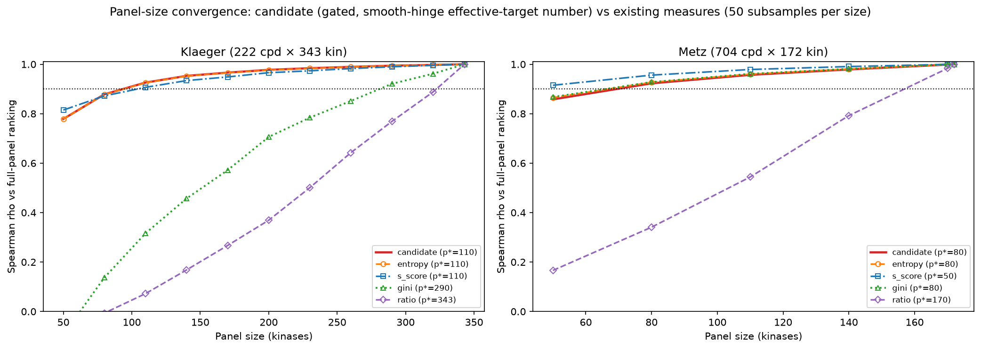
Figure 7. Panel-size convergence of the candidate measure compared with the four existing definitions, on the two sparse-coverage datasets (Klaeger, left; Metz, right; 50 random subpanels per size). Curves show the mean Spearman correlation between the ranking computed on a random subpanel and the full-panel ranking; $p^{*}$ (legend) is the smallest panel reaching mean $ρ>0.90$.

Discussion
The central finding of this work is that existing kinase inhibitor selectivity definitions do not measure the same quantity. The ratio definition and the distribution-based family (S-score, entropy, Gini) produce substantially different compound rankings (cross-family $r=0.14$–$0.62$ across four datasets, versus within-family $r>0.72$), and the sources of disagreement are mechanistically interpretable rather than random. This has practical consequences: a compound that ratio-based analysis designates as selective may be designated as moderately promiscuous by entropy-based analysis, and vice versa, depending on the shape of its binding profile. Go/no-go decisions in early drug discovery are routinely made on the basis of selectivity assessments without a principled choice of selectivity definition.
The clustering of definitions into two families reflects a difference in what is being measured. Distribution-based definitions ask: how concentrated is the compound’s binding activity across the full profiled kinome? The ratio definition asks: how much more potently does the compound bind its primary target than a specified off-target? The selectivity measure discrepancy is most pronounced for compounds with one clearly dominant target that also bind many kinases at moderate affinity (Type 3 profiles in our taxonomy), among compounds that clear the activity threshold. The largest ratio–entropy disagreements overall belong to the zero-active Type 1 compounds, which D1 excludes from scoring. For such compounds, ratio-based methods report high selectivity while distribution-based methods report moderate promiscuity. The properties proposed in the Motivated Properties section do not define selectivity. They state what we want any measure of it to do, with each property drawn from one of the failure modes above.
This coexistence has a historical explanation. In classical pharmacology and analytical chemistry, selectivity is inherently pairwise. IUPAC formalizes it as a selectivity coefficient, the ratio of binding constants for an analyte and an interferent^{[26]}, and ratio measures entered kinase profiling on that basis. Kinome-wide profiling, however, poses a distributional question: how concentrated is a compound’s binding across hundreds of kinases? Entropy and Gini were introduced because ratio measures are ill-suited to it, since they discard all but two points of a 300–500 kinase profile.

Practical Recommendations
Pending a formal resolution, three practical recommendations follow from our findings. First, D1 (reliability threshold) should be adopted as a reporting standard. Compounds with no binding above the $pK_{d}>6$ activity threshold should not receive selectivity scores, or should have their scores explicitly flagged as unreliable. Of the 222 Klaeger compounds, 16 (7.2%) fall into this category and currently receive scores that are indistinguishable from noise. Note that these compounds are not below the assay detection floor of $pK_{d}=5.0$, which none of the 222 is: their maximum affinities run from 5.16 to 6.00. The gate is set at the activity threshold, not at the detection limit.
Second, selectivity assessments should report the sensitivity of rankings to parameter choice rather than a single score at a single parameter value. Our analysis shows that rank standard deviation across the parameter sweep is a compound-specific, interpretable quantity that identifies which compounds have robust selectivity assessments and which do not. This is analogous to reporting confidence intervals in statistical estimation.
Third, when comparing selectivity across studies that use different definitions, the comparison should be restricted to the subset of compounds and parameter values for which the definitions agree. The high within-family correlations ($r>0.72$) suggest that S-score, entropy, and the Gini coefficient are interchangeable for most purposes when parameters are chosen consistently. This is an empirical observation rather than a preset adequacy bar: $r=0.72$ is the lowest within-family correlation we observed (Klaeger S-score vs. Gini, Table 1), and it measures a different property than the $ρ>0.90$ criterion used in the panel-size analysis below. The former measures how similarly two distinct definitions rank compounds on the full panel; the latter measures how similarly the same definition ranks compounds on a subpanel versus the full panel. The within-family agreement is measured on the complete kinome, and the panel-size analysis shows that the Gini coefficient can diverge from the entropy and S-score on the smaller panels used in practice (on Klaeger it requires roughly 290 of 343 kinases to recover its full-panel ranking, against 110 for entropy and the S-score). The three measures should therefore be treated as interchangeable only when compared on panels of similar, near-complete coverage. This caveat is itself conditional on D1. When the convergence is recomputed over only the compounds that clear the activity threshold on both the subpanel and the full panel, the Gini coefficient reaches $ρ>0.90$ at 80 kinases rather than 290, level with the entropy. The Gini coefficient’s apparent panel-size handicap is therefore largely an artefact of scoring compounds that should not be scored, which is a further argument for adopting D1 as a reporting standard and a caution against reading the 290 figure as a property of the Gini coefficient itself. Ratio-based measures, in turn, should not be compared directly with distribution-based measures at any panel size without acknowledging the conceptual distinction.

Limitations
The analysis covers four profiling datasets spanning three assay technologies and two readout types, but these still represent a fraction of the chemical and kinase space relevant to drug discovery. The assay technologies are not directly comparable in absolute terms — the active-compound fractions differ across datasets. As a consequence, our analysis relies on within-dataset rank comparisons rather than cross-dataset absolute scores. The two-family structure replicates across all four datasets, and the instability predictors across three of the four, which indicates that the findings are not artifacts of a single assay platform. The exception is the top$​_{1}$–top$​_{2}$ dependence on Anastassiadis ($r=−0.104$, $p=0.23$), the one percent-inhibition dataset, so we cannot exclude that this predictor is specific to affinity readouts. However, findings should still be interpreted in light of these technological differences. Our comparison is also restricted to four widely used, historically established definitions. Bosc et al.’s window score and ranking score^{[8]} were not included, but a check on the same four datasets confirms both correlate with the ratio family (Spearman $r=0.80$–$0.96$) rather than forming a distinct third cluster. The CATDS score^{[7]}, historically classified alongside the ratio-based measures, was also not implemented directly. Unlike $R(k)$, CATDS normalizes each target’s binding reduction by the sum of reductions across the entire panel rather than comparing to a single off-target, a construction it shares with the distribution-based family rather than with $R(k)$. A proxy computed from our baseline-subtracted affinity profiles, in place of the raw concentration-response data CATDS requires, correlates far more strongly with Gini and entropy than with $R(k)$ on all four datasets (Spearman correlation $0.91$–$0.99$ against Gini and $0.85$–$0.96$ against entropy, versus $0.45$–$0.70$ against $R(k)$), consistent with this structural reading. On our data CATDS does not behave like a ratio measure, and assigning it to that family would have misdescribed the cross-family correlations reported above. We did not add it as a fifth measure: the distribution family is already represented by three members, and CATDS appears to be an additional instance of the same underlying construct rather (see repository for results).
A further axis of platform dependence that this analysis does not examine is cell-based versus cell-free profiling. Recent work shows that selectivity classifications for the same compounds can differ substantially between biochemical binding panels and cellular target-engagement assays. For example, several type II (DFG-out-binding) inhibitors show cellular interactions that cell-free assays miss^{[27,28]}. A plausible contributor, not established by that work, is that the cellular assays report occupancy of full-length kinase in intact cells, with regulatory domains, binding partners and intracellular ATP present, whereas the cell-free panels score isolated kinase-domain constructs under defined conditions.
We also examined whether in vitro selectivity predicts clinical toxicity, correlating the selectivity rankings of the FDA-approved Klaeger compounds with FAERS adverse-event rates ($n=46$) and FDA-label discontinuation rates ($n=33$). None of the rate-based outcomes were significantly associated with selectivity under any definition (all $|r|<0.17$, all $p>0.27$). The only nominal signal is a weak correlation between raw FAERS report counts and the ratio ranking ($r=0.31$, $p=0.035$), which most likely reflects prescription volume rather than toxicity. We do not read the absence of a rate-based association as evidence that selectivity and toxicity are unrelated. FAERS report counts mostly track how often a drug is prescribed, and label discontinuation depends on the patient population treated for each indication, so neither can isolate the effect of selectivity. A proper test would require indication-stratified, treatment-related adverse-event rates from controlled trials with matched comparators, which are not available in standardized form across these drugs.
Finally, a formal proof of each of the D1– D4 properties for each definition (for which informal assessments given in Table 2) is left for future work.
The four properties are also unlikely to be the complete set, and this work suggests three further candidates that we do not assess here. A measure should be correctly oriented against a crude external proxy for the concept, such as the number of active kinases, since a measure can satisfy D2 to D4 and still rank promiscuous compounds as selective. A measure should declare its scale type, because the four definitions report on incomparable scales and Figure 1 shows that leaving the operationalization undeclared can reverse a ranking. The panel-size behaviour reported above could itself be stated as a property rather than as a description. Two further candidates, stability under measurement error in the affinities and agreement across datasets profiling the same compounds, are not testable on the present data, the second because at most 19 compounds are shared between any two of the four datasets.

Conclusion
We have shown that commonly used kinase inhibitor selectivity definitions split three to one, into a distribution-based group whose members agree closely and a ratio measure that agrees with none of them, and that the two measure fundamentally different properties of binding profiles. We also showed that rank instability within and between families is predictable from binding profile shape, and that three structurally distinct sources of instability can be identified and characterized. These findings motivate four properties that any well-formed selectivity measure should satisfy: a reliability threshold condition, bounded gap sensitivity, distributional consistency, and monotonicity under weak off-target addition.
None of the four definitions assessed satisfies all four properties, but we show that a gated, smooth-hinge effective-target number does. We demonstrate that it recovers its full-panel ranking from roughly a third of a typical panel, and from roughly a quarter once the reliability gate is applied, and that it is part of a whole family of candidate definitions satisfying the four properties. Because the candidate is a local modification of the entropy, the two rank the compounds they both score almost identically (Spearman $+0.999$ on Klaeger). So, our candidate measure is neither unique nor a guaranteed universal improvement on existing measures.
The main goal of this work, however, is to identify criteria for judging a candidate that could be considered a principled, universally adopted choice of selectivity measure in the future. Such criteria must be justified (which we argue they are), and jointly satisfiable (which we empirically demonstrate). Further properties may discriminate where these four do not, and the candidate may separate from the entropy on panels whose active fractions differ from the four studied here. Establishing additional properties that uniquely characterize a selectivity measure, as Shannon’s axioms do for entropy, is a natural next step, for which additional datasets may be required.
The immediate practical implication is that selectivity assessments should report the sensitivity of rankings to parameter choice, and should explicitly flag compounds with no binding above the activity threshold as unreliable. The longer-term implication is that the field needs a principled basis for choosing among selectivity definitions. The need for a principled measure is not specific to selectivity. As future and ongoing work, we are developing a general measurement-theoretic framework for defining and comparing the competing measures of one concept, reporting where they agree and which pairs they leave undecided, with kinase selectivity as one instance alongside cases as varied as biological age and variant effect prediction.

Acknowledgement
The author thanks the developers of the Davis, Klaeger, Anastassiadis, and Metz datasets for making their data publicly available. The author used Claude (Anthropic, claude.ai), a large language model assistant, during the preparation of this manuscript. Specifically, Claude was used to assist with: data analysis code development and debugging in Python; literature search and identification of related work; drafting and editing of manuscript text; and research planning and interpretation of results. All scientific conclusions, the conceptual framework, the properties proposed in the Motivated Properties section, and the final manuscript content were developed, verified, and approved by the author. The author takes full responsibility for the accuracy and integrity of all content in this work. The use of Claude does not transfer any rights over the content of this manuscript to Anthropic or any third party.

Data and Software Availability
All data and software used in this study are publicly available. The Davis kinase inhibitor profiling dataset is available at https://github.com/dingyan20/Davis-Dataset-for-DTA-Prediction. The Klaeger et al. dataset is available as supplementary data to the original publication (Science, 2017, https://doi.org/10.1126/science.aan4368). The Anastassiadis et al. (Nat. Biotechnol. 2011) and Metz et al. (Nat. Chem. Biol. 2011) datasets are available as supplementary data to their original publications (https://doi.org/10.1038/nbt.2017; https://doi.org/10.1038/nchembio.530). All analysis scripts, processed data files, and the LaTeX source for this manuscript are available at https://github.com/polinavino/kinase-selectivity-definitions; this repository includes the code and full per-definition results for the secondary clinical-outcome analysis (FAERS adverse-event report rates, obtained via openFDA queries, and FDA-label discontinuation rates, from FDA product labels, for the FDA-approved Klaeger compounds). No confidential data were used in this study. All results reported in this manuscript are fully reproducible from the publicly available data and code. A preprint of this manuscript is available on ChemRxiv at https://doi.org/10.26434/chemrxiv.15001618/v1.

Funding
This research received no specific grant from any funding agency in the public, commercial, or not-for-profit sectors.

Conflict of Interest
The author declares no conflict of interest.

References
[1] R. Roskoski, “Properties of FDA-approved small molecule protein kinase inhibitors: A 2024 update” Pharmacol. Res. 2024, 200, 107059.
[2] G. Manning, D. B. Whyte, R. Martinez, T. Hunter, S. Sudarsanam, “The protein kinase complement of the human genome” Science 2002, 298, 1912–1934.
[3] K. S. Bhullar, N. O. Lagarón, E. M. McGowan, I. Parmar, A. Jha, B. P. Hubbard, H. P. V. Rupasinghe, “Kinase-targeted cancer therapies: Progress, challenges and future directions” Mol. Cancer 2018, 17, 48.
[4] M. W. Karaman, S. Herrgard, D. K. Treiber, et al., “A quantitative analysis of kinase inhibitor selectivity” Nat. Biotechnol. 2008, 26, 127–132.
[5] J. C. M. Uitdehaag, G. J. R. Zaman, “A theoretical entropy score as a single value to express inhibitor selectivity” BMC Bioinformatics 2011, 12, 94.
[6] P. P. Graczyk, “Gini coefficient: A new way to express selectivity of kinase inhibitors against a family of kinases” J. Med. Chem. 2007, 50, 5773–5779.
[7] S. Klaeger, S. Heinzlmeir, M. Wilhelm, et al., “The target landscape of clinical kinase drugs” Science 2017, 358, eaan4368.
[8] N. Bosc, C. Meyer, P. Bonnet, “The use of novel selectivity metrics in kinase research” BMC Bioinformatics 2017, 18, 17.
[9] T. Bello, T. S. Gujral, “KInhibition: A kinase inhibitor selection portal” iScience 2018, 8, 49–53.
[10] C. E. Shannon, “A mathematical theory of communication” Bell Syst. Tech. J. 1948, 27, 379–423.
[11] F. Miljkovic, J. Bajorath, “Reconciling selectivity trends from a comprehensive kinase inhibitor profiling campaign with known activity data” ACS Omega 2018, 3, 17196–17206.
[12] M. Saifudeen, S. Zhu, S. Liang, M. Eason, A. Goupil, D. F. Mische, C. M. Loch, H. Ma, M. Chan, T. S. Gujral, “Comprehensive profiling of clinically approved kinase inhibitors reveals mutation-specific inhibitors and opportunities for drug repurposing” Nat. Biotechnol. 2026, DOI 10.1038/s41587-026-03090-8.
[13] A. Ya. Khinchin, Mathematical foundations of information theory, Dover, New York, 1957.
[14] K. J. Arrow, Social choice and individual values, Wiley, New York, 1951.
[15] J. Singleton, R. Booth, “Towards an axiomatic approach to truth discovery” Auton. Agents Multi-Agent Syst. 2022, 36, 43.
[16] M. I. Davis, J. P. Hunt, S. Herrgard, et al., “Comprehensive analysis of kinase inhibitor selectivity” Nat. Biotechnol. 2011, 29, 1046–1051.
[17] H. Öztürk, A. Özgür, E. Ozkirimli, “DeepDTA: Deep drug–target binding affinity prediction” Bioinformatics 2018, 34, i821–i829.
[18] T. Anastassiadis, S. W. Deacon, K. Devarajan, H. Ma, J. R. Peterson, “Comprehensive assay of kinase catalytic activity reveals features of kinase inhibitor selectivity” Nat. Biotechnol. 2011, 29, 1039–1045.
[19] J. T. Metz, E. F. Johnson, N. B. Soni, P. J. Merta, L. Kifle, P. J. Hajduk, “Navigating the kinome” Nat. Chem. Biol. 2011, 7, 200–202.
[20] Y. Gao, S. P. Davies, M. Augustin, A. Woodward, U. A. Patel, R. Kovelman, K. J. Harvey, “A broad activity screen in support of a chemogenomic map for kinase signalling research and drug discovery” Biochem. J. 2013, 451, 313–328.
[21] M. P. Patricelli, T. K. Nomanbhoy, J. Wu, H. Brown, D. Zhou, J. Zhang, S. Jagannathan, A. Aban, E. Okerberg, C. Herring, B. Nordin, H. Weissig, Q. Yang, J.-D. Lee, N. S. Gray, J. W. Kozarich, “In situ kinase profiling reveals functionally relevant properties of native kinases” Chem. Biol. 2011, 18, 699–710.
[22] C. R. Harris, K. J. Millman, S. J. van der Walt, et al., “Array programming with NumPy” Nature 2020, 585, 357–362.
[23] W. McKinney in Proceedings of the 9th Python in Science Conference, 2010, pp. 56–61.
[24] P. Virtanen, R. Gommers, T. E. Oliphant, et al., “SciPy 1.0: Fundamental algorithms for scientific computing in Python” Nat. Methods 2020, 17, 261–272.
[25] T. K. Koo, M. Y. Li, “A guideline of selecting and reporting intraclass correlation coefficients for reliability research” J. Chiropr. Med. 2016, 15, 155–163.
[26] J. Vessman, R. I. Stefan, J. F. van Staden, et al., “Selectivity in analytical chemistry” Pure Appl. Chem. 2001, 73, 1381–1386.
[27] M. J. Binder, F. M. Bashore, K. K. Dunn Hoffman, C. Damgaard, M. Slater, D. H. Drewry, M. B. Robers, A. D. Axtman, “Cellular context influences kinase inhibitor selectivity” J. Med. Chem. 2026, 69, 4208–4220.
[28] M. J. Binder, F. M. Bashore, K. K. Dunn Hoffman, C. Damgaard, M. Slater, D. H. Drewry, M. B. Robers, A. D. Axtman, “Correction to ‘cellular context influences kinase inhibitor selectivity’” J. Med. Chem. 2026, 69, 20069–20071.

