**ПРАКТИЧЕСКОЕ ЗАДАНИЕ 26**

**ЯЗЫК РАЗМЕТКИ XAML**

Задание 1. Создать XML файл Автостоянка состоящий из автомобилей (марка, год выпуска, срок аренды стоянки(дни)).

Листинг программы

public class XmlDocumentWorker:IXmlWorker

{

private readonly XmlDocument _document;

private readonly ILogger _logger;

private string _xmlFilePath;

public XmlDocumentWorker(ILogger logger)

{

_logger = logger;

_document = new XmlDocument();

}

public void Add(Auto auto)

{

var xRoot = _document.DocumentElement;

XmlElement parkingElem = _document.CreateElement("Auto");

XmlAttribute markAttribute = _document.CreateAttribute("mark");

XmlText markText = _document.CreateTextNode(auto.Mark);

markAttribute.AppendChild(markText);

XmlElement yearElem = _document.CreateElement("year");

XmlText yearInnerText = _document.CreateTextNode(auto.Year.ToString());

yearElem.AppendChild(yearElem);

parkingElem.AppendChild(yearElem);

XmlElement dateElem = _document.CreateElement("RentDate");

XmlText dateInnerText = _document.CreateTextNode(auto.RentDays.ToString());

dateElem.AppendChild(dateInnerText);

parkingElem.AppendChild(dateElem);

xRoot.AppendChild(parkingElem);

_document.Save(_xmlFilePath);

}

public void Delete(string mark)

{

var xRoot = _document.DocumentElement;

foreach (XmlNode xNode in xRoot)

{

if (xNode.Attributes.Count > 0)

{

var attributeMark = xNode.Attributes.GetNamedItem("mark");

try

{

var atrributeMarkText = attributeMark?.InnerText;

if (atrributeMarkText.Equals(mark))

{

xRoot.RemoveChild(xNode);

}

}

catch (Exception ex) when (ex is XmlException || ex is NullReferenceException)

{

_logger.LogWarning(ex.Message, nameof(attributeMark));

}

}

}

}

public Auto FindBy(string mark)

{

Auto parking = null;

var xRoot = _document.DocumentElement;

foreach (XmlNode xmlNode in xRoot)

{

parking = GetParking(xmlNode);

if (parking.Mark.Equals(mark))

{

return parking;

}

return parking;

}

public List<Auto> GetAll()

{

List<Auto> parkingg = new List<Auto>();

var xRoot = _document.DocumentElement;

foreach (XmlNode node in xRoot)

{

var parking = GetParking(node);

parkingg.Add(parking);

}

return parkingg;

}

public void Load(string xmlDocPath)

{

_xmlFilePath = xmlDocPath;

_document.Load(xmlDocPath);

}

private Auto GetParking(XmlNode node)

{

var parking = new Auto();

if (node.Attributes.Count > 0)

{

var attributeMark = node.Attributes.GetNamedItem("mark");

parking.Mark = attributeMark?.Value;

}

foreach (XmlNode childNode in node.ChildNodes)

{

try

{

if (childNode.Name.Equals("year"))

{

parking.Year = (childNode.InnerText);

}

if (childNode.Name.Equals("RentDate"))

{

parking.RentDays = int.Parse(childNode.InnerText);

}

}

catch (Exception ex) when (ex is FormatException || ex is NullReferenceException)

{

_logger.LogError(ex.Message, ex.StackTrace, nameof(childNode.InnerText));

}

}

return parking;

}

Анализ результатов:

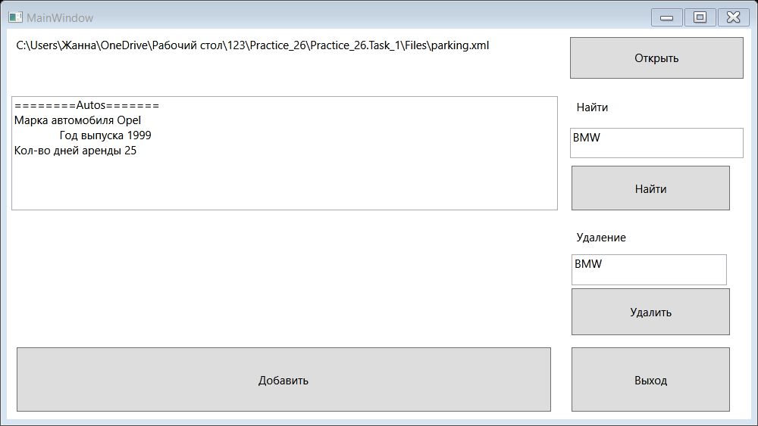

Рисунок 1.1 – Результат работы программы