Bitcoin Market Behavior Analysis

Introduction:

The cryptocurrency market has evolved significantly over the past decade, and specifically Bitcoin, as it is the most well-known and widely traded digital assets. This has sparked the interest of investors, analysts and economist alike, who seek to understand the factors driving its volatility and its dramatic price fluctuations.

This report aims to investigate the trends in Bitcoin’s closing price and trading volume over time, focusing on data from 2013 to 2021. The goal is to uncover the relationship between price and volume and develop a predictive model to forecast Bitcoin’s trading volume based on its daily returns. This will be achieved by conducting a series of key tasks, including calculating daily returns, testing hypotheses related to Bitcoin’s price movements and building a regression model to explore the relationship between price volatility and trading volume.

Method and Analysis:

Task 1: Analyze trends in price and volume over time

Firstly, the data was pre-processed by handling missing values and converting the date column to its necessary format. This was carried out by removing rows with missing values and ensuring the Date column was correctly formatted for the following analysis. To continue, summary statistics were calculated for both Closing Price and Volume, including minimum and maximum values, mean, median, 1st and 3rd quartiles and standard deviation. A line chart was then produced for both Closing Price and Volume over the years of 2014 to 2021. This allowed the visualization of significant price movements and fluctuations of the volume traded over time.

Task 2: Calculation and visualization of daily returns

The data was firstly assorted in chronological order to ensure a correct time-series analysis. Following, was the calculation of log returns using the formula “ Log Return = log( Close t/ Close t-1) which uses the current day’s closing price ( Close t) and the previous day’s closing price ( Close t-1) to compute the log return for each day. This method is preferred in financial analysis due to its time additive properties. After the calculation any rows containing missing values were removed; such as the first row, which has no previous day to compare to. A boxplot and a histogram were also derived in order to visualize these returns, highlighting the distribution and any potentially significant outliers present.

Task 3: Hypothesis testing for daily returns

In this task, three hypothesis tests were conducted in order to assess the statistical properties of the daily log returns. The tests were as follows: whether the mean of the daily returns differs significantly from zero, which would imply no overall returns, whether the mean is greater than 5% and 10%. The first hypothesis calls for a two-tailed test which evaluates whether there is any significant deviation from the mean being zero.

Task 4: Hypothesis testing for variance of daily returns

This hypothesis tests whether the variance of Bitcoin’s daily returns exceeds 10%. A Chi-squared test was used in this hypothesis since we are comparing the sample variance to a hypothesized population variance. A variance of grater than 10% would imply higher variability in the returns than expected.

Task 5: Regression analysis to predict trading volume

A linear regression model was built in order to predict Bitcoin’s trading volume based on the absolute value of daily log returns. The absolute value of returns was used to capture the magnitude of the price movements regardless of their direction, as both positive and negative movements can have an impact on this volatile market. Following, a log transformation of the trading volume was applied to scale the data to avoid issues with large variations in trading volumes and make the model more suitable for analysis.

Results and Interpretations:

Figure 1: Summary statistics

 | Closing Price | Trading Volume
Minimum value | $178.1 | 2.86mil
1st Quartile | $495.7 | 48.72mil
Median | $3671.2 | 2.22bil
Mean | $7280.3 | 11.87bil
3rd Quartile | $8910.0 | 17.57bil
Maximum value | $63503.5 | 351bil
Standard deviation | 11613.8 | 19411747656

Figure 2: Line chart of Bitcoin’s Closing Price Over Time
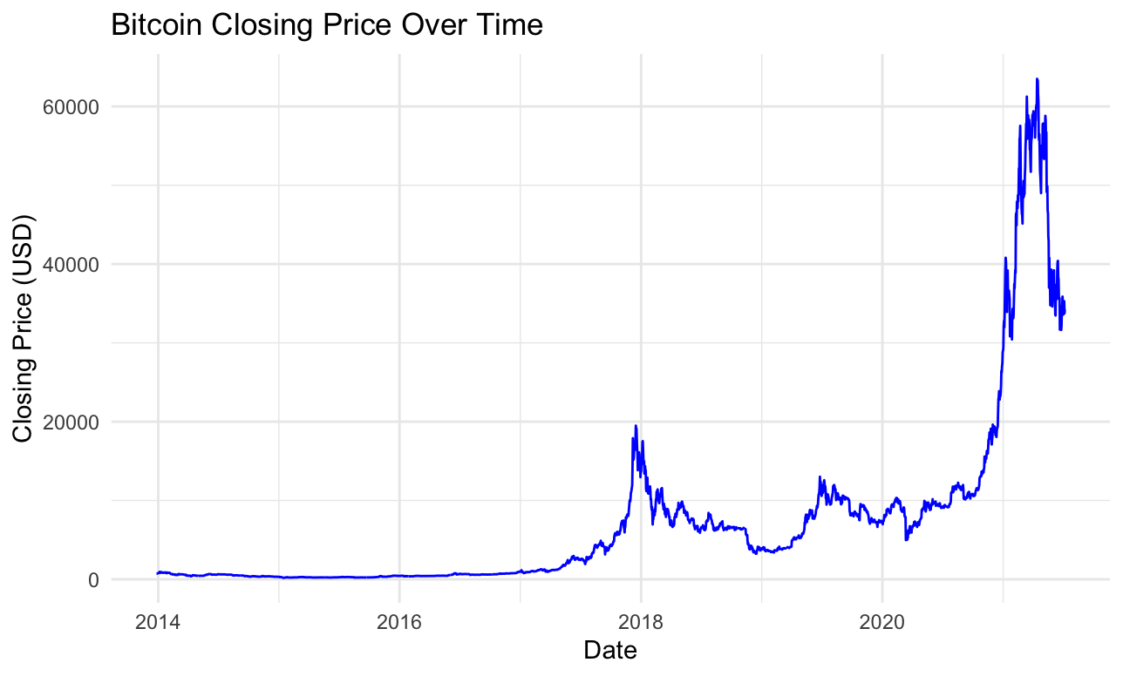

As shown in figure 1, the summary statistics for Bitcoin’s closing price reveal significant
variability as the minimum closing price was $178.1 and the maximum closing price was $63,503.5. This highlights substantial variability in Bitcoin’s closing prices over the analyzed period. The mean and median suggest a right-skewed distribution. In addition, the standard deviation further reinforces Bitcoin’s reputation of being a highly volatile asset.

Figure 3: Line chart of Bitcoin’s Trading Volume Over Time

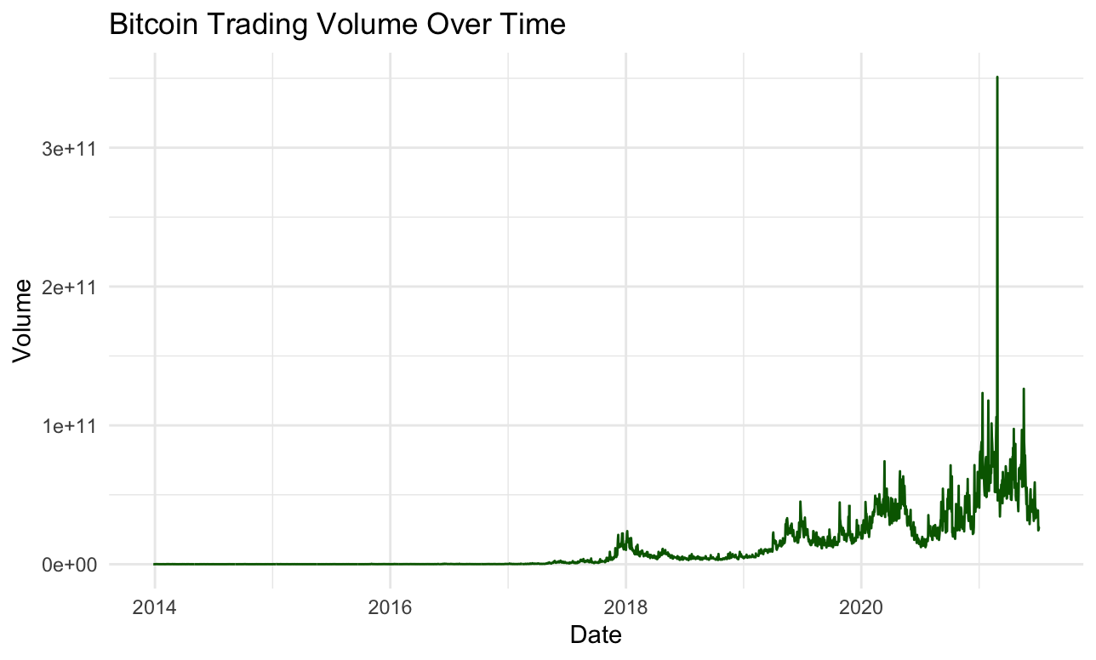
The trading volume over time (Figure 3) reveals significant variability in the peaks shown and also coincide with those in closing price (Figure 2), particularly in late 2017 and 2020-2021. These periods likely correspond to movements in the market. Firstly, in 2017 a major price surge took place, where Bitcoin reached its all-time high which also caused trading volume to sharply increase. This was caused by “market manipulation by so-called bitcoin whales” – large investors who hold significant quantities of Bitcoin who can cause a dramatic movement in the market just by a single transaction. Later on, in 2020-2021 Bitcoin experienced another boom where both its trading volume and its closing price reached sky-rocketing peaks. This was driven by “ increasing institutional adoption”, where major companies like Tesla and Square invested in Bitcoin as well as macroeconomic factors such as the COVID-19 pandemic which caused global economic uncertainty.

Figure 4: Histogram of Bitcoin Daily Log Returns

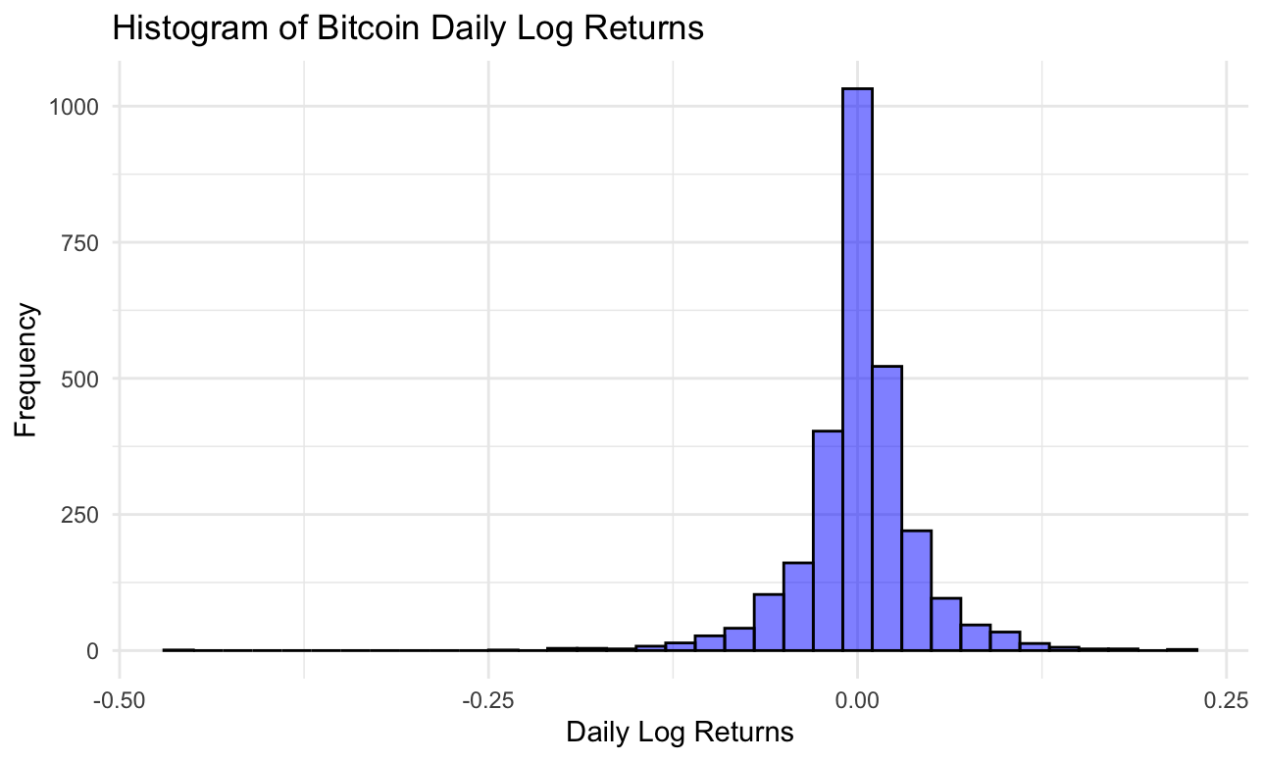

Figure 5: Boxplot of Bitcoin Daily Log Returns

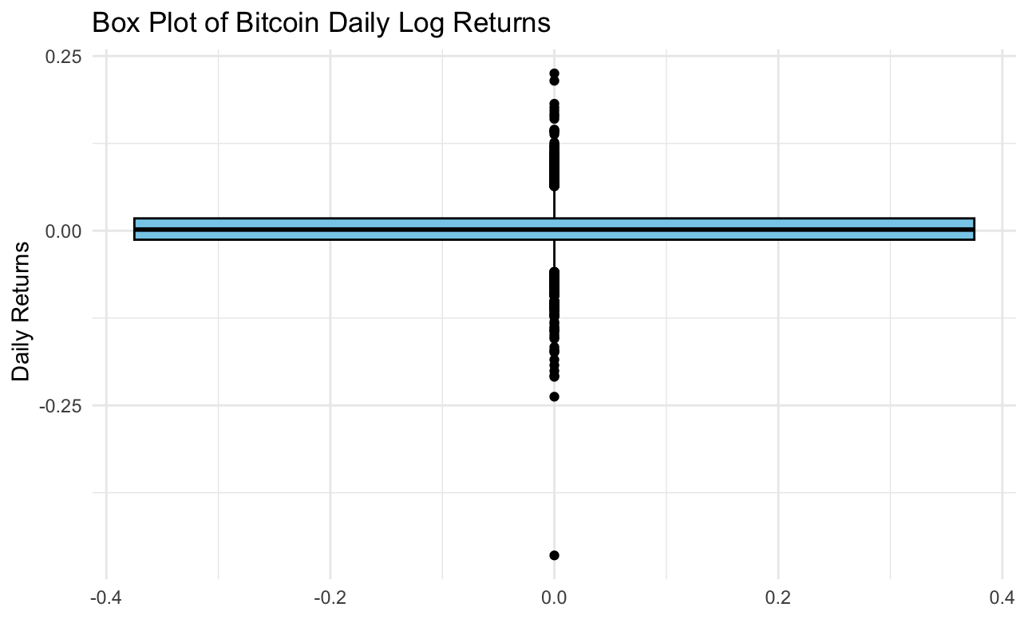
The histogram shown in Figure 4 shows a high concentration of Bitcoin’s returns around zero, implying that bitcoin experienced relatively small day to day price fluctuations. The distribution being right-skewed suggests that the number of small but positive returns exceed the number of extreme negative values. In addition, Figure 5 further illustrates this point with most daily returns being centered around zero. The presence of outliers, which extend well beyond the upper and lower bounds, indicate bitcoin’s significant daily movements, although these extreme values are rare they still suggest that Bitcoins market is susceptible to sudden shifts, often steered by external factors and speculation.

Furthermore, in Task 3, three hypothesis tests were conducted on the mean of Bitcoin’s daily log returns. The two-tailed test (mean = 0) yielded a t-statistic of 1.841 with a p-value of 0.066, which is above than the significance level of 0.05 and therefore we fail to reject the null hypothesis and conclude that the mean is indifferent to zero signifying that the small positive average returns are not significant enough to claim that the mean is different from zero. The right-tailed tests both produced a p-value of 1 and therefore, we fail to reject the null hypothesis for both significance levels (5% and 10%), concluding that the mean of Bitcoin’s daily log returns is slightly positive, but far below 5% and 10% and not significantly different from zero.

For task 4, the Chi-squared test to determine whether the variance of Bitcoins Daily returns was greater than 10%, produced a p-value of 1. Testing at a significance level of 5%, we fail to reject the null hypothesis and therefore conclude that the volatility in Bitcoin’s daily returns does not exceed the 10% threshold even if it is still notable.

Lastly, a linear regression model was produced in order to predict Bitcoin’s log trading volume. The results showed a significant positive relationship, with a slope of 15.97, implying that a unit increase in the absolute return leads to a 15.97 increase in trading volume. The intercept of 20.29 represents the expected log trading volume when the absolute return is zero. The R-squared value of 2.6% represents the variation explained in trading volume, therefore signifying that other factors may be at play despite this statistical significance.

Conclusion:

To conclude, this analysis provides valuable insights on Bitcoin’s volatile price and trading volume over time. The findings enabled by this analysis highlight and confirm Bitcoin’s significant price fluctuations and trading volume spikes. It is notable that these movements as shown by the analysis are most often caused by external factors such as macroeconomic events, speculation among investors and regulatory news. Therefore, validating Bitcoin’s unpredictable nature as an asset. However, Bitcoin’s price and trading volume are crucial in understanding the dynamic of its market, where price movements are often correlated with fluctuations in trading activity. Lastly, as Bitcoin continues to grow and evolve, it is essential that both investors and regulators understand the forces that are at play in this market’s behavior.

References:

Cuthbertson, A. (2019, November 5) Bitcoin’s record price surge of 2017 was caused by a single person, study claims, Independent https://www.independent.co.uk/tech/bitcoin-price-record-2017-buy-cryptocurrency-whale-a9185451.html

Bitcoin Magazine (2020, December 14) What Does Institutional Adoption Of Crypto Mean For 2021 And Beyond? Nasdaq

https://www.nasdaq.com/articles/what-does-institutional-adoption-of-crypto-mean-for-2021-and-beyond-2020-12-14

