
USER INTERFACE DESIGN
23CSE113 LAB
MANUAL
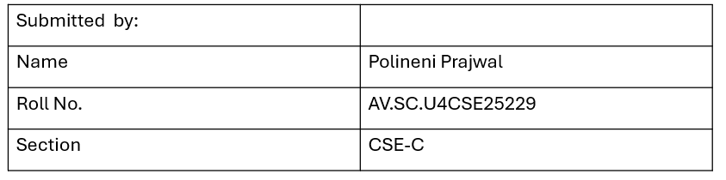
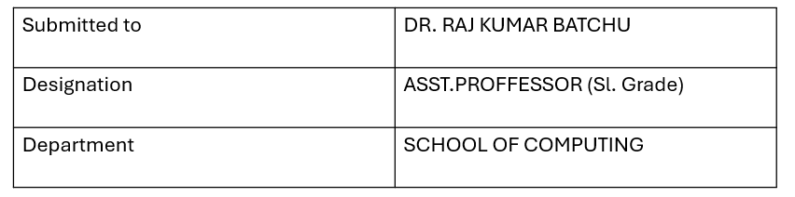

INDEX
s.no | Title | Page.no | Remarks
1. | Week-1: 1. Installation of VS Code tool.  2. Understanding basic of html structure.  3. Understanding basic html tags and attributes . | 5-12
2. | Week-2: Design a basic webpage with headings , paragraph, pre, table by adding styles. | 13-15
3. | Week-3: 2.A) Creating timetable using HTML.  2.B)Creating a HTML web page that should display all the syllabus as images | 16-25
4. | Week-4: 1. Collage admission registration form using HTML.  2. Create two different forms in one webpage using Iframes | 26-32
5. | Week-5: 5A) .creating a card layout using  tag consider three cards and a button using html and css.  5B) navigation using iframe (mini website) upon clicking each buttons the details about that button should be display on the same page.  5C) Design amrita login page by showing different campus on home page.upon clicking on each campus the details about each campus should be display on the same page use html and css to design a stylish webpage | 33-58
6. | Week-6: (6)Design a responsive e-commerce application using the grid layout. This application should contain different categories of products such as electronics, clothing, home-appliances, books. Based on the category we select corresponding products should be displayed on the sidebar. | 59-75
7. | Week-7: To create an account in git hub and add all html codes into a repository. | 76-78
8. | Week-8 : A) : To create a webpage that displays a square that continuously rotates  ${360}^{o}$ using css animations.  B) : To create a ball that moves up and down continuously using css Animations.  C): To create a ball that moves horizontally and rotates at same time. | 79-85
9. | Week-9: Create a webpage using html,css,js based on the give conditions, create a button for each program , based on the button, clicked the corresponding program has to be executed and should display the logics for each button includes finding an even or odd number , prime or not , factorial of a number , Armstrong or not use appropriate design to display the output. | 86-92
10. | Week-10:  A ) Write a java script conditional statement to find the sign of product of three numbers using functions.Disply an alert box with specified sign.  B) Write a java script conditional statement to sort three numbers using functions. Disply an alert box to show result.  C) Write a java script conditional statement to find largest of five numbers using functions. Disply an alert box to show result.  D) Write a java script loop that will iterate from 0 to 15 for each iteration it will check odd or even . Disply an a message to screen.  E) Write a java script program to read 6 subjects marks from student then compute the average marks of student. Then this average isused to determine the corresponding grade. | 93-104
11. | Week - 11 :  1. A website requires users to enter a username. The system should display a message while typing if the username is less than 5 characters.  2. A registration form should validate email format before submission. If invalid, the form should not be submitted.  3. A system should check password strength while typing and display whether it is weak or strong.  4. A form should validate a mobile number when the user leaves the input field. The number must be exactly 10 digits.  5. Design an HTML page, such that the registration form must validate:  Name (not empty)  Email (valid format)  Password (minimum 6 characters) | 105-115

WEEK – 1
- Aim :- Steps to download visual studio code.

Procedure:
Step-1: Open any browser and search for visual studio code and click on the first link to download. Click on download option according to your operating system.
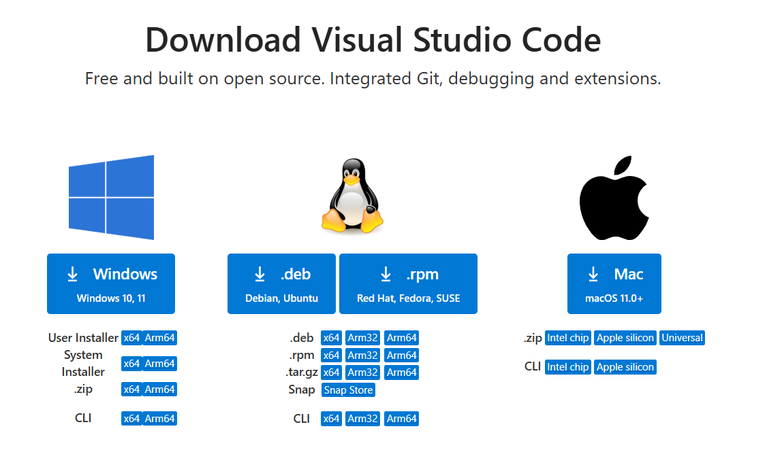
Step-2: Accept the agreement and click on next.
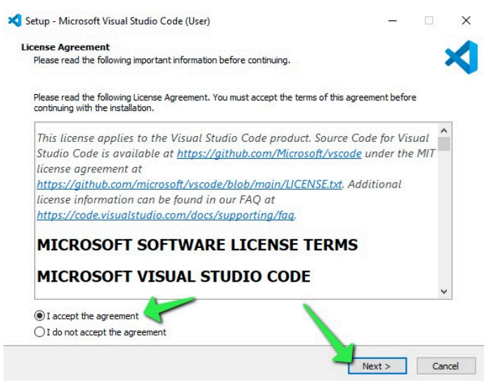
Step-3: Select the drive to download and click on next.
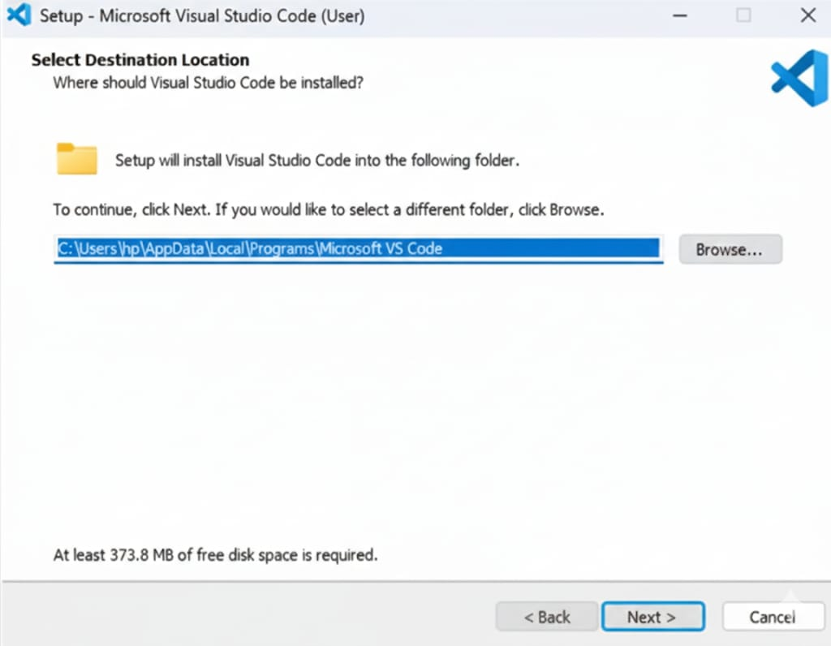
Step-4: Select all additional tasks.
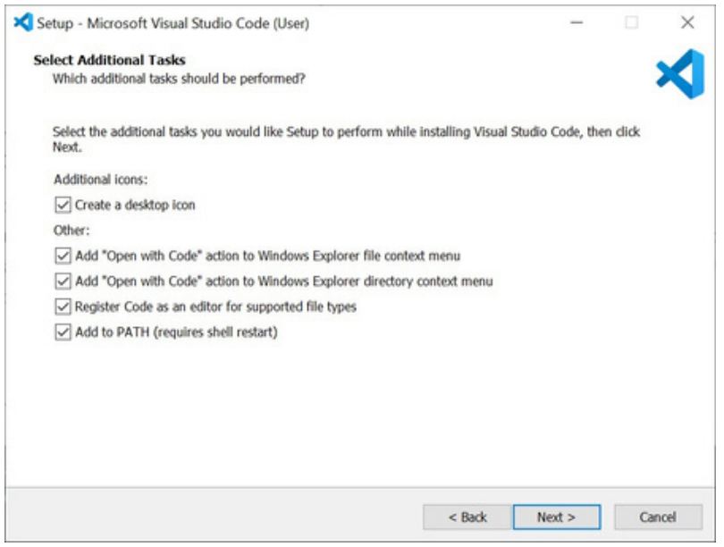
Step-5: Wait for it to download.
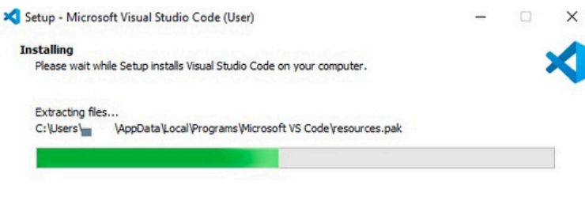
Step-6:Select launch vs code option and select finish.
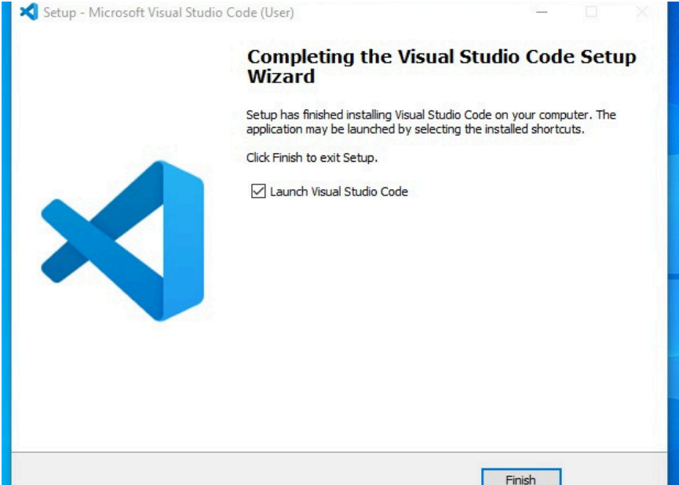

Step-7: Setting up visual studio code is completed.
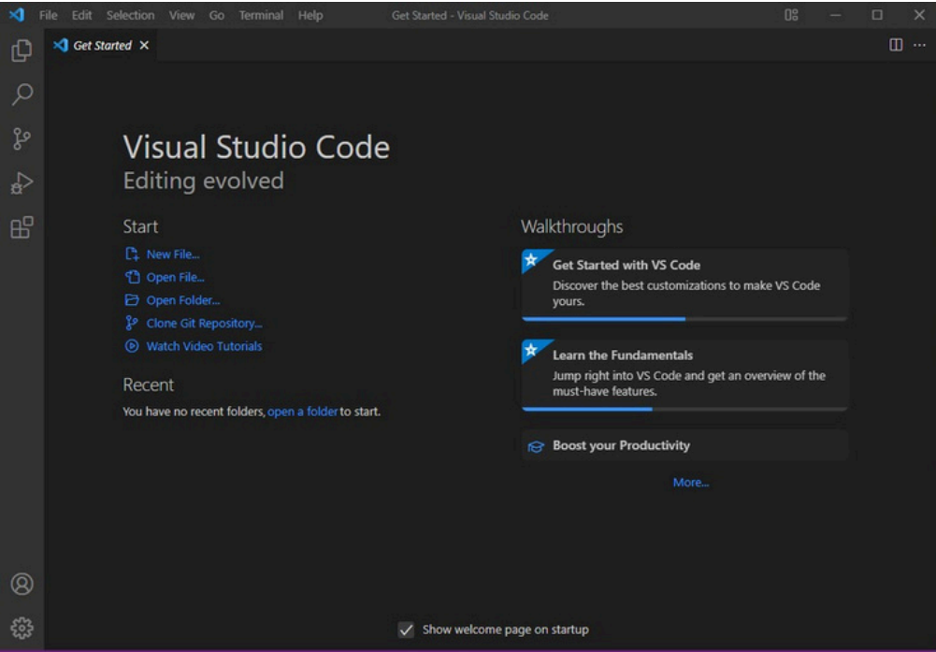

2.Aim : To learn bacics of HTML.
Program:
Name = prajwal polineni , Roll no =25229 , Section-C
<!DOCTYPE html>
<html>
<head>
<title>First web page</title>
<body>
<h1>Happy to learn HTML</h1>
<p>This is my first codeS</p>
</body>
</head>
</html>

Output:
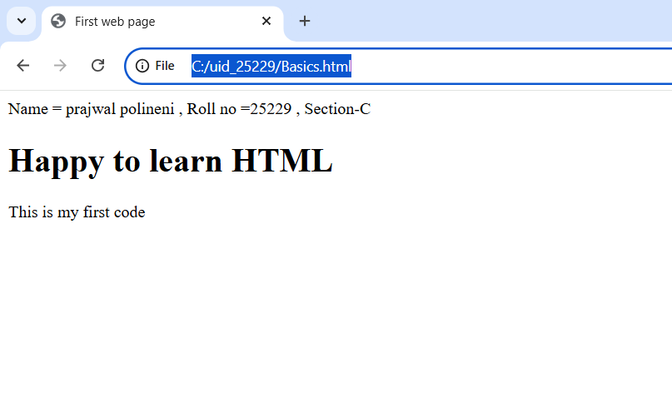

Explanation:
<!DOCTYPE html> = To tell web browser about version of HTML being used.
<html> = This is root element that encloses all other documents in html document.
<head> = It contains metadata about html page such as title , which is not displayed on main page body.
<title> = This specifies for the webpage.
<body> = This holds all vivible of webpage.
<h1> = <h1> tag is used to define main heading.
<p> = This tag is used to define paragraph of text.

3.Aim : To understand basic HTML tags and attributes.
Tags: <h1> ,<h3> ,<p> ,<img> ,<a> ,<br>
Attributes: href ,src ,color ,width,height ,alt,font-family
Program:
Name = prajwal polineni , Roll no = 25229 , Section-C
<!DOCTYPE html>
<html>
<head>
<title>university links</title>
<body>
<h1 style="font-family: cursive;">University links</h1>
<h3 style="color: rgb(182, 38, 67);">Amrita university link</h3>
<a href="https://www.amrita.edu/">amrita university</a>
<p>Amrita vishwa vishwa vidya peetham. <br>Established in 1994.</p>
<img src="amritha.png" alt="https://www.amrita.edu/" width="400" height="300">
<hr>
<h3 style="color: rgb(64, 64, 214);">VIT university</h3>

<a href="https://vit.ac.in/">VIT university</a>
<p>VIT deemed to be university. <br>Established in 1984.</p>
<img src="vit.png" width="600" height="300">
</head>
</html>

Output:
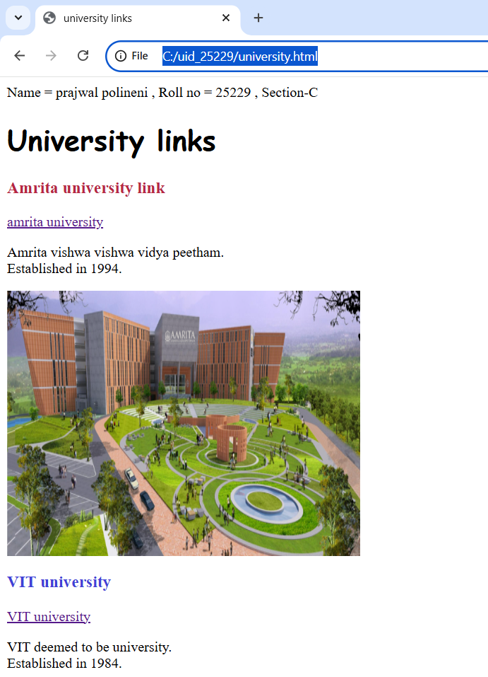


Explanation:
1.<p> = This to used to define paragraph of text.
2.<img src=https://webfiles.amrita.edu/2022/03/nbElb5oz-amrita-amaravati-campubanner-2022.jpg alt="https://www.amrita.edu/" width="400" height="300">
1. This used to display image in webpage.
2.src = this is image url.
3.alt = this is used because if the provided url does not work.
4. width = This is used for width of image.
5.height = This is used for height of image.
3.<a> = This is used to connect different documents or locations in same document.
4. <a href="https://www.amrita.edu/">amrita university</a>
1. href specifies the destination of url.
2.amrita university = clickable link.
5. color is used for change color of text.
6. font-family is used for different fonts of text.
7.<br> = this is used to write paragraph in multiple lines without using <p> every time.

Week-2

- Aim :Design a basic webpage with headings,paragraph,pre,table by adding styles.

Program:
Name = prajwal polineni , Roll no = 25229 , Section-C
<!DOCTYPE html>
<html>
<head>
<title>porsche </title>
</head>
<body style="text-align: center;background-image: url(Screenshot.png);">

<a href="https://www.porsche.com/international/models/911/911-gt3-models/911-gt3/" style="font-family: cursive;color:#000; border: 7px solid rgb(0, 0, 0); display: inline-block; padding: 10px; text-align: left;font-size: 350%;">Porsche </a>

<pre style="font-size: larger;"><i><mark style="color: rgb(0, 0, 0);">The Porsche 911 is arguably the most famous sports car in history.
Since its debut in 1963 (as the 901), it has maintained a unique rear-engine layout and
a silhouette that has evolved rather than changed,
making it a "timeless machine."</mark></i></pre>
<table width: 400 border=1 align="center" cellspacing="4" cellpadding=10 style="text-align: center; background-color: aliceblue;">
<tr style="text-align: center;">
<th>Brand</th>or
<th>Model</th>
<th>Cost</th>
<th>Horse power</th>
<th>Type of engine</th>
<th>Model ofEngine</th>
</tr>
<tr style="text-align: center;">
<td>Porsche</td>
<td>911</td>
<td>$250,000+</td>
<td>473 hp</td>
<td rowspan="2">Petrol engines</td>
<td rowspan="2">v-6 Twin turbo</td>
</tr>
<tr>
<td>Porsche</td>
<td>Macan</td>
<td>$135,555+</td>
<td>434hp</td>
</tr>
<tr>
<td>Porsche</td>
<td>Taycan</td>
<td>$233,350+</td>
<td>616.72hp</td>
<td>electric</td>
<td>Dual motor electric setup</td>
</tr>
</table>
</body>
</html>

Output:
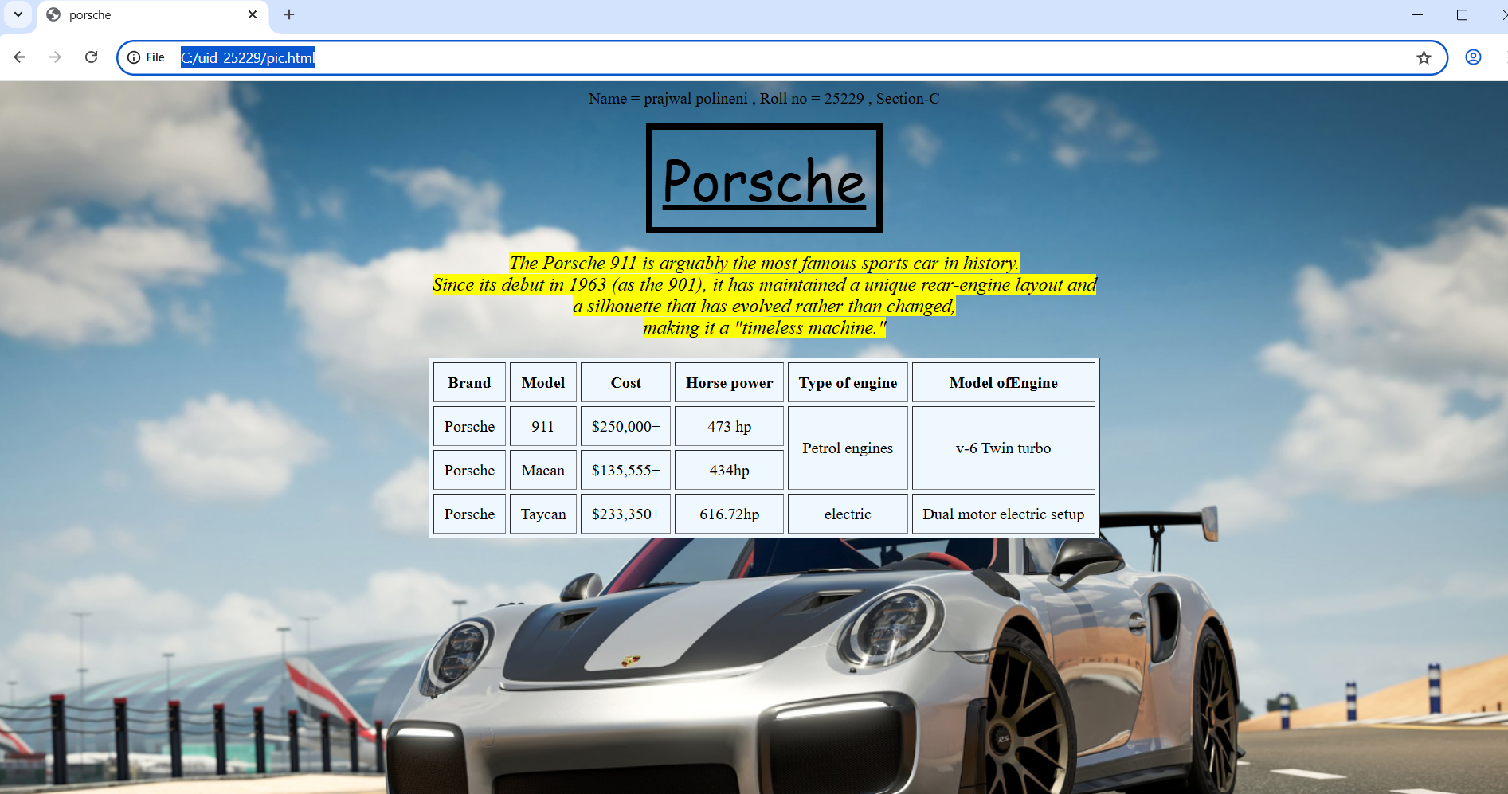
Explanation:
- <a> = Creates a hyperlink that takes the user to a different webpage when clicked
- <i> = Displays text in italics.
- <table> = the <table> tag is used to arrange data into rows and columns.
- <tr> = Creates a horizontal row.
- <th> = Defines a header cell (usually bold and centred by default).
- <td> = the <td> tag stands for table Data.
- <b> = Used for bold text.
- <pre> = to display text exactly as written in the HTML source code, preserving both whitespace and line breaks
- colspan attribute = It is used to merge multiple columns across horizontally.
10.rowspan attribute = It is used to merge multiple rows across vertically.

Week-3
3.A)Aim : Create a class timetable using HTML elements.
B)Aim : Create a HTML web page that should display al subjects as an image of all syllabus .

Program:
Name = prajwal polineni , Roll no = 25229 , Section-C
<!DOCTYPE html>
<html>
<head>
<title>Time table</title>
</head>
<body style="background-color: rgb(224, 250, 253);">
<table width="100%" border="1" cellpadding="1" cellspacing="2" style="text-align: center; background-color: rgb(255, 255, 255);">
<tr>
<th colspan="12">Master Time Table CSE II Semester C Section</th>
</tr>
<tr>
<td colspan="4" align="left"><b>Dept. CSE</b><br><b>Class: B. Tech. CSE-C</b><br><b>Semester-II</b></td>
<td colspan="8" align="left"><b>Class Room Venue: 512</b></td>
</tr>
<tr>
<th colspan="4" align="left"><b>class Advisors:<br>1. Name: Mr. Budati Jaya Lakshminarayana<br>Email : bj_lakshminarayana@av.amrita.edu<br>Mobile Number :+91-7989795768</b></th>
<th colspan="8" align="left"><b>2. Name: Dr. Arun Kumar s<br>Email : s_arunkumar@av.amrita.edu<br>Mobile Number : +91-8940857202</b></th>
</tr>
<tr>
<th rowspan="2">Time/Day</th>
<th><b>Slot-1</b></th>
<th><b>Slot-2</b></th>
<th rowspan="2">10:35AM - 10:45Am</th>
<th><b>Slot-3</b></th>
<th><b>Slot-4</b></th>
<th><b>Slot-5</b></th>
<th rowspan="2"><b>1:15PM - 2:10PM</b></th>
<th><b>Slot-6></b></th>
<th rowspan="2"><b>3:00PM - 3:10PM</b></th>
<th><b>Slot-7</b></th>
<th><b>Slot-8</b></th>
</tr>
<tr>
<th><b>8:55AM - 9:45AM</b></th>
<th><b>9:45AM - 10:35AM</b></th>
<th><b>10:45AM - 11:35AM</b></th>
<th><b>11:35AM - 12:25PM</b></th>
<th><b>12:25PM - 1:15PM</b></th>
<th><b>2:10PM - 3:00PM</b></th>
<th><b>3:10PM -4:00PM</b></th>
<th><b>4:00PM - 4:50PM</b></th>
</tr>
<tr>
<th><b>MonDay</b></th>
<td colspan="2" style="background-color: beige;">Discrete Math Lab</td>
<td rowspan="5" style="background-color: rgb(138, 212, 215);">s<br>h<br>o<br>r<br>t<br> <br>b<br>r<br>e<br>a<br>k<b></b></td>
<td>Modren physics</td>
<td>Object oriented programming</td>
<td>glimpse of glorious india</td>
<td rowspan="5" style="background-color: rgb(138, 212, 215);">L<br>u<br>n<br>c<br>h<br> <br>b<br>r<br>e<br>a<br>k</n></td>
<td>glimpse of glorious india</td>
<td rowspan="5" style="background-color: rgb(138, 212, 215);">s<br>h<br>o<br>r<br>t<br> <br>b<br>r<br>e<br>a<br>k<b></b></td>
<td colspan="2" style="background-color: rgb(180, 205, 156);">Library</td>
</tr>
<tr>
<th><b>Tuesday</b></th>
<td colspan="2" style="background-color: beige;">User interface design Lab</td>
<td>Linear Algebra</td>
<td>Discrete mathematics</td>
<td style="color:red ;">Councelling</td>
<td style="background-color: beige;">Manfacturing practice Lab</td>
<td colspan="2" style="background-color: beige;">Manfacturing practice Lab</td>
</tr>
<tr>
<th><b>Wednesday</b></th>
<td>Modren Physics</td>
<td>User interface design</td>
<td colspan="2" style="background-color: beige;">Linear algebra Lab</td>
<td style="color: red;">Councelling</td>
<td>Library</td>
<td>Glimpse of glorious india</td>
<td>library/sports</td>
</tr>
<tr>
<th><b>Thursday</b></th>
<td>Object oriented programming</td>
<td>Discrete Mathematics</td>
<td colspan="2" style="background-color: beige;">Object oriented programming Lab</td>
<td>Linear algebra</td>
<td>Library</td>
<td colspan="2">Library/Sports</td>
</tr>
<th><b>Friday</b></th>
<td>Object oriented programming</td>
<td>Discrete mathematics</td>
<td>Modren physics</td>
<td>User interface design</td>
<td>Linear algebra</td>
<td>library</td>
<td colspan="2">Library/sports</td>
</table>
<br>
<br>
<table width="100%" border="1" cellpadding="1" cellspacing="2" style="text-align: center;background-color: aliceblue;">
<tr>
<th>Course code</th>
<th>Course Name</th>
<th> L-T-P</th>
<th> Credits</th>
<th>Faculty Name</th>
<th> Assisting Faculty</th>
</tr>
<td>23MAT116</td>
<td>Discrete Mathematics</td>
<td> 3-0-2 </td>
<td>04</td>
<td> Dr.Srivivasa Rao Thota</td>
<td> </td>
<tr>
<td>23MAT117</td>
<td>Linear Algebra</td>
<td> 3-0-2 </td>
<td>04</td>
<td> Mr.Sapavat Bixapathi</td>
<td> </td>
</tr>
<tr>
<td>23CSE111</td>
<td>Object Oriented Programming</td>
<td> 3-0-4</td>
<td>04</td>
<td>Dr.SATYA RAJENDRA SINGH R</td>
<td> Dr. Balaji TK</td>
</tr>
<tr>
<td>23PHY115</td>
<td>Modern Physics</td>
<td> 2-1-0</td>
<td>03</td>
<td>Dr.Soumya</td>
<td> </td>
</tr>
<tr>
<td>23CSE113</td>
<td>User Interface Design</td>
<td> 2-0-2 </td>
<td>03</td>
<td> Dr.Rajkumar Batchu</td>
<td> Mr. Barge Bharadwaj</td>
</tr>
<tr>
<Td>23MEE115</Td>
<td>Manufacturing Practice</td>
<td> 0-0-3</td>
<td>01</td>
<td>Dr. Sathies S.</td>
<td> </td>
</tr>
<tr>
<td>22ADM111</td>
<td>Glimpses of Glorious India</td>
<td> 2-0-1</td>
<td>02</td>
<td>Dr. Siva Panuganti</td>
<td> </td>
</tr>
<tr>
<td> </td>
<td>Total (15L + 1Tut +12P =28 hrs)</td>
<td>15-1-12</td>
<td>21</td>
<td> </td>
<td> </td>
</tr>
</table>
<h1 style="text-align: center;">Syllabus</h1>
<h2 style="color: crimson;">Discrete mathematics</h2>
<img src="discrete.png">
<h2 style="color: crimson;">Linear Algebra</h2>
<img src="linear.png">
<h2 style="color: crimson;">User interface design</h2>
<img src="uid.png">
<h2 style="color: crimson;">Manufacturing practice</h2>
<img src="manufacturing.png">
<h2 style="color: crimson;">Object oriented programming</h2>
<img src="oops.png">
<h2 style="color: crimson;">Modren Physics</h2>
<img src="modern.png">
<h2 style="color: crimson;">Glimpses of glorious india</h2>
<img src="glimpse.png">

</body>
</html>
Output:
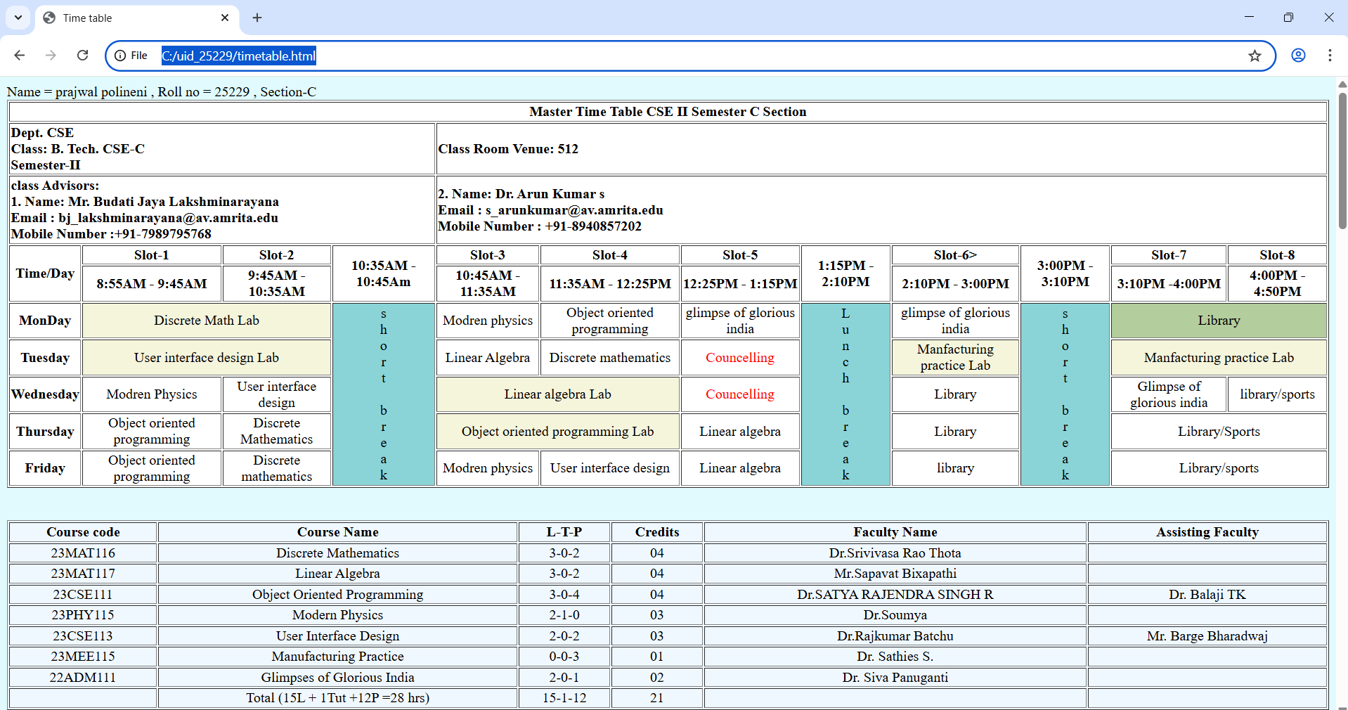

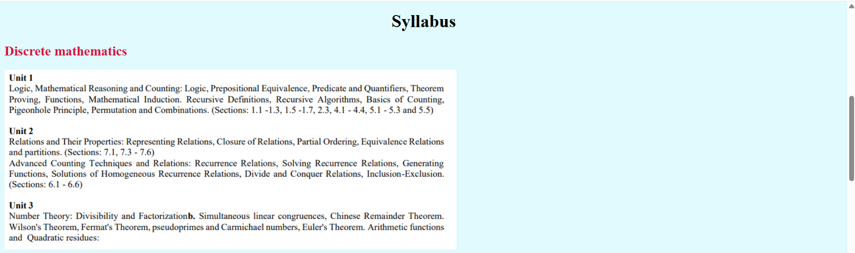
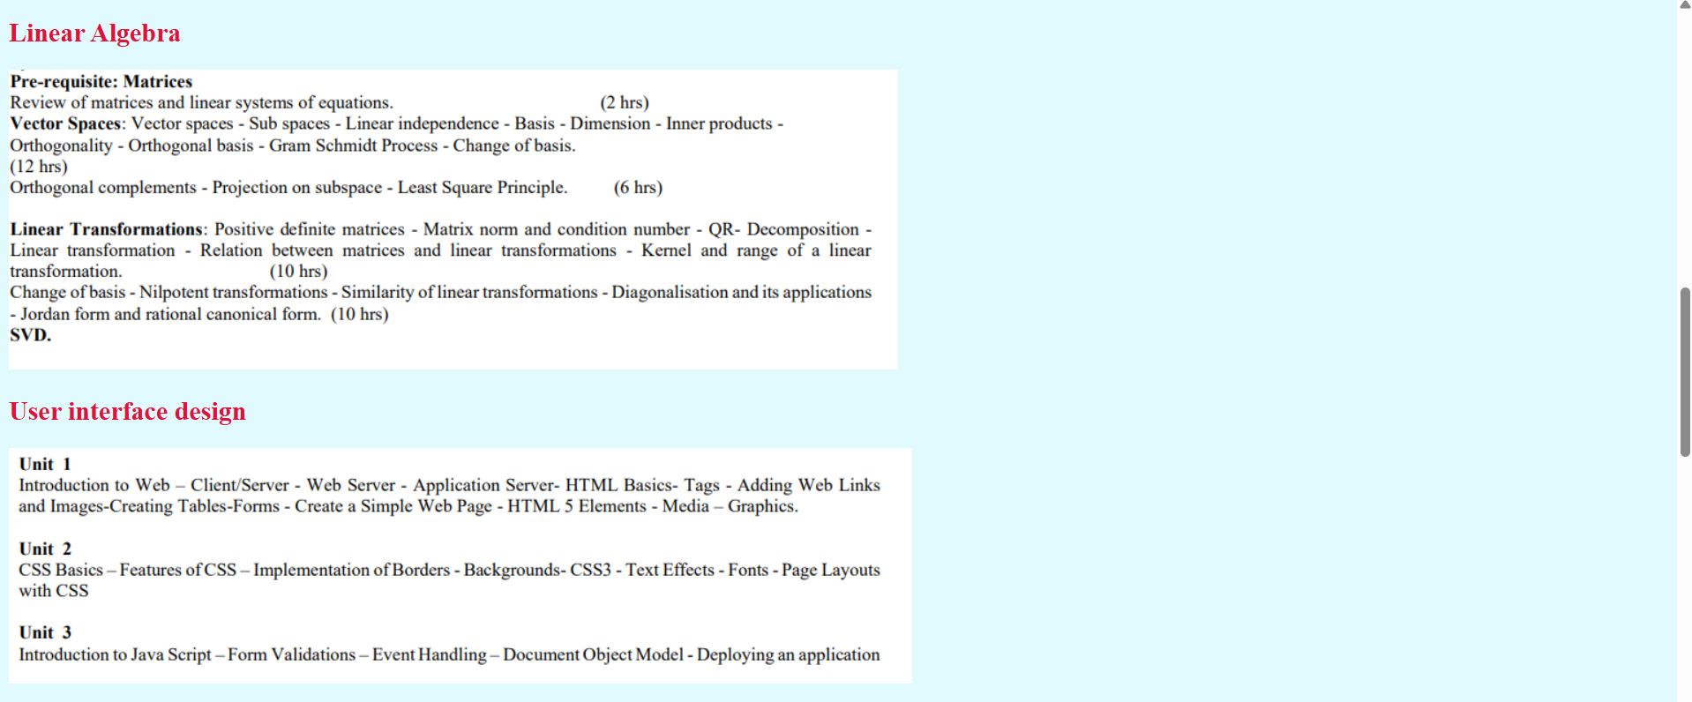
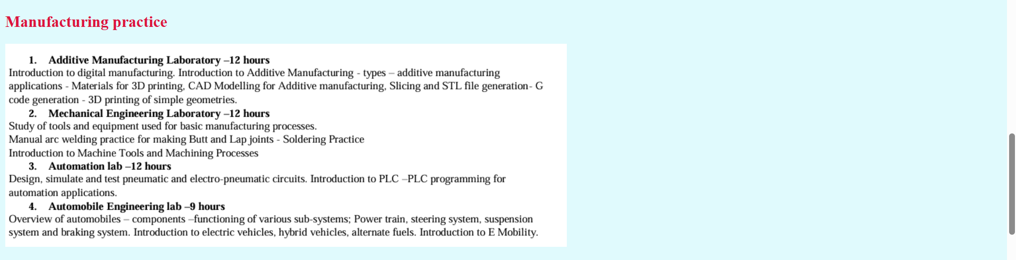
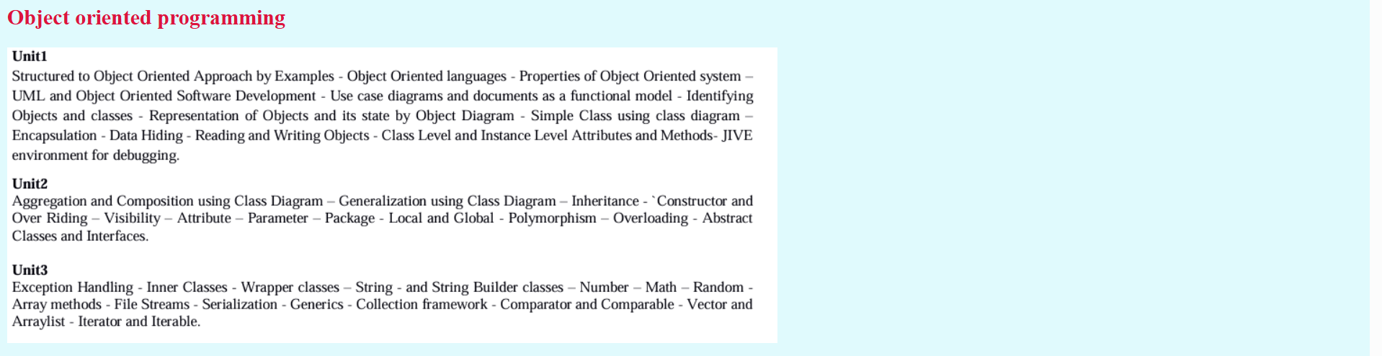

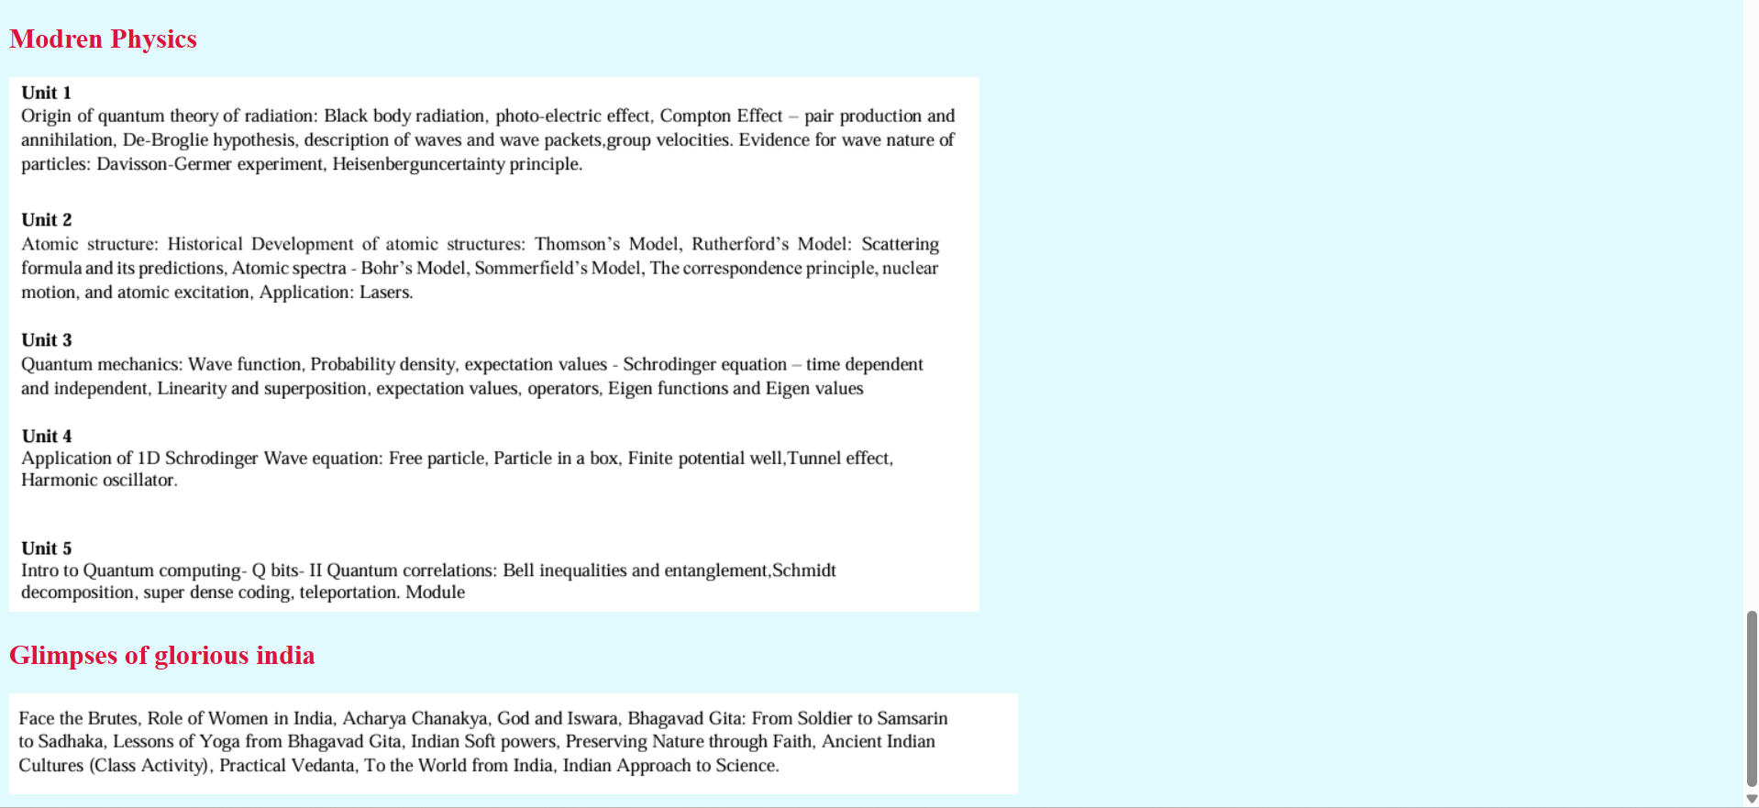
Explanation:
- <table> = the <table> tag is used to arrange data into rows and columns.
- <tr> = Creates a horizontal row.
- <th> = Defines a header cell (usually bold and centred by default).
- <td> = the <td> tag stands for table Data.
- <b> = Used for bold text.
- colspan attribute = It is used to merge multiple columns across horizontally.
- rowspan attribute = It is used to merge multiple rows across vertically.

Week-4
4.A)Aim: Creating a collage registration form using HTML.

Program:
Name = prajwal polineni , Roll no = 25229 , Section-C
<!DOCTYPE html>
<html>
<head>
<title>College Admission Registration</title>
</head>
<body>
<h2 style="text-align: center;">Collage Registration Form</h2>
<table border="1" align="center" cellpadding="10" cellspacing="1" >

<form>
<tr>
<td><label for="name">Full Name:</label></td>
<td><input type="text" id="name" name="name"></td>
</tr>

<tr>
<td><label for="email">Email:</label></td>
<td><input type="email" id="email" name="email"></td>
</tr>

<tr>
<td><label for="phone">Phone Number:</label></td>
<td><input type="tel" id="phone" name="phone"></td>
</tr>

<tr>
<td>Gender:</td>
<td>
<input type="radio" id="male" name="gender" value="male">
<label for="male">Male</label>
<input type="radio" id="female" name="gender" value="female">
<label for="female">Female</label>
<input type="radio" id="other" name="gender" value="other">
<label for="other">Other</label>
</td>
</tr>

<tr>
<td>Course Applying For:</td>
<td>
<select name="course">
<option value="btech">B.Tech</option>
<option value="mtech">M.Tech</option>
<option value="bsc">B.Sc</option>
<option value="aiml">AIML</option>
<option value="aids">AIDS</option>
<option value="cse-ai">CSE-AI</option>
</select>
</td>
</tr>

<tr>
<td>Hobbies:</td>
<td>
<input type="checkbox" id="sports" name="hobbies" value="sports">
<label for="sports">Sports</label>
<input type="checkbox" id="music" name="hobbies" value="music">
<label for="music">Music</label>
<input type="checkbox" id="reading" name="hobbies" value="reading">
<label for="reading">Reading</label>
</td>
</tr>
<tr>
<td><label for=dob>Date of birth:</label></td>
<td><input type=date id="dob"></td>
</tr>
<tr>
<td><label for=certificates>Upload certificates:</label></td>
<td><input type="file" id="certificates" name="certificates"></td>
</tr>
<tr>
<td><label for=address>Address :</label></td>
<td>
<textarea name="address" id="address" rows="4" cols="30"></textarea>
</td>
</tr>
<tr>
<td colspan="2" align="center">
<input type="submit" value="Submit">
<input type="reset" value="Reset">
</td>
</tr>
</form>
</table>

</body>
</html>
Output:

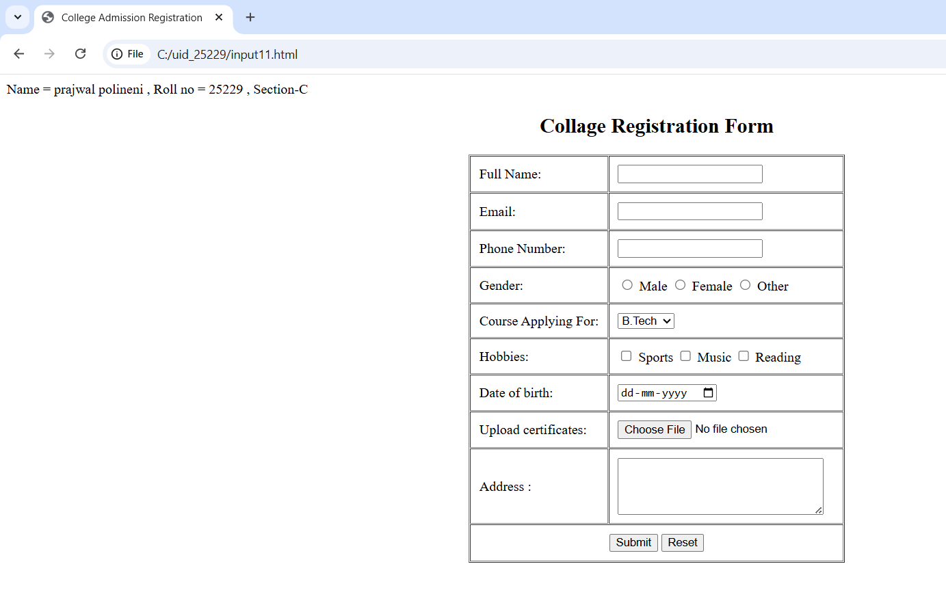

4.B)Aim:Create two different forms in one webpage using Iframes.
Program:

Name = prajwal polineni , Roll no = 25229 , Section-C
<!DOCTYPE html>
<html>
<head>
<title>Two Forms Using Iframes</title>
</head>
<body style="background-color: rgb(255, 250, 216);">
<center>
<h2>Two Forms Using Iframes</h2>
<iframe src="User Login form.html" width="400" height="500"></iframe>
<iframe src="User Registration.html" width="400" height="500"></iframe>
</center>
</body>
</html>

User Login Form.
<!DOCTYPE html>
<html>
<body style="background-color: rgb(188, 255, 255);">
<center>
<h2>User Login</h2>
<form>
<tr>
<table width="50" border="1" cellpadding="25" cellspacing="2" style="text-align:center;">
<tr>
<td>
<label for="fname">Username:</label>
</td>
<td>
<input type="text" id="fname" name="fname" placeholder="User Name">
</td>
</tr>
<td>
<label for="password">Password:</label>
</td>
<td>
<input type="password" id="password" name="password" placeholder="Password">
</td>
<tr>
<td colspan="2" style:align="center">
<input type="Submit" id="Login" name="Login" value="Login">
</td>
</tr>
</table>
</center>
</form>
</body>
</html>
User Registration Form.
<!DOCTYPE html>
<html>
<body style="background-color: rgb(188, 255, 255);">
<center>
<h2>User Registration</h2>
<form>
<table width="50" border="1" cellpadding="25" cellspacing="2" style="text-align:center;">
<tr>
<td>
<label for="fname">FullName:</label>
</td>
<td>
<input type="text" id="fname" name="fname" placeholder="Full Name ">
</td>
</tr>
<td>
<label for="Email">Email:</label>
</td>
<td>
<input type="Email" id="Email" name="Email" placeholder="Email ">
</td>
<tr>
<td>
<label for="phone number">Phone:</label>
</td>
<td>
<input type="text" id="phone number" name="phone number" placeholder="phone number">
</td>
</tr>
<tr>
<td>
<label for="password">Password:</label>
</td>
<td>
<input type="password" id="password" name="password" placeholder="password">
</td>
</tr>
<tr>
<td colspan="2" style:align="center">
<input type="Submit" id="Register" name="Register" value="Register">
<input type="Reset" id="Reset" name="Reset" value="Reset">
</td>
</tr>
</form>
</table>
</tr>
</center>
</body>
</html>

Output:
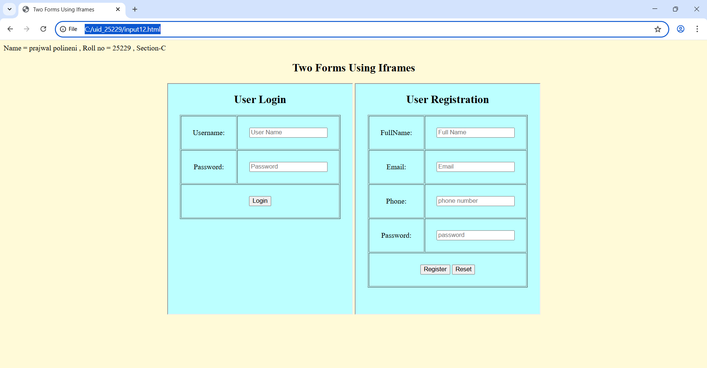
Explanation:
- <label> = Provides a clickable text description that tells the user what information to enter.
- <input> = Creates an interactive field where the user can actually type data or select options.
- <iframe> = Acts as a window to display another website or HTML document inside your current page.
- <centre> = Used to align content to the middle of the page.
- Src = Tells the <iframe> exactly which file to display inside the window.
- Type = Defines what kind of input to show (e.g., text for names, password to hide characters, or submit for a button).
- Id = A unique name for an element that connects it to a <label>.
- Name = The "key" or label sent to the server so it knows which piece of data belongs to which field.
- For = Used in a <label> to link it to the id of an <input>, making the label clickable.

Week-5
5.A)Aim: creating a card layout using tag consider three cards and a button using html and css.
Program:
Name = prajwal polineni , Roll no = 25229 , Section-C
<!DOCTYPE html>
<html>
<head>
<style>
.container {
display: flex;
justify-content: center;
gap: 20px;
padding: 40px;
background-color: #e9ecef;
border: 3px solid #343a40;
border-radius: 15px;
margin: 20px;
}

.card {
background: #ffffff;
padding: 20px;;
max-width: 300px;
border-radius: 10px;
box-shadow: 0 4px 6px rgba(0,0,0,0.1);
text-align: center;
font-family: sans-serif;
}
.img{
width:250px;
border-radius: 15px;

}
.h1{
text-align: center;
font-family: cursive;
}

.click-me-box {
display: block;
margin: 15px auto 0;
padding: 10px;
background-color: #5148f9;
color: white;
border: none;
border-radius: 55px;
cursor: pointer;

}

.click-me-box:hover {
background-color: #7094ff;
}
</style>
</head>
<body>
<h1 class="h1">Porsche</h1>

<div class="container">

<div class="card">
<h3>911</h3>
<img src="911.png" class="img">
<p>The quintessential all-rounder, balancing iconic design and daily-driver comfort with a twin-turbo flat-six that provides plenty of punch for both city streets and winding backroads.</p>
<button class="click-me-box">Click Me</button>
</div>

<div class="card">
<h3>911 GT3</h3>
<img src="gt3.png" class="img">
<p>The purist’s track weapon, featuring a high-revving, naturally aspirated engine that screams to 9,000 rpm and a specialized suspension designed for surgical precision on a race circuit.</p>
<button class="click-me-box">Click Me</button>
</div>

<div class="card">
<h3>911 Turbo S</h3>
<img src="turbo.png" class="img">
<p>The ultimate "land rocket," using a massive 700+ hp hybrid-assisted engine and all-wheel drive to deliver mind-bending, supercar-crushing acceleration while remaining incredibly luxurious.</p>
<button class="click-me-box">Click Me</button>
</div>

</div>
</body>
</html>

Output:

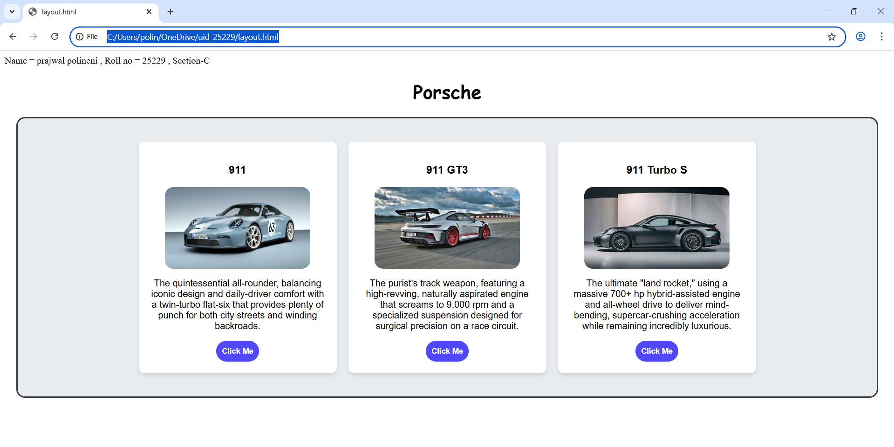Explanation:
- <div> = A <div> is an invisible container used to group HTML elements together so you can style them with CSS or manipulate them with JavaScript as a single unit.
- <button> = we use <button> element for creating button.
- Class = A class is a reusable identifier used to apply the same CSS styles.
- Display : flex = Display flex is a CSS property used to easily align, gap, and distribute space among items within a container.
- Gap = Gap is the external space between multiple items inside a Flex or Grid container.
- Padding = Padding is the internal space inside an element (between its border and its content).
- Cursor : pointer = Cursor pointer is a CSS property used to change the mouse icon into a hand with a pointing finger.
- Margin = Margin is a CSS property used to create empty space around an element.
- box-shadow: 0 4px 6px rgba(0,0,0,0.1) = box-shadow is used for creating a shadow around a box.

This page was created using interal css.

5.B)Aim: Navigation using iframe (mini website) upon clicking each buttons the details about that button should be display on the same page.
Program:
Index.html;(main)
Name = prajwal polineni , Roll no = 25229 , Section-C
<!DOCTYPE html>
<html>
<head>
<style>
body{
background-color: aliceblue;
font-family:Arial;
}
.menu{
display:flex;
background-color: #526272;
padding: 10px;
text-align: center;
justify-content: center;
border-radius: 15px;

}
.menu a{
color:white;
margin:0 15px;
text-decoration:none;
background:black;
padding:8px 12px;
text-align: center;
align-items: center;
align-content: center;
border-radius: 15px;
}
h1{
text-align:center;
background:#79ecfb;
color:rgb(0, 0, 0);
padding:20px;
font-family: cursive;
border-radius: 15px;
}
iframe{
width:100%;
height:4000px;
border:none;
}

</style>
</head>
<body>
<h1 >Porsche</h1>
<div class="menu">
<a href="about.html" target="frame" class="menu a">About</a>
<a href="home.html" target="frame" class="menu a">Engine</a>
<a href="contact1.html" target="frame" class="menu a">contact</a>
</div>
<iframe name="frame"></iframe>
</body>
</html>
About.html;
<!DOCTYPE html>
<html>
<head>
<style>
body{
font-family:Arial;
text-align:center
}
.box{
border:2px solid black;
padding:20px;
display:inline-block;
border-radius: 15px;
}
h2{
color:#000000;
font-family: cursive;
}
.img{
width: 250px;
border-radius: 15px;
}
</style>
</head>
<body>
<div class="box">
<h2>Porsche 911</h2>
<p>The Porsche 911 is a rear-engine sports car manufactured by Porsche.</p>
<p>Company: Porsche</p>
<img src=" turbo.png" class="img" >
</div>
</html>
Home.html;
<!DOCTYPE html>
<html>
<head>
<style>
body{
font-family:Arial;text-align:center;
}
.img{
width: 250px;
border-radius: 15px;
}
.box{
border:2px solid black;
padding:20px;
display:inline-block;
border-radius: 15px;
}
h2{
color:#000000;
font-family: cursive;
}
</style>
</head>
<body>
<div class="box">
<h2>Engine</h2>
<p>The Porsche 911 is equipped with a powerful boxer engine.</p>
<p>Engine type : 4.0L Naturally Aspirated Flat-6</p>
<p>Horse power : 502hp</p>
<p>Torque : 384 lb-ft</p>
<p>Max RMP : 9,000 rpm</p>
<img src=" porsche-911-t-hybrid.png" class="img">
</div>
</body>
</html>
Contact1.html;
<!DOCTYPE html>
<html>
<head>
<style>
body{
font-family:cursive;
text-align:center
}
.img{
width: 250px;
border-radius: 15px;
}
.box{
border:2px solid black;
padding:20px;
display:inline-block;
border-radius: 15px;
}
h2{
color:#000000;
}
</style>
</head>
<body>
<div class="box">
<h2>Contacts and websites</h2>
<p>www.porsche.com</p>
<p>Location : Mumbai, Delhi-NCR (Gurugram), Bengaluru, Chennai, Kolkata, Ahmedabad, Kochi, Hyderabad, and Pune</p>
<p>contact info : +91 86550 00911 or toll-free at 1800 1036 911 / 1800 1086 911</p>
<img src=" show.png" class="img">
</div>
</body>
</html>

Output: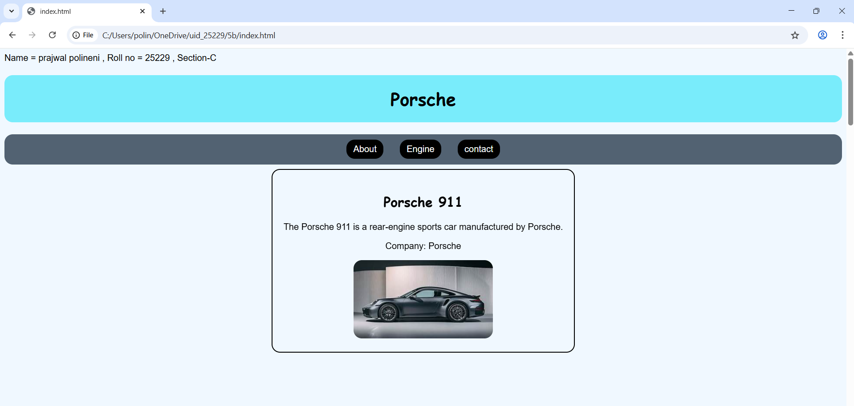 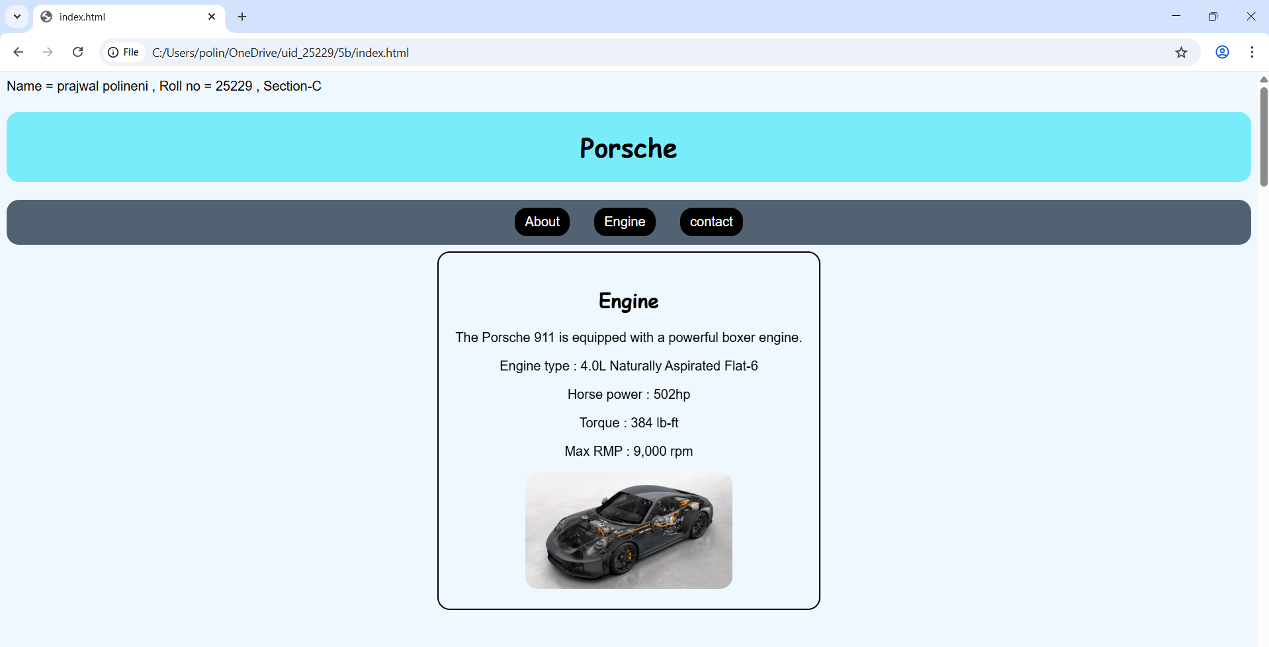

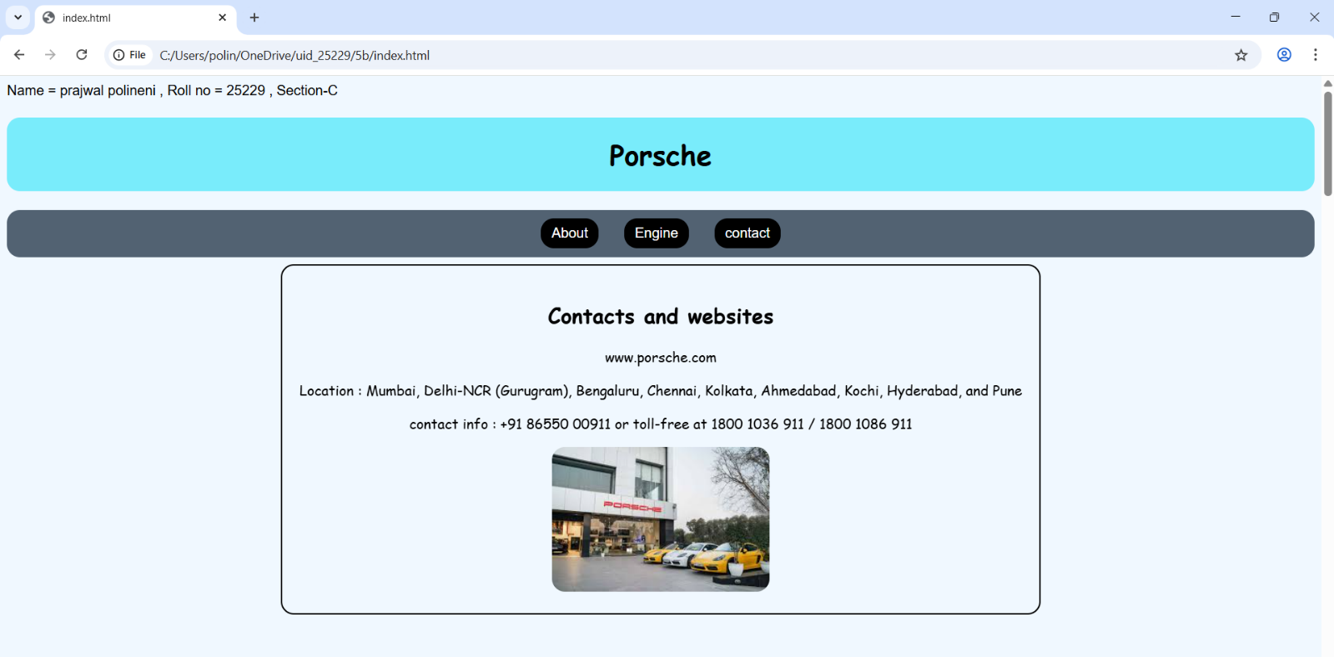
Explanation:
- <div> = A <div> is an invisible container used to group HTML elements together so you can style them with CSS or manipulate them with JavaScript as a single unit.
- <button> = we use <button> element for creating button.
- Class = A class is a reusable identifier used to apply the same CSS styles.
- Display : flex = Display flex is a CSS property used to easily align, gap, and distribute space among items within a container.
- Gap = Gap is the external space between multiple items inside a Flex or Grid container.
- Padding = Padding is the internal space inside an element (between its border and its content).
- Cursor : pointer = Cursor pointer is a CSS property used to change the mouse icon into a hand with a pointing finger.
- Margin = Margin is a CSS property used to create empty space around an element.
- box-shadow: 0 4px 6px rgba(0,0,0,0.1) = box-shadow is used for creating a shadow around a box.
10.Display : inline-block = Display inline-block is a CSS property that blends the best of both worlds: it allows elements to sit side-by-side.
This code is written using internal css. And all the other three codes are combined using <a herf > in the main code.
5.c)Aim: Design amrita login page by showcampus on home page.upon clicking on each campus the details about each campus should be display on the same page use html and css to design a stylish webpage.

Program:
Main.html:
Name = prajwal polineni , Roll no = 25229 , Section-C
<!DOCTYPE html>
<html>
<head>
<title>login webpage</title>
<style>
body{
background-image: url(img.png);
background-size: cover;
}
nav{
background:#0b5ea6;
text-align:center;
padding:10px;
}
nav a{color:yellow;
margin:12px;
text-decoration:none;
font-weight:bold;
padding:5px;
}
.heading{
font-size: 35px;
color: white;
background-color: rgb(195, 81, 81);
text-align: center;
padding:12px;
border-radius: 15px;
}
.main-container {
width: 1150px;
height: 50px;
}
.login-box {
float: left;
width: 360px;
background-color: #006400;
padding: 35px;
color: white;
border-radius: 15px;
opacity: 0.8;
border: 1px solid rgba(255,255,255,0.3);
height: 450px;
}
.login input[type="email"],
.login input[type="password"]{
width:90%;
padding:6px;
margin:6px 0;
}
.button{
border-radius: 15px;
background-color: #501df7;
color: white;
width: 75px;
}
iframe{
flex:1;
margin-left:20px;
height:520px;
border:none;
background:rgb(181, 227, 255);
border-radius:10px;
width: 950px;
opacity: 0.9;
}
</style>
</head>
<body>
<div class="heading">Amrita Vishwa Vidyapeetham</div>
<br>

<nav>
<a href="amaravati.html" target="campus">AMARAVATI</a>
<a href="amritapuri.html" target="campus">AMRITAPURI</a>
<a href="bengaluru.html" target="campus">BENGALURU</a>
<a href="chennai.html" target="campus">CHENNAI</a>
<a href="coimbatore.html" target="campus">COIMBATORE</a>
<a href="kochi.html" target="campus">KOCHI</a>
<a href="mysuru.html" target="campus">MYSURU</a>
</nav>
<div class="login-box">
<h2>Login</h2>
Email<br>
<input type="email"><br>
Password <br>
<input type="password">
<div class="remember">
<input type="checkbox"><label>Save me</label>
</div>
<input type="button" value="Login" class="button" >
<br><br>
<a href=" ">Forgot Password?</a><br>
No account? <a href=" ">Register</a>
</div>
<iframe name="campus" src="amaravati.html"></iframe>

</body>
</html>
Amaravati.html:
<!DOCTYPE html>
<html>
<body style=" text-align:center;">
<h1 style="color:#a00000;">Amaravati Campus</h1>
<p>
One of the newer additions, this 200-acre campus in Andhra Pradesh is designed as a modern tech-and-business-centric educational center.
</p>
<p>
nirf ranking : 8th for university<br>
Popular Courses: CSE, AI, Data Science<br>
Facilities: Library, Smart Classrooms, Hostel<br>
Focus: Innovation and Research
</p>
<img src=" amara.png" width="450" style="border-radius: 15px;">
</body>
</html>
Amritapuri.html:
<!DOCTYPE html>
<html>
<body style="text-align:center;">
<h1 style="color:#ff0b0b;">Amritapuri Campus</h1>
<p>
Located near the headquarters of the Mata Amritanandamayi Math, it's famous for blending high-end research with a spiritual, seaside atmosphere.
</p>
<p>
nirf ranking : 8th for university<br>
Popular Courses: Engineering, Arts, Sciences<br>
Facilities: Research Labs, Hostel,Beautiful nature <br>
Focus: Academic Excellence with Values
</p>
<img src="amp1.png" width="450" style="border-radius: 15px;">
</body>
</html>
Bengaluru.html
<!DOCTYPE html>
<html>
<body style="text-align:center;">
<h1 style="color:#a00000;">Bengaluru Campus</h1>
<p>
Located in India's tech hub, Bengaluru campus offers advanced
engineering programs with strong industry connections.
</p>
<p>
nirf ranking : 8th for university <br>
Popular Courses: Robotics, CSE, ECE<br>
Facilities: Coding Labs, Innovation Centres<br>
Focus: Industry Collaboration
</p>
<img src=" bang.png" width="450" style="border-radius:15px;">
</body>
</html>
Chennai.html:
<!DOCTYPE html>
<html>
<body style="text-align:center;">
<h1 style="color:#a00000;">Chennai Campus</h1>
<p>
Chennai campus provides top-quality computing and management education
with modern infrastructure.
</p>
<p>
nirf ranking : 8th for university<br>
Popular Courses: IT, MBA, Electronics<br>
Facilities: Digital Library, Placement Cell<br>
Focus: Career Development
</p>
<img src=" chennai.png" width="450" style="border-radius:15px;">
</body>
</html>
Coimbatore.html:
<!DOCTYPE html>
<html>
<body style="text-align:center;">
<h1 style="color:#a00000;">Coimbatore Campus</h1>
<p>
The massive 450-acre headquarters known for its top-tier engineering programs and lush, eco-friendly "oasis" setting.
</p>
<p>
nirf ranking : 8th for university<br>
Popular Courses: Mechanical, Civil, CSE<br>
Facilities: Workshops, Labs, Hostel<br>
Focus: Core Engineering Skills
</p>
<img src="coim.png" width="450" style="border-radius: 15px;">
</body>
</html>
Kochi.html:
<!DOCTYPE html>
<html>
<body style="text-align:center;">
<h1 style="color:#a00000;">Kochi Campus</h1>
<p>
A premier healthcare hub that houses the renowned Amrita Institute of Medical Sciences (AIMS)
and a major multi-specialty hospital.
</p>
<p>
nirf ranking : 8th for university<br>
Popular Courses: MBA, Commerce, Finance<br>
Facilities: Seminar Halls, Library<br>
Focus: Industry Training
</p>
<img src="kochi.png" width="450" style="border-radius: 15px;">
</body>
</html>
Mysuru.html:
<!DOCTYPE html>
<html>
<body style="text-align:center;">
<h1 style="color:#a00000;">Mysuru Campus</h1>
<p>
Mysuru campus is known for its peaceful environment,
green campus, and quality education.
</p>
<p>
nirf ranking : 8th for university<br>
Popular Courses: Arts, Sciences, Engineering<br>
Facilities: Hostel, Library, Sports Complex<br>
Focus: Calm Learning Atmosphere
</p>
<img src="mys.png" width="450" style="border-radius:15px;">
</body>
</html>

Output:
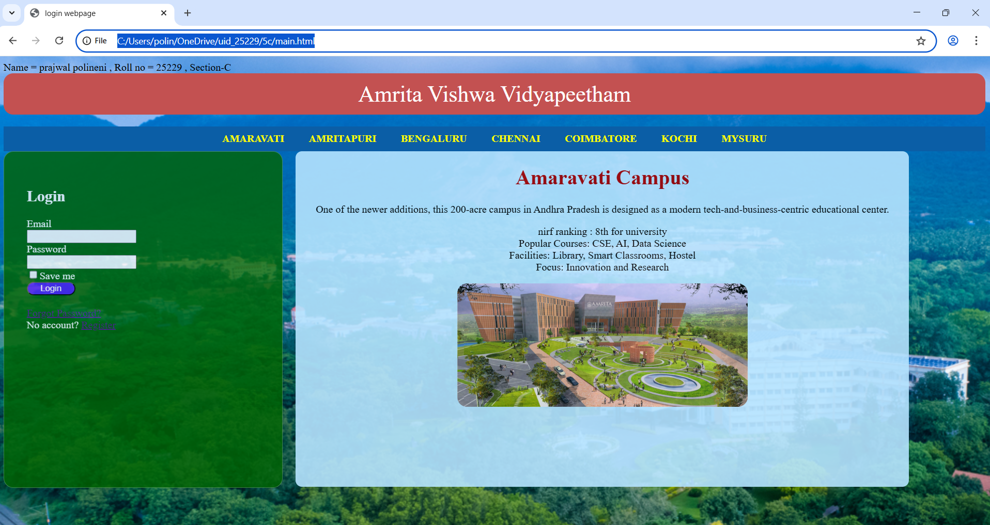
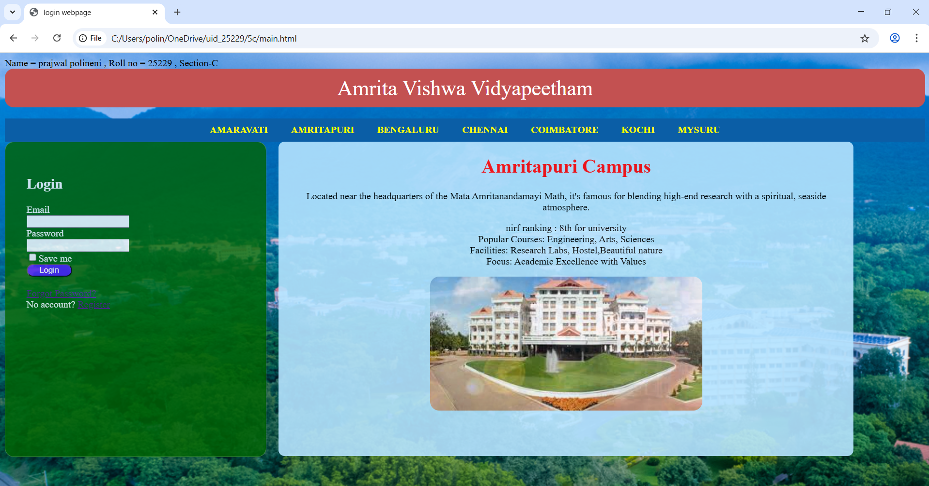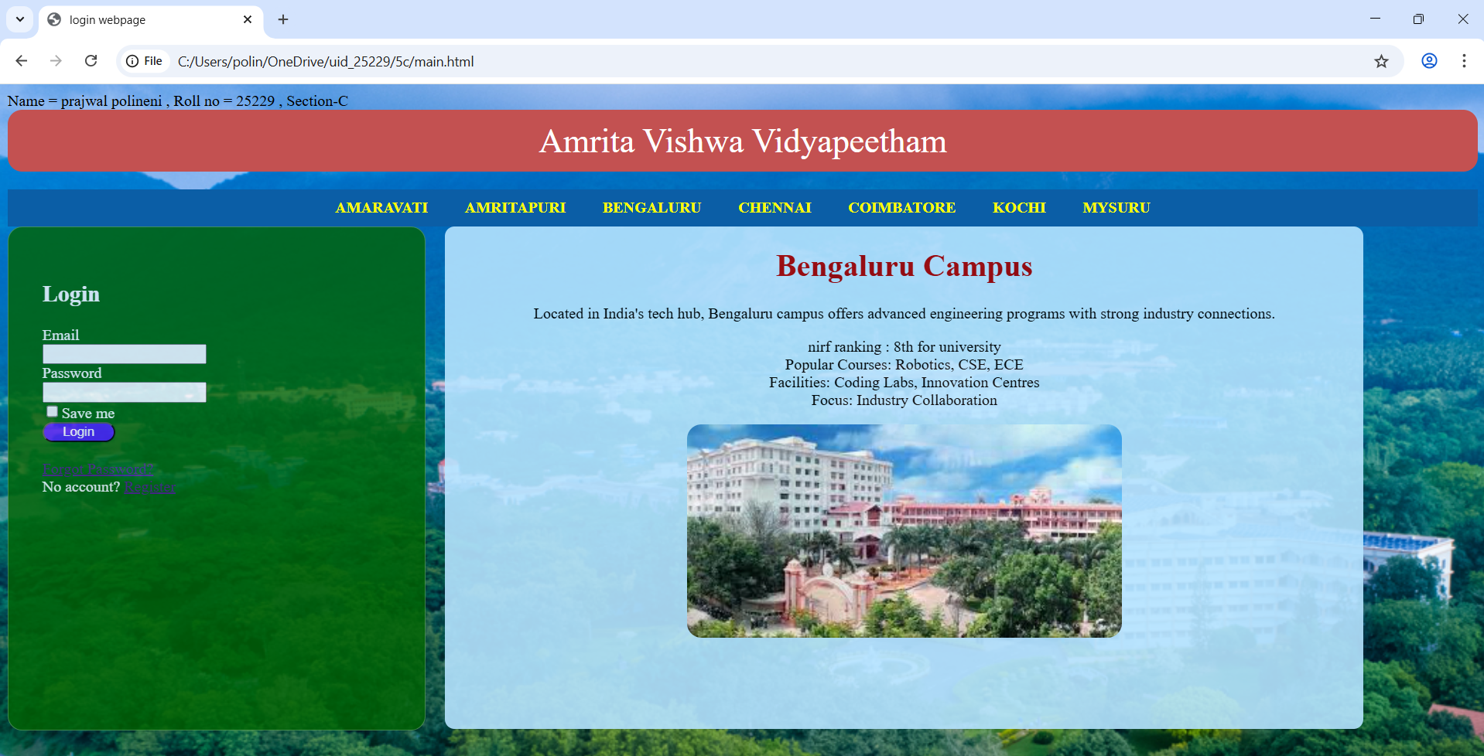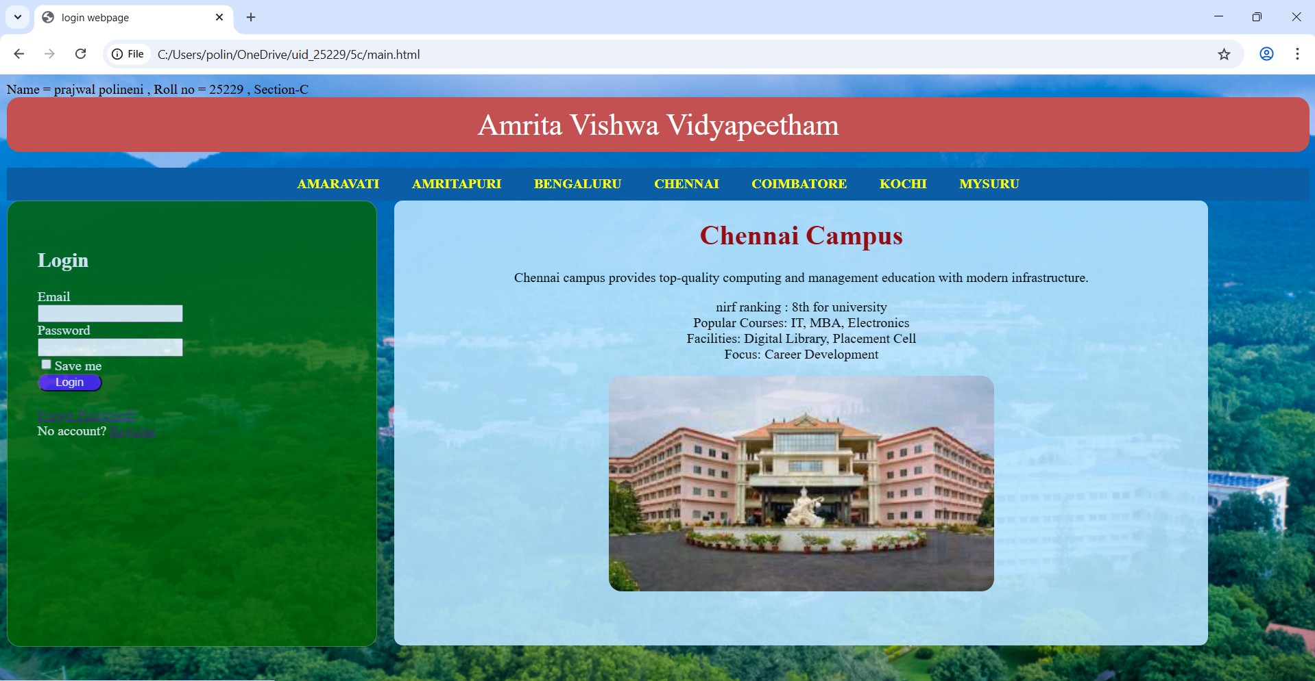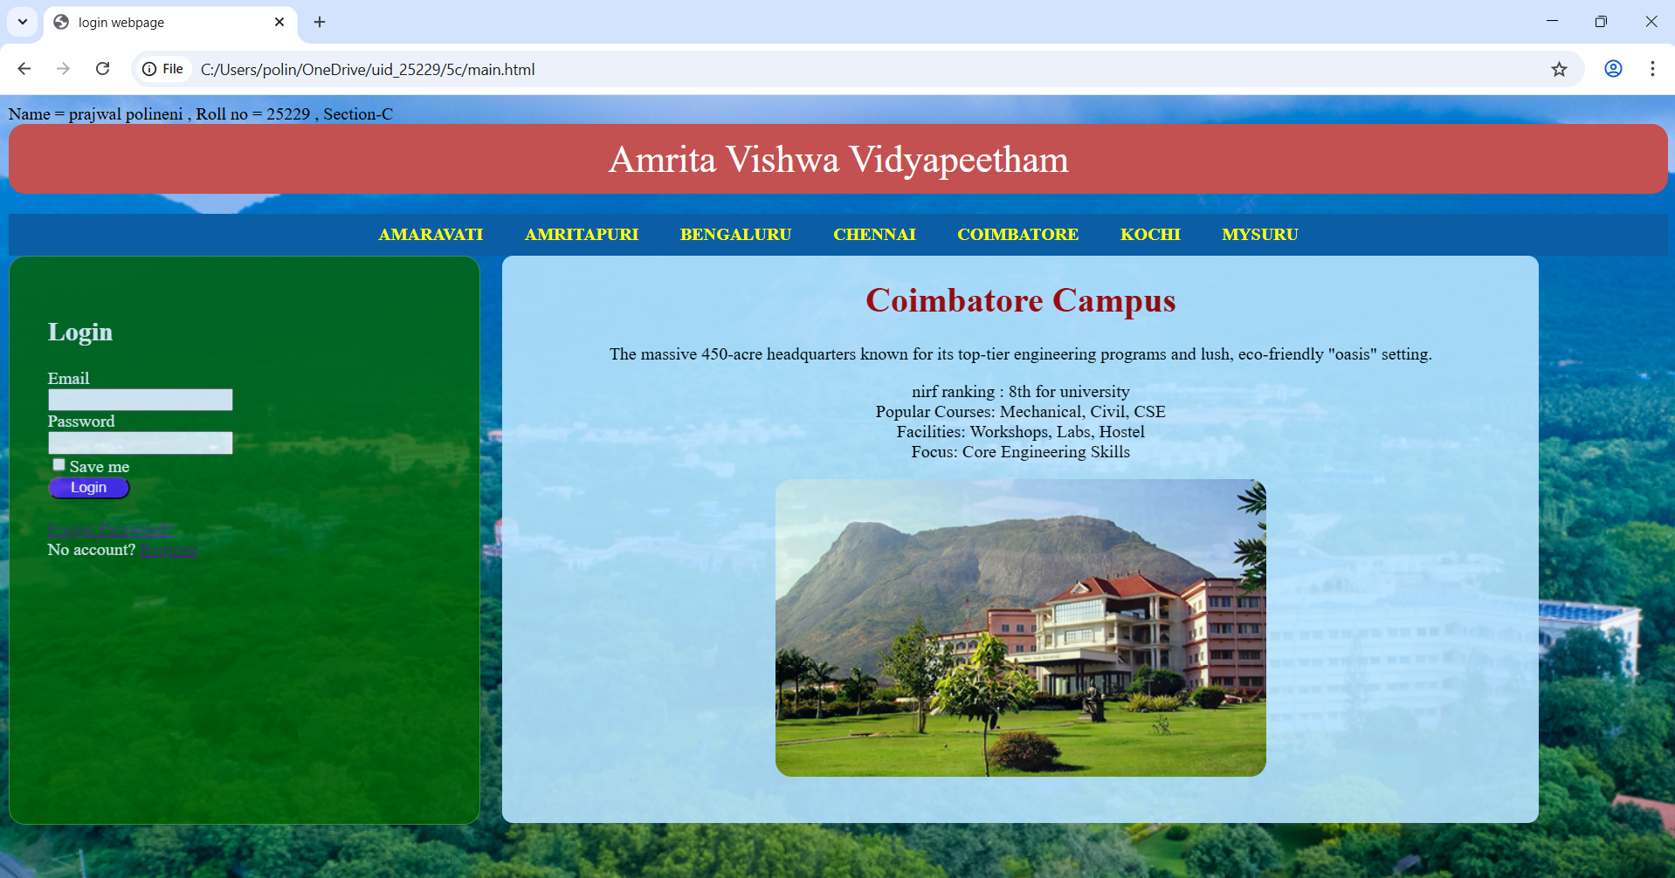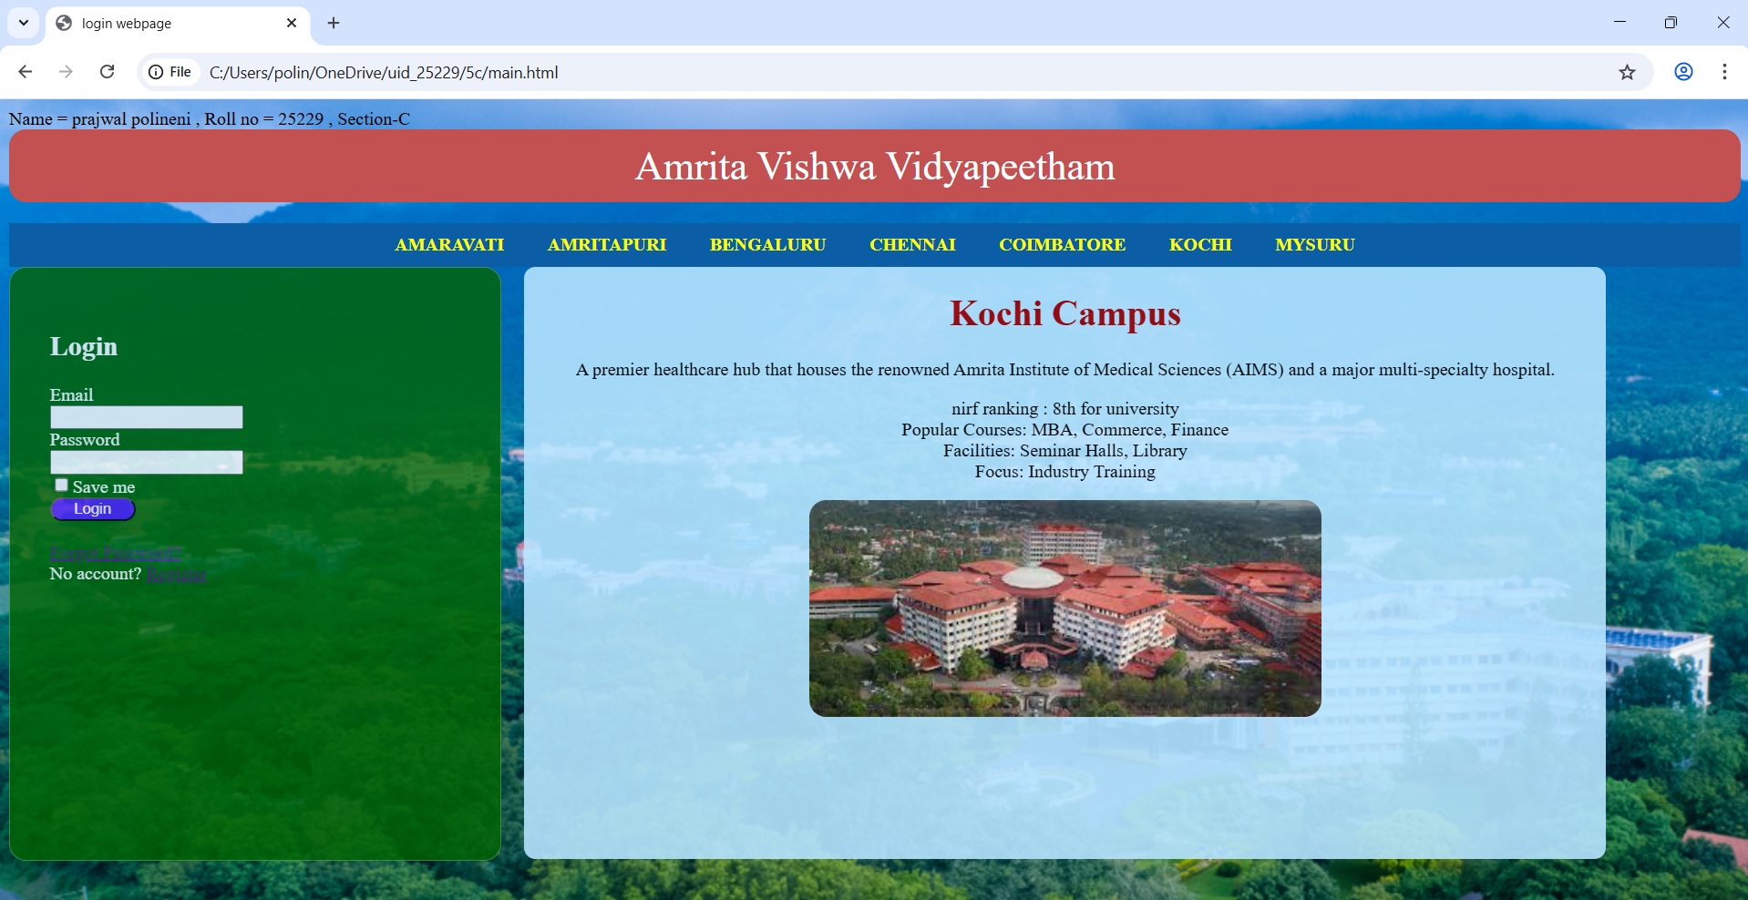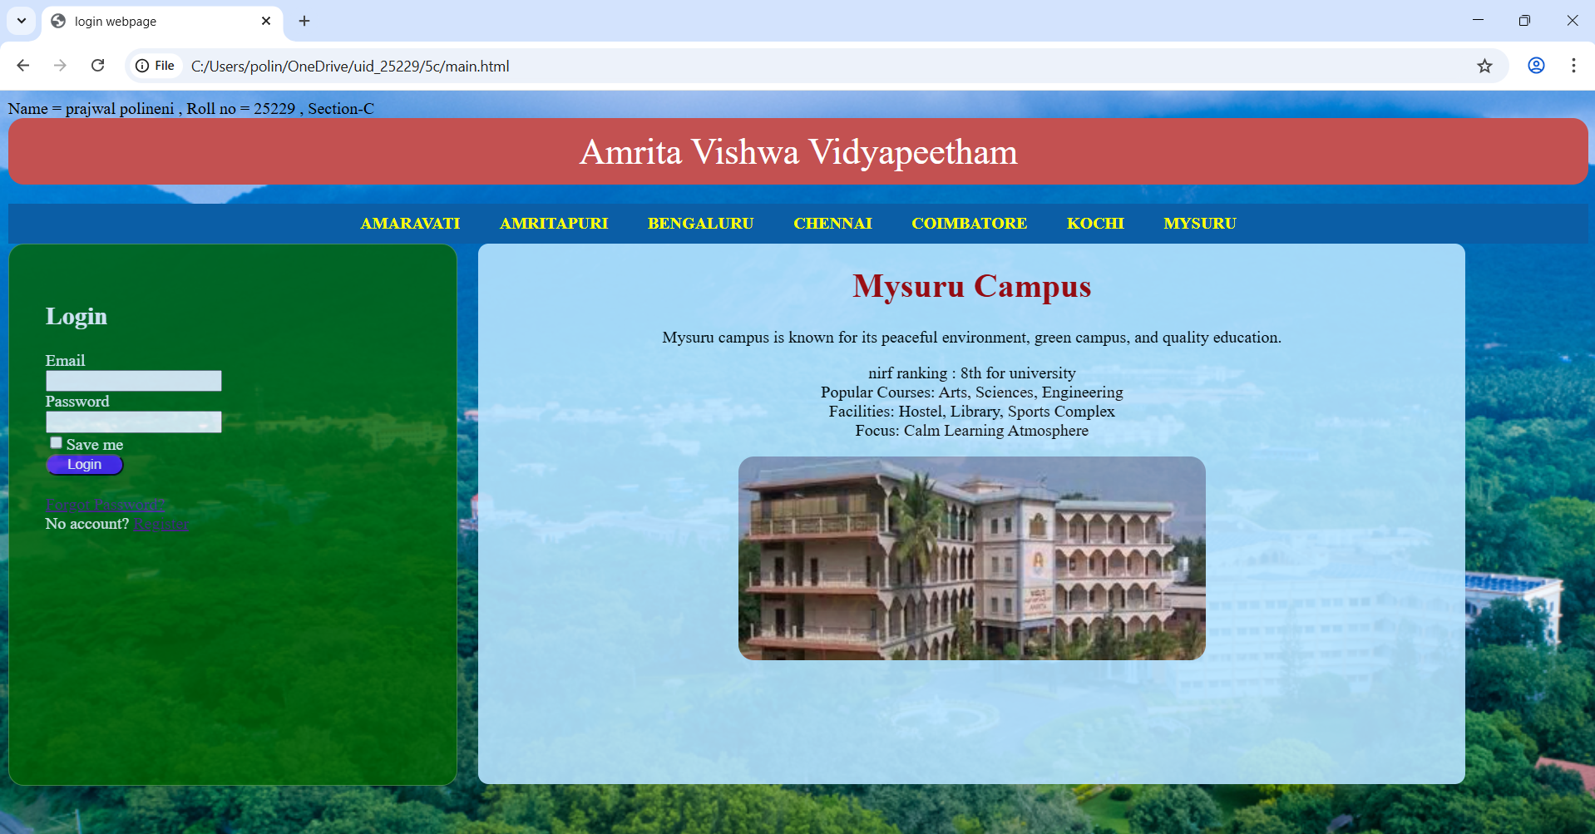
Explanation:
- <div> = A <div> is an invisible container used to group HTML elements together so you can style them with CSS or manipulate them with JavaScript as a single unit.
- <button> = we use <button> element for creating button.
- Class = A class is a reusable identifier used to apply the same CSS styles.
- Display : flex = Display flex is a CSS property used to easily align, gap, and distribute space among items within a container.
- Gap = Gap is the external space between multiple items inside a Flex or Grid container.
- Padding = Padding is the internal space inside an element (between its border and its content).
- Cursor : pointer = Cursor pointer is a CSS property used to change the mouse icon into a hand with a pointing finger.
- Margin = Margin is a CSS property used to create empty space around an element.
- box-shadow: 0 4px 6px rgba(0,0,0,0.1) = box-shadow is used for creating a shadow around a box.
10.Display : inline-block = Display inline-block is a CSS property that blends the best of both worlds: it allows elements to sit side-by-side.
This code is written using internal css. And all the other three codes are combined using <a herf > in the main code.

Week-6
6.A)Aim: Design a responsive e-commerce application using the grid layout. This application should contain different categories of products such as electronics, clothing, home-appliances, books. Based on the category we select corresponding products should be displayed on the sidebar.
Program:
Main.html:
Name = prajwal polineni , Roll no = 25229 , Section-C
<!DOCTYPE html>
<html>
<head>
<title>E-commerce Site</title>
<style>
body {
margin: 0;
background-color: aliceblue;
font-family: sans-serif;
}

.container {
display: grid;
min-height: 100vh;
grid-template-rows: auto auto 1fr auto;
grid-template-columns: 200px 1fr;
grid-template-areas:
"header header"
"sale sale"
"sidebar products"
"footer footer";

}

.header {
grid-area: header;
background-color: rgb(151, 82, 224);
text-align: center;
padding: 10px;
margin-top: 0px;
border-radius: 8px;
}

.sale {
grid-area: sale;
background-color: tomato;
opacity: 0.9;
color: white;
border-radius: 8px;
text-align: center;
padding: 10px;
font-size: 19px;
font-weight: bold;
}

.sidebar {
grid-area: sidebar;
background-color: #e3f2fd;
padding: 20px;
border-radius: 9px;
opacity: 0.9;
border-right: 1px solid #ccc;
}
.frame {
grid-area: products;
width: 100%;
height: 100%;
border: none;
}

.sidebar a {
display: block;
color: black;
text-decoration: none;
padding: 10px 0;
border-bottom: 1px solid #d1e9ff;
}

.sidebar a:hover {
color: blue;
}

.footer {
grid-area: footer;
background-color: black;
color: white;
text-align: center;
padding: 2px;
}
</style>
</head>
<body>

<div class="container">
<div class="header">
<h1>My Ecommerce store</h1>
</div>

<div class="sale">
<p>BIG SALE! 75% OFF!!</p>
</div>

<div class="sidebar">
<h3>Categories</h3>
<hr>
<a href="electronics.html" target="frame">Electronics</a>
<a href="clothes.html" target="frame">Clothes</a>
<a href="accessories.html" target="frame">Accessories</a>
</div>

<iframe class="frame" name="frame" src="electronics.html"></iframe>

<footer class="footer">
<p>2026 E-commerce Store Concept</p>
</footer>
</div>

</body>
</html>
Electronics.html:
<!DOCTYPE html>
<html>
<head>
<style>
body {
margin: 0;
background-color: aliceblue;
font-family: sans-serif;
}

.products {
grid-area: products;
display: grid;
grid-template-columns: repeat(2, 1fr);
gap: 10px;
padding: 20px;
}

.product-card {
background: white;
border: 1px solid #ddd;
padding: 20px;
text-align: center;
border-radius: 8px;
height: auto;
width: 600px;
}
.p{
text-align: center;
background-color: tomato;
align-items: center;
}
img{
width: 120px;
height: auto;
border-radius: 8px;
}

.button {
background-color: blue;
color: white;
border: none;
padding: 10px 20px;
cursor: pointer;
border-radius: 50px;
margin-top: 10px;
}

.button:hover {
background-color: #7094ff;
}
</style>
</head>
<body>
<div class="products">
<div class="product-card">
<img src=" ip17.png">
<h3>Iphone 17</h3>
<p>$899</p>
<p>12GB RAM | 256GB Storage</p>
<button class="button">Add to Cart</button>
</div>
<div class="product-card">
<img src="s26.png">
<h3>Samsung Galaxy S26</h3>
<p>$1199</p>
<p>12GB RAM | 512GB Storage</p>
<button class="button">Add to Cart</button>
</div>
<div class="product-card">
<img src="d15.png">
<h3>Dell G15</h3>
<p>$799</p>
<p>16GB RAM | 1024GB Storage</p>
<button class="button">Add to Cart</button>
</div>
<div class="product-card">
<img src="vic.png">
<h3>HP victus</h3>
<p>$749</p>
<p>16GB RAM | 512GB Storage</p>
<button class="button">Add to Cart</button>
</div>
</div>
</body>
clothes.html:
<!DOCTYPE html>
<html>
<head>
<style>
body {
margin: 0;
background-color: aliceblue;
font-family: sans-serif;
}

.products {
grid-area: products;
display: grid;
grid-template-columns: repeat(2, 1fr);
gap: 20px;
padding: 20px;
}

.product-card {
background: white;
border: 1px solid #ddd;
padding: 20px;
text-align: center;
border-radius: 8px;
}
img{
width: 120px;
height: auto;
border-radius: 8px;
}
.p{
text-align: center;
background-color: tomato;
align-items: center;
}

.button {
background-color: blue;
color: white;
border: none;
padding: 10px 20px;
cursor: pointer;
border-radius: 50px;
margin-top: 10px;
}

.button:hover {
background-color: #7094ff;
}
</style>
</head>
<body>
<div class="products">
<div class="product-card">
<img src="uwhite.png">
<h3>USPA off-white shirt</h3>
<p>$39</p>
<p>Size: S , M , XL , XXL</p>
<button class="button">Add to Cart</button>
</div>
<div class="product-card">
<img src=" ublue.png">
<h3>USPA blue Shirt</h3>
<p>$59</p>
<p>Size: S , M , L , XL</p>
<button class="button">Add to Cart</button>
</div>
<div class="product-card">
<img src=" bp.png">
<h3>USPA black pants</h3>
<p>$49</p>
<p>Size: 28 , 30 , 32 , 34</p>
<button class="button">Add to Cart</button>
</div>
<div class="product-card">
<img src="gp.png">
<h3>USPA Green pants</h3>
<p>$52</p>
<p>Size: 28 , 30 , 32 , 34</p>
<button class="button">Add to Cart</button>
</div>
</div>
</body>
accessories.html:
<!DOCTYPE html>
<html>
<head>
<style>
body {
margin: 0;
background-color: aliceblue;
font-family: sans-serif;
}

.products {
grid-area: products;
display: grid;
grid-template-columns: repeat(2, 1fr);
gap: 20px;
padding: 20px;
}

.product-card {
background: white;
border: 1px solid #ddd;
padding: 20px;
text-align: center;
border-radius: 8px;
}
.p{
text-align: center;
background-color: tomato;
align-items: center;
}
img{
width: 120px;
height: auto;
border-radius: 8px;
}

.button {
background-color: blue;
color: white;
border: none;
padding: 10px 20px;
cursor: pointer;
border-radius: 50px;
margin-top: 10px;
}

.button:hover {
background-color: #7094ff;
}
</style>
</head>
<body>
<div class="products">
<div class="product-card">
<img src="w6.png">
<h3>Samsung Galaxy Watch 6</h3>
<p>$169</p>
<button class="button">Add to Cart</button>
</div>
<div class="product-card">
<img src="b41.png" >
<h3>Samsung Galaxy Buds 4</h3>
<p>$249</p>
<button class="button">Add to Cart</button>
</div>
<div class="product-card">
<img src=" ri.png">
<h3>Samsung Galaxy ring </h3>
<p>$459</p>
<button class="button">Add to Cart</button>
</div>
<div class="product-card">
<img src="ca.png">
<h3>Samsung S26 case </h3>
<p>$59</p>
<button class="button">Add to Cart</button>
</div>
</div>
</body>

Output:
Electronics:
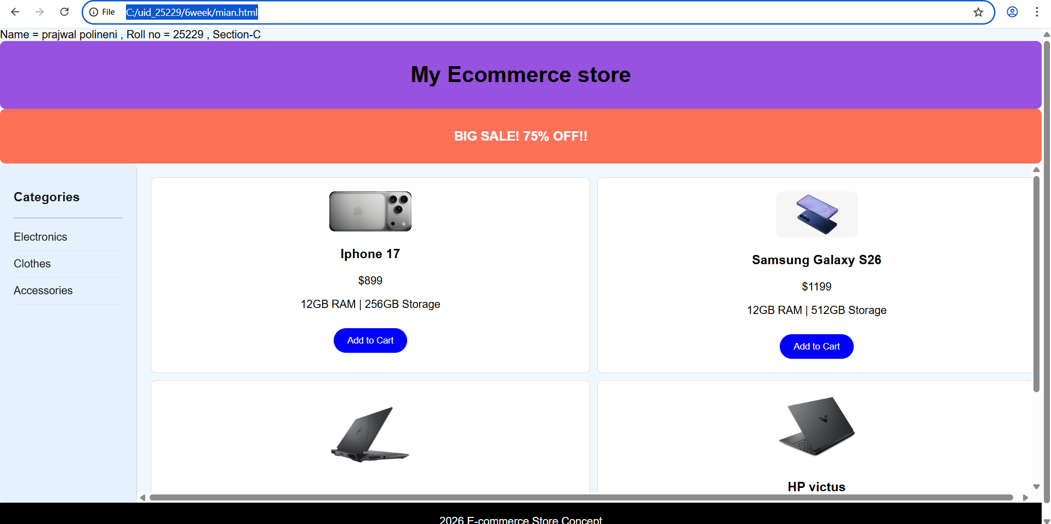
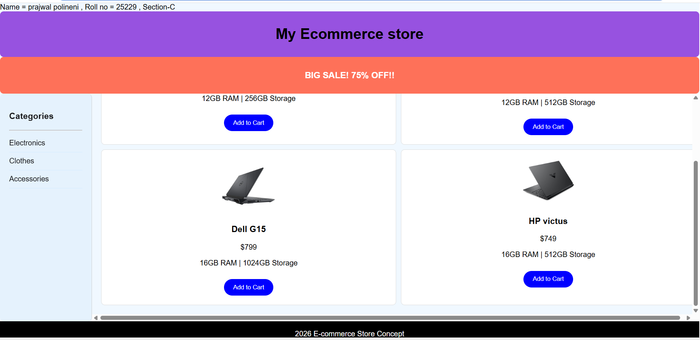
Clothes:
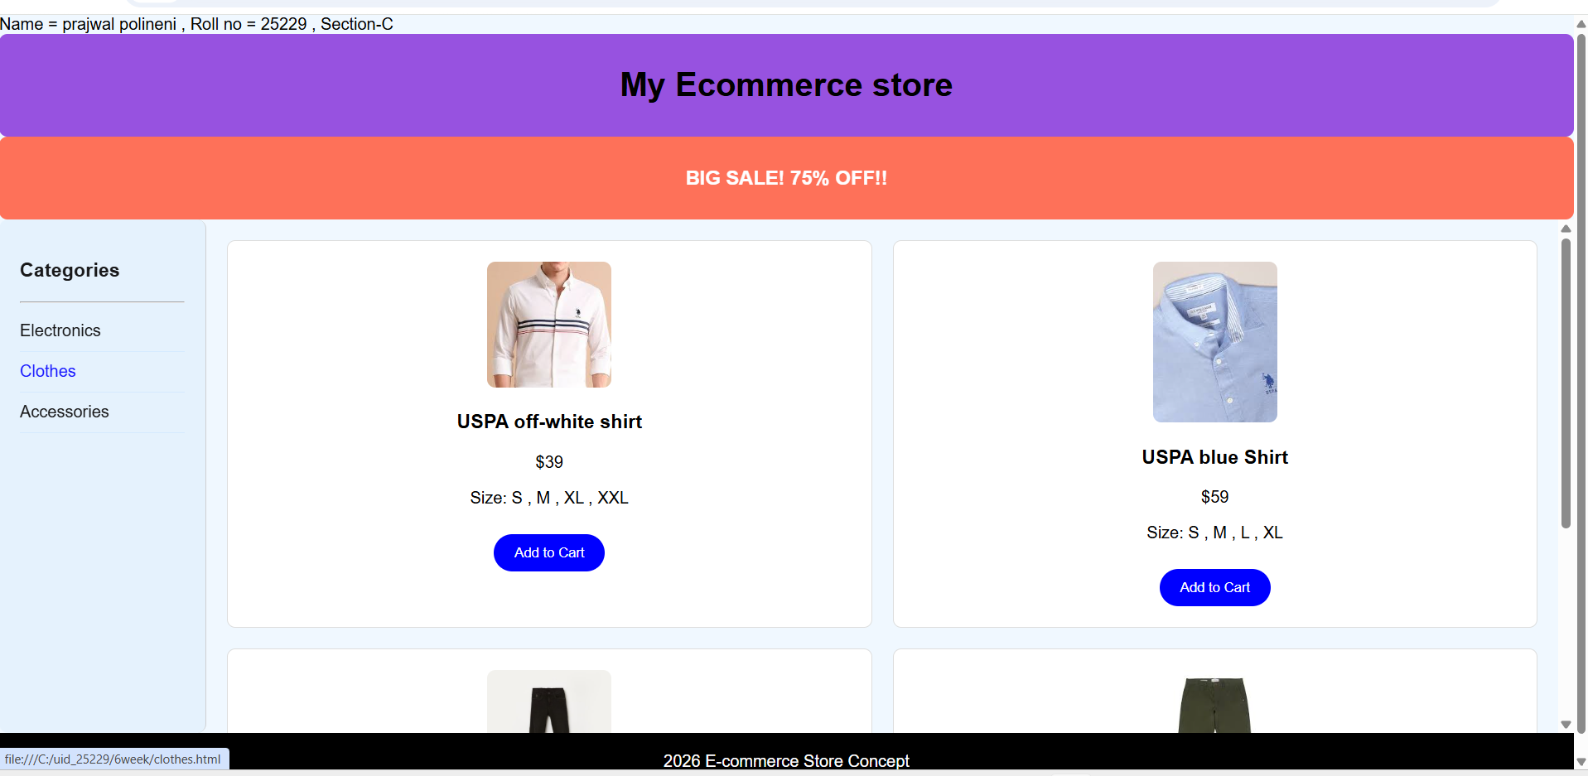
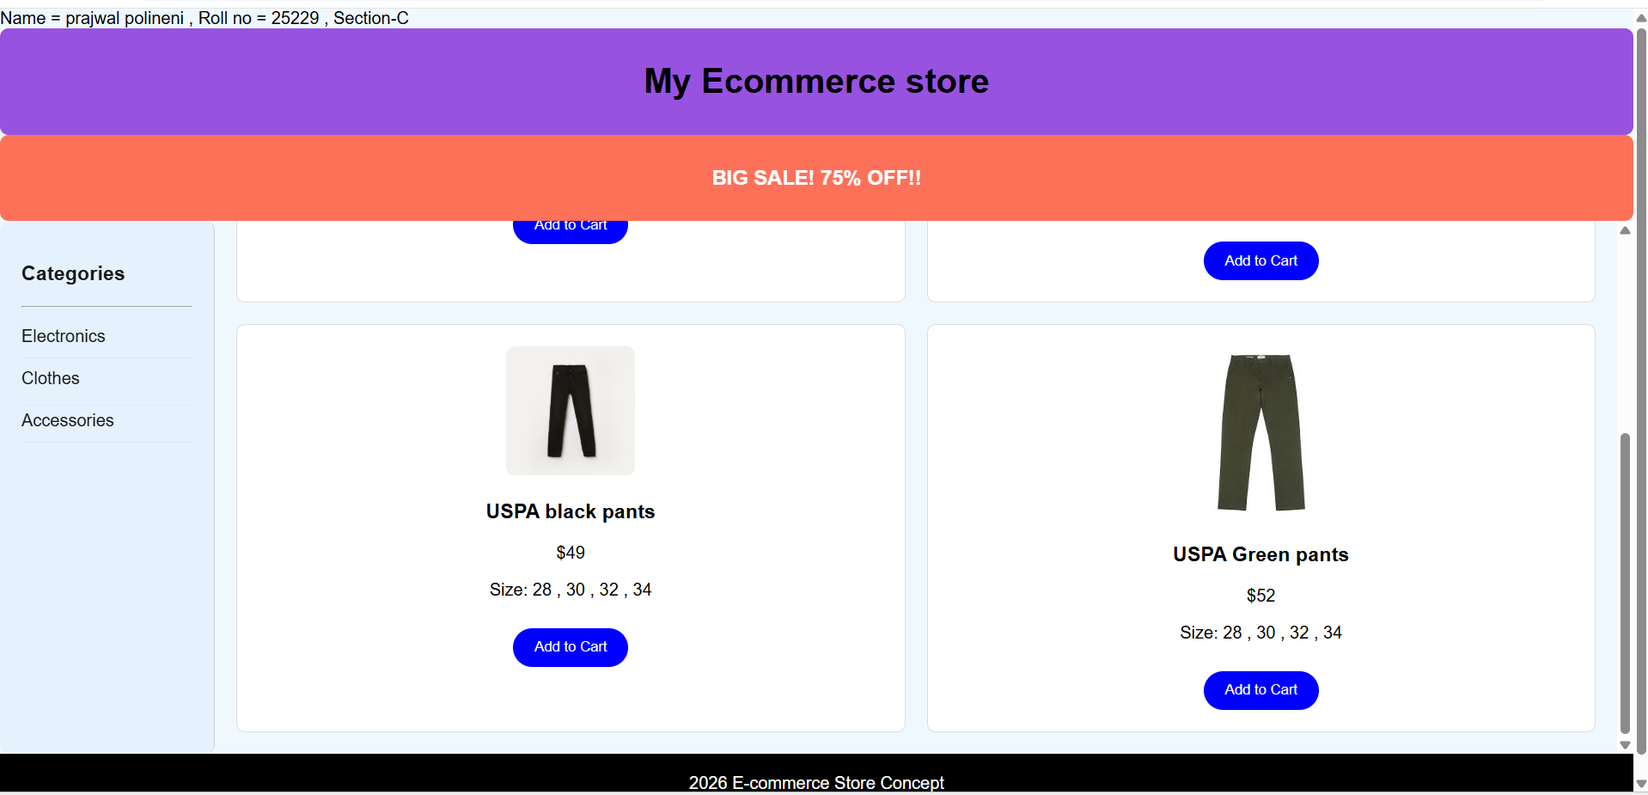
Accessories:
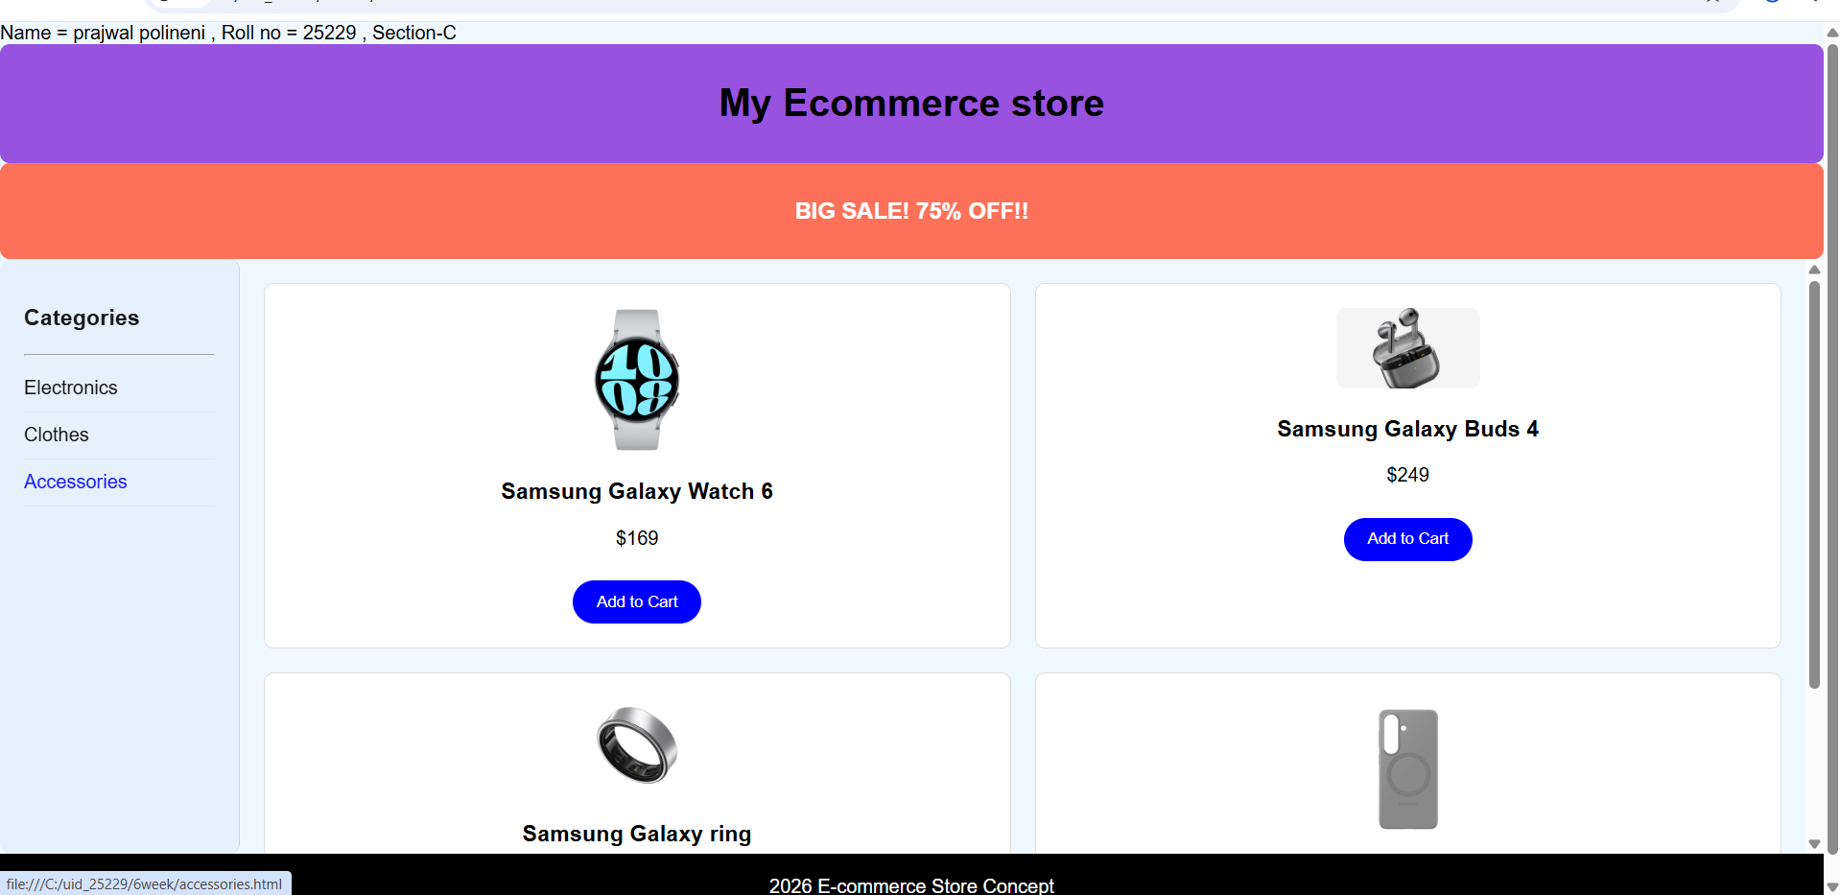
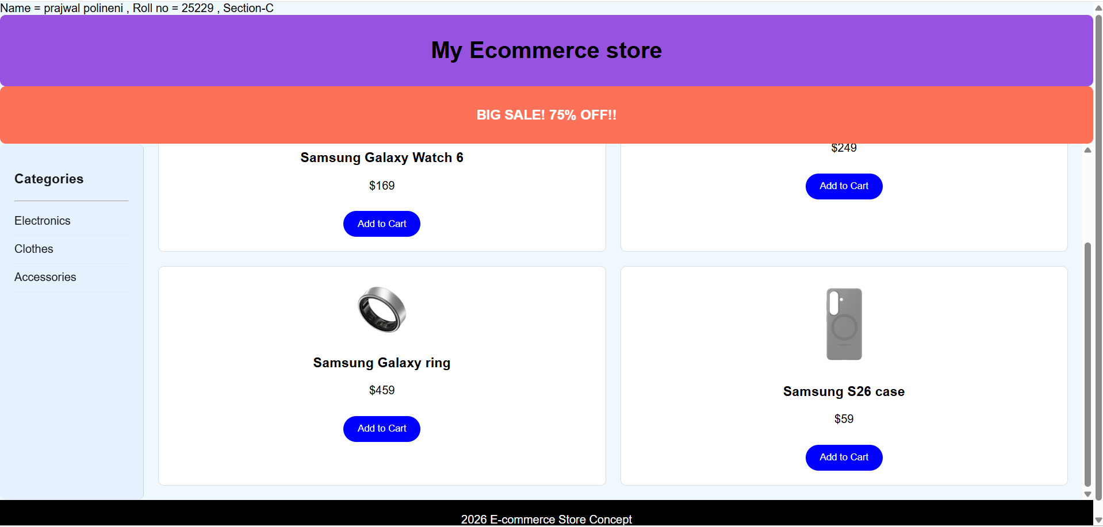
Explanation:
- <div> = A <div> is an invisible container used to group HTML elements together so you can style them with CSS
- <button> = we use <button> element for creating button.
- Class = A class is a reusable identifier used to apply the same CSS styles.
- Display : grid = Display grid is a CSS property used to turn an element into a grid container.
- grid-template-columns: Defines how many columns you want.
- grid-template-rows: Defines the height of your rows.
- gap: Controls the spacing between your grid items without using margins.
- grid-area: Assigns a name to an item so you can place it exactly where you want in the layout.
- Padding = Padding is the internal space inside an element (between its border and its content).
10.<I frame>=we <iframe> tag to create link other webpages into it.
11. <img>: we use <img> tag for displaying the image.
- Cursor:pointer = Cursor pointer is a CSS property used to change the mouse icon into a hand with a pointing finger.
This code is written using internal css. And all the other three codes are combined using <a herf > in the main code.
Week-7
7)Aim: To create an account in github and create repository and add all the previous weeks tasks into one repository.
Procedure:
Step-1: Search for git-hub on a browser.
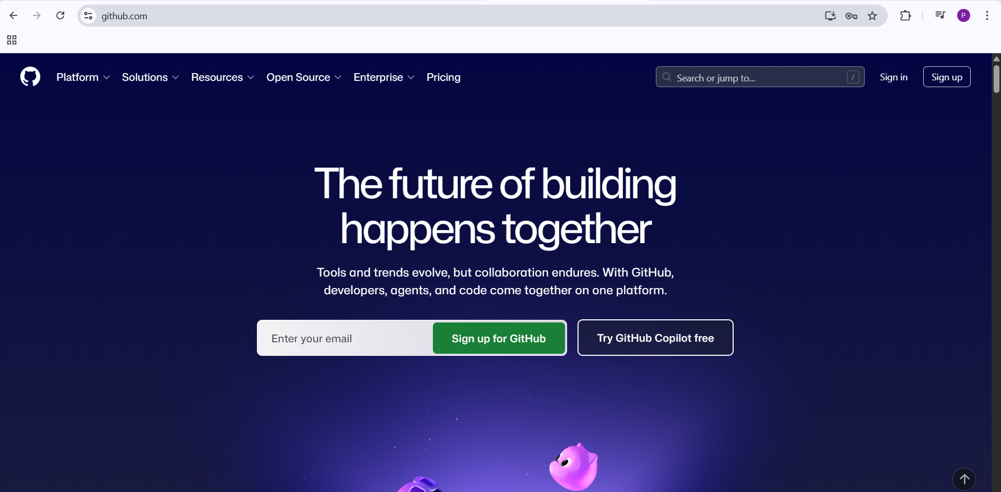
Step-2: create an github account.
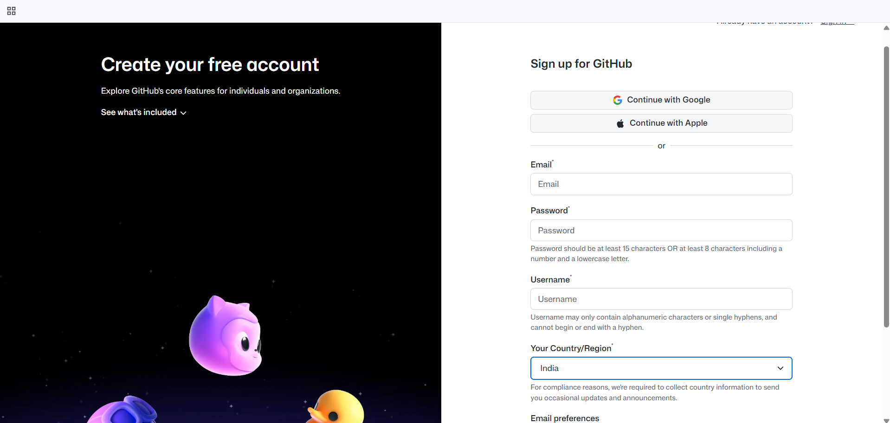
Step-3: Create a repository. 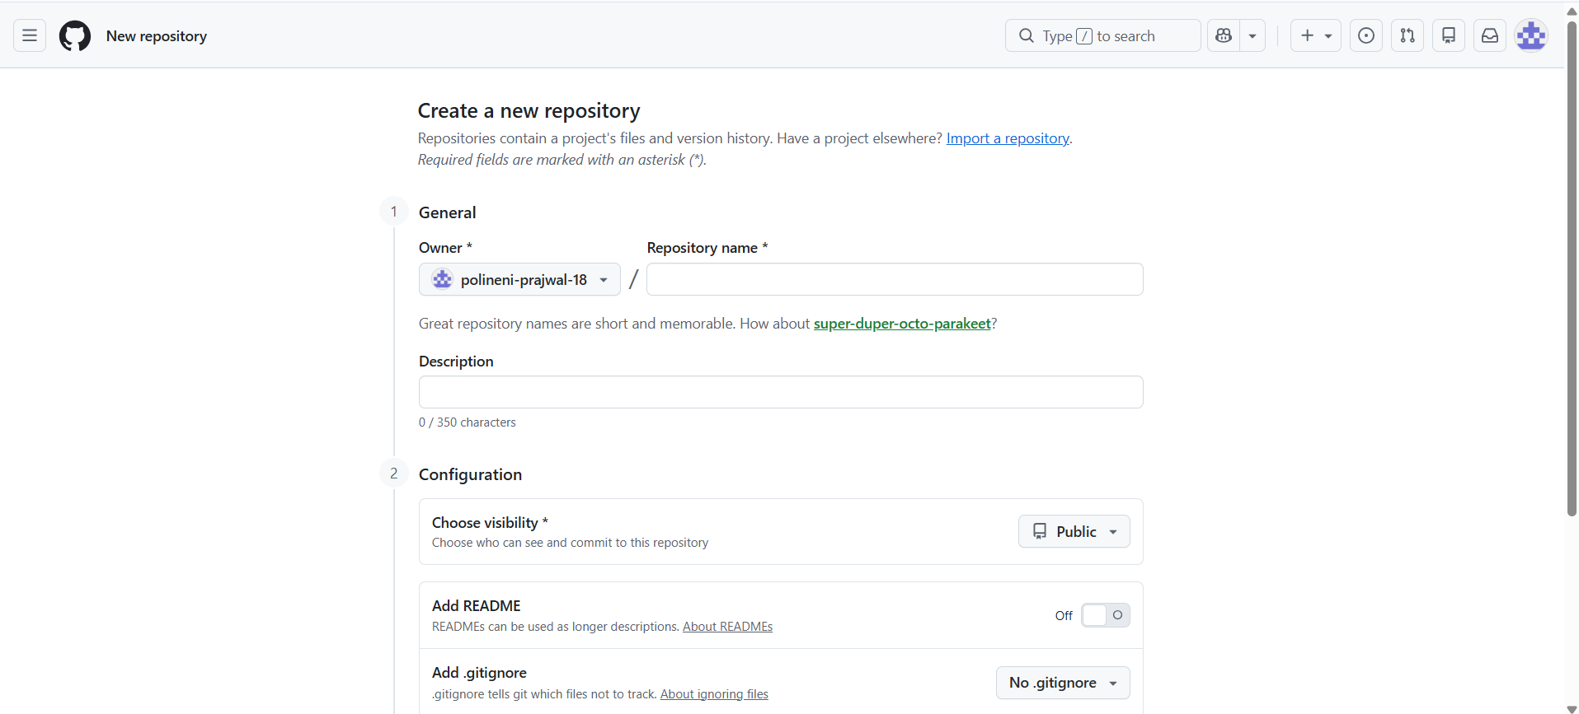
Step-4: Click on upload files and upload the files for the device storage.
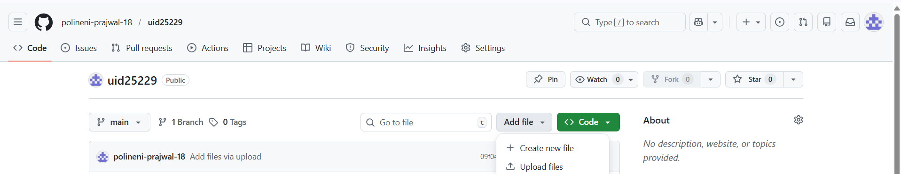
Step-5: Drag files into the given box and click on commit changes. 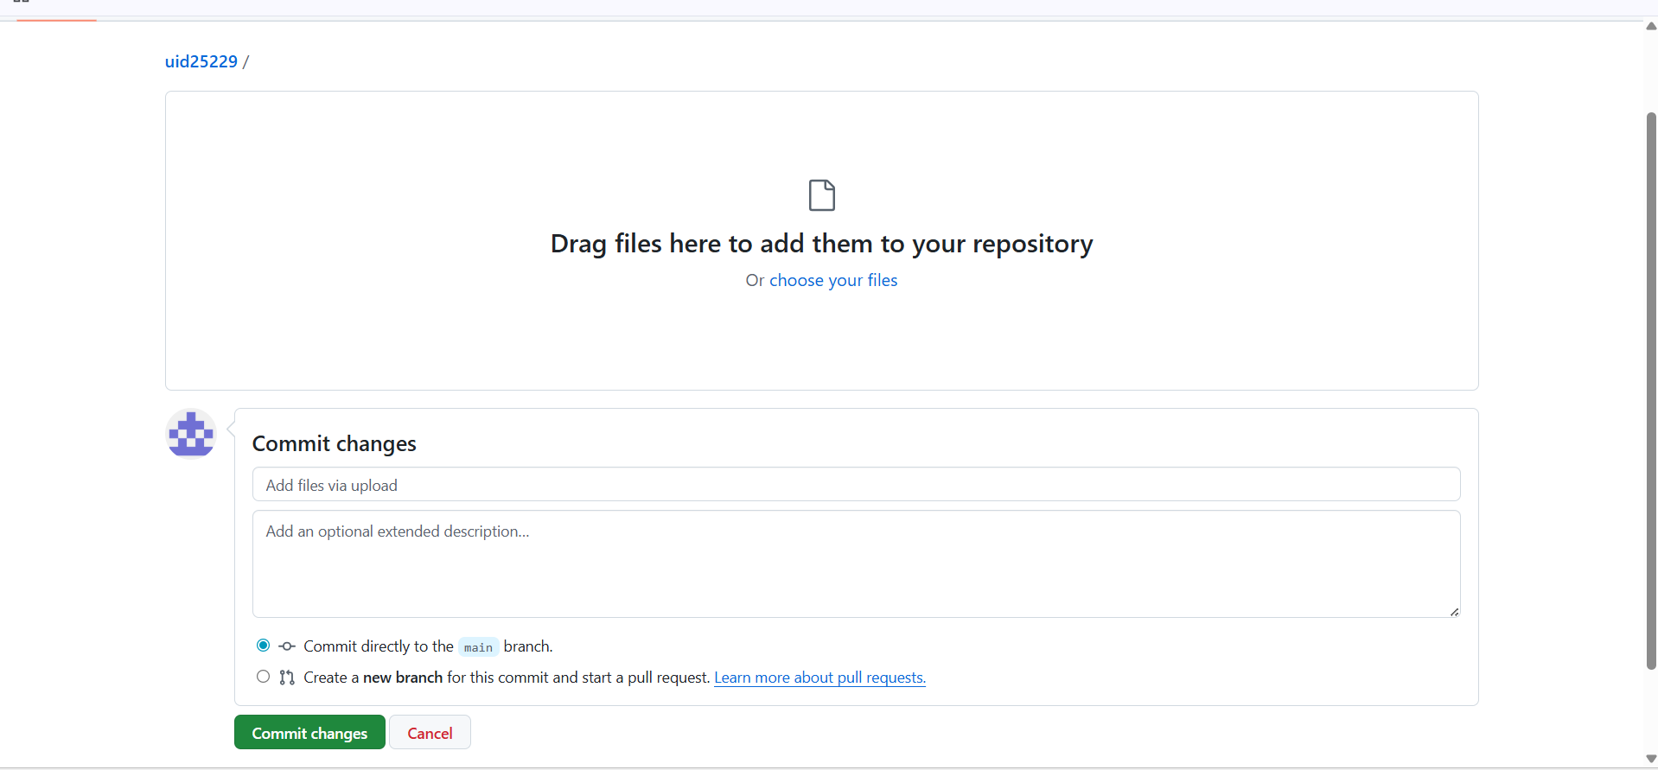

Step-6: 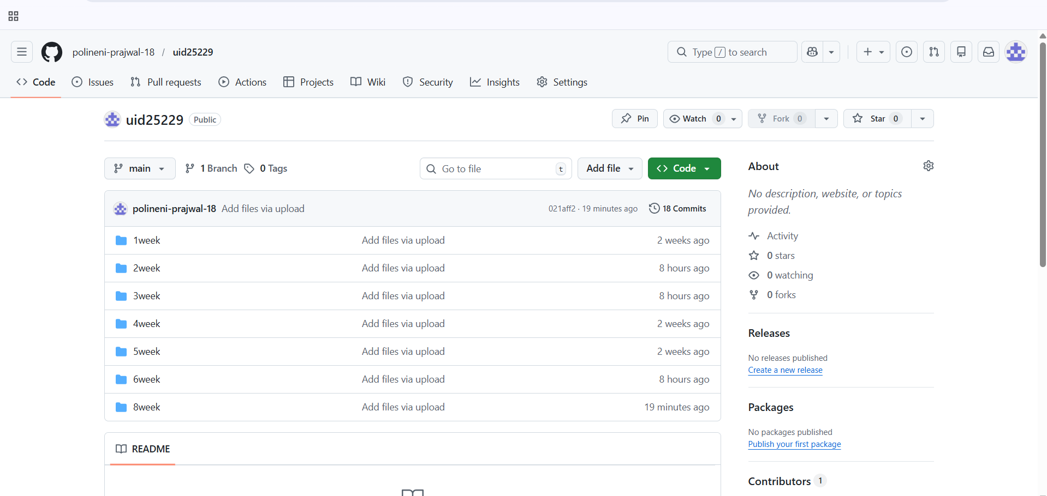
Link for repository:
https://github.com/polineni-prajwal-18/uid25229.git

Week-8
8.A)Aim: To create a webpage that displays a square that continuously rotates
${360}^{o}$ using css animations.
Program:
Name = prajwal polineni , Roll no = 25229 , Section-C
<!DOCTYPE html>
<html>
<head>
<title>Continuous Rotating Square</title>
<style>
body {
display: flex;
flex-direction: column;
align-items: center;
margin: 0;
}
.rotating-square {
width: 150px;
height: 150px;
background-color: #e05050;
border-radius: 15px;
box-shadow: 0 4px 15px rgba(0,0,0,0.2);
animation: spin 4s linear infinite;
}
@keyframes spin {
from {
transform: rotate(0deg);
}
to {
transform: rotate(360deg);
}
}
</style>
</head>
<body>
<h1>Continuous Rotating Square</h1>
<div class="rotating-square"></div>

</body>
</html>

Output:
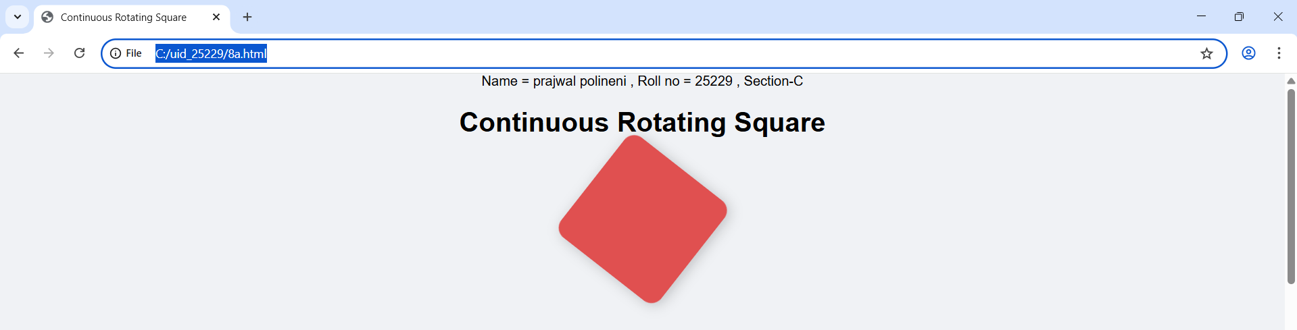
Explanation:
- display: flex = It is used to easily align the items and distribute space within
the container.
- flex-direction: column = is used to change the orientation of your layout from a horizontal row to a vertical column.
- Align-items:centre = It is used to horizontally center the content because of the flex direction.
- <div> = A <div> is an invisible container used to group HTML elements together so you can style them with CSS.
- @keyframes = a keyframe tells the computer exactly how an element should look at a specific point in time.
- Animation = Animation is shorthand property for name , duration , timing function , delay , iteration count , direction , fill mode , play state.

8.B)Aim: To create a ball that moves up and down continuously using css
Animations.

Program:
Name = prajwal polineni , Roll no = 25229 , Section-C
<!DOCTYPE html>
<html>
<head>
<style>
body {
display: flex;
flex-direction: column;
align-items: center;
margin: 0;
}
h1{
text-align: center;
}
.ball {
width: 70px;
height: 70px;
background: red;
border-radius: 100%;
animation: updown 3s linear infinite;
}
@keyframes updown {
0% { transform: translateY(550px); }
50% { transform: translateY(-50px); }
100% { transform: translateY(550px); }
}
</style>
</head>
<body>
<h1>A ball that moves Up and Down continuously</h1><br>
<div class="ball"></div>
</body>
</html>

Output:
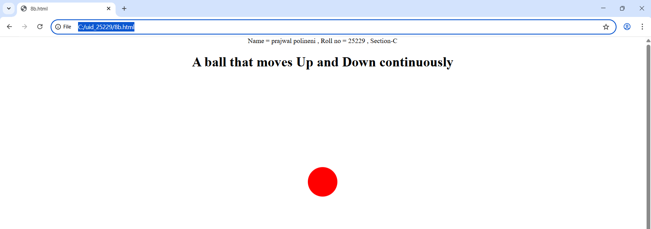

Explanation:
- flex-direction: column = is used to change the orientation of your layout from a horizontal row to a vertical column.
- display: flex = It is used to easily align the items and distribute space within the container.
- Align-items:centre = It is used to horizontally center the content because of the flex direction.
- <div> = A <div> is an invisible container used to group HTML elements together so you can style them with CSS.
- @keyframes = a keyframe tells the computer exactly how an element should look at a specific point in time.
- Animation = Animation is shorthand property for name , duration , timing function , delay , iteration count , direction , fill mode , play state.
- We denote percentages to tell at a particular time which work should be happen.
- The transform: translateY(550px); property is a CSS tool used to move an element vertically along the Y-axis.

8.C)Aim: To create a ball that moves horizontally and rotates at same time.
Program:
Name = prajwal polineni , Roll no = 25229 , Section-C
<!DOCTYPE html>
<html>
<head>
<title>Moving Rotating Circle</title>
<style>
body {
display: flex;
flex-direction: column;
align-items: center;
margin: 0;
}
.circle {
width: 100px;
height: 100px;
background-color: #862e3d;
border-radius: 50%;
animation: horizontallyrotate 5s linear infinite;
}
@keyframes horizontallyrotate {
0% {
transform: translateX(-600px) rotate(0deg);
}
50% {
transform: translateX(600px) rotate(180deg);
}
100% {
transform: translateX(-600px) rotate(360deg);
}
}
</style>
</head>
<body>
<h1>Moving Rotating Circle</h1>
<div class="circle" style="text-align: center; color: aliceblue;"> css<br> animations</div>
</body>
</html>

Output:
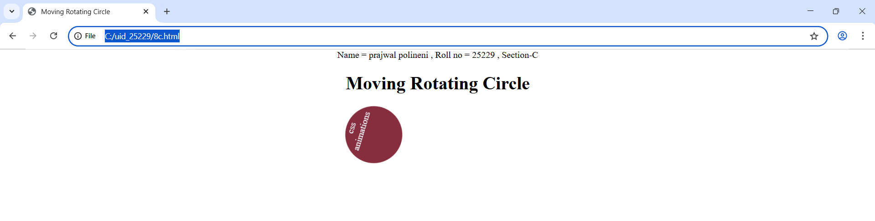

Explanation:
- flex-direction: column = is used to change the orientation of your layout from a horizontal row to a vertical column.
- display: flex = It is used to easily align the items and distribute space within the container.
- Align-items:centre = It is used to horizontally center the content because of the flex direction.
- <div> = A <div> is an invisible container used to group HTML elements together so you can style them with CSS.
- @keyframes = a keyframe tells the computer exactly how an element should look at a specific point in time.
- Animation = Animation is shorthand property for name , duration , timing function , delay , iteration count , direction , fill mode , play state.
- We denote percentages to tell at a particular time which work should be happen.
- The transform: translateX(___px); property is a CSS tool used to move an element vertically along the X-axis.
Week-9
9)Aim: Create a webpage using html,css,js based on the give conditions, create a button for each program , based on the button, clicked the corresponding program has to be executed and should display the logics for each button includes finding an even or odd number , prime or not , factorial of a number , Armstrong or not use appropriate design to display the output.
Program:

<!DOCTYPE html>
<html>
<head>
<title>Logic Programs - All in One</title>
<style>
body {
text-align: center;
font-family: Arial;
margin-top: 50px;
background-color: rgb(144, 238, 232);
}
.box {
border: 2px solid black;
display: inline-block;
padding: 30px;
border-radius: 20px;
background-color: white;
width: 450px;

}
input {
padding: 10px;
font-size: 14px;
border: 2px black solid;
border-radius: 5px;
width: 90%;
margin-bottom: 20px;
text-align: center;
}
.grid {
display: grid;
grid-template-columns: 1fr 1fr;
gap: 15px;
}
button {
padding: 12px;
font-size: 14px;
background-color: rgb(84, 84, 250);
color: white;
border: none;
border-radius: 15px;
cursor: pointer;
font-weight: italic;
}
button:hover {
background-color: darkblue;
}
#result {
margin-top: 20px;
color: #333;
min-height: 40px;
}
</style>
</head>
<body>
<p>Name = prajwal , Roll no = 25229 , Section-C</p>
<div class="box">
<h1>Logic Programs</h1>
<input type="number" id="num" placeholder="Enter number">

<div class="grid">
<button onclick="checkEvenOdd()">Even / Odd</button>
<button onclick="checkPrime()">Prime / Not</button>
<button onclick="calcFactorial()">Factorial</button>
<button onclick="checkArmstrong()">Armstrong</button>
</div>

<i><h2><p id="result"></p></h2></i>
</div>

<script>
function checkEvenOdd() {
let n = document.getElementById("num").value;
if (n === "") return;
let msg = (n % 2 == 0) ? n + " is Even" : n + " is Odd";
document.getElementById("result").innerHTML = msg;
}

function checkPrime() {
let n = document.getElementById("num").value;
if (n === "" || n < 2) {
document.getElementById("result").innerHTML = n + " is Not Prime";
return;
}
let isPrime = true;
for (let i = 2; i <= Math.sqrt(n); i++) {
if (n % i == 0) {
isPrime = false; break;
}
}
document.getElementById("result").innerHTML = isPrime ? n + " is Prime" : n + " is Not Prime";
}

function calcFactorial() {
let n = document.getElementById("num").value;
if (n === "" || n < 0) return;
let f = 1;
for (let i = 1; i <= n; i++) f *= i;
document.getElementById("result").innerHTML = "Factorial is: " + f;
}

function checkArmstrong() {
let n = document.getElementById("num").value;
let k = n;
let s = 0;
let p = n.toString().length;

let temp = n;
while (temp > 0) {
let r = temp % 10;
s = s + Math.pow(r, p);
temp = Math.floor(temp / 10);
}

if (s == k)
document.getElementById("result").innerHTML = k + " is Armstrong";
else
document.getElementById("result").innerHTML = k + " is Not Armstrong";
}
</script>

</body>
</html>

Output:
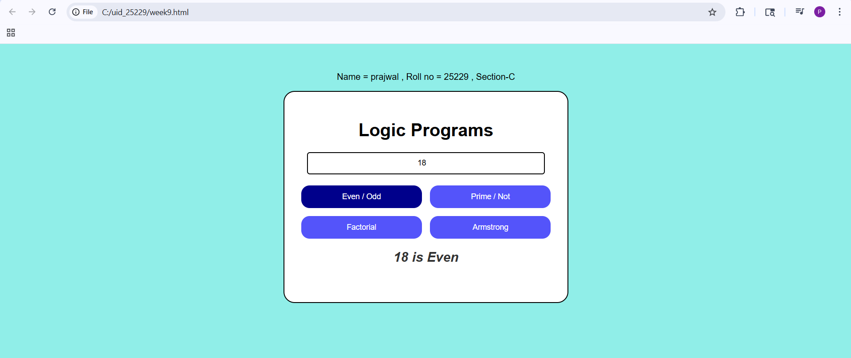
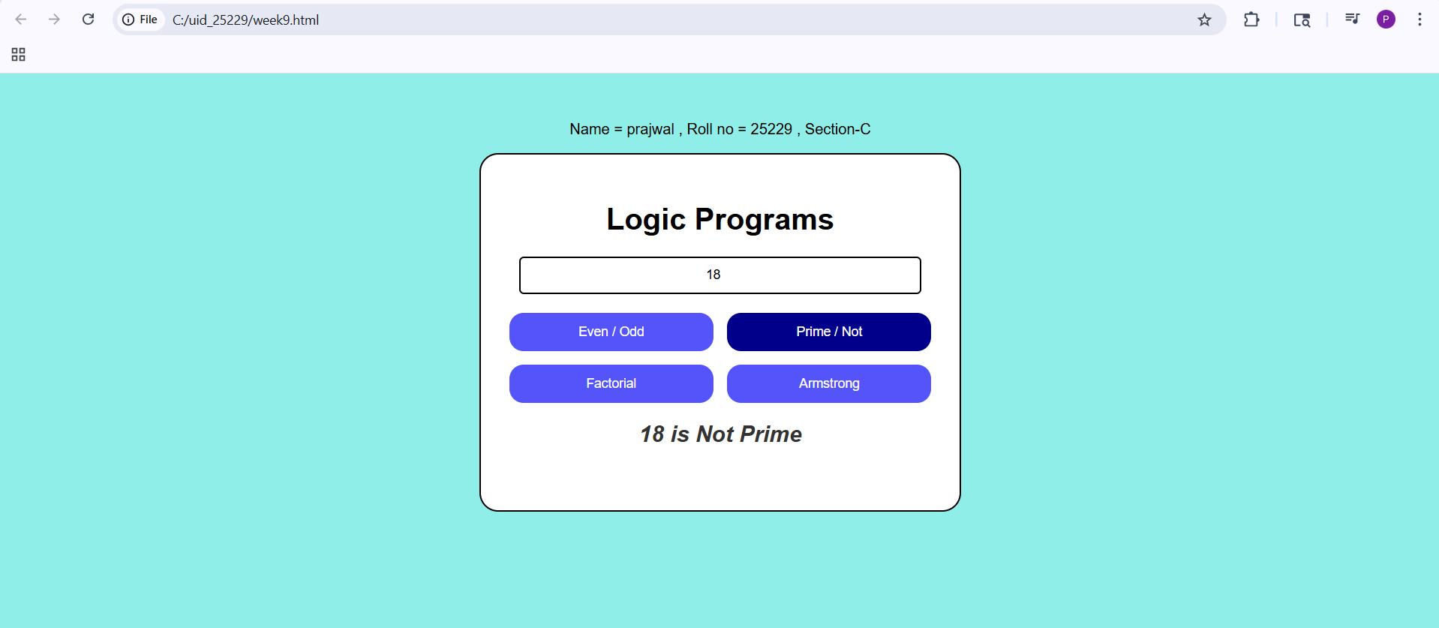
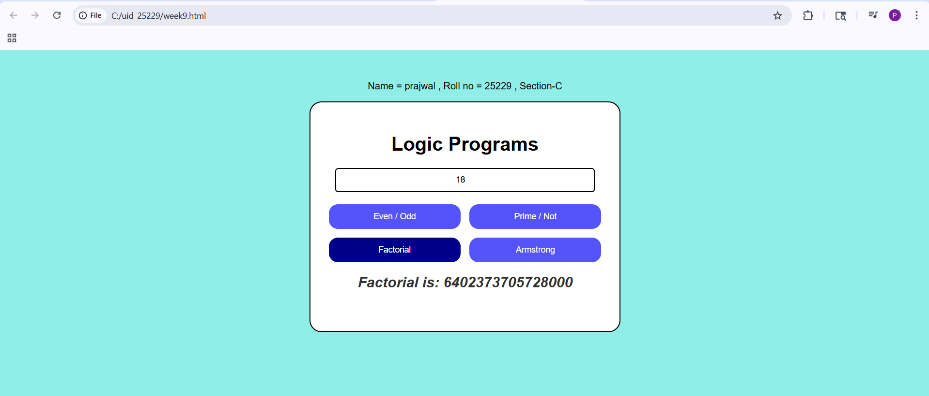
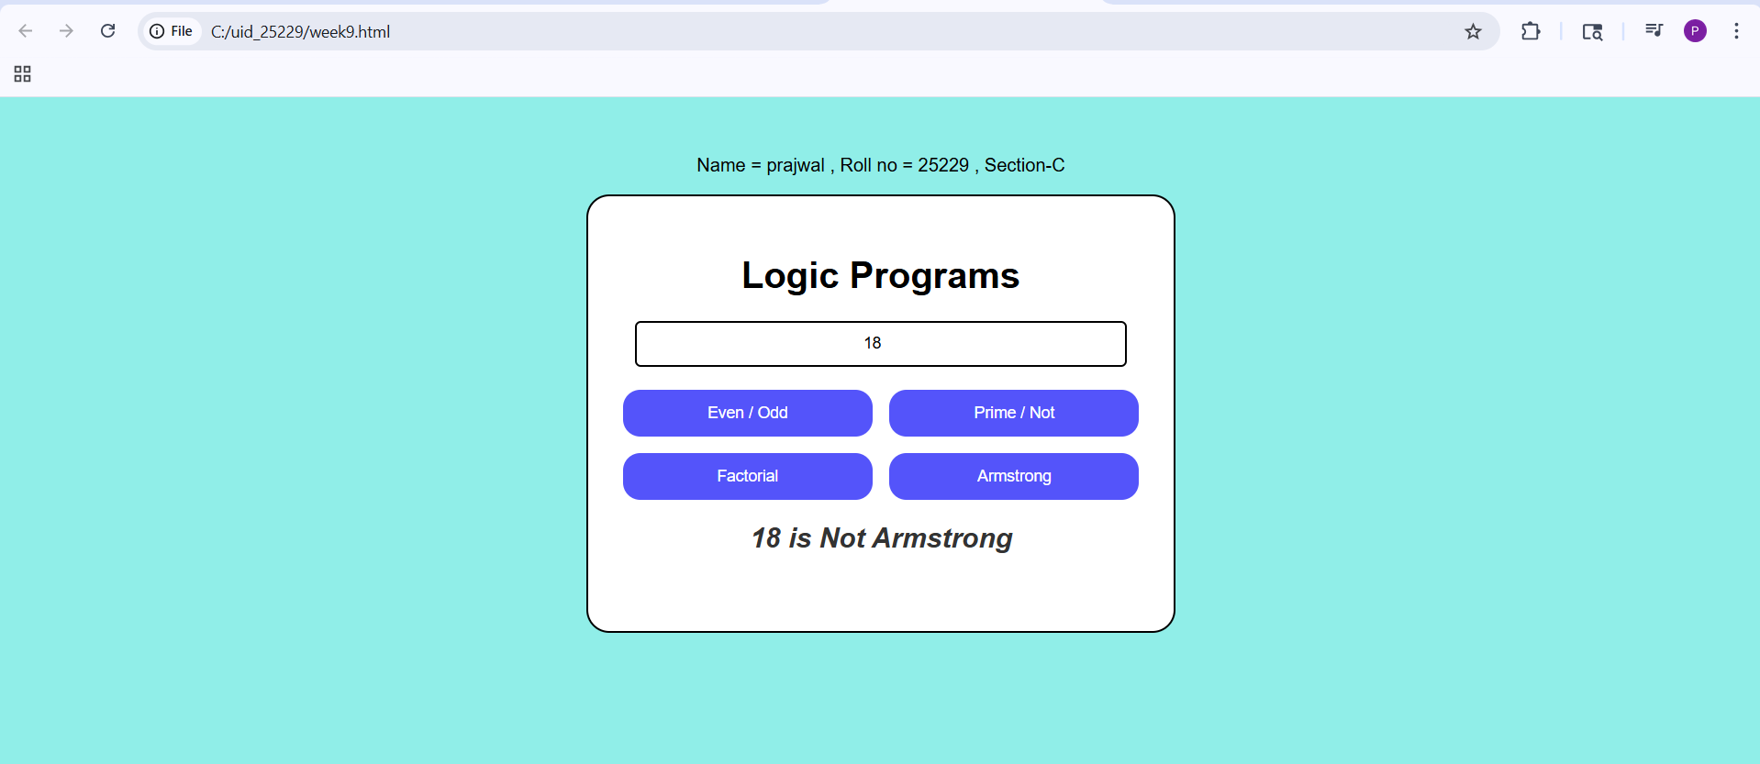
Explanation:
- document.getElementById() : used to access HTML elements using id.
- .value : used to get value from input box
- .innerHTML: to change the text on the screen instantly.
- .textContent : used to display or change text inside an element
- function : used to define a block of code that performs a task
- checkEvenOdd() : checks whether number is even or odd uses n % 2
- checkPrime() : checks whether number is prime or not uses loop and division logic
- calcFactorial() : calculates factorial of a number multiplies numbers from 1 to n
- checkArmstrong() : checks Armstrong number sum of digits power equals number
- parseInt() : converts string to integer.
- Math.sqrt() : used to find square root (used in prime logic).

Week-10
10.A)Aim: Write a java script conditional statement to find the sign of product of three numbers using functions.Disply an alert box with specified sign.
Sample numbers: 3,-7,2
Sample Output: The sign is minus(-)
Program:
<!DOCTYPE html>
<html>
<head>
<style>
body{
align-items: center;
justify-self: center;
}
.button {
padding: 10px 20px;
font-size: 16px;
cursor: pointer;
border-radius: 15%;
background-color: #5275f5;
color: white;
}
</style>
</head>
<body>
<button onclick="checkSign()" class="button">Check Product Sign</button>
<script>
function checkSign() {
let n1, n2, n3;
n1 = parseFloat(prompt("Enter number 1:"));
n2 = parseFloat(prompt("Enter number 2:"));
n3 = parseFloat(prompt("Enter number 3:"));
let product = n1 * n2 * n3;
if (product > 0) {
alert("The sign is plus");
} else if (product < 0) {
alert("The sign is minus");
} else if (product === 0) {
alert("The product is zero");
} else {
alert("Invalid input detected.");
}
}
</script>

</body>
</html>
Output:
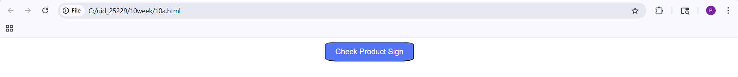
If numbers are 3 , -7 , 2.
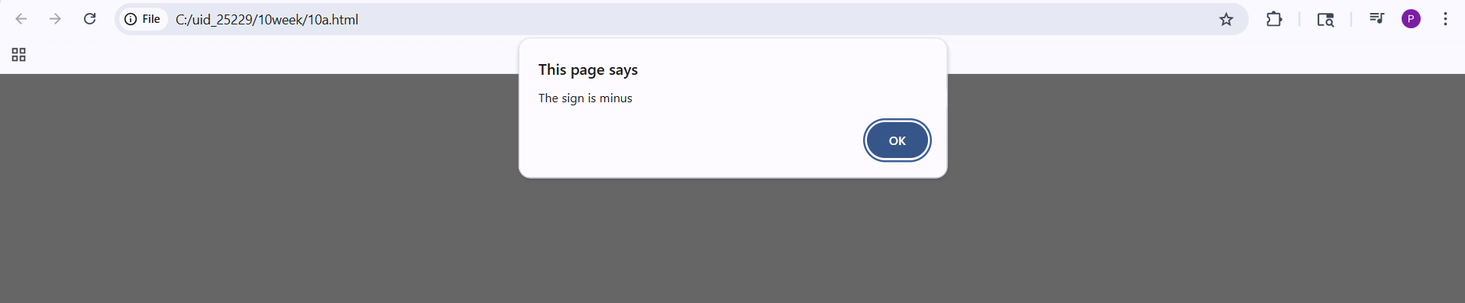
Explanation:
- button : the <button> element is used to perform actions onclick is used to call JavaScript functions.
- function : used to define a block of code that performs a task.
- parseInt() : converts string to integer.
- Alert: Alert is used to display pop up message.
- Checksign(): This is used for checking sign by function.

10.B)Aim: Write a java script conditional statement to sort three numbers using functions. Disply an alert box to show result.
Sample numbers: 0,-1,4
Sample Output: 4,0,-1
Program:
<!DOCTYPE html>
<html>
<head>
<title>Sort Three Numbers</title>
<style>
body{
align-items: center;
justify-self: center;
}
.button {
padding: 10px 20px;
font-size: 16px;
cursor: pointer;
border-radius: 15%;
background-color: #5275f5;
color: white;
}
</style>
</head>
<body>

<button onclick="sortNumbers()" class="button">Sort Numbers</button>

<script>
function sortNumbers() {
const n1 = parseFloat(prompt("Enter first number:"));
const n2 = parseFloat(prompt("Enter second number:"));
const n3 = parseFloat(prompt("Enter third number:"));
if (n1 >= n2 && n1 >= n3) {
if (n2 >= n3) {
alert(n1 + ", " + n2 + ", " + n3);
} else {
alert(n1 + ", " + n3 + ", " + n2);
}
}
else if (n2 >= n1 && n2 >= n3) {
if (n1 >= n3) {
alert(n2 + ", " + n1 + ", " + n3);
} else {
alert(n2 + ", " + n3 + ", " + n1);
}
}
else if (n3 >= n1 && n3 >= n2) {
if (n1 >= n2) {
alert(n3 + ", " + n1 + ", " + n2);
} else {
alert(n3 + ", " + n2 + ", " + n1);
}
}
}
</script>

</body>
</html>

Output:
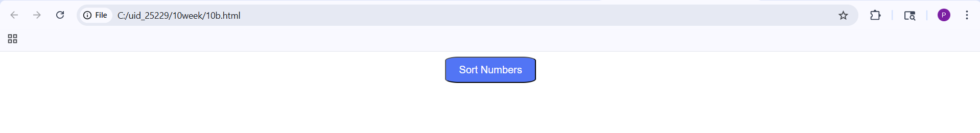
If the numbers are -1,0,4.
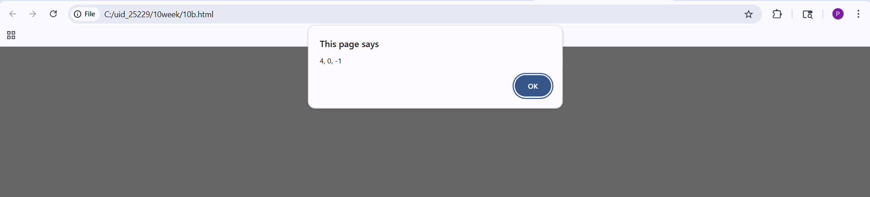
Explanation:
- button : the <button> element is used to perform actions onclick is used to call JavaScript functions.
- function : used to define a block of code that performs a task.
- parseInt() : converts string to integer.
- Alert: Alert is used to display pop up message.
- SortNumbers(): This is used for sorting numbers by function.

10.C)Aim: Write a java script conditional statement to find largest of five numbers using functions. Disply an alert box to show result.
Sample numbers: -5,-2,-6,0,-1
Output: 0
Program:
<!DOCTYPE html>
<html>
<head>
<style>
body{
align-items: center;
justify-self: center;
}
.button {
padding: 10px 20px;
font-size: 16px;
cursor: pointer;
border-radius: 15%;
background-color: #5275f5;
color: white;
}
</style>
</head>
<body>

<button onclick="findLargest()" class="button">Enter Numbers</button>

<script>
function findLargest() {
const n1 = parseFloat(prompt("Enter number 1:"));
const n2 = parseFloat(prompt("Enter number 2:"));
const n3 = parseFloat(prompt("Enter number 3:"));
const n4 = parseFloat(prompt("Enter number 4:"));
const n5 = parseFloat(prompt("Enter number 5:"));
let largest = n1;
if (n2 > largest) {
largest = n2;
}
if (n3 > largest) {
largest = n3;
}
if (n4 > largest) {
largest = n4;
}
if (n5 > largest) {
largest = n5;
}
alert("The largest number is: " + largest);
}
</script>

</body>
</html>

Output:
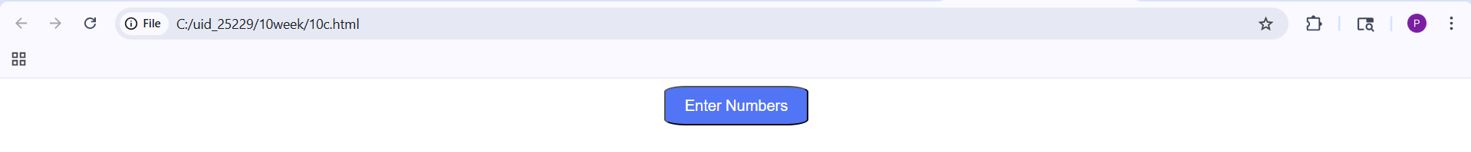
If the numbers are -5,-2,-6,0,-1
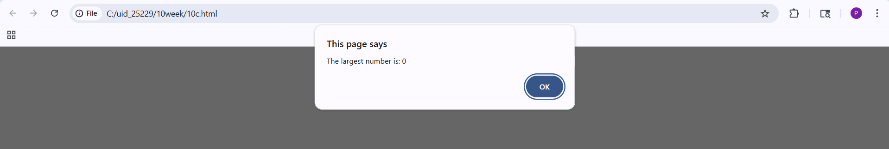
Explanation:
- button : the <button> element is used to perform actions onclick is used to call JavaScript functions.
- function : used to define a block of code that performs a task.
- parseInt() : converts string to integer.
- Alert: Alert is used to display pop up message.
- findLargest(): This is used for finding largest number by function.

10.D)Aim: Write a java script loop that will iterate from 0 to 15 for each iteration it will check odd or even . Disply an a message to screen.
Sample Output: 0 is even
1 is odd
.
.
15 is odd
Program:
<html>
<head>
<script>
let a = 15;
for(let i = 0; i <= a ; i++){
if(i % 2 == 0){
document.write(i + " is Even<br>");
}
else{
document.write(i + " is Odd<br>");
}
}
</script>
</head>
<body>

</body>
</html>

Output:
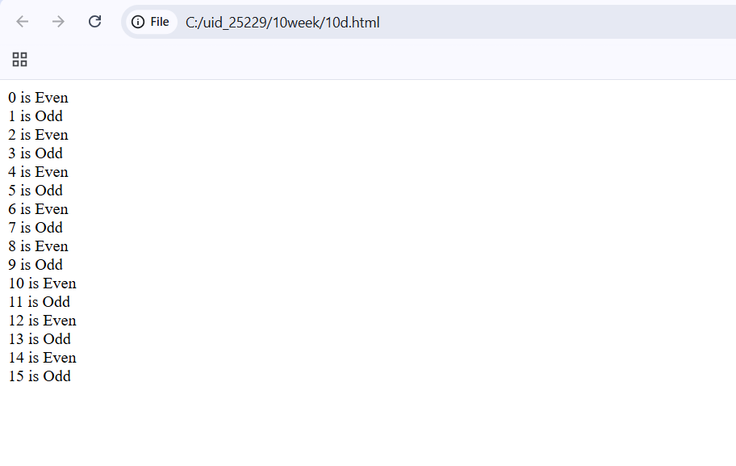
Explanation:
- button : the <button> element is used to perform actions onclick is used to call JavaScript functions.
- parseInt() : converts string to integer.
- Document.write: is used to display output directly on the webpage.
- Prompt : it is used for taking inputs.

10.E)Aim: Write a java script program to read 6 subjects marks from student then compute the average marks of student. Then this average isused to determine the corresponding grade.
Range Grade
<60 F
<70 D
<80 C
<90 B
<100 A
Program:
<!DOCTYPE html>
<html>
<head>
<script>
let s1 = parseInt(prompt("Enter marks of Subject 1:"));
let s2 = parseInt(prompt("Enter marks of Subject 2:"));
let s3 = parseInt(prompt("Enter marks of Subject 3:"));
let s4 = parseInt(prompt("Enter marks of Subject 4:"));
let s5 = parseInt(prompt("Enter marks of Subject 5:"));
let s6 = parseInt(prompt("Enter marks of Subject 6:"));

let total = s1 + s2 + s3 + s4 + s5 + s6;
let avg = total / 6;

if(avg >= 90){
document.write("Grade: A");
}else if(avg >= 80){
document.write("Grade: B");
}else if(avg >= 70){
document.write("Grade: C");
}else if(avg >= 60){
document.write("Grade: D");
}else{
document.write("Grade: F");
}

</script>
</head>
</html>

Output:
If marks are 98 , 77, 18, 100 ,45,89
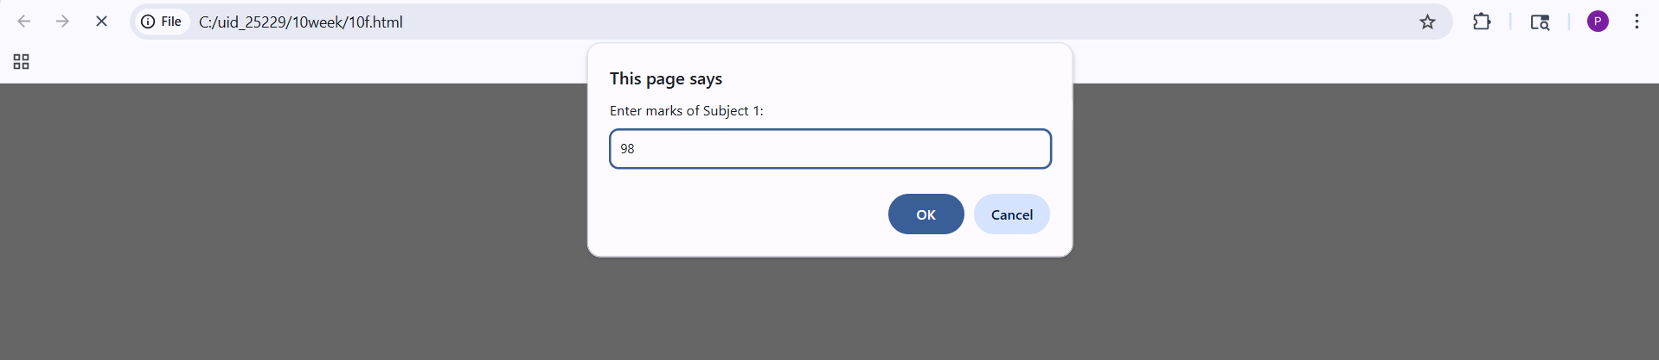
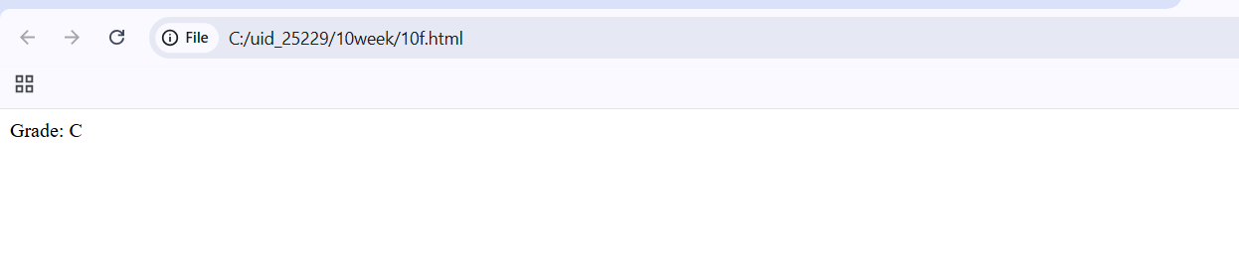
Explanation:
- button : the <button> element is used to perform actions onclick is used to call JavaScript functions.
- parseInt() : converts string to integer.
- Document.write: is used to display output directly on the webpage.
- Prompt : it is used for taking inputs.

Week-11
11.A)Aim: To a website requires users to enter a username. The system should display a message while typing if the username is less than 5 characters.
Program:
Name = prajwal polineni , Roll no = 25229 , Section-C
<!DOCTYPE html>
<html>
<body>
<h3>Enter Username:</h3>
<input type="text" id="username" onkeyup="checkUsername()">
<p id="msg"></p>
<script>
function checkUsername() {
let username = document.getElementById("username").value;
let msg = document.getElementById("msg");
if (username.length < 5) {
msg.innerHTML = "Username must be at least 5 characters";
msg.style.color = "red";
} else {
msg.innerHTML = "Valid username";
msg.style.color = "green";
}
}
</script>
</body>
</html>
Output:
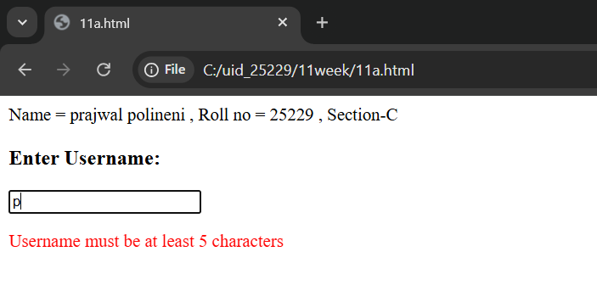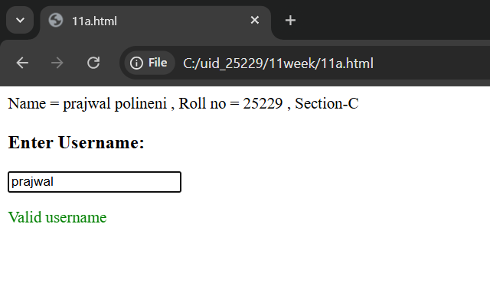
Explanation:
- document.getElementById("...").value: This reaches into the HTML, finds the input box by its ID, and pulls out whatever the user typed.
- .innerHTML: Changes the actual text inside the <p> tag.
- <p id="msg"></p>: An empty paragraph. It acts as a placeholder where your JavaScript will inject error messages like "Minimum 5 letters required”.
- <input type="text">: Creates a standard text box for user input.
- id="username": This is a unique identifier. It acts like a "hook" that allows JavaScript to find this specific input box among all other elements on the page.
- onkeyup="checkUsername()":Every time the user releases a key (after pressing it), the checkUsername() function is triggered.
- .length: This property counts the number of characters in the string.

11.B)Aim: To create a registration form should validate email format before submission. If invalid, the form should not be submitted.
Program:
Name = prajwal polineni , Roll no = 25229 , Section-C
<!DOCTYPE html>
<html>
<body>
<h2>Email:</h2>
<input type="text" id="mail" placeholder="Enter email">
<br><br>
<button onclick="email()">Verify</button>
<p id="result" style="font-weight: bold;"></p>
<script>
function email() {
let pattern = /^[a-zA-Z0-9._%+-]+@[a-zA-Z0-9.-]+\.[a-zA-Z]{2,4}$/;
if (pattern.test(document.getElementById("mail").value)) {
document.getElementById("result").innerHTML = "Valid Email Format";
document.getElementById("result").style.color = "green";
} else {
document.getElementById("result").innerHTML = "Invalid Email Format";
document.getElementById("result").style.color = "red";
}
}
</script>
</body>
</html>

Output:
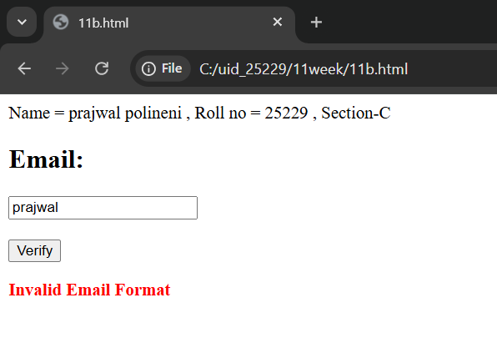
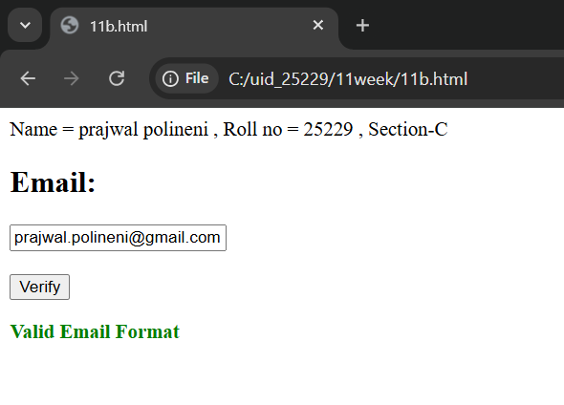

Explanation:
- document.getElementById("...").value: This reaches into the HTML, finds the input box by its ID, and pulls out whatever the user typed.
- .innerHTML: Changes the actual text inside the <p> tag.
- <p id="msg"></p>: An empty paragraph. It acts as a placeholder where your JavaScript will inject error messages like "Invalid Email."
- <input type="text" id="mail" placeholder="Enter email">:The placeholder attribute provides a faint hint inside the box that disappears once the user starts typing.
- ^[a-zA-Z0-9._%+-]+: Matches the username part before the @. It allows letters, numbers, dots, underscores, and plus signs.
- @[a-zA-Z0-9.-]+: Matches the domain name.
- \.[a-zA-Z]{2,4}$: Matches the extension (like .com or .in). The {2,4} means the extension must be between 2 and 4 characters long.
- document.getElementById("msg").style.color : It gives the user immediate visual feedback: Red for a mistake and Green for success.
11.C)Aim: To create a system should check password strength while typing and display whether it is weak or strong.

Program:
Name = prajwal polineni , Roll no = 25229 , Section-C
<!DOCTYPE html>
<html>
<body>
<h3>Enter Password:</h3>
<input type="password" id="password" onkeyup="checkPassword()">
<p id="msg"></p>
<script>
function checkPassword() {
let pass = document.getElementById("password").value;
let msg = document.getElementById("msg");

if (pass.length < 6) {
msg.innerHTML = "Weak Password";
msg.style.color = "red";
} else {
msg.innerHTML = "Strong Password";
msg.style.color = "green";
}
}
</script>
</body>
</html>
Output:
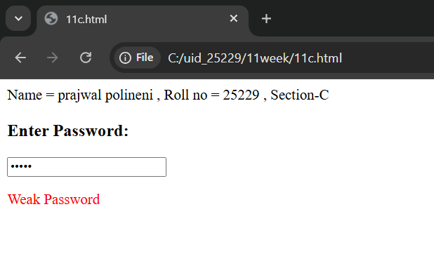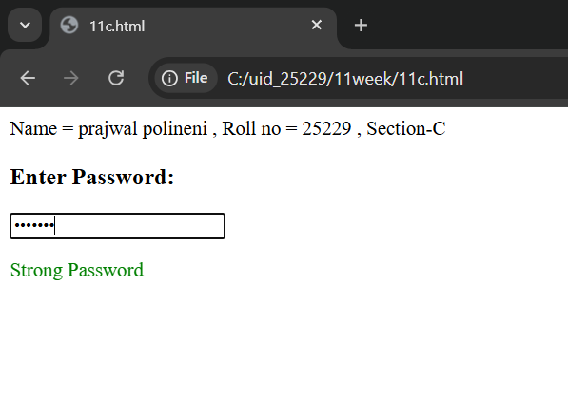
Explanation:
- document.getElementById("...").value: This reaches into the HTML, finds the input box by its ID, and pulls out whatever the user typed.
- .innerHTML: Changes the actual text inside the <p> tag.
- onkeyup: Fires when the user releases the key.
- .length: This is a built-in JavaScript property that counts how many characters are in the string.
- document.getElementById("msg").style.color : It gives the user immediate visual feedback: Red for a mistake and Green for success.
- <input type="password">: Creates a text box where characters are masked.

11.D)Aim: To create a form should validate a mobile number when the user leaves the input field. The number must be exactly 10 digits.
Program:
Name = prajwal polineni , Roll no = 25229 , Section-C
<!DOCTYPE html>
<html>
<body>
<h3>Enter Mobile Number:</h3>
<input type="text" id="mobile" oninput="Mobilenumber()">
<p id="msg"></p>
<script>
function Mobilenumber() {
let mobile = document.getElementById("mobile").value;
let pattern = /^[0-9]{10}$/;
if (!mobile.match(pattern)) {
document.getElementById("msg").innerHTML = "Enter a valid 10-digit mobile number";
document.getElementById("msg").style.color = "red";
} else {
document.getElementById("msg").innerHTML = "Valid mobile number";
document.getElementById("msg").style.color = "green";
}
}
</script>
</body>
</html>

Output:
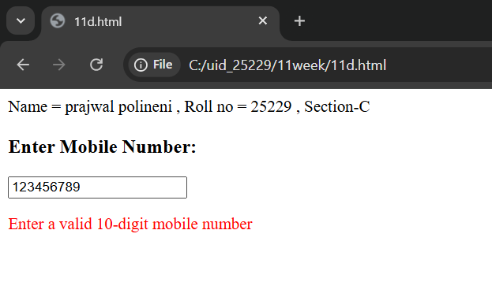
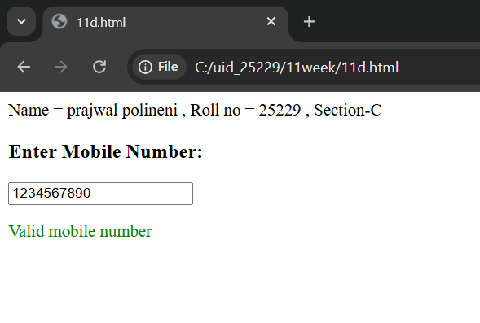

Explanation:
- document.getElementById("...").value: This reaches into the HTML, finds the input box by its ID, and pulls out whatever the user typed.
- .innerHTML: Changes the actual text inside the <p> tag.
- let pattern = /^[0-9]{10}$/; : This is a regular expression.
- ^ : Start of the string.
- [0-9] : Only digits are allowed.
- {10} : Exactly 10 digits required.
- $ : End of the string.
- document.getElementById("msg").style.color : It gives the user immediate visual feedback: Red for a mistake and Green for success.
- oninput="Mobilenumber()":fires every single time the value inside the box changes.
- .match(pattern) : Compares the user's input against the Regex.

11.E)Aim: To design an HTML page, such that the registration form must validate:
Name (not empty)
Email (valid format)
Password (minimum 6 characters)
Program:
Name = prajwal polineni , Roll no = 25229 , Section-C
<!DOCTYPE html>
<html>
<body>
<h2>Registration Form</h2>
<form onsubmit="return validateForm()">
Name: <input type="text" id="name"><br><br>
Email: <input type="text" id="email"><br><br>
Password: <input type="password" id="password"><br><br>
<input type="submit" value="Register">
</form>
<p id="msg"></p>
<script>
function validateForm() {
let name = document.getElementById("name").value;
let email = document.getElementById("email").value;
let password = document.getElementById("password").value;
let msg = document.getElementById("msg");
let emailPattern = /^[a-zA-Z0-9._%+-]+@[a-zA-Z0-9.-]+\.[a-zA-Z]{2,4}$/;
if (name === "") {
msg.innerHTML = "Name cannot be empty";
return false;
}

if (!email.match(emailPattern)) {
msg.innerHTML = "Invalid Email";
return false;
}

if (password.length < 6) {
msg.innerHTML = "Password must be at least 6 characters";
return false;
}

return true;
}
</script>
</body>
</html>

Output:
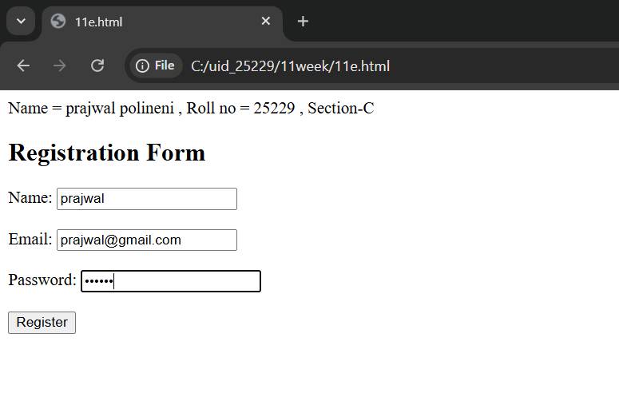

Explanation:
- document.getElementById("...").value: This reaches into the HTML, finds the input box by its ID, and pulls out whatever the user typed.
- return false: Returning false stops the form from submitting.
- return true: Returning true means the data is valid and the form can proceed.
- <form>: Defines a container for user input.
- <input>:
- type="text": Creates a basic single-line text box.
- type="password": Creates a text box where characters are masked.
- type="submit": Creates a button that automatically triggers the form's submission.
- id="...": A unique identifier for the element, which the JavaScript uses to "grab" the data entered by the user.
- <p id="msg"></p>: An empty paragraph. It acts as a placeholder where your JavaScript will inject error messages like "Invalid Email."

