KT Project Report
Design of a Computer Network for District Schools
Student: Sevastianova Polina
Group: IFDU-4
Variant: Jpg No. 184
Software: Cisco Packet Tracer

1. Introduction
The objective of this project is to design functional computer network connecting 5 schools within designated district to central administration hub, and successfully build and test network model using Cisco Packet Tracer.
Variant: 184.
Assigned school configurations:
School No. | Location | Configuration
1 | Viešvėnai | 5a
2 | Luokė | 15v + 20v
3 | Ryškėnai | 18v + 10a
4 | Degaičiai | 18v + R
5 | Žarėnai | 12v + 5a
IP ranges:
Address pool | Network / mask
Public networks | 172.16.20.0 /23
Administration networks | 192.168.8.128 /26
Server relations (router links) | 10.10.13.64 /27
Task image:
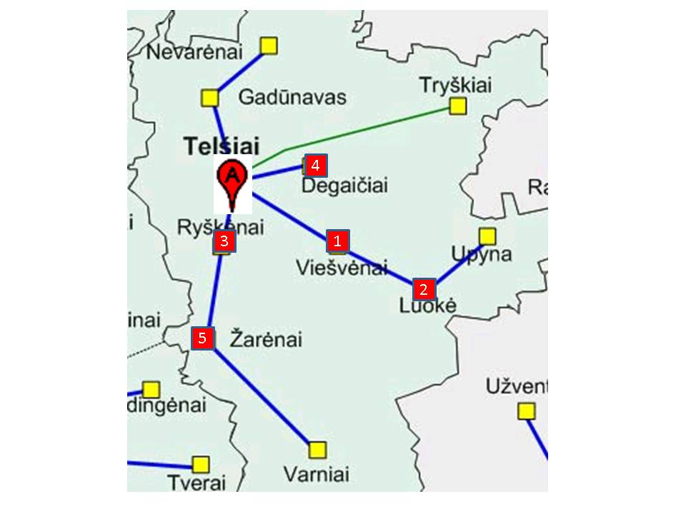
Figure 1. District map for variant 184.

2. Network topology design
The map shows three physical cable routes leaving the district centre (Telšiai):
- Telšiai -> 1 (Viešvėnai) -> 2 (Luokė) -> Upyna (outside the project)
- Telšiai -> 3 (Ryškėnai) -> 5 (Žarėnai) -> Varniai (outside the project)
- Telšiai -> 4 (Degaičiai)
Schools 1 and 3 are positioned mid-cable rather than at branch endpoints. Following network design rules, subsequent schools on these lines are connected sequentially through routers of preceding schools(school 2 via school 1’s router, and school 5 via school 3’s router). School 4 serves as branch endpoint and links directly to district center.
Router placement and purpose:
School | Configuration | Router required | Reason
1 Viešvėnai | 5a | Yes (Rvie) | Located mid-cable before school 2; router is needed to relay traffic to school 2.
2 Luokė | 15v+20v | No | Only public (v) subnets, not marked +R, and nothing connects further behind it; its switches connect to backbone through Rvie.
3 Ryškėnai | 18v+10a | Yes (Rrys) | Has both public and administrative subnets, so router is needed to join them; it is also mid-cable before school 5.
4 Degaičiai | 18v+R | Yes (Rdeg) | Configuration explicitly marks +R, so router is required even though only one subnet type is present.
5 Žarėnai | 12v+5a | Yes (Rzar) | Has both public and administrative subnets, so router is needed to join them.
No configuration contains the letter W, so no wireless devices are used in this variant.

2.1 Device list
Device role | Model | Quantity | Device names
Router | Router-PT-Empty | 5 | Rtel, Rvie, Rrys, Rdeg, Rzar
Access switch | 2960-24TT | 8 | K-deg-v, K-vie-a, K1-luo, K2-luo, K-rys-v, K-rys-a, K-zar-v, K-zar-a
Uplink switch | Switch-PT-Empty | 1 | Kgw-luo
Server | Server-PT | 1 | Server-tel
End devices | PC-PT | 98 | 5+35+28+18+17 PCs per school configuration

2.2 Router interface
Router | Modules installed | Purpose
Rtel | 1x 1CFE, 3x 1FGE | 1CFE - server; 1FGE (x3) - Rvie, Rrys, Rdeg
Rvie | 2x 1FGE, 1x 1CGE | 1FGE - Rtel (up), 1FGE - Kgw-luo (down); 1CGE - K-vie-a
Rrys | 2x 1FGE, 2x 1CGE | 1FGE - Rtel (up), 1FGE - Rzar (down); 1CGE - K-rys-v, K-rys-a
Rdeg | 1x 1FGE, 1x 1CGE | 1FGE - Rtel (up); 1CGE - K-deg-v
Rzar | 1x 1FGE, 2x 1CGE | 1FGE - Rrys (up); 1CGE - K-zar-v, K-zar-a

2.3 Topology schema
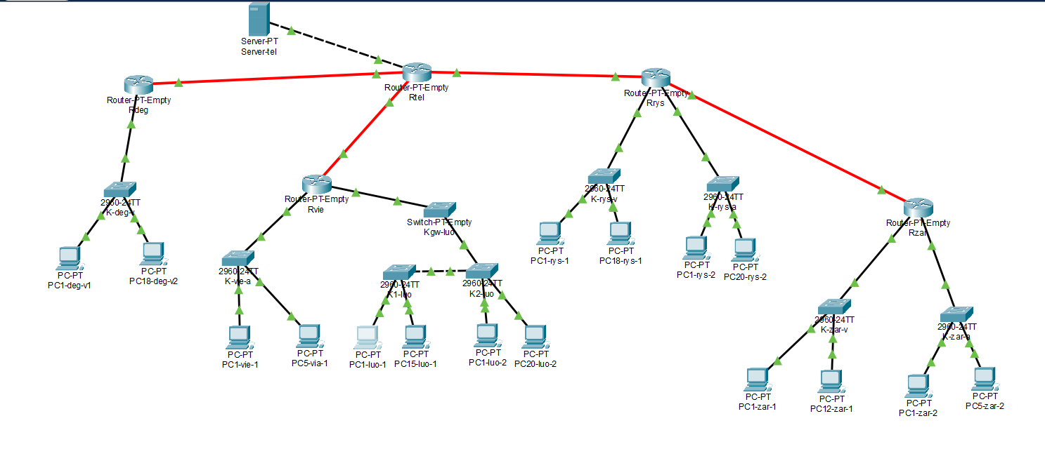
Figure 2. Network topology with node names, built in Cisco Packet Tracer.

3. Distribution of IP addresses

According to the task we have the following IP address:
Address pool | Network / mask
Public networks | 172.16.20.0 /23
Administration networks | 192.168.8.128 /26
Server relations (router links) | 10.10.13.64 /27

LAN | Number of interfaces | Subnet type | Subnet size | Prefix | Mask | Address range from - to
Luokė (v) | 36 | Public | 64 | /26 | 255.255.255.192 | 172.16.20.0 – 172.16.20.63
Ryškėnai (v) | 19 | Public | 32 | /27 | 255.255.255.224 | 172.16.20.64 – 172.16.20.95
Degaičiai (v) | 19 | Public | 32 | /27 | 255.255.255.224 | 172.16.20.96 – 172.16.20.127
Žarėnai (v) | 13 | Public | 16 | /28 | 255.255.255.240 | 172.16.20.128 –172.16.20.143
Ryškėnai (a) | 11 | Admin | 16 | /28 | 255.255.255.240 | 192.168.8.128 – 192.168.8.143
Viešvėnai (a) | 6 | Admin | 8 | /29 | 255.255.255.248 | 192.168.8.144 – 192.168.8.151
Žarėnai (a) | 6 | Admin | 8 | /29 | 255.255.255.248 | 192.168.8.152 – 192.168.8.159
Server–Rtel | 2 | Admin | 4 | /30 | 255.255.255.252 | 192.168.8.160 – 192.168.8.163
Rtel–Rvie | 2 | Server Relations | 4 | /30 | 255.255.255.252 | 10.10.13.64 – 10.10.13.67
Rtel–Rrys | 2 | Server Relations | 4 | /30 | 255.255.255.252 | 10.10.13.68 – 10.10.13.71
Rtel–Rdeg | 2 | Server Relations | 4 | /30 | 255.255.255.252 | 10.10.13.72 – 10.10.13.75
Rrys–Rzar | 2 | Server Relations | 4 | /30 | 255.255.255.252 | 10.10.13.76 – 10.10.13.79

It is useful to record which addresses remain unused within each given pool, so the network can be expanded later if required.
Purpose | Given segment | Used | Left free
Public School Networks | 172.16.20.0 /23 | 172.16.20.0 – 172.16.20.143 | 172.16.20.144 – 172.16.21.255
Administrative networks | 192.168.8.128 /26 | 192.168.8.128 – 192.168.8.163 | 192.168.8.164 – 192.168.8.191
Server Relation networks | 10.10.13.64 /27 | 10.10.13.64 – 10.10.13.79 | 10.10.13.80 – 10.10.13.95

To avoid mistakes when assigning addresses to routers and computers, the table below lists, for every LAN, the usable address range, the gateway (router interface) address, and the addresses given to computers. The first usable address in each subnet is assigned to the router (gateway); the remaining usable addresses are assigned to computers in order.
LAN | Computers | Mask | Address range | Gateway | Computer addresses
Luokė (v) | 35 | 255.255.255.192 | 172.16.20.0–63 | 172.16.20.1 | 172.16.20.2 – 172.16.20.36
Ryškėnai (v) | 18 | 255.255.255.224 | 172.16.20.64–95 | 172.16.20.65 | 172.16.20.66 – 172.16.20.83
Degaičiai (v) | 18 | 255.255.255.224 | 172.16.20.96–127 | 172.16.20.97 | 172.16.20.98 – 172.16.20.115
Žarėnai (v) | 12 | 255.255.255.240 | 172.16.20.128–143 | 172.16.20.129 | 172.16.20.130 – 172.16.20.141
Ryškėnai (a) | 10 | 255.255.255.240 | 192.168.8.128–143 | 192.168.8.129 | 192.168.8.130 – 192.168.8.139
Viešvėnai (a) | 5 | 255.255.255.248 | 192.168.8.144–151 | 192.168.8.145 | 192.168.8.146 – 192.168.8.150
Žarėnai (a) | 5 | 255.255.255.248 | 192.168.8.152–159 | 192.168.8.153 | 192.168.8.154 – 192.168.8.158
Server–Rtel | 1 (server) | 255.255.255.252 | 192.168.8.160–163 | Rtel: 192.168.8.161 | Server: 192.168.8.162

4. Network simulation

We create the network topology in Cisco Packet Tracer following these steps:

1. Choosing the right network devices

Routers: We use Router-PT-Empty models, which allow us to manually insert the required Gigabit Ethernet modules for both UTP (copper) and optical (fibre) connections.

Switches: We use 2960-24TT switches, which provide 24 FastEthernet ports for computer connections and 2 Gigabit Ethernet ports for uplinks. For modular requirements (such as in Luokė), we use Switch-PT-Empty.

Wireless devices: Since no school configuration in variant 184 contains the letter W, no wireless routers or access points are required or used in this model.

2. Building the topology and setting up the central hub

We build the devices on the workspace branch by branch, starting from the district center (Rtel) and the central server (Server-tel).

On Rtel, we install one 1CFE module for the server connection and three 1FGE modules for the school router links (Rvie, Rrys, Rdeg).

We connect Server-tel to Rtel, configure the interface IP address (192.168.8.162), set the gateway (192.168.8.161), and activate the HTTP service. We edit the default index.html file to display your student name, group, and variant number.
Network view with node names and interface marks:
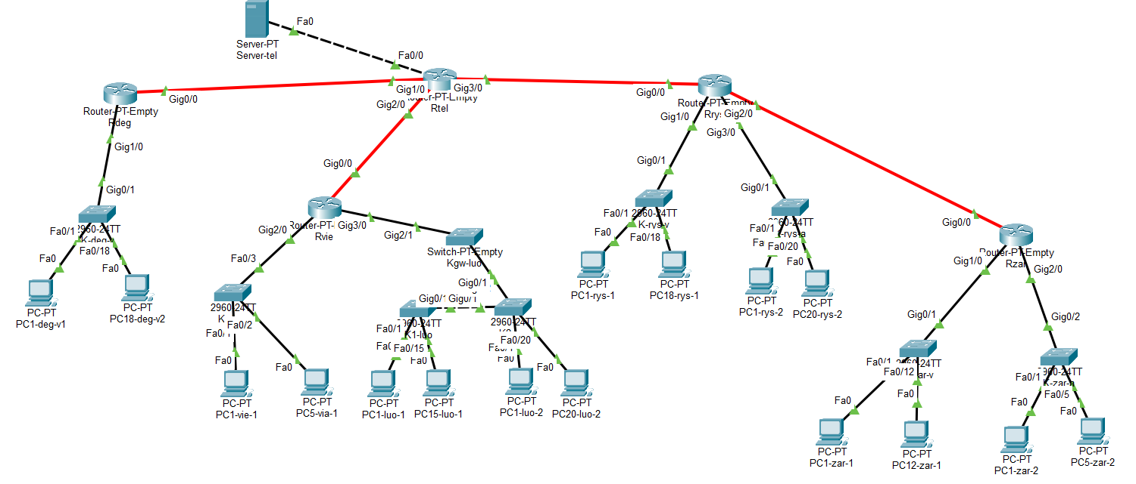
Figure 3. Network view of the simulated model.

5. Creation of routing tables

After connecting all the schools and configuring the IP addresses, the next stage is establishing routing between the networks. Routers must ensure seamless data transfer between all school subnets and the central server, as well as between the school networks themselves. Before configuring the routes, we verify that all directly connected interfaces have correct IP addresses according to our IP table, and we note the router interface numbers in the topology schema. For networks not directly connected, we must explicitly add static routes.

Routing Logic:

Rtel (District Center): Positioned at the top of the network tree. Since it has multiple independent branches, it cannot use a single default route and must explicitly list every remote subnet in the project.

Rvie, Rdeg, and Rzar (Leaf Routers): Each of these has only one uplink toward the center, meaning a single default route (0.0.0.0/0) pointing upward is sufficient.

Rrys (Intermediate Router): It sits between the center (Rtel) and the child school (Rzar). Therefore, it requires a default route upward, direct connections to its local subnets, and explicit static routes downward for the Žarėnai subnets.

5.1 Rtel
Marking | Network IP Address | Network Mask | Through which router | The next hop address
Luokė (v) | 172.16.20.0 | 255.255.255.192 | Rvie | 10.10.13.66
Viešvėnai (a) | 192.168.8.144 | 255.255.255.248 | Rvie | 10.10.13.66
Ryškėnai (v) | 172.16.20.64 | 255.255.255.224 | Rrys | 10.10.13.70
Ryškėnai (a) | 192.168.8.128 | 255.255.255.240 | Rrys | 10.10.13.70
Žarėnai (v) | 172.16.20.128 | 255.255.255.240 | Rrys | 10.10.13.70
Žarėnai (a) | 192.168.8.152 | 255.255.255.248 | Rrys | 10.10.13.70
Degaičiai (v) | 172.16.20.96 | 255.255.255.224 | Rdeg | 10.10.13.74

5.2 Rvie
Marking | Network IP Address | Network Mask | Through which router | The next hop address
All remote networks (Default) | 0.0.0.0 | 0.0.0.0 | Rtel | 10.10.13.65

5.3 Rrys
Marking | Network IP Address | Network Mask | Through which router | The next hop address
Žarėnai (v) | 172.16.20.128 | 255.255.255.240 | Rzar | 10.10.13.78
Žarėnai (a) | 192.168.8.152 | 255.255.255.248 | Rzar | 10.10.13.78
Default route (Upward) | 0.0.0.0 | 0.0.0.0 | Rtel | 10.10.13.69

5.4 Rdeg
Marking | Network IP Address | Network Mask | Through which router | The next hop address
All remote networks (Default) | 0.0.0.0 | 0.0.0.0 | Rtel | 10.10.13.73

5.5 Rzar
Marking | Network IP Address | Network Mask | Through which router | The next hop address
All remote networks (Default) | 0.0.0.0 | 0.0.0.0 | Rrys | 10.10.13.77

Configuring “Routing-> Static“ Tables for Routers:
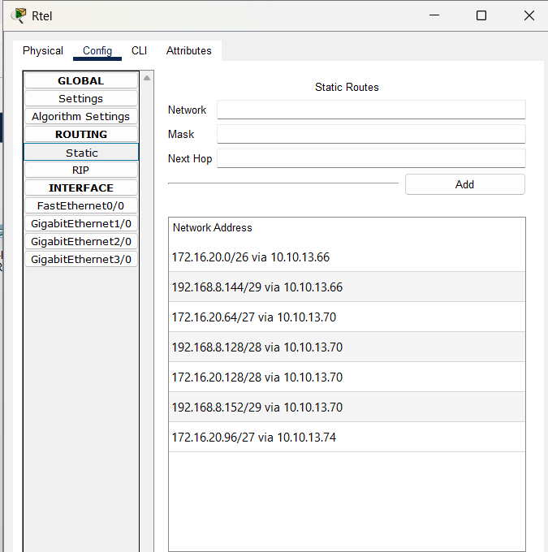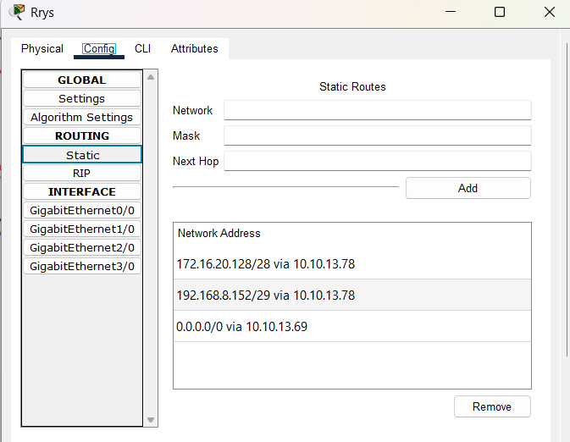

6. Network Configuration Testing
The network was verified with connectivity tests at increasing distance: pings to the local gateway, pings between different schools, traceroute across the full topology, and access to the HTTP server.

6.1 Gateway connectivity
Each school's subnet was verified with a ping from a PC to its default gateway. All gateways responded successfully.
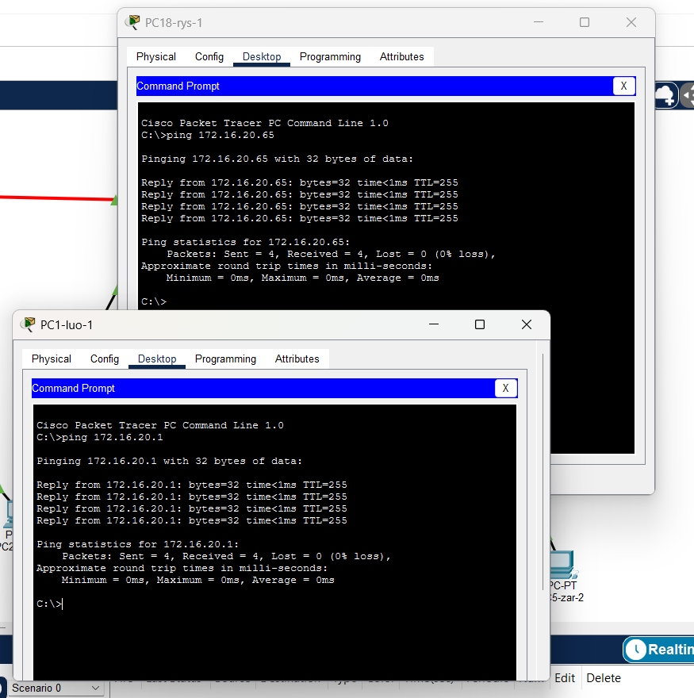

6.2 Inter-school connectivity
Pings between PCs of different schools confirm that the static routes on every router work correctly across the whole tree, including the longest path (Luokė - Žarėnai, four routers).
Result verified from the Rtel router to the Ryškėnai subnet (172.16.20.66):
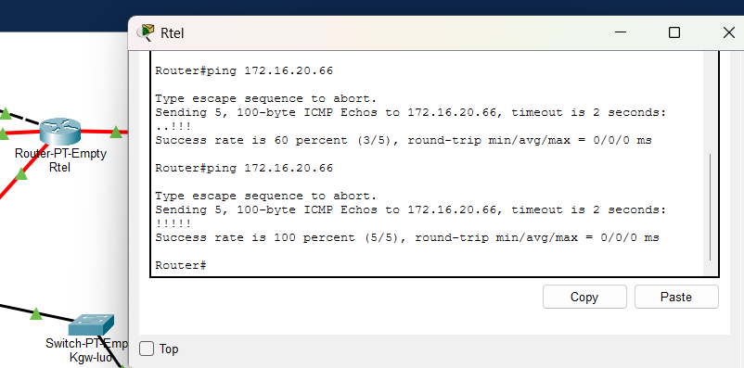
The first two requests time out because of normal ARP resolution delay along the path; a repeated ping completes without loss.

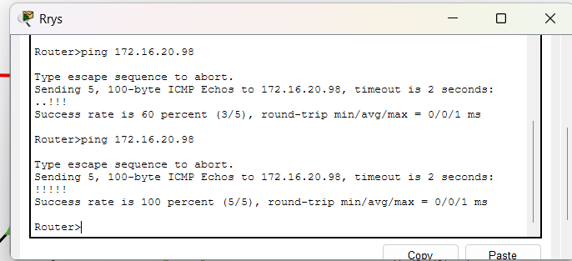

6.3 Traceroute

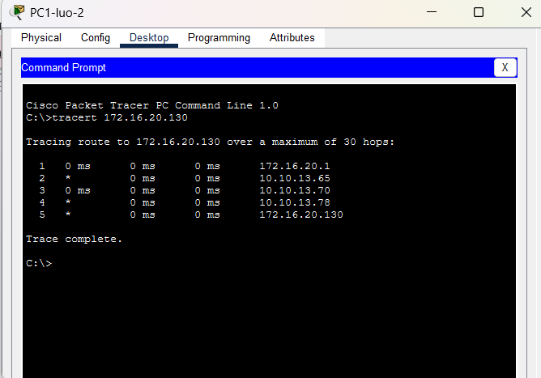

6.4 Server connectivity
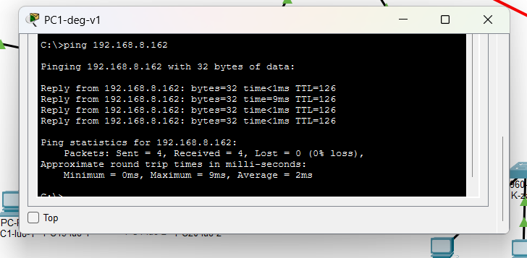

6.5 HTTP service test
The district server (Server-tel, 192.168.8.162) was reached from a PC web browser and returned the configured index.html page with the student's name, group and variant number.
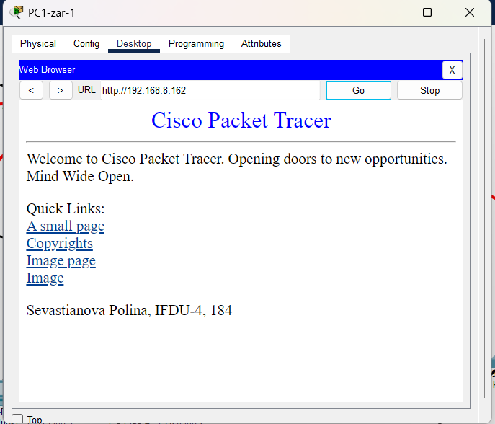
Figure 4. HTTP page served by Server-tel, opened from PC1-zar-1.

7. Conclusions
In this project, a complete computer network model for the five schools of the Telšiai district (Variant 184) was successfully designed, built, and tested in Cisco Packet Tracer.
During the implementation, all network topology requirements, router placement rules, and modular device configurations were properly applied. Using Variable Length Subnet Masking (VLSM), the IP address space was efficiently divided into public, administrative, and inter-router segments without wasting resources. Configuring static routing tables across all routers ensured reliable and seamless connectivity throughout the entire district hierarchy. Finally, successful tests—including end-to-end ping checks, web server access, and route tracing (tracert)—confirmed that the network functions correctly and meets all technical specifications.

