

Kaunas University of Technology
Department of Applied Informatics

Machine Learning
Laboratory work 1

Student: Sevastianova Polina

Lecturers: Prof. dr. Dalia Čalnerytė

Kaunas, 2026

Task

The aim of this laboratory work is to build a multiple linear regression model for predicting property prices using the Philippines Housing Market dataset.
The main target variable is Price. The model uses information about the property such as number of bedrooms, bathrooms, floor area, land area, geographical location and latitude. During the laboratory work, the dataset was first analyzed and cleaned. After that, several new features were created and the categorical location variable was encoded.
The regression model was implemented manually using two methods: Ordinary Least Squares and Gradient Descent. Their results were compared to check whether the implemented Gradient Descent reaches the same solution as the analytical method.
The final model was also evaluated using 5-fold cross-validation and on a separate test set. Three different feature sets were compared. Finally, the custom implementation was compared with the LinearRegression implementation from Scikit-Learn, and a function was used to predict the price of a new property.

Data description and quality analysis
The dataset used in this laboratory work is Housing_v2.csv. It contains information about properties in the Philippines. At the beginning, the dataset contained 1500 rows and 9 columns:

Numerical | Categorical
Price | Description
Bedrooms | Location
Bathrooms
Floor Area
Land Area
Latitude
Longitude

The Description column contains free text. It has a very high number of unique values and cannot be directly used as a normal numerical or categorical feature. Because of this, I removed it before further analysis. The only categorical column is Location.
The numerical variables contain different amounts of missing data. The largest amount of missing values is found in Latitude and Longitude, where 289 values are missing in each column. In total, there are 834 missing values in the original dataset, which is about 6.95% of all values.
Numerical values:
The main statistics of the numerical variables are shown below.
 | Price | Bedrooms | Bathrooms | FloorArea | LandArea | Latitude | Longitude
Total | 1500 | 1500 | 1500 | 1500 | 1500 | 1500 | 1500
Missing values | 49 | 63 | 80 | 37 | 23 | 289 | 289
Missing % | 3,2 | 4,2 | 5,3 | 2,4 | 1,5 | 19,2 | 19,2
Cardinality | 831 | 13 | 18 | 411 | 413 | 459 | 459
Minimum | 300000 | 1 | 1 | 22 | 27 | 6.12 | 120.22
Maximum | 2500000000 | 13 | 43 | 2200 | 25000 | 17,39 | 125,80
Q1 | 4902000 | 3 | 2 | 67,56 | 81 | 14,37 | 120,90
Q3 | 25000000 | 4 | 4 | 250 | 240 | 14,91 | 121,07
Mean | 32822180 | 3,62 | 3 | 213,93 | 274,17 | 14,24 | 121,20
Median | 9200000 | 3 | 3 | 142 | 121 | 14,53 | 121,03
Std | 101201200 | 1,37 | 1,85 | 236,52 | 889,24 | 1,75 | 0,99

Dataset contains 1500 property records with mix of details and coordinates used to predict real prices. Like most data, it is a bit messy and requires some cleaning. For location(latitude/longitude) are missing 289 rows which makes up 19,27% of dataset. Other columns have minor gaps.
Price data is heavily skewed. While median price sits at 9200000, mean has gone up to 32822180 due to extreme outlier of 2.5 billion. Both Floor Area and Land Area have huge ranges. For example, land area has median of just 121 but peaks at 25000 for massive properties. But I cleaned these up with IQR capping as well.

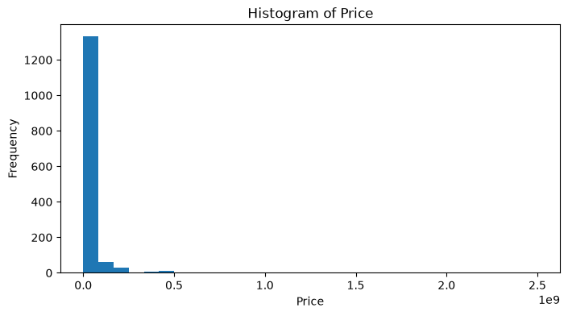  'Price' has a right-skewed distribution. Most values are concentrated on the left side (standard affordable properties), while the long tail extends to the right up to $0.5*{10}^{9}$, representing a few elite properties (outliers). | 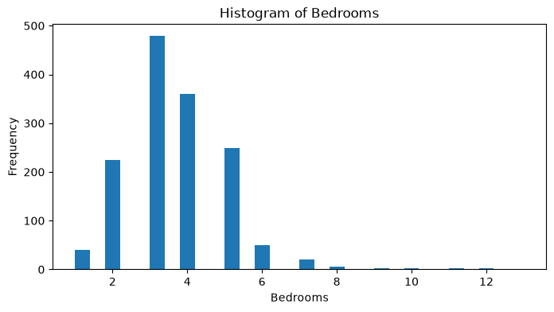  'Bedrooms' has a right-skewed distribution with peaks at 3-4 bedrooms, which dominate the market. However, notable anomalies appear at 10–12 bedrooms, which likely represent outliers or hotels.
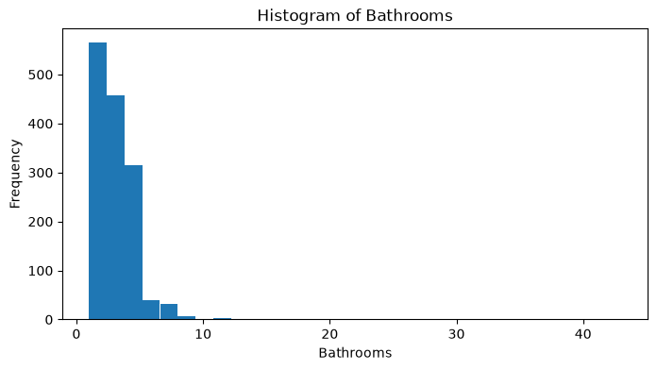  'Bathrooms' is right-skewed, with 2–3 bathrooms being the most common. The tail on the right side needs to be checked for potential outliers. | 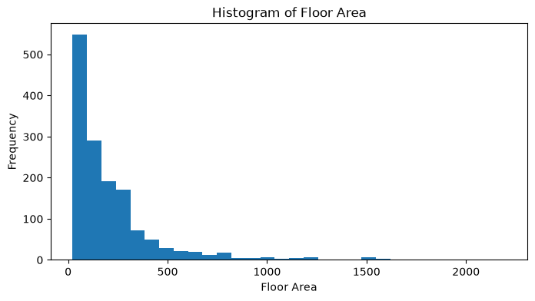  'Floor Area' follows an exponential right-skewed distribution. The majority of houses have small to average floor areas, but there are visible enormous areas that stretch the tail.
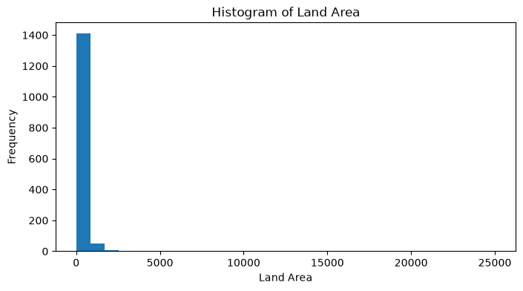  'Land Area' shows extreme right-asymmetry. Almost all properties are clustered near minimal values, while the tail stretches out to 25,000 for properties with large land plots. | 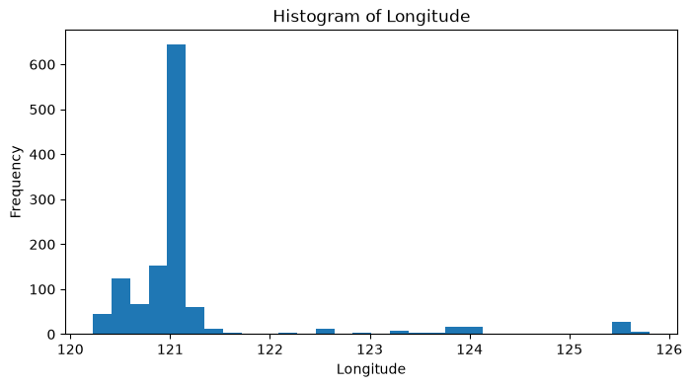  'Latitude' and 'Longitude' show multimodal distributions with peaks. For latitude, the main peak is around 14–15 degrees with smaller clusters near 7, 10, and 16 degrees. For longitude, the highest peak is near 121 degrees with smaller clusters around 123–125 degrees.
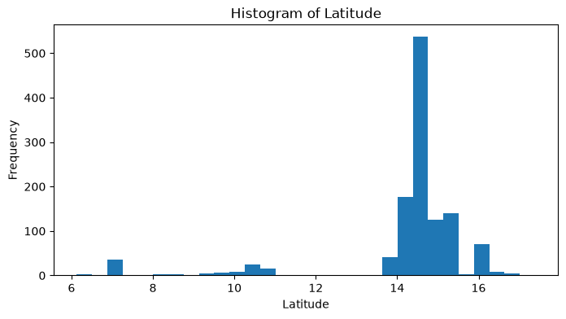

Mean: Add all variables together and divided be total count. It gives overall balance point of data.
$$\text{Mean}=\frac{1}{n}\sum_{i=1}^{n}{x_{i}}$$

Median: Sort all values and pick exact middle one. If there is even number of rows, it is average of two middle numbers.
Q1: 25th percentile. Once data is sorted, it is median of lower half of dataset.
Q3: 75th percentile. It is median of upper half of dataset, meaning 75% of values are below this point.
Standard deviation: Measures how much individual values spread out. Low std means houses/rooms are similar, while high means they vary widely.
$$s=\sqrt{\frac{\sum_{i=1}^{n}{{\left(x_{i}-\text{Mean}\right)}^{2}}}{n-1}}$$

Categorical values:
 | Location
Total | 1500
Missing values | 4
Missing % | 0,26
Cardinality | 664
Mode1 | Emilio Vergara Hwy Santa Arcadia, Cabanatuan
Mode1 Frequency | 71
Mode1 % | 4,75
Mode2 | MacArthur Hwy Anonas, Urdaneta
Mode2 Frequency | 59
Mode2 % | 3,95%

The only categorical variable after removing Description is Location. There are 664 unique locations in the dataset. Only 4 location values are missing, which is 0.27%. The most frequent location is: Emilio Vergara Hwy Santa Arcadia, Cabanatuan. It occurs 71 times, which is 4.75% of the dataset. The second most frequent location is: MacArthur Hwy Anonas, Urdaneta. It occurs 59 times, which is 3.94%.
The high cardinality of Location makes One-Hot Encoding unsuitable. Creating hundreds of dummy variables would make the feature space unnecessarily large. Because of this, I used target encoding for the location variable.

Missing Values and Data Cleaning
Before modeling, the dataset was cleaned. First, duplicated rows were checked. There were 114 duplicated rows. All of them were removed because duplicates could give some observations too much influence during training. After removing duplicates, rows without a valid target value were removed. The Price column is the target variable, so missing prices cannot be imputed. A fake price would not represent a real observation and could affect the evaluation of the model. The code also checked for invalid values in Price and Floor Area. There were no values smaller than or equal to zero in these columns. After removing duplicates and rows with missing or invalid target values, 1340 property records remained. The dataset was then split into training and test parts using an 80/20 split.
The final split was:
- Training set: 1072 rows
- Test set: 268 rows
The split was performed with a fixed random seed of 42, so the same split can be reproduced. Missing numerical values were filled using the median calculated only from the training set. Missing categorical values were filled using the mode from the training set. I used the median because it is less affected by extreme values than the mean. This is especially useful for this dataset because property prices and areas contain several very large values. Using statistics calculated only from the training set also prevents information from the test set from leaking into the training process.

Outlier Analysis
Outliers were detected using the Interquartile Range (IQR) method. The number of detected outliers before the final preprocessing was:
Price: 162 outliers identified, driven by luxury listing and extreme pricing.
Bedrooms: 125 outliers, representing non-standard properties.
Bathrooms: 12 outliers, showing extreme bathrooms counts.
Floor Area: 113 outliers, capturing large houses.
Land Area: 156 outliers, showing massive land.
Latitude: 190 outliers, making properties on geographic edges of target region.
Longitude: 327 outliers, properties spread across longitude lines.
The outliers were not simply deleted. This is important for a real estate dataset because very expensive properties and very large houses can be real observations and may contain useful information.
For the modeling features Price, Bedrooms, Bathrooms, Floor Area and Land Area, the values were capped using the IQR lower and upper bounds calculated from the training set.
Latitude and Longitude were not clipped because they represent geographical coordinates. Applying IQR clipping to coordinates could remove real properties located in areas further away from the center of the geographical region.
For example, the original maximum Price was 2.5 billion, while after preprocessing the maximum training price becomes 55 million because of the IQR capping.

Relationships between variables:
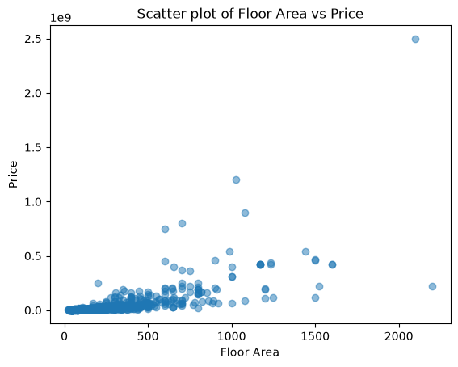 | The plot shows a positive relationship between Floor Area and Price. Most observations are concentrated in the lower-left part of the graph, representing smaller and cheaper properties. As the floor area increases, the price generally also increases. There are several extreme observations with very large prices and areas. These observations explain the long tail in the price distribution.
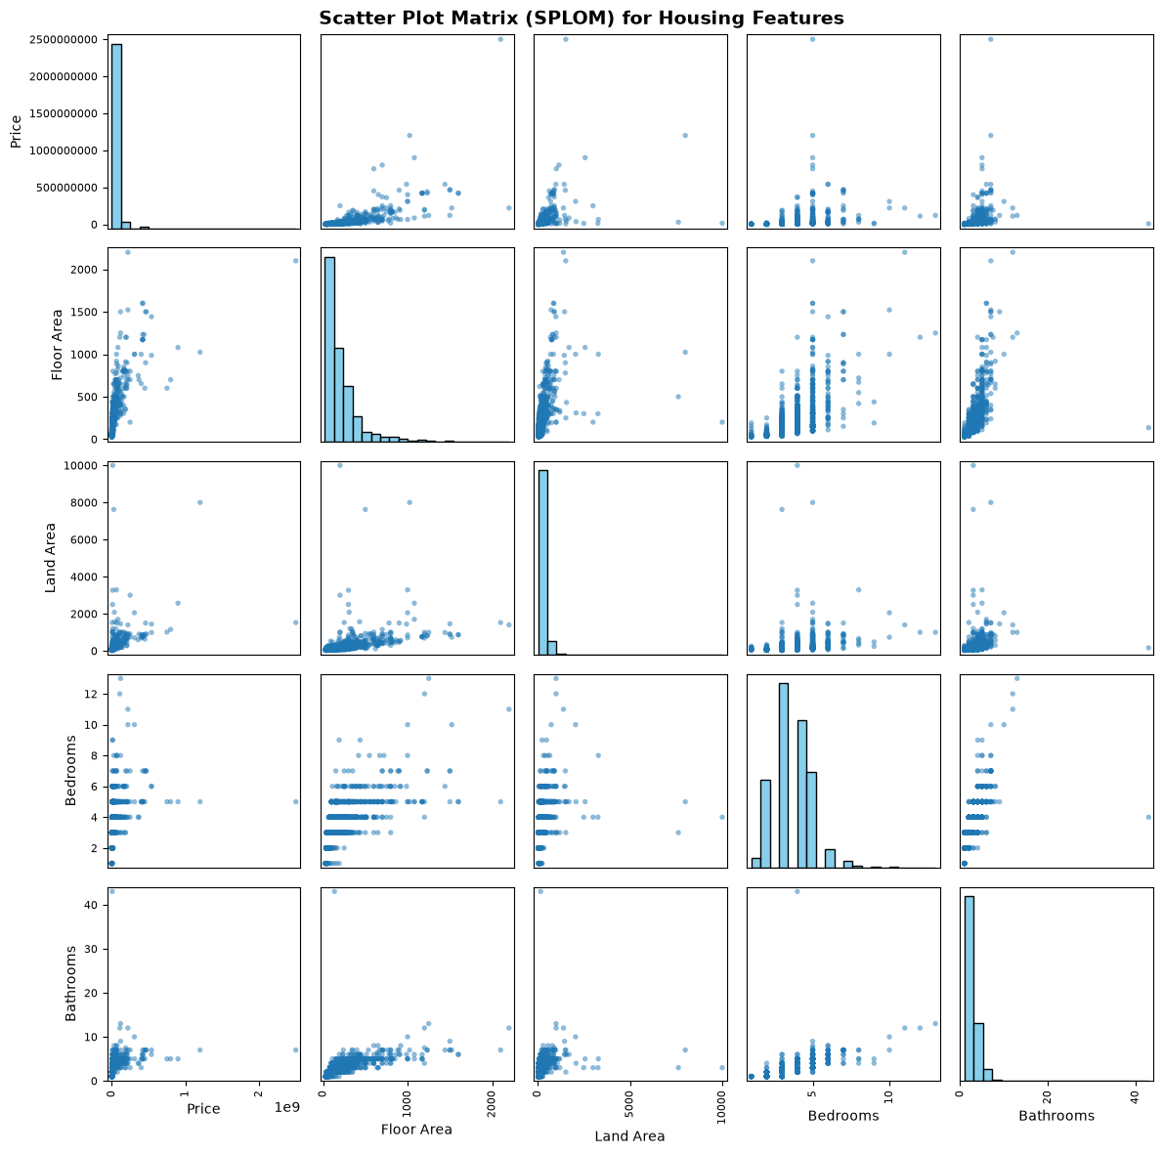

The scatter plot matrix shows that Floor Area has a clear positive relationship with Price. Land Area also has a positive relationship, but the points are more widely distributed. Bedrooms and Bathrooms show weaker individual relationships with Price.

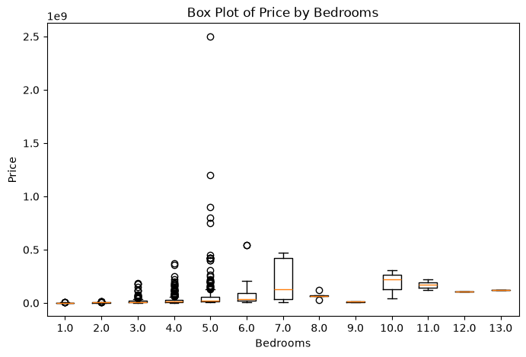 | The median price generally increases as the number of bedrooms increases, although the relationship is not perfectly linear. Some bedroom categories contain very expensive properties, which appear as high-value outliers.

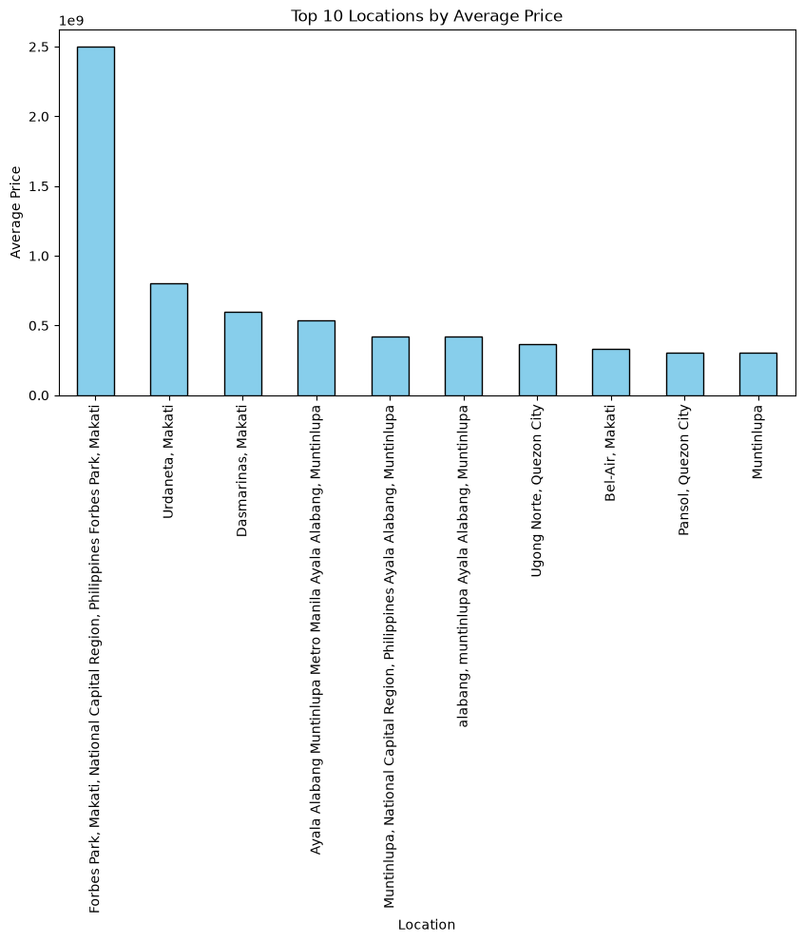 | The location averages are very different from each other. Some locations have much higher average property prices than others. This suggests that location can be an important variable for price prediction. Locations such as "Forbes Park, Makati" significantly outrank others, with average prices reaching up to 2$.5*{10}^{9}$, indicating exclusive elite neighborhoods.

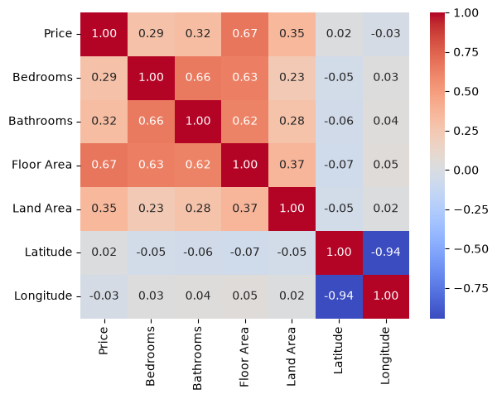
The strongest positive correlation with Price is Floor Area, with a correlation coefficient of approximately 0.67. Bathrooms have a correlation of approximately 0.32 with Price, while Land Area has a correlation of approximately 0.35. Latitude and Longitude have a very strong negative correlation with each other, approximately -0.94. This means that they contain a lot of overlapping geographical information. Because of this strong correlation and because Longitude does not provide a strong direct linear relationship with Price, Longitude was removed from the final model. Latitude was kept.

Feature Engineering
Several new features were created to give the model additional information.
The first feature is Total_Rooms: Total_Rooms = Bedrooms + Bathrooms
The second feature is Total_Area: Total_Area = Floor Area + Land Area
The third feature is Area_Per_Room: Area_Per_Room = Total_Area / Total_Rooms
The fourth feature is Floor_To_Land_Ratio: Floor_To_Land_Ratio = Floor Area / Land Area
These features combine existing information into variables that can describe the property in a slightly different way. However, some of these features are mathematically related to the original variables. For example, Total_Rooms is directly calculated from Bedrooms and Bathrooms, and Total_Area is calculated from Floor Area and Land Area. Because of this, the individual coefficients should not be interpreted separately without considering the multicollinearity between features.

Target Encoding of Location
Location has 664 unique values, so One-Hot Encoding would create a very large number of additional columns. Instead, target encoding was used. The encoded value represents information about the average price of properties in a particular location. However, a simple target encoding can cause data leakage. For example, if a location appears only once, using its own price to calculate the encoded value would basically give the model the correct answer during training. To avoid this problem, the training data uses out-of-fold target encoding. The training set is divided into five folds, and the encoded value for a row is calculated using the other folds rather than the row itself. Smoothing is also used:
encoded = (n * location_mean + m * global_mean) / (n + m)
This makes rare locations less extreme and moves them towards the global mean price. For the test set and new records, the location mapping is calculated from the complete training set. If a new location is not present in the training data, the global mean price is used. This prevents the test prices from being used when creating the test features.

Normalization
After preprocessing and feature engineering, numerical input variables were normalized using Min-Max normalization. The formula is: x_normalized = (x - min) / (max - min). The minimum and maximum values were calculated from the training data and then applied to both training and test data. The target variable Price was not normalized. This makes the final prediction and error metrics easier to interpret because they remain in the original price units. After normalization, the input numerical variables have values between 0 and 1.
Linear Regression Model
Multiple linear regression was used for predicting property prices. The model has the following general form: y = b0 + b1*x1 + b2*x2 + ... + bn*xn where b0 is the intercept and the other coefficients represent the model parameters. A column of ones was added to the feature matrix so that the intercept could be calculated together with the other coefficients.
Two different methods were implemented for calculating the coefficients:
- Ordinary Least Squares
- Gradient Descent

Ordinary Least Squares
It is analytical approach to solving linear regression. Instead of looping iteratively, it calculates the exact global minimum of cost function in single mathematical step.
For solving $β$ intercepts standard normal equation:
$$β={\left(X^{T}X\right)}^{-1}X^{T}y$$
Features can be collinear or redundant, meaning matrix $X^{T}X$ might not be fully invertible. To prevent errors, I used pseudo-inverse(np.linalg.pinv), which computes stable generalized inverse even when matrix is singular.
Gradient descent
It is iterative numerical optimization algorithm. It starts with initial random weights and updates them by moving in opposite direction of gradient until it reaches the lowest error point. For calculating gradient:
$$\text{grad}=\frac{1}{m}X^{T}\left(Xθ-y\right)$$
In each epoch(iteration), every parameter is updated simultaneously using learning rate that controls step size:
β = β - learning_rate * gradient
In the final implementation, a learning rate of 0.5 and 50,000 epochs were used.
Because the input features were normalized, Gradient Descent was able to converge to the same solution as Ordinary Least Squares.

Comparison of OLS and Gradient Descent
The coefficients obtained from the two methods were almost exactly the same.
Parameter Least squared Gradient desc Absolute difference
Intercept, b0 -7.067270e+06 -7.067270e+06 9.313226e-08
b_1 -7.174123e+06 -7.174123e+06 1.732260e-07
b_2 8.070551e+05 8.070551e+05 3.984896e-07
b_3 2.396525e+07 2.396525e+07 1.218170e-06
b_4 2.074423e+07 2.074423e+07 1.553446e-06
b_5 7.340014e+06 7.340014e+06 2.505258e-07
b_6 -2.385416e+06 -2.385416e+06 1.387205e-06
b_7 2.296020e+07 2.296020e+07 1.303852e-07
b_8 -2.703727e+07 -2.703727e+07 2.477318e-06
b_9 1.810297e+07 1.810297e+07 7.413328e-07

The absolute differences between the coefficients are around ${10}^{-6}$ or smaller.
This shows that the implemented Gradient Descent successfully converges to the same solution as the analytical Least Squares method for this dataset. A smaller learning rate or fewer iterations produced less accurate coefficients because the optimization had not completely converged yet. After increasing the number of epochs and using the final learning rate, the two methods produced practically identical results.

Statistical Significance of Coefficients
The statistical significance of each coefficient was checked using the standard error, t-statistic and p-value.
The results were:

Feature Coefficient Std. Error t-statistic p-value
Intercept -7.067270e+06 1.748225e+06 -4.042540 5.669649e-05
Bedrooms -7.174123e+06 1.627871e+06 -4.407059 1.154245e-05
Bathrooms 8.070551e+05 2.100141e+06 0.384286 7.008434e-01
Floor Area 2.396525e+07 2.273575e+06 10.540779 0.000000e+00
Land Area 2.074423e+07 2.809717e+06 7.383034 3.121947e-13
Latitude 7.340014e+06 1.828233e+06 4.014814 6.367833e-05
Total_Rooms -2.385416e+06 1.137166e+06 -2.097686 3.616900e-02
Total_Area 2.296020e+07 1.500913e+06 15.297492 0.000000e+00
Area_Per_Room -2.703727e+07 4.715367e+06 -5.733863 1.279071e-08
Floor_To_Land_Ratio 1.810297e+07 3.628809e+06 4.988681 7.099318e-07
Location_encoded 1.382804e+07 1.929537e+06 7.166505 1.438183e-12

Significant variables (p < 0.05): ['Bedrooms', 'Floor Area', 'Land Area', 'Latitude', 'Total_Rooms', 'Total_Area', 'Area_Per_Room', 'Floor_To_Land_Ratio', 'Location_encoded']
Top 3 variables: ['Floor Area', 'Total_Area', 'Land Area']

Using the threshold p < 0.05, all variables except Bathrooms are statistically significant. It is important to note that statistical significance does not mean that each feature works independently. Several engineered features are calculated from the original variables, so there is still multicollinearity between some predictors.

Cross-Validation

5-fold cross-validation was performed using only the training data. Three feature configurations were compared:
- Top 3 Variables
- Significant Variables
- All Variables
The target encoding of Location was recalculated inside each cross-validation fold. This was done to make sure that validation prices were not used when creating validation features.
The results were:
Model Case Mean MSE Std Dev MSE
ii. Top 3 Variables 7.760242e+13 2.394683e+13
i. Significant Variables 6.807654e+13 2.244572e+13
iii. All Variables 6.807654e+13 2.244572e+13

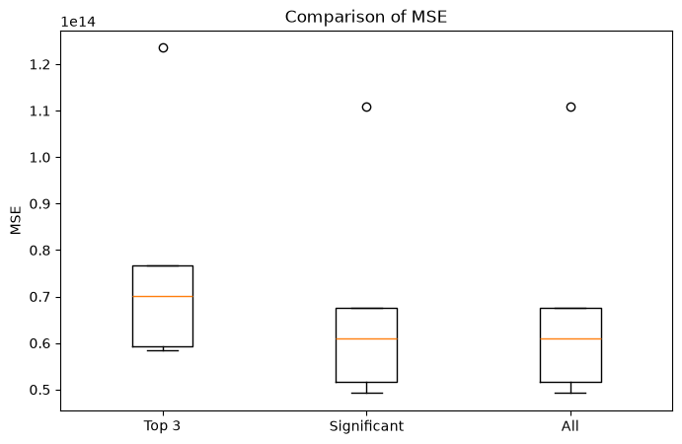

The Significant and All Variables models have exactly the same results. This happens because the only variable removed from the All Variables model is Bathrooms. Since Total_Rooms already contains Bedrooms and Bathrooms, the remaining variables can represent the same linear feature space. The Top 3 model has a higher MSE, which means that using only three variables does not improve the model in this case. The standard deviation is also slightly higher for the Top 3 model. The relatively large standard deviations for all models are caused by expensive properties, because MSE gives a very large penalty to large prediction errors. Therefore, based on cross-validation, keeping the significant variables gives a lower validation error than reducing the model to only three variables.

Test Set Evaluation
The final models were evaluated on the 268 observations that were not used for training.
Model MSE RMSE MAE
ii. Top 3 Variables 5.766695e+13 7.593876e+06 4.855378e+06
i. Significant Variables 5.355508e+13 7.318133e+06 5.107293e+06
iii. All Variables 5.355508e+13 7.318133e+06 5.107293e+06

The Significant and All Variables models again give exactly the same result. The Top 3 model has a higher MSE and RMSE, so it has larger squared errors on the test set. At the same time, it has a lower MAE. This means that the typical absolute error is slightly smaller, but a few large errors are bigger, which has a stronger effect on MSE. The Significant and All Variables models achieve an MSE of approximately
$5.36*{10}^{13}$ and an RMSE of approximately 7.32 million. The test results are of the same order as the cross-validation results, which indicates that the preprocessing and target encoding are working without the earlier target leakage problem.

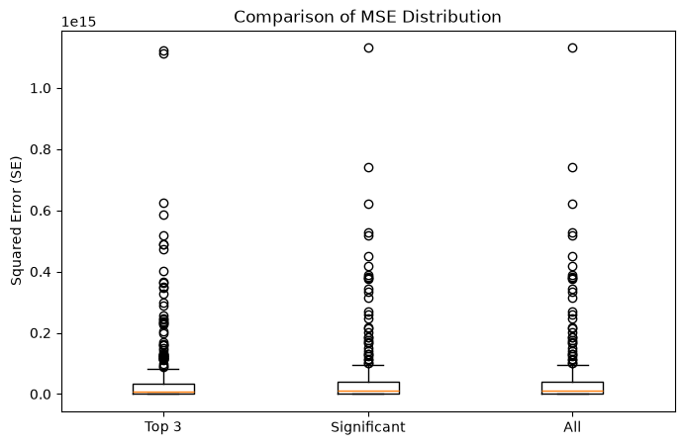

Actual vs Predicted Prices
The actual versus predicted price plots were created for all three feature configurations. The red diagonal line represents perfect predictions, where the predicted price is equal to the actual price. The predictions are closer to the ideal line for cheap and medium-priced properties, because most observations belong to this part of the dataset. For very expensive properties, the errors become larger. This is expected because the price distribution is highly skewed and the linear model has more difficulty predicting extreme values. The Significant and All Variables plots are identical because the two models produce identical predictions. The Top 3 model has a wider spread of predictions and tends to underestimate some of the expensive properties.
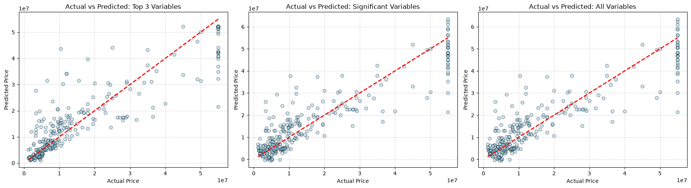

Residual Analysis
Residuals were calculated as: Residual = Actual Price - Predicted Price.
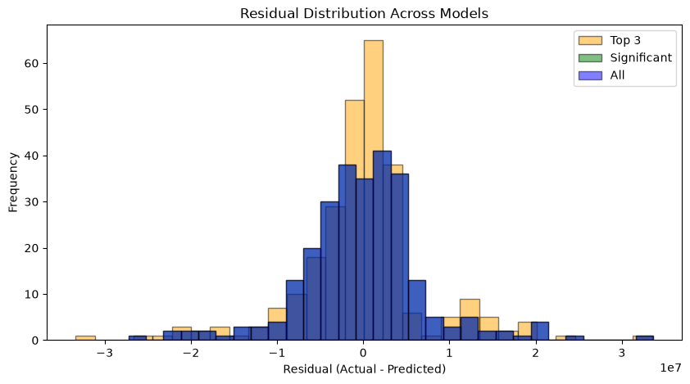
The residual distributions of the three models are similar. For the Significant and All Variables models, the residuals have a mean close to zero and a standard deviation of approximately 7.3 million. The Top 3 model has a slightly larger spread, around 7.6 million. The long tails in the residual distributions are mainly caused by expensive properties. These observations are more difficult for the linear regression model to predict accurately. The residual distribution being centered close to zero suggests that there is no strong systematic overprediction or underprediction across the whole test set.

Custom Model vs Scikit-Learn
The custom Gradient Descent implementation was compared with LinearRegression from Scikit-Learn.
The results were:

Scikit-Learn Metrics (Top 3 features): | Custom Gradient Descend (Top 3 features)
MSE: 57666953828032.976562 | MSE: 5.766695e+13
RMSE: 7593876.074050 | RMSE: 7.593876e+06
MAE: 4855378.288108 | MAE: 4.855378e+06
Scikit-Learn Metrics (Significant features): | Custom Gradient Descend (Significant features)
MSE: 53555077219022.796875 | MSE: 5.355508e+13
RMSE: 7318133.451846 | RMSE: 7.318133e+06
MAE: 5107293.451057 | MAE: 5.107293e+06
Scikit-Learn Metrics (All features): | Custom Gradient Descend (All features)
MSE: 53555077219022.789062 | MSE: 5.355508e+13
RMSE: 7318133.451846 | RMSE: 7.318133e+06
MAE: 5107293.451057 | MAE: 5.107293e+06

The results are the same to all printed digits.This is a strong check that the manually implemented Gradient Descent is working correctly. It reaches the same regression solution and produces the same predictions as the library implementation.
Single Property Prediction
To check whether the complete pipeline can be used for a new property, a separate prediction function was created.
The example property has:
- Bedrooms: 3
- Bathrooms: 2
- Floor Area: 120
- Land Area: 200
- Location: Quezon City
- Latitude: 14.65
The record goes through the same preprocessing steps as the training data:
- Missing-value handling
- Outlier capping
- Feature engineering
- Location target encoding
- Normalization
- Price prediction
The predicted price for this property is: 11,711,887.47
This shows that the model is not limited to evaluating the existing dataset. The same preprocessing and trained model can also be applied to a new property record.

Conclusion
In this laboratory work, I built a complete multiple linear regression pipeline for predicting property prices using the Philippines Housing Market dataset.
First, I analyzed the structure and quality of the data. The original dataset contained 1500 records and several missing values, duplicated rows and extreme observations. The Description column was removed because it contained free text with very high cardinality. After removing duplicates and rows without a valid target value, 1340 records remained.
Missing numerical values were filled using medians calculated from the training set, while categorical missing values were filled using the mode. Outliers were handled using IQR capping for the main numerical variables instead of deleting them. This was important because very expensive properties can still be valid and useful observations.
The dataset was split into 1072 training records and 268 test records. Several additional features were created, including Total_Rooms, Total_Area, Area_Per_Room and Floor_To_Land_Ratio.
Because Location has 664 unique values, One-Hot Encoding was not used. Instead, I implemented smoothed target encoding with out-of-fold encoding for the training data. This was necessary to avoid target leakage, especially for locations that occur only once.
Longitude was removed because it has a very strong correlation with Latitude. The remaining input variables were normalized using Min-Max scaling, while Price was kept in its original units.
For calculating regression coefficients, I implemented both Ordinary Least Squares and Gradient Descent. After using 50,000 epochs and the final learning rate, the two methods produced practically identical coefficients. The differences were around 10^-6 or smaller, which confirms that Gradient Descent successfully converged to the same solution as the analytical method.
The statistical significance analysis showed that all variables except Bathrooms had p-values below 0.05. The three variables selected as the top three were Floor Area, Total_Area and Land Area.
However, cross-validation showed that reducing the model to only these three variables did not improve the results. The Top 3 model had a Mean MSE of 7.76 × 10^13, while both the Significant and All Variables models had a lower Mean MSE of 6.81 × 10^13.
On the test set, the Significant and All Variables models again produced identical results, with MSE of 5.36 × 10^13, RMSE of 7.32 million and MAE of 5.11 million. The Top 3 model had a higher MSE and RMSE, although its MAE was slightly lower.
Finally, I compared my custom Gradient Descent implementation with Scikit-Learn's LinearRegression. The metrics matched exactly to all printed digits for all three feature configurations. This confirms that the custom implementation is working correctly.
The final pipeline was also tested on a new example property in Quezon City. The predicted market price was 11,711,887.47.
Overall, the laboratory work showed the full process of preparing real-world data, creating features, implementing linear regression manually, checking statistical significance, validating the model and using it to make a prediction for a new property.

