**ECOMMERCE: SHOE STORE**

**1)INTRODUCTION:**

**1.1) OVERVIEW:**

The objective of the ECOMMERCE: SHOE STORE project is to create a fully functional and user-friendly online shoe store. This e-commerce platform will allow customers to browse, search, and purchase a wide variety of shoes, providing a seamless shopping experience.

**1.2) PURPOSE:**

**Product Catalog:**

* + Display a wide range of shoe products.
  + Organize products into categories (e.g., sneakers, heels, boots).
  + Provide product details, including images, prices, sizes, and descriptions.
  + Allow users to filter and sort products.
* **Shopping Cart:**
  + Enable users to add products to their shopping carts.
  + Calculate the total cost of items in the cart.
  + Allow users to adjust quantities and remove items.
* **User Reviews and Ratings:**
  + Allow users to leave reviews and ratings for products.
  + Display average ratings and reviews on product pages.
* **User Profiles:**
  + Users can edit their profiles, update personal information, and view order history.
  + Store shipping addresses for convenience.
* **Search and Navigation:**
  + Implement a search bar with auto-suggestions.
  + Create a user-friendly navigation menu.
* **Admin Panel:**
  + Admins can manage product listings, including adding, editing, or removing products.
  + Monitor and manage customer orders.
  + Review and moderate user reviews.
* **Security:**
  + Implement security measures to protect user data and payment information.
  + Use HTTPS and encryption for data transmission.
* **Responsive Design:**
  + Ensure the platform is accessible on various devices (desktop, tablet, mobile).
* **Analytics and Reporting:**
  + Track website performance and user behavior.
  + Generate reports for sales and customer trends.

**2)LITERATURE SURVEY:**

**2.1) EXISITING APPROACHES:**

A literature survey on e-commerce shoe stores involves reviewing existing academic and industry research, articles, and publications related to various aspects of online shoe retail. Below, I'll outline key themes and findings from such a survey:

**1. E-commerce Market Trends:**

* Research often covers the global trends in e-commerce, including the growth of online retail and the shift from brick-and-mortar stores to online platforms.
* Studies may highlight the increasing consumer preference for online shopping for footwear.

**2. Consumer Behavior and Preferences:**

* Research investigates consumer behavior when buying shoes online, including factors influencing purchase decisions.
* Studies may discuss the importance of product information, user reviews, and return policies in influencing consumer choices.

**3. User Experience and Website Design:**

* Literature explores the role of user experience (UX) and website design in e-commerce success.
* Research may discuss best practices for designing intuitive and visually appealing e-commerce shoe store websites.

**4. Mobile Commerce (M-Commerce):**

* With the rise of mobile devices, studies may focus on the importance of mobile-responsive e-commerce sites and mobile app usage for shoe shopping.

**5. Product Presentation and Visualization:**

* Research may discuss the use of 3D visualization, augmented reality (AR), and virtual reality (VR) technologies to enhance the online shoe shopping experience.
* This can include virtual try-on features.

**6. Personalization and Recommendation Systems:**

* Studies explore the use of AI-driven recommendation systems to suggest shoes based on customer preferences and browsing history.
* Personalization strategies to improve customer engagement are often discussed.

**7. Inventory Management and Supply Chain:**

* Literature may delve into the challenges of managing shoe inventory in an e-commerce setting.
* This includes topics such as demand forecasting, warehousing, and order fulfillment.

**8. Customer Reviews and Ratings:**

* Research examines the impact of customer reviews and ratings on consumer trust and purchase decisions.
* Studies often discuss the role of fake reviews and strategies to maintain credibility.

**9. Security and Trust:**

* Literature addresses the importance of secure payment gateways and data protection in e-commerce shoe stores.
* Trust-building strategies to mitigate fraud and cyber threats are explored.

**10. Marketing and Digital Advertising:** - Studies investigate digital marketing strategies, including s social media marketing, pay-per-click advertising, and email marketing, to promote e-commerce shoe stores.

**2.2) PROPOSED SOLUTION:**

Proposing a solution for an eCommerce shoe store involves outlining the technical and strategic aspects of the project. Here's a proposed solution:

**Technical Stack:**

* **Frontend Development:**
  + Use React.js for the frontend to create a dynamic and responsive user interface.
  + Utilize HTML5 and CSS3 for structuring and styling the website.
  + Implement Redux for state management to handle user data, cart, and authentication.
  + Utilize a UI framework or library like Bootstrap or Material-UI for design consistency.
* **Server and Hosting:**
  + Implement load balancing and auto-scaling to handle traffic spikes during promotions or sales.
* **Security:**
  + Implement HTTPS for secure data transmission.
  + Utilize security best practices to protect against common web vulnerabilities (e.g., XSS, SQL injection).
  + Regularly update dependencies to address security vulnerabilities.
* **Testing and Quality Assurance:**
  + Perform thorough testing, including unit testing, integration testing, and end-to-end testing.
  + Conduct security assessments and penetration testing to identify vulnerabilities.
  + Set up automated testing and continuous integration (CI) pipelines.

**3)THEORITICAL ANALYSIS:**

* 1. **BLOCK DIAGRAM:**

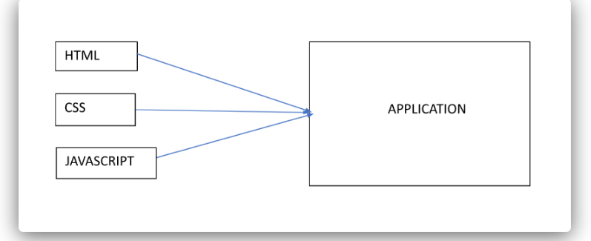

* 1. **HARDWARE / SOFTWARE DESIGNING:**

**Pre-Requisites:**

To complete this project, you will need:

* A code editor (such as Visual Studio Code, Sublime Text, or Atom)
* A web browser
* An internet connection
* HTML, CSS or Bootstrap, and JavaScript knowledge

**Project Objectives:**

By the end of this project, you will:

* Create a user interface using HTML and CSS to display information about e-commerce product of shoes.
* Dynamically update the UI with the fetched shoes data which is coming from data present in script file.
* Allow users to add shoes in cart and can get how many shoes they have send to the cart.

**Project Flow:**

To accomplish the objectives, we will complete the following activities:

* Set up the project structure
* Design and implement the user interface
* Fetch data from the script file
* **Project Structure:**

The project structure will include the following files:

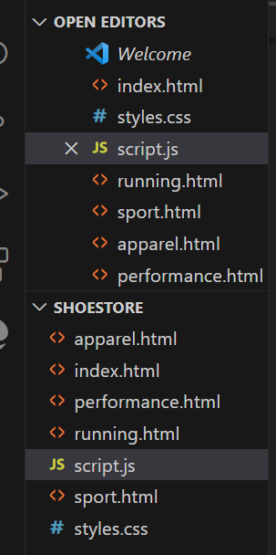

index.html: The main HTML file that contains the structure of the web page. style.css: The CSS file that defines the styles for the user interface. script.js: The JavaScript file that handles updates the UI

**Milestone 1: Set up the project structure**

Create a new project folder for the ECOMMERCE: SHOE STORE.

Inside the project folder, create the following files/folders:

**index.html**

**style.css**

**script.js**

Next, put css and js files in **static** folder while index.

**Milestone 2: Design and implement the user interface**

Open index.html in your code editor.

Set up the basic HTML structure.

Design the layout and structure of the user interface using HTML elements and CSS classes.

Apply styles to the UI elements using CSS in style.css.

Link style.css to index.html.



Design the layout and structure of the user interface using HTML elements and CSS classes.

Apply styles to the UI elements using CSS in style.css.

Link style.css to index.html.

**4)RESULT:**

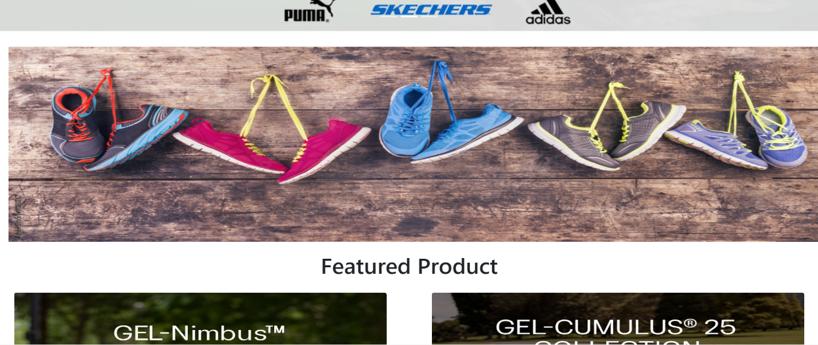

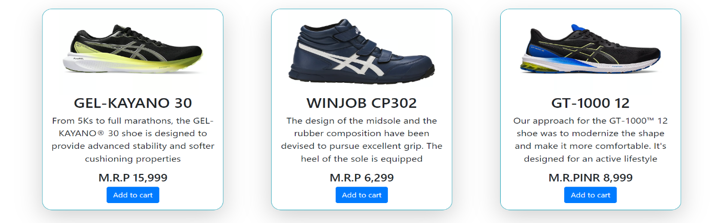

**5)ADVANTAGES AND DISADVANTAGES:**

**Advantages:**

1. **Global Reach:** E-commerce allows you to reach a global audience, breaking down geographical barriers and expanding your customer base.
2. **Low Overhead Costs:** Operating an online store typically incurs lower overhead costs than brick-and-mortar stores, as you don't need physical storefronts, utilities, or as much staff.
3. **24/7 Availability:** Your online store is open 24/7, providing customers with the convenience to shop at any time, increasing potential sales.
4. **Wider Product Selection:** You can offer a vast selection of shoes without the limitations of physical space, catering to various tastes and preferences.
5. **Inventory Management:** E-commerce systems often come with inventory management features to help you keep track of stock levels and prevent overstock or stockouts.
6. **Personalization:** You can personalize the shopping experience, showing customers product recommendations based on their preferences and previous purchases.
7. **Customer Reviews and Ratings:** Online reviews and ratings can build trust and credibility with potential customers and influence their buying decisions.
8. **Scalability:** It's relatively easy to scale your e-commerce store as your business grows, adding more products, expanding to new markets, and increasing revenue.

**Disadvantages:**

1. **Intense Competition:** The e-commerce shoe market can be highly competitive, with many established players and newcomers vying for market share.
2. **Security Concerns:** Handling sensitive customer information and online transactions requires robust security measures to protect against data breaches and fraud.
3. **Initial Investment:** While the overhead costs are lower than physical stores, there can be significant upfront costs in developing and maintaining an e-commerce website.
4. **Technical Challenges:** Managing the technical aspects of an online store, including website maintenance, updates, and server issues, can be complex and require expertise.
5. **Shipping and Logistics:** Shipping costs, packaging, and logistics can be challenging to manage efficiently, impacting your bottom line.
6. **Customer Trust:** Building trust with online shoppers can be difficult, especially for new or lesser-known brands.
7. **Returns and Refunds:** Dealing with returns and refunds can be time-consuming and costly, affecting your profit margins.
8. **Market Saturation:** Depending on your niche, the market may be saturated, making it harder to stand out and gain market share.
9. **Customer Service:** Providing excellent customer service is crucial, and managing customer inquiries and complaints can be demanding.
10. **Digital Marketing Costs:** While digital marketing can be cost-effective, it can also require a significant budget, and the competition for ad space can drive up costs.

**6)APPLICATIONS:**

1. **Retail Shoe Sales:**
   * The primary purpose of an e-commerce shoe store is to sell shoes to customers. Customers can browse, select, and purchase shoes online, eliminating the need to visit physical stores.
2. **Fashion and Style:**
   * An e-commerce shoe store can cater to fashion-conscious customers by offering trendy and stylish footwear, helping them stay up-to-date with the latest fashion trends.
3. **Athletic and Sports Footwear:**
   * Specialized e-commerce shoe stores can focus on selling athletic shoes, including running, basketball, soccer, and other sports-specific footwear, along with sports accessories.
4. **Customization and Personalization:**
   * Some e-commerce stores allow customers to design and customize their own shoes, choosing colors, materials, and designs to create unique footwear.
5. **Foot Health and Comfort:**
   * Stores specializing in orthopedic or comfort shoes can provide customers with options that address specific foot conditions or provide extra comfort for long hours of wear.
6. **Kids' and Children's Shoes:**
   * E-commerce shoe stores can cater to children's shoe needs, offering a wide range of sizes, styles, and designs for kids of all ages.
7. **Special Occasions:**
   * Some e-commerce shoe stores focus on providing formal and special occasion footwear, including wedding shoes, prom shoes, and evening heels.
8. **Wholesale and Bulk Orders:**
   * Businesses and retailers can purchase shoes in bulk from e-commerce stores, making it convenient for them to stock their physical stores.

**7)CONCLUSION:**

In summary, the successful development and launch of an e-commerce shoe store require careful planning, a well-defined strategy, and attention to detail. By addressing these key factors, you can increase the likelihood of creating a thriving online business that offers customers a satisfying shopping experience and meets your business goals.