Big Data Testing

Install Docker

<https://desktop.docker.com/win/main/amd64/Docker%20Desktop%20Installer.exe>

Open docker desktop, make sure your engine in running

Open CMD

Running the existing container

docker container run -it -p 9870:9870 -p 8088:8088 registry.gitlab.com/training-support/training-environments:hadoop-v1 bash

Once you run the container, it takes inti Hadoop shell - >

root@2a72dc32f2df:/#

To go into hive, just give hive command on top of Hadoop shell

**PROJECT**

**PIG Activities:**

**Activity 1 :**

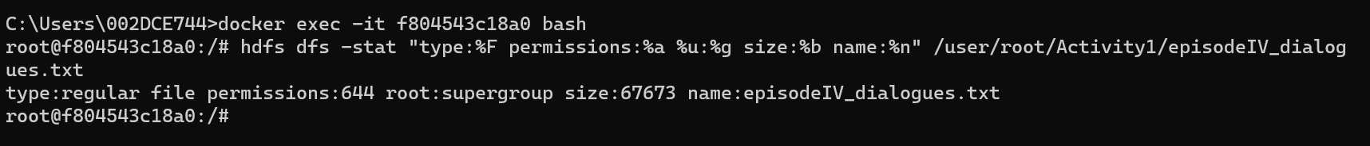

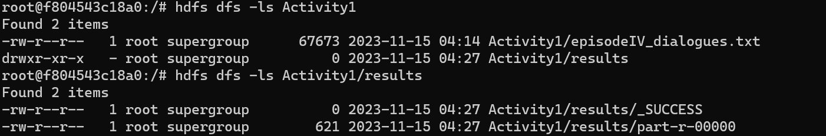

OUTPUT :

HIVE ACTIVITIES

Activity1

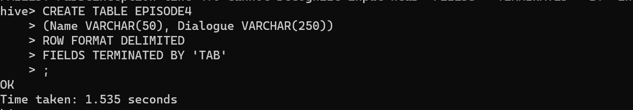

Activity2

