Production Infrastructure for bigger number of points

1. The layer which gives some interface for sending inputs and showing outputs:
TBD, as the format of input and output, as well as speed in which data is coming isn’t known.

2. Apache Kafka topics for writing/reading the trades to the engine:
I am not very familiar with noSQL architectures, but Apache Kafka seems to be one of the optimal choices. We could choose another high-speed noSQL DB, as the speed of reading and writing is the goal.
Also, it’s available on AWS: https://aws.amazon.com/msk/what-is-kafka/

3. The engine itself that will consist of Order, Trade, OrderBook, Engine classes that will save and process all the information with regards to the orders, prices, quantities in the real-time. The language of the engine will depend heavily on the priorities, but, as speed of transactions are one of the main goals, low-level language and/or open source engine on low-level language should be considered (for example, one of the engines from this source: https://blog.krybot.com/a?ID=ee745716-a6e7-4549-99bc-0692cbb44f2e).

To sum, up the architecture will look like this:
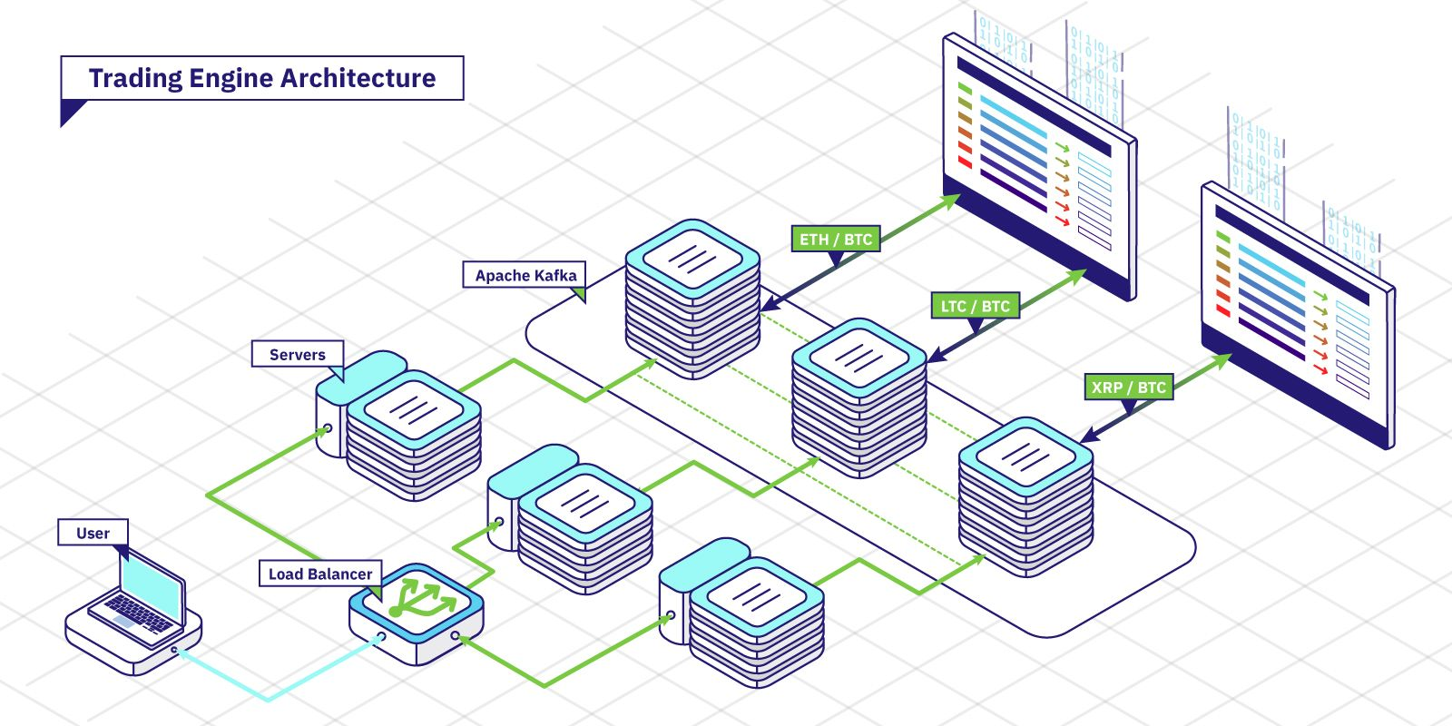
source: https://around25.com/blog/building-a-trading-engine-for-a-crypto-exchange/

