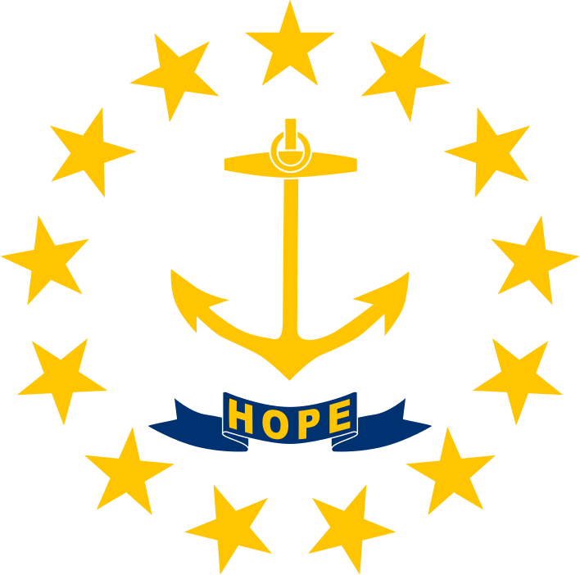 | MEMORANDUM
TO: Governor-elect, State of Rhode Island
FROM: Alexander McAllister, Policy Analyst
DATE: November 9, 2026
RE: Lifting the charter moratorium and doubling the cap from 28 to 56

1. Executive summary
Lifting the moratorium and doubling the cap would probably raise statewide proficiency, but only slightly and with real uncertainty. Rhode Island's charters serve mostly low-income students of color and score well above what their poverty levels predict, and rigorous studies elsewhere find large urban charter gains. But charters enroll only 10% of public-school students, so even large per-student gains move the statewide rate by about one point at most. Effects and budget strain would concentrate in Providence and nearby cities. The outcome depends on which operators expand.
EXPLORE THE DATA: open the interactive map of Rhode Island charter schools at https://political-economy-analysis.github.io/ri-charter-schools-map/
2. The proposal and the starting point
The June 18, 2026 law pauses charter approvals and expansion through 2028-29, limits new charter funding through fiscal 2029, and cut the cap from 35 to 28. The proposal would end the pause and raise the cap to 56. Rhode Island has 24 charters running 42 school sites with 13,465 students, 10% of charter and district enrollment. They serve a needier population (Exhibit 1): 79% of charter students are low-income (eligible for free or reduced-price lunch) versus 51% in district schools, and 81% are students of color versus 47%. Because families choose to apply, raw comparisons mislead; this memo leans on studies that account for that.
3. Overall proficiency
Raw scores are about equal. In 2018-19, charter students were 31% proficient in math and 41% in reading, versus 31% and 43% in district schools. But charters enroll poorer students, who score lower anywhere. Compared with district schools of similar poverty, charters score about 12 points higher in math and 14 in reading (Exhibit 2). That is suggestive, not proof: applicants may differ in ways lunch eligibility misses.
Lottery studies, which compare students who narrowly won and lost admission, remove that problem. Boston charters produced large gains (Abdulkadiroğlu et al. 2011), and new campuses matched their parents after the sector's market share doubled (Cohodes, Setren and Walters 2021). Gains concentrate in urban “No Excuses” schools; Massachusetts charters outside cities lowered achievement (Angrist, Pathak and Walters 2013). Nationally, charter students gain 16 more days of learning in reading and 6 in math per year (CREDO 2023).
The statewide effect is diluted. Doubling charter enrollment lifts the charter share to about 20%. If each switching student gained 5 percentage points in proficiency, the statewide rate would rise half a point; at 10 points, one point.
4. Inequality
In 2018-19, charter students scored higher in math than district peers in every group: Black 35% proficient versus 16%, Hispanic 27% versus 13%, low-income 28% versus 14%, English learners 26% versus 8%, students with disabilities 23% versus 14%. The white-Black gap is 15 points at charters and 24 in district schools. These raw averages, from 18 to 32 charters per group, are not causal, and I did not test whether charters enroll and keep their share of students with disabilities or English learners. Lottery studies find the largest gains for low-income, non-white and lower-scoring urban students. If new charters resemble existing ones, expansion would modestly narrow gaps; because charters serve few students, the aggregate effect would be small.
5. Geography
Charters cluster in the urban core: 36 of 42 sites and 87% of charter students are in six cities, and Providence alone hosts 46% (Exhibit 3). Charter seats sited in Central Falls equal 53 per 100 district-school students there; Cumberland 32, Providence 30, Woonsocket 19, Cranston 11, Pawtucket 10. These show where seats are, not where students live. Per-pupil funding follows the student, so districts lose revenue at once while building, bus and staff costs fall slowly; Governor McKee cited about 10,000 students leaving public schools since 2021. Suburban and rural districts would feel little direct effect. Charter operators report lower spending per pupil ($15.6k versus $18.6k, fiscal 2020), though not like for like.
6. Other constituencies
Teachers: charters employ about 1,000 teachers versus 9,300 in district schools. Moving 13,465 students would create roughly 1,000 charter jobs and cut district staffing needs by a similar number, through attrition or layoffs. A few charters, including Paul Cuffee, have recently unionized. Taxpayers: stranded costs fall on municipal budgets. Families: waitlist data were unavailable. Operators: a Providence dual-language charter blocked by the pause is suing.
7. Risks, uncertainty and recommendation
Key uncertainties: new charters may underperform established ones; the best evidence is from Massachusetts, and I found no lottery study of Rhode Island charters; poverty is measured crudely; test data are from 2018-19. A neutral design could end the pause but condition approvals on operator track record, high-need locations, and enrollment of students with disabilities and English learners; phase the cap (say 28 to 40, then review); and give sending districts transition aid. Rhode Island lottery results, subgroup enrollment and attrition data, and early results from new schools would change this assessment.

Exhibit 1. Charters serve a needier student body (math panel weighted by students tested)
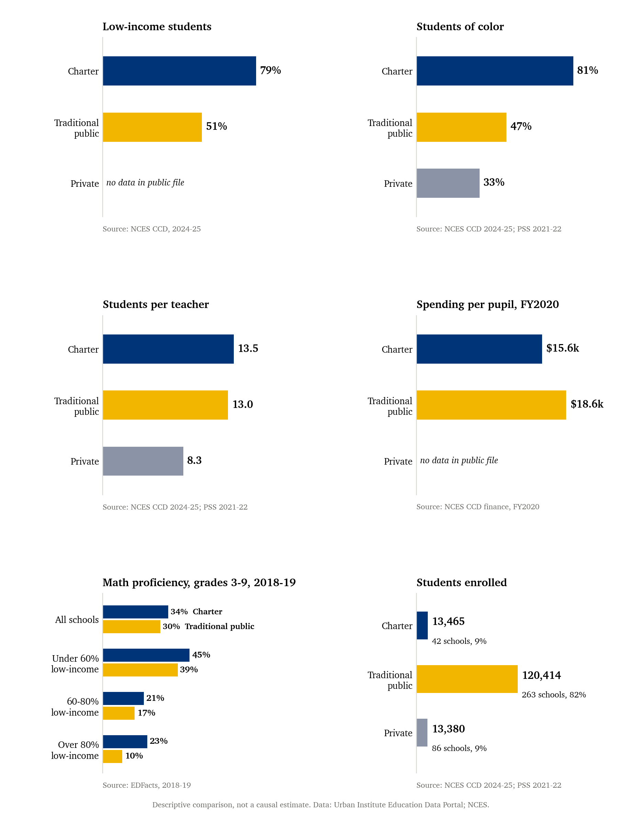

Exhibit 2. Charters sit above the poverty-adjusted line; raw averages are equal (averages weighted by enrollment)
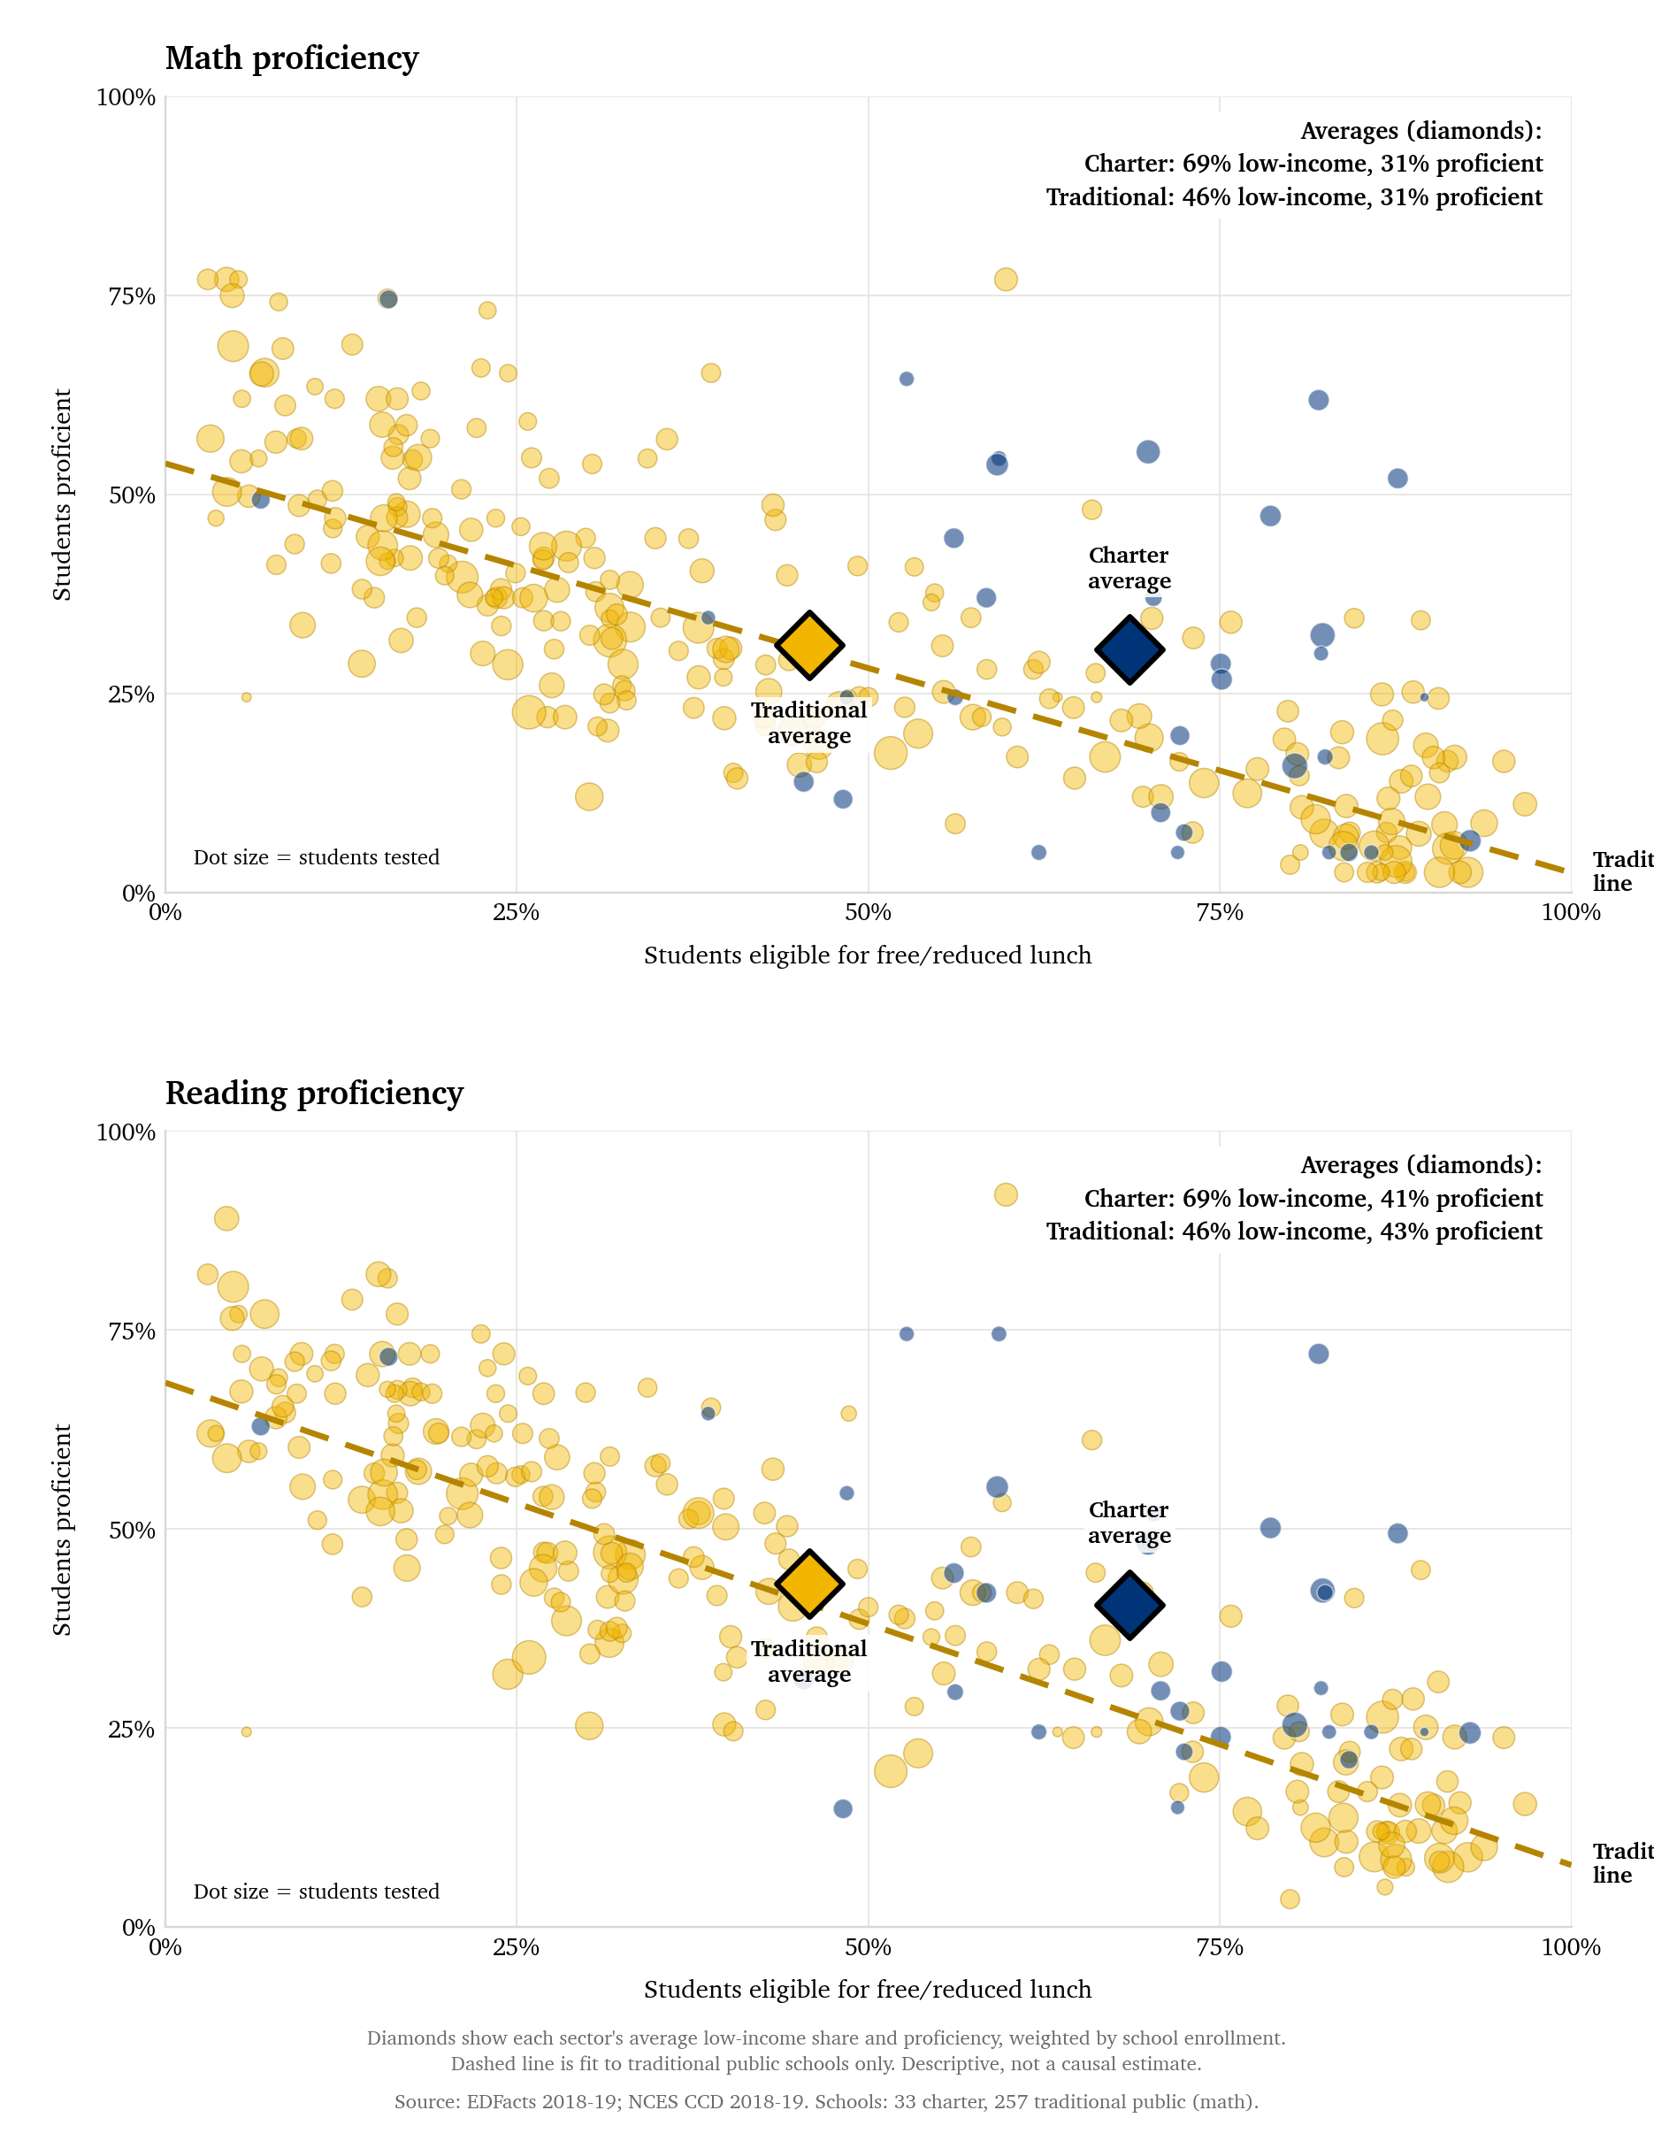

Exhibit 3. Providence hosts nearly half of charter enrollment (42 sites, 2024-25; dot area proportional to enrollment)
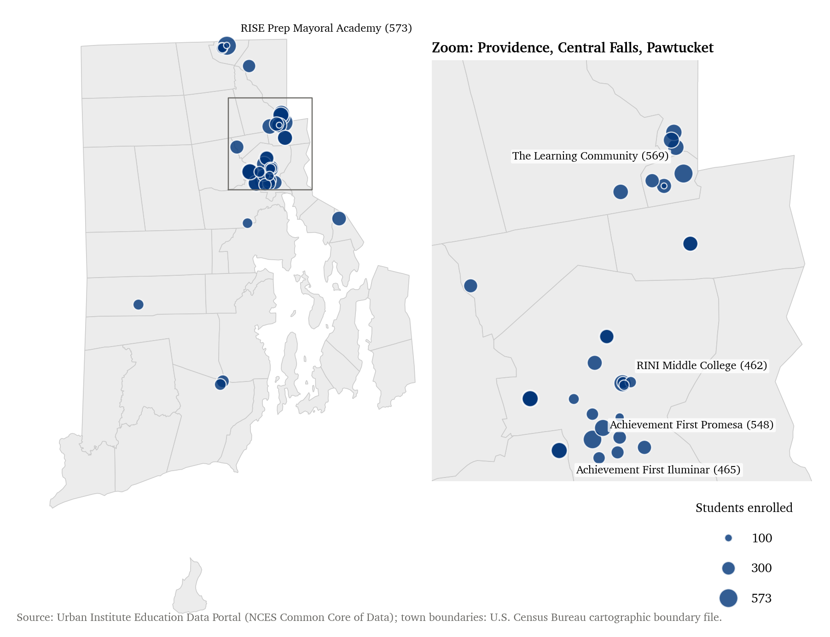

TECHNICAL APPENDIX

This appendix documents how each exhibit and number in the memo was produced, so a technical reader can rebuild them. All code is in the project's scripts/ folder and runs from the project root. All data are public; no API keys or passwords are needed. Paths are relative to the project root.
A. Reproduction
Environment. Python 3.9.6 with pandas 2.3.3, numpy 2.0.2, matplotlib 3.9.4, pyshp 3.1.6, pillow 11.3.0, fonttools 4.60.2, reportlab 5.0.1 and python-docx. Figures and this document use the Charter font that ships with macOS (figure scripts fall back to DejaVu Sans if it is missing). Downloads are cached in data/raw/ and reused.
Script | Purpose | Main output
01 | Charter school list (CCD directory, 2024) | ri_charter_schools_2024.csv
03 | Adds district finance (FY2020) to school lists | *_enriched.csv
05 | Private schools from the NCES Private School Survey | ri_private_schools_2021.csv
06 | Test-score, graduation and race-enrollment downloads | ri_edfacts_*.csv; ri_ccd_enrollment_by_race.csv
07 | Master list of charter, traditional public and private schools | ri_school_master_list.csv
08 | Exhibit 1 (sector comparison); --memo gives the memo version | figures/memo/exhibit1_*.png
09 | School-level scores and poverty, 2018-19 | proficiency_vs_poverty_schools.csv
11 | Exhibit 2 (scores against poverty); --memo version | figures/memo/exhibit2_*.png
02 | Exhibit 3 (charter map); --memo version | figures/memo/exhibit3_*.png
13 | Other statistics quoted in the memo | memo_statistics_*.csv
14 | Builds this document | memo.pdf, memo.docx

Run order: 01, 03, 05, 06, 07; then 08, 09, 11 and 02; then 13; then 02, 08 and 11 again with --memo; then 14. Scripts 04 (interactive map), 10 and 12 (chart variants) are not used in the memo.
B. Data sources and conventions
Source | Used for | Access
Urban Institute Education Data Portal: NCES Common Core of Data (CCD) | School directory for 2018, 2020 and 2024 (charter flag, enrollment, lunch eligibility, teachers FTE, coordinates); enrollment by race (2020, 2024); district finance (2020) | educationdata.urban.org/api/v1/ : schools/ccd/directory/{year}/?fips=44; schools/ccd/enrollment/{year}/grade-99/race/; school-districts/ccd/finance/2020/
Urban Institute Education Data Portal: EDFacts assessments | Share proficient in math and reading by school, grade (3-9), race and special-population group; 2015-18 and 2020 | schools/edfacts/assessments/{year}/grade-{g}/ with optional race/ or special-populations/
NCES Private School Universe Survey, 2021-22 | Private school enrollment, teachers, percent White, affiliation, coordinates | nces.ed.gov/surveys/pss/zip/pss2122_pu_csv.zip
U.S. Census Bureau cartographic boundary file, 2022 county subdivisions | Rhode Island town outlines for the map | cb_2022_44_cousub_500k, stored in data/raw/ri_cousub/
Flag of Rhode Island (public domain) | Emblem on page 1 | Wikimedia Commons; data/raw/logo/flag.png

• Years. The portal's year is read as the start of the school year (2018 = 2018-19; 2024 = 2024-25). This is an inference from the portal's conventions, not a documented fact, and should be confirmed.
• Proficiency is published as a range (low, high, midpoint). All results use the midpoint. Values coded -1 (missing), -2 (not applicable) or -3 (suppressed) are dropped; about 98% of school-grade rows in each year are usable.
• Low-income means eligible for free or reduced-price lunch, divided by enrollment. Schools that offer lunch to all students may report this inconsistently.
• Students of color is 100 minus the White share (CCD race file; for private schools, 100 minus the survey's percent White).
C. School universe
The master list (script 07) holds every school in the 2024 CCD directory with positive enrollment and status open or new: 263 traditional public schools and 42 charter school sites, plus 86 private schools with positive enrollment in the survey (391 in all). Eleven directory entries were excluded because they report no enrollment (career-technical centers, annexes and two closed schools). “Charter” follows the CCD charter flag. The memo's 24 charters are the 24 operators running those 42 sites, matching a June 2026 Rhode Island Current count; the cap of 28 counts charters, not sites. In test-score tables, a school is a charter if it appears in the 2024 or 2020 charter lists (Exhibit 1) or is flagged in the 2018 directory (Exhibit 2).
D. Exhibit 1: sector comparison (script 08)
Panel | Definition | Weights and values
Low-income students | Free or reduced-price lunch count ÷ enrollment, CCD 2024-25 (public sectors only) | Enrollment-weighted mean over schools. Charter 79.2%; traditional 51.3%
Students of color | 100 × (1 − White enrollment ÷ total), CCD 2024-25; private: survey percent White | Enrollment-weighted. Charter 81.0%; traditional 46.6%; private 32.6%
Students per teacher | Total enrollment ÷ total teacher FTE (private: 2021-22) | Charter 13.5; traditional 13.0; private 8.3
Spending per pupil | Current spending on elementary-secondary education ÷ district enrollment, FY2020 (CCD finance); enrollment is the sum of 2020 school enrollments in the operator. Districts that merely contain a charter (Providence, Cranston) are excluded from the charter figure | Weighted by operator enrollment: 19 charter-only operators, $15,595; 41 districts, $18,588
Math proficiency, grades 3-9, 2018-19 | Midpoint share proficient, weighted by students tested. Poverty bands use each school's lunch eligibility in the 2020 directory | All schools: charter 33.8%; traditional 29.8%. Bands below
Students enrolled | Sum of enrollment, CCD 2024-25 and survey 2021-22 | Charter 13,465; traditional 120,414; private 13,380

Poverty band | Charter % proficient | Traditional % proficient | Charter schools | Traditional schools
Under 60% | 44.9 | 38.7 | 16 | 175
60-80% | 21.3 | 16.5 | 6 | 35
Over 80% | 23.0 | 10.1 | 7 | 40

E. Exhibit 2: scores against poverty (scripts 09 and 11)
• Unit: the school. Poverty is free or reduced-price lunch ÷ enrollment from the 2018 directory, capped at 100%. Proficiency is the midpoint share proficient averaged over grades 3-9, weighted by students tested. Schools missing either value are dropped: 33 charters and 257 traditional public schools (math and reading alike). Marker area grows with the square root of students tested.
• Dashed line: least squares fit of proficiency on poverty for traditional schools only (numpy.polyfit, degree 1, weights equal to the square root of students tested, so each school counts in proportion to students tested). Math: intercept 53.9, slope −0.51 points per percentage point of poverty. Reading: intercept 68.4, slope −0.61.
• Diamonds: sector averages of poverty and proficiency, weighted by school enrollment. The gap is the charter average minus the line's prediction at the charter average poverty level.
• Exhibit 1's math panel weights by students tested (charters 33.8%) and Exhibit 2 by enrollment (30.5%), which includes grades not tested; the memo's text quotes Exhibit 2.
Subject | Sector | Schools | Students enrolled | Avg. low-income % | Avg. proficient %
Math | Charter | 33 | 9,351 | 68.6 | 30.5
Math | Traditional public | 257 | 128,756 | 45.8 | 31.1
Reading | Charter | 33 | 9,351 | 68.6 | 40.5
Reading | Traditional public | 257 | 128,756 | 45.8 | 43.1

Subject | Charter avg. low-income % | Line predicts % | Charter avg. proficient % | Charter above line (points)
Math | 68.6 | 18.6 | 30.5 | +11.9
Reading | 68.6 | 26.8 | 40.5 | +13.7

F. Exhibit 3 and geography (scripts 02 and 13)
Each dot is a charter site at its 2024 CCD coordinates; area is proportional to enrollment (largest: RISE Prep Mayoral Academy, 573 students). Town outlines come from the Census file above; the inset zooms on Providence, Central Falls and Pawtucket. Each site is assigned to its listed city. Charter seats per 100 students divides charter enrollment in a city by enrollment of traditional public schools located in that city. Charters draw students from several towns, so the ratio shows where seats are, not where students live. The six cities below hold 36 of 42 sites and 87.4% of charter students.
City | Charter sites | Charter students | % of charter students | Seats per 100 district students
Providence | 19 | 6,151 | 45.7 | 30.1
Cumberland | 4 | 1,533 | 11.4 | 31.6
Central Falls | 4 | 1,306 | 9.7 | 53.3
Cranston | 3 | 1,047 | 7.8 | 10.8
Woonsocket | 4 | 996 | 7.4 | 18.7
Pawtucket | 2 | 734 | 5.5 | 9.5

G. Other memo statistics (script 13)
Math proficiency by group, 2018-19 (midpoint share proficient, weighted by students tested; school counts are schools with scores for the group):
Group | Charter % | Traditional % | Charter schools | Traditional schools
Black | 34.6 | 15.5 | 23 | 119
Hispanic | 26.9 | 13.2 | 31 | 191
White | 49.3 | 39.1 | 20 | 246
Low-income | 27.5 | 14.3 | 32 | 247
English learners | 25.5 | 8.3 | 18 | 105
Students with disabilities | 23.4 | 13.5 | 24 | 238

• Gap by race: white minus Black proficiency is 49.3 − 34.6 = 14.7 points at charters and 39.1 − 15.5 = 23.6 in traditional schools.
• Scenario: charters enroll 13,465 of 133,879 charter and district students (10.1%). If charter enrollment doubled with students moving from districts, the share would be 20.1%. Statewide change = 13,465 × g ÷ 133,879, where g is the proficiency gain per switching student: g = 2.5 gives 0.25 points, g = 5 gives 0.50, g = 10 gives 1.01. The gain g is an assumption for illustration, not an estimate.
• Teachers: teacher FTE is 995 at charters and 9,298 at traditional schools. Students moved ÷ students per teacher: 13,465 ÷ 13.0 ≈ 1,040 district FTE and 13,465 ÷ 13.5 ≈ 995 charter FTE, assuming staffing scales with enrollment.
• Cap: 24 charters operate under a cap of 28, leaving 4 slots; the proposal would allow 56.
H. Limitations
• Descriptive comparisons do not separate school effects from who enrolls. The memo's causal evidence rests on the cited lottery studies; none is from Rhode Island, and I did not read CREDO's Rhode Island report.
• Test data are from 2018-19. Results the portal labels 2020 show charters lower (math 15.9% versus 21.7%); they appear to be 2020-21, when far fewer students were tested, and are not used.
• Lunch eligibility is a crude poverty measure; Exhibit 1's bands use 2020 data and Exhibit 2 uses 2018.
• Spending compares charter-only operators with whole districts for FY2020 and is not like for like.
• Subgroup results rest on 18 to 32 charters per group and on midpoints of reported ranges; no significance tests were run.
• The staffing and fiscal scenarios assume proportional staffing and unchanged per-pupil funding.

REFERENCES

Research
Abdulkadiroğlu, A., Angrist, J. D., Dynarski, S. M., Kane, T. J., and Pathak, P. A. (2011). Accountability and flexibility in public schools: Evidence from Boston's charters and pilots. Quarterly Journal of Economics, 126(2), 699–748. https://doi.org/10.1093/qje/qjr017
Angrist, J. D., Pathak, P. A., and Walters, C. R. (2013). Explaining charter school effectiveness. American Economic Journal: Applied Economics, 5(4), 1–27. https://doi.org/10.1257/app.5.4.1
Cohodes, S., Setren, E., and Walters, C. R. (2021). Can successful schools replicate? Scaling up Boston's charter school sector. American Economic Journal: Economic Policy, 13(1), 138–167. https://econpapers.repec.org/RePEc:aea:aejpol:v:13:y:2021:i:1:p:138-67
Center for Research on Education Outcomes (CREDO) (2023). National Charter School Study III. Stanford University. Figures cited (16 days in reading, 6 in math) are from the press release: https://credo.stanford.edu/wp-content/uploads/2023/06/NCSS3-Press-Release-.pdf
Law, policy and news
Ballotpedia (July 15, 2026). Rhode Island enacts three-year charter school moratorium. https://news.ballotpedia.org/2026/07/15/rhode-island-enacts-three-year-charter-school-moratorium/
Rhode Island Current (June 18, 2026). McKee signs charter school moratorium bills with five days to spare, ending uncertainty. https://rhodeislandcurrent.com/2026/06/18/mckee-signs-charter-school-moratorium-bills-with-five-days-to-spare-ending-uncertainty/
Providence Business News. Paul Cuffee becomes first fully unionized charter school in R.I. https://pbn.com/paul-cuffee-becomes-first-fully-unionized-charter-school-in-r-i/
Rhode Island Department of Education, Funding Formula Working Group, charter school funding presentation (the statement that state and local per-pupil funding follows the student; not read in full, so confirm against current law, R.I. Gen. Laws title 16, chapter 77). https://ride.ri.gov/Portals/0/Uploads/Documents/Funding-and-Finance-Wise-Investments/Funding-Sources/State-Education-Aid-Funding-Formula/FundingFormulaWorkingGroup/Mtg2-Charter_Schools_presentation.pdf
Debate #3 preparation sheet (course materials): background on the June 18, 2026 law.
Data
Urban Institute, Education Data Portal (NCES Common Core of Data; EDFacts). https://educationdata.urban.org/
National Center for Education Statistics, Private School Universe Survey, 2021-22. https://nces.ed.gov/surveys/pss/
U.S. Census Bureau, cartographic boundary files, 2022 county subdivisions (Rhode Island, 1:500,000).
Flag of Rhode Island, Wikimedia Commons (public domain), used for the emblem on page 1.

