Political juggernauts a quantitative analysis of candidates in the 2019 lok sabha elections

1. Introduction :

The Lok Sabha is composed of representatives of people chosen by direct election on the basis of Universal Adult Suffrage. The Constitution of India allows for a maximum of 550 members in the House, with 530 members representing the States and 20 representing the Union Territories.

General elections were held in India in seven phases from 11 April to 19 May 2019 to elect the members of the 17th Lok Sabha. Votes were counted and the result was declared on 23 May.[1][2][3][4] The election resulted in a landslide victory for the BJP which won 303 seats and formed the government.

1.1 overview :

The Lok Sabha is composed of representatives of people chosen by direct election on the basis of Universal Adult Suffrage. The Constitution of India allows for a maximum of 550 members in the House, with 530 members representing the States and 20 representing the Union Territories. The 17th Lok Sabha was formed by the members elected in the 2019 Indian general election. Elections, all across India, were conducted in seven phases from 11 April 2019 to 19 May 2019 by the Election Commission of India.

The Bharatiya Janata Party received 37.36% of the vote, the highest vote share by a political party since the 1989 general election, and won 303 seats, further increasing its substantial majority. In addition, the BJP-led National Democratic Alliance (NDA) won 353 seats.

3. Purposes :

An election is considered the prime pillar of democracy.

election is an excellent opportunity for people to voice their dissatisfaction. Most importantly, if people dislike a particular leadership, then they can remove it. People can replace an undesirable leadership with a better alternative through elections.Individuals understand the candidates’ propaganda and wisely choose the right one based on their experiences.

2. problem definitions and design thinking :

2.1 Empathy map :

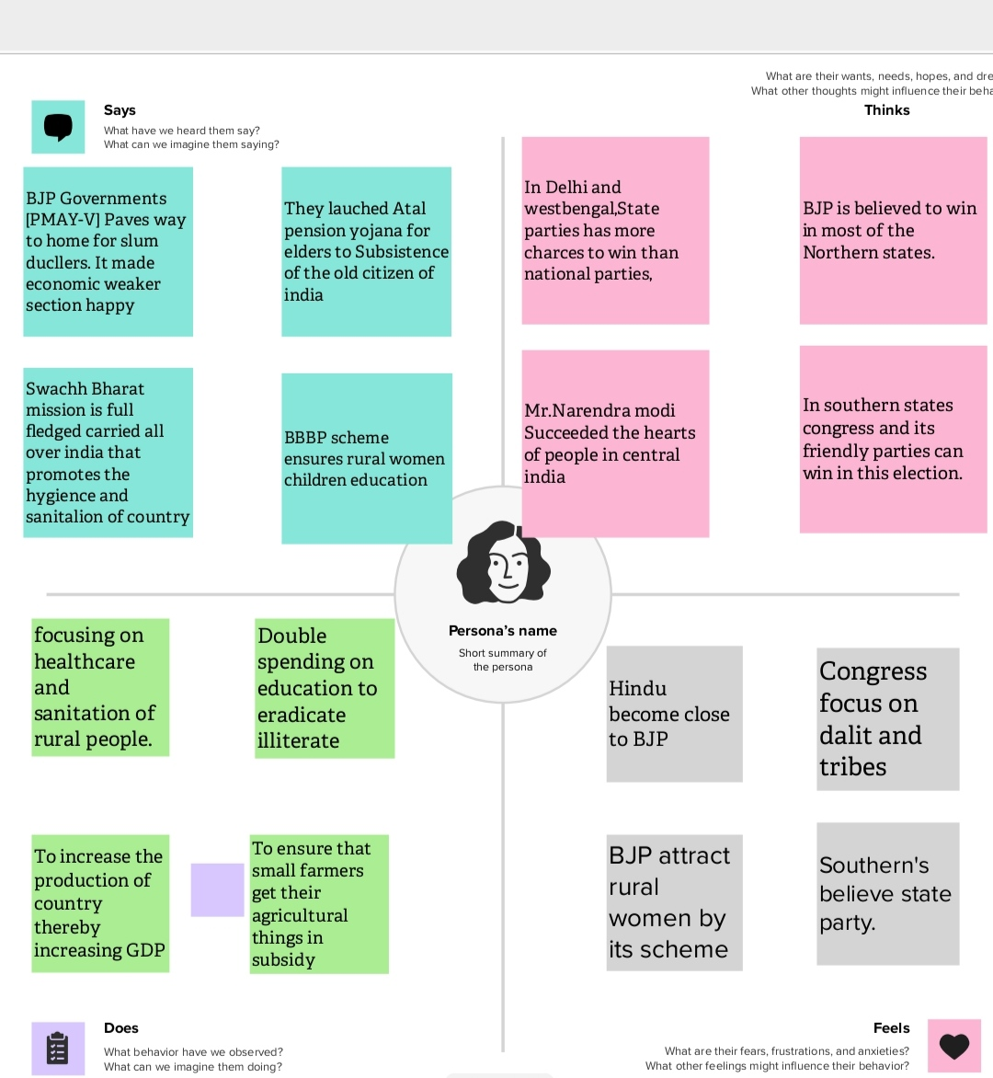

2.2 Ideation and brainstorming map :

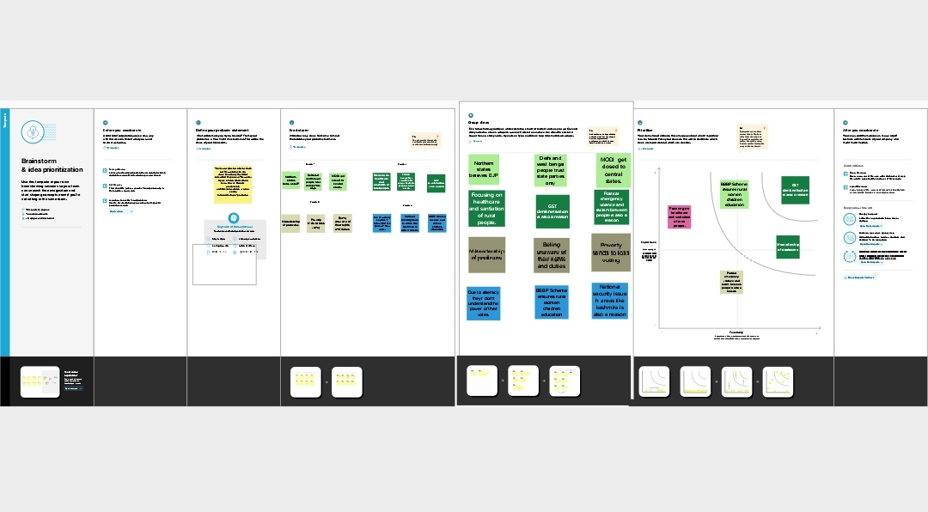

3. Advantage and disadvantage :

Advantage :

Candidate appearance is easily available for uninformed voters.

There is no gender difference in how voters reward beauty of male and female candidates; therefore, there is no evidence on gender discrimination in terms of how beauty is rewarded.

Voters can, to a certain extent, infer candidate ideology from appearance by using beauty as a cue for conservatism.

Even if well-informed voters do not rely on beauty to guide their voting behavior, less informed voters can and do draw inferences about ideology from it.

Disadvantages :

The beauty premium may discourage competent but unattractive people from entering politics.

Uninformed voters can be persuaded by good looks, and may, as a result, vote against their own interests.

Empirical results do not imply that political parties should replace their less photogenic established politicians with good-looking novices to maximize their electoral success.

Voters associate beauty with competence, so even the choice of voters who think that they vote for the more competent-looking candidate may be driven by beauty differences.

3. Results :

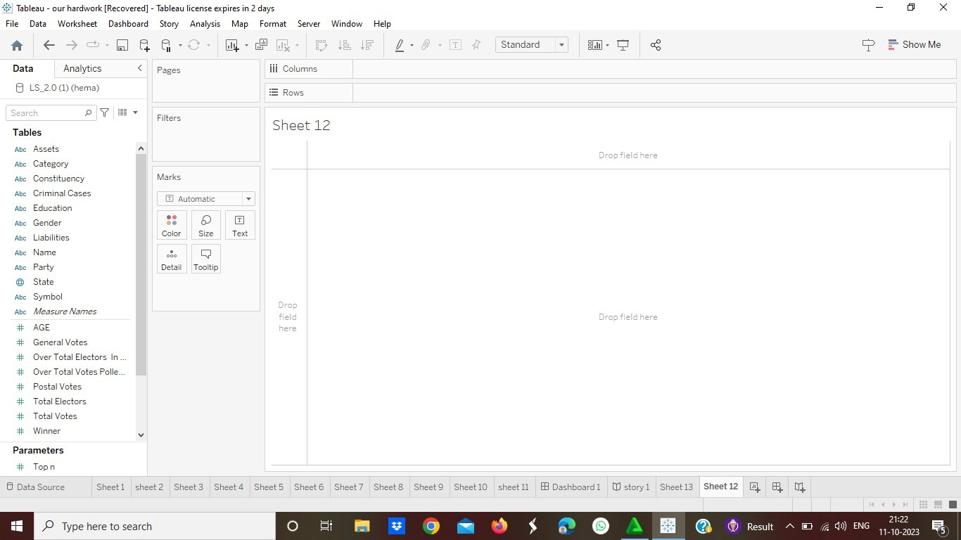

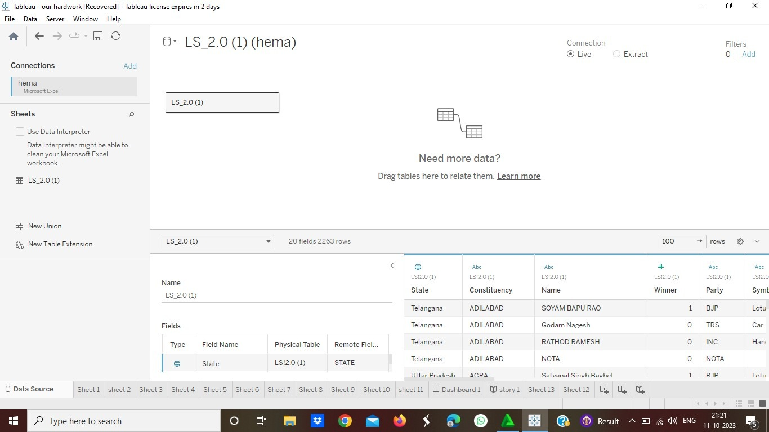

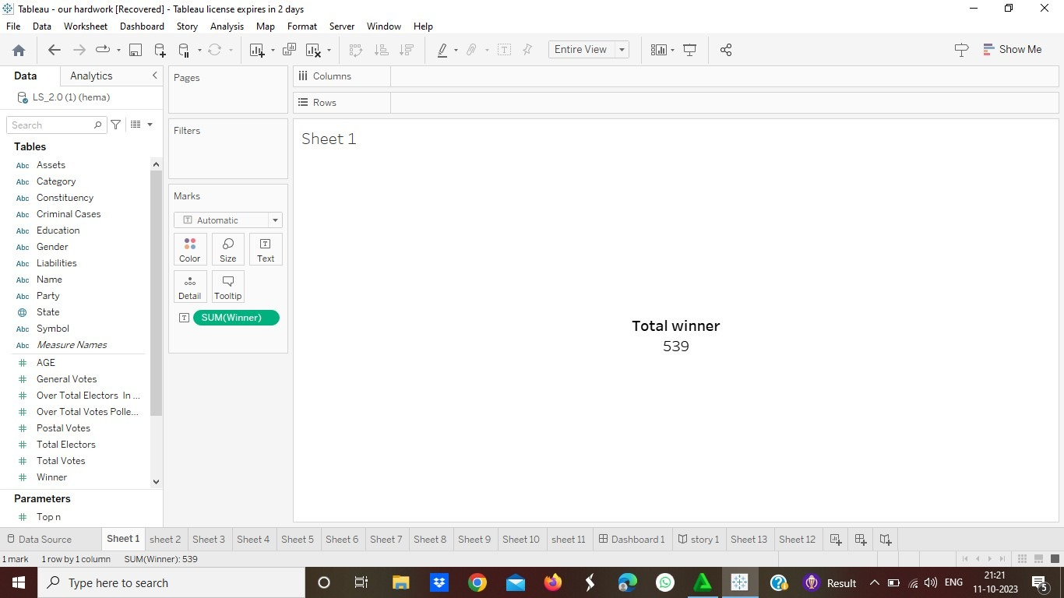

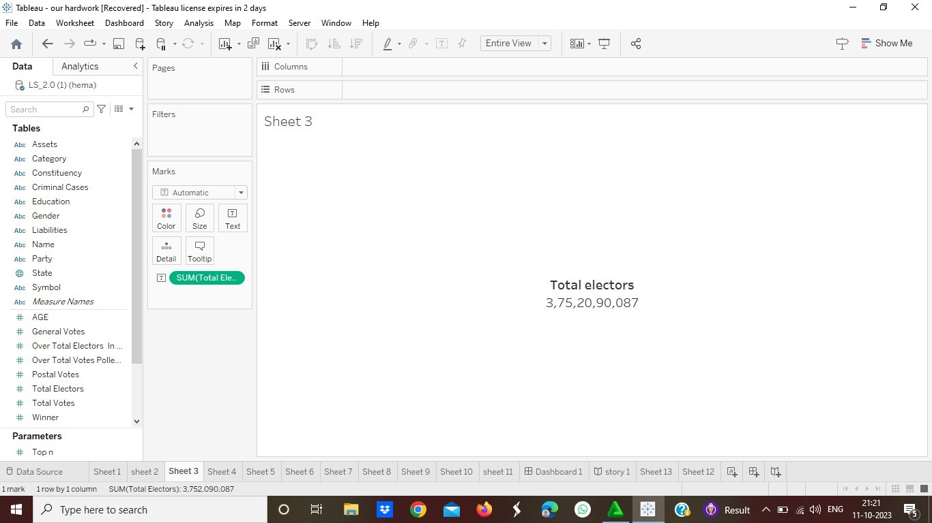

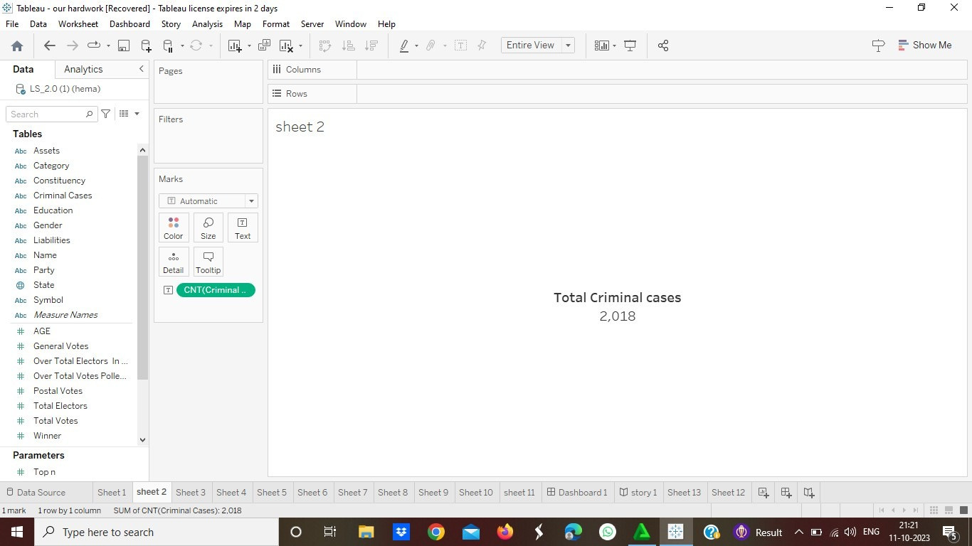

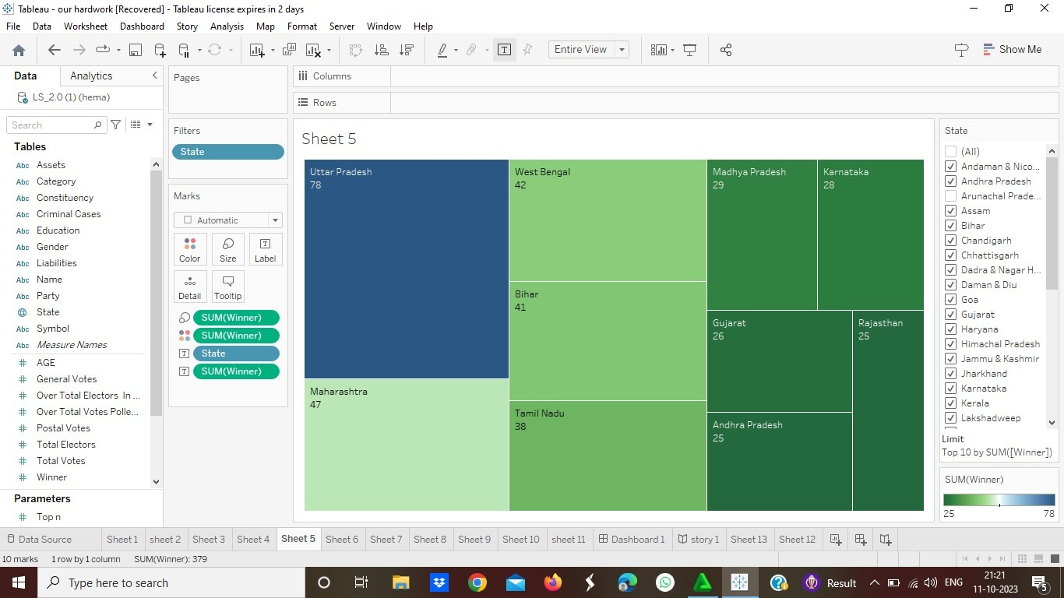

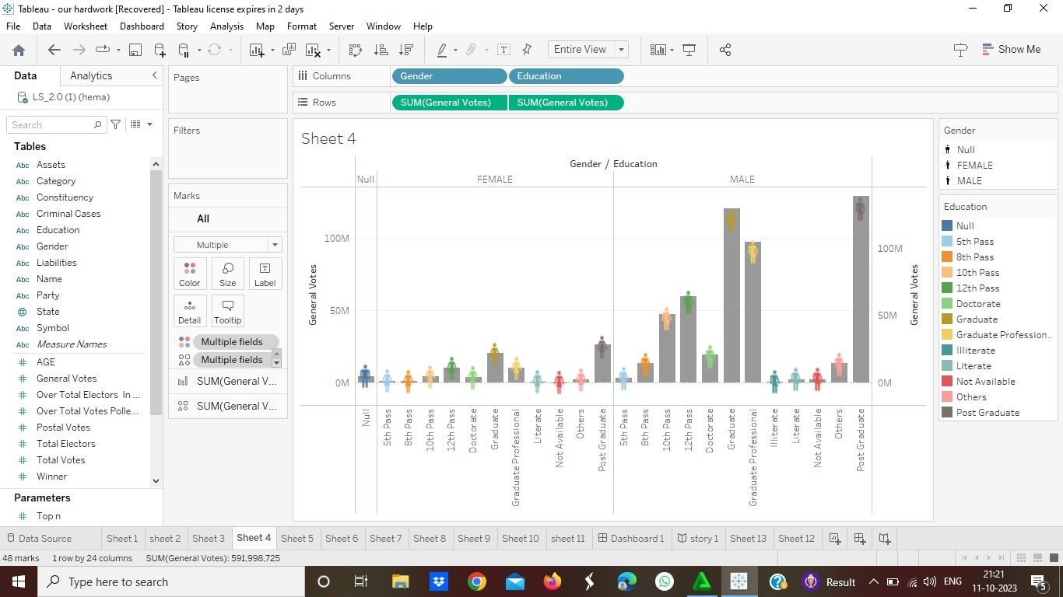

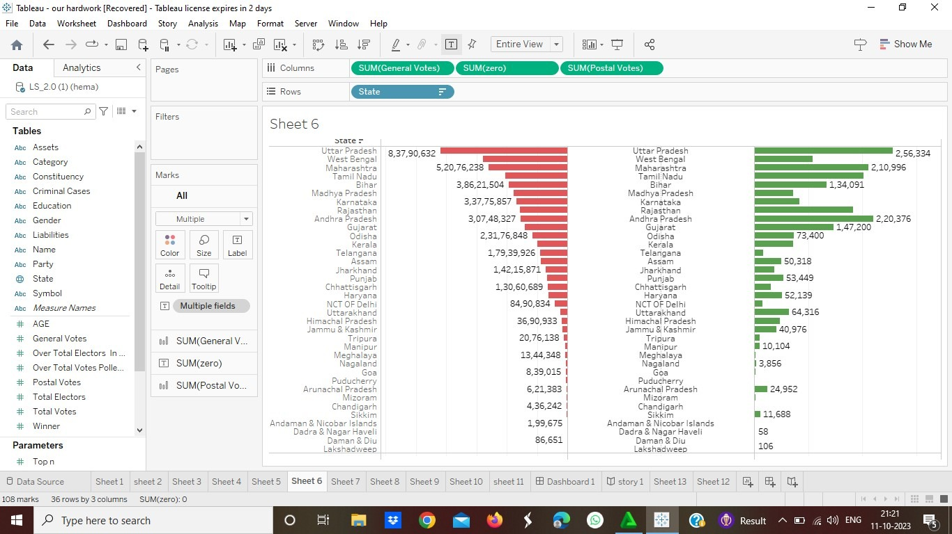

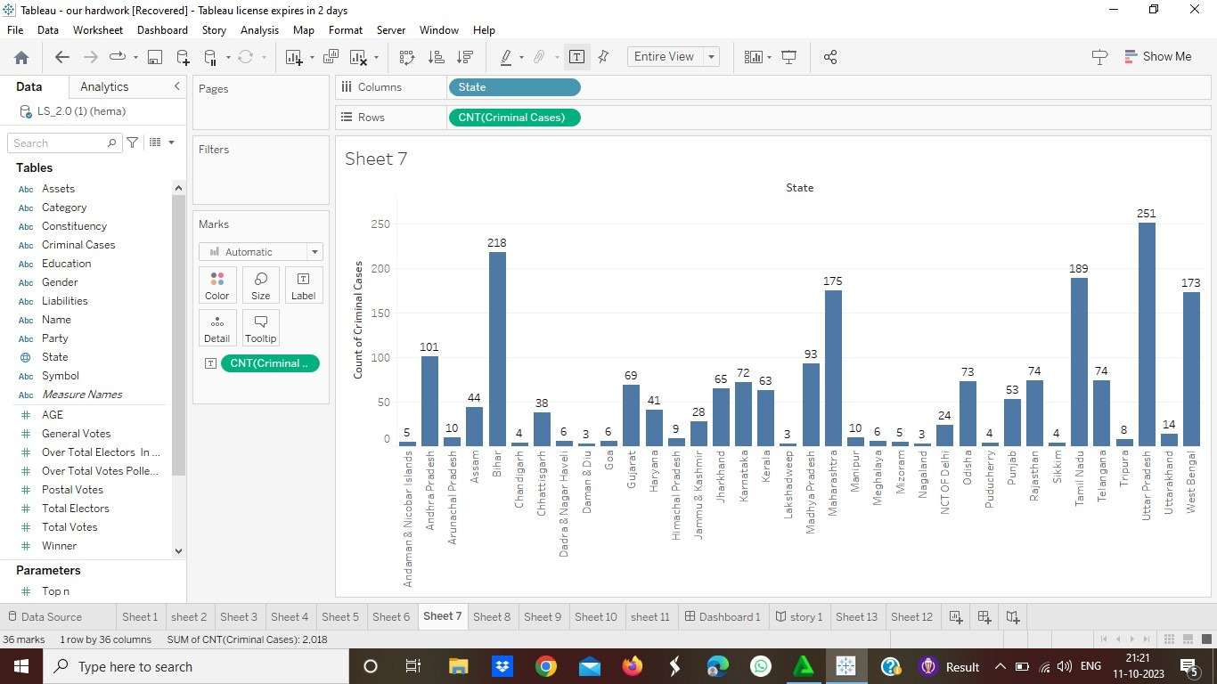

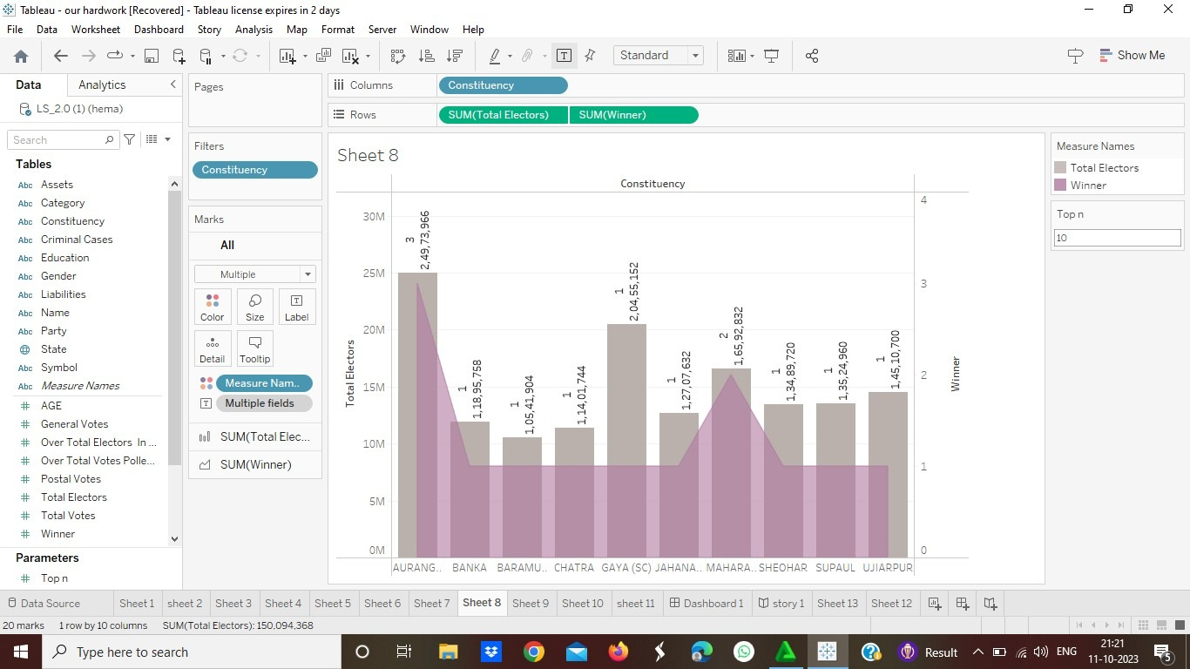

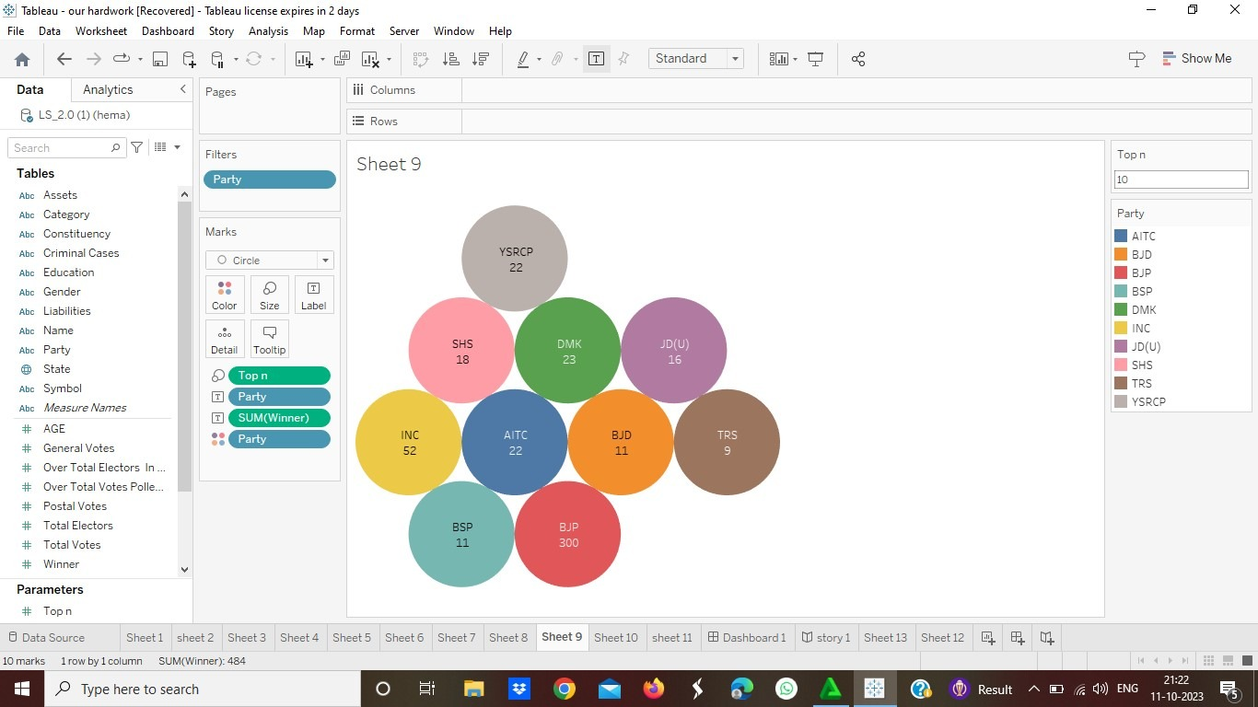

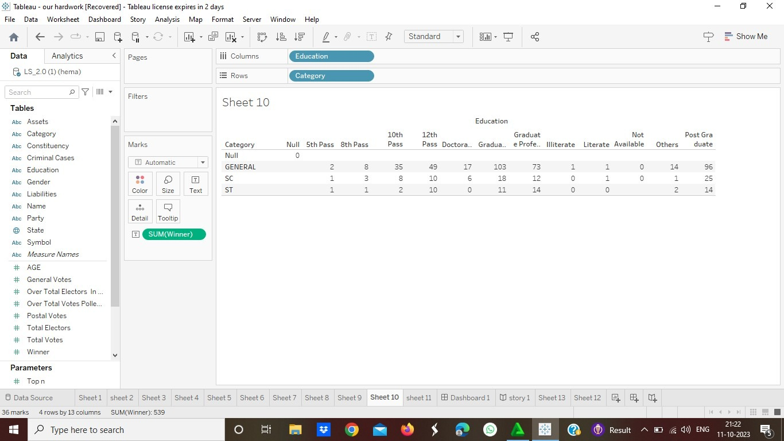

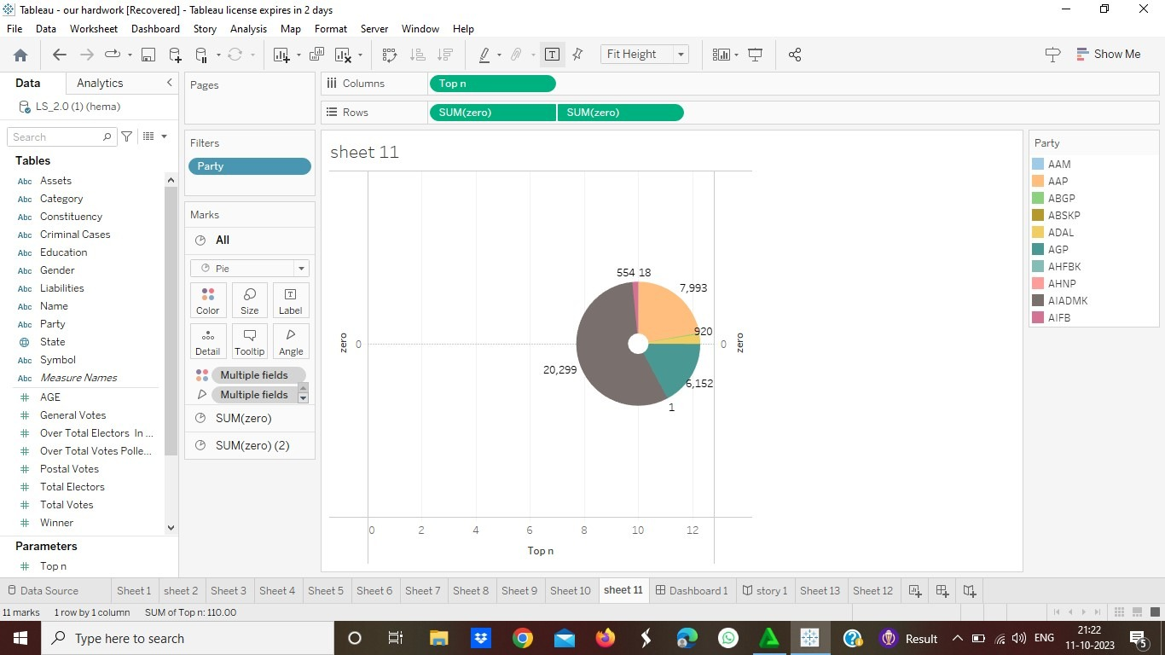

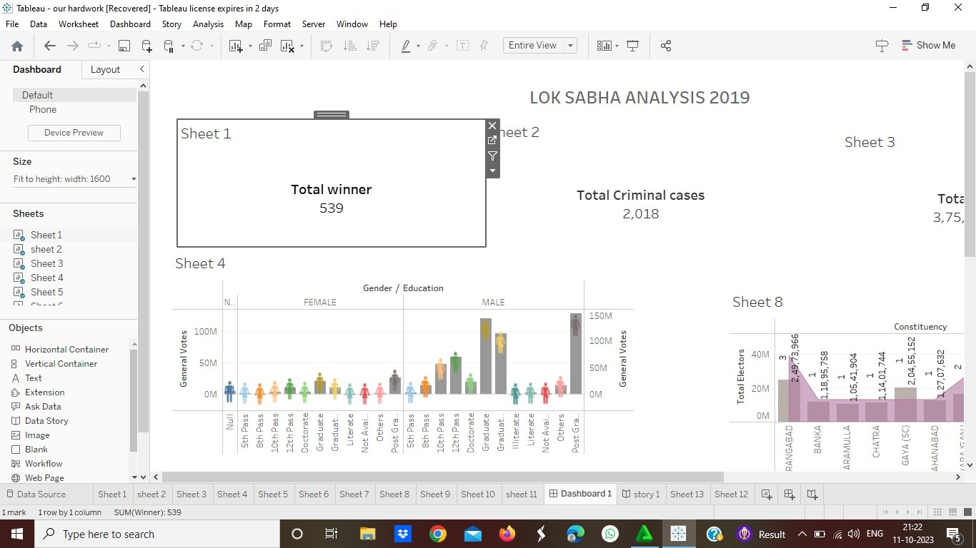

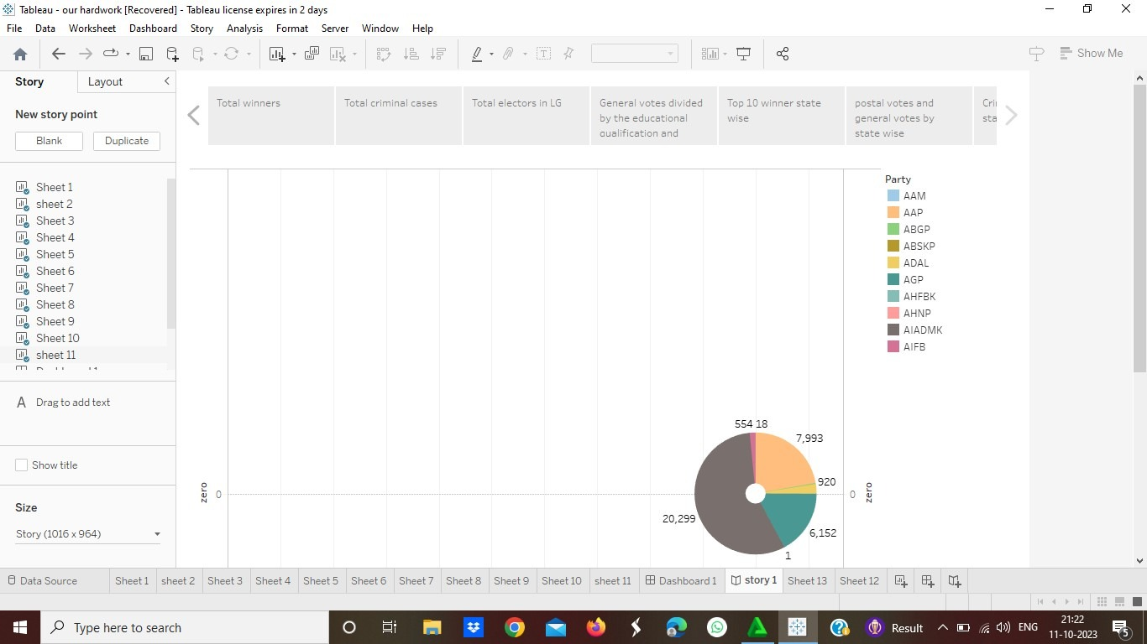

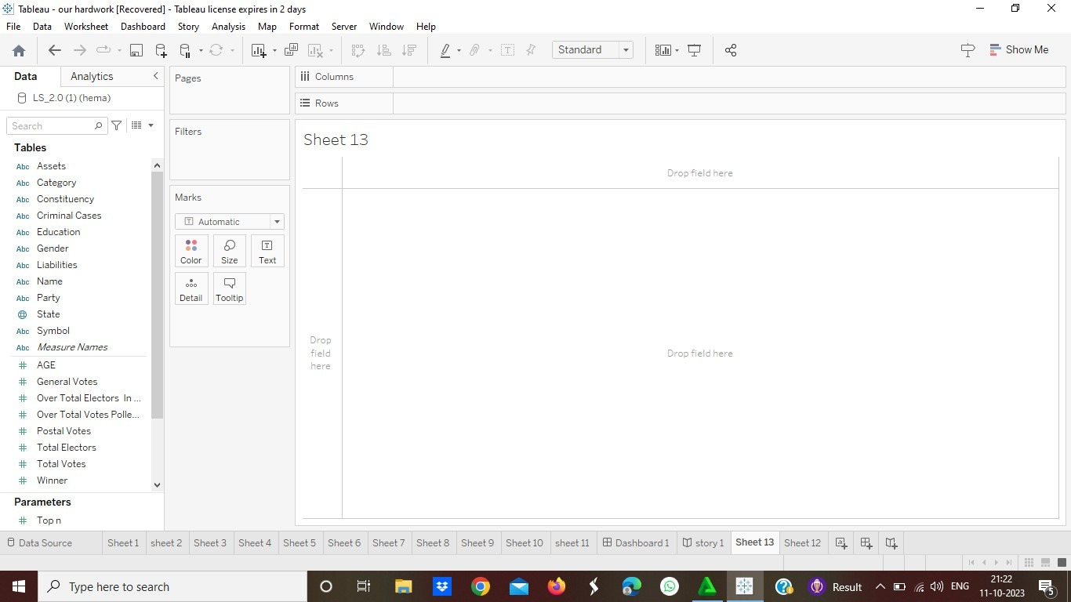

Application :

It brings clarity to people who were unaware of voting system.

It accumulate knowledgeable data to people to peer through the weaker section and weaker places of election. People get to know about about the candidates that helps them to choice the right one.

Conclusion :

In a democratic country, every person has the right to showcase his political views. This is called suffrage. It is the prime element of the election. Going a step ahead, we need to find out who can cast their votes. People of all ages will not be able to commend the importance of voting and choosing a leader.hence this analysis will useful to people.

Future scope :

India has been exploring the possibilities of implementing a remote voting system through technologies such as blockchain since the past few years. The Election Commission has taken up this idea with enthusiasm, and has been working towards initiatives that could bring a blockchain-based remote voting system to reality.

Appendix

https://public.tableau.com/app/profile/hemalatha.i/viz/LOKSABHAANALYSIS2019STORY/Story1