**KODERAT E RINJ**

[**www.HOW2**](http://www.koderaterinj.com/)**.CODES**

Function Specification

Contents

Overview 3

Methodology 3

Technology 3

Main feature 3

Objectives 4

Target Audience 4

Sitemap 4

Height-level Flow 5

Wireframe 6

Non-Functional Requirements 10

Graphic Design 10

Responsive Web 10

Timelines 12

Testing Scenarios 13

# Overview

Project called “HOW2.CODES” is web based software application to teach kids how to code. It’s focused in basic operation, add information, refresh information, browse information, search information, like, comment and share every information.

All information will be presented with text, photo and video. All of that information will be presented step by step and will be clear to all.

This website will be too easy to use by beginners and advanced users.

# Methodology

This project will be delivered in a 3 phases:

## Technology

This web application will be developed using:

* Database: MySQL
* Programing language: PHP, Laravel
* Client Side: CSS3, HTML3, Bootstrap Framework, jQuery
* Server: Apache
* IDE: Sublime Text 2

# Main feature

HOW2.CODES is an website allowing visitors to teach how to code.

Individual functions include:

* Browse information
* Search information
* View an article details (with up to one image and one thumbnail and a video)
* Like information
* Comment articles
* Share information

Administrative functions include:

* Add / edit / delete categories
* Add / edit / delete information

# Objectives

We need a website to create a place from which children’s can learn how to start coding. If our website is a place where children’s keep as reference for themselves and refers to others to learn coding then we can say outcomes are achieved. Objectives are measurable because are a lot of kids who want to start coding.

# Target Audience

The target audience of the site would be the general kids, young people and professors who are interested to teach and learn about coding.

# Sitemap

**Main navigation:**

* Home
* About us
* Learn
* Teach
* Search
* Sign in

**Administrative navigation:**

When the site administrator is logged in, the Main Navigation will change to the following:

* Home
* Information
* Logout

# Height-level Flow

Below is the high-level flow for the functions a visitor/customer can perform in these areas:

Browse information

Information detail

Select information

Back to information

Select info

# Wireframe

**User**

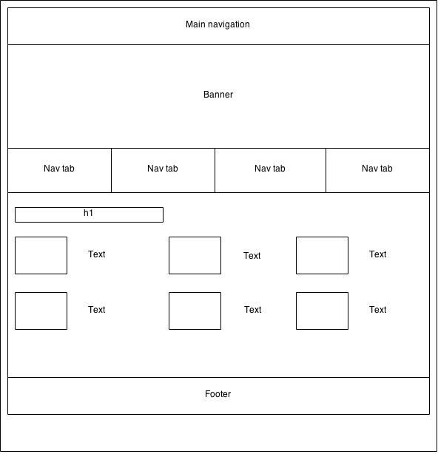

Fig.1 Homepage

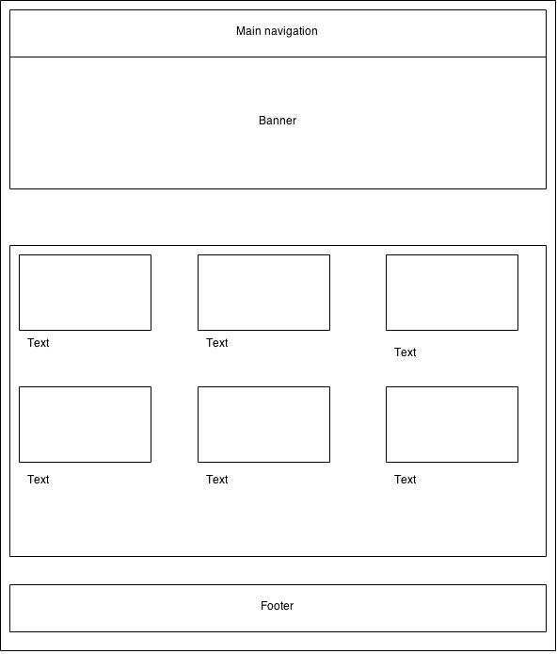

Fig.2 Section

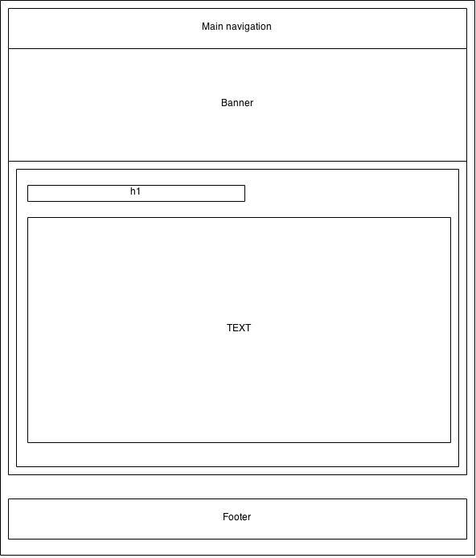

Fig.3 Article

**Administrator**

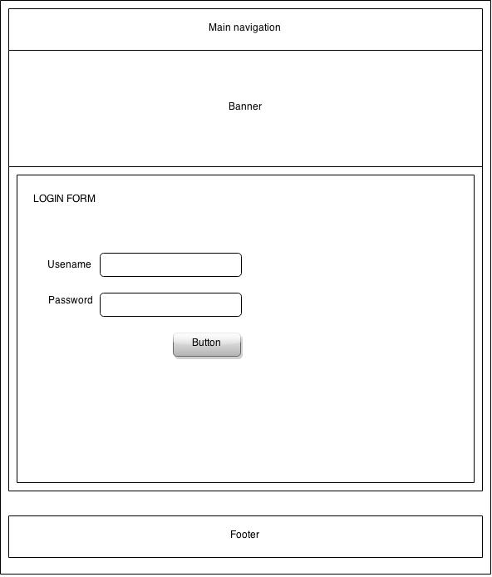

Fig. 4 Admin Login form

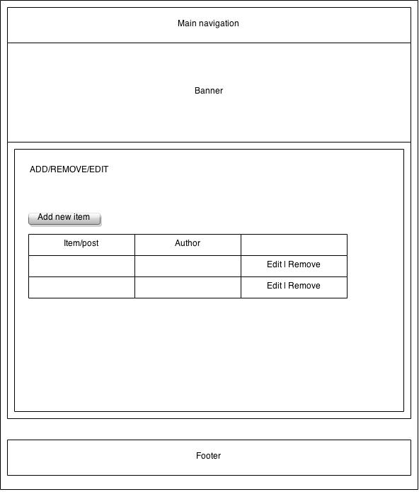 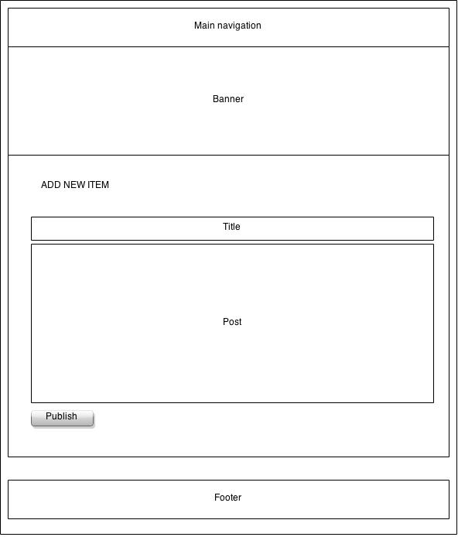

Fig. 5 Add/edit/remove form

# Non-Functional Requirements

* Accessible – Accessible from different devices
* Responsive / Performance – Response times. Speed of page loads and calculations
* Usable – Easy to use by target users. Both humans and web crawlers

# Graphic Design

## Responsive Web

Our approach to this solution will be Responsive Web – creating a more flexible, more responsive approach to designing for the web solution.

The benefits of this adaptive approach are:

* The solution will be available to the user regardless device or screen size “One size to reach them all”
* Smoother user experience, the user receives an optimized experience based on their device
* Prepared for future needs. New devices with different screen size are continually begun created.

The solution will use the same bask end logic. Only presentation layer will take of delivering different experience depending on the screen size and type of device.

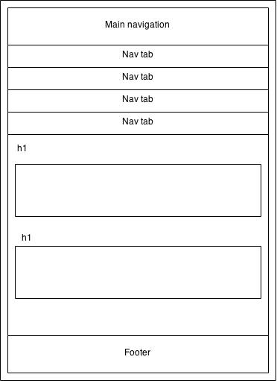

Fig.5 View on mobile screen

# Timelines

|  |  |  |  |  |  |  |  |  |
| --- | --- | --- | --- | --- | --- | --- | --- | --- |
| **Jan 12 - 19** | **Jan 19 - 26** | **Jan 26 - Feb 2** | **Feb 2 - 9** | | **Feb 9 - 16** | **Feb 16 - 23** | | **Feb 23 – Mar 2** |
| **W1** | **W2** | **W3** | **W4** | | **W5** | **W6** | | **W7** |
| Choosing a name for the company | Building a Responsive Website Exercise Assignment |  | Analyze the workload for front-end development of final project | | | Developing the remaining of the elements of the website | | |
| Finding a domain name and hosting | Developing the main Front-End pages of website | | | Delegate tasks to each member | | | Making the website ready to be integrated with the back-end | |
| Specifications for the website |  | | | Developing the homepage and a side page for final project | | |  | |

# Testing Scenarios

Before handing in the final end product that is a designed and developed “Koderat e rinj Website”, this will runs out of scenario tests and checks all defined quality elements.