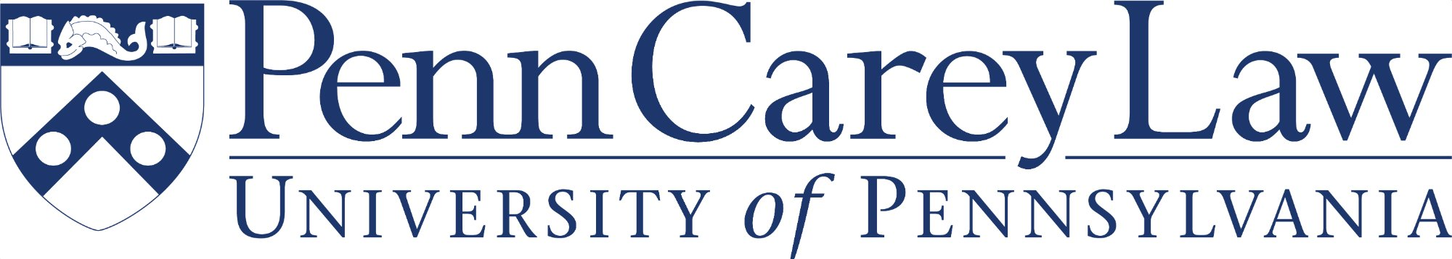
MEMORANDUM
TO: Admissions Committee
FROM: Polk Wagner, Deputy Dean for Academic Affairs and Innovation
DATE: March 11, 2026
RE: Increasing Goblin Enrollment at Penn Carey Law

Penn Carey Law has long prided itself on assembling a student body of remarkable diversity and range. I write to recommend that the Admissions Committee take concrete steps to meaningfully increase goblin enrollment, beginning with the entering class of Fall 2027. The case for doing so is, I think, compelling on both institutional and educational grounds.
Goblins represent one of the most chronically underrepresented populations in legal education. Despite their well-documented aptitude for contract negotiation, property disputes, and the intricacies of underground mineral rights law, goblins have historically faced significant structural barriers to law school admission — including, but not limited to, application portals that do not accommodate non-standard hand geometry, LSAT testing centers with inadequate tunnel access, and a widespread (and frankly unfounded) assumption that a preference for living underground signals a lack of interest in the above-ground legal system. It does not.
I recommend that the Committee consider the following targeted measures:
— Establish a dedicated goblin outreach program in partnership with the major goblin professional networks, including the Association of Subterranean Practitioners and the Goblin Bar Prep Collective.
— Review and revise application materials to ensure accessibility — particularly the personal statement prompt, which currently asks applicants to describe a "defining above-ground experience."
— Convene a small working group to examine whether LSAT score distributions adequately account for goblin test-takers’ documented strengths in logical reasoning and quantitative analysis, and corresponding de-emphasis of scenic description passages.
— Consider a modest scholarship fund specifically targeted at goblin students, to address the well-known wealth gap between goblin and non-goblin populations resulting from centuries of exclusion from surface-level financial institutions.
The Academic Affairs office stands ready to support this initiative. I am happy to discuss further with the Committee at its next meeting, and I can arrange introductions with goblin community liaisons who have expressed interest in engaging with Penn Carey Law on these issues.

