**Flappy Bird**

Sapphire Group

**Introduction**

Flappy bird was an addictive mobile game which received a well acceptance among players however it had been stopped later by the owner. We implemented the game with some twists like adding level of difficulty which comes with different number of lives and different distances of columns as well as other changes to overcome some critics that the original game received one of which the game was so difficult to play so that we create it with slightly easier way to win the game.

**Start Screen**

When a player starts the game it starts with a screen which displays options to set the sound on/off and the level of difficulty for the game. The game has three levels of difficulty easy, normal and hard. The easy level Flappy has five lives and the top and bottom columns distances are wide open as well as having long period between one column pair to the next. In the normal level the bird has three lives and slightly closer distances of the columns. In the hard level the bird will have one live and the columns distance gets further closer to each other. The player has option to reset the best score which is displayed alongside with the current score. Please see Figure1.

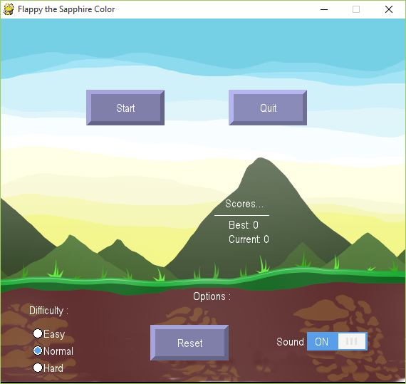

Figure 1 First screen provides options and enable user to start the play

**Game Play**

The game’s goal is to fly the bird passing though as much as columns without colliding with them. By passing each column a point will be counted for the player. If the bird collides with columns or with the top and bottom of the screen one live will be lost and the game will be over if it is the last live. During the game player should control the bird to make it fly up and down. Each fly up and fly down of the bird have certain speed and duration, the player should guess the right timing to command the bird to fly up.

Important Keys to play the game:

1. Mouse click, space, up key, enter: to fly up
2. p key: to pause and resume the game
3. escape key: to quit the game and return to the first screen without finishing the game

**Game Development**

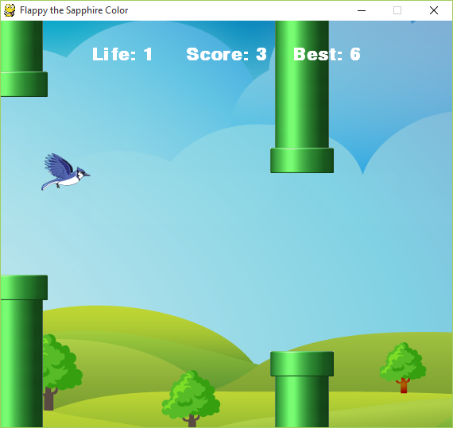

Figure 2 A screen Shot during the game paly

This game consist of multiple classes and a main function which is in main.py file. The classes are flappy which represent the bird, column which represent the obstacles for the flappy to fly through, param which contain all game numeric parameters and responsible of saving and loading game statues and images, and multiple classes which represent users GUI and catches actions on them (like click, select)

**GUI classes**

For the graphical user interface which communicate with users like button switch radio we used sgc package which has been created on top of pygame package to be consistent in trapping events by using single loop for that purpose. To handle user event like on_click and select we had to create subclasses of the existing GUI elements like button, radio and switch and implementing event methods for them. The subclasses which we create are: StartButton, StopButton, ResetButton, SoundSwitch, EasyRadio, NormalRadio and HardRadio

**Flappy** **class**

This class represents the bird’s location and dimension and it’s responsible for moving the bird up and down in response to players’ action and to flapping the wings.

**Columns** **class**

This class represent obstacles to the flappy to fly through the column consist of two pieces top and bottom pieces which the flappy should fly through.

**Play class**

This class represents game play logic and draws all elements on the screen the elements are flappy, the columns, the best score, the current score and the remaining life of flappy.

**Param class**

This class contains all important constants which has been used in the game so that the can be saved, loaded and changed to represent different levels of the difficulty of the game. This class also responsible of changing deferent measures like fame to milliseconds and vice versa.