Dr

Polla Fattah

Lecturer

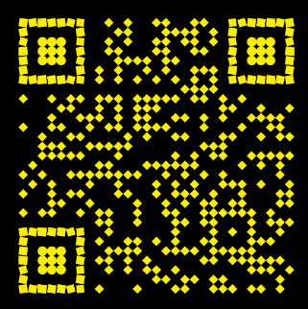

academics.su.edu.krd/polla.fattah

polla.fattah@su.edu.krd

0750 446 3750

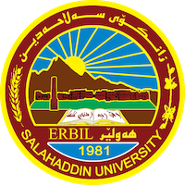

University of Salahaddin-Erbil

College of Engineering

Software Eng. Dept.