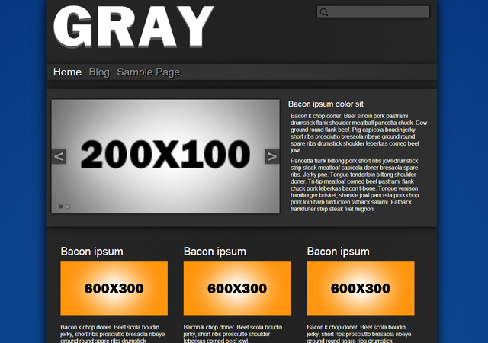

|  |  |
| --- | --- |
| By: Michael Pollind  Created: 9/3/2013  Email: contact@baseplatedesigns.com | Thanks you, for downloading Gray. If you have an additional question feels free to use the given email or drop a line via this contact form [here](http://baseplatedesigns.com/?page-id=Contact%20Us). |

Table of Contents

**CSS2**

**Theme Options3**

**Page-Template**………………………………………………………………………………………………………………………..…………….**4**

CSS

This theme uses a single large CSS file given that the theme doesn’t changes a lot from page to page.

The CSS is organized into these sections:

/*BASIC STRUCTURE----------------------------------------------*/

[CSS]

/*SIDEBAR-------------------------------------------------*/

[CSS]

/*COMMENTS-------------------------------------------------------*/

[CSS]

/*HEADER-----------------------------------------------------------*/

[CSS]

/*POST---------------------------------------------------------------*/

[CSS]

/* SLIDE PRESENTATION------------------------------------------*/

[CSS]

/*FOOTER---------------------------------------------------------*/

[CSS]

/*CLASSES------------------------------------------------------*/

[CSS]

/* WordPress Core-------------------------------------------------------------- */

[CSS]

Theme Options

The theme options are located under, “appearances/theme options”. This is where the content for the home page itself can be modified.

* Slides : slide show on the left
  + Add Slides: adds a slide
    - Empty fields will be removed
    - A single slide will be displayed alone by itself without slide show
  + Enable HTML input: will plug the html itself directly into the slide without the containing img tag
  + Upload image: loads an image and drops the images url into the text area
  + Remove: removes slide
* Blurb: statement on the right of the slide show
* Left header box: below slide show container and to the left with a given title, image and content
* Middle header box: below slide show container and in the middle with a given title, image, and content
* Right header box: below slide show container and to the right with a given title, image, and container

Page-templates

This theme uses 4 page templates. One displays the main home which can be seen in the window of the appearance tab with this selected theme. There are two versions of the given page, one with the default home and another with a sidebar and two of the most current post. The full width template will display on a full page without a sidebar and the default on the other hand will have the sidebar.

* Default Template: Default is the General page with a sidebar on the right and the main content on the left.
* Full Width Template: displays the title with given content and no sidebar
* Front Page Template: displays the Front page and any content will be displayed below the three header boxes.
* Front Page Template with Post: displays the front page but with a blog on the bottom with a sidebar and the two most current posts. Any content written into the editor will appear between the three header boxes and section of the blog.