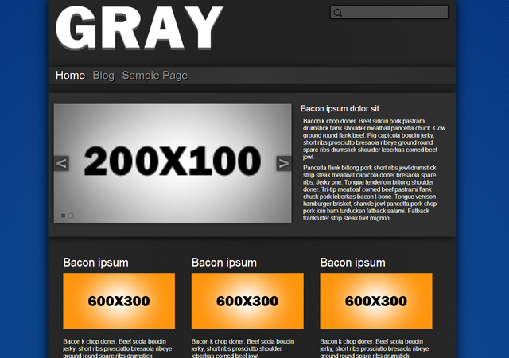

|  |  |
| --- | --- |
| By: Michael Pollind  Created: 9/3/2013  Email: contact@baseplatedesigns.com | Thanks you, for downloading Gray. If you have an additional question feels free to use the given email or drop a line via this contact form [here](http://baseplatedesigns.com/?page-id=Contact%20Us). |

Bundled images are licensed under the GPL. Copyright 2013

Table of Contents

**CSS2**

**Theme Options3**

**Page-Template**………………………………………………………………………………………………………………………..………………**4**

CSS

This theme uses a single large CSS file given that the theme doesn’t changes a lot from page to page.

The CSS is organized into these sections:

/*BASIC STRUCTURE----------------------------------------------*/

[CSS]

/*SIDEBAR-------------------------------------------------*/

[CSS]

/*COMMENTS-------------------------------------------------------*/

[CSS]

/*HEADER-----------------------------------------------------------*/

[CSS]

/*POST---------------------------------------------------------------*/

[CSS]

/* SLIDE PRESENTATION------------------------------------------*/

[CSS]

/*FOOTER---------------------------------------------------------*/

[CSS]

/*CLASSES------------------------------------------------------*/

[CSS]

/* WordPress Core-------------------------------------------------------------- */

[CSS]

Theme Options

The theme options are located under, “appearances/theme options”. This is where the content for the home page itself can be modified.

* Slides : slide show on the left
  + Add Slides: adds a slide
    - Empty fields will be removed
    - A single slide will be displayed alone by itself without slide show
  + Enable HTML input: will plug the html itself directly into the slide without the containing img tag
  + Upload image: loads an image and drops the images url into the text area
  + Remove: removes slide
* Blurb: statement on the right of the slide show
* Left header box: below slide show container and to the left with a given title, image and content
* Middle header box: below slide show container and in the middle with a given title, image, and content
* Right header box: below slide show container and to the right with a given title, image, and container

Page-templates

This theme uses 1 page templates. The full width template will display on a full page without a sidebar and the default on the other hand will have the sidebar.

* Default Template: Default is the General page with a sidebar on the right and the main content on the left.
* Full Width Template: displays the title with given content and no sidebar