1.

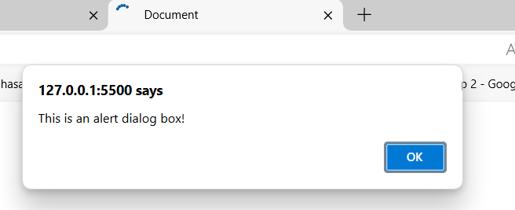

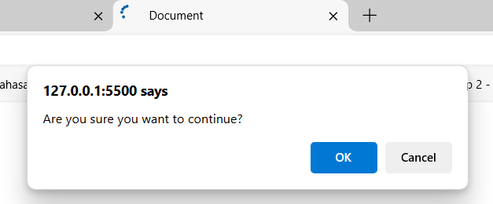

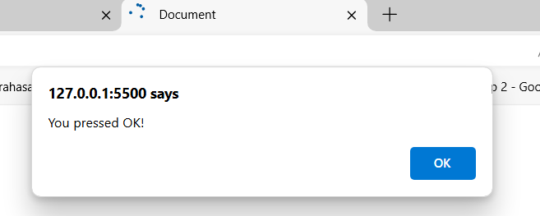

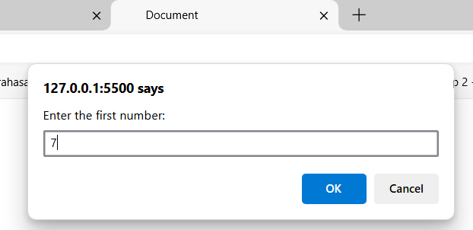

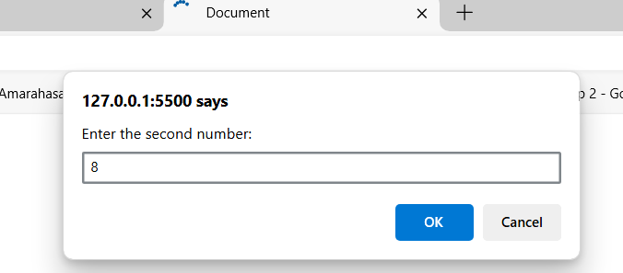

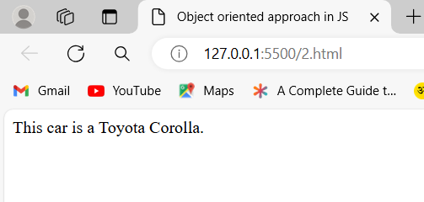

3.

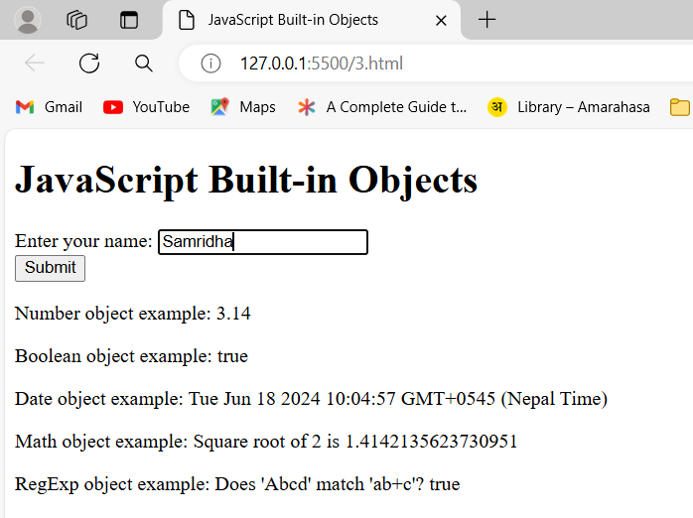

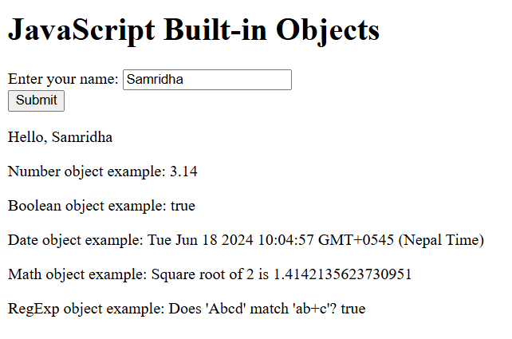

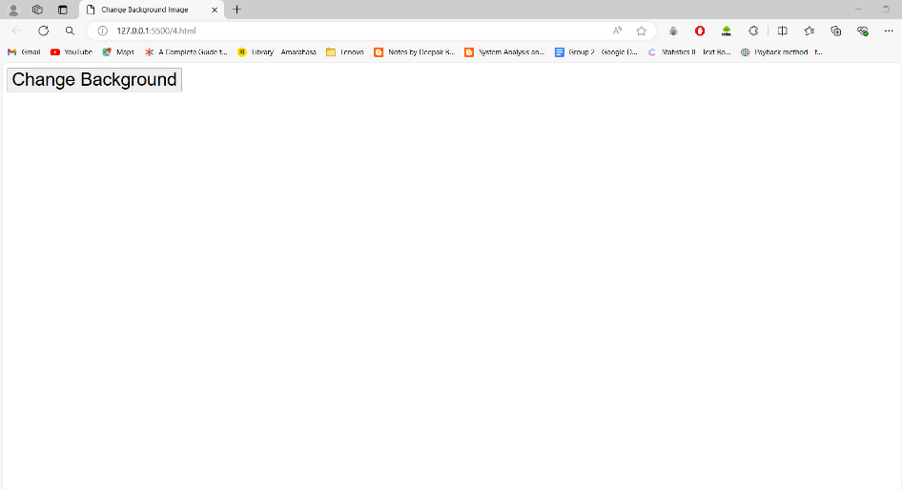

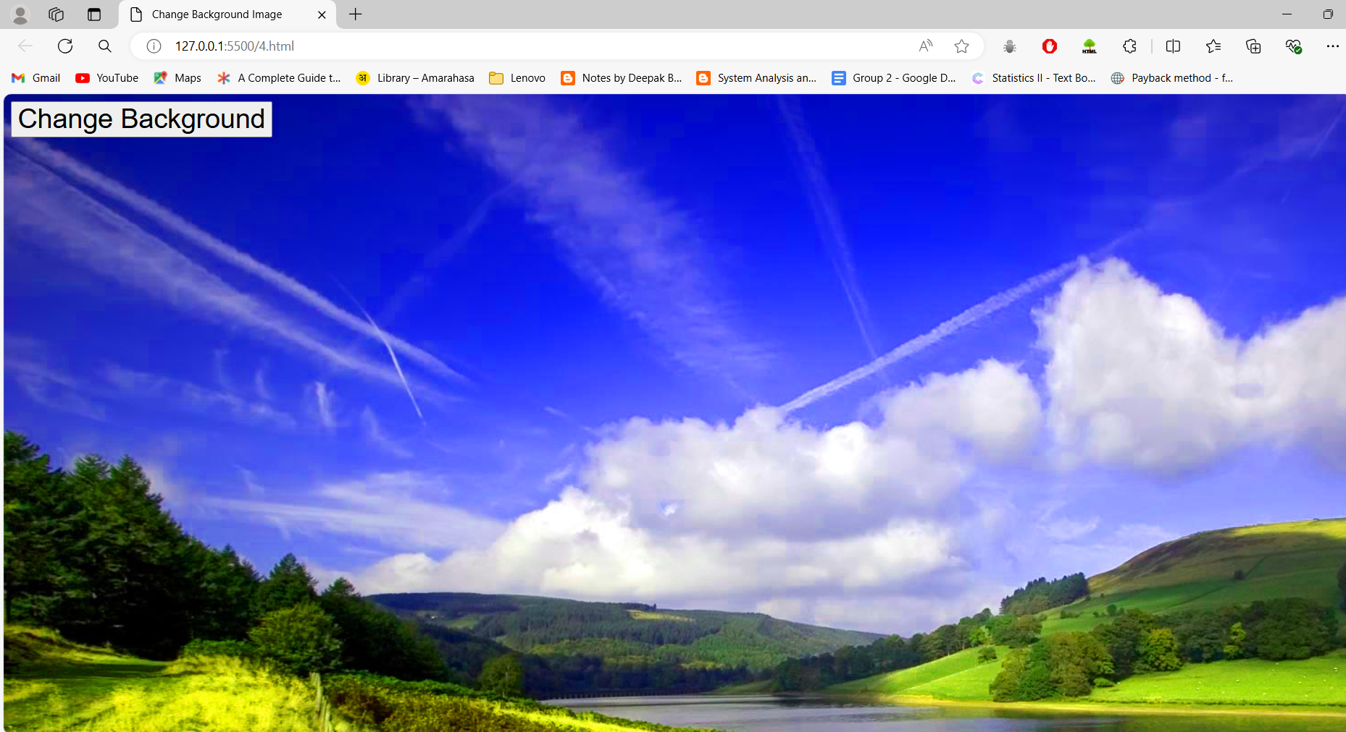

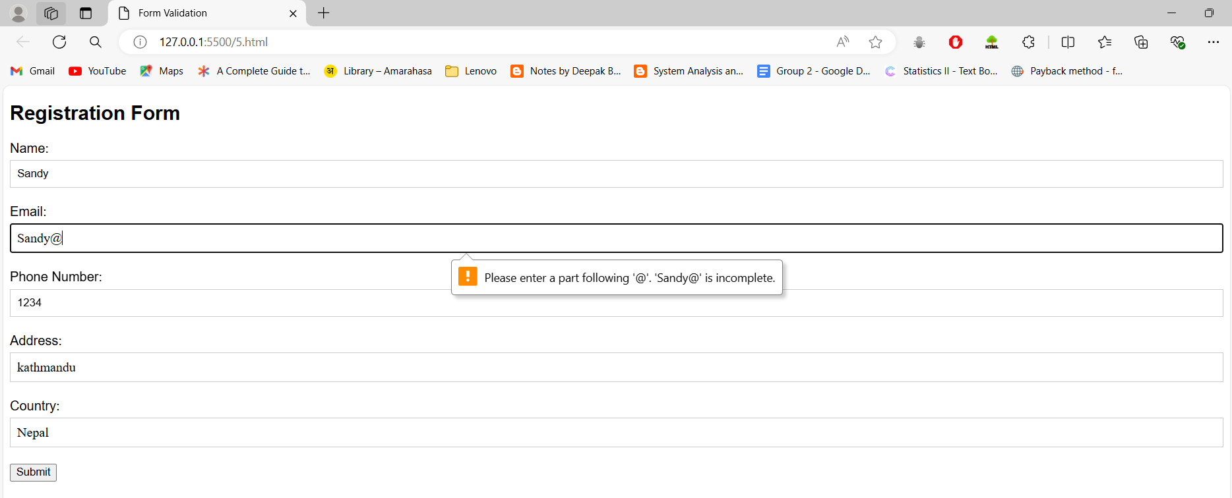

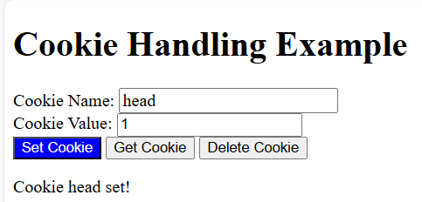

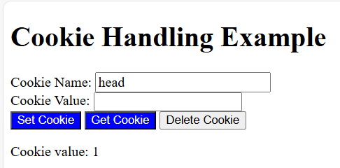

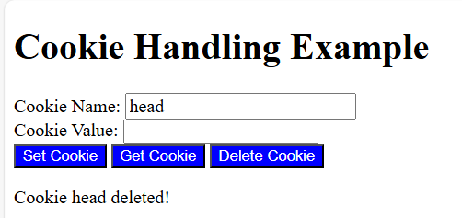

Initially:

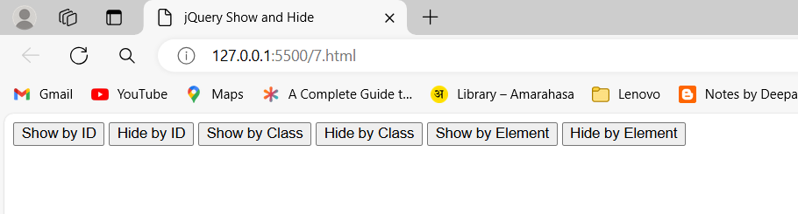

After clicking show by ID

After clicking hide by ID

After clicking show by class

After clicking hide by class

After clicking show by element

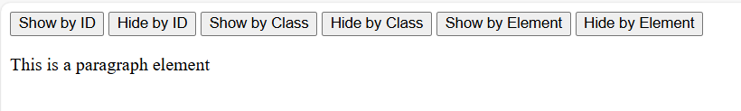

After clicking hide by element

