Supplementary figures
Project Title: Assessing Spatio-Temporal Precipitation Variability and Extreme Events in India
Figure 1
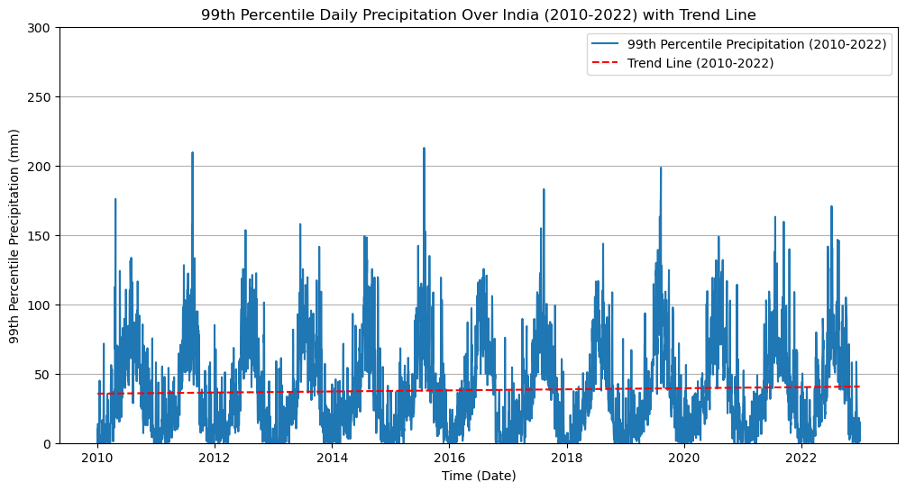99th percentile of daily precipitation over India from 2010 to 2022
Figure 2
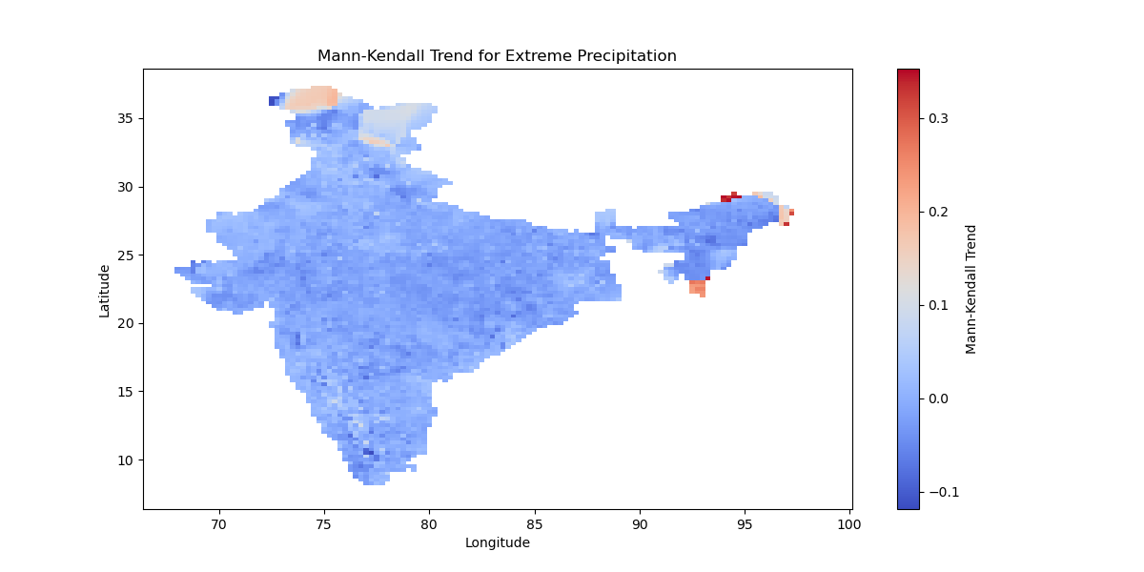Spatial plot of India with values of extreme precipitation showing an increasing trend
Figure 3
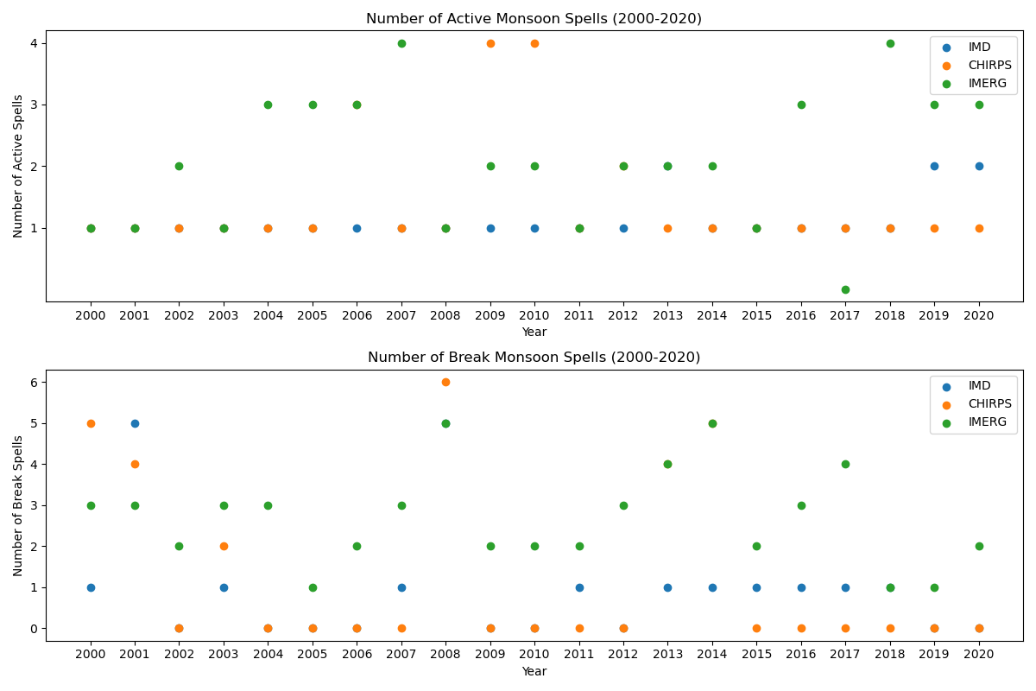
Comparison of IMD, IMERG and CHIRPS datasets in capturing active and break spells of Indian monsoon

