Final Project
Polls Duong
CSE 622

Problem Summary and Assumption
Given an even number of participants, the objective is to simulate how a rumor about an unconfirmed new discovery spread among a group of people. The parameters specify that there are four satellite rooms, with participants divided equally among them. Initially, four individuals begin spreading the rumor, each starting in a different room. When two participants meet, there is a 50% probability that the rumor will be shared. Once a person has heard the rumor twice, they assume that everyone is already aware of it and will no longer attempt to spread it. After some time, all participants gather in a fifth main room, where a coordinator announces that a rumor has been spreading and asks about it. The goal of this simulation is to determine how the average percentage of participants who have heard the rumor changes based on the number of participants and the amount of time allowed for the rumor to spread. We assume that each person who knows the rumor has a 50% chance of spreading it. Additionally, once a person has heard the rumor twice, they will no longer share it. Each interaction between participants lasts one minute before they are randomly paired with a new partner.
Design
The design approach began by creating a simulation for a single instance. Two lists were used: one to track whether each participant has heard the rumor, and another to track how many times each participant has heard it. These lists were initialized so that no participant had heard the rumor and all counters were set to zero. After initialization, the participants were shuffled and evenly distributed into four rooms. One participant from each room was randomly selected as an initial rumor spreader. For each minute of the simulation, participants within each room were shuffled and paired randomly. For each pair, the simulation checks whether either participant can spread the rumor by verifying that they have heard the rumor and have heard it fewer than two times. If these conditions are met, there is a 50% probability that the rumor is shared with the partner. The simulation tracks the percentage of participants who have heard the rumor over time. After implementing a single simulation, a threshold-checking function was developed to determine the time required to reach specific percentages (10% and 50%). To obtain reliable results, a Monte Carlo simulation approach was used. The simulation was run 100 times for each scenario, and the results were averaged to estimate the expected percentage of participants who had heard the rumor at different time intervals. Graphs and tables were generated to visually represent the results.
Results Summary and Discussion
The simulation was conducted based on the following requirements:
- Average percentage of participants who have heard the rumor at T = 10 minutes for N = {1,000, 10,000}
- Average percentage at T = 30 minutes
- Average percentage at T = 60 minutes
- Time required for 10% of participants to hear the rumor (N = 10,000)
- Time required for 50% of participants to hear the rumor (N = 10,000)
The simulation was run 100 times, and the average percentage of participants who heard the rumor was recorded at each time interval. The graph shows how the percentage of participants who have heard the rumor evolves over 60 minutes. The blue line represents 1,000 participants, while the orange line represents 10,000 participants. The spread begins slowly but accelerates rapidly after approximately five minutes, eventually reaching around 90% by 30 minutes.
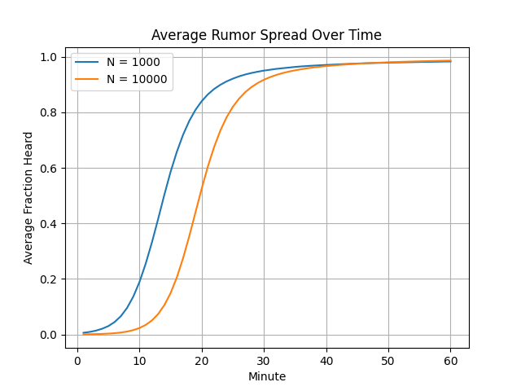
This table shows the average percentage of how many of the attendees have heard the rumors.
N | Avg % at 10 min | Avg % at 30 min | Avg % at 60 min
1000 | 18.11600000000000 | 95.30700000000000 | 98.84900000000000
10000 | 2.2808 | 91.73620000000000 | 98.62690000000000

This table shows the average time it took for rumors to reach the percentage of the attendee.
Metric | Value
Avg time to 10% heard | 14.49
Avg time to 50% heard | 20.3

Critical Thinking Summary
From the results, it is evident that as time progresses, the number of participants who have heard the rumor increases significantly. Interestingly, the total number of participants does not drastically change the overall spread behavior after sufficient time has passed. These findings can be interpreted in two ways. If the goal is to disseminate information efficiently, the simulation suggests that starting with a small number of individuals can still result in widespread dissemination within a relatively short period. Specifically, the rumor reaches nearly the entire population within approximately one hour. Conversely, if the goal is to contain misinformation, the results highlight the importance of early intervention. Once the rumor reaches a critical mass, it becomes increasingly difficult to control its spread. Early identification of the initial spreaders would be crucial in limiting dissemination. One limitation of this simulation is that it assumes exactly four initial spreaders. Future work could explore how varying the number of initial spreaders affects the rate of propagation. It is expected that increasing the number of initial spreaders would accelerate the spread, while reducing it would slow the process.
Conclusion
In this project, a Monte Carlo simulation was developed to model the spread of a rumor among a population divided into multiple groups. The results demonstrate that rumor propagation follows a nonlinear pattern, beginning slowly and then accelerating rapidly before eventually saturating as most participants become informed. The findings indicate that the total population size has a limited impact on the long-term spread, as both smaller and larger populations approach similar levels of saturation over time. However, larger populations exhibit a slower initial spread, requiring more time to reach early thresholds such as 10% awareness. Additionally, the simulation highlights the importance of early stages in rumor propagation. Once a rumor reaches a critical threshold, it spreads quickly and becomes difficult to control. This behavior underscores the importance of early intervention in scenarios involving misinformation or rapid information dissemination. Overall, this project demonstrates how simulation techniques can be used to analyze complex systems with uncertainty. By leveraging repeated trials and averaging results, the Monte Carlo approach provides meaningful insights into how information spreads within a population over time.

