6.5 Integrate JMeter with Jenkins

This section will guide you to:

* Configure JMeter with Jenkins.

This guide has five subsections, namely:

6.5.1 Install JMeter

6.5.2 Create test cases in Jmeter

6.5.3 Login to Jenkins

6.5.4 Add performance plugin

6.5.5 Create Jenkins job for JMeter

**Step 6.5.1:** Install JMeter

* Open your Linux terminal and run the below command to check if JDK is installed: **java -version**
* Click the following URL to download the latest version of JMeter. You can download the binary or source file of this tool from this location. Click on the ‘**Apache-JMeter-5.0.zip’**link to download the binary zip file of JMeter.

[**http://jmeter.apache.org/download_jmeter.cgi**](http://jmeter.apache.org/download_jmeter.cgi)

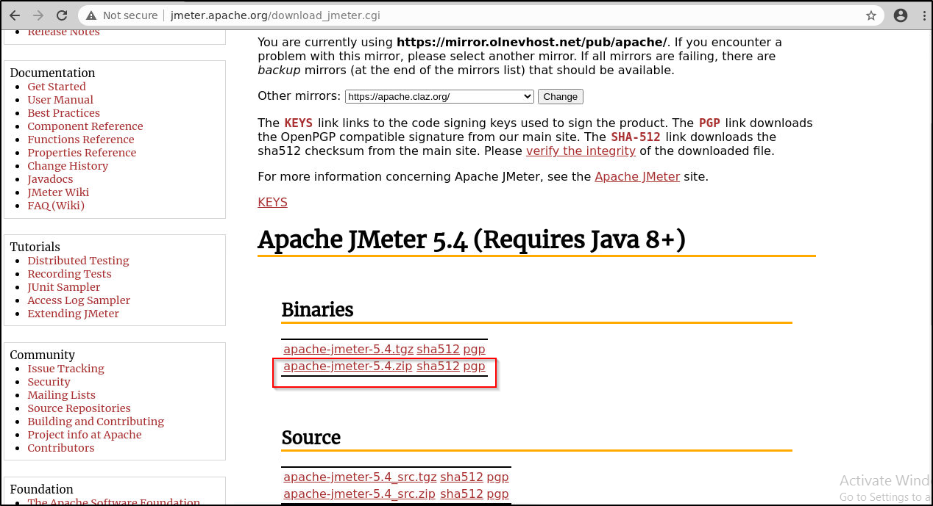

* The file will be downloaded in **the Downloads** folder. Run the following commands to extract the zip file.  
  **cd Downloads**

**unzip apache-jmeter-5.4.zip**

* Navigate to the bin of the unzipped folder:

**cd Downloads/apache-jmeter-5.4/bin**

Execute the below command to add the following line in user.properties file.   
**vi user.properties**

Add the below line in the file

**jmeter.save.saveservice.output_format=xml**

save the file and exit

* Run the below command to run Jmeter:

**./jmeter**

**Step 6.5.2:** Create test cases in Jmeter

* Once your jmeter opens up, give the name for the Test Plan as: **JmeterJenkinsIntegration** and click on the Save icon and select the **/home/labuser** folder as the location to save.

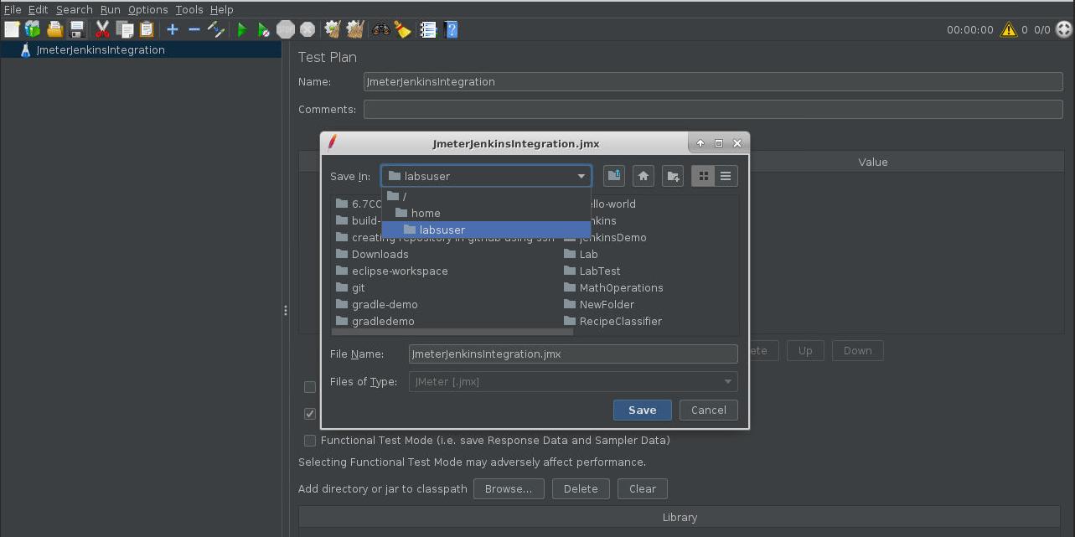

* Right click on **JmeterJenkinsIntegration** in the left pane and select add thread group as shown below:

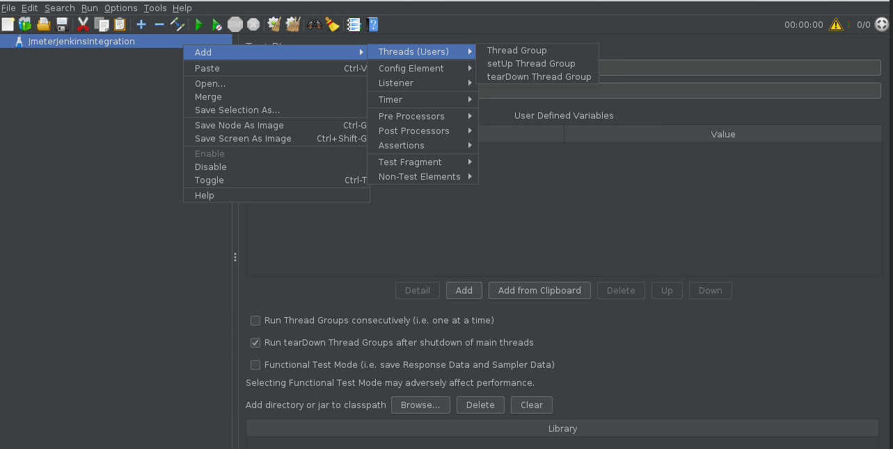

* Name your thread group as User.
* Right click on **User** -> **Add** -> **Sampler** -> **HTTP Request**.
* Enter the **server name** or IP : www.merriam-webster.com and **Path**: /word-of-the-day
* Right click on **User** -> **Add** -> **Listener**-> **View Results in Table**.

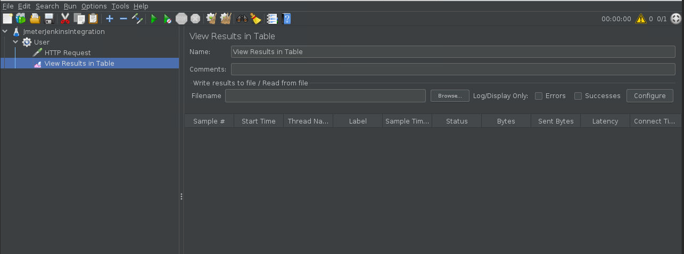

* Click on the run button to run the test.
* You can see the status marked in green once the test run is complete.

This means that the testcases are ready.  
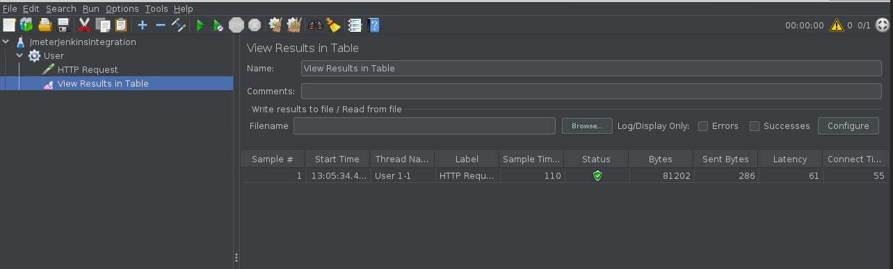

**Step 6.5.3:** Login to Jenkins

* Open your browser and navigate to **localhost:8081**
* Provide your username and password and click on **Login.**

**Step 6.5.4:** Add performance plugin

* Install the performance plugin via **Manage Jenkins -> Manage Plugins**.

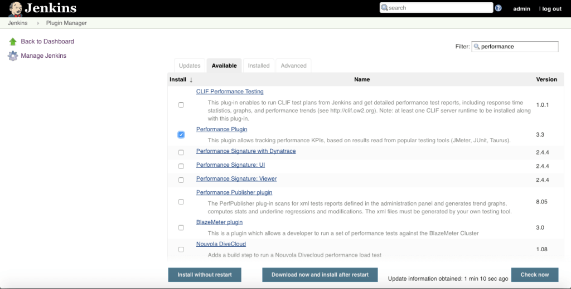

* Click on Install without restart.

**Step 6.5.5:** Create Jenkins job for JMeter

* Go to Jenkins home page and click on **Create New Job**, specify a name, select **Freestyle Project,** and click **OK**.
* Now you will have to configure the job. In the **Build** section, select **execute from shell** and enter the commands given below:

**cd /home/labsuser/Downloads/apache-jmeter-5.4/bin/**

**sh jmeter.sh -Jjmeter.save.saveservice.output_format=xml -n -t /home/labsuser/JmeterJenkinsIntegration.jmx -l /home/labsuser/TestResult1.jtl**

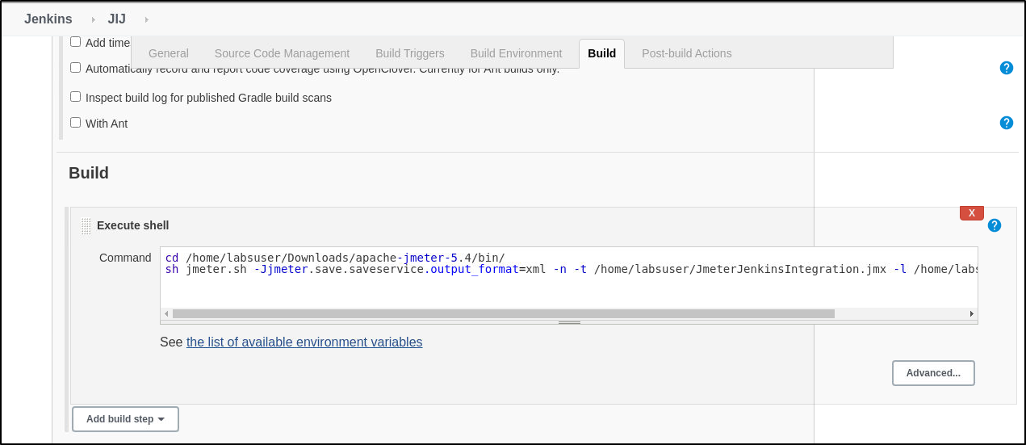

* In the **Post build Actions** sections, click on add a post build step and select **publish performance test result report**.

In the source data files textbox enter the path to your test result file. (ie. /*home/*labsuser/TestResult1.jtl)

Select the evaluation mode as : standard mode

Configure the job as shown in the screenshots.

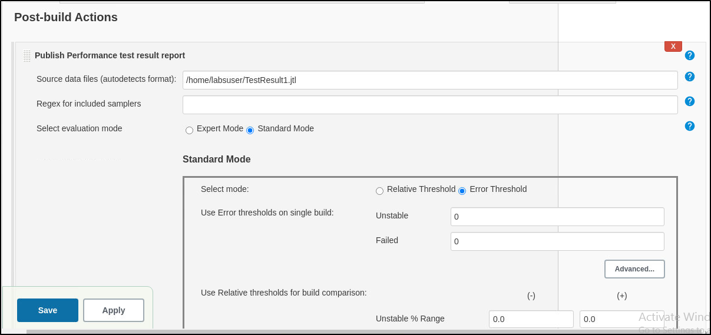

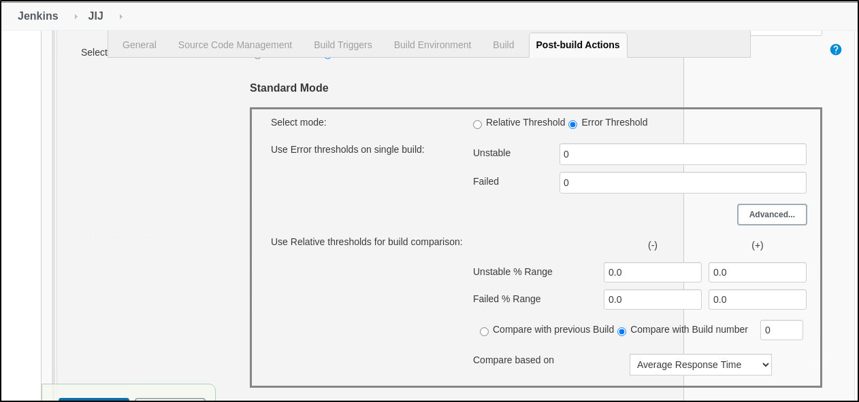

* Build the job and check the performance report in the job page.

