Rafting Site Plan
João Paulo Alves

Overview

Purpose
Our purpose is to expand this opportunity of having a healthy and fun familiar time to as much people as possible. Everybody should have such an opportunity and were are working on it!
Audience
Groups of friends,groups of company and school colleages, families looking for fun time;

Branding

Website Logo

Style Guide

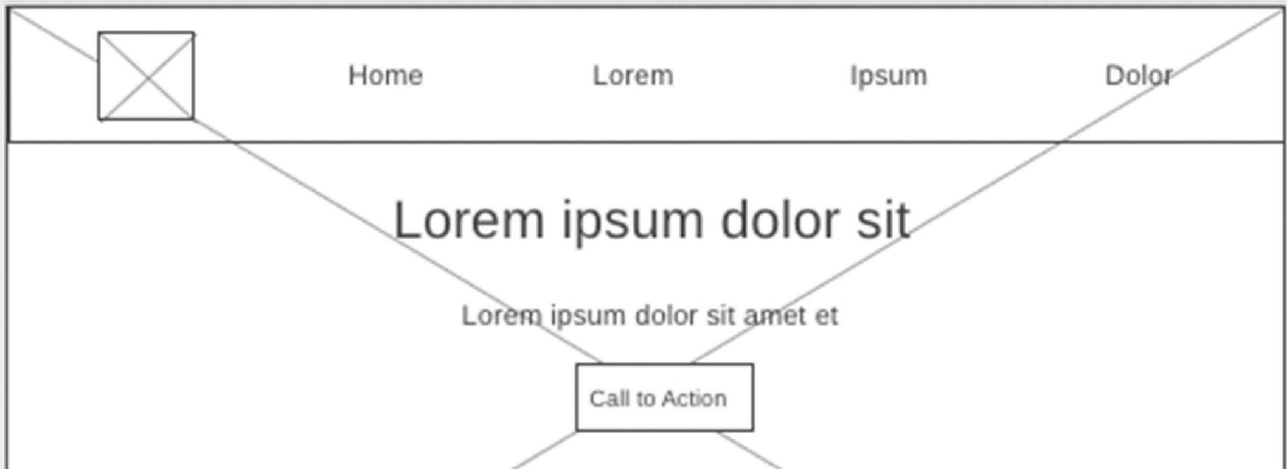
Color Palette
primary-color: #fcf300 secondary-color: #00b4d8 accent1-color: #8dffcd accent2-color: #04724d
Palette URL: coolors.co

Typography
Shantell Sans
Heebo
Lorem ipsum dolor sit amet consectetur adipisicing elit. Minima, inventore.
Secular One
Lorem ipsum dolor sit amet consectetur adipisicing elit. Minima, inventore.
Navigation
Home Page 2 Contact Us

Wireframes

Home Page Wireframe
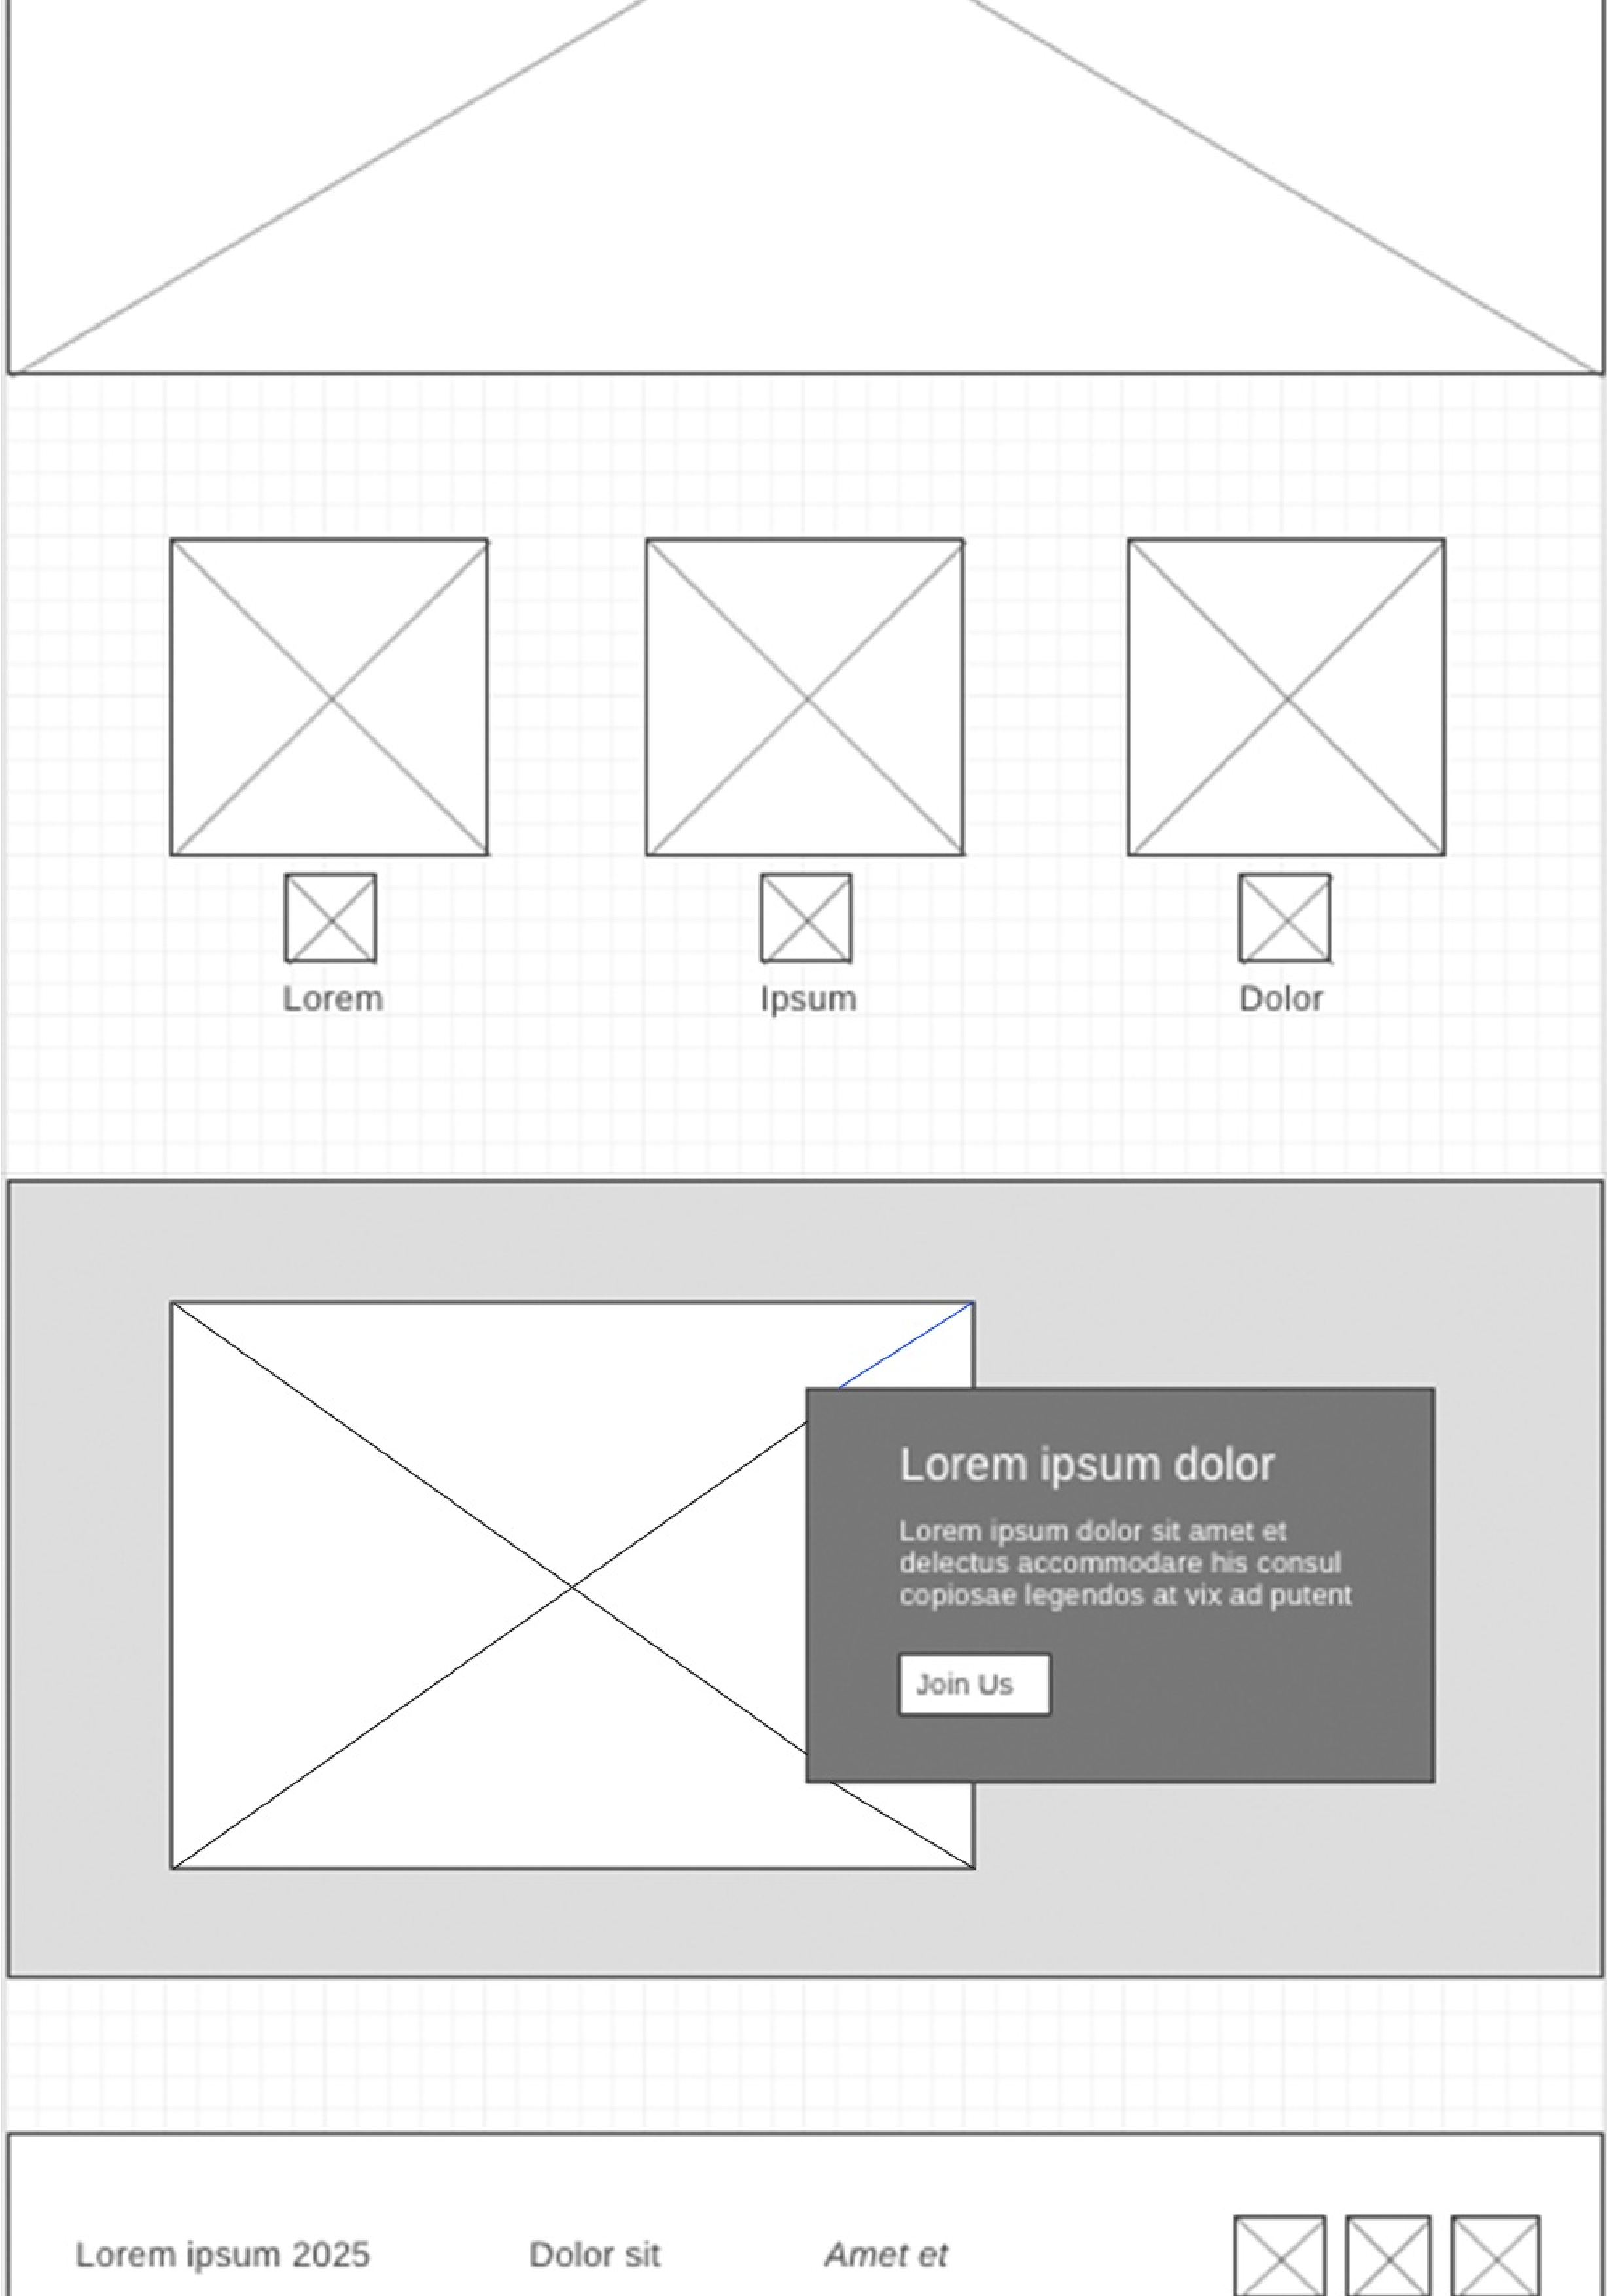

Page 2 Wireframee
©2025️ Rafting Site Document João Paulo Alves WDD 130

