Objectives:

1. To design a FL technique to classify apples according to their external features developing effective fuzzy membership functions and fuzzy rules for input and output variables based on quality standards and expert

expectations.

2. To compare the classification results from the FL approach and from sensory evaluation by a human

expert.

3. To establish a multi-sensor measuring system for quality features in the long term.

Apple Defects Used in the Study

No defect formation practices by applying forces on apples were performed. Only defects occurring naturally or forcedly on apple surfaces during the growing season and handling operations were accounted for in terms of number and size, ignoring their age. Scars, bitter pit, leaf roller, russeting, punctures and bruises were among the

defects encountered on the surfaces of Golden Delicious apples. In addition to these defects, a size defect (lopsidedness) was also measured by taking the ratio of maximum height of the apple to the minimum height.

Defect = 10 x B + 5 x ND + 3 x R + 0.3 x SD (1)

where B is the amount of bruising, ND is the amount ofnatural defects, such as scars and leaf roller, as total area (normalized), R is the total area of russeting defect (normalized) and SD is the normalized size defect.

Size = 5 x C + 3 x W + 5 x BL (2)

where C is the circumference of the apple (normalized), W is weight (normalized) and BL is the normalized blush percentage. After the combinations of features given in equations 1 and 2, input variables were reduced to 3 defect, size and color. Along with the measurements of features, the apples were graded by the human expert into 3 quality groups, bad, medium and good, depending on the experts experience, expectations and USDA standards (USDA, 1976).

Application of Fuzzy Logic

Size = ex (3)

where e is approximately 2.71828 and x is the value of size feature.

Fuzzy Rules

If the color is greenish, there is no defect, and it is a well formed large apple, then quality is very good (rule Q1,1 in Table 1). If the color is pure yellow (overripe), there are a lot of defects, and it is a badly formed (small) apple, then quality is very bad (rule Q3,17 in Table 1).

D = {(x, µD(x))| x  X}

µD(x):  [0,1] (4)

where X represents the universal set, D is a fuzzy subset in X and µD(x) is the membership function of fuzzy set D.

Degree of membership for any set ranges from 0 to 1. A value of 1.0 represents a 100% membership while a value of 0 means 0% membership. If there are 3 subgroups of size, then 3 memberships are required to express the size values in a fuzzy rule. Three primary set operations in fuzzy logic are AND, OR, and the Complement, which are given as follows

AND: µCD = (µC  µD) = min(µC,µD) (5)

OR: µCD = (µC  µD) = max(µC,µD) (6)

Complement = µÐC = 1 - µD. (7)

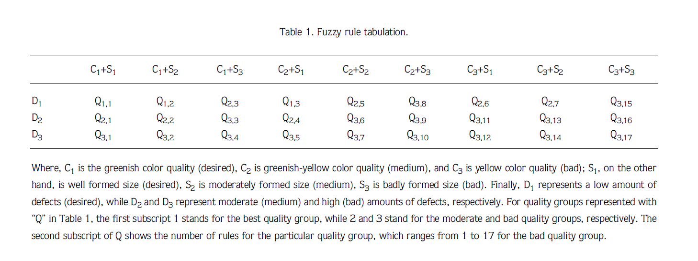

Determination of Membership Functions

The membership function used in this study for defect quality in general is given in equation 4. The membership function for high amounts of defects, for instance, was formed as given below:

If the input vector x is given as x = [defects, size, color], then the membership function for the class of a high amount of defects (D3) is

µ(D3) = 0, when x(1) < 1.75,

µ(D3) = $\frac{(x\left(1\right)-1.75)}{2.77}$ when, 1.75 ≤ x(1) < 4.52, or

µ(D3) = 1, when x(1) ≥ 4.52. (12)

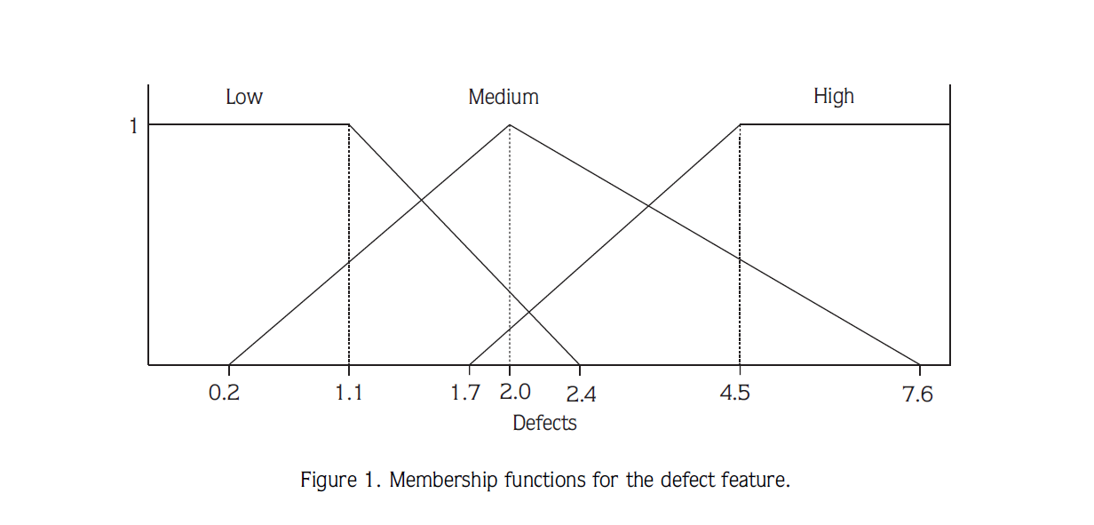

For a medium amount of defects (D2), the membership function is

µ(D2) = 0, when defect input x(1) < 0.24 or x(1) > 7.6,

µ(D2) = $\frac{(x\left(1\right)-.24)}{1.76}$, when 0.24 ≤ x(1) < 2,

µ(D2) = $\frac{(7.6-x\left(1\right))}{5.6}$, when 2 ≤ x(1) ≤ 7.6. (13)

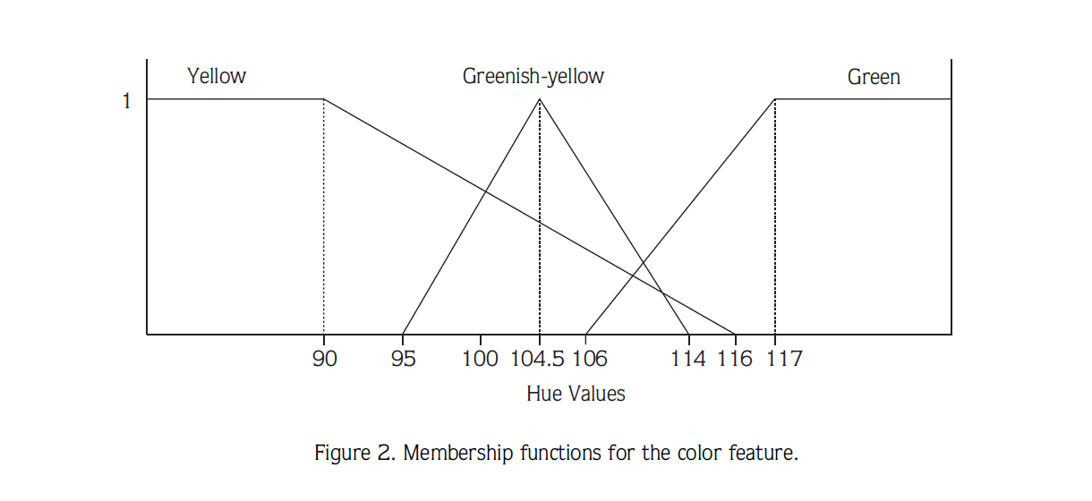

For a low amount of defects (D1), the membership function is

µ(D1) = 0, when defect input x(1) > 2.4,

µ(D1) = $\frac{(2.4-x\left(1\right))}{1.3}$, when 1.1 < x(1) ≤ 2.4 or

µ(D1) = 1, when x(1) ≤ 1.1. (14)

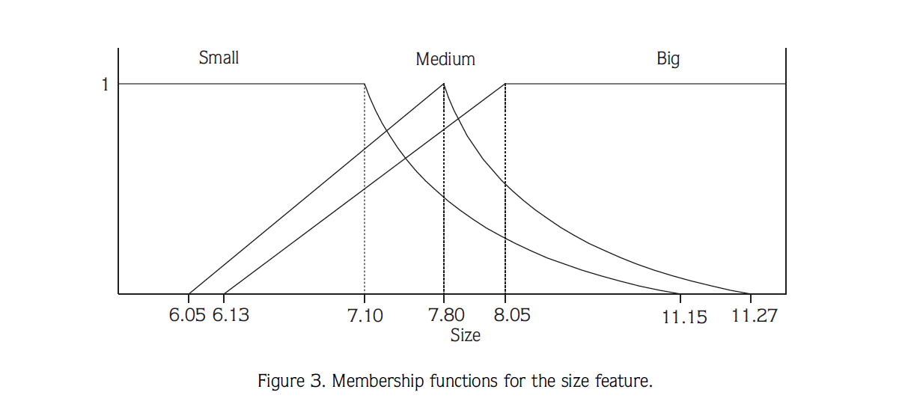

Results and Output

In the results of the defuzzification process, grades for all the apples were calculated between 0 and 3.99. Grade (g) ranges for the output quality classes were chosen as follows: 2.3 £ g £ 4 for the best class, 1.4 £ g < 2.3 for the moderate class and 0 £ g < 1.4 for the bad classs

