Prob1.

After calculating the time to maturity based on the given value, I get the time to maturity is 0.0384. After that I checked put call parity with derived results with an absolute tolerance of 0.1 which return no problem. Then, since we don’t know the strike price of call and put, I classify them into 2 situations, one is that put and call have the same strike price and another is put and call have different strike price and plot the above diagram. From the graph of both situations, I can find that the value of put and call options have the same trend, with the implied volatility increased, their value increased. The graph with same strike price shows a linear relationship and the graph with non-linear shows a non-linear relationship. From supply and demand side, when the demand of the stock goes up, and supply of the stock is limited or goes down, the expectation of the stock will go up, implied volatility will go up and thus the price will go up. Similarly, if the demand goes down but supply is to much, the expectation of the stock will go down, implied volatility will go down and thus the price will go down.

Prob 2.

After calculating the volatility for each option, I can plot the graph below of put and call option with such trend. The result of implied volatility is shown:

The shape of the graph is quite interesting. With the strike price going up, call and put show total different behaviors. Call option begins with a increasing implied volatility until reaching the peak then goes down, but put option is different, which begins with a decreasing implied volatility until reaching the bottom and then goes up. The downward trend can be due to a demand of downside protection, which investors are concerned about some negative impact may cause stock decrease, thus they want to buy stock with lower strike price to protect their portfolio. And the transition for call and put option can be due to there are some investors who want to take more risks and get a high return, therefore there are some increasing at the begin of call and end of put.

Prob3.

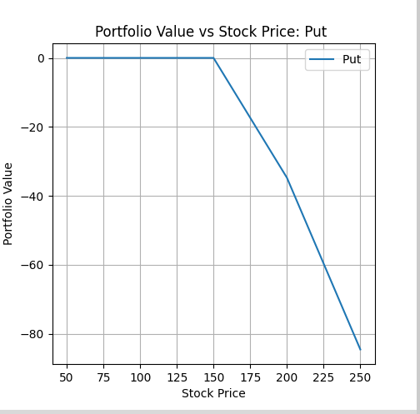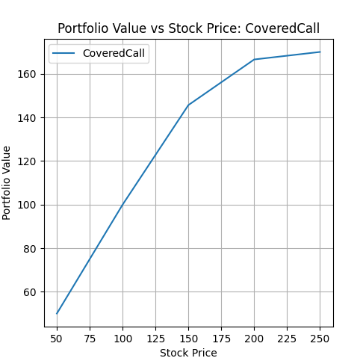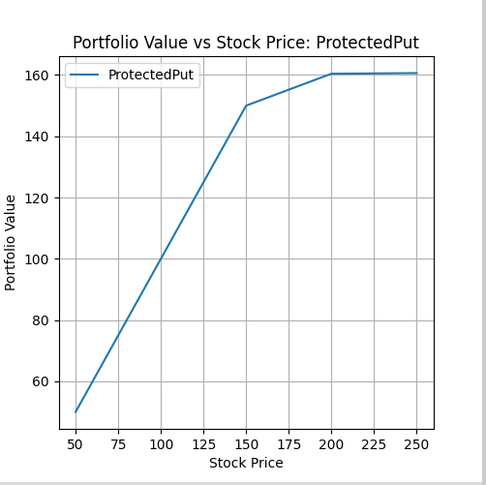

I can plot these graphs based on the requirements.

For portfolio Call and put options, the money can be made only when the stock price goes up or down, they are basic options. For callspread and putspread, comparing to basic options, they have lower return. For portfolio coveredcall and portectedput, they employ a combination of stock and option, thus the portfolio values are similar to those basic options. For Synlong and stock, their patterns are very similar, but synlong tempts to maximize the return with a high risk. For portfolio straddle, the relationship between value and price is strange, the value will change always follow the price change, regardless of whether price is increased or decreased.

After simulation of AAPL 10 days returns, I get the following data:

Portfolio: Straddle

Mean: 7.50

VaR (95%): 3.39

Expected Shortfall (ES): 2.79

Portfolio: SynLong

Mean: 7.88

VaR (95%): 3.39

Expected Shortfall (ES): 2.79

Portfolio: CallSpread

Mean: 4.59

VaR (95%): 2.55

Expected Shortfall (ES): 2.16

Portfolio: PutSpread

Mean: -5.94

VaR (95%): -17.16

Expected Shortfall (ES): -20.20

Portfolio: Stock

Mean: 151.25

VaR (95%): 138.16

Expected Shortfall (ES): 135.12

Portfolio: Call

Mean: 7.69

VaR (95%): 3.39

Expected Shortfall (ES): 2.79

Portfolio: Put

Mean: -0.19

VaR (95%): -0.12

Expected Shortfall (ES): -3.73

Portfolio: CoveredCall

Mean: 146.15

VaR (95%): 136.33

Expected Shortfall (ES): 133.67

Portfolio: ProtectedPut

Mean: 150.64

VaR (95%): 138.16

Expected Shortfall (ES): 135.12

These data somehow shows a large gap between each other, but from the VaR, I think the protectedPut and stock are relatively risky because they have largest VaR value which can be really risky but with real high return.