**Introduction**

**Tools:**

**. Visual Studio 2019**

**.MS Sql Server**

**Use Stories:**

As a user I want to register using API.

As a user I want Authenticate for using API by JWT Token.

The user should be able to create Cities.

The user should be able to see all Cities.

The user should be able to Delete Cities.

Registering a new User

* Name
* Password
* Email

Request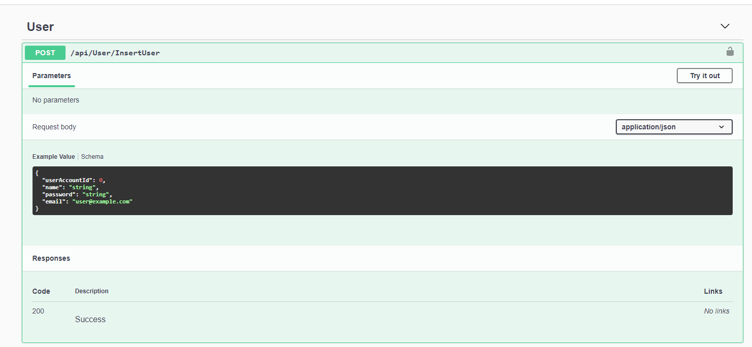

By using the BCrypt package we’re encrypting the password

Authentication a User

* Email
* Password

Request

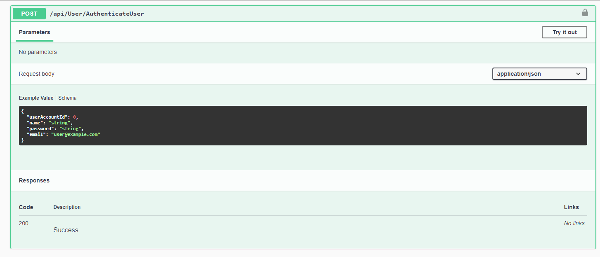

Response

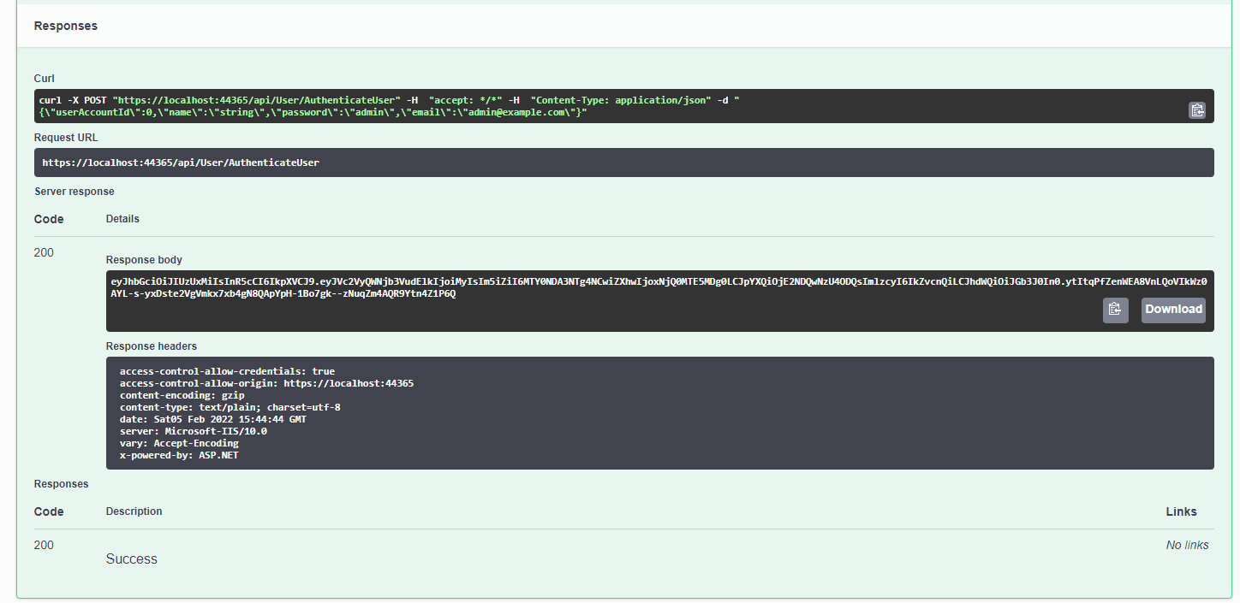

In response body we’ll be getting the JWT Token. Using this Token we should Authorize in Swagger.

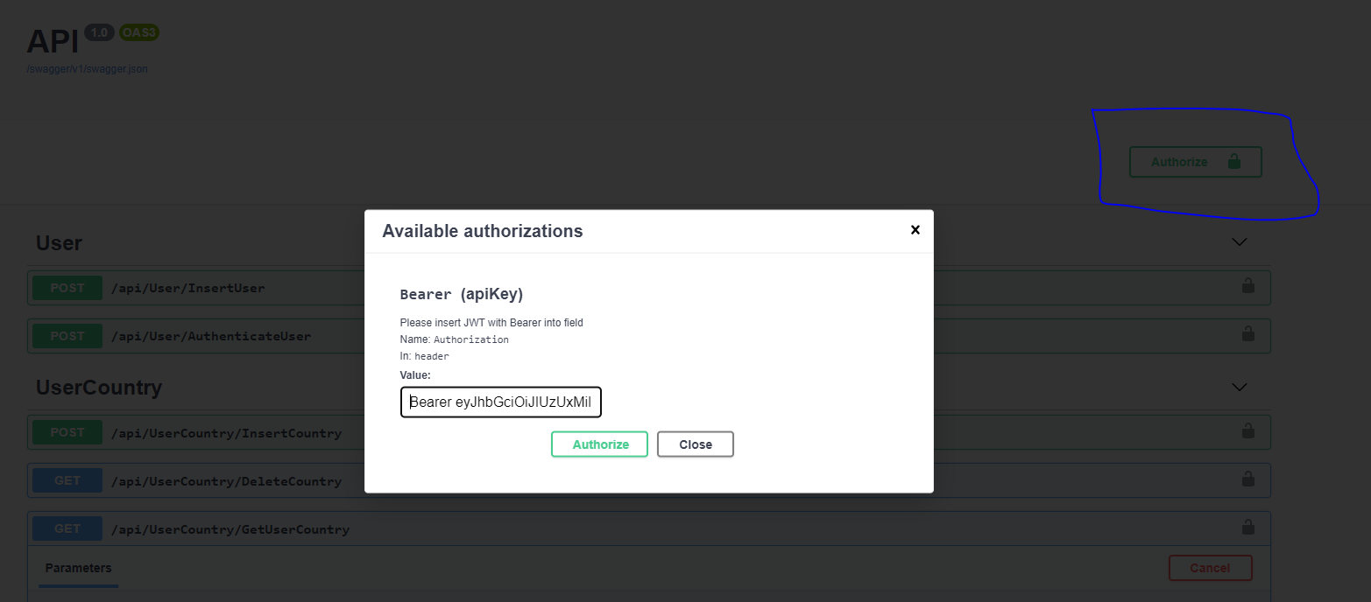

For inserting the Country & City

* Country
* City

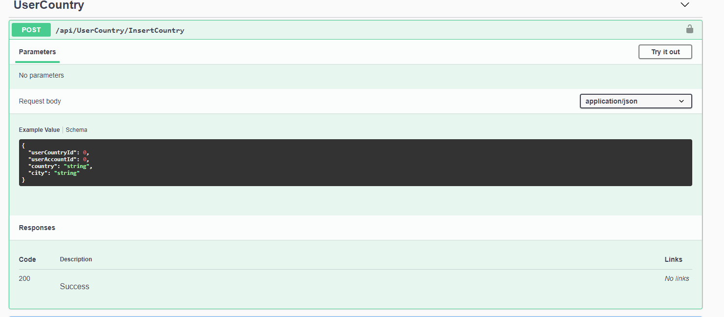

For Deleting the country, we need to pass CountryId

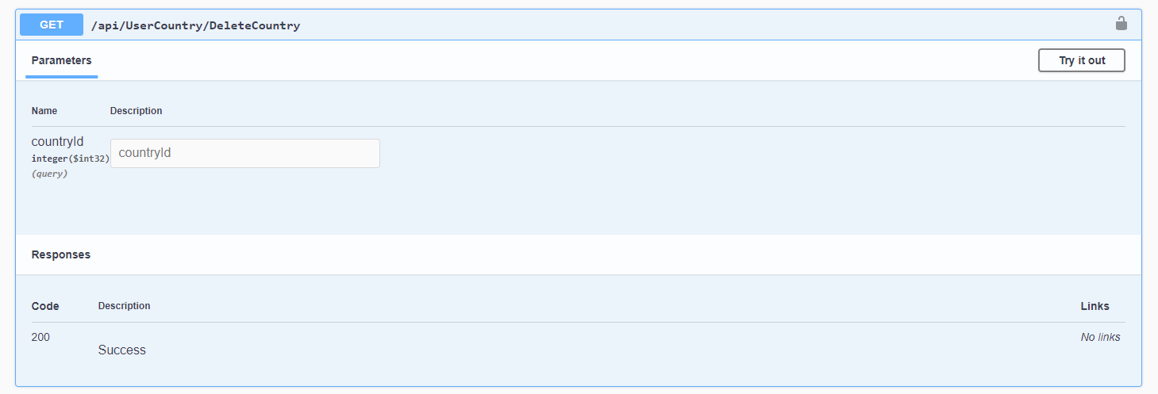

For getting the country details based on user Login.

* Here there is no need to passing userid as we’re saving userid in Token.

So we’re getting the userid from the Token.

