ARCTIC MEDICAL DELIVERY | UAV CANDIDATES | 5 NOV 2026
Airbus U030 Flexrotor
Compact shipboard VTOL • liquid fuel
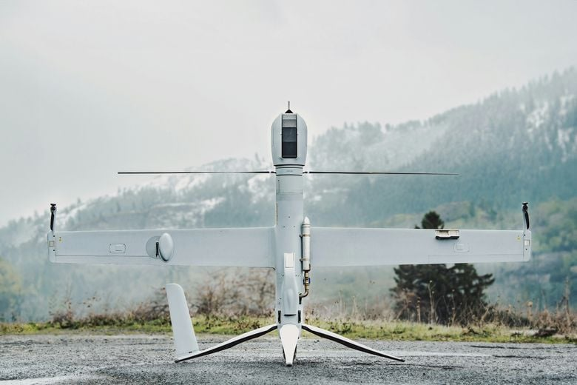
Photo: Airbus product page; Flexrotor in its vertical takeoff/landing position.
Takeoff / landing | Autonomous vertical takeoff and landing; transitions to wing-borne cruise. No catapult or runway. Published landing zone: 3.7 × 3.7 m.
Weight / cargo | Maximum takeoff mass: 25 kg; empty: 15 kg. Useful load: 10 kg INCLUDING fuel. Payload up to 8 kg; fuel and cargo must share the mass allowance. Wingspan: 3 m.
Energy | 28 cc two-stroke engine; gasoline or heavy-fuel engine configurations. Requires refuelling, not just a battery swap.
Speed | Minimum cruise: 78 km/h; maximum dash: 140 km/h. Use current brochure values; dash speed is not an endurance cruise.
Maximum distance | Maximum flight distance with 3 kg cargo is not published. Typical endurance: 12–14 h. The 312–600 km mission needs a payload, wind and reserve calculation.
Arctic features | Airbus reports 6 h in a −40 °C cold chamber and takeoff/landing winds up to 27 kt (≈13.9 m/s). Cold-chamber exposure does not establish flight at −40 °C or icing capability.
Project fit: promising for compact ship recovery. Medical packaging, weather instruments and loaded mission reach require integration checks.
Sources: 2026 Airbus brochure | Product page / photo
Manufacturer claims checked 5 Nov 2026. Maximum values may refer to different configurations. Cargo allowance must cover packaging and added equipment.
1 / 3

ARCTIC MEDICAL DELIVERY | UAV CANDIDATES | 5 NOV 2026
TEKEVER AR3-EVO
Modular fixed-wing / VTOL • several propulsion options
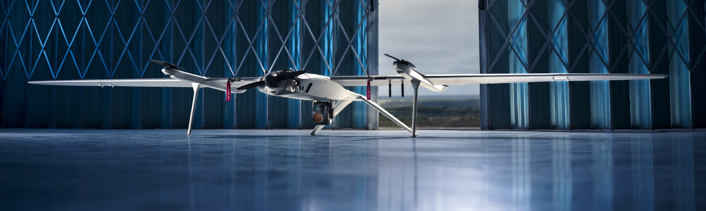
Photo: TEKEVER AR3-EVO product gallery; aircraft with VTOL modules fitted.
Takeoff / landing | VTOL configuration: vertical ship-deck launch and recovery, advertised from 5 × 5 m. Fixed-wing option: catapult launch / parachute recovery; small-deck recovery is a separate check.
Weight / cargo | Maximum takeoff mass: 25 kg, up to 30 kg with VTOL. Published payload capacity: 6 kg. Wingspan: 4.2 m; length: 1.96 m.
Energy | Manufacturer offers electric, combustion and heavy-fuel options. Exact propulsion, fuel grade and payload/endurance combination must be specified in a quotation.
Speed | Cruise: 46 kt (≈85 km/h). Maximum speed is not stated in the reviewed EVO specifications.
Maximum distance | Loaded maximum flight distance is not published. Up to 14 h endurance with VTOL; 22 h fixed-wing. The 230 km figure is COMMUNICATIONS range, not flight distance; SATCOM options are offered.
Arctic features | Ship-deck capability and modular SATCOM support are relevant. Reviewed EVO sources do not establish −40 °C operation, a landing wind limit or whole-aircraft icing capability.
Project fit: promising for long legs and ship operations. Do not apply the 14-hour endurance figure to a battery version without confirmation.
Sources: Specifications / photo | Manufacturer brochure
Manufacturer claims checked 5 Nov 2026. Maximum values may refer to different configurations. Cargo allowance must cover packaging and added equipment.
2 / 3

ARCTIC MEDICAL DELIVERY | UAV CANDIDATES | 5 NOV 2026
ElevonX Tango VTOL
Two sizes: Tango 3.0 / Tango 4.4 MAX
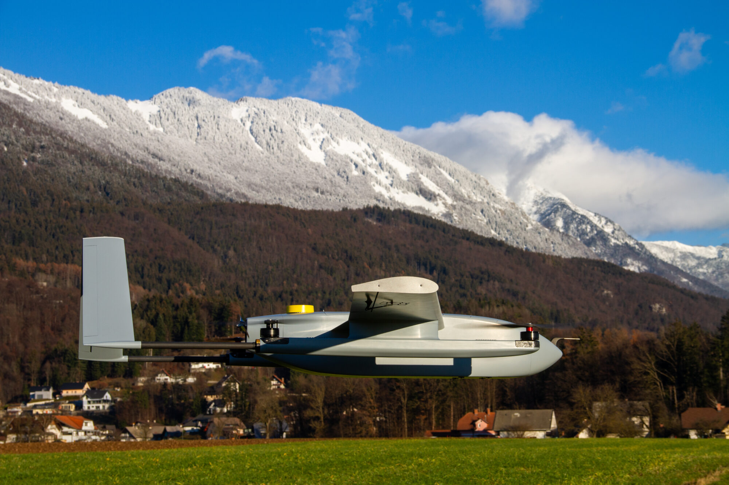
Photo: ElevonX Tango product gallery; exact size/propulsion variant is not identified.
Takeoff / landing | Electric lift rotors provide vertical takeoff and landing; wing-borne cruise. Naval versions are offered. A verified minimum deck area and moving-deck limits were not found.
Weight / cargo | Tango 3.0 / 4.4 MAX: maximum takeoff mass 21.5 / 29 kg; payload up to 5 / 10 kg; wingspan 3 / 4.4 m. Payload and endurance maxima are not simultaneous guarantees.
Energy | Battery-electric, internal-combustion and hydrogen fuel-cell options are advertised. The brochure does not map each endurance figure to an exact propulsion and payload configuration.
Speed | Published cruise up to 22 / 24 m/s (≈79 / 86 km/h), for 3.0 / 4.4 MAX respectively. Maximum dash speed is not given.
Maximum distance | No loaded maximum distance published. Up to 3 / 5 h with lightweight payloads. Simple speed × time gives ≈238 / 432 km before reserves (illustration only). Radio link: 70 km, not flight distance.
Arctic features | Naval versions and optional sealed payload bay. Wind limits: 8 m/s takeoff/landing; 17 m/s cruise. No whole-aircraft −40 °C or icing qualification found. Snow in the photo is not qualification evidence.
Project fit: the larger variant is conditional near the lower reach target; 312 km with our payload and reserves remains unproven.
Sources: Manufacturer brochure | Product page / photo
Manufacturer claims checked 5 Nov 2026. Maximum values may refer to different configurations. Cargo allowance must cover packaging and added equipment.
3 / 3

