Emergency medicine delivery by UAV in the Russian Arctic
Team 5: Satenik Akopyan, Maxim Golubev, Svetlana Polonnikova, Zhanar Sirgebayeva
Ships on the Northern Sea Route and remote Arctic ports are often hours or even days away from a hospital. We model a UAV service that brings urgent medicine to a ship or a port and, on the way, measures temperature, pressure, wind and visibility. The model is built in Capella with the Arcadia method: first Operational Analysis, then System Analysis.

1. Operational analysis
This is the corrected version of Problem set 1. At this stage the system does not exist yet: we only look at who is involved and what they need to do.

1.1 Stakeholders
All stakeholders are grouped into seven entities. UAV Service Provider is the one whose work our system will take over; everyone else stays outside. Investors and buyers are one group, Customer & Funding, because for this service they are the same companies.
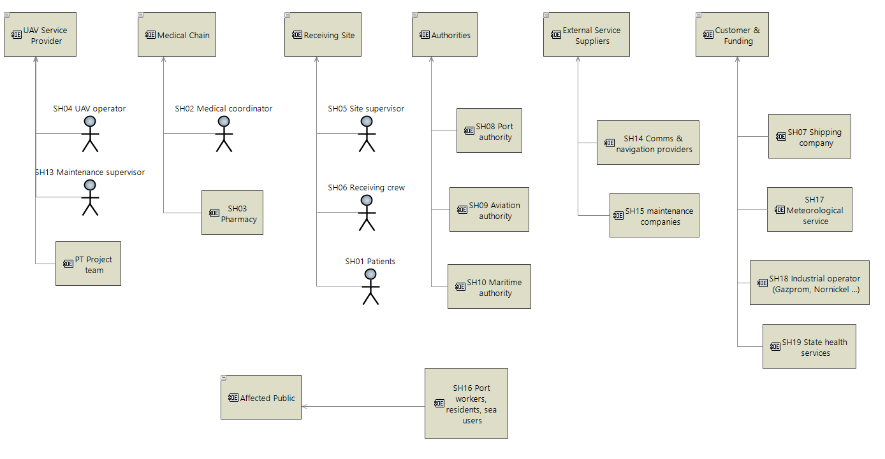
Figure 1. Stakeholders grouped into entities (OEBD)

1.2 Capabilities
The main capability is OC1, deliver emergency medicine. It has two cases: delivery to a port or shore site (OC1.1) and delivery to a ship at sea (OC1.2). Three supporting capabilities keep the service legal (OC2), collect weather data (OC4) and keep it ready and funded (OC5).
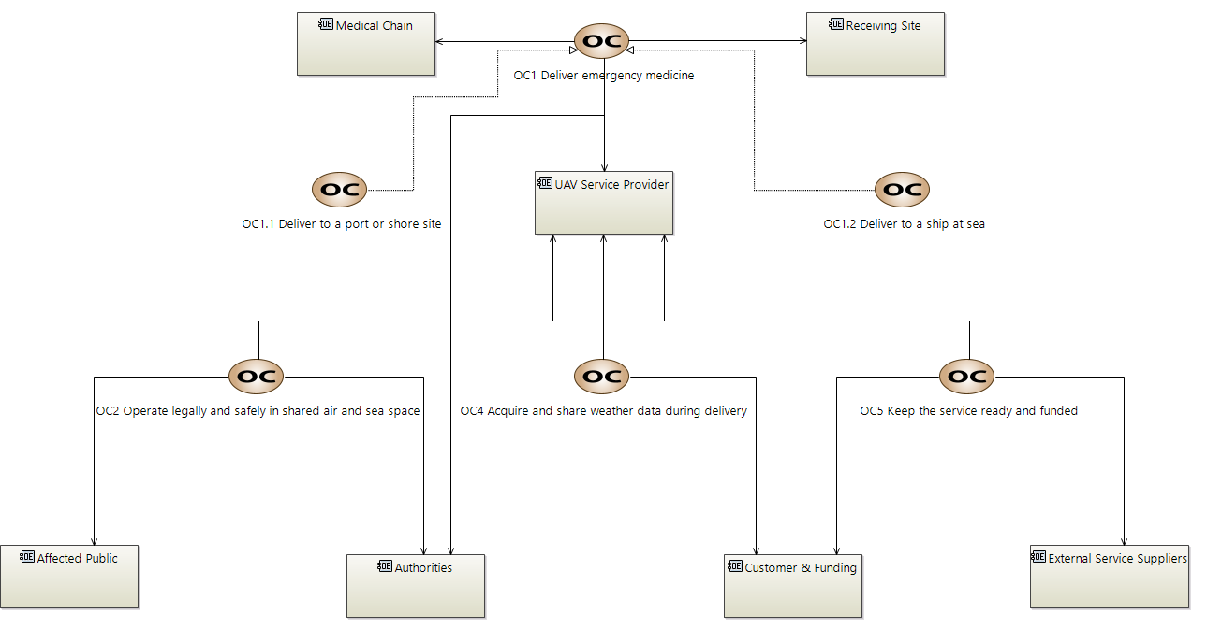
Figure 2. Operational capabilities (OCB)

1.3 Operational activities
Each capability has its own activity diagram. They show who does what and what is passed between them.
Delivery. The receiving site reports an emergency, the medical coordinator decides on treatment, the pharmacy prepares the package, the authorities approve the flight and the provider delivers it.
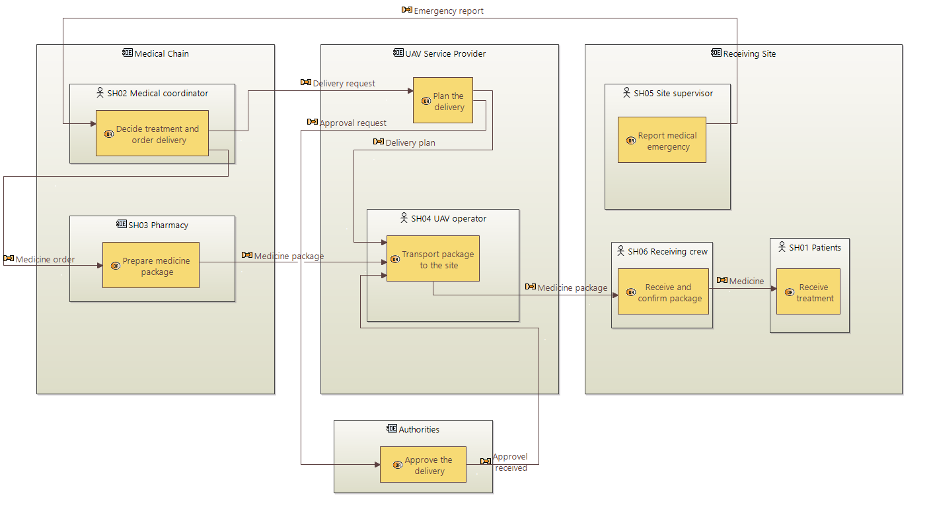
Figure 3. Emergency delivery (OAB, OC1)
Readiness. Customers pay, the provider buys supplies, maintenance companies repair the equipment and the maintenance supervisor releases it for flight.
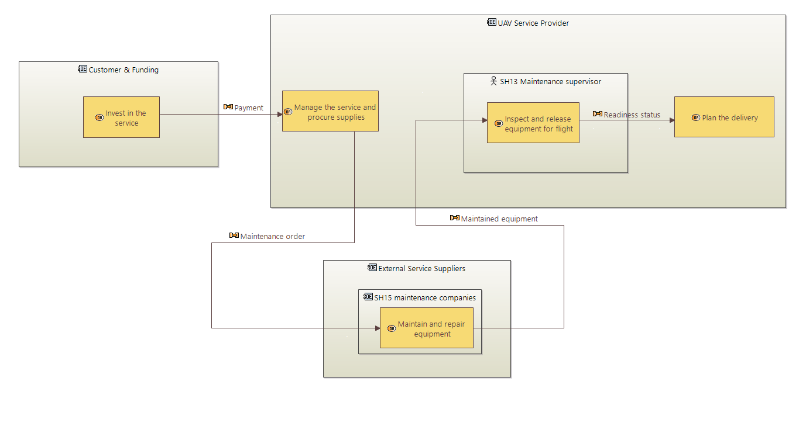
Figure 4. Keep the service ready (OAB, OC5)
Safe and legal operation. The provider applies for permits, the authorities issue operating rules, and the public can raise concerns.
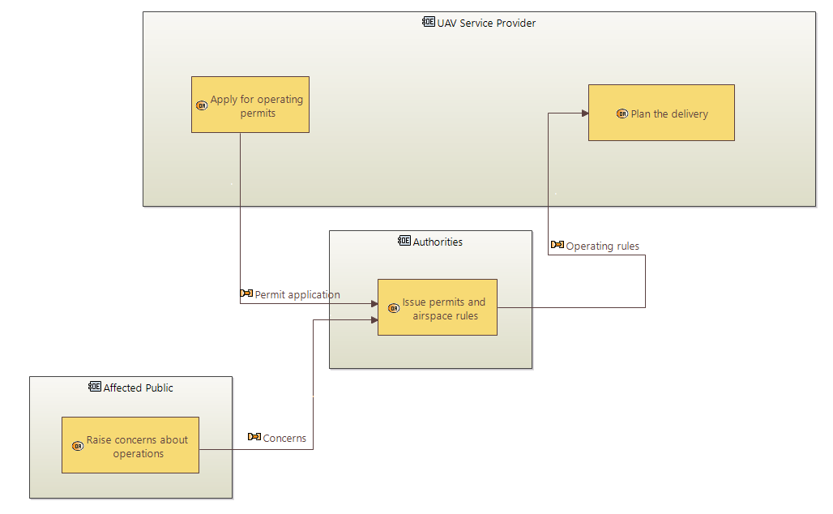
Figure 5. Operate legally and safely (OAB, OC2)
Weather data. Data collected during the flight goes to the meteorological service, and its forecasts come back for planning. This is a second product of the service.
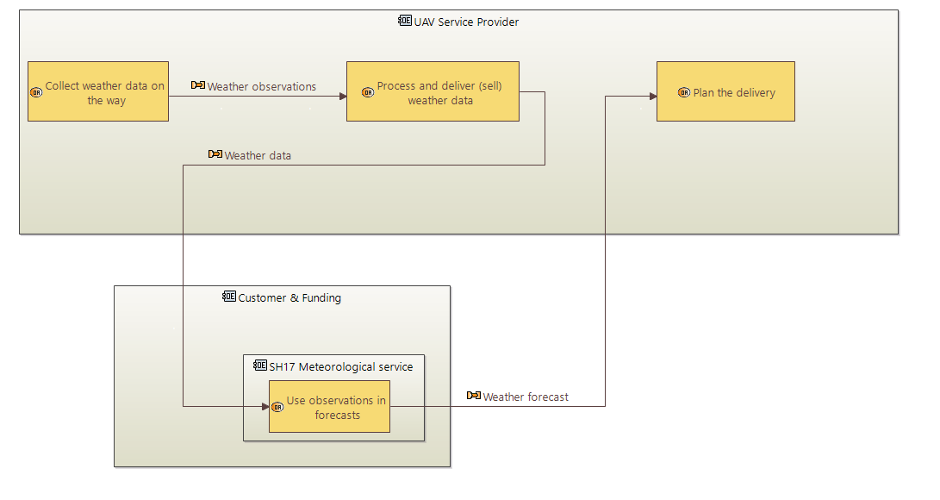
Figure 6. Acquire and share weather data (OAB, OC4)

2. System analysis
Now the system appears as one black box. The activities of UAV Service Provider that can be automated became system functions. People (mission control, medical staff, ship crew) and outside services stay as actors.

2.1 Mission and capabilities
The system has one mission, M1 Provide emergency medical supply in the Arctic, supported by four capabilities. They keep the names of the operational capabilities, so every SA element can be traced back to OA.
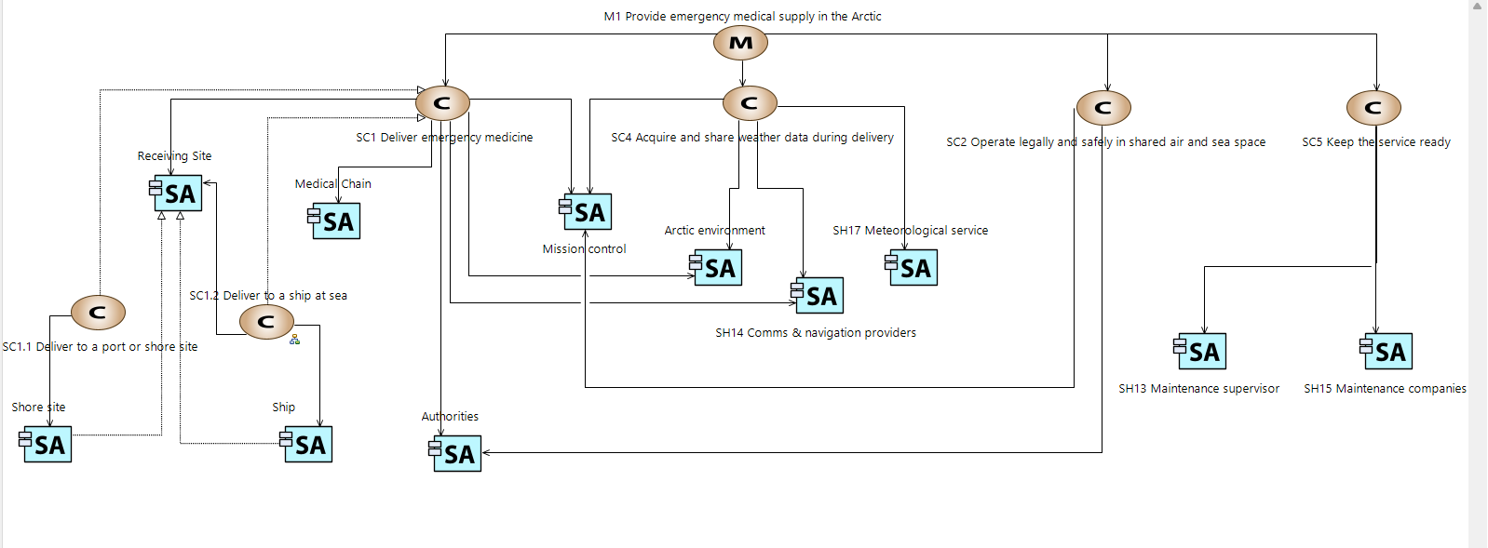
Figure 7. Mission and capabilities (MCB)

2.2 Delivery to a ship at sea (SC1.2)
This is the main diagram. The blue block is the system, the light blocks are actors. Mission control is people: it accepts the request, gets the approval and can change or abort the flight. Route building and replanning are done inside the system, because the ship moves and the weather changes during the flight.
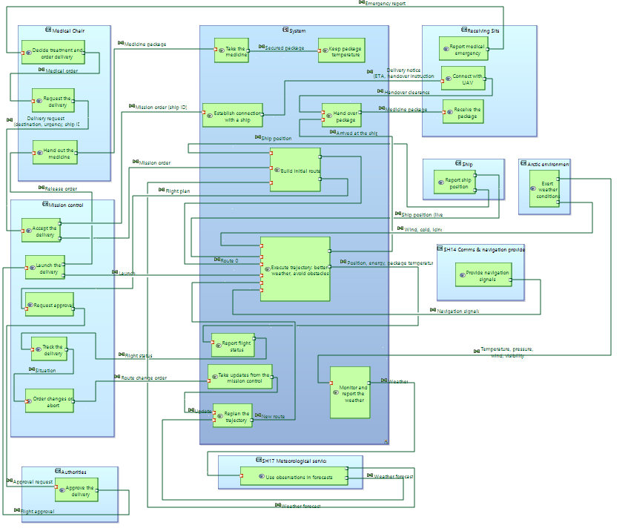
Figure 8. System functions and exchanges for delivery to a ship (SAB, SC1.2)
The two close-ups below show the same diagram in parts.
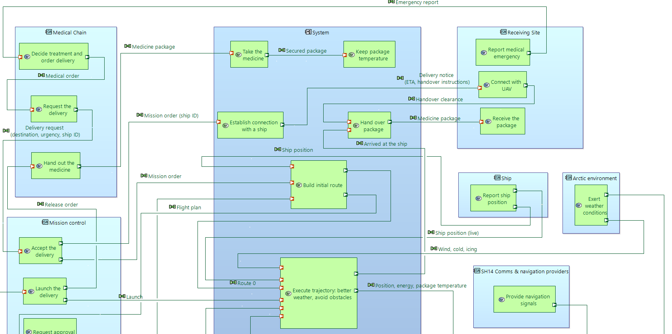
Figure 9. SC1.2, upper part: request, planning and handover
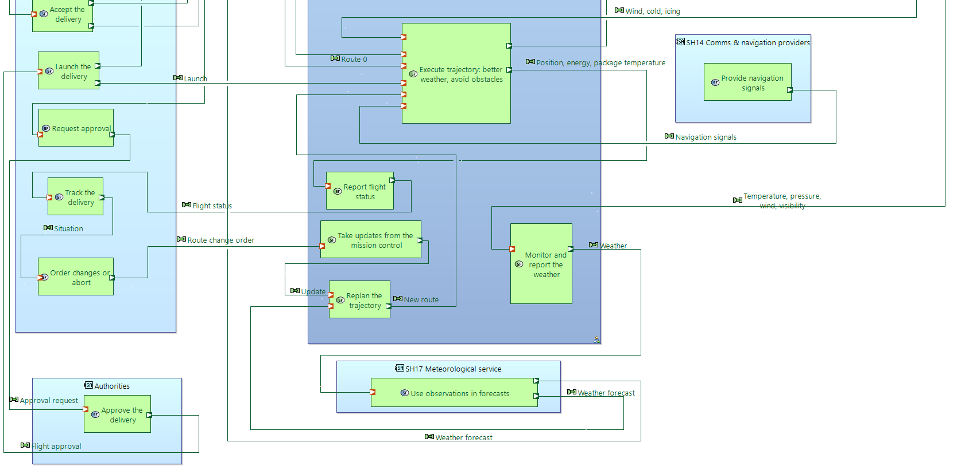
Figure 10. SC1.2, lower part: flight, monitoring and replanning

2.3 Delivery to a port or shore site (SC1.1)
Both cases share one concept and the same functions. The only difference is that a port does not move, so the Ship actor and its position updates are removed. The receiving functions belong to Receiving Site, which can be a ship or a shore site, so they work in both diagrams without copies.
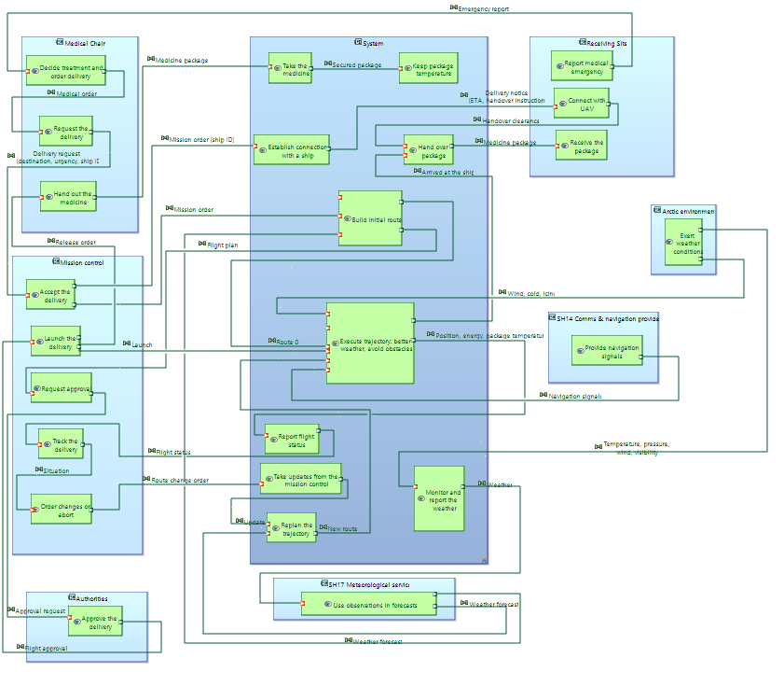
Figure 11. Delivery to a port or shore site (SAB, SC1.1)

2.4 Exchange scenario (SC1.2)
The scenario shows the same delivery as a sequence in time. Only exchanges between the system and the actors are drawn; exchanges inside the system are already in the SAB. The scenario for SC1.1 is almost the same, and the other capabilities are much simpler, so they are not shown here.
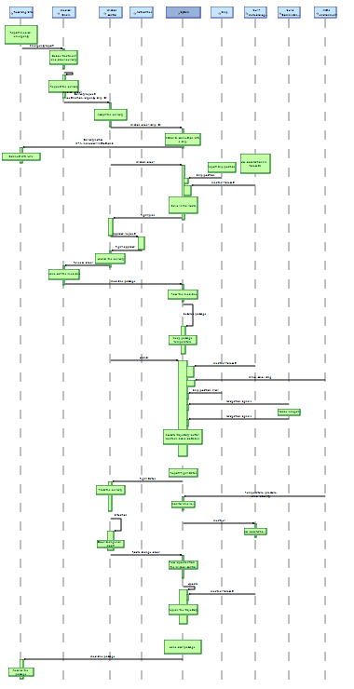
Figure 12. Exchange scenario for delivery to a ship (ES, SC1.2), overview
Before the flight. The emergency is reported, the delivery is requested and accepted, the system builds the initial route, the authorities approve it, and the package is loaded and launched.
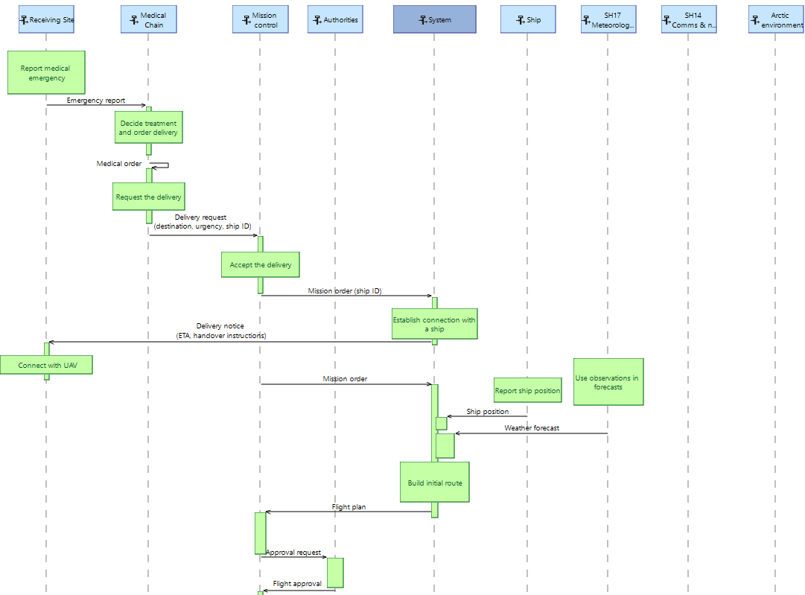
Figure 13. Request, planning and approval
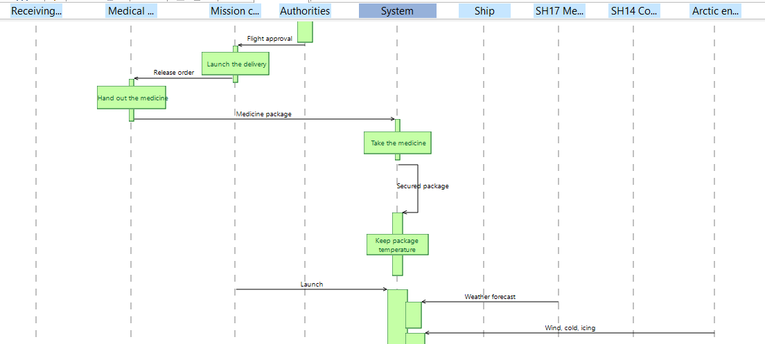
Figure 14. Loading and launch
During the flight. The system uses the live ship position, forecasts and navigation signals, sends weather data and flight status, and replans the route if mission control or a new forecast requires it. The scenario ends with the handover of the package.
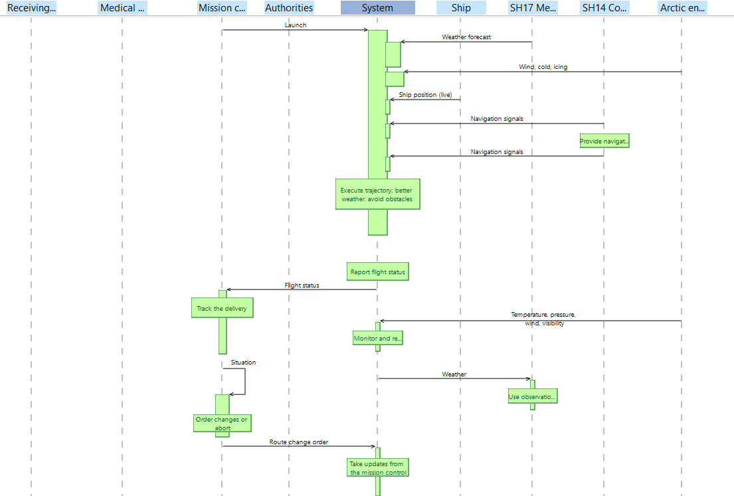
Figure 15. Flight, weather data and status
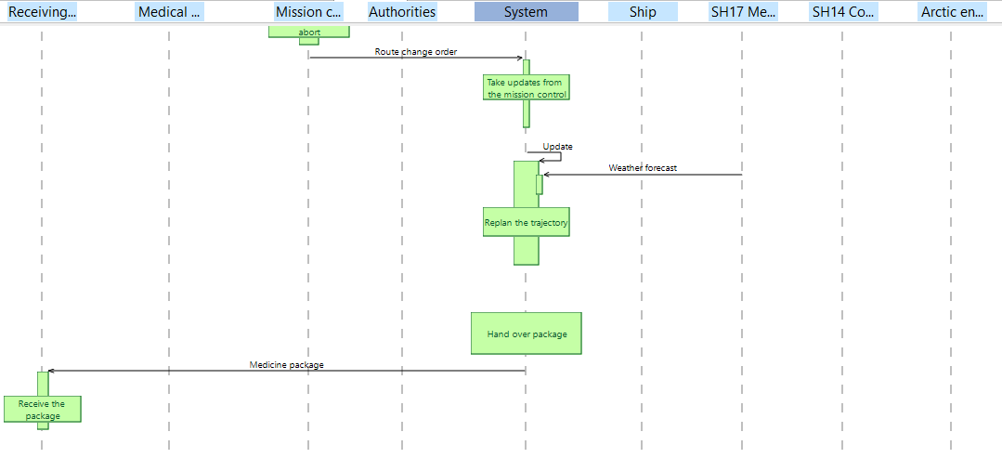
Figure 16. Route change and handover

3. Result
OA and SA together gave us a full description of what the system must do. From it we wrote a list of questions that must be answered with numbers: delivery time, payload, range, weather limits, handover, safety and cost. The answers are in the attached table (UAV_NFR_Questions.xlsx).
The key values so far: medicine delivered within 4 hours, a payload of 3 kg kept at +2…+8 °C, up to 300 km to a ship, flights at −40…+20 °C and winds up to 15 m/s. This table is the input for the next step, building the system architecture.

