**My Day Trading System (MDTS) is a Trend Following**

**I) Determining the trend**

H4: Set QQE (TF:1440 – Daily)

**Up Trend: QQE cross up**

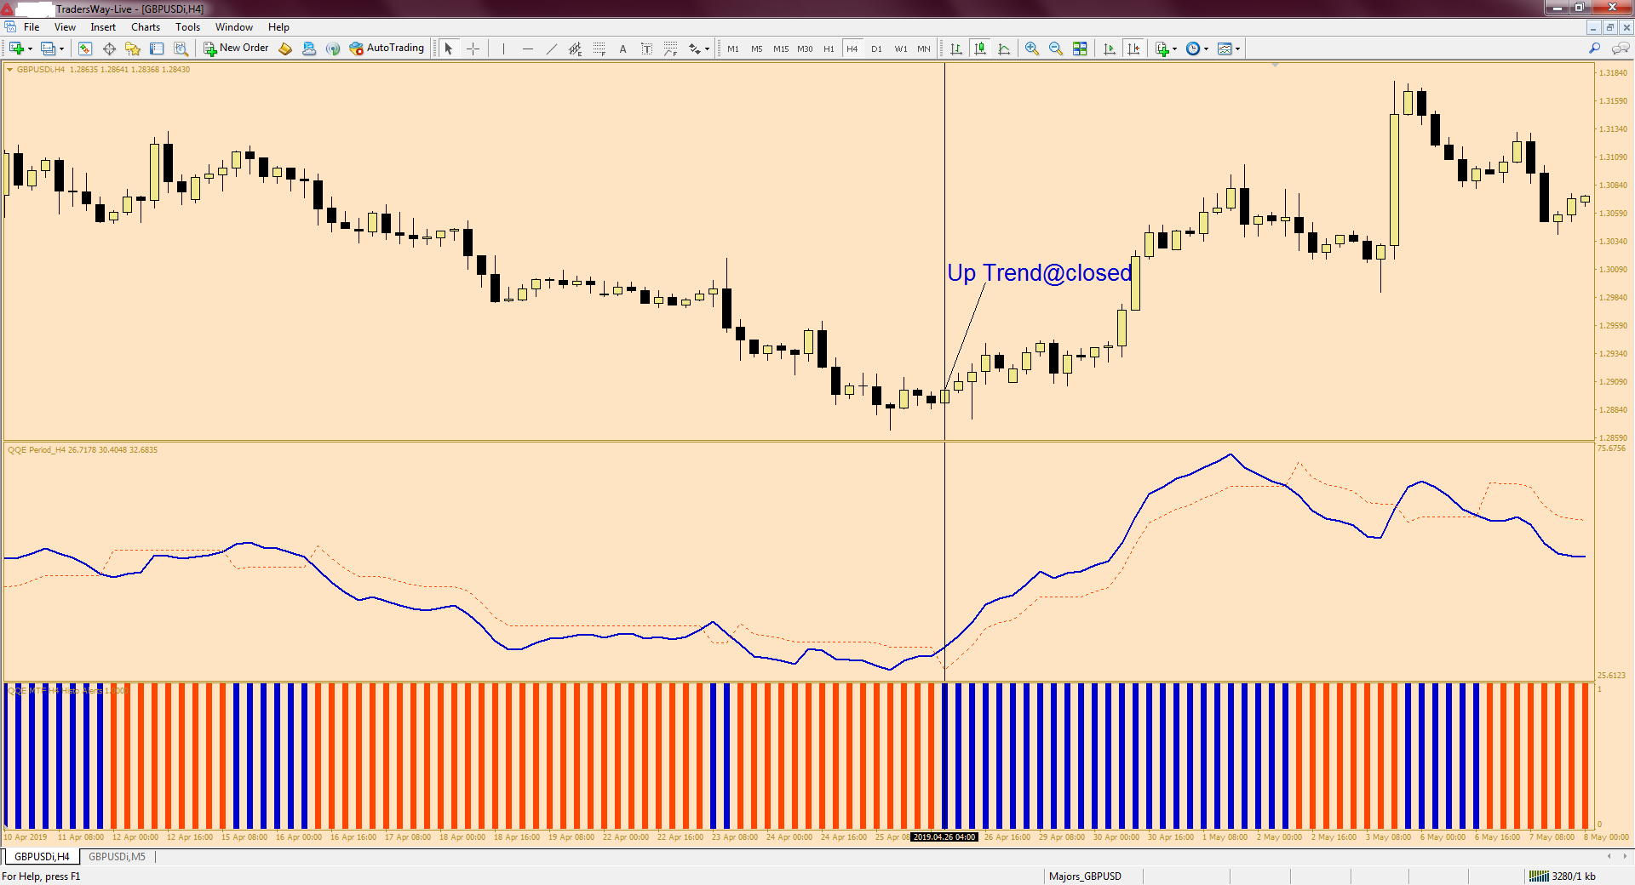

**Down Trend: QQE cross down**

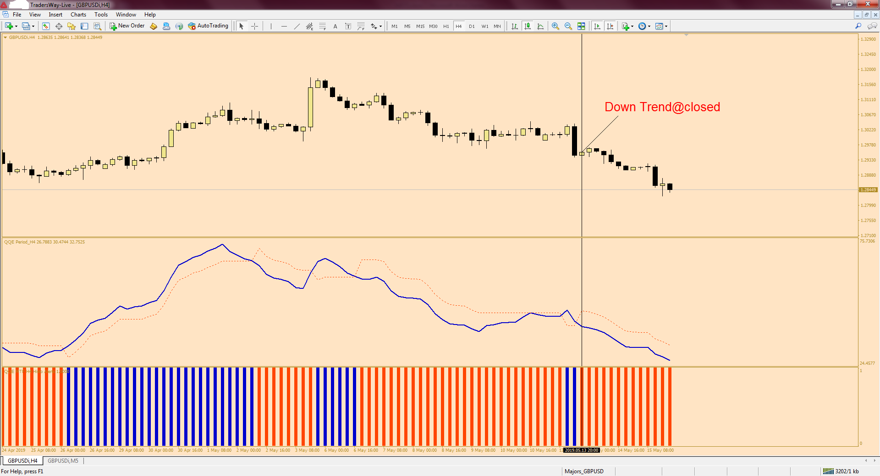

**II) Waiting for a pull back and entering a trade**

M15 or M5:

**For an up trend:**

**1) Price must touching the 5 EMA (H1) of the low;**

**2) Force Index (H1) bar (Blue) is above zero;**

**3) Macd bar (Blue) is above zero.**

**Buy = 1) + 2) + 3)**

**Additional information:**

*If the entry signal occurs at a time when the price is above the 20 period ЕМА (H1) of the Closes, this indicates a much stronger trade.*

a) Stop Loss is placed below the previous cycle low or 20 pips but 20 pip min.

b) Your discretionary.

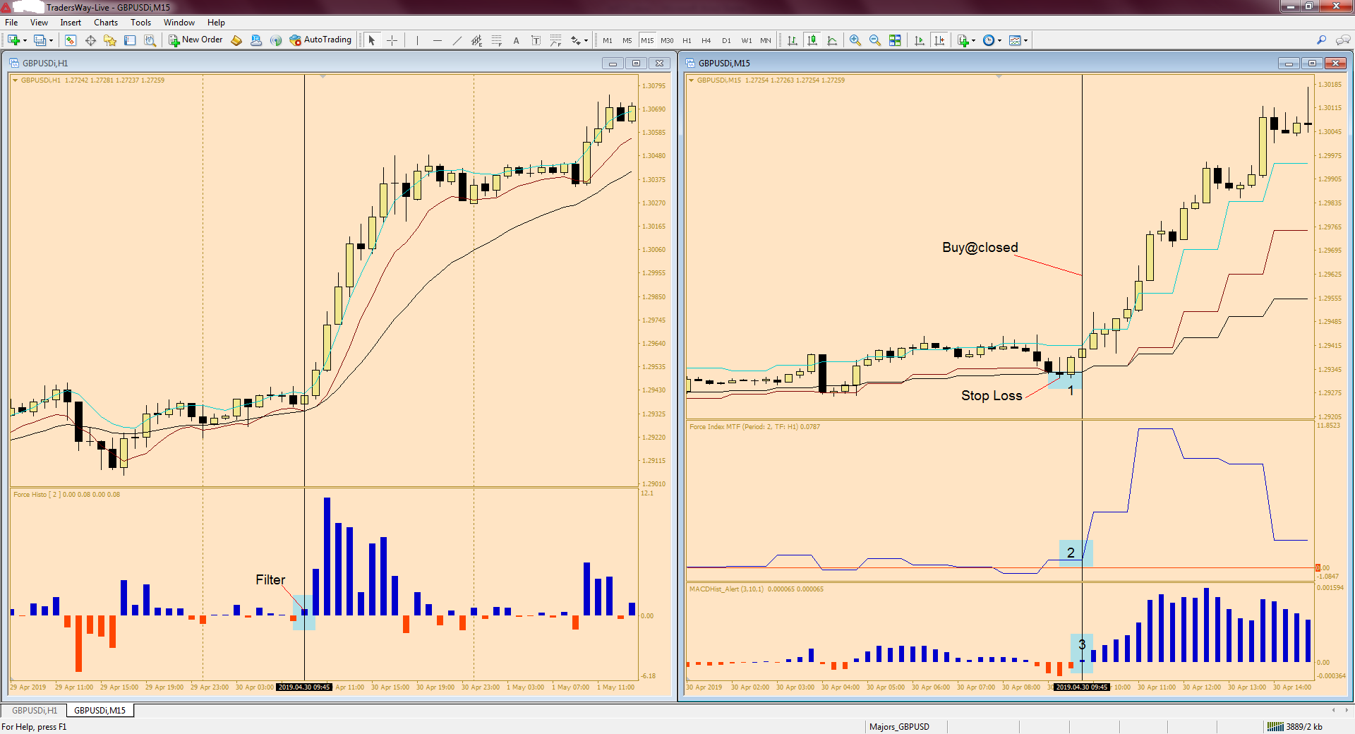

**For a down trend:**

**1) Price must touching the 5 EMA (H1) of the high;**

**2) Force Index (H1) bar (Red) is below zero;**

**3) Macd bar (Red) is below zero.**

**Sell = 1) + 2) + 3)**

**Additional information:**

*If the entry signal occurs at a time when the price is below the 20 period ЕМА (H1) of the Closes, this indicates a much stronger trade.*

a) Stop Loss is placed above the previous cycle high or 20 pips but 20 pip min.

b) Your discretionary.

