- Project management
- Project is used to store source code, makefiles, binaries, and related files.
- Project type: there are 6 types of project such as
- Static library project: A collection of object files that you can link into another application (libxx.a). The CDT combines object files (*.o) into an archive (*.a) that is directly linked into an executable.
(Makefile is automatically created by CDT)

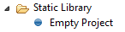

- Executable project: Provides an executable application. This project type folder contains 3 templates.
(Makefile is automatically created by CDT)

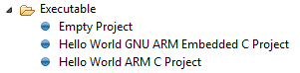
After you select a template, the result is a project with only the meta-data files required for the project type. You are expected to modify these source files, as required, and provide source files for the project's target.

- Debug-only project: be used to debug externally built executables
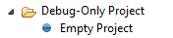

- Shared library project: An executable module that is compiled and linked separately. When you create a project that uses a shared library (libxx.so), you define your shared library's project as a Project Reference for your application. For this project type, the CDT combines object files together and joins them so they're relocatable and can be shared by many processes. Shared libraries are named using the format libxx.so.version, where version is a number with a default of 1. The libxx.so file usually is a symbolic link to the latest version.

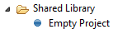

- Makefile project: Creates an empty project without the meta-data files. This selection is useful for importing and modifying existing makefile-based projects; a new makefile is not created for this project type

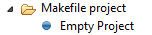

- Others:
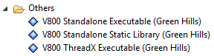

- Executable project (Renesas): An executable project that has a project which contains some sample files.
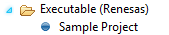

- Static library project (Renesas): A static library project that has a project which contains some sample files.

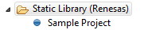

- Project menu

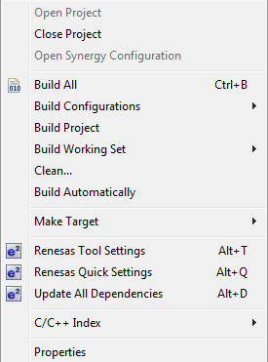

- Project explorer: (one or more projects can be opened at the same time)

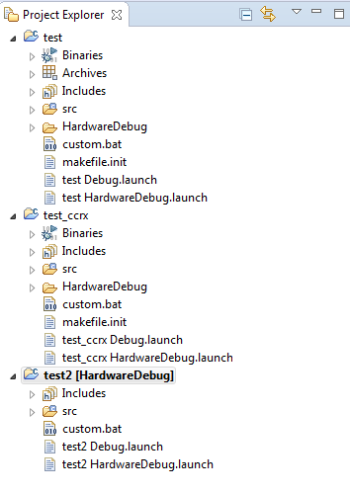

- Create project

Step 1: On task bar, go to File > New > choosing type of Project

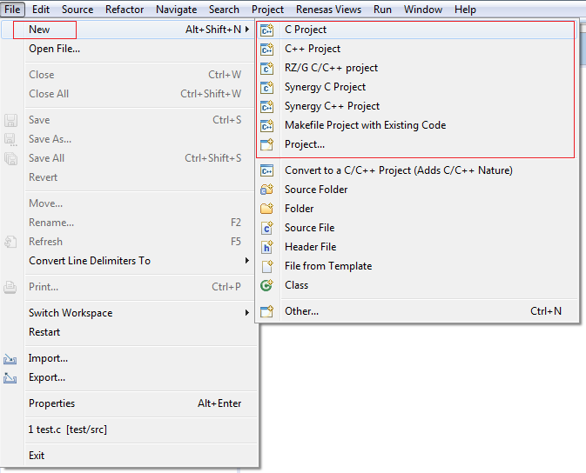

Step 2: Fill in some compelled information of project

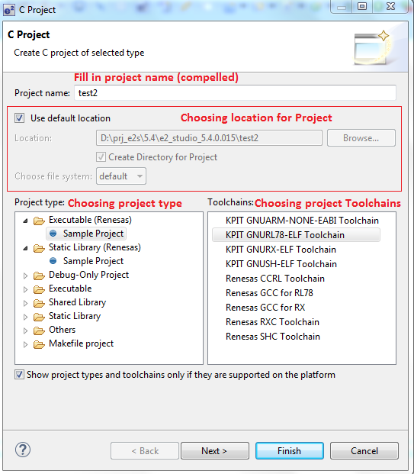

Step 3: User can choose “Finish” to create project by default or choose “Next” to set up some project options

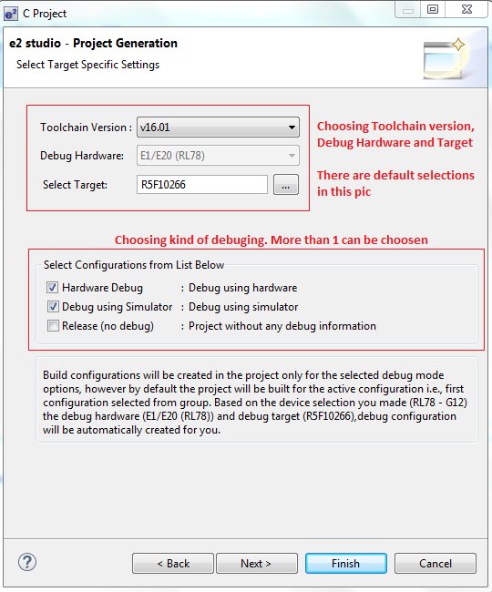

- Toolchain version: versions of Toolchains, there would be one or more choices
- Debug hardware: On-chip debugger emulator
- Target: device

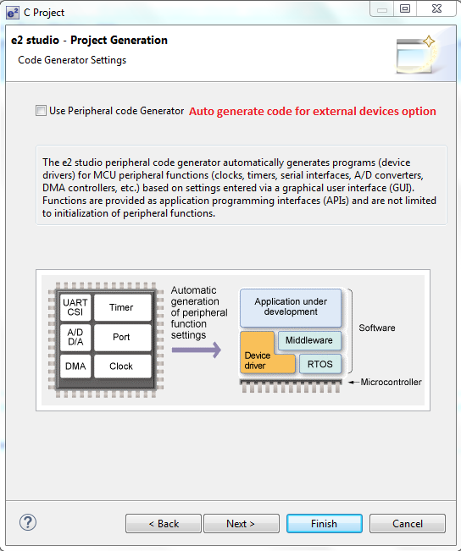

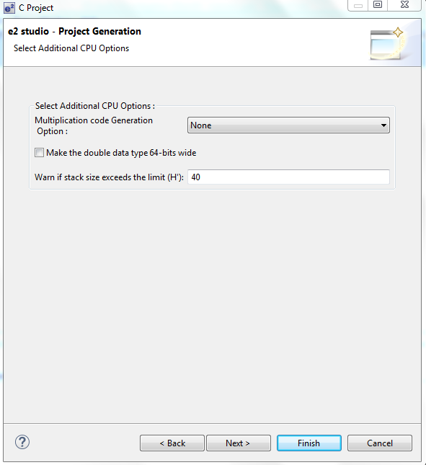
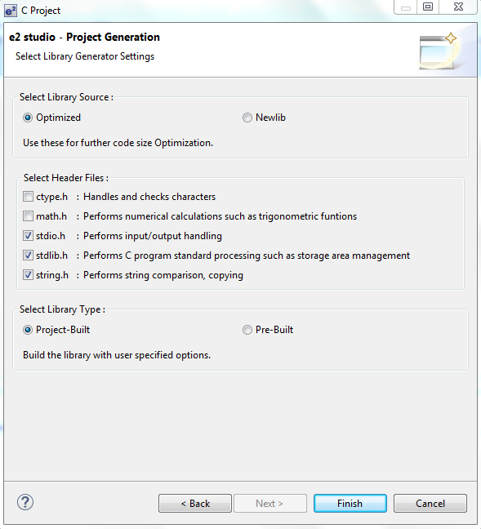

Step 4: A project summary will appear, click OK to create

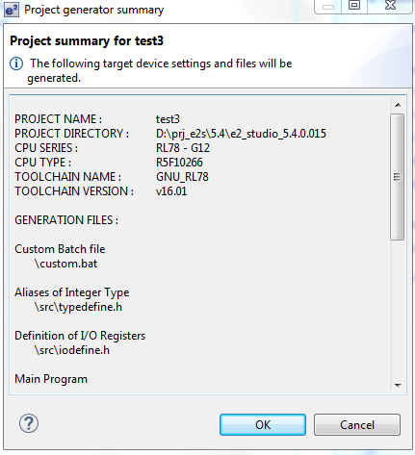

- Other manipulations:

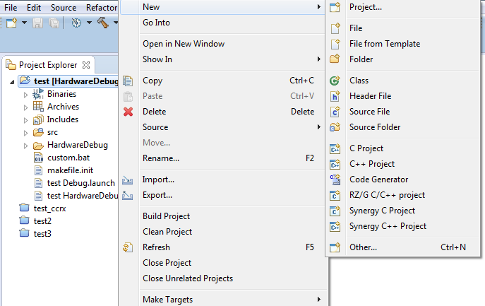

Example Executable projects of some toolchains
GNURX:
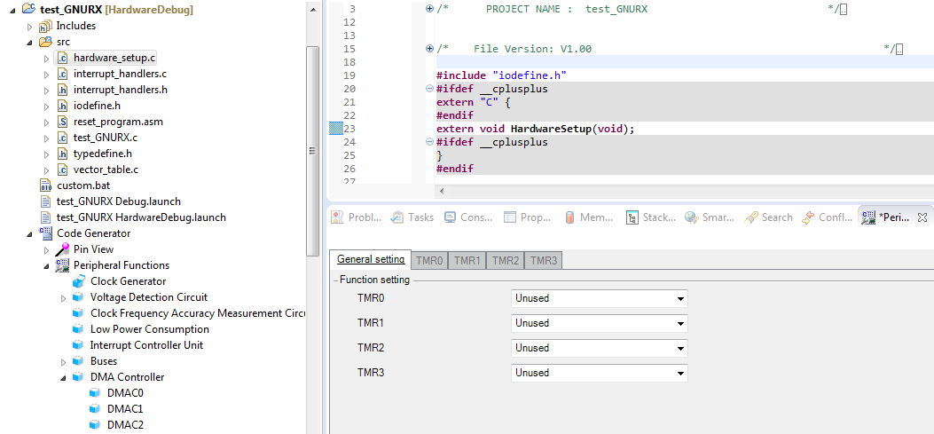

GCCRX:
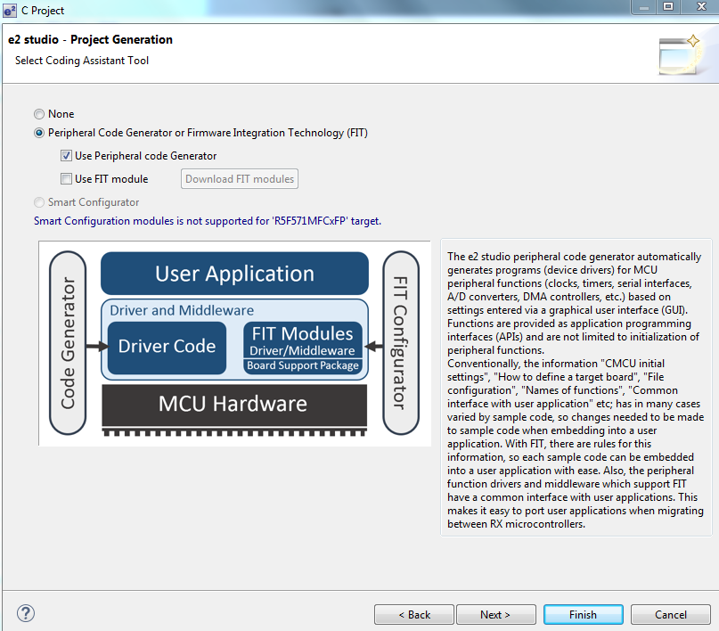

- Peripheral code generator:
- FIT (Firmware intergration technology) module
- Smart configuration

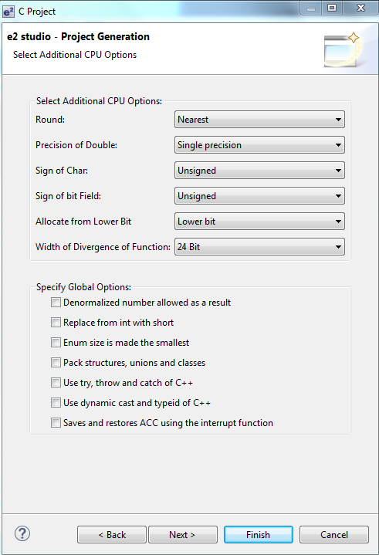
- Round:
- Precious of Double
- Sign of char
- Sign of bit field
- Allocate from lower bit
- Width of Divergence of function

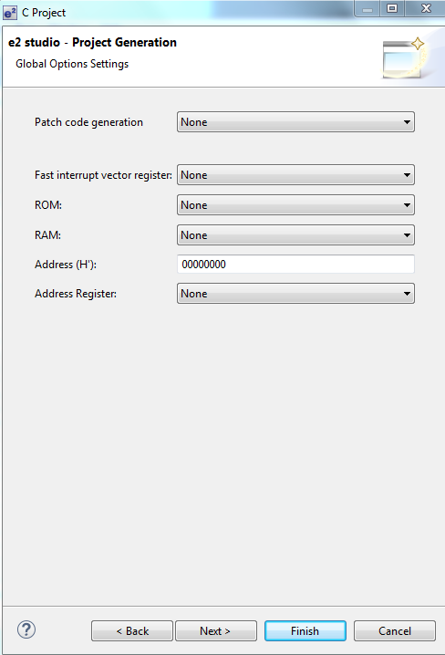

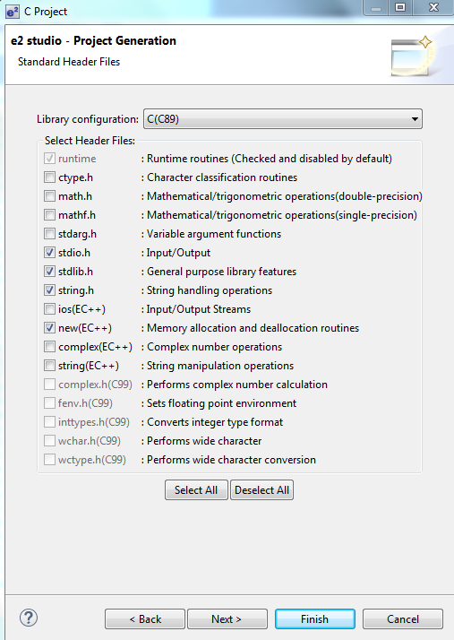

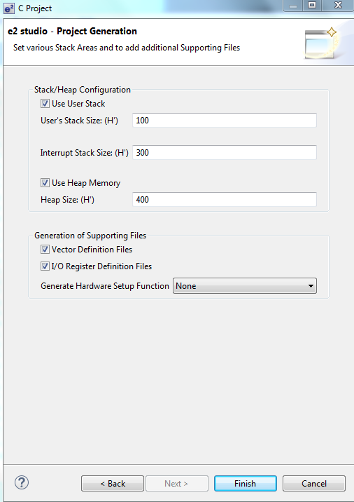

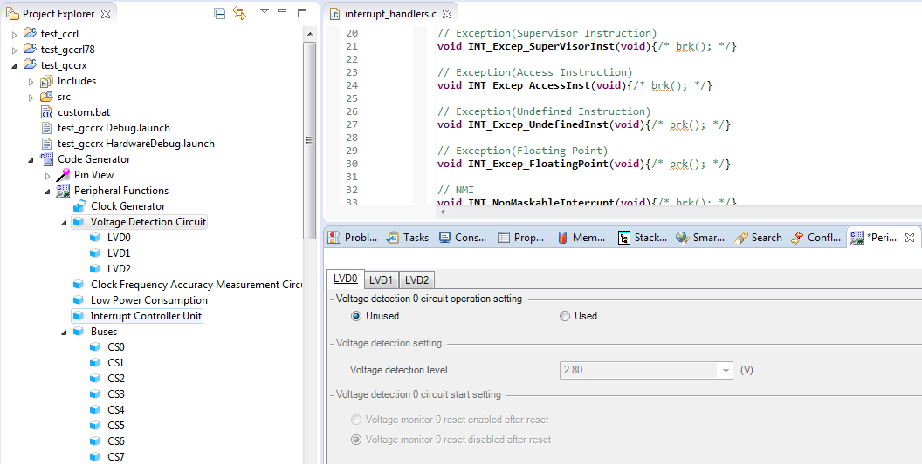

GNURL78:

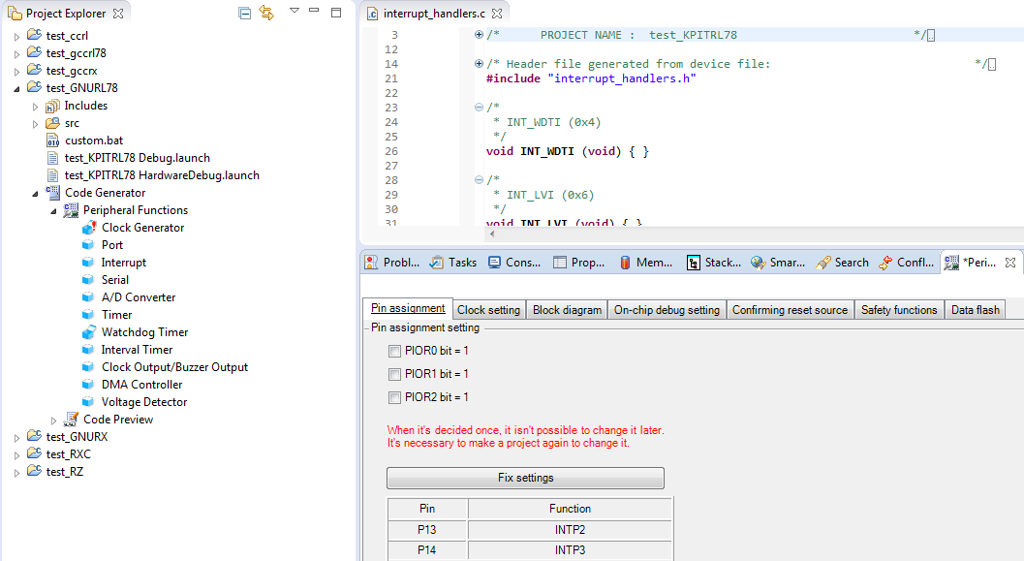

GCCRL78:

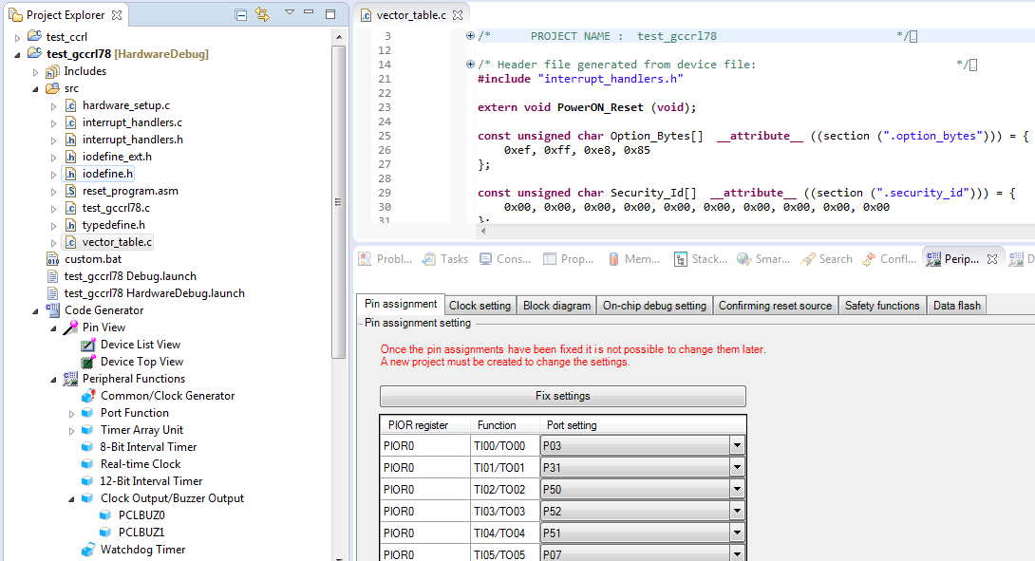

RZ: (peripheral code generator only supports RZ/T)
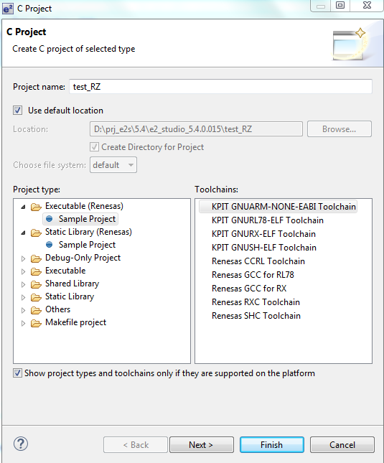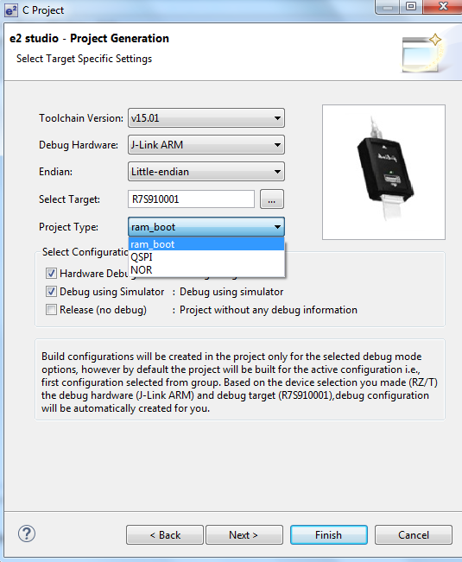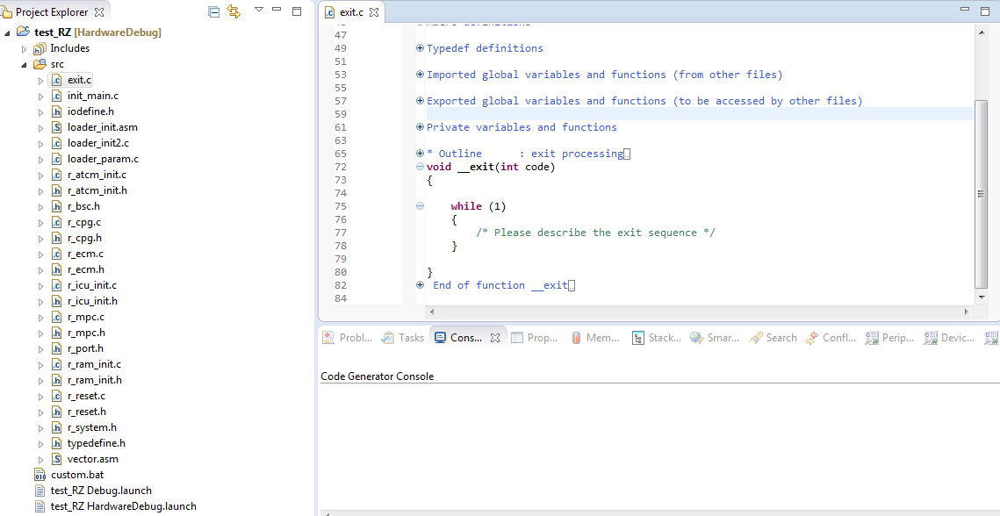

Synergy:
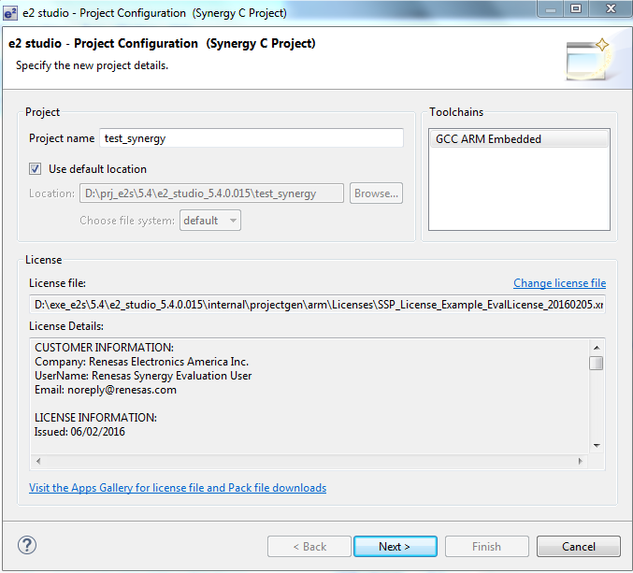
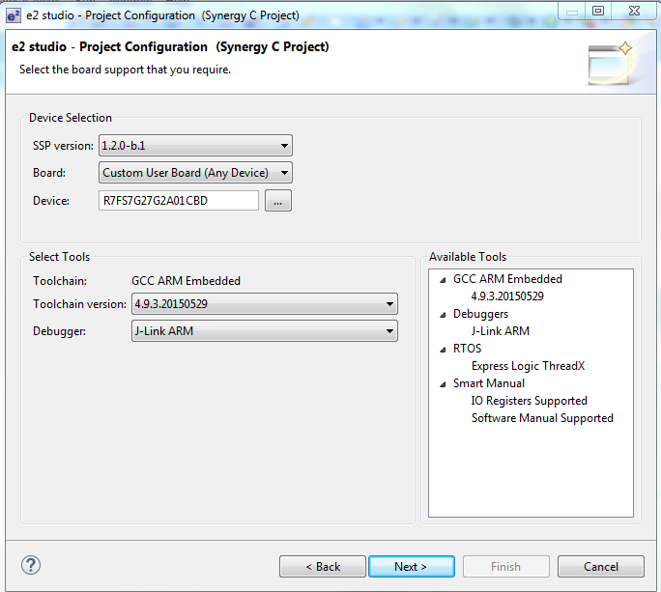

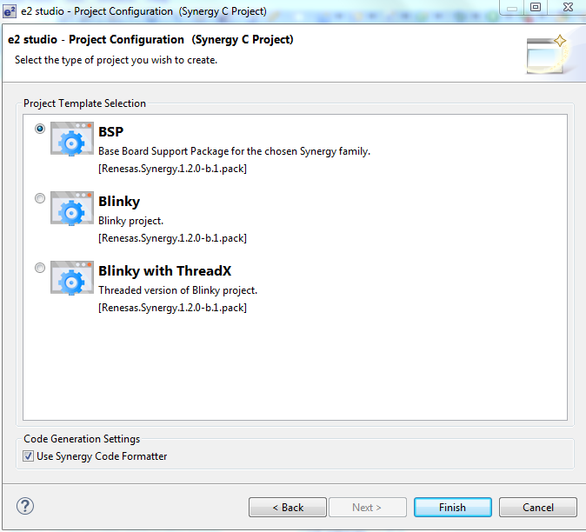

- Build a project
- There are 3 solutions:
- Build project
- Build All
- Build Working Set
- Build Automatically

- “Build project” guide:
Step 1: Configure building by right clicking on project > “Build Configurations” > “Set Active” > choosing “Debug” or “HardwareDebug”

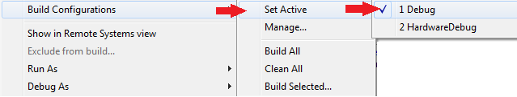

Step 2: Building project by right clicking on the project name > choose “Build project”

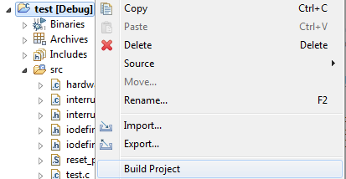

Step 3: Build

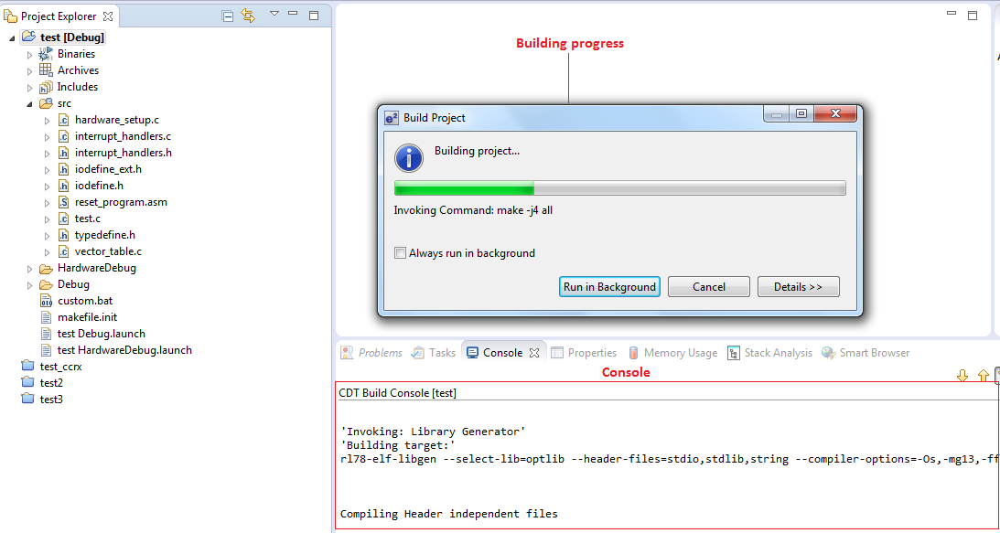

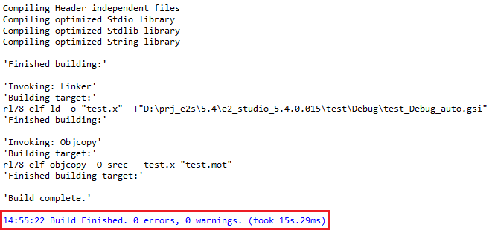

Build configuration

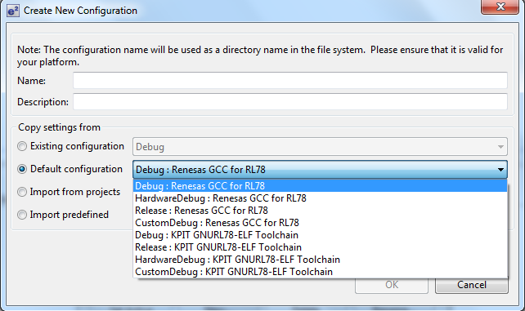

- Buildtool settings
- Library generator
- Compiler
- Assembler
- Linker
- Objcopy
- Toolchain Renesas CC (CCRX)
- Compiler
- Source: display detailed information on the options for controlling preprocessor and make changes to the settings
- Source/Source file: display detailed information on the character code options and make changes to the settings.
- Object: display detailed information on the output-related options and make changes to the settings.
- List: display detailed information on the list options and make changes to the settings.
- Optimize: display detailed information on the optimization options and make changes to the settings.
- Optimize/Advanced: display detailed information on the other optimization options and make changes to the settings
- Miscellaneous: display detailed information on the miscellaneous options and make changes to the settings.
- User: display detailed information on other items regarding the compiler and make changes to the settings.
- CPU: display detailed information on the options for controlling CPU and make changes to the settings.
- CPU/Advanced: display detailed information on the other options for controlling CPU and make changes to the settings
- PIC/PID: display detailed information on the PIC/PID options and make changes to the settings.
- MISRA C Rule Check: display detailed information on the MISRA C options and make changes to the settings.
- Assembler:
- Source: display detailed information on the options for controlling preprocessor and make changes to the settings
- Object: display detailed information on the output-related options and make changes to the settings.

- Toolchain Renesas GCC RL78

- General
- Error Log
- The Error Log view captures all the warnings and errors logged by plug-ins. The underlying log file is a .log file stored in the .metadata subdirectory of the workspace.
- Opening error log:

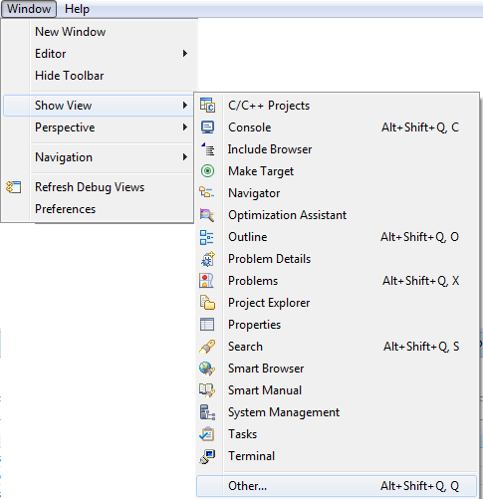

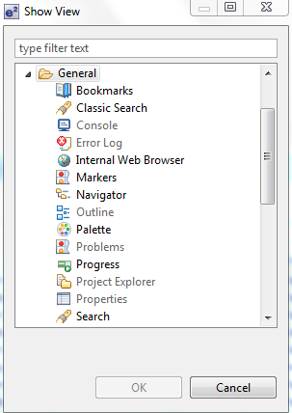

- Error log view includes: Message, Plug-in and Date that error happens. Moreover, there are some functions such as: Filrer, Import log, Export log, Clear log viewer, Delete log, Open log, Restore log, Grouping log by session or plug-in…

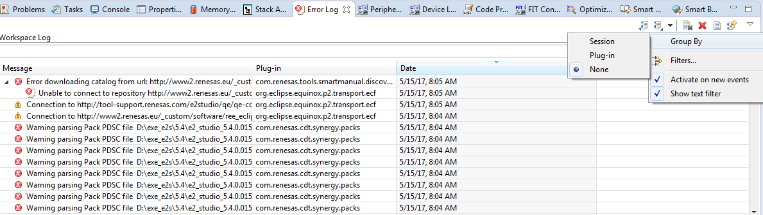
- Error details will appear when double click on error
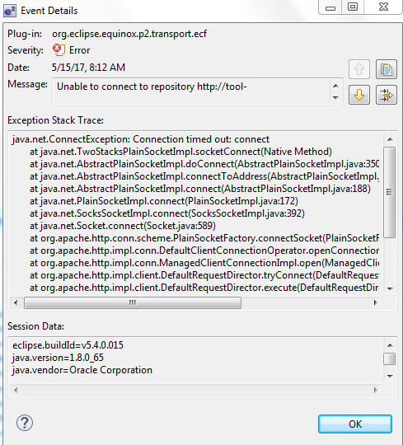

- e2 solution toolkit
- Open e2 solution toolkit:

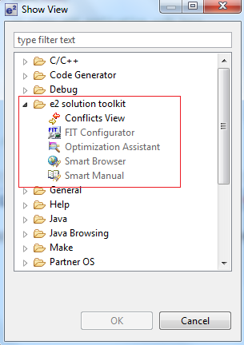

- FIT Configuration
- Firmware Integration Technology modules can be embedded into your program by adding FIT modules to your e2 studio C/C++ project and utilizing APIs provided by FIT modules.
- The FIT Configurator facilitates the selection and addition of FIT modules to any C/C++ project in e2 studio.
- The procedure for adding FIT modules to C/C++ project is as follows.

- Making the C/C++ project to which the FIT modules would be added
- Downloading FIT modules
- Adding FIT modules to C/C++ project

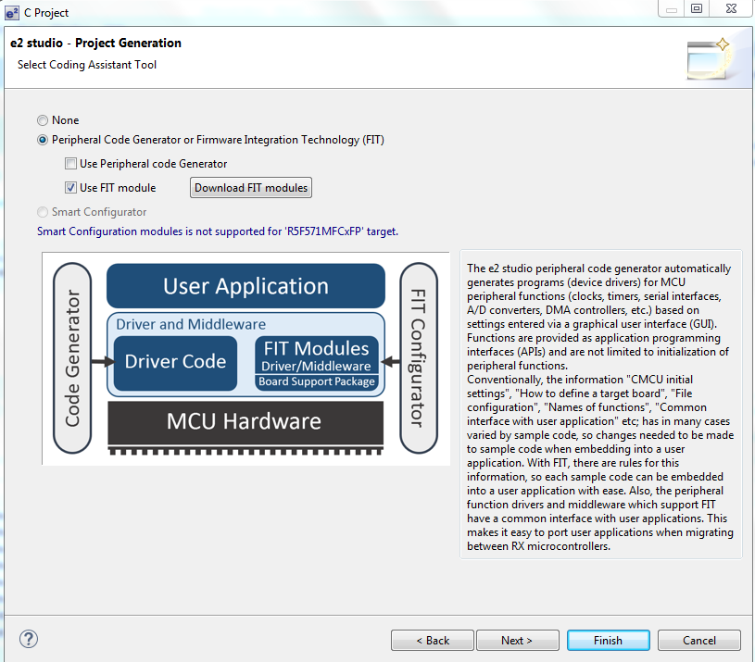

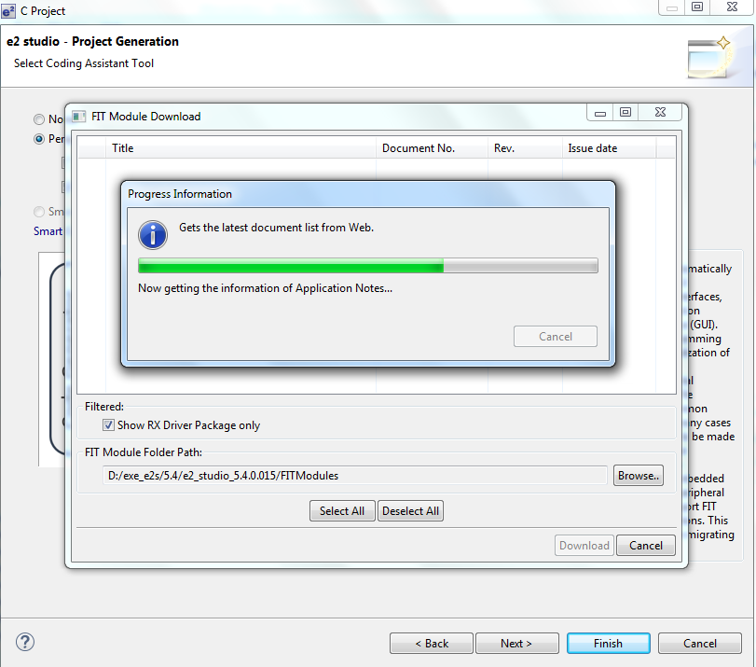

- Optimization Assistant
- Optimization Assistant plug-in displays comparison result of optimization options so as to find effective combination of optimization options.
- Only Renesas CC-RX/CC-RL and GNU-RX/RL78 Toolchain are supporting the creating recommended combination of optimization options.
- The Optimization Assistant display will be updated when user opens a project, changes selection to another project, performs “Measure and Compare”.
- Optimization assistant view

- Functions:
      - Create configuration
      - Generate stack info for all configuration: Add “-stack” option (Linker option) to all configurations and show result message for Renesas CC-RX/CC-RL Toolchain. Add “-fstack-usage” option (Compiler option) to all configurations and show result message for GNU-RX/RL78 Toolchain.
      - Measure and compare: Build configurations and show result of analysis configurations.
      - Show build options setting dialog: Open build options setting dialog
      - Time measurement setting
      - Create configuration

- Smart Browser:
The Smart Browser view provides functions:
- Display the user's manuals, technical updates, application notes, and tool news related to the device selected for the project.
- Download the sample code included in the selected application note when it is available.

- Smart Manual
Smart Manual is the view that displays information (register information / search results by keyword) extracted from the user's manual: hardware.
The user's manual and technical update will be updated from time to time.

