Orion Client Package Instructions

The Orion client is a mostly an open source third party client for playing Ultima Online®. It is still under development and is not at a 1.0 release version yet. It is however quite functional and is in active development. You can download it from https://orion-client.online/index.php?pages/downloads/
This document will only cover using this package. Instructions on installing and using Orion can be found at the above website.

This package was developed to provide support for the Orion client’s features which can be disabled by sending a special TCP packet at logon and at re-connection. A few examples of features that can be disabled are constant light level, hiding roofs and turning tress into stumps. There are more features both in the client and the Orion Assistant (A utility similar to Razor.) that can also be disabled. You can place this package anywhere in the pkg directory. I placed it under \pkg\utils.

Currently any shard developer wishing to allow the Orion client to be used must ONLY allow Orion clients. This is due to the fact that the TCP packet which disables certain Orion client features will cause the official UO clients to freeze upon receiving this packet. We are waiting on the Orion developers to help us in determining a way to send a query to any client logging in which the Orion client would use to identify itself. If we can do that then we would only send the feature disable packet to the Orion client and thus solve our problem.

This package consists of 5 files, logon.src, reconnect.src, settings.inc, settings.cfg, and this document. The only file you as the administrator need to modify is settings.cfg found in \OrionClient\config.

This is how you configure Orion. After placing the package in your pkg directory you will need to shut down your server and compile logon.src and reconnect.src. Do not restart your server yet. Now run the Orion Launcher. Click on the Orion Features tab. The first thing to do is click the radio button labeled POL on the right side of the window. You will see a script appear in the box below the button. Now look on the left side and decide which features you want to disable in the client. They are all enabled by default. Uncheck those you want to disable. As you uncheck them you will notice the script change a little. Actually it is the packet information that changes. Once uo are satisfied double-click somewhere in that hexadecimal number in the script to highlight ONLY the hex string of digits. See the example below.

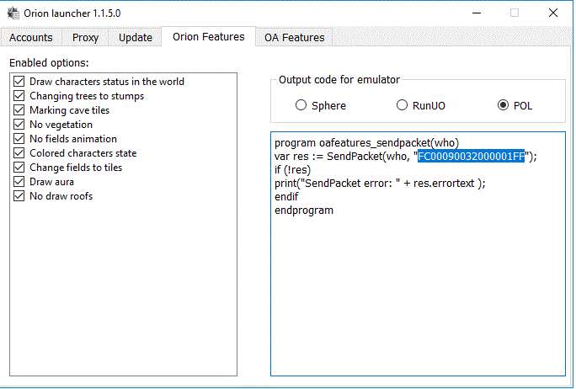

Right-click on the highlighted text and copy it to the clipboard. Now open the settings.cfg file located in \OrionClient\config. Find the setting ClientFeatures and replace the hex number to the right of that setting with the one you copied from the script in the Orion Launcher.

Setting restrictions on the Orion Assistant are just as simple. Click on the tab labeled OA. Make sure the POL radio button is ticked. Now choose from the lists of restrictions you want to disable. When you are satisfied double-click on the hex number in the script. This hexadecimal string is much longer than the previous one so some of it will be hidden. You can see most of the number by using the scroll bar at the bottom of the script example. Right-click and copy it to the clipboard.
See the example below:
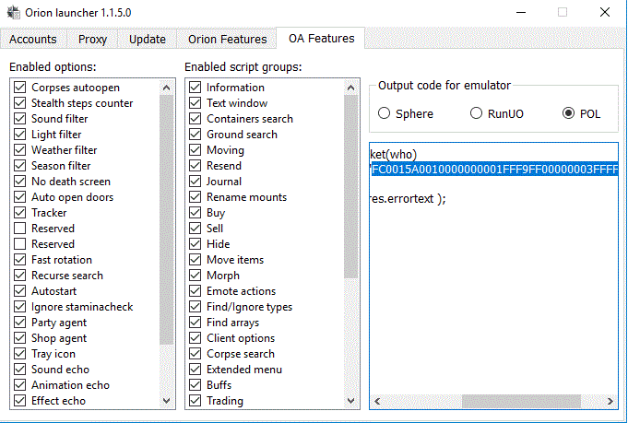

In settings.cfg find the setting AssistantFeatures and replace the hex string to the right with the one you copied from the script example on the Orion Launcher form.

The final setting in settings.cfg is DoNotRestrictStaffAtOrAbove. This allows administrators to allow unfettered access by staff at or above a certain command level to all of the features of the Orion Client and the Orion Assistant. The default setting is command level 3 which on most shards is the Game Master (GM) level. Your shard may have more or less command levels and they may have different names but the numbers for the command levels will be in ascending order from lowest to highest command level. Decide at which level and above you want to have unrestricted access to Orion’s features. If you do not want anyone to have unrestricted access then set this to zero (0).

Save the settings file and restart your server. Congratulations! You have now configured your shard for exclusive use of the Orion Client and Assistant.

I hope you find this useful.
Yukiko
POL Distro leader.
POL Development Team
https://polserver.com

