HOW TO SETUP ULTRA EDIT 32 AS AN IDE

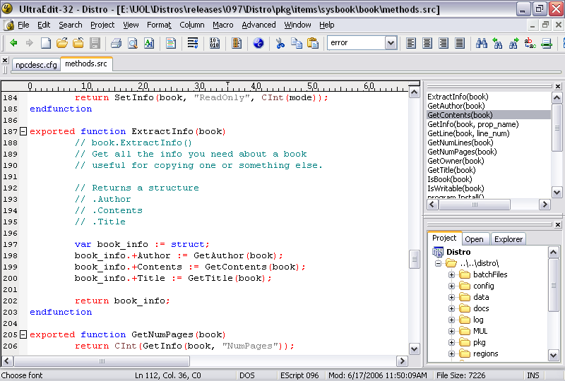
1. Project Files

The first most important feature for using Ultra Edit 32 well is a project file.

You can either setup windows to have Ultra Edit to open .prj files by default or go inside of Ultra Edit, go to the Project menu and then open project/workspace and select Distro.prj.

If you use a folder setup different than the distro, you will need to also go to the Project Settings area and set the path to the POL directory.

What this will do is setup filters for what types of files to display in the file tree viewer and a separate syntax highlight file to use that is specifically made for POL’s config file format, .em modules, .inc includes and .src scripts.

2. Setting up CTRL+F9 to compile scripts

Go to the Advanced menu and select DOS Command.

For the command, enter the path to where your ecompile.exe program is and place a space and %f at the end of it.

Example: E:\UOL\Distros\096\scripts\ecompile.exe %f

For the working directory field, enter the folder above where ecompile is.

Example: E:\UOL\Distros\releases\097\Distro\

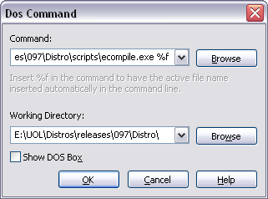

Now when you have a .inc file or .src file open, you can hit CTRL+F9 to compile the include/script. It will give you a new file tab with the output from ecompile.
3. Showing functions/elems in scripts/configs

The project’s word file comes with function commands so you can easily double click them on a list and quickly go to them. Press the F8 key or go to View -> Views/Lists -> Function List.

When you have an open .cfg .inc or .src file it will find the functions and elems and list them in this window.

Config Example Script Example
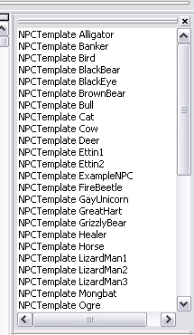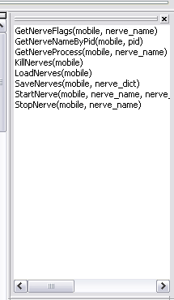

4. The File Tree Viewer

The last part of this guide is the File Tree Viewer. This takes in the filter list from the project file and will only list .txt, .log, .cfg, .inc, .src files. You can change this in the project settings menu.

To bring up this menu, hit CTRL+U or go View->Views/Lists -> File Tree View
