Cyber-Energy Operation Management System

Subsystems Report

Version <1.5>

Document Control

Approval

The Guidance Team and the customer shall approve this document.

Document Change Control

|  |  |
| --- | --- |
| Initial Release: | 1.0 |
| Current Release: | 1.5 |
| Indicator of Last Page in Document: | @ |
| Date of Last Review: | 03/14/2013 |
| Date of Next Review: | To Be Determined |
| Target Date for Next Update: | To Be Determined |

Distribution List

This following list of people shall receive a copy of this document every time a new version of this document becomes available:

**Guidance Team Members:**

Dr. Yoonsik Cheon

Dr. Irbis Gallegos

Aditi Barua

**Customer**:

Dr. Ralph Martinez

**Software Team Members:**

Gabriel Arellano

Chris Duran

Crystal Lopez

John McKallip

Ramon Vega

Matthew Wojciechowski

Change Summary

The following table details changes made between versions of this document

|  |  |  |  |
| --- | --- | --- | --- |
| Version | Date | Modifier | Description |
| 1.0 | 03/09/2013 | Crystal Lopez | Initial Document |
| 1.1 | 03/09/2013 | Crystal Lopez | Introduction |
| 1.2 | 03/13/2013 | Gabriel Arellano,  Chris Duran,  Crystal Lopez,  Ramon Vega,  Matthew Wojciechowski | CRC Cards |
| 1.3 | 03/13/2013 | John McKallip | Subsystem Cards |
| 1.4 | 03/13/2013 | Chris Duran | Class Diagram |
| 1.5 | 03/13/2013 | Gabriel Arellano | Collaboration Graphs |

Table of Contents

Document Control ii

Approval ii

Document Change Control ii

Distribution List ii

Change Summary iii

1. Introduction 1

1.1. Purpose and Intended Audience 1

1.2. Scope of Product 1

1.3. Definitions, Acronyms and Abbreviations 2

1.4. Overview 2

1.5. References 2

2. CRC Cards 3

3. Subsystem Cards 10

4. Diagrams 12

4.1. Class diagram 12

4.2. Collaboration graphs 13

# Introduction

## Purpose and Intended Audience

The primary focus of this document is to provide methods to simplify the patterns of communication between the classes in the Cyber-Energy Operation Management System (C-EOMS). The document will demonstrate how classes can be grouped together and show how they collaborate among themselves in order to support a set of cohesive responsibilities, which can be depended on by a client, otherwise known as contracts. Furthermore the contracts identified here are used as an abstraction tool, for refining class hierarchies and detecting subsystems. [2] The target audiences for this document are the system developers (Team 5), the client and any other person(s) involved in the development of the C-EOM system.

## Scope of Product

The Cyber-Energy Operation Management System (C-EOMS) will be used to gather information from several different energy-management sites situated around the UTEP campus. Presently, UTEP is becoming more energy efficient with the introduction of solar cells to harness the sun's clean, natural energy, as well as other green energy solutions. The C-EOMS system will not only read the energy received by these new pieces of technology (along with existing resources), but will also keep records on the energy consumption within UTEP itself. By creating a system with the capabilities to oversee and integrate all of this information, UTEP will be able to better assess issues and problems related to energy consumption, along with a guide to help point out areas for further improvement in energy management.

The C-EOMS will contain two main categories of user interfaces with which to view data, a generalized one for public viewing, and a private interface for viewing live data and statistics about the campus' energy system. Additionally, the private interface will also provide a means to focus on relevant data sets during a system malfunction. Employees registered with the C-EOMS will also be able to receive system status summaries, either by voluntary request or automatically during a system malfunction.

By offering all of this information on the campus' energy system, we hope to provide non-employees a chance to see how their campus' energy is being distributed overall, as well as support employees with an invaluable tool to help transition our university into an environmentally sound energy consumer and energy producer.

## Definitions, Acronyms and Abbreviations

Below is a list of acronyms and abbreviations along with their definitions.

|  |  |
| --- | --- |
| **Acronym/Abbreviation** | **Definition** |
| C-EOMS | Cyber-Energy Operation Management System |
| FD | Facilities Director |

## Overview

The Subsystems report is divided into the following sections: Introduction, CRC Cards, Subsystem Cards and Diagrams. The Introduction is divided into five subsections, which contain the Purpose and Intended Audience of the document; the Scope of the product we are building (C-EOMS); a table containing the all acronyms and abbreviations along with their definitions; followed by an overview of the document, ending with a list of references that were used. The next section, CRC Cards, includes a list of “index” cards, which now include contracts and their collaborations. The following section, Subsystem cards, is composed of “index” cards that include classes grouped together that cooperate among themselves and support a set of contracts (also identified in the CRC cards). The document concludes with a section devoted to the displaying of a UML class diagram and a high-level collaboration graph as well as a lower level collaboration graph.

## References

[1] Gabriel Arellano, Chris Duran, Crystal Lopez, John McKallip, Ramon Vega, and Matthew Wojciechowski. *Cyber-Energy Operation Management CRC Report*.

[2] Cheon, Yoonsik & Gallegos, Irbis.*Contracts* [Microsoft Power Point] El Paso : s.n., 2013.

[3] Cheon, Yoonsik & Gallegos, Irbis.*Subsystems* [Microsoft Power Point] El Paso : s.n., 2013.

# CRC Cards

Below is an alphabetized list of CRC Cards that are composed of the Candidate Classes, Responsibilities, Contracts and their respective collaborations.

|  |  |
| --- | --- |
| **Class Name:** Alert | |
| **Description:** Manage communication and creation of new malfunctions | |
| **Contracts:**  10. Generate Alert   * Generate an Alert with given parameters * Send Alert to FD Interface   **Private Responsibilities:**   * Generate SMS/ e-mail * Update FD Interface | **Collaborations:**  FD Interface(11)  Malfunction(7) |
| **Comments:**  Known attributes: Building(s), Data, Time, Sensor(s) | |

|  |  |
| --- | --- |
| **Class Name:** Building | |
| **Description:** Abstraction of each building on campus | |
| **Contracts:**  5. Calculate Consumption   * Calculate total Building consumption values   **Responsibilities:**   * Manage Sensors * Calculate consumption of Building objects | **Collaborations:**  Consumption(4)  Map Graphic(13)  Sensor(6,9) |
| **Comments:**  Known Attributes: Geolocation, and Sensor(s) | |

|  |  |
| --- | --- |
| **Class Name:** Consumption | |
| **Description:** Abstract class used to compute consumption data | |
| **Contracts:**  4. Generate Graph data   * Compute graph data by calculated consumption values.   **Responsibilities:**   * Compute Consumption | **Collaborations:**  Building(5)  Graphic Graphic(3) |
| **Comments:**  Used with the Sensor and Building classes to compute consumption statistics of sensor(s) and/or building(s) | |

|  |  |
| --- | --- |
| **Class Name:** Facility Director Interface (FD Interface) | |
| **Description:** Handles the dynamic data requests between the facility director and the system | |
| **Contracts:**  11. Display Alerts   * Display given Alerts to FD Interface   **Responsibilities:**   * Display FD interface | **Collaborations:**  Interface  Alert(10) |
| **Comments:**  Requires successful login by a user with facility director credentials | |

|  |  |
| --- | --- |
| **Class Name: Graph** | |
| **Description:** Create various graphs for consumption visualization | |
| **Contracts:**  2. Draw graph   * Request data with specified parameters * Return image of a graph displaying requested data   **Private Responsibilities:**  - Draw Graph | **Collaborations:**  Graph Graphic (3)  Graphic  Interface |
| **Comments:**  Known attributes: Start time of content, end time of content, type(s) of content displayed (electricity, gas, water, etc.) | |

|  |  |
| --- | --- |
| **Class Name**: Graph Graphic | |
| Superclass: Graphic | |
| Description: Will be used to get data | |
| **Contracts**:  3. Draw Graph   * Gather data * Construct graph based on data gathered   **Private** **Responsibilities**:  - Validate selection  - Criteria | Collaborations:  Consumption (4)  Graphic  Building  Sensor  Reading |
| **Comments**:  None at this time. | |

|  |  |
| --- | --- |
| **Class Name: Graphic** | |
| **Description:** Encapsulate data in various formats as requested for all major graphic content | |
| **Contracts:**  **Private Responsibilities:**  - Retrieve and package data for use within another object | **Collaborations:**  Consumption (4)  Graph Graphic  Malfunction (7)  Map Graphic |
| **Comments:**  PHP allows for associative arrays, which can hold various types of data concurrently | |

|  |  |
| --- | --- |
| **Class Name: Interface** | |
| **Description:** Abstract class of the user view interfaces | |
| **Contracts:**  **Private Responsibilities:**  - Access Database  - Initialize web page  - Initialize graphics | **Collaborations:**  Graph(2)  Map (12)  User(1) |
| **Comments:**  None at the time | |

|  |  |
| --- | --- |
| **Class Name: Malfunction** | |
| **Description:** Class used to identify and manage a malfunction | |
| **Contracts:**  7. List current malfunctions based on parameters given   * prepare a list for Graphics class * provide locations and status data   15. Provide Malfunction status transactions   * return current condition of a specific malfunction * update malfunction data   **Private Responsibilities:**  **-** Manage malfunction status  - Instantiate Alert | **Collaborations:**  Alert  Graphic  Reading  Task |
| **Comments:**  Known attributes: Time, Type, Technician Assigned | |

|  |  |
| --- | --- |
| **Class Name:** Map | |
| **Description:** Class used to generate maps in the user interface | |
| **Contracts:**  12. Draw map   * Display the campus map   **Responsibilities:**  - Draw map | **Collaborations:**  Graphic  Interface  Map Graphic (13) |
| **Comments:**  Will implement by using Google maps API | |

|  |  |
| --- | --- |
| **Class Name:** Map Graphic | |
| **Superclass**: Graphic | |
| **Description:** Will be used to compose buildings and check for malfunctions | |
| **Contracts**:  13. Draw Map   * Gather map data * Construct image of map based on data gathered   **Private Responsibilities:**  - Compose buildings  - Check for malfunctions | **Collaborations:**  Graphic  Building  Malfunction (15)  Consumption (4) |
| **Comments:**  None at this time. | |

|  |  |
| --- | --- |
| **Class Name:** Mobile Interface | |
| **Description:** Handles the dynamic data requests between mobile user and the system | |
| **Contracts:**  **Responsibilities:**  - Display Mobile Interface | **Collaborations:**  Tech Interface |
| **Comments:**  Requires successful login by user with technician credentials | |

|  |  |
| --- | --- |
| **Class Name:** Public Interface | |
| **Description:** Handles the dynamic data requests between the general user and the system | |
| **Contracts:**  **Responsibilities:**  - Display Public Interface | **Collaborations:**  Interface |
| **Comments:**  None at this time | |

|  |  |
| --- | --- |
| **Class Name:** Reading | |
| **Description:** Representation of a consumption reading generated from a sensor | |
| **Contracts:**  8. Read data from sensors   * Get sensor data * Record sensor data * Calculate consumption for sensor   **Responsibilities:**  - Calculate Consumption  - Store Reading | **Collaborations:**  Sensor (9) |
| **Comments:**  Known attributes: Data, and Timestamp | |

|  |  |
| --- | --- |
| **Class Name:** Sensor | |
| **Description:** Retrieves specific sensor’s history or metadata | |
| **Contracts:**  6. Provide reading data   * Assist relative buildings in calculating total consumption values   9. Store reading to sensor object   * Periodically update database about new values   **Private Responsibilities:**  - Retrieve Sensor Data | **Collaborations:**  Building  Reading |
| **Comments:**  Known attributes: Time, Expected Value, Sensor Data Type, Current data being read | |

|  |  |
| --- | --- |
| **Class Name:** Task | |
| **Description:** Handles extra data about a malfunction | |
| **Contracts:**  14. Manage task data   * Tech users modify/update data as needed   **Private Responsibilities:**  - Manage Tasks | **Collaborations:**  Malfunction (15)  Tech Interface |
| **Comments:**  Known routines: Add, Edit, and Delete | |

|  |  |
| --- | --- |
| **Class Name: Tech Interface** | |
| **Description:** Handles the dynamic data requests between Techs and the system | |
| **Contracts:**  **Private Responsibilities:**  - Display Tech Interface  - Update Tech Availability | **Collaborations:**  Interface  Mobile Interface  Task (14) |
| **Comments:**  Requires successful login by user with technician credentials | |

|  |  |
| --- | --- |
| **Class Name: User** | |
| **Description:** Helps validate users and set up contents of interface | |
| **Contracts:**  1. Validate user credentials   * Accept credentials as parameters * Return denial of access or redirect/load into personal workflow   **Private Responsibilities:**  - Validate user credentials  - Generate personal workspace and connect to user interface | **Collaborations:**  Interface |
| **Comments:**  None at this time | |

# Subsystem Cards

Below is a list of “index” cards, which define the subsystems in the C-EOMS and their contracts.

|  |
| --- |
| **Subsystem Name:** Graphics Subsystem |
| **Classes:** Graphic, Graph Graphic, Map Graphic, Graph, Map |
| **Collaboration Graph:** See figure 4.2 |
| **Description:** Responsible for retrieving data, packaging data, and drawing maps and graphs to user interface. |
| **Contracts:**  2. Draw graph  - Server: Graph  3.Retrieve and package graph data  - Server: Graph Graphic  12. Draw map  - Server: Map  13. Retrieve and package map data  - Server: Map Graphic |

|  |
| --- |
| **Subsystem Name:** User Interface Subsystem |
| **Classes:** Interface, Public Interface, FD Interface, Tech Interface, Mobile Interface, User |
| **Collaboration Graph:** See figure 4.2 |
| **Description:** Responsible for validating a user’s credentials and displaying alerts to the facility director user interface. |
| **Contracts:**  1. Validate user credentials  - Server: User  11. Display alerts  - Server: FD Interface |

|  |
| --- |
| **Subsystem Name:** Math Subsystem |
| **Classes:** Building, Consumption, Sensor |
| **Collaboration Graph:** See figure 4.2 |
| **Description:** Responsible for storing readings data, providing readings data, calculating consumption data, and generating graph data. |
| **Contracts:**  4. Generate graph data  - Server: Consumption  5. Calculate consumption  - Server: Building  6. Provide reading data  - Server: Sensor  9. Store reading to sensor object  - Server: Sensor |

|  |
| --- |
| **Subsystem Name:** Observation Subsystem |
| **Classes:** Alert, Task, Malfunction, Reading |
| **Collaboration Graph:** See figure 4.2 |
| **Description:** Responsible for reading data from sensors, generating alerts, listing current malfunctions, providing malfunction status updates, and managing task information. |
| **Contracts:**  7. List current malfunctions based on parameters given  - Server: Malfunction  8. Read data from sensors  - Server: Reading  10. Generate alert  - Server: Alert  14. Manage task data  - Server: Task  15. Provide malfunction status updates  - Server: Malfunction |

# Diagrams

## Class diagram

Below is a representation of the classes in UML form.

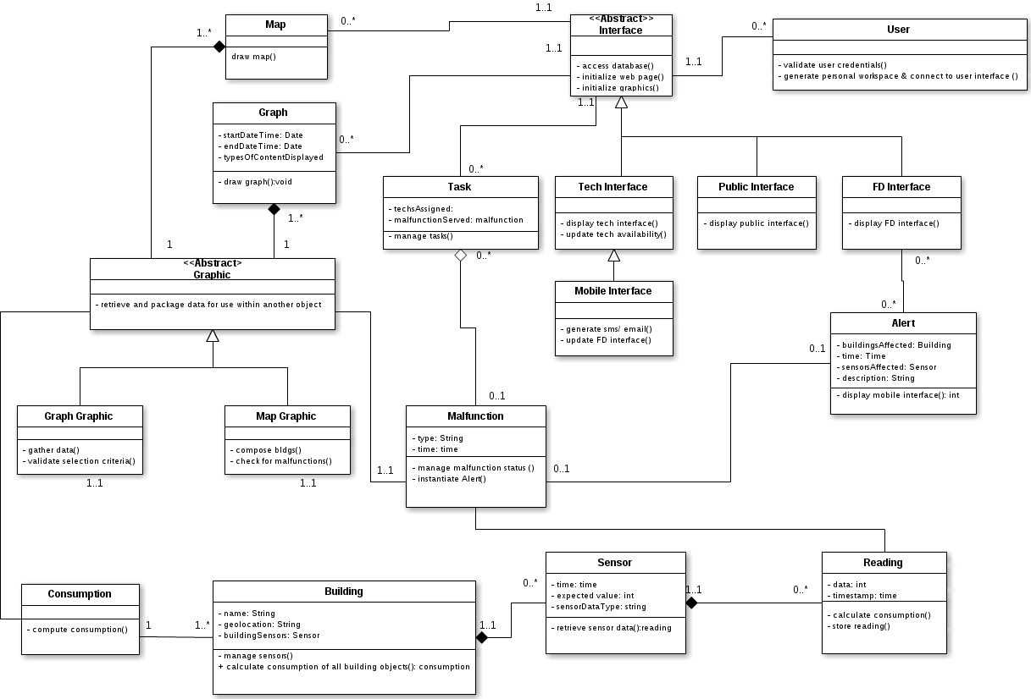

## Collaboration graphs

Below is a set of collaboration graphs.

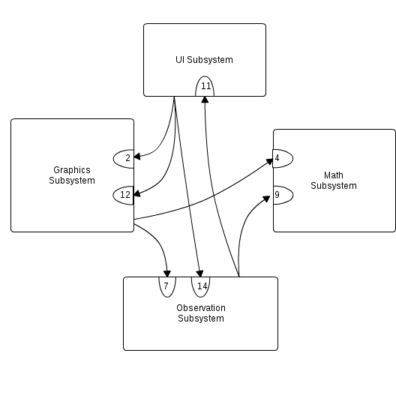

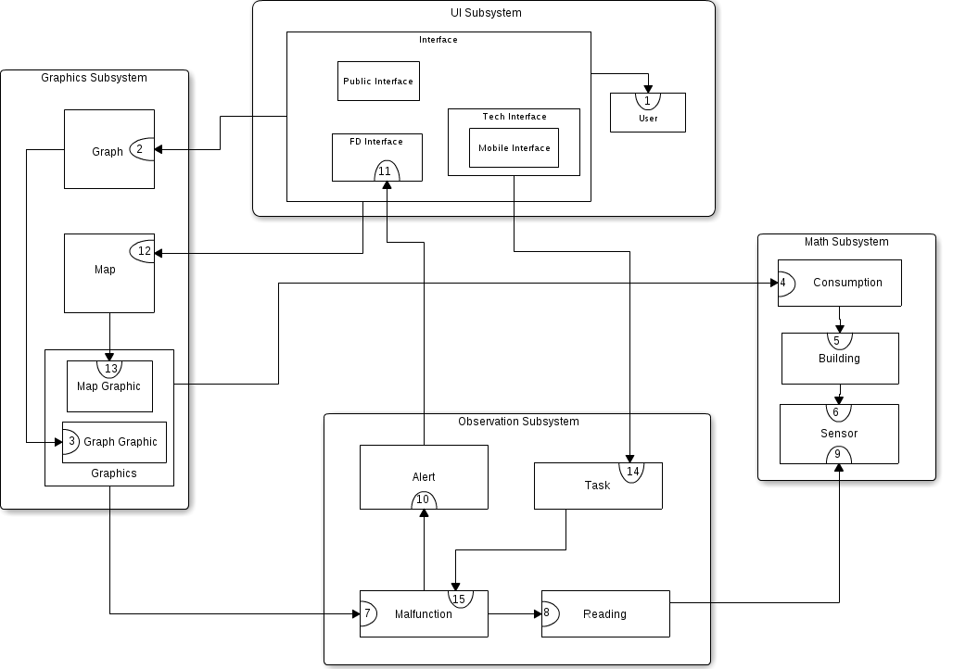

@ END OF DOCUMENT