**Solidity Assignment**

**Phase - 2 ( KYC smart contract using remix)**

Submitted By : Sumeet Pol

**Deployment Instructions:**

1. Copy code from KYC.sol and paste in Remix IDE.

2. Press **Ctrl +S** to compile contract.

3. Switch to **Run** Tab

4. Change the Gas limit to **6000000**

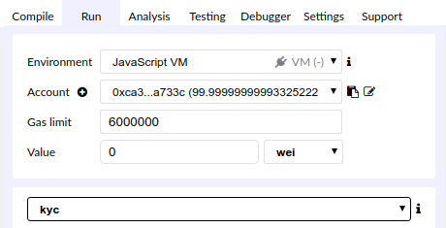

5. To deploy smart contract press Deploy Button.

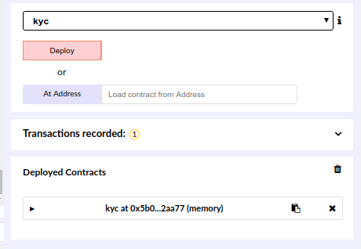

**Execution Instructions:**

|  |
| --- |
| ***Note:***  *Contract deployed by address will act as admin for KYC contract.* |

**1. addBank()**

Input : "bank1","bid01","0x14723a09acff6d2a60dcdf7aa4aff308fddc160c",true

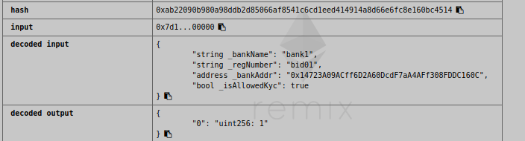

**2. getBankName()**

Input: "0x14723a09acff6d2a60dcdf7aa4aff308fddc160c"

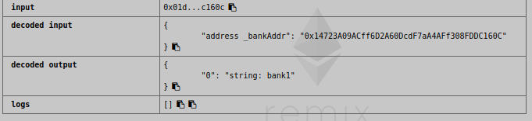

**3. blockBankFormSubmittingKyc()**

Input: "0x14723a09acff6d2a60dcdf7aa4aff308fddc160c"

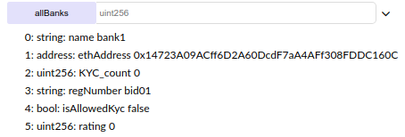

**4. unblockBankFromSubmittingKyc()**

Input: "0x14723a09acff6d2a60dcdf7aa4aff308fddc160c"

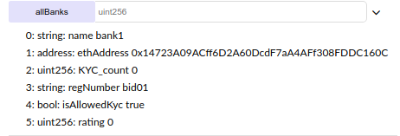

|  |
| --- |
| ***Note:***  *For Bank function to execute, please change the execution address to 2nd from list* |

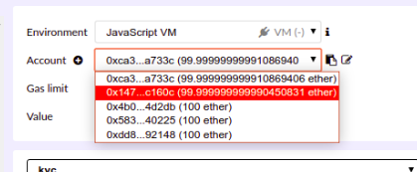

**5. addCustomer()**

Input : "sumeet","eed38600fe7dbd179cbaa86e00ab362a707b88d121120bb45e0891e0583e10f1"

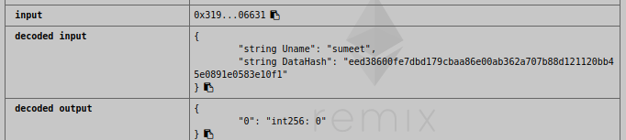

**6.modifiyCustomer()**

INPUT: "sumeet","eed38600fe7dbd179cbaa86e00ab362a707b88d12112"

**7. addRequest()**

Input : "sumeet","0x14723A09ACff6D2A60DcdF7aA4AFf308FDDC160C"

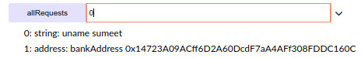

**8. updateKycVotes()**

Input: "sumeet",true

|  |
| --- |
| ***Note :***  ***Perform updateKycVotes 6 times***  *As currently there is only 1 bank created.*  *If there are more banks created by admin, please switch the respective bank’s address to perform updateKycVotes. To simulate votes by different banks.* |

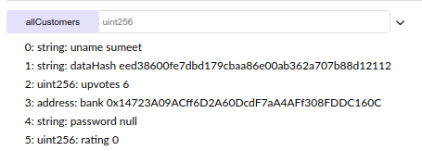

**9. validKYCs**

Input: 0

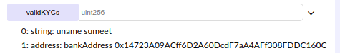

**10. updateKycVotes() // down vote**

Input: "sumeet",false

|  |
| --- |
| ***Note:***  *Perform updateKycVotes 2 times*  *If upvotes are less than 5, then kyc is removed from validKYCs list.* |

**11. addRatingToBank()**

Input : "0x14723a09acff6d2a60dcdf7aa4aff308fddc160c"

**12. addRatingToCustomer()**

Input : "sumeet"

**13. viewCustomer()**

Input: "sumeet"

**14: setCustomerPassword()**

Input : "sumeet","password"

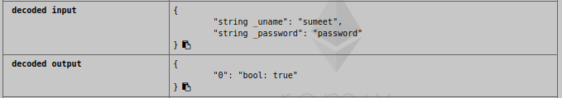

|  |
| --- |
| ***Note :***  *Password can be set only once.*  *If you try setting password again, it will give you error. Password already Set.* |

**15. getBanksRating()**

Input : "0x14723A09ACff6D2A60DcdF7aA4AFf308FDDC160C"



**16. getCustomerRating()**

Input: "sumeet"



**17. removeRequest()**

Input : “sumeet”

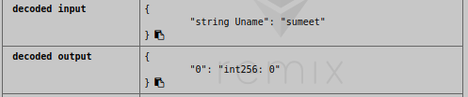

**18. removeCustomer()**

Input : “sumeet”

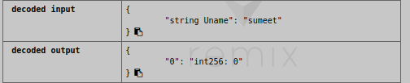

**19. Switch to admin account address**

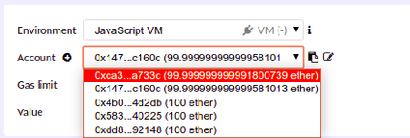

**20. removeBank()**

Input : "0x14723A09ACff6D2A60DcdF7aA4AFf308FDDC160C"

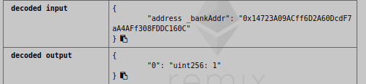

**List of API’s Completed in KYC contract**

**Bank**

1. addKycRequest(username,bankaddress) - done

2. addCustomer(username,documentHash) - done

3. removeCustomer() - done

4. updateCustomer() - done

5. viewCustomer() - done

6. getBankRequest() -not done

7. rateCustomer(uname) - done

8. rateBank(address) - done

9. getCustomerRating(uname) - done

10. getBankRating(address) - done

11. accessHistroy(uname) - returns banks address

**Customer**

1. setPassword(username,password) - done

2. viewCustomerData() - done

3. getBankName(address) - done

4. getBankAddress(name) - done

**Admin**

1. addBank(name,address,isAllowed) - done

2. removeBank(address) - done

3. getBankName(address) - done

4. getBankAddress(name) - done

5. blockBankFormSubmittingKyc(address) - done

6. unblockBankFormSubmittingKyc(address) - done