WEB DEVELOPMENT PROJECTS
Project Screenshots and Documentation
This document presents three sample web application interfaces. Each section includes a screenshot and a short description of the page and its main features.

1. User Registration and Login System
This webpage provides user registration, login, password recovery, and profile setup forms. Users can enter their personal details, create an account, sign in, reset a forgotten password, and save profile information.
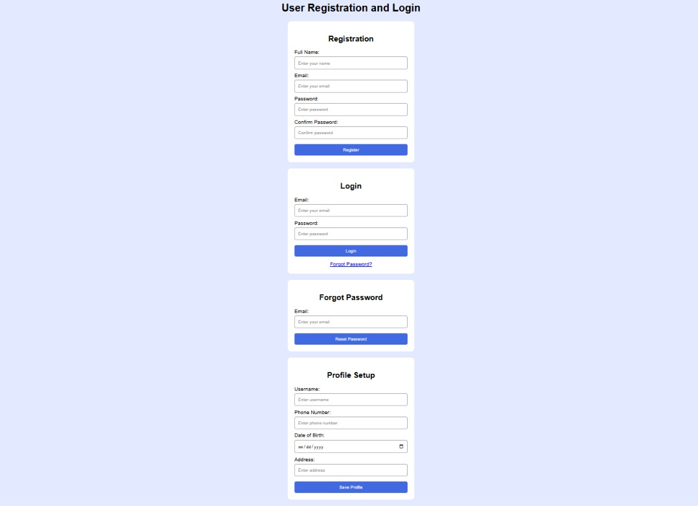
Figure 1: User Registration and Login System interface

Main Features
- Registration form
- Login form
- Forgot password option
- Profile setup form

2. Project Management Dashboard
This dashboard displays project statistics and organizes tasks into To Do, In Progress, and Completed sections. It also shows task priority, team assignments, deadlines, progress bars, and team members.
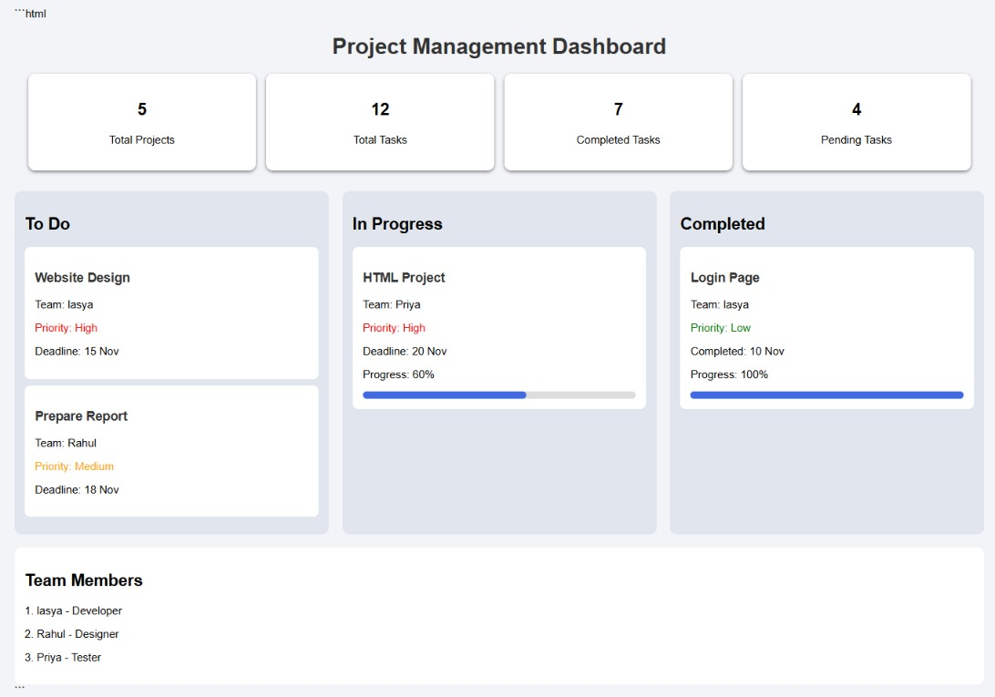
Figure 2: Project Management Dashboard interface

Main Features
- Project and task summary cards
- To Do / In Progress / Completed columns
- Priority, team, and deadline details
- Task progress indicators and team list

3. Bus and Train Ticket Booking
This webpage allows users to enter travel details and passenger information, view available bus and train services, compare fares, select a seat, and proceed to book a ticket.
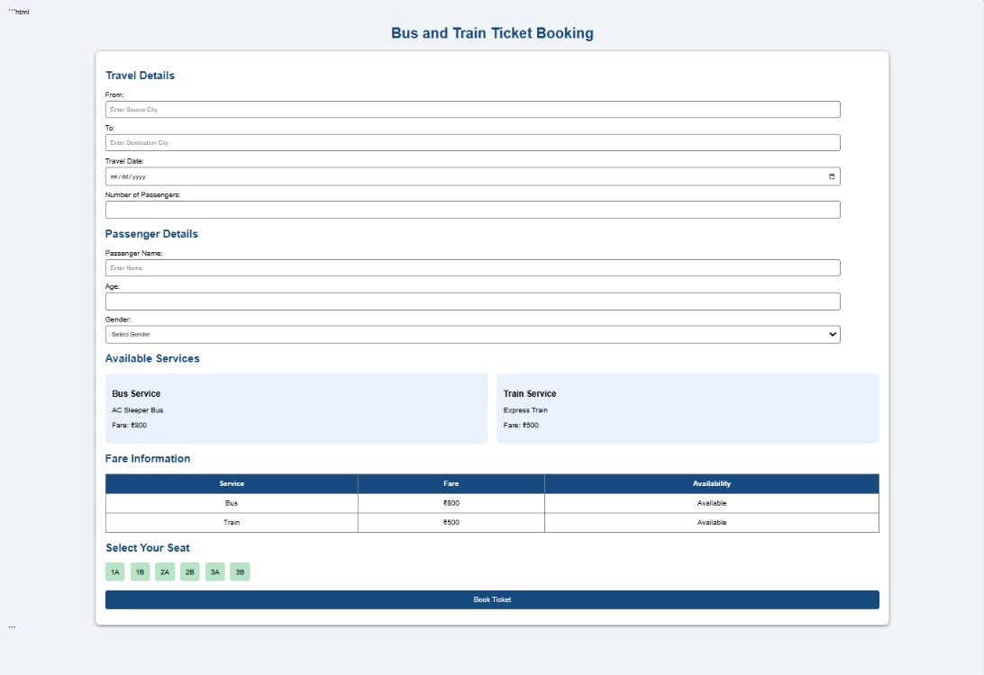
Figure 3: Bus and Train Ticket Booking interface

Main Features
- Source and destination fields
- Travel date and passenger details
- Bus and train service information
- Fare table, seat selection, and booking button

Conclusion
The three interfaces demonstrate common web development features: user forms, dashboard layouts, task tracking, travel information, tables, and responsive-style cards. They provide examples of how HTML and CSS can be used to organize information and create clear, user-friendly webpages.

