POLURU MAMATHA

EMPLOYEE ID:11717500

EMAIL ID:p.mamatha@dxc.com

**1.Explain the kernel operating system, OS is a resource allocator and OS is a control program**

**Ans.**

**Kernel operating system:** Kernel is central component of an operating system that manages operations of computer and hardware. It basically manages operations of memory and CPU time. It is core component of an operating system. It basically acts as an interface between user applications and hardware. Kernel loads first into memory when an operating system is loaded and remains into memory until operating system is shut down again. It is responsible for various tasks such as disk management, task management, and memory management.

**OS is a resource allocator and OS is a control program:**It is an central component of operating system which is used to manage operations of computer and hardware. It is difficult to operate. It transmits message from operating system to hardware component. It is resource allocator because it manages all resources. And is also a control program as it manages execution of the program and prevent from errors.

**2.What is resource management? Explain the components:**

**Ans.** Resource management is acquiring, allocating and managing the resources, such as individuals and their skills, finances, technology, materials, machinery and natural resources required for a project. Resource management ensures that internal and external resources are used effectively on time and to budget.

Components of resource management:

* **Program execution:**

A process includes the complete execution of the written program or code. There are some of the activities which are performed by the operating system: The operating system Loads program into memory. It also Executes the program. It Handles the program's execution

* **I/O operations:**

Input-output (I/O) systems transfer information between computer mainmemory and the outside world. An I/O system is composed of I/O devices I/O control units, and software to carry out the I/O transaction(s) through a sequence of I/O operations

* **File System manipulation:**

The operating system gives the permission to the program for operation on file.

Permission varies from read-only, read-write, denied and so on.

Operating System provides an interface to the user to create/delete files.

* **Communication:**

Communications management is the systematic planning, implementing, monitoring, and revision of all the channels of communication within anorganization and between organizations; it also includes the organization and dissemination of new communication directives connected with an organization, network.

* **Protection:**

Protection refers to a mechanism which controls the access of programs, processes, or users to the resources defined by a computer system. We can take protection as a helper to multi programming operating system, so that many users might safely share a common logical name space such as directory or files.

**3.Explain 1. Security and maintenance with the screen shots,**

**2. Back up and restore of your computer system.**

**Ans.**

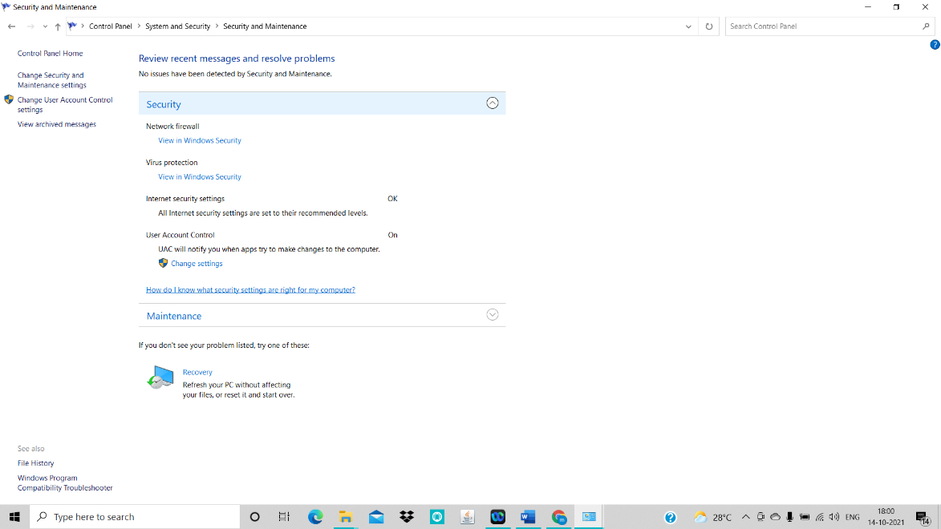

**Security**: It provide the security facilities about our pc and network connections such as network firewall, virus protection etc.

**Maintenance:**

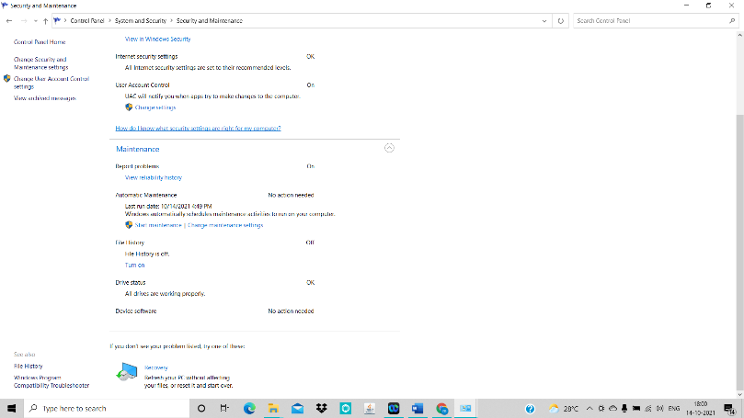

We can maintain the computer settings by using this maintenance settings in security and storage settings.

**Back-up and Restore**:

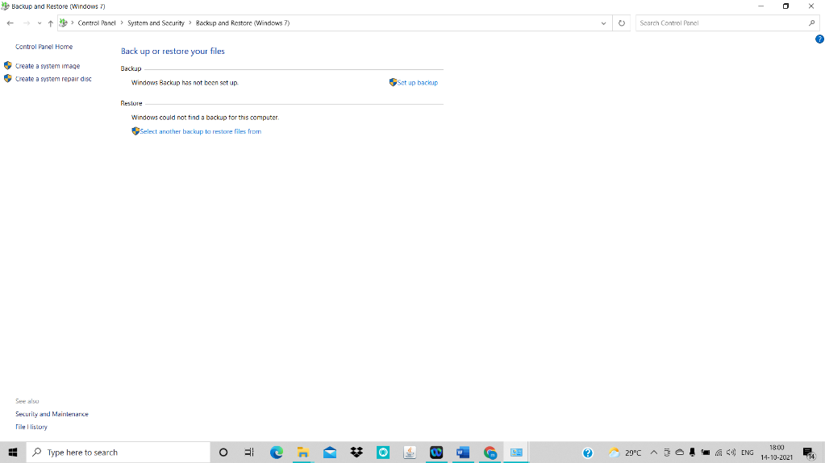

Back-up and Restore settings are used to retrieve the lost data from our computer by using our drive.

**4.Explain what is shell and kernel?**

**Ans. Kernel:** The computer programs that allocate the system resources and coordinate all the details of the computers internals is called the kernal. Users communicate with the os through a program called shell. Kernel is the heart of the operating system. The Linux kernel is used by Linux distributions alongside GNU tools and libraries. This combination is sometimes referred to as GNU/Linux. Popular Linux distributions include Ubuntu, Fedora, and Arch Linux.

**Shell:** The shell is a command line interpreter. It translates commands enter by the user and converts them into a language understood by the kernel. Kernel controls all essential computer operations, and provides the restriction to hardware access, coordinates all executing utilities, and manages Resources between process. Using kernel only user can access utilities provided by operating system. 5.Write minimum 10 differences between the linux and windows operation

**5.Write minimum difference between Linux and windows operating system.**

**Ans.**

|  |  |
| --- | --- |
| **Linux** | **Windows** |
| 1.file system:  In linux files are ordered in a tree structure starting with the root directory.  2.Security:  Linux is very stable and more secure than windows. Any new problem raised can be solved within few hours.  3.compatibility:  Linux is not as compatible as windows with software and services available.  4.Ease of use:  Non-technical users can install linux and do normal day to day activities like web browsing, email, playing, music etc.  5.Privacy:  Linux system come with an option of built-in military grade encryption, and user can be sure that device theft poses no real problem to data. 6.source code:  Linux is open source. users have access to the source code. | In Microsoft files are stored in folder on different data like C.D.E.  Windows user has faced securely and stability issues. since windows Is the most widely used operating system. Hackers spammer target windows.  Windows is compatible with most software and services available to the user.  Users are used to the UI of windows. This makes it good for power and non-power users.  Windows can also watch what user do. Offering syncing to the Microsoft one drive service or to learn user behaviour to improve upon cartana.  Windows is proprietary only select personal have access to the source code |

**6.Explain the components and architecture of linux?**

**Ans.**

The following are the components contained in linux architecture:

**1.Applications or utilities:** It is responsible for doing specialized level and individual activities.

**2.Shell:** It can take commands through the user and runs the functions of the kernel. The shell is available in distinct types of OSes. These operating systems are categorized into two different types, which are the graphical shells and command-line shells.

**3.Kernal:** The kernel is one of the core section of an operating system. It is responsible for each of the major actions of the Linux OS. This operating system contains distinct types of modules and cooperates with underlying hardware directly. The kernel facilitates required abstraction for hiding details of low-level hardware or application programs to the system.

There are some of the important kernel types which are mentioned below:

* Monolithic Kernel
* Micro kernels
* Exo kernels
* Hybrid kernels

**4. Hardware:** Linux operating system contains a hardware layer that consists of several peripheral devices like CPU, HDD, and RAM. 4.Breifly explain resource management in operating system? Ans. An operating system (OS) is basically a collection of software that manage.

Architecture of Linux operating system:

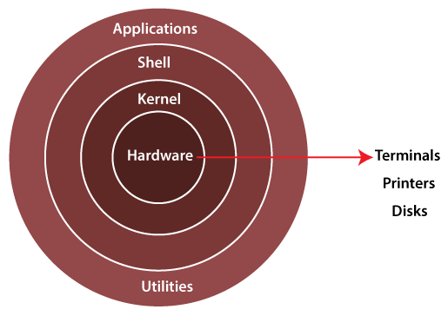

**7. Briefly explain the resource management in operating system?**

**Ans.** An operating system (OS) is basically a collection of software that manages computer hardware resources and provides common services for computer programs. The operating system is a crucial component of the system software in a computer system.

These are some few common services provided by an operating system −

* Program execution
* I/O operations
* File System manipulation
* Communication
* Error Detection
* Resource Allocation
* Protection

In the matter of multi-user or multi-tasking environments, resources such as main memory, CPU cycles and files storage are to be allocated to each user or job. Some major activities of an OS with respect to resource management are

* The Operating System manages all kinds of resources using schedulers.
* CPU scheduling algorithms are employed for better utilization of CPU.

**8. What are the types of operating system and explain each.**

**Ans.** There are five types of operating systems:

They are:

* Batch operating system
* Multiprogramming operating system
* Multitasking operating system
* Multiprocessing operating system
* Real time operating system

**Batch operating system:** Basically it is non-interactive operating system. The users who using a batch operating system do not interact with the computer directly. Each user prepares its job on an off-line device like punch cards and submits it to the computer operator. To speed up the processing, jobs with similar needs are batched together and run as a group. The programmers exit their programs with the operator and the operator then sorts the programs with similar requirements into batches. Punch cards are mainly used int this.

**Multiprogramming operating system:** A multiprogramming operating system may run many programs on a single processor computer. If one program must wait for an input/output transfer in a multiprogramming operating system, the other programs are ready to use the CPU. As a result, various jobs may share CPU time. However, the execution of their jobs is not defined to be at the same time period.

**Multitasking operating system:** It is a logical extension of a multiprogramming system that enables the execution of multiple programs simultaneously. In an operating system, multitasking allows a user to perform more than one computer task simultaneously. Multiple tasks are also known as processes that share similar processing resources like a CPU. The operating system keeps track of where you are in each of these jobs and allows you to transition between them without losing data.

**Multiprocessing operating system**: Multiprocessor[Operating System](https://ecomputernotes.com/fundamental/disk-operating-system/what-is-operating-system) refers to the use of two or more central processing units within a single [computer](https://ecomputernotes.com/fundamental/introduction-to-computer/what-is-computer) system.

These multiple CPUs are in a close communication sharing the [computer](https://ecomputernotes.com/fundamental/introduction-to-computer/what-is-computer) bus, [memory](https://ecomputernotes.com/fundamental/input-output-and-memory/memory) and other peripheral devices. These systems are referred as tightlycoupled systems*.*

These types of systems are used when very high speed is required to process a large volume of data. These systems are generally used in environment like satellite control, weather forecasting etc.

**9.Explain evolution of linux system and distribution:**

**Ans.** Since 1991 the Linux Evolution has become immense. Let’s talk about what Linux is and what a Linux Distribution is. The term Linux itself refers to the core code in a Linux distribution; Linux is the kernel and is Open Source Software made freely available. For this reason Linux can be deployed as an Operating System without licensing costs associated with some other systems. Linus Torvalds, a Finnish student developed this software initially in 1991 and in 1992 released the code as Open Source. If Linux is the kernel, the core of the Operating System then it is the Linux Distribution that make the kernel usable. A Linux distribution is the collection of software applications and drivers that make Linux usable on your hardware. Common Linux distributions in 2021 include:

* Red Hat Enterprise Linux 8, free to use but support agreements are chargeable
* CentOS 8, Red Hat rebuild with only community support and scheduled to be discontinued at the end of 2021
* Ubuntu 20.04 LTS, the current Long Term Support, (5 years) version from Canonical
* SUSE Linux Enterprise Server 15
* openSUSE 15.2, community edition of the SUSE Enterprise product
* Kali, Linux distribution with tools developed by Offensive Security
* Raspbian, Debian based Linux distribution used on Raspberry Pi credit card sized computer
* Android, Phone based Linux distribution

**Distributions of linux operating system**:

The following are the distributions of linux operating system:

* Red Hat: Provide paid support and is often a safe choice for the enterprise.
* Ubuntu LTS: Long Term Support versions are released every two years and supported for five years. The current version is 20.04 and that will be supported until 2025. Optional paid support is available from Canonical, the company behind Ubuntu.
* CentOS: Is a Red Hat rebuild and provide long term updates and community support. They are currently owned by Red Hat/IBM and it is planned to discontinue CentOS Linux at the end of 2021.
* Debian: Is a respected Enterprise version with community Support. The Raspberry Pi OS, Raspbian, is based on Debian.