**Battle for Weakness** is a board multiplayer PvP card game, the goal of which is to defeat your opponent.

**Preparing for the “battle”**

Before the start of the battle, each player must choose a deck of a certain faction (at the moment these are “Mountains” and “Swamp”). For each faction, certain cards are available that are related to the selected faction in style and have a certain set of unique parameters and abilities. The choice of your strategy for the game and the gaming experience you have gained will depend on the choice of the faction.

After choosing a faction, you will be presented with an 8x6-cell playing field (see the real prototype in Figure 1). Each player needs to be given 5 stacks of cards corresponding to the selected faction (why 5 will be explained later). Each stack of cards will be conventionally called a “library".

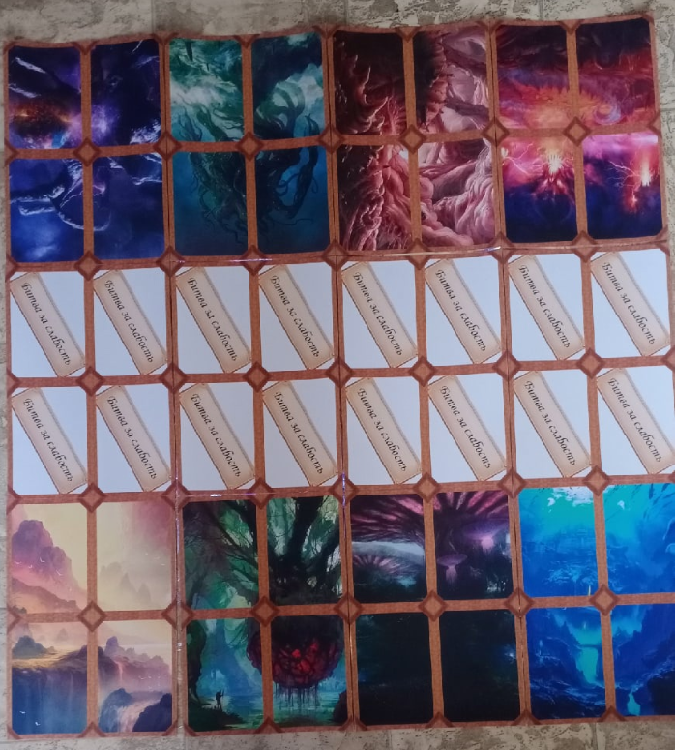

*рис 1.*

The libraries will be distributed according to the “rarity" of the cards. In the first library there will be cards of **ordinary** rarity, in the second **unusual**, in the third **rare**, in the fourth **epic** and finally in the fifth **legendary** rarity.

At the beginning of the game, each player will only have access to a library of **ordinary** cards. The remaining libraries will be opened during the gameplay.

As it was said at the very beginning, the goal of the game is to defeat your opponent, which is achieved by reducing the other player's “health points" to 0. At the beginning of the game, everyone has 25 points.

**The “battle” process**

The game begins by choosing the player whose turn will be the first, after which everyone takes 7 cards from the usual library into their hand, without showing them to their opponent. The player receives 2 units of in-game currency called “Babos$”, which he can spend on playing cards from his hand.

After much thought, the player, for example, decides to play a card worth 1 Babos $. He can select any cell in the 8x2 section closest to him and place the selected card there, after which 1 Babos$ remains in our “storage”. You can put up any number of cards for your turn. The unspent Babos$ are saved for the next moves, which can be used for your strategic purposes.

Each card, as mentioned earlier, has its own set of parameters (see the example in Fig. 2), namely:

1. Attack

2. Health

3. Evasion

4. Cost

5. Attack speed

6. Speed of movement

The parameters are responsible for interacting with other cards on the battlefield, moving around the battlefield and interacting with the opponent's health points.

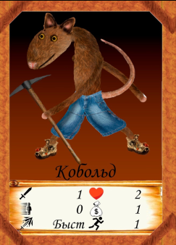 *pic 2.*

If a card has been played in this turn, then for now it gets an “enter sickness” and cannot interact with the environment, so the player who moves first simply passes the move to his opponent. The opponent takes another card before and also gets 2 Babos$, after which he already plays his cards or decides not to play anything and passes the move for the same reasons. At the end of the turn, if a player has more than 9 cards, he is obliged to put the excess under the rarity library of the “discarded” card.

The first player takes his turn, takes a card, gets Babos$, plays cards, after which the “combat phase" begins. During this phase, the player can interact with the cards without “enter sickness". The map can be moved by the number of cells equal to the speed of movement. The card can be moved vertically or horizontally (Clarification: at a running speed of 2, the card can move first 1 cell forward, and then 1 to the left. You can move the cards by the number of cells less than the value of the running speed (including 0)). You cannot move to cells occupied by other cards.

After moving, the card can cause **damage** equal to the value of the attack on the opponent's card, located at a distance of 1 cell vertically or horizontally from the original card. The health of the card is responsible for how many units of damage this card can withstand. After receiving damage, the current health of the card is permanently reduced by the corresponding number of units. If the health of the card drops to 0, then it will go to the bottom of the library of the corresponding rarity.

The card can also cause damage to the opponent's health points if it is located in one of the 8 cells closest to the opponent.

During your combat phase, the opponent's cards also do not sit idle. After you have moved all the cards and dealt damage, the opponent's cards can already deal damage to your cards in the neighborhood. In fact, the attack speed parameter is responsible for the order of damage.

First, your cards with a Fast attack speed cause damage, then the opponent's cards with a Fast, then your cards with Medium, the opponent's cards with Medium, your cards with Slow, and finally the opponent's cards with Slow.

A card can avoid damage if its evasion parameter is greater than 0. If the evasion is not zero, then a hexagon cube is thrown on the card when attacking, and if the value that falls out is less than or equal to the evasion value, then the damage will not pass.

After the end of the combat phase, the player passes the move and the process repeats.

For the accumulated Babos$, in addition to drawing cards, you can open libraries with new rarities and exhibit collectors of Babos$. Having discovered a new rarity, the player at the beginning of his turn can choose the library from which he will take a card. Rarities can only be opened in order:

1. Unusual – 3 Babos$

2. Rare – 5 Babos$

3. Epic – 7 Babos$

4. Legendary – 9 Babos$

Collectors are placed outside the field behind the nearest 8 cells near the player. The opponent's cards can destroy the collector while being near him, since he also has his own vision. Each subsequent collector costs 2 Babos$ and is more expensive for each collector in the game. After the collector has been destroyed, the player can rearrange it. A new collector can be set only after the discovery of a new rarity. There can be a maximum of 4 collectors.

**That's all! Have a nice game for the brave souls who decided to fight for “Weakness”!**