2011-8-26 Variation among 156 Contigs in regard to distance from 8 genomes to contig itself (based on all sites)
*
*
2011-8-2 Distance from 5 non-ref genomes to Contig is larger than the corresponding distance to either ref-454 or ref-GA based on SNPs from the same contig.
2011-8-2 Variation among 156 Contigs in regard to distance from 8 genomes to contig itself (based on variants alone)
2011-7-11 Initial result (distance matrix) based on Contig0

2011-8-26 Variation among 156 Contigs in regard to distance from 8 genomes to contig itself (based on all sites)

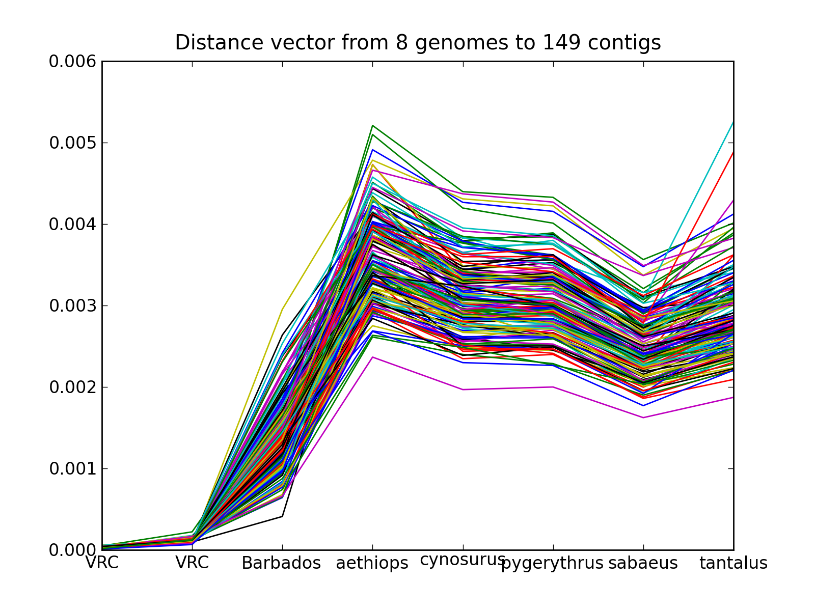

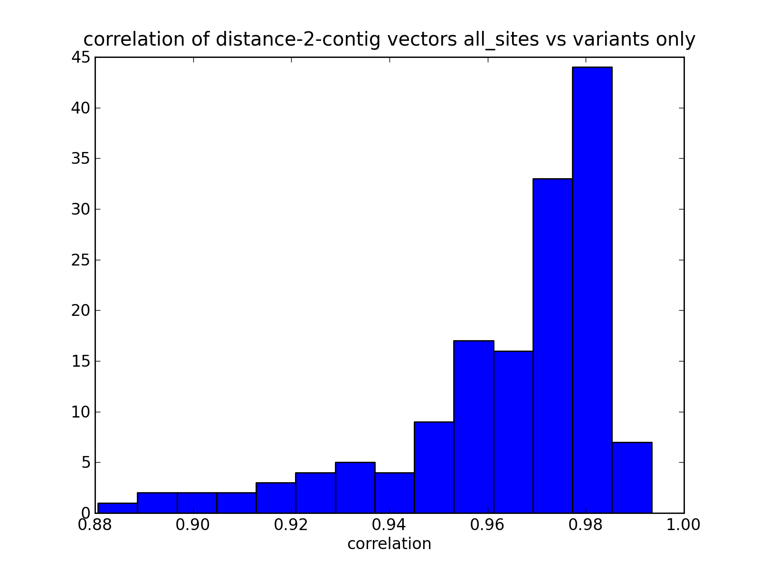

2011-8-2 Distance from 5 non-ref genomes to Contig is larger than the corresponding distance to either ref-454 or ref-GA based on SNPs from the same contig.
Why is that? given contigs, ref-454, ref-GA are all from the same individual.

2011-8-2 Variation among 156 Contigs in regard to distance from 8 genomes to contig itself (based on variants only)

After running the whole alignment + GATK pipeline, a pairwise distance matrix was returned regarding how far each genome is from each other based on the called SNPs.

For each contig, there is a vector of distance from 8 genomes to the contig itself. Here is a plot of all distance vectors.
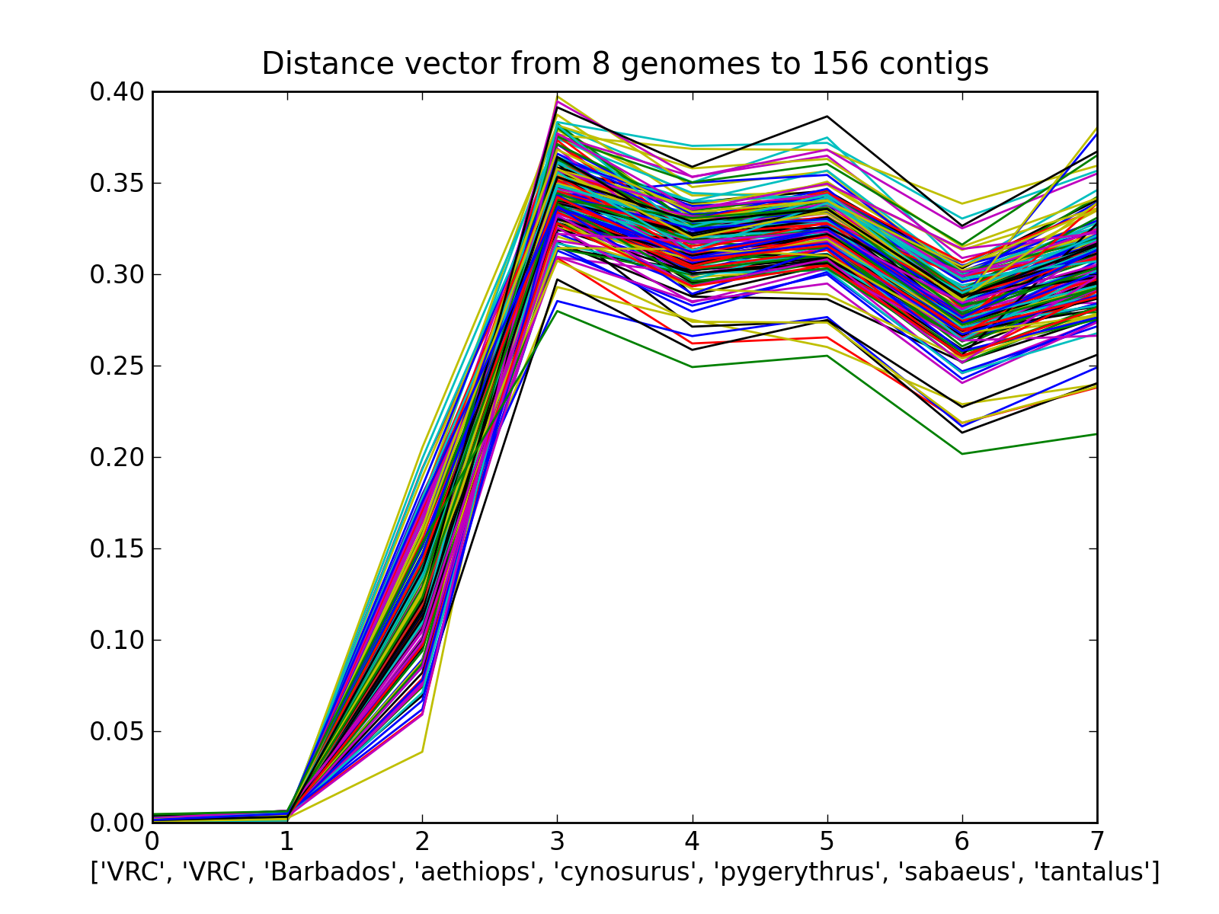
Figure 1. Every contig is represented by 1 line. Coloring is recycled among ~6 colors. First ‘VRC’ is 454 reads. 2nd ‘VRC’ is Illumina reads.

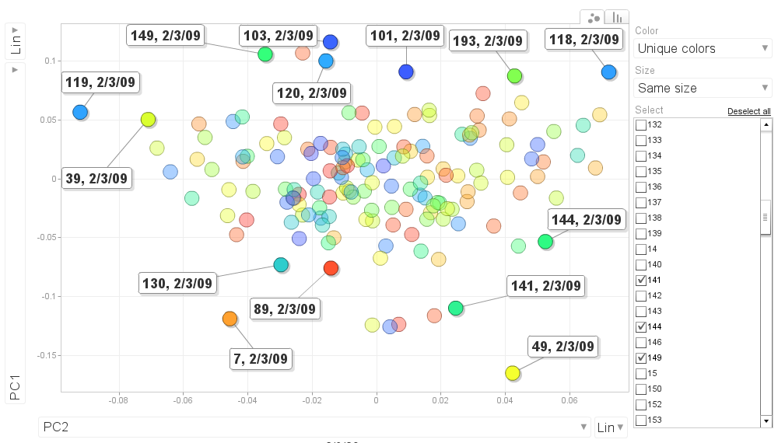
Figure 2. A PCA plot showing clustering of contigs based on distance vectors. Run PCA on the matrix of distance vectors from Figure 1. The bottom outlier contigs are mostly at the bottom of Figure 1. The top outliers are at the top of Figure 2. Whether they are on the left or right depends on the Barbados distance to the contig.

2011-7-11 Initial result (distance matrix) based on Contig0

While the 156-contig has finally started cranking in parallel (i expect them to finish in one day), the result (2011-7-10 8-genome Dist-Matrix, Contig0 as ref) from the biggest contig (contig0) seems to agree with earlier result (Pairwise distance among sub-species by BAC) based on 1Mb BAC. No major surprise here.

- The two are almost identical in terms of who is closest to who. The ones that differ are within each matrix's discordance margin.
- sabaeus/tantalus is still pointed as closest to the Carribean ref. but 2X of distance(ref, Barbados), slightly larger when Contig0 is reference.
- The relationship among African subspecies is same in two results. Even the strange observation that distance(sabaeus, pygerythrus) is smaller than either dist(sabaeus, cynosurus) and dist(pygerythrus, cynosurus), given that cynosurus was situated between the two geographically (and both genetic distance matrices seem to say that cynosurus is closer to pygerythrus than sabaeus).
- aethiops is far from almost every other subspecies. that said, both results seem to hint that tantalus should be the closest among all.
- under the same filtering setting, discordance between 454 and illumina of the reference is slightly smaller when Contig0 is used as ref.
- Contig0 produced 13-14X more polymorphic sites than 1Mb BAC, which is expected.

Check the human-genome-as-reference result (Pairwise distance among sub-species by hg19) for comparison. It has a filtering setting (MAF>=0.2) that is biased towards increasing the distance between Africa and Carribean islands (because the minimum MAF is 0.2 and 454 & illumina-ref are basically the same genome, so SNPs that are shared in Carribean monkeys are more likely to be retained after filtering).

