Methods
QC Based on Trios
Summary of Variants Discovered
Compare polymorphism level between VRC, St. Kitts and Nevis

Methods
The pipeline uses bwa, picard, & samtools for alignment; GATK & samtools for genotype calling. The final calls are intersection between GATK and samtools calls. GATK runs are in default setting while samtools has minimum mapping quality set to 20 and maximum depth set to 1000. All individuals are split into different populations for calling, 116 VRC monkeys in one group, 5 St. Kitts in one, 5 Nevis in one, and 5 subspecies in another group.

In order to get an accurate estimate of AAF (alternative allele frequency), 15 distantly-related (>=3 meiotic distance away) ones out of 116 VRC monkeys were picked form an additional group. We made this choice because genotype caller GATK/samtools has HWE (Hardy-Weinberg-Equilibrium) assumption built into their internal statistics.

The alignment was done against ~7000 contigs whose size is above 2Kb. The total number of bases of these ~7000 contigs is ~2.8Gb (~3Gb for all ~480K contigs).

However SNP discovery is done on the top 156 big contigs (4.7Mb-13.4Mb), which is about 1Gb in accumulated size. In another word, we are discovering SNPs from 1/3rd of the vervet genome.

QC Based on Trios
Among the 116 VRC monkeys that have been sequenced, there are 4 sets of trios that we could use to estimate error rate indirectly. Since it is not the direct error rate estimate, we call it inconsistent rate. Inconsistency occurs when the child genotype could not be explained by any combination of the parental genotypes. Inconsistent rate equals the number of inconsistent loci divided by total number of variants.

The median inconsistent rate of 4 trios ranges from 5.3% to 8.6% if all variants are included. The rate varies from 1.4% to 1.8% if only homozygous calls are included. Figure 1.1, 1.2, 1.3 are based on variants from one of the 4 trios. Variants called by samtools are better than those by GATK. However, not much parameter tuning of either software has been tried at this stage.

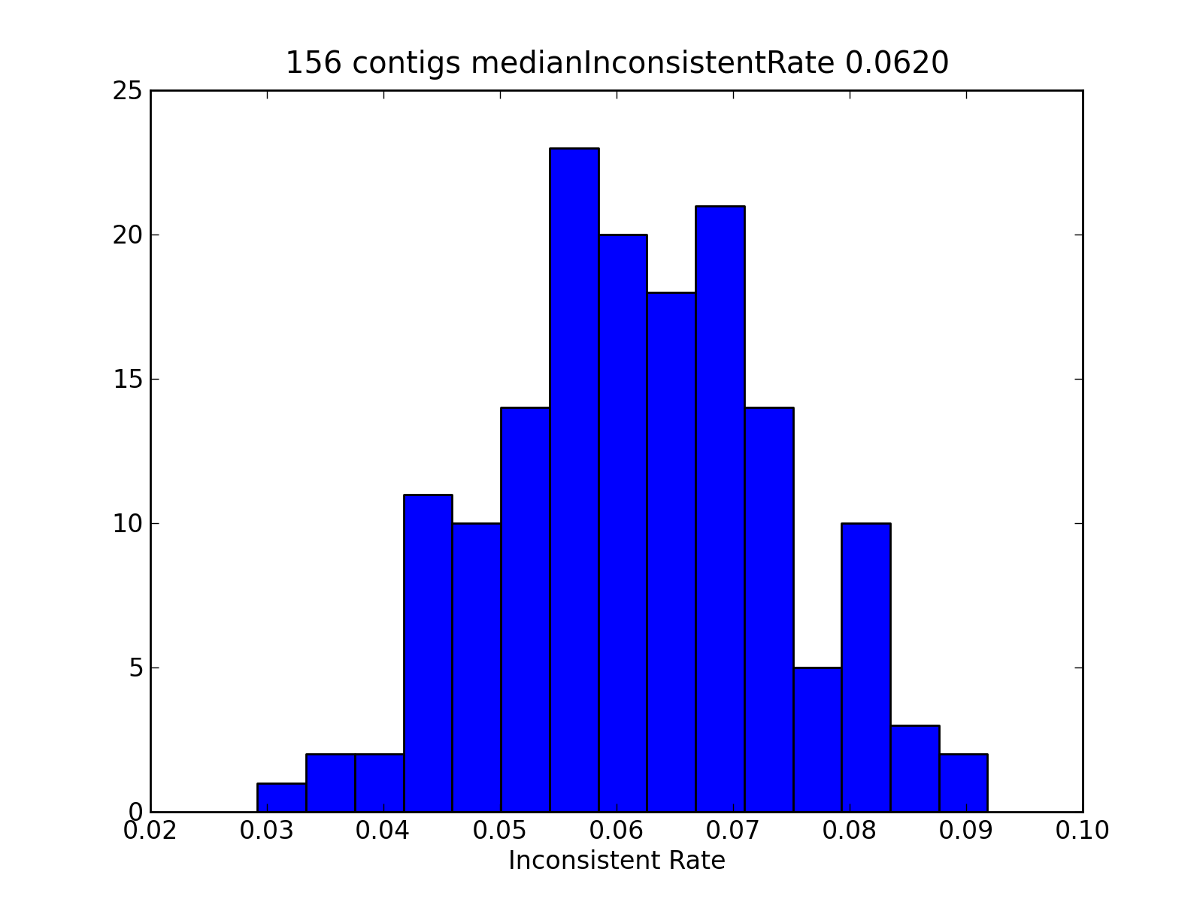

Figure 1.1 Histogram of trio inconsistent rate. Using all variant sites in one trio (117,101,80; UCLA code: 1992006,1995116,2000037), including the heterozygous calls, shows the median inconsistency rate to be 6.2%. (For reference, the 1000-genome project gets ~5%-30% error rate in heterozygous calls depending on allele frequency.)

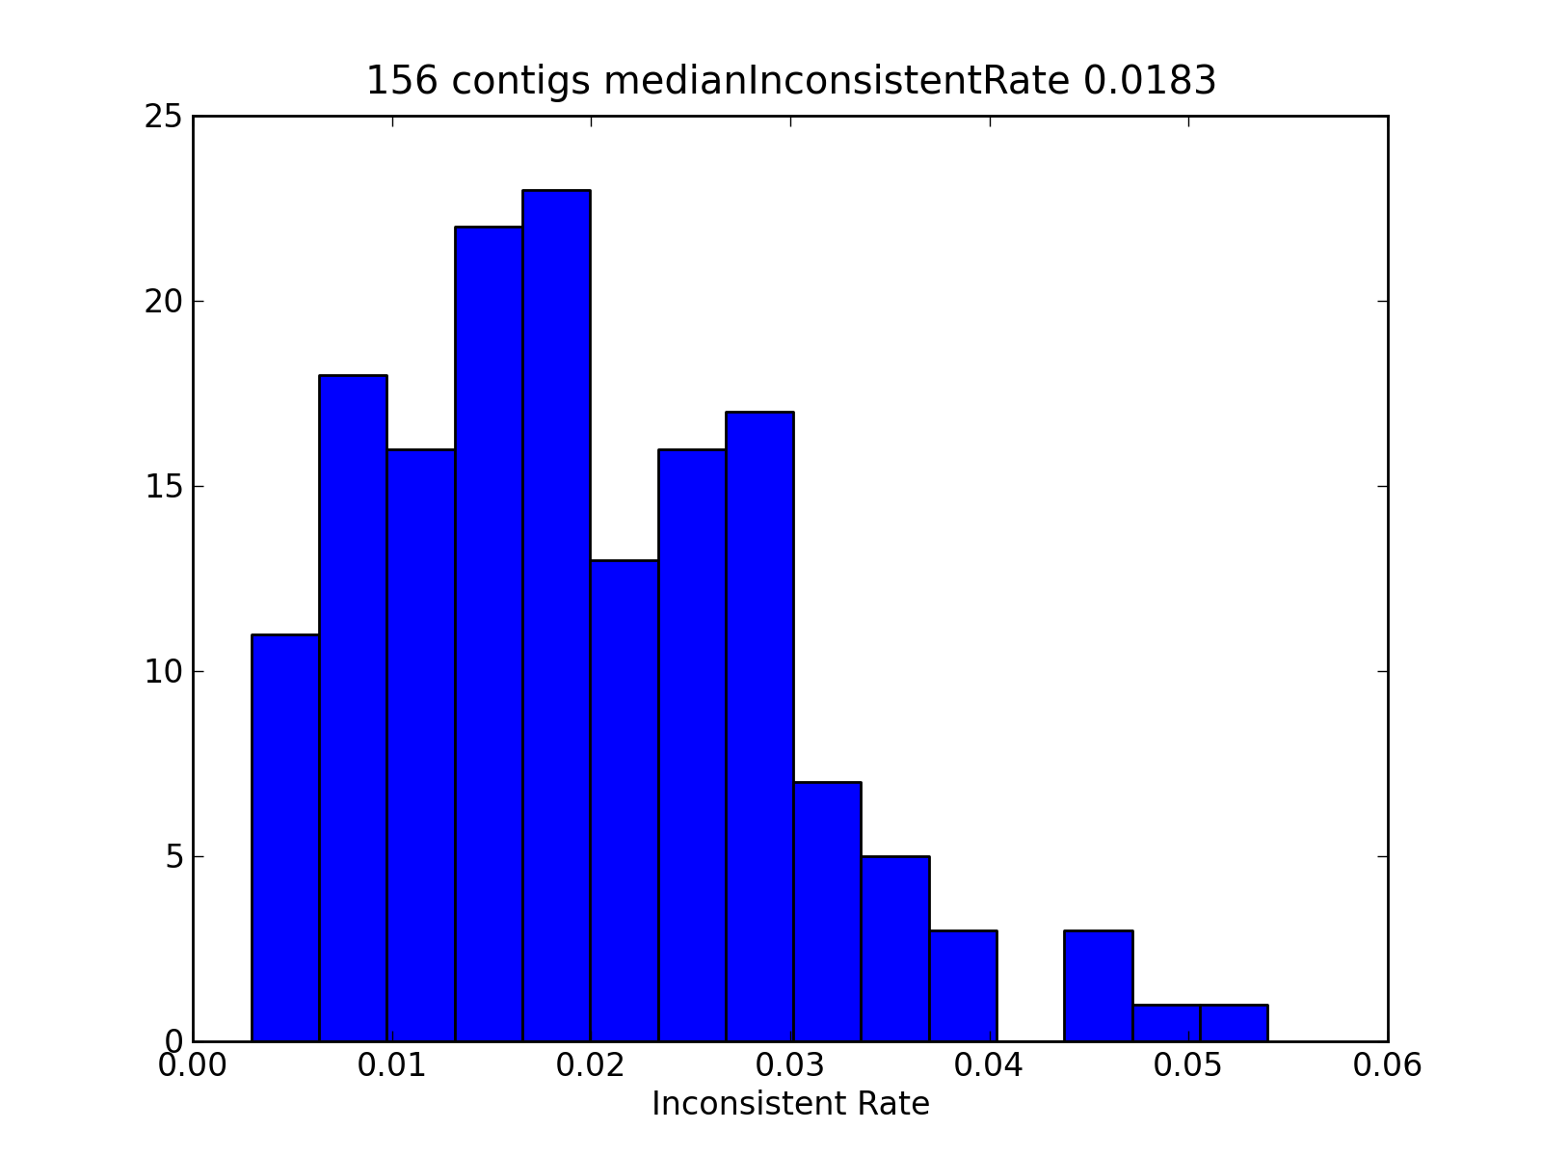
Figure 1.2 Using sites that are homozygous in both parents and child, we found the inconsistent rate to be 1.83% for trio (117,101,80; UCLA code: 1992006,1995116,2000037).

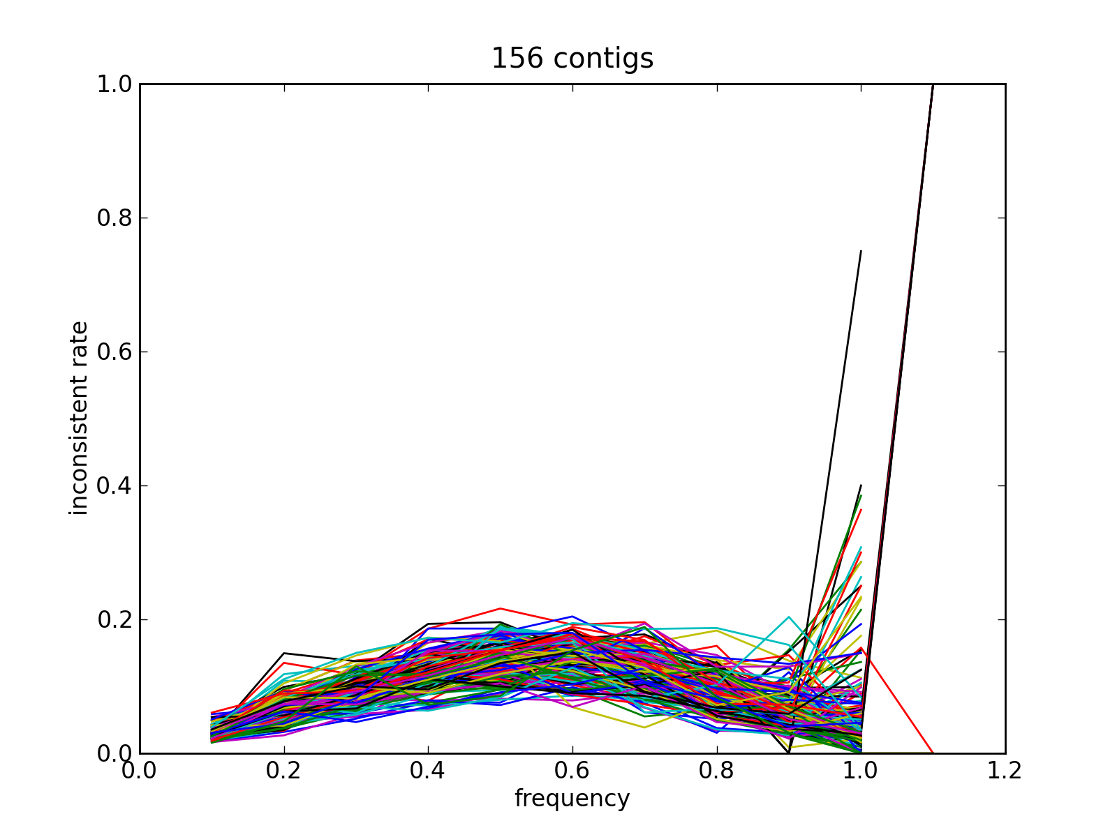
Fig 1.3 Relationship between Inconsistent Rate and AAF (Alternative Allele Frequency). Each colored line represents one contig. The inconsistent rate increases as AAF (Alternative Allele Frequency), labelled as “frequency” on X-axis, increases from 0 to 0.5 and then it decreases as AAF goes from 0.5 to 1.0. The sudden increase in the variation of inconsistent rate near 1.0 is due to insufficient number of sites (require a distribution of AAF to examine this). The point beyond 1.0 is due to float precision issue (i.e. 1.00001 is regarded as above 1.0). All variant sites from one trio (117,101,80; UCLA code: 1992006,1995116,2000037) are used.

More detailed look is in these slides.

Summary of Variants Discovered

Table 1. Average number of variants discovered in each population

monkey population | number of variants per kb
15 Distant VRC monkeys | 4.5
5 St. Kitts | 3.4
5 St. Nevis | 3.2
5 African subspecies | 8.1

ToDo:
- Nucleotide Diversity
- MAF (Minor Allele Frequency) Spectrum
- Heterozygosity
- LD

Compare polymorphism level between VRC, St. Kitts and Nevis
The comparison is done through comparing AAF (Alternative Allele Frequency) between two populations. If one locus’s AAF is between 0 and 1 in one population, it is regarded as polymorphic in that population.

- 5 Nevis and 5 St. Kitts monkeys in the VWP (Vervet Wild Population) are pretty different, Figure 3.1. (A few contigs do show some correlation between two populations.)
- VRC has contribution from both St. Kitts (Figure 3.2) and Nevis (Figure 3.3) population, more from St. Kitts population.
- Only 5-15% of Nevis or St. Kitts polymorphism are not found in VRC while ~20-35% of VRC polymorphism are not found in Nevis or St. Kitts, Figure 3.2 & 3.3.

Figures shown in this paragraph are mostly based on Contig0 but it represents most of 156 contigs. There are a few exceptions, i.e. Contig83, Contig193, which deserve careful look.

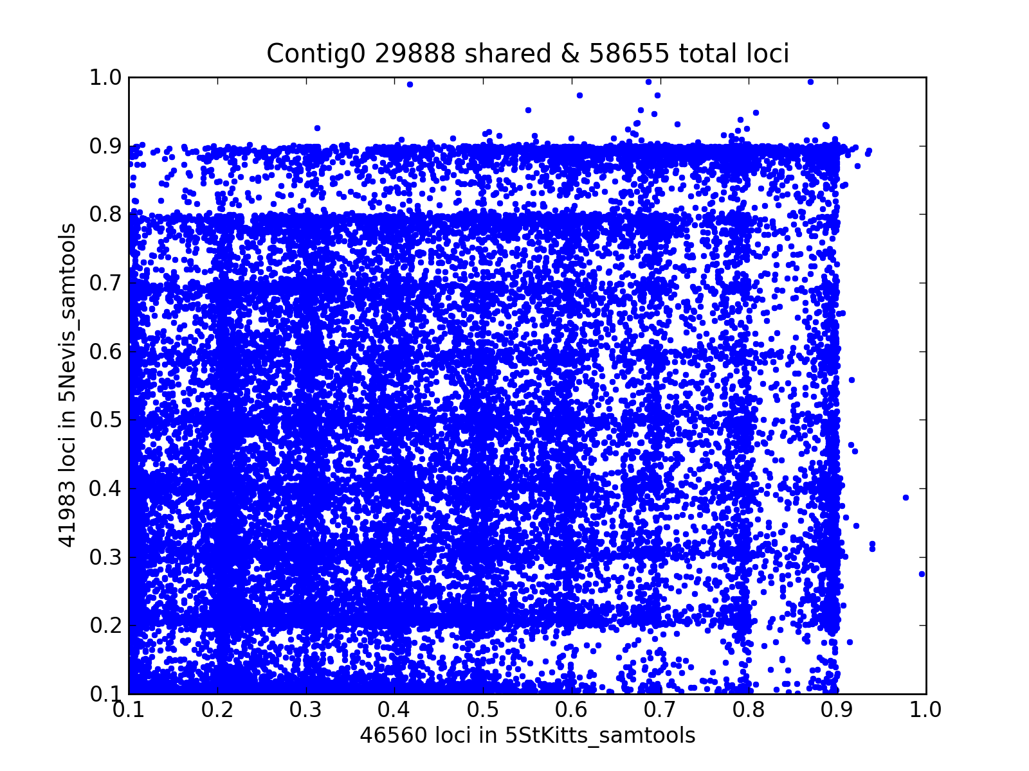
Figure 3.1 X-axis is AAF of variants from population of 5 St. Kitts monkeys. Y-axis is AAF from population of 5 Nevis monkeys. Each dot is a variant. Plotted is the 29,888 shared polymorphic variants. 16,672 (~35.8%) St. Kitts variants are not polymorphic in 5 Nevis monkeys. 12,095 (28.8%) for the Nevis variants. Variants discovered from majority of contigs display this kind of plot. More pictures are available here.

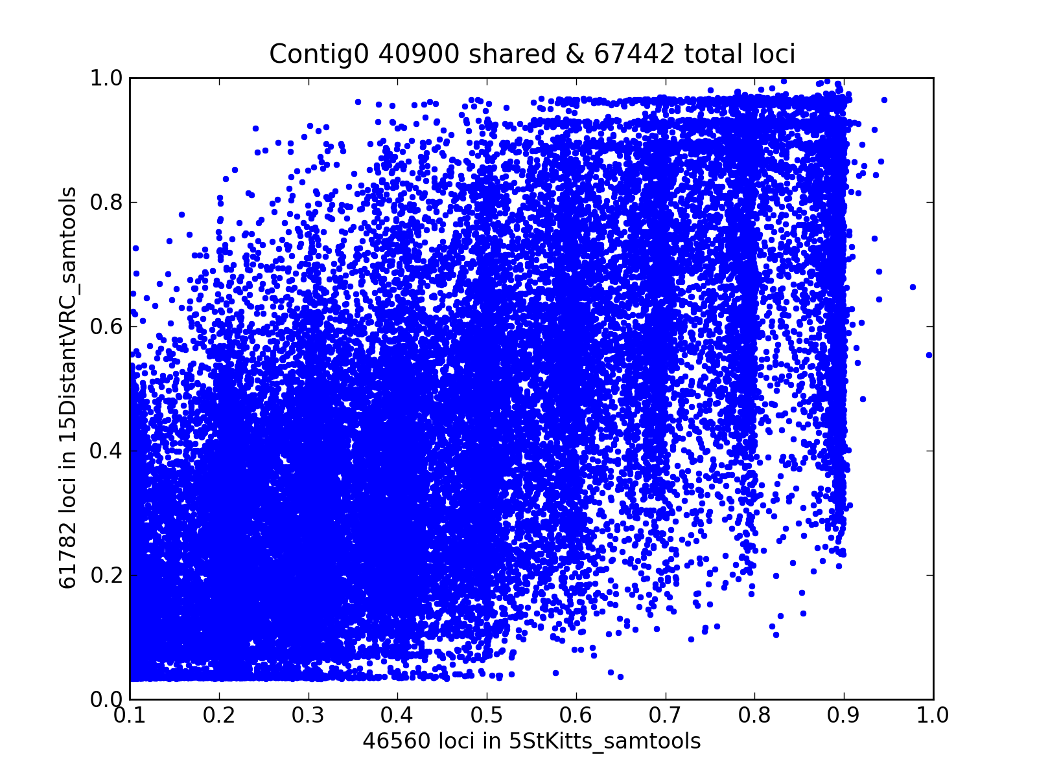
Figure 3.2 X-axis is AAF of variants from population of 5 St. Kitts monkeys. Y-axis is AAF from population of 15 distant VRC monkeys. Each dot is a variant. Plotted is the 40,900 shared polymorphic variants. 5,660 (12.1%) St. Kitts variants are not polymorphic in 15 distant VRC monkeys. 20,882 (33.8%) for variants from 15 distant VRC monkeys are not polymorphic in 5 St. Kitts monkeys. More pictures are available here.

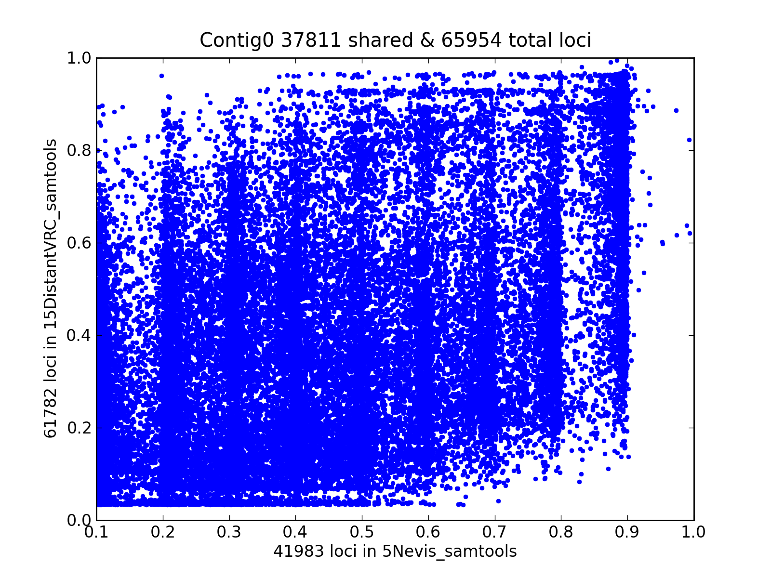

Figure 3.3 X-axis is AAF of variants from population of 5 Nevis monkeys. Y-axis is AAF from population of 15 distant VRC monkeys. Each dot is a variant. Plotted is the 37,811 shared polymorphic variants. 4,172 (9.9%) Nevis variants are not polymorphic in 15 distant VRC monkeys. 23,971 (38.8%) for variants from 15 distant VRC monkeys are not polymorphic in 5 Nevis monkeys. More pictures are here.

ToDo:
- a better method is through Fst measure.
- between VRC and St. Kitts
  - histogram of proportion of St. Kitts polymorphism present in VRC
  - histogram of proportion of VRC polymorphism present in St. Kitts
  - histogram of correlation of AAF (alternative allele frequency)
- between VRC and Nevis
- between St. Kitts and Nevis

