TITLE: PATAJOB – JOB ADVERTISEMENT/SERARCHING WEBSITE

A project report submitted to the School of Information Communication Technology as required for the completion and accordance Degree in

**BACHELOR OF SCIENCE**

*In*

**INFORMATION TECHNOLOGY**

*At*

ZETECH UNIVERSITY

*Compiled and prepared by:*

**John Ndun’gu –** BSCIT-

**Ezra Wenanga** BSCIT-

*Supervisor:*

**John Ndun’gu**

APRIL, 2022.

# DECLARATION

# STUDENTS

This is to certify that the project report titled **PATAJOB – JOB ADVERTISEMENT / SERARCHING WEBSITE** is an original work and has not been submitted before for the award of any Degree or Diploma.

JOHN NDUN’GU EZRA WENANGE

ADM. No: BSCIT ADM. No: BSCIT

Signature…………………. Signature…………………….

Date………………………. Date………………………….

# SUPERVISOR

I approve the submission of this project to be examined and awarded. I supervised the students throughout their development phase.

Mr. NICHOLAS MURIITHI

Signature………………….

Date……………………….

# DEDICATION

We dedicate this project to our precious institution for providing a conducive environment and all the necessary support since we started this project till the end.

# ACKNOWLEDGEMENT

We would wish to sincerely thank our project supervisor, Mr. Nicholas Muriithi for being there to support and direct us whenever we needed guidance. We are also grateful to our peers for challenging us to go out of our comfort zones and bring the best out of us as far as the project is concerned.

# ABSTRACT

*PataJob* is a word coined from two of our national languages: *Pata* means get, *Job* means work. Our project is basically centered on bringing job opportunities closer to those who seek them. Inspired by the wide gap between the employed and unemployed numbers, this web-based project looks into providing a space where many can find jobs that match their specifications

Contents

DECLARATION 1

STUDENTS 1

SUPERVISOR 1

DEDICATION 2

ACKNOWLEDGEMENT 3

ABSTRACT 4

TABLE OF CONTENTS 5

LIST OF FIGURES 6

LIST OF TABLES 6

1. CHAPTER ONE 1

1.0 Introduction 1

*PataJob* is a website for job application. Hiring companies post vacancies, alongside job requirements and job seekers apply for positions that fit them. 1

1.1 Problem Statement 1

1.2 Objectives 2

1.3.1 Main objective 2

1.3.2 Specific objectives 2

1.3 Project Justification 2

1.4.1 Benefits 2

1.4.2 Assumptions 2

1.4 Scope 2

1.5 Limitations of the project 3

Features of Application 3

Roles/privileges of the admin 4

2. CHAPTER TWO 5

2.0 Literature Review 5

2.1 Existing Applications 5

The current website for job recruitment includes traditional methods like Employment agencies, advertising through newspapers, televisions and radios, college fairs etc., which are too slow and stressful. 5

There are also other available similar job seeking websites. 5

2.1.1 Fuzu 5

2.1.2 Craig-list 5

3. CHAPTER THREE 6

3.1 Methodology 6

3.1.1 Agile Method 6

3.2 Advantages of Agile 7

3.3 Disadvantages of Agile 7

4. CHAPTER FOUR 8

1.1 SYSTEM ANALYSIS 8

1.2 System Requirements 8

1.2.1 Software requirement Specification 8

1.2.2 Hardware Requirement Specification 8

1.3 Functional requirements 9

1.3.1 Usability requirements 9

1.3.2 Implementation requirements 9

CHAPTER FIVE 10

5.0 SYSTEM DESIGN 10

5.1 Architectural Design 10

5.2 Logical Design 11

Context Level DFD. 11

5.3 Physical Design 13

5.3.1 Homepage design 14

2. SYSTEM TESTING 15

6.1 Testing: 15

6.2 Testing Methodologies: 15

6.3 Levels of Testing 15

6.3.1 STLC (Software Testing Life Cycle) 15

6.4 Types of Testing 15

6.5 TCD (Test Case Document) Test scope: 16

Test Scenario: 16

Test Procedure: 16

6.6 Test Cases: 16

SYSTEM IMPLEMENTATION 17

FINDINGS 18

RECOMMENDATION 19

CONCLUSION 20

3.2 Cost/Benefit Analysis 21

# CHAPTER ONE

## Introduction

## *PataJob* is a website for job application. Hiring companies post vacancies, alongside job requirements and job seekers apply for positions that fit them.

## Problem Statement

In many occasions, skilled persons find it difficult to find jobs, as they have to manually knock at ever door with their documents. This process is not only tiring but also time consuming. Most of them end up picking odd jobs, or jobs they never even trained for.

Companies on the other hand may not easily reach the kind of workers they need for their services to be delivered. This is because there is no direct link between hiring companies and job seekers.

Corruption as well locks the skilled but “less fortunate” persons out of their well-deserved positions in various organizations.

## Objectives

## Main objective

To lower the graph of unemployment rates by linking skilled personnel to their matching potential employers.

## Specific objectives

* To create a central platform to connect job seekers to the job market without having to toil or go through a middleman.
* To fight corruption i.e., buying of jobs by unqualified persons by ensuring equality in considering job applications.
* To help identify markets with most job opportunities for market analysis.

## Project Justification

Based on the objectives of this project, no one can fail to agree to the fact that it is a necessary move, as it open up doors for opportunities to the unemployed.

## Benefits of our project

* + - 1. Time saving – Job seekers apply for jobs in few clicks of buttons, rather than having to move from one office to another.
      2. Equality – applicants are picked based on their qualifications and not through corruption or other unscrupulous means.
      3. Analysis – data from the app can be used to determine competition in the market, helping in future planning.
      4. It helps match skilled persons to available opportunities in their fields of specialization
      5. The application is viewed on the web, hence accessible through any internet-enabled device.

## Assumptions

* + - 1. Users of the platform have access to mobile phones or computers with web browsers e.g., Chrome, Safari and Microsoft Edge
      2. Users have access to Internet.
      3. Users have basic web navigation knowledge e.g., using log in interfaces

## Scope

Development of this project runs from February 2022 to 20th April 21, 2022.

## Limitations of the project

The platform is only accessible to users with internet enabled devices i.e., smartphones and computers since it is a web-based application.

## Features of Application

* + 1. Admin panel
    2. User Sign-up/Log-in interface
    3. Jobs page
    4. Application page for seekers

## Roles/privileges of the admin

1. Create and delete other users i.e., fellow admins, Staff/employees and hiring companies
2. Modify or remove Jobs
3. Add, edit and remove job categories
4. View all job applicants

# CHAPTER TWO

## Literature Review

The aim of developing a Job Search Portal comes from my idea to make the job search efficient and handy. It helps the recruiters as a primary source of searching for skills. It also helps the job applicants to search for current vacancies at a single point. Therefore, we can say that Online Job Search Portal act as a bridge of communication between organizations and applicants. With the evolution of technology and internet being the main source of information for the applicants, these job portals and have become an excellent method to reach wide range of audience. Initially, when I am unaware of these portals, I used to do research about companies and their technology stack through their respective websites and apply if the job responsibilities match my interests. This requires lots of effort and time. However, later when I realized the importance of job search portals, I am able to access jobs in companies, locations that I might not otherwise have learned.

## Existing Applications

## The current website for job recruitment includes traditional methods like Employment agencies, advertising through newspapers, televisions and radios, college fairs etc., which are too slow and stressful.

## There are also other available similar job seeking websites.

## Fuzu

This is the leading job portal on the internet, mainly focusing on corporate/office jobs.

## Craig-list

This site mostly focuses on small-scale or short-term gigs such as video-editing services

# CHAPTER THREE

## Methodology

The Systems Development Life Cycle (SDLC) describes the phases involved in development and maintenance of projects.

We are going to use Agile Software Development life cycle model since our path is not very clear and certain.

In particular, we’ll use Agile System Development Methodology for developing *PataJob* website.

## Agile Method

Agile limits risks by developing software in cycles called **Iterations**. Software development being essentially a human activity will always have variations in processes and inputs and the model should be flexible enough to handle the variations. The following are the characteristics of agile model that makes it suitable for *PataJob* website development.

* + - 1. Iterative with short cycles enabling fast verifications and corrections.
      2. Time bound iterative cycles.
      3. Modularity at development process level.
      4. People oriented.
      5. Collaborative and communicative working style.
      6. Incremental and convergent approach that minimizes risks and facilitates functional additions

## Advantages of Agile

1. Customer satisfaction
2. Allows changes to be made.
3. Deliver a working software frequently, ranging from a few weeks to a few months, considering shorter time-scale.
4. Promotes collaboration
5. Provides motivation between individual team members.
6. Allows face-to-face Conversation
7. Measure the Progress as per the Working Software.
8. Maintain Constant Pace
9. Monitoring - Pay regular attention to technical excellence and good design to enhance agility.
10. Simplicity - Keep things simple and use simple terms to measure the work that is not completed.
11. Review the Work Regularly

## Disadvantages of Agile

1. Limited support for distributed development environments.
2. Limited support for subcontracting.
3. Limited support for developing large, complex software.
4. Limited support for development involving large teams.

# 4. CHAPTER FOUR

# SYSTEM ANALYSIS

Various resources or features are necessary for the successful development of our project.

These will therefore form the requirements of the *PataJob* and will be categorized as Functional requirements and the Non-functional requirements.

## System Requirements

## Software requirement SpecificationThese refer to the programs associated with the operation of a computer, enabling the user to interact with physical hardware components.

The minimum software requirement specifications for developing this project are as follows: Operating System: Windows 10 or latest, Ubuntu 18.04 or latest

Presentation layer: PHP (and HTML/CSS), jQuery, bootstrap, XAMPP Server and browsers e.g., Chrome

Database: MySQL 5.5.3+ Documentation: Microsoft Office Word

## Hardware Requirement Specification

Tangible components of a computer e.g., CPU and its internal components, Monitor and peripheral devices are the Hardware parts of a computer

The minimum hardware requirement specifications for developing this project are:

Processor: Standard processor with a speed of 1.6 GHz or more RAM: at least 512 MB

Hard Disk: at least 20 GB

Monitor: Standard color monitor Keyboard: Standard keyboard Mouse: Standard mouse

## Functional requirements

1. Administrative Privileges
2. Authentication
3. Authorization levels
4. Security; to ensure confidentiality, integrity and availability
5. Legal and regulatory requirement
6. Transaction corrections, adjustments and cancellations

## Usability requirements

This website is user-friendly and easy to use so that users can perform their tasks easily.

## Implementation requirements

In implementing the website, it uses PHP as the main tool for the front-end.

At the back-end, the Apache and MYSQL will be synchronized and be used to maintain the information in the database. This is formed by the databases and other data stores.

# CHAPTER FIVE

# SYSTEM DESIGN

## Architectural Design

*PataJob* website uses three-tier architecture. Three-tier architecture is a client-server architecture in which the functional process logic, data access, computer data storage and user interface are developed and maintained as independent modules on separate platforms. Three-tier architecture is a software design pattern and well-established software architecture.

The three tiers in *PataJob* three-tier architecture are:

**Presentation Tier**: Occupies the top level and displays information related to services available on a website. This tier communicates with other tiers by sending results to the browser and other tiers in the network; **Application Tier**: Also called the middle tier, logic tier, business logic or logic tier, this tier is pulled from the presentation tier. It controls application functionality by performing detailed processing; and **Data Tier**: Houses database servers where information is stored and retrieved. Data in this tier is kept independent of application servers or business logic.

Figure 3 below illustrates the three-tier architecture of *PataJob* website.

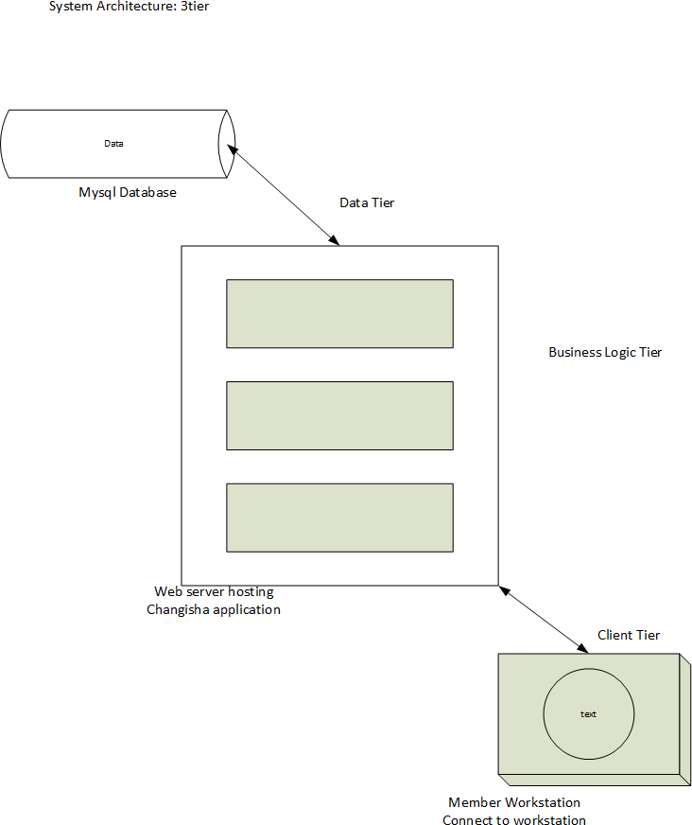

*Figure 3: PataJob Three tier Architecture*

## Logical Design

* + 1. **Use-Case**

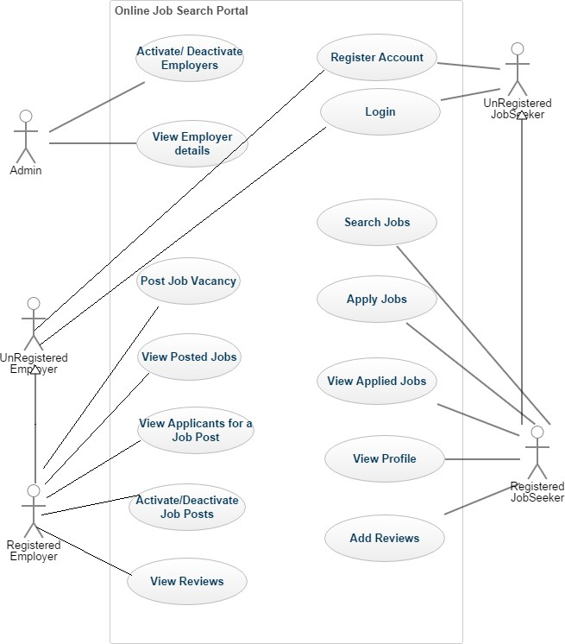

* + 1. **Behavioral Description**

**Data Flow**

## Context Level DFD.

Below is an illustration of *PataJob* in a DFD showing Inputs to the overall website and outputs from the overall website shown together with their destinations.

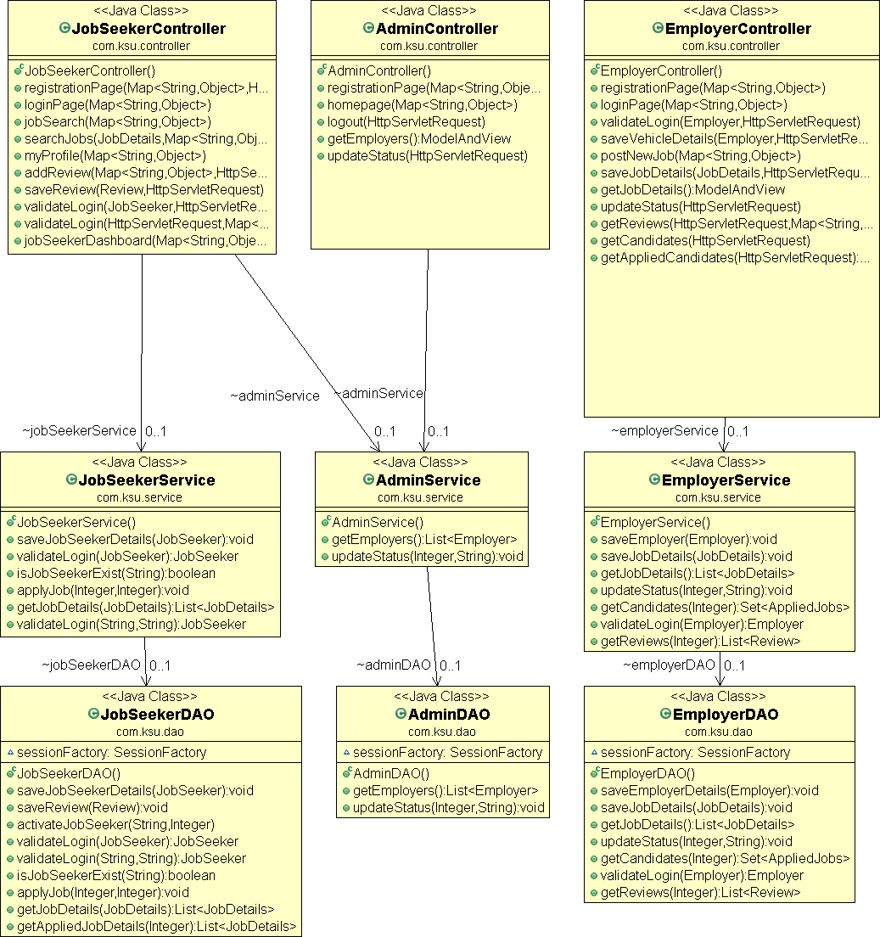

## Physical Design

Physical design relates to the actual input and output processes of the website. In physical design, we decided on the following requirements about the *PataJob* website. Physical design can be broken down into three sub tasks:

1. User interface
2. Data design
3. Process design.

## Homepage design

Figure 12 below gives an overview of *PataJob* homepage design.

*Figure 12: PataJob Homepage design*

# SYSTEM TESTING

## Testing:

Testing is defined as the process in which defects are identified, isolated, subjected for rectification and ensured that product is defect free in order to produce the quality product and hence customer satisfaction.

## Testing Methodologies:

White box Testing: is the testing process in which tester can perform testing on an application with having internal structural knowledge. Usually, The Developers are involved in white box testing. We as the developers of *PataJob* applied white box testing as our testing methodology.

## Levels of Testing

## STLC (Software Testing Life Cycle)

**Test Planning:** While planning for testing of *PataJob* website, we identified objectives of the test, areas that needed to be tested, areas that were not to be tested, and Scheduling Resource Planning,

**Test Development**: In the test development, we prepared a checklist (Test case Development) and the description of the test cases (Test Procedure preparation.)

**Test Execution**: Test execution phase of *PataJob* involved implementation of test cases and observing the result of the test.

**Result Analysis**: Result analysis of testing *PataJob* website contained Expected value: behavior of the website and Actual value: actual behavior of the website.

**Bug Tracing:** We collected all the failed cases and prepared related documents.

**Reporting:** The results of the test gave us the status of the website.

## Types of Testing

**Smoke Testing**: We performed an initial test on *PataJob* website for the availability of all the functionalities.

**Sanity Testing:** We then conducted an initial test on the website to check for the proper behavior of an application.

**Regression Testing:** During the project, we carried out several tests on functionalities that we tested before whenever we made a change to the existing functionality.

**Adhoc Testing:** We performed an Adhoc test (positive and negative) to perform GUI testing.

## TCD (Test Case Document) Test scope:

This involved the areas of the website to be tested including homepage, fund seeker dashboard and projects dashboard.

## Test Scenario:

Our test scenario for the website included when the fund seeker fills in the application form, upload documents and hit the quit button.

## Test Procedure:

Positive testing, Negative testing using the corresponding GUI test cases, helped us in performing adhoc testing.

## Test Cases:

**Positive Test Cases:** The positive flow of the functionality was considered, valid inputs were used for testing and expected value was positive to verify whether the requirements are justified. Table 1 below shows *PataJob* positive test case.

|  |  |  |  |  |
| --- | --- | --- | --- | --- |
| Test case number | Description | Expected value | Actual value | Result |
| 1 | Check for all the features in  the screen | The screen must contain  all the features |  |  |
| 2 | Enter the valid username and password for fund seeker | It should accept |  |  |

*Table 1: PataJob Positive Test Case*

**Negative Test Cases:** Must have negative perception and invalid inputs must be used for test. Table 2 below describes *PataJob* negative test case.

|  |  |  |  |  |
| --- | --- | --- | --- | --- |
| Test case number | Description | Expected value | Actual  value | Result |
| 1 | Try to modify the information in date and time | Modification should not be allowed |  |  |
| 2 | Enter invalid data in to the job seeker login form | It should not accept invalid data, save should not allow |  |  |

*Table 2: Negative Test Case*

# SYSTEM IMPLEMENTATION

It is the process of ensuring that the information website is operational, and then allowing users to take over its operation for use and evaluation. Implementation of *PataJob* includes activities such as:

1. Training of end users how the whole website operates and the functionalities of the website
2. Completion of user documentation.
3. System changeover.
4. Evaluation of the website on regular intervals.

# FINDINGS

# RECOMMENDATION

1. Many project ideas go into waste due to insufficient funds to carry out the project. Successful implementation of this website and its integration into the mobile money platform will help bridge the gap between project ideas and their successful implementation.
2. Implementation of *PataJob* will aid in minimizing fraud by encrypting user data, ensuring multiple layers of security to avoid phishing.
3. Creating awareness and training the public.
4. Putting down rules, laws and guidelines that one must fulfill in order to apply for funding

e.g., a person applying for funding from the crowd need to be a member of a registered company with clearly defined period, business plan and legal documents.

1. *PataJob* would help to eliminate cross border conflicts since mobile money platform can be restricted for a certain region of choice.

# CONCLUSION

In conclusion, *PataJob* is a crowdfunding website that enables project fund seekers to make an application for funding, and then the administrator approves the project idea or rejects the project idea based on a set down criterion and then published into the mobile money platform to allow funders to contribute towards the project idea. *PataJob* is secure, fast and reliable since most people in Kenya have access to mobile phone thereby able to access mobile money service

## Cost/Benefit Analysis

Table 3 below shows *PataJob* Cost/Benefit Analysis.

|  |  |
| --- | --- |
| **ITEM** | **COST (KSHS)** |
| Laptop | 35000 |
| Smartphone | 8000 |
| Internet | 1000 |
| **TOTAL** | **46,000** |

*Table 3: PataJob Cost/Benefit Analysis*