Clearer Dogs
Balanced Training, Calm Leadership, and Building
the Relationship Every Dog Needs
Matthew Campbell
Campbell K9's

Clearer Dogs
Copyright © 2025 Matthew Campbell
All rights reserved.
Campbell K9's
Rhode Island

For my father, Bob “Whoop” Campbell,
who taught me that consistency, hard work, and follow-through
matter more than perfection ever will.
And for every dog still waiting to be understood.

Contents
Chapter 1: What Your Dog Is Really Learning
Chapter 2: Timing, Consistency, and Accountability
Chapter 3: Calmness Is a Skill
Chapter 4: Leadership Without Drama
Chapter 5: Why Dogs Need Clarity
Chapter 6: Jumping, Barking, and Everyday Chaos
Chapter 7: Loose Leash Walking and Real-World Structure
Chapter 8: What Fearful Dogs Actually Need
Chapter 9: Resource Guarding, Possession, and Boundaries
Chapter 10: Recall: The Most Important Command Your Dog Will Ever Learn
Chapter 11: The Most Misunderstood Tool in Dog Training
Chapter 12: Puppy Biting, Adolescence, and the Tiny Velociraptor Phase
Chapter 13: Why So Many Modern Dogs Are Overwhelmed
Chapter 14: Why Dogs Need Jobs, Purpose, and Adventure
Chapter 15: The Human Side of Dog Training
Chapter 16: Living With Dogs Instead of Managing Them
Chapter 17: The Dog You Wanted vs. The Dog You Got
Chapter 18: What Dogs Teach Us About Ourselves
Chapter 19: Choosing the Right Dog for the Life You Actually Live
Chapter 20: The Myth of the Perfect Dog
Chapter 21: Why Training Never Really Ends
Chapter 22: The Hardest Dog to Train Is Usually the Human
Conclusion: Clearer Dogs, Better Relationships

Chapter 1
What Your Dog Is Really Learning
One of the biggest mistakes dog owners make is assuming their dog is only learning when formal training is happening.
The reality is far different.
Your dog is learning all the time.
Every interaction.
Every walk.
Every meal.
Every greeting.
Every correction.
Every reward.
Every single day.
Whether you realize it or not, your dog is constantly collecting information and drawing conclusions about how the world works.
That’s why I often tell owners that dogs are always in training.
The question isn’t whether your dog is learning.
The question is:
What is your dog learning?
Because dogs become incredibly good at whatever they practice repeatedly.
If barking works, they’ll bark more.
If pulling works, they’ll pull more.
If jumping works, they’ll jump more.
If calm behavior works, they’ll become calmer.
If listening works, they’ll listen more often.
Dogs are not trying to make our lives difficult.
They’re simply responding to consequences.
They do what works.
And honestly, humans aren’t much different.
Most of us repeat behaviors that produce results and abandon behaviors that don’t.
Dogs just tend to be more honest about it.
One of the most common things I hear from owners is:
“He knows better.”
Sometimes that’s true.
But often what the owner is actually seeing is a dog that has learned a different lesson than the one they intended to teach.
For example, an owner may believe they’re teaching a dog not to jump on visitors.
The dog may actually be learning:
“If I jump long enough, eventually someone pets me.”
The owner thinks they’re correcting the behavior.
The dog thinks they’re being rewarded for persistence.
Both are participating in the same interaction.
Both are learning.
The dog is simply learning the more effective lesson.
That’s why timing matters so much.
Dogs connect actions and consequences incredibly quickly.
They live in the moment.
They aren’t analyzing events the way humans do.
They don’t replay conversations from three days ago.
They don’t spend the afternoon wondering what you meant by your tone during breakfast.
They connect what happened right now with what happened immediately afterward.
That means rewards matter.
Corrections matter.
Structure matters.
Consistency matters.
And timing matters tremendously.
One thing I’ve noticed over the years is that owners often reward behaviors they dislike without realizing it.
Not because they’re bad owners.
Because they’re human.
A great example is barking.
A dog barks.
The owner talks.
The dog barks again.
The owner talks louder.
The dog barks more.
Now both parties are participating enthusiastically in a conversation nobody intended to have.
The owner thinks they’re stopping barking.
The dog thinks:
“Excellent. I’ve successfully initiated communication.”
The behavior continues because, from the dog’s perspective, it’s working.
This happens constantly.
Owners unknowingly reward:
barking,
whining,
jumping,
demanding behavior,
anxiety,
pushiness,
and attention-seeking behaviors.
Not because they want those things.
Because they don’t always recognize what the dog is learning from the interaction.
I remember a Labradoodle I worked with whose owners described him as insecure, anxious, and demanding.
After a week of training, I brought him home for the owner’s lesson.
That’s when owners become students.
During the session, the dog barked sharply at the father.
Almost immediately, the father reached down and started petting him.
Not consciously.
Not intentionally.
Almost automatically.
We both laughed because it happened so fast.
Years of repetition had trained both of them.
The dog had learned:
“When I bark, Dad responds.”
And Dad had learned:
“When the dog barks, I do something about it.”
Neither realized they were reinforcing the cycle.
That moment became one of the most valuable lessons of the entire session.
Dogs train people surprisingly well sometimes.
One of the most important concepts in dog training is understanding that behavior that gets rewarded tends to continue.
Behavior that doesn’t work tends to fade away.
It’s simple.
Not always easy.
But simple.
This doesn’t mean we ignore dogs.
It doesn’t mean we become cold or robotic.
Quite the opposite.
It means we become more intentional.
More aware.
More thoughtful about what we’re reinforcing every day.
Because every interaction teaches something.
One thing I learned growing up in Raynham, Massachusetts as the youngest of four boys was that consistency matters.
My father, Bob “Whoop” Campbell, wasn’t loud.
He wasn’t dramatic.
But if he said no, he meant it.
There wasn’t a second negotiation.
There wasn’t a fifth request hoping for a different answer.
There wasn’t a strategy meeting among the children trying to locate loopholes in family policy.
If Whoop said no, we understood where the boundary was.
Looking back now, I realize dogs appreciate that same clarity.
Not because they’re looking for control.
Because they’re looking for understanding.
Dogs thrive when life makes sense.
They do better when:
expectations are clear,
consequences are predictable,
communication is consistent,
and leadership is calm.
Confusion creates stress.
Clarity creates confidence.
That’s true for children.
It’s true for adults.
And it’s certainly true for dogs.
As you move through this book, I want you to keep one simple question in mind:
What is my dog really learning?
Because once you start asking that question consistently, dog training becomes much clearer.
And honestly, so does life with your dog.

Chapter 2
Timing, Consistency, and Accountability
If I had to pick three concepts that solve more dog training problems than almost anything else, they would be:
timing,
consistency,
and accountability.
They’re not flashy.
They won’t get millions of views on social media.
Nobody is making dramatic movie trailers about them.
But these three things are responsible for more success—and more failure—in dog training than almost anything else.
The funny thing is that most owners already know these concepts matter.
They just don’t realize how much they matter.
Over the years, I’ve worked with countless owners who genuinely loved their dogs and wanted things to improve.
Good people.
Good intentions.
Good hearts.
But sometimes the dog was receiving completely different information than the owner believed they were sending.
And usually it came down to one of these three things.
Timing.
Consistency.
Accountability.
Let’s start with timing.
Dogs live in the moment.
They don’t sit around analyzing events the way people do.
They’re not replaying yesterday’s mistakes while drinking coffee and reflecting on personal growth.
Dogs connect behavior to consequences that happen immediately afterward.
That’s why timing is so important.
If your dog sits and you reward him three seconds later, he’ll probably connect the reward to sitting.
If he sits, stands up, spins in a circle, scratches himself, and then gets rewarded, the lesson becomes a lot less clear.
Dogs learn fastest when communication is immediate and understandable.
The clearer the timing, the clearer the lesson.
The same applies to corrections.
One of the biggest mistakes owners make is correcting behavior long after it has happened.
The dog has already moved on.
Mentally, emotionally, and physically.
Meanwhile the owner is still upset.
The dog isn’t connecting the correction to the original behavior.
The dog is simply wondering why the human suddenly became irritated.
That’s not training.
That’s confusion.
Good timing creates clarity.
Poor timing creates frustration.
And frustrated dogs don’t learn nearly as efficiently as clear-headed dogs.
Now let’s talk about consistency.
This is where a lot of training plans quietly fall apart.
Most owners are surprisingly consistent for about three days.
Then life happens.
Work gets busy.
The weather is bad.
Family visits.
Schedules change.
And suddenly the rules become flexible.
The dog notices immediately.
Dogs are masters of pattern recognition.
Far better than most people realize.
They pay attention to:
routines,
habits,
repetition,
follow-through,
and predictability.
When rules constantly change, dogs become confused.
Imagine driving down a road where the speed limit changes every quarter mile and nobody tells you when it changes.
You’d be frustrated.
Dogs feel the same way when expectations shift constantly.
One day jumping isn’t allowed.
The next day Grandma visits and suddenly everybody is encouraging it.
One day barking is corrected.
The next day the owner is tired and ignores it.
One day recall matters.
The next day it doesn’t.
Dogs aren’t being stubborn.
They’re trying to figure out which version of the rules applies today.
That’s why consistency matters so much.
Not perfection.
Consistency.
There’s a huge difference.
Dogs don’t need perfect owners.
They need predictable owners.
One of the most common things I hear is:
“He listens to my husband but not me.”
Or:
“She behaves for me but not for my wife.”
That’s almost always a consistency issue.
Dogs quickly learn which people mean what they say and which people occasionally negotiate.
They’re incredibly observant.
And honestly, some dogs become highly skilled attorneys specializing in loopholes and policy exceptions.
Especially smart dogs.
Now let’s talk about accountability.
This word makes some people uncomfortable.
But it shouldn’t.
Accountability simply means behavior matters.
Good choices matter.
Poor choices matter.
Actions have consequences.
That’s not harsh.
That’s life.
Dogs learn through consequences every single day.
If a behavior consistently works, it tends to continue.
If a behavior consistently doesn’t work, it tends to decrease.
That’s how learning happens.
One thing I think modern dog owners sometimes struggle with is the idea that love and accountability can exist together.
They absolutely can.
In fact, they should.
The people who raised me understood this.
My parents loved us deeply.
There was support.
Encouragement.
Patience.
But there were also expectations.
Accountability didn’t mean the absence of love.
It was part of love.
And honestly, I think dogs benefit from that same balance.
A dog can be:
loved,
respected,
understood,
supported,
and still be held accountable for behavior.
Those ideas are not mutually exclusive.
One of the biggest misconceptions in dog training is that correcting unwanted behavior somehow damages the relationship.
Poorly timed corrections can certainly create confusion.
Unfair corrections can create problems.
But clear, fair accountability often creates more stability, not less.
Dogs generally feel safer when life becomes predictable.
Predictability requires accountability.
The dog understands:
“This works.”
“This doesn’t.”
“These are the rules.”
“This is how I succeed.”
That’s clarity.
And clarity reduces stress tremendously.
One thing I’ve noticed repeatedly over the years is that many difficult dogs actually become calmer once expectations become consistent.
Not because they became afraid.
Because life finally started making sense.
The rules stopped changing.
The communication became clearer.
The relationship became more predictable.
And the dog could finally relax.
That’s one of the greatest gifts good training provides.
Not control.
Not domination.
Clarity.
As you continue through this book, remember this:
Dogs don’t need perfect timing every second of every day.
They don’t need flawless consistency.
They don’t need owners who never make mistakes.
They simply need people who are trying to communicate clearly, follow through consistently, and hold them accountable fairly.
Because when timing improves, consistency improves, and accountability becomes part of everyday life, something remarkable happens.
Training becomes easier.
Behavior improves.
Stress decreases.
And the relationship between dog and owner becomes stronger than either one ever thought possible.

Chapter 3
Calmness Is a Skill
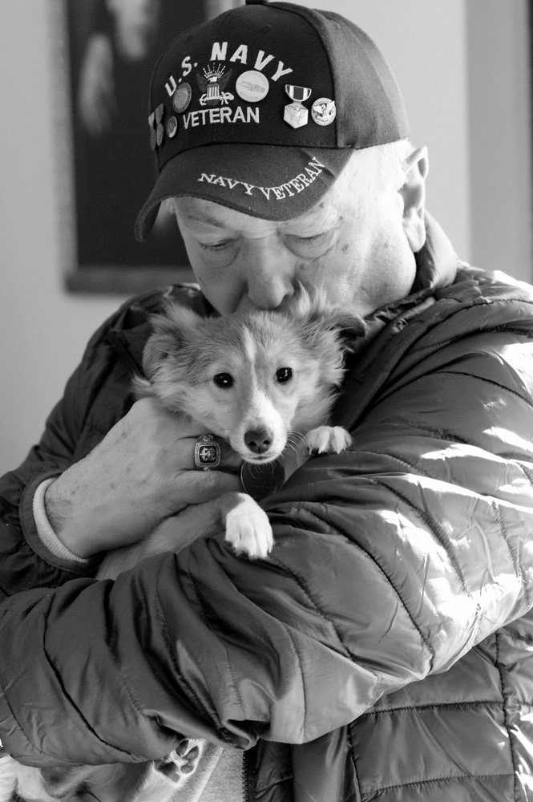
One of the biggest misconceptions in dog training today is the belief that calmness is something a dog either has or doesn’t have.
People often look at a calm dog and assume:
“He’s just naturally relaxed.”
Or they look at a hyperactive dog and think:
“That’s just the way she is.”
The reality is usually much different.
Calmness is a skill.
And like most skills, it can be learned.
The problem is that many modern dogs never actually get the opportunity to learn it.
Instead, they’re constantly stimulated.
Constantly entertained.
Constantly excited.
Constantly engaged.
Constantly reacting.
From the time they’re puppies, many dogs are taught:
play,
chase,
bark,
run,
jump,
greet,
react,
perform.
Very few are taught how to simply settle.
And that’s where a lot of problems begin.
One thing I notice constantly is how many dogs have absolutely no idea how to relax.
Not because they’re bad dogs.
Because their lives never slow down long enough for them to learn how.
A surprising number of dogs move through life in a constant state of emotional stimulation:
barking,
reacting,
anticipating,
socializing,
playing,
scanning,
chasing,
demanding,
and emotionally supervising the household like unpaid security consultants.
Then owners wonder why the dog struggles to settle calmly at home.
Meanwhile the dog’s nervous system has been operating like Times Square on New Year’s Eve since puppyhood.
That isn’t calmness.
That’s constant arousal.
And constant arousal eventually creates problems.
Over the years, I’ve worked with countless owners who believed their dog needed more exercise.
Sometimes they were right.
But often what the dog actually needed was more emotional regulation.
There’s a difference.
A dog can run for miles every day and still have terrible impulse control.
A dog can play fetch for an hour and still struggle to settle in the house.
A dog can be physically exhausted and emotionally chaotic at the same time.
I’ve seen it repeatedly.
Owners trying desperately to “wear the dog out.”
The dog becomes a world-class endurance athlete while remaining emotionally unprepared for everyday life.
That’s not fulfillment.
That’s conditioning.
And those are two very different things.
One of the most valuable things a dog can learn is how to do nothing.
That sounds simple.
It’s not.
Especially in today’s world.
Dogs are constantly being stimulated by:
televisions,
visitors,
neighborhood activity,
other dogs,
social media training trends,
toys,
games,
noises,
and endless excitement.
Nobody teaches them that calmness has value too.
The funny thing is that owners often accidentally reward excitement while overlooking calm behavior completely.
The dog barks.
Everyone notices.
The dog jumps.
Everyone responds.
The dog demands attention.
Everybody engages.
Meanwhile the dog quietly lying on a bed making excellent decisions receives absolutely no recognition whatsoever.
Imagine working at a company where only bad behavior got attention.
Eventually you’d figure out how the system works.
Dogs do the same thing.
They learn what gets engagement.
One thing I tell owners all the time is:
Notice the behavior you want more of.
If your dog is calmly relaxing, acknowledge it.
If your dog is making good decisions, acknowledge it.
If your dog is choosing self-control, acknowledge it.
Don’t wait until chaos starts before interacting.
Calmness deserves reinforcement too.
One thing I’ve noticed about truly stable dogs is that they have learned how to recover.
That’s a skill.
They get excited.
Then they settle.
They get stimulated.
Then they recover.
They encounter stress.
Then they regulate.
That’s very different from dogs who remain emotionally elevated for hours after every exciting event.
Recovery matters tremendously.
In fact, I often care more about recovery than I do about excitement itself.
Dogs should get excited.
Dogs should play.
Dogs should have fun.
They’re dogs.
The goal isn’t emotional suppression.
The goal is emotional balance.
A dog that can enjoy excitement and then return to calmness is incredibly enjoyable to live with.
A dog that remains emotionally overwhelmed all day is often exhausting for both the dog and the owner.
This becomes especially important when dealing with fearful or reactive dogs.
Many owners feel compelled to comfort every emotional reaction immediately.
The intention comes from love.
I understand that.
But sometimes constant reassurance during emotional instability can accidentally reinforce the very state we’re trying to help the dog overcome.
Confidence grows through successful experiences.
Growth often requires discomfort.
Not overwhelming discomfort.
Not trauma.
But challenge.
The same way people become stronger by stepping outside their comfort zones, dogs often become more capable by learning they can successfully navigate difficult situations.
One of the greatest gifts we can give dogs is helping them discover:
“I can handle this.”
Not:
“I’ll never have to deal with this.”
Those are very different lessons.
That’s one reason I don’t believe in avoiding every trigger forever.
I don’t believe in teaching dogs that the world is something they should constantly escape from.
I believe in helping dogs learn how to move through the world successfully.
With structure.
With guidance.
With leadership.
With support.
And eventually with confidence.
Remember the fearful shepherd mix I mentioned earlier?
She wasn’t helped by avoiding life.
She was helped by learning she could handle life.
One successful experience at a time.
One calm repetition at a time.
One victory at a time.
That’s how confidence grows.
And honestly, calmness grows much the same way.
It’s practiced.
It’s reinforced.
It’s developed.
It’s learned.
Because calmness is not a personality trait reserved for lucky dogs.
It’s a skill.
And like every important skill in your dog’s life, it becomes stronger the more consistently it’s practiced.
When dogs learn calmness, something remarkable happens.
Life becomes easier.
The dog becomes easier to live with.
The owner becomes less stressed.
Communication improves.
Freedom increases.
And the relationship becomes more enjoyable for everyone involved.
Not because the dog lost its personality.
Because the dog finally learned how to balance excitement with self-control.
And honestly, that’s a lesson many humans could probably benefit from learning too.

Chapter 4
Leadership Without Drama
If there’s one word that creates more confusion in dog training than almost any other, it’s leadership.
Some people hear the word and immediately picture somebody trying to dominate a dog.
Others hear it and assume it means controlling every aspect of the dog’s life.
Neither is what I mean when I talk about leadership.
Good leadership isn’t about power.
It’s about responsibility.
It’s about creating enough clarity, consistency, and stability that your dog no longer feels like they need to figure everything out for themselves.
And honestly, that’s a relief for most dogs.
One thing I’ve noticed over the years is that many behavior problems develop when dogs start believing they’re responsible for handling situations they aren’t equipped to handle.
The dog sees a stranger.
The dog handles it.
The dog sees another dog.
The dog handles it.
The dog hears a noise.
The dog handles it.
The dog sees movement outside.
The dog handles it.
Eventually the dog becomes emotionally exhausted because they’re carrying responsibilities that were never supposed to belong to them in the first place.
That’s where leadership matters.
Not because dogs need controlling.
Because dogs need guidance.
Think about the best leaders you’ve ever met.
Whether it was:
a coach,
a teacher,
a parent,
a mentor,
or a boss.
The good ones weren’t constantly emotional.
They weren’t unpredictable.
They weren’t changing the rules every five minutes.
They weren’t screaming.
They weren’t trying to prove how important they were.
The good ones created confidence because they were steady.
Predictable.
Fair.
Consistent.
Dogs respond remarkably well to those same qualities.
Growing up, my father, Whoop, never had to turn every situation into a dramatic event.
If he said something, he meant it.
If there was a rule, it remained a rule.
There wasn’t a daily family debate committee meeting to determine whether expectations still applied.
Life was predictable.
As kids, we knew where the boundaries were.
And because we knew where the boundaries were, we spent very little time worrying about them.
Dogs are remarkably similar.
When expectations are clear and consistent, dogs spend less time testing boundaries and more time simply living their lives.
One thing I think modern dog culture sometimes gets wrong is confusing love with leadership.
Love is incredibly important.
Dogs should absolutely feel loved.
But love alone doesn’t create stability.
Love without structure often creates confusion.
Love without accountability often creates inconsistency.
Love without leadership sometimes creates anxiety.
Because while affection feels wonderful, affection alone doesn’t answer important questions like:
What are the rules?
What happens when I make a poor decision?
Who is responsible for handling difficult situations?
What am I supposed to do here?
Dogs benefit from those answers.
A lot.
One thing I tell owners frequently is this:
Your dog should not have to make every important decision.
That’s not freedom.
That’s pressure.
Imagine if a young child had complete responsibility for:
household safety,
financial decisions,
family planning,
transportation,
and emergency management.
Most people would recognize immediately that this isn’t empowering.
It’s overwhelming.
Yet many dogs live exactly this way emotionally.
They feel responsible for:
visitors,
noises,
other dogs,
strangers,
movement,
and anything else that enters their environment.
That’s a heavy burden for an animal to carry.
Leadership helps remove that burden.
One of the most powerful things a dog can learn is:
“My human has this.”
Not:
“I have to handle everything myself.”
That’s where confidence often begins.
Especially for insecure dogs.
I think about the fearful shepherd mix from earlier in the book.
Her transformation didn’t happen because somebody convinced her the world was magically safe.
The world isn’t always safe.
Her transformation happened because she learned she didn’t have to face the world alone.
She learned that somebody else was willing to provide:
guidance,
structure,
accountability,
and calm leadership.
That changed everything.
Confidence grew because responsibility shifted.
She stopped carrying the entire weight of every situation herself.
And honestly, I think a lot of dogs are desperate for that relief.
One thing that separates good leadership from poor leadership is fairness.
Dogs should absolutely be held accountable.
But accountability should be fair.
Clear.
Understandable.
Predictable.
Good leaders don’t create confusion.
They create understanding.
A dog should know:
what is expected,
what isn’t acceptable,
and how to succeed.
That clarity creates trust.
And trust strengthens relationships.
One thing I find interesting is that many owners are completely comfortable providing leadership in every other area of life.
They lead:
their children,
employees,
teams,
projects,
organizations,
and households.
But when it comes to dogs, they suddenly become afraid that setting boundaries might somehow damage the relationship.
In my experience, the opposite is usually true.
Healthy boundaries often improve relationships.
Because boundaries create clarity.
And clarity creates confidence.
The best relationships I’ve seen between dogs and owners are rarely built on constant affection alone.
They’re built on a balance of:
love,
trust,
accountability,
communication,
structure,
and leadership.
Not harsh leadership.
Not emotional leadership.
Calm leadership.
That’s the difference.
Good leaders don’t constantly demand attention.
They create stability.
And honestly, that’s what most dogs are looking for.
Not perfection.
Not domination.
Not endless freedom without responsibility.
Stability.
Because when dogs trust that someone capable is guiding the journey, they stop feeling the need to control every turn in the road.
And that’s often where real peace begins.

Chapter 5
Why Dogs Need Clarity

If there is one idea that appears over and over throughout this book, it’s this:
Clarity changes everything.
In fact, if you remember only one concept from this entire book, I hope it’s that.
Because most behavior problems aren’t caused by dogs being stubborn, dominant, manipulative, spiteful, or trying to take over the household.
Most behavior problems are rooted in confusion.
The dog doesn’t understand.
The dog doesn’t know what works.
The dog doesn’t know what the rules are.
The dog doesn’t know who is handling the situation.
And when dogs become confused, they start experimenting.
Sometimes those experiments go well.
Sometimes they don’t.
But dogs are always searching for answers.
One thing I’ve noticed over the years is that many owners unintentionally create unclear environments.
Not because they don’t care.
Because they’re human.
One day the dog is allowed on the couch.
The next day he’s not.
One day barking gets attention.
The next day it gets ignored.
One day jumping is adorable.
The next day it’s a problem.
One day recall matters.
The next day it doesn’t.
Imagine living in a world where the rules changed constantly.
You’d become confused too.
You’d start guessing.
You’d start testing.
You’d start looking for patterns.
Dogs do exactly the same thing.
And honestly, most dogs become far less stressful to live with when life simply starts making sense.
One thing I tell owners often is:
Dogs thrive on understanding.
Not uncertainty.
Not mixed messages.
Understanding.
A dog that clearly understands expectations is often a far happier dog than one constantly trying to figure things out.
That’s especially true for anxious dogs.
A lot of anxiety comes from uncertainty.
Humans experience this too.
Think about how stressful uncertainty can be.
Waiting for test results.
Waiting for a phone call.
Waiting for answers.
Not knowing what comes next.
Dogs experience their own version of uncertainty every day when communication becomes inconsistent or unclear.
One of the biggest mistakes I see with fearful dogs is that owners become afraid to provide clarity.
They’re worried about upsetting the dog.
Hurting the dog’s feelings.
Making the dog uncomfortable.
And while those concerns come from a good place, they often create even more confusion.
Dogs need information.
Sometimes that information is:
“Good job.”
Sometimes it’s:
“That’s not acceptable.”
Both can be valuable.
Both can be fair.
Both can help a dog better understand the world.
One thing I strongly believe is that kindness and clarity are not opposites.
In fact, I think they’re partners.
A lot of people confuse kindness with endless accommodation.
But constantly removing every challenge, avoiding every trigger, or rescuing a dog from every uncomfortable moment doesn’t always help them grow.
Growth requires information.
Growth requires learning.
Growth requires experience.
That’s true for people.
And it’s true for dogs.
One thing I love about clear communication is that it lowers stress for everyone involved.
The dog relaxes.
The owner relaxes.
The relationship relaxes.
Because both parties finally understand each other better.
Think about the dogs you’ve met that seem most comfortable in their own skin.
The stable dogs.
The confident dogs.
The dogs that move through life calmly.
Usually those dogs aren’t living in complete freedom without boundaries.
They’re living with enough clarity that they understand how to succeed.
That’s a huge difference.
One thing I’ve noticed repeatedly is that clarity often creates confidence.
The fearful shepherd mix from earlier in this book didn’t become confident because life became easier.
She became confident because life became clearer.
She learned:
what was expected,
what wasn’t expected,
how to respond,
and who was responsible for handling difficult situations.
As clarity increased, anxiety decreased.
That’s not a coincidence.
That’s a pattern.
One of the greatest gifts we can give dogs is helping them understand the world around them.
Not shielding them from every challenge.
Helping them understand it.
Helping them navigate it.
Helping them succeed within it.
That requires communication.
It requires consistency.
It requires leadership.
And sometimes it requires accountability.
But most of all, it requires clarity.
Because clarity creates confidence.
Clarity creates calmness.
Clarity creates trust.
And ultimately, clarity creates freedom.
A dog that clearly understands expectations is far more capable of enjoying life than a dog constantly guessing.
That’s why so much of this book comes back to the same simple idea:
Dogs don’t need harsher lives.
They need clearer ones.
And honestly, so do many people.
I’ve seen the power of clarity change dogs that many people believed were beyond help. One of the most memorable dogs I worked with was a German Shepherd named Bane. By the time he came to me, he was on his third owner. Two trainers had already worked with him and failed, and one had even suggested that he be euthanized.
Bane was dog-aggressive and highly reactive toward people. His owners were frustrated and losing hope. Underneath all that behavior, though, I saw a dog who was confused more than anything else.
For years, people had tried to manage his behavior with redirection, treats, and avoidance. Every time he reacted, they changed the subject. Every time he made a poor decision, they tried to distract him from it. In fairness to Bane, I don’t think anyone had ever clearly told him “no” in a way he understood.
Over the course of a week, I began having a different conversation with him. When he made the wrong choice, there was a consequence. When he made the right choice, there was praise and reward. The rules became clear. The expectations became consistent. For the first time, Bane understood where the boundaries were.
Something remarkable happened once that clarity was established. The aggression began to fade. The reactivity diminished. As his understanding increased, so did his confidence.
Following his training, Bane became a regular at daycare. He learned to socialize appropriately with other dogs, relax around people, and enjoy freedoms that many believed would never be possible for him. He went on to live a full life and remained a success story until his passing from natural causes years later.
The lesson from Bane isn’t that every aggressive dog can be transformed in a week. The lesson is that many dogs are never given the clarity they need. We spend so much time trying to distract dogs from bad decisions that we forget to teach them those decisions are unacceptable in the first place. Once Bane understood the rules, his behavior changed dramatically.
Bane taught me something I have seen over and over again throughout my career. Many dogs don’t need more treats, more distractions, or more management. They need clearer communication. Once a dog understands the rules, understands the boundaries, and understands that those boundaries are consistently enforced, remarkable changes can happen.
Clarity is not harsh. Clarity is not unfair. In fact, clarity is one of the kindest things we can give a dog. It removes confusion and replaces it with understanding. Dogs thrive when they know what is expected of them, and they struggle when the rules are constantly changing or never clearly defined.

Chapter 6
Jumping, Barking, and Everyday Chaos
One of the biggest mistakes owners make is waiting until a behavior becomes a major problem before addressing it.
Most behavior problems don’t appear overnight.
They grow.
Slowly.
One successful repetition at a time.
A puppy jumps on somebody.
Everyone laughs.
The puppy gets attention.
The puppy learns something.
The next day the puppy jumps again.
More attention.
More learning.
Months later that same puppy weighs seventy pounds and is launching itself at visitors like a furry missile with absolutely no regard for personal space.
Suddenly nobody finds it adorable anymore.
The dog didn’t change.
The consequences changed.
The dog simply continued practicing what had worked all along.
That’s how many unwanted behaviors develop.
Not through malice.
Not through dominance.
Through repetition.
One successful repetition at a time.
Jumping is one of the clearest examples.
Most dogs don’t jump because they’re trying to challenge authority.
They jump because jumping works.
It gains:
attention,
interaction,
eye contact,
conversation,
touching,
excitement,
and engagement.
From the dog’s perspective, it’s a highly successful strategy.
That’s why owners often become frustrated.
They’re trying to stop the behavior while accidentally rewarding it at the exact same time.
The dog jumps.
The owner says:
“No.”
The dog receives:
eye contact,
attention,
engagement,
conversation.
Mission accomplished.
The dog learns:
“Jumping starts interactions.”
One thing I’ve learned over the years is that dogs don’t care nearly as much about our intentions as they do about our consistency.
We may intend to discourage a behavior.
The dog simply pays attention to what actually happens.
That’s why clear boundaries matter.
If jumping never works, jumping begins losing value.
If jumping occasionally works, jumping becomes extremely persistent.
Dogs become little gamblers.
And gambling is a powerful motivator.
The same principle applies to barking.
A lot of owners view barking as communication.
And sometimes it is.
But barking can also become a habit.
A strategy.
A learned behavior that produces results.
The dog barks.
Something happens.
The dog learns.
One thing I notice constantly is owners unintentionally participating in barking.
The dog barks.
The owner talks.
The dog barks again.
The owner talks louder.
The dog barks more.
Now everybody is contributing equally to the noise.
From the dog’s perspective:
“Excellent. The meeting is underway.”
Nobody intended that outcome.
But that’s what the dog learned.
Dogs learn from outcomes.
Not intentions.
I remember working with an owner who insisted her dog barked constantly for no reason.
As we observed the dog together, a pattern became obvious.
Every single bark produced a response.
Every bark generated:
conversation,
eye contact,
movement,
attention,
interaction.
The dog wasn’t barking randomly.
The dog had developed an extremely effective communication system.
The barking made things happen.
And behaviors that work tend to continue.
One thing I want owners to understand is that many everyday behavior problems are surprisingly simple at their core.
Not easy.
But simple.
The dog is doing something because it has value.
Remove the value consistently and the behavior often begins changing.
That’s where accountability becomes important.
And this is something I think many people misunderstand.
Accountability isn’t anger.
It isn’t frustration.
It isn’t punishment driven by emotion.
It’s information.
Clear information.
The dog learns:
“That behavior doesn’t work.”
“This behavior does.”
That’s learning.
That’s communication.
That’s clarity.
And honestly, dogs tend to appreciate clarity far more than confusion.
One thing I find fascinating is how quickly many dogs improve once expectations become predictable.
The chaos starts fading.
The barking decreases.
The jumping decreases.
The relationship improves.
Not because the dog suddenly became perfect.
Because the dog finally understands how to succeed.
And that’s what good training really does.
It doesn’t simply stop unwanted behavior.
It shows dogs a better path forward.
Because when dogs understand:
what works,
what doesn’t,
what is expected,
and how to earn success,
life becomes easier for everyone.
Including the dog.
And honestly, that’s where everyday chaos finally starts turning into everyday companionship.

Chapter 7
Loose Leash Walking and Real-World Structure
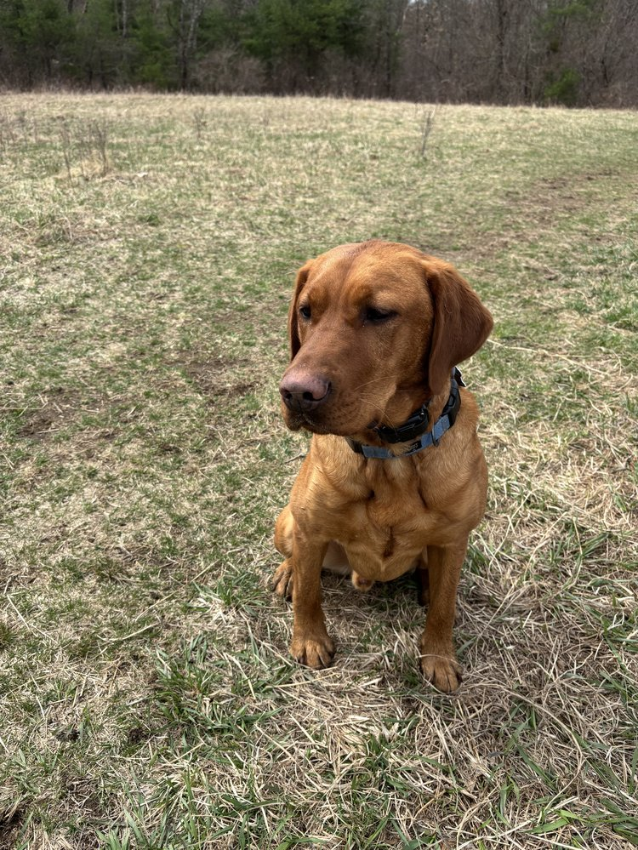
Few things frustrate dog owners more consistently than leash pulling.
It doesn’t matter whether the dog weighs:
ten pounds,
fifty pounds,
or one hundred pounds.
Being dragged down the street by an animal that appears to have urgent business three neighborhoods away is exhausting.
And honestly, it can take a lot of enjoyment out of dog ownership.
One of the first questions I often ask owners is:
“Who is walking who?”
Usually we laugh.
But there’s an important point hidden inside the joke.
Because many dogs are not actually taking walks.
They’re conducting independent environmental investigations while the owner gets dragged along as an unpaid intern.
That’s not a walk.
That’s a hostage situation with a leash attached.
The funny thing is that most leash-pulling dogs aren’t trying to be difficult.
They’re trying to get somewhere.
And historically, pulling has been an incredibly successful strategy.
The dog pulls.
The dog moves forward.
The dog learns something.
The lesson becomes:
“Pulling works.”
Dogs learn through outcomes.
Not intentions.
The owner may hate the pulling.
The dog only sees the result.
And the result is usually movement.
That’s why leash pulling becomes so persistent.
Every successful pull reinforces the behavior.
One step.
Then another.
Then another.
The dog is practicing leash pulling every single day.
Eventually it becomes a habit.
One thing I think people underestimate is how much information exists inside a walk.
Walks are not just exercise.
They’re communication.
Every walk teaches:
patience,
self-control,
boundaries,
engagement,
focus,
accountability,
and relationship.
Or it teaches the opposite.
Depending on how the walk unfolds.
One thing I’ve noticed repeatedly is that dogs who struggle in everyday life often struggle on leash too.
The same dog that:
ignores boundaries,
demands attention,
reacts emotionally,
pulls toward distractions,
and struggles with impulse control
is often showing those same patterns during walks.
The leash simply makes them easier to see.
That’s why I don’t view leash pulling as merely a walking problem.
It’s often a communication problem.
A relationship problem.
A clarity problem.
And occasionally an accountability problem.
One thing I tell owners constantly is this:
The leash is one of the greatest communication tools you’ll ever have.
Not because it’s restrictive.
Because it’s informative.
A leash allows us to communicate:
direction,
expectations,
boundaries,
and guidance.
Used properly, it’s one of the clearest ways dogs learn how to move through the world alongside us.
Unfortunately, many owners spend entire walks negotiating.
The dog pulls.
The owner follows.
The dog pulls harder.
The owner follows faster.
The dog reaches the destination.
Everybody accidentally confirms the strategy.
The dog learns:
“Excellent.
Pulling remains highly effective.”
Then the owner wonders why tomorrow looks exactly the same.
One thing I learned from working with difficult dogs is that movement itself can become a reward.
Forward motion matters.
A lot.
Which means owners have tremendous opportunities to teach during walks.
The dog learns:
“Loose leash equals progress.”
Or:
“Pulling equals progress.”
The dog doesn’t care which lesson we choose.
The dog simply learns whichever lesson happens consistently.
That’s why consistency matters so much.
One thing I love about teaching loose leash walking is how quickly many owners begin seeing improvements in other areas of life.
Because loose leash walking requires:
patience,
follow-through,
calmness,
consistency,
and leadership.
The exact same qualities that improve behavior elsewhere.
The walk becomes a daily practice session for the entire relationship.
And honestly, that’s one reason I enjoy it so much.
A good walk is about far more than exercise.
It’s about connection.
One thing I think modern dog culture sometimes gets wrong is treating walks as entertainment only.
Owners often feel responsible for making every walk exciting.
Every tree.
Every smell.
Every distraction.
Every dog.
Every squirrel-sized emergency.
The dog is encouraged to investigate absolutely everything.
Then people wonder why the dog struggles to focus.
There’s nothing wrong with dogs enjoying walks.
They absolutely should.
Dogs should sniff.
Explore.
Experience the world.
But they should also learn how to move through that world calmly and respectfully alongside their humans.
Those two things can absolutely coexist.
One of my favorite moments with owners is when they finally experience a truly connected walk.
Not perfect.
Connected.
The leash becomes loose.
The dog begins checking in naturally.
The owner relaxes.
The tension disappears.
And suddenly the walk feels less like work and more like a partnership.
That’s a powerful moment.
Because it represents something much bigger than leash manners.
It represents communication.
Trust.
Relationship.
The dog is no longer dragging the owner through life.
The owner is no longer fighting the dog through life.
They’re moving together.
And honestly, that’s the goal.
Not robotic obedience.
Not military precision.
Partnership.
Because when a dog learns how to walk respectfully beside you, they’re learning much more than leash manners.
They’re learning:
self-control,
engagement,
accountability,
and how to successfully share the journey.
And that’s a lesson that extends far beyond the end of the leash.

Chapter 8
What Fearful Dogs Actually Need
Few things pull at a person’s heartstrings more than a fearful dog.
You see it in their eyes.
The uncertainty.
The anxiety.
The constant scanning of the environment looking for danger.
And if you’re anything like most dog owners, your first instinct is to make the dog feel better.
That’s a natural human response.
We see fear.
We want to comfort it.
We see uncertainty.
We want to remove it.
We see struggle.
We want to fix it.
The problem is that what makes people feel better and what helps dogs become more confident are not always the same thing.
That’s one of the most important lessons I’ve learned in dog training.
Over the years, I’ve worked with countless fearful dogs.
Some were afraid of:
strangers,
dogs,
traffic,
noises,
new environments,
movement,
or simply the world in general.
And while every dog is different, I’ve noticed a pattern.
The dogs that improve most are usually not the ones protected from life.
They’re the ones gradually taught how to handle life.
There’s a big difference.
One of the greatest mistakes owners make with fearful dogs is assuming confidence comes from avoiding discomfort.
It doesn’t.
Confidence comes from successfully navigating discomfort.
Think about your own life.
The things that made you stronger probably weren’t the things you avoided.
They were the things you faced.
The difficult conversations.
The challenges.
The uncomfortable situations.
The moments where you discovered you were capable of more than you thought.
Dogs are remarkably similar.
Confidence grows when dogs learn:
“I can handle this.”
Not:
“I’ll never have to deal with this.”
Those are completely different lessons.
One thing I see often is owners unintentionally feeding fear.
Not because they’re doing anything wrong intentionally.
Because they love their dogs.
The dog becomes nervous.
The owner immediately responds with:
excessive reassurance,
petting,
soothing,
nervous energy,
emotional concern.
Again, the intention comes from love.
I understand that.
But sometimes what the dog actually needs is something different.
Sometimes the dog needs calm leadership.
Calm guidance.
Calm structure.
Someone quietly communicating:
“You’re okay.”
“We’ve got this.”
“Let’s keep moving.”
Not panic.
Not pity.
Not emotional chaos.
Just steadiness.
.Case Study: The Young White Maltipoo
A client came to me with a young white Maltipoo that seemed afraid of everything. New people, unfamiliar sounds, walks outside the neighborhood, even simple changes in routine would send the dog into a state of anxiety. The owners loved him deeply and wanted to help, so they constantly reassured him whenever he became nervous.
The problem was that the dog wasn’t learning confidence. He was learning that his fears were important.
Every time he hesitated, someone rushed to comfort him. Every time he became anxious, the environment changed to accommodate his discomfort. The owners had the best intentions, but the dog was becoming more dependent and less resilient.
We started by creating structure. Walks became purposeful. Expectations became clear. Instead of constantly talking to him when he was worried, we calmly guided him through situations and allowed him to discover that he could handle them.
At first, he resisted. He wanted reassurance. He wanted permission to avoid things that made him uncomfortable.
But confidence doesn’t come from avoiding challenges. Confidence comes from overcoming them.
Over the next several weeks, the Maltipoo began walking past things that previously worried him. He became more curious and less reactive. His body language changed. His tail carriage improved. He recovered more quickly from new experiences.
Nothing magical happened.
No one convinced him he was safe.
He learned he was capable.
That’s a lesson many dogs never get the opportunity to learn because the people around them confuse protection with leadership.
A good leader doesn’t remove every challenge from a dog’s life. A good leader helps the dog navigate those challenges successfully.
By the end of training, the little Maltipoo wasn’t a different dog. He was the same dog with a different understanding of the world. He had learned that discomfort wasn’t dangerous, uncertainty wasn’t an emergency, and he could look to his handler for direction instead of relying on fear.
That is where real confidence comes from.
One thing I strongly believe is that many fearful dogs are desperately looking for leadership.
Not domination.
Not force.
Leadership.
They want somebody capable to help them navigate situations that feel overwhelming.
That’s where owners can make a tremendous difference.
By remaining calm when the dog is struggling.
By remaining consistent when the dog is uncertain.
By remaining steady when the dog is emotional.
Dogs learn from our behavior too.
If we treat every challenge like an emergency, many dogs begin believing the world is full of emergencies.
If we approach challenges calmly, many dogs begin learning that challenges are manageable.
That doesn’t mean we throw fearful dogs into situations they’re not prepared for.
That’s not helpful either.
Confidence grows through achievable challenges.
Not overwhelming ones.
The goal is not flooding dogs with stress.
The goal is helping them build skills.
Just enough challenge to create growth.
Just enough success to build confidence.
One thing I tell owners often is:
Growth lives just outside the comfort zone.
That’s true for people.
And it’s true for dogs.
The world can be a scary place sometimes.
For humans.
For dogs.
For everyone.
But confidence isn’t built by hiding from life.
It’s built by learning how to move through life successfully.
With support.
With guidance.
With structure.
With leadership.
And ultimately with trust.
Because when fearful dogs discover they’re capable of handling more than they ever imagined, something incredible happens.
The world stops feeling like something to survive.
And starts feeling like something they can finally enjoy.

Chapter 9
Resource Guarding, Possession, and Boundaries
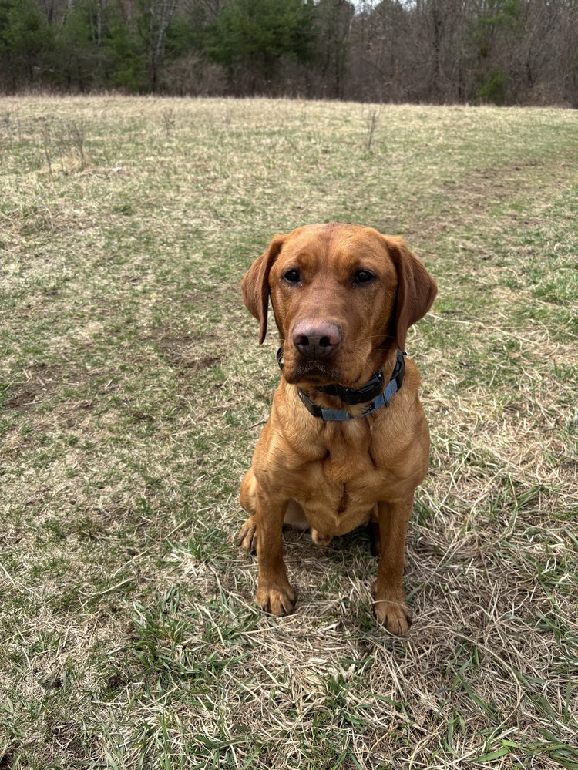
Nothing gets an owner’s attention faster than hearing their dog growl.
Especially when that growl happens over:
food,
toys,
bones,
furniture,
or even people.
For many owners, it’s frightening.
And honestly, it should be taken seriously.
Not because every guarding dog is dangerous.
Because guarding behavior is communication.
And communication matters.
One of the biggest mistakes people make is assuming resource guarding is automatically a sign of aggression.
Sometimes it is.
Often it isn’t.
Many resource-guarding dogs are actually communicating insecurity.
They’re worried about losing access to something they value.
That doesn’t excuse the behavior.
But understanding it helps us address it more effectively.
One thing I’ve learned over the years is that dogs guard things for a variety of reasons.
Some dogs guard:
food,
toys,
sleeping areas,
stolen objects,
attention,
specific people,
or spaces within the home.
The common denominator is usually the same:
The dog believes the resource belongs to them and feels responsible for protecting it.
That’s where things can become problematic.
Because once a dog starts believing they control access to important resources, conflict often follows.
One thing I tell owners frequently is:
Ownership and access are not the same thing.
Your dog may enjoy:
food,
toys,
bones,
couches,
beds,
and privileges.
But enjoyment does not equal ownership.
The resources still flow through you.
That distinction matters.
A lot.
One thing I think gets misunderstood in modern dog training is the idea that every growl should automatically be rewarded.
I disagree.
And here’s why.
If a dog growls, stiffens, lunges, or displays guarding behavior and immediately receives food, treats, or rewards because of that behavior, we have to be very careful about what lesson the dog is actually learning.
Dogs learn from consequences.
That’s one of the central themes of this book.
If guarding behavior consistently produces something valuable, we should not be surprised if guarding behavior increases.
Timing matters.
What the dog is learning matters.
That’s why I don’t recommend carelessly rewarding guarding displays themselves.
The goal is not to reinforce guarding.
The goal is to help the dog learn a different relationship with resources altogether.
One based on trust.
Clarity.
And accountability.
One thing I’ve noticed is that many guarding dogs improve significantly once structure improves.
Not because they’re intimidated.
Because expectations become clearer.
The dog learns:
“I don’t need to manage this.”
“I don’t need to protect this.”
“I don’t need to control access to this.”
That’s a powerful shift.
A lot of guarding behavior comes from dogs feeling responsible for something.
Leadership helps relieve that responsibility.
One thing I want owners to understand is that boundaries are not the enemy of trust.
Healthy boundaries often create trust.
Dogs feel safer when expectations are predictable.
Predictability lowers anxiety.
And lower anxiety often reduces guarding behavior.
Now, let’s talk about growling.
I actually don’t hate growling.
That may surprise some people.
Growling is information.
It’s a warning.
It’s communication.
A dog that’s growling is still communicating before escalating.
That’s valuable information for us as trainers and owners.
The answer isn’t to punish communication.
The answer is to address the underlying issue.
Why is the dog guarding?
What belief is driving the behavior?
What responsibility has the dog taken upon themselves?
What clarity is missing?
Those questions matter far more than the growl itself.
One thing I find encouraging is that many resource-guarding dogs improve dramatically once owners stop treating the dog as the decision-maker regarding resources.
When leadership improves, accountability improves.
When accountability improves, clarity improves.
When clarity improves, anxiety often decreases.
And when anxiety decreases, many guarding behaviors begin fading as well.
Not overnight.
Not magically.
But steadily.
One clear repetition at a time.
One successful interaction at a time.
One better decision at a time.
At its core, resource guarding is often about responsibility.
The dog believes:
“This is mine.”
“I must protect it.”
Good training helps replace that belief with something healthier:
“I don’t have to manage this.”
“I don’t have to protect this.”
“I can trust the people around me.”
And honestly, that’s a much easier burden for a dog to carry.
Because the best relationships are not built on possession.
They’re built on trust.

Chapter 10
Recall: The Most Important Command Your Dog Will Ever Learn
If I could teach a dog only one command for the rest of its life, it would be recall.
Not sit.
Not down.
Not place.
Not heel.
Recall.
Every single time.
Without hesitation.
Because a reliable recall has the potential to save a dog’s life.
And honestly, there aren’t many commands that can make that claim.
A dog that comes when called can avoid:
traffic,
wildlife encounters,
dangerous dogs,
lost situations,
injuries,
and countless other problems that arise in everyday life.
But recall is about much more than safety.
It’s about freedom.
Real freedom.
Not the kind of freedom people imagine when they hear the phrase:
“My dog just does whatever he wants.”
That’s not freedom.
That’s chaos.
Real freedom comes from reliability.
The more reliable a dog becomes, the more opportunities they earn.
The more opportunities they earn, the more freedom they can safely enjoy.
That’s one of the most important philosophies at Campbell K9’s.
Structure creates freedom.
Not the other way around.
One of my favorite moments with owners is watching the first truly reliable off-leash recall.
The dog is:
running,
exploring,
sniffing,
investigating,
enjoying life.
Then the owner calls.
The dog immediately turns.
Runs back.
Checks in.
And reconnects.
That’s not control.
That’s relationship.
That’s trust.
That’s communication.
And honestly, it’s one of the most beautiful things you’ll ever see between a dog and a human.
Unfortunately, many dogs never learn reliable recall because owners accidentally teach the wrong lesson.
The dog comes.
The owner grabs the leash.
The fun ends.
The dog comes.
The dog gets loaded into the car.
The adventure ends.
The dog comes.
The walk ends.
The dog quickly learns something.
“Coming to my owner predicts the end of good things.”
That’s not a lesson we want.
One thing I tell owners all the time is:
Make coming to you one of the best decisions your dog can make.
Not because you’re bribing the dog.
Because you’re building value.
The dog should feel that checking in with you is worthwhile.
That being connected to you matters.
That coming when called leads to good outcomes.
One thing people often misunderstand about recall is that it’s not built during emergencies.
It’s built during ordinary moments.
Every successful repetition matters.
Every recall matters.
Every opportunity to reinforce the behavior matters.
That’s how reliability develops.
One clear repetition at a time.
One successful experience at a time.
One good decision at a time.
Over the years I’ve seen owners accidentally poison their recall cue.
They repeatedly call the dog:
when they know the dog won’t come,
when they’re angry,
when the dog is overwhelmed,
when distractions are far beyond the dog’s skill level.
Eventually the cue loses value.
The dog learns:
“That word doesn’t really mean anything.”
Or worse:
“That word predicts something unpleasant.”
That’s why I tell owners to protect their recall cue.
Treat it like something valuable.
Because it is.
One thing I love about off-leash hiking is that it reveals the true strength of a relationship.
When a dog has freedom, they also have choices.
And choices reveal training.
The dog chooses whether to:
check in,
stay connected,
follow guidance,
and return when called.
That’s where trust becomes visible.
Not because the dog is forced.
Because the dog chooses the relationship.
That’s powerful.
I’ve worked with countless dogs that owners believed could never be trusted off leash.
Dogs that:
chased distractions,
ignored commands,
disappeared into the distance,
and acted as though human existence was merely a minor inconvenience.
Yet once communication improved, accountability improved, and clarity improved, many of those same dogs became incredibly reliable.
Not perfect.
Reliable.
There’s a difference.
One thing I want owners to understand is that reliable recall isn’t about creating a robot.
It’s about creating freedom safely.
The goal isn’t to remove personality.
The goal is to create trust.
Some of the happiest dogs I’ve ever worked with are dogs enjoying enormous amounts of freedom because they earned it.
They can:
hike,
swim,
explore,
adventure,
and experience life fully.
Because somebody invested the time to teach reliability.
And that’s one of the greatest gifts we can give a dog.
A larger world.
More opportunities.
More experiences.
More freedom.
One thing I’ve learned over the years is that freedom isn’t the opposite of accountability.
Freedom is often the result of accountability.
A dog that understands expectations can be trusted with more.
A dog that can be trusted with more gets to experience more.
That’s true in dog training.
And honestly, it’s true in life.
At its core, recall is not just a command.
It’s a conversation.
The dog hears:
“Come back to me.”
And responds:
“I’m here.”
That’s relationship.
That’s trust.
That’s partnership.
And if you ask me, that’s the most important lesson a dog can ever learn.

Chapter 11
The Most Misunderstood Tool in Dog Training
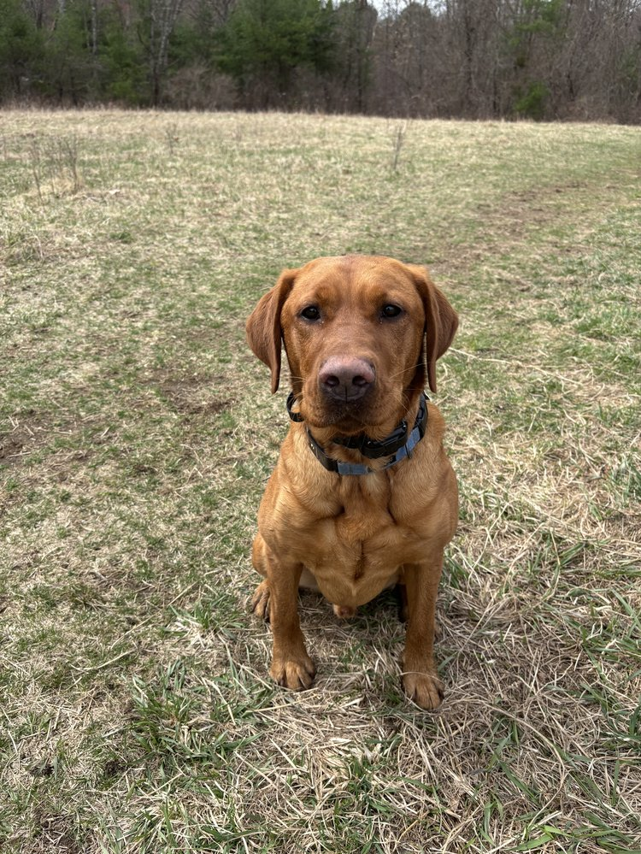
If there’s one tool in dog training that creates more arguments than almost anything else, it’s the electronic collar.
Mention an e-collar in a room full of dog owners and you’ll usually get one of two reactions.
Some people believe it’s the greatest training tool ever created.
Others believe it’s cruel, abusive, and should never be used under any circumstances.
The truth, as usual, lives somewhere in the middle.
Over the years, I’ve trained hundreds of dogs using e-collars.
Not because I enjoy correcting dogs.
Not because I’m looking for shortcuts.
Not because I want control.
I use them because, when introduced properly and used fairly, they are one of the clearest communication tools available.
That’s an important distinction.
Communication.
Not punishment.
Communication.
Unfortunately, many people have never seen an e-collar used correctly.
They imagine someone standing in a yard repeatedly shocking a dog into submission.
That’s not training.
That’s ignorance.
And frankly, it gives good trainers a bad name.
A properly conditioned e-collar should feel less like punishment and more like a tap on the shoulder.
The dog feels information.
The dog responds.
Communication occurs.
That’s it.
The Problem With Distance
One thing owners quickly discover is that dogs become very different creatures when distance enters the picture.
In the living room, they listen beautifully.
In the backyard, they listen fairly well.
At the park, things become questionable.
In the woods, they suddenly develop complete hearing loss.
The dog isn’t being stubborn.
The environment simply became more valuable than the owner.
Squirrels.
Birds.
Deer.
Smells.
Movement.
Adventure.
The world becomes incredibly interesting.
That’s where communication becomes difficult.
Because once a dog is fifty yards away, your leash no longer reaches them.
Your hand signals become less effective.
And yelling usually accomplishes very little besides entertaining nearby hikers.
The e-collar bridges that communication gap.
It allows the conversation to continue regardless of distance.
What Most People Get Wrong
One of the biggest misconceptions about e-collars is that they create obedience through fear.
Good e-collar training doesn’t work that way.
In fact, when I introduce an e-collar, many dogs work at levels so low that owners can barely feel the stimulation themselves.
The goal is not discomfort.
The goal is awareness.
The dog learns:
“I felt that.”
Then:
“I know what that means.”
Eventually:
“I understand what my handler wants.”
That’s learning.
Not fear.
Not intimidation.
Learning.
The collar becomes another language.
Another way to communicate.
Nothing more.
Freedom Through Reliability
One of the core beliefs at Campbell K9’s is that structure creates freedom.
Not the other way around.
A reliable dog earns opportunities.
A reliable dog earns trust.
A reliable dog earns freedom.
The dogs I hike with off leash every day are not free because they ignore accountability.
They’re free because accountability exists.
The owners know the dog will come when called.
The dog understands expectations.
The relationship becomes dependable.
And because the relationship becomes dependable, the dog gets to enjoy a much bigger world.
That’s the real gift of good training.
Not control.
Freedom.
The ability to safely explore, hike, swim, travel, and experience life.
Tools Are Not The Problem
Over the years I’ve watched people blame:
leashes,
crates,
prong collars,
e-collars,
slip leads,
for problems they didn’t create.
The reality is that tools are just tools.
A hammer can build a house.
A hammer can also break a window.
The tool isn’t making the decision.
The person using it is.
An e-collar in the hands of an inexperienced person can absolutely create problems.
So can a leash.
So can a crate.
So can food rewards.
Any training method can be misused.
That’s why education matters.
That’s why proper instruction matters.
That’s why timing matters.
The tool itself isn’t good or bad.
The application determines the outcome.
The Goal Is Always Communication
At the end of the day, dog training is communication.
That theme appears throughout this entire book because it sits at the center of everything I believe.
Dogs thrive when communication becomes clear.
Dogs struggle when communication becomes confusing.
A properly used e-collar simply provides another way to communicate.
Another way to provide information.
Another way to maintain a conversation when distance, distraction, and real life get involved.
When introduced correctly, it becomes one of the most powerful tools available for building reliability, confidence, and freedom.
Not because dogs fear it.
Because dogs understand it.
And when dogs understand us, remarkable things become possible.
Including something every dog owner wants:
The freedom to enjoy more of life together.

Chapter 12
Puppy Biting, Adolescence, and the Tiny Velociraptor Phase
One of the biggest surprises for new dog owners is discovering that puppies are not born knowing how to be good dogs.
I know that sounds obvious.
But social media has done a remarkable job convincing people that puppies arrive home as adorable little bundles of happiness whose primary goals are cuddling, sleeping, and looking photogenic in matching bandanas.
Then reality arrives.
And reality has teeth.
Lots of teeth.
Tiny ones.
Sharp ones.
The kind that somehow find their way into:
fingers,
ankles,
shoelaces,
pant legs,
sleeves,
furniture,
remote controls,
and occasionally parts of the human body nobody knew were vulnerable.
Suddenly the adorable puppy resembles a furry land shark with impulse control issues.
Welcome to puppyhood.
The good news is that most of this is completely normal.
The bad news is that normal doesn’t always feel enjoyable while you’re living through it.
One thing I tell puppy owners constantly is this:
Your puppy is not giving you a hard time.
Your puppy is having a hard time.
Think about what puppies are dealing with.
Everything is new.
Everything is exciting.
Everything is stimulating.
They’re learning:
the world,
the rules,
the people,
the environment,
and themselves.
That’s a lot for a young dog to process.
And when dogs become overwhelmed, overexcited, frustrated, tired, or confused, biting often becomes part of the picture.
Not because they’re aggressive.
Because they’re immature.
One thing I’ve noticed is that many owners accidentally interpret normal puppy behavior as personality.
The puppy bites.
The owner says:
“He’s dominant.”
The puppy steals socks.
The owner says:
“He’s stubborn.”
The puppy ignores instructions.
The owner says:
“He’s trying to be the boss.”
In reality, the puppy is often just being a puppy.
Immature behavior should not automatically be treated as character flaws.
Young dogs are learning.
That’s their job.
Our job is helping guide that learning.
One thing I find interesting is how much puppy ownership resembles parenting.
You don’t expect a toddler to make perfect decisions.
You don’t expect emotional regulation.
You don’t expect maturity.
You expect growth.
Dogs deserve that same understanding.
That doesn’t mean we excuse everything.
Far from it.
Structure still matters.
Boundaries still matter.
Accountability still matters.
But expectations should match development.
One thing that creates a lot of frustration for owners is adolescence.
Just when you think things are improving, your dog suddenly appears to forget everything you’ve taught them.
Recall weakens.
Focus decreases.
Impulse control disappears.
The dog begins making decisions that leave you wondering whether they’ve secretly suffered a head injury.
Welcome to adolescence.
It’s completely normal.
Frustrating.
But normal.
One thing I want owners to understand is that adolescence isn’t usually rebellion.
It’s development.
The dog’s brain is changing.
Priorities are changing.
The environment becomes more interesting.
Distractions become more powerful.
The world suddenly feels bigger.
And often the dog’s judgment temporarily becomes smaller.
This is where many owners make a mistake.
They panic.
They assume training has failed.
They assume the dog is being stubborn.
They assume all progress is lost.
Usually none of that is true.
What the dog needs most during adolescence is often exactly what they needed as a puppy:
consistency,
structure,
accountability,
patience,
and leadership.
The principles don’t change.
The challenge simply becomes greater.
One thing I love about working with adolescent dogs is that they force owners to become more consistent.
A puppy can occasionally succeed despite inconsistent leadership.
An adolescent dog tends to expose inconsistency immediately.
That’s not a bad thing.
It’s information.
One thing I tell owners all the time is:
The dog you’re living with today is not the dog you’ll have forever.
That matters.
Because many owners become discouraged during difficult stages.
The biting stage ends.
The chewing stage ends.
The adolescent chaos eventually settles.
The puppy that once seemed incapable of making a good decision eventually becomes a mature dog.
Growth happens.
Slowly.
One repetition at a time.
One lesson at a time.
One day at a time.
The owners who succeed are usually not the owners with perfect dogs.
They’re the owners who remain consistent long enough for maturity and training to meet each other.
And when that happens, something remarkable occurs.
The puppy becomes a dog.
The chaos becomes companionship.
The frustration becomes understanding.
And the tiny velociraptor that once viewed your ankles as recreational equipment becomes a trusted member of the family.
At least most of the time.
Because honestly, even adult dogs occasionally make questionable decisions.
That’s part of the fun too.

Chapter 13
Why So Many Modern Dogs Are Overwhelmed
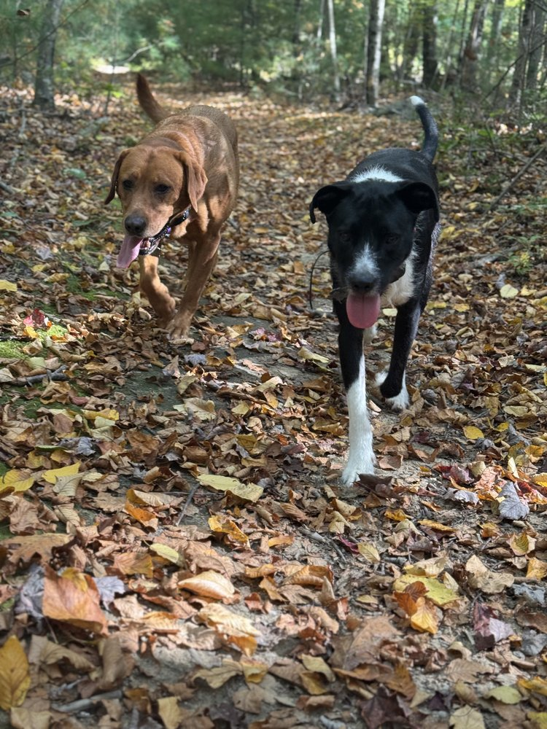
One of the biggest changes I’ve noticed over the years isn’t in dogs.
It’s in how people live with dogs.
And honestly, I think a lot of modern dogs are exhausted.
Not physically.
Emotionally.
Mentally.
Behaviorally.
The strange part is that many of these dogs are receiving more attention, more activities, and more stimulation than dogs have ever received before.
Yet many seem less settled than ever.
Less capable of relaxing.
Less capable of being alone.
Less capable of handling boredom.
Less capable of simply existing peacefully.
That isn’t a coincidence.
One thing I often tell owners is:
Being busy and being fulfilled are not the same thing.
And that’s true for dogs too.
A dog can spend the entire day:
playing,
training,
socializing,
attending daycare,
chasing balls,
visiting stores,
going to events,
and participating in activities.
And still struggle with calmness.
Why?
Because stimulation and fulfillment are not identical.
One thing I think modern dog culture sometimes gets wrong is the belief that every waking moment needs to be occupied.
Dogs are constantly entertained.
Constantly engaged.
Constantly stimulated.
And while activity is important, so is recovery.
So is rest.
So is learning how to simply settle.
Imagine if every minute of your day looked like this:
notifications,
meetings,
conversations,
phone calls,
social obligations,
errands,
tasks,
entertainment,
and constant engagement.
Eventually you’d feel overwhelmed.
Dogs aren’t much different.
Many dogs live in a near-constant state of stimulation.
Then owners wonder why the dog:
can’t relax,
can’t settle,
can’t focus,
can’t regulate emotions,
or can’t handle frustration.
The dog’s nervous system never gets a chance to come back down.
One thing I notice often is that owners mistake excitement for happiness.
Now don’t get me wrong.
Excitement can absolutely be part of happiness.
Dogs should:
play,
explore,
adventure,
and enjoy life.
But excitement alone isn’t the goal.
A dog bouncing off the walls isn’t necessarily fulfilled.
A dog spinning in circles isn’t necessarily happy.
A dog screaming with excitement every time something moves isn’t necessarily thriving.
Sometimes they’re simply overstimulated.
One of the most valuable skills a dog can learn is how to transition from activity to calmness.
From excitement to relaxation.
From engagement to recovery.
Unfortunately, many dogs never learn that skill.
They learn:
how to play,
how to react,
how to chase,
how to demand,
how to seek stimulation.
But nobody teaches them how to settle.
The result is a dog that constantly needs something.
And honestly, that’s exhausting for everyone involved.
One thing I love about off-leash hiking is that it often provides something many dogs desperately need.
Not just exercise.
Purpose.
A dog gets to:
explore,
investigate,
navigate terrain,
use their senses,
make decisions,
and move naturally through the environment.
That’s very different from mindlessly chasing a tennis ball for an hour.
Again, there’s nothing wrong with fetch.
But fulfillment usually runs deeper than simple stimulation.
Dogs were designed to engage with the world.
Not just consume entertainment.
One thing I find fascinating is how quickly many dogs improve once life becomes more balanced.
Not busier.
Balanced.
They still:
exercise,
train,
play,
socialize,
and explore.
But they also learn:
patience,
calmness,
recovery,
and self-control.
The entire nervous system benefits.
Behavior often improves too.
Not because the dog became tired.
Because the dog became regulated.
That’s a huge difference.
One thing I think owners need to hear is this:
Your dog does not need to be entertained every minute of every day.
In fact, learning how to be comfortably bored is an incredibly valuable life skill.
For dogs.
For people.
For everyone.
Dogs should absolutely enjoy life.
But they should also learn how to:
wait,
relax,
observe,
settle,
and simply exist peacefully.
That’s not deprivation.
That’s emotional maturity.
And emotional maturity creates freedom.
A dog that can settle calmly:
handles guests better,
handles travel better,
handles public spaces better,
handles everyday life better.
The dog becomes easier to live with because the dog becomes easier to live with emotionally.
One thing I’ve learned over the years is that many behavior problems improve when dogs stop living in a constant state of stimulation.
The barking decreases.
The reactivity decreases.
The anxiety decreases.
The frustration decreases.
Not because we eliminated activity.
Because we introduced balance.
At its core, a fulfilled dog is not necessarily the busiest dog.
It’s often the dog whose life contains the right combination of:
structure,
adventure,
accountability,
purpose,
rest,
and relationship.
That’s where stability lives.
And honestly, stability is one of the greatest gifts we can give a dog.
Because when dogs stop feeling overwhelmed by the world around them, they can finally start enjoying it.

Chapter 14
Why Dogs Need Jobs, Purpose, and Adventure
One of the most common things I hear from owners is:
“My dog has endless energy.”
Sometimes that’s true.
But often what they’re really describing is a dog that lacks purpose.
There’s a difference.
Over the years, I’ve worked with countless dogs whose owners were doing everything they could think of:
longer walks,
more fetch,
more daycare,
more toys,
more treats,
more exercise,
more activity.
Yet the dog still seemed restless.
Still seemed unsatisfied.
Still seemed to be searching for something.
The missing ingredient was often purpose.
One thing I think people sometimes forget is that dogs were originally bred to do things.
Not just exist.
For generations, dogs worked alongside humans.
They:
herded,
hunted,
guarded,
retrieved,
tracked,
protected,
pulled,
searched,
and assisted.
They had jobs.
Responsibilities.
Purpose.
The modern dog often lives a very different life.
Many spend most of their day:
waiting,
watching,
pacing,
or looking for ways to create their own entertainment.
And honestly, when dogs create their own jobs, owners don’t usually like the results.
The dog decides:
“I’ll guard the front window.”
Or:
“I’ll supervise every squirrel in the neighborhood.”
Or:
“I’ll alert everyone every time a leaf moves.”
Suddenly the dog is working full-time at a position nobody hired them for.
One thing I’ve learned is that dogs desperately want to feel useful.
Not in a human sense.
But in a canine sense.
They want opportunities to:
think,
solve problems,
move,
explore,
engage their instincts,
and participate in life.
That’s why purpose matters so much.
One thing I love about off-leash hiking is that it allows dogs to be dogs.
Not just pets.
Dogs get to:
navigate terrain,
use their noses,
explore environments,
make decisions,
solve problems,
and engage naturally with the world.
It’s incredibly fulfilling.
And honestly, it’s one of the reasons I’ve built so much of Campbell K9’s around adventure.
Adventure changes dogs.
I’ve seen:
fearful dogs become confident,
anxious dogs become calmer,
reactive dogs become more stable,
and insecure dogs become more resilient.
Not because hiking is magic.
Because meaningful experiences build capable dogs.
One thing I find fascinating is how often behavior problems decrease when dogs begin living fuller lives.
The dog that spent all day obsessing over the front window suddenly has something better to think about.
The dog that barked at every sound begins focusing on the environment instead.
The dog that constantly searched for stimulation starts finding genuine fulfillment.
That’s a powerful shift.
One thing I tell owners frequently is:
A tired dog is not always a fulfilled dog.
That’s an important distinction.
A dog can be exhausted from:
chasing a ball,
running laps,
or nonstop activity.
And still feel unfulfilled.
Fulfillment comes from engaging both body and mind.
It comes from allowing dogs to use the instincts and abilities they were born with.
That’s why some dogs finish a hike looking relaxed and content in a way that hours of random exercise never seem to achieve.
The experience matters.
The purpose matters.
The journey matters.
One thing I think modern dog ownership sometimes overlooks is that fulfillment isn’t always exciting.
Sometimes it’s quiet.
Sometimes it’s simply a dog feeling capable.
Confident.
Connected.
Useful.
There’s something deeply satisfying about a dog who understands its role in the world.
Not because the role is complicated.
Because the role is clear.
And if you’ve read this far, you’ve probably noticed that clarity keeps appearing throughout this book.
That’s not accidental.
Dogs thrive when life makes sense.
Purpose helps create that sense.
A dog with purpose often develops:
confidence,
resilience,
emotional stability,
patience,
and better decision-making.
Not because purpose solves everything.
Because purpose gives direction.
Direction matters.
For dogs.
For people.
For everyone.
One thing I learned growing up is that people tend to do better when they have responsibility and purpose.
My father, Whoop, worked hard his entire life.
My mother dedicated herself to caring for others as a nurse.
Neither approached life by asking:
“How can I avoid responsibility?”
They found meaning through responsibility.
Through contribution.
Through purpose.
And honestly, I think dogs are similar.
Not identical.
But similar.
Most dogs don’t want a life completely free of challenges.
They want a life they can participate in.
A life where they feel engaged.
A life where they feel connected.
A life where they get to be part of something.
That’s why I believe adventure matters.
Not because every dog needs to climb mountains.
Because every dog deserves opportunities to experience the world.
To learn.
To grow.
To explore.
To discover what they’re capable of.
And when that happens, something remarkable occurs.
The dog becomes more than just exercised.
The dog becomes fulfilled.
And honestly, fulfilled dogs are often some of the easiest dogs in the world to live with.
Because a dog with purpose is rarely searching for one.

Chapter 15
The Human Side of Dog Training
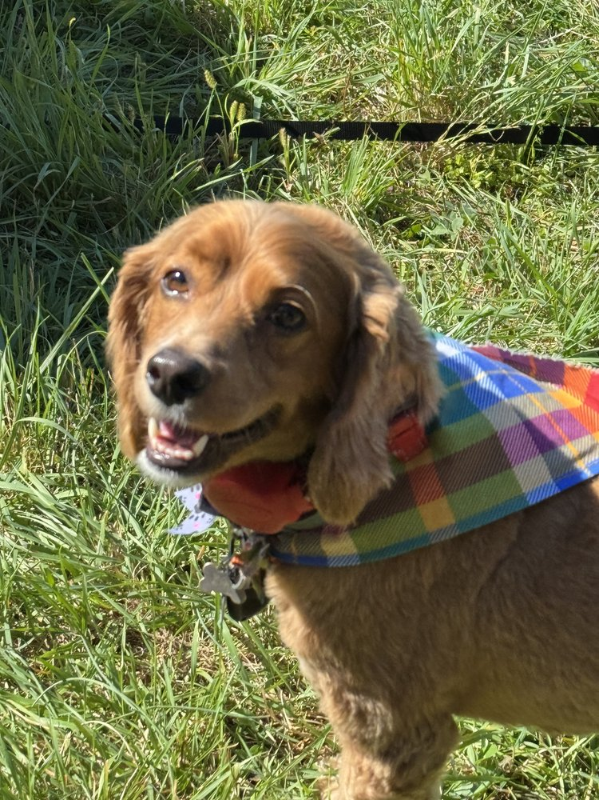
Most people think they’re hiring a dog trainer to change their dog.
And honestly, that’s understandable.
The dog is:
barking,
pulling,
jumping,
reacting,
chewing,
ignoring commands,
or generally making life more difficult than expected.
So naturally, the focus starts on the dog.
But after years of training, I’ve learned something interesting.
The biggest transformations often happen on the other end of the leash.
With the humans.
That isn’t criticism.
It’s reality.
Because dogs have a remarkable ability to expose things about us that we might not notice otherwise.
They expose:
inconsistency,
impatience,
frustration,
poor communication,
unrealistic expectations,
and emotional reactions.
And they do it with incredible honesty.
Dogs don’t care what our intentions were.
They respond to what we actually do.
That’s one reason dog training can be so humbling.
A dog doesn’t care how many books we’ve read.
A dog doesn’t care how many training videos we’ve watched.
A dog cares about:
clarity,
consistency,
timing,
accountability,
and communication.
The same things we’ve talked about throughout this book.
One thing I’ve noticed over the years is that many owners begin training because they want a better dog.
They finish training with a better understanding of themselves.
I’ve watched people become:
more patient,
more observant,
more disciplined,
more calm,
more intentional,
and more self-aware.
Not because somebody forced them to.
Because the dog required it.
A dog has a way of holding up a mirror.
Sometimes we like what we see.
Sometimes we don’t.
But the lesson is there regardless.
One thing I think people underestimate is how much energy they bring into interactions with their dogs.
Dogs notice everything.
They notice:
tension,
frustration,
nervousness,
uncertainty,
excitement,
confidence,
and calmness.
Many times I’ve watched an owner become anxious before a situation even unfolds.
The dog immediately notices.
The leash tightens.
The owner’s breathing changes.
The body language changes.
The energy changes.
The dog responds.
Then the owner assumes the dog created the problem.
Sometimes the dog did.
Sometimes the dog simply reacted to information the owner didn’t realize they were providing.
That’s not blame.
It’s awareness.
Awareness creates growth.
One thing I love about working with owners is watching confidence develop.
Not just in the dogs.
In the people.
The fearful owner becomes calmer.
The overwhelmed owner becomes more capable.
The frustrated owner becomes more patient.
The relationship improves because both sides are growing.
That’s a beautiful thing to witness.
I remember the Labradoodle I mentioned earlier in the book.
The dog barked.
Dad automatically reached down and started petting him.
Neither one realized the pattern had become automatic.
The dog had trained the human just as effectively as the human had trained the dog.
We laughed.
Not because anybody was doing something wrong intentionally.
Because awareness had just arrived.
And awareness changes everything.
Once the owner saw it, he couldn’t unsee it.
The relationship improved because understanding improved.
That’s one of my favorite parts of dog training.
The lightbulb moments.
The moments when people suddenly realize:
“Oh.
That’s what my dog has been learning.”
Those moments change lives.
Not just behavior.
Lives.
One thing I learned growing up from Whoop and my mother was that growth often comes from responsibility.
Not avoiding responsibility.
Accepting it.
It’s easy to blame:
the dog,
the breed,
the breeder,
the rescue,
the previous owner,
or circumstances.
Sometimes those things absolutely contribute.
But meaningful change usually begins when we ask:
“What can I do differently?”
That’s an empowering question.
Because it puts growth back within our control.
And honestly, that’s where progress starts.
One thing I find fascinating is how often dog training lessons apply to human relationships.
Think about how many concepts we’ve discussed:
communication,
consistency,
trust,
accountability,
patience,
leadership,
clarity.
Those principles improve nearly every relationship in life.
Not just relationships with dogs.
Maybe that’s why dogs have such a profound impact on people.
They force us to practice skills that matter everywhere else too.
One thing I tell clients often is:
Your dog doesn’t need you to be perfect.
That’s true.
Your dog doesn’t need perfection.
Your dog needs effort.
Honesty.
Consistency.
A willingness to learn.
A willingness to grow.
The same things we ask from them.
That’s what makes great relationships possible.
Not perfection.
Partnership.
At its core, dog training is not really about obedience.
It’s about understanding.
It’s about two completely different species learning how to communicate, trust, and live together successfully.
And when that happens, something remarkable occurs.
The dog improves.
The owner improves.
The relationship improves.
And both end up better than they were before.
Honestly, that’s one of the reasons I love this work so much.
Because the best dog training isn’t just about creating better dogs.
It’s about helping people become better partners for the dogs they already love.

Chapter 16
Living With Dogs Instead of Managing Them
One of the biggest changes I see after successful training isn’t obedience.
It’s peace.
Life simply becomes easier.
Not perfect.
Easier.
The dog isn’t constantly:
barking,
pulling,
demanding,
reacting,
pacing,
or creating daily chaos.
And the owner isn’t constantly:
correcting,
negotiating,
worrying,
supervising,
or feeling frustrated.
The relationship begins to feel natural.
That’s when owners often realize something important.
They’ve stopped managing the dog.
And started living with the dog.
There’s a huge difference.
Many owners spend years managing behavior.
Managing the barking.
Managing the jumping.
Managing the chewing.
Managing the reactivity.
Managing the anxiety.
Managing the chaos.
The dog becomes a never-ending project.
A list of problems to solve.
A collection of behaviors to monitor.
And honestly, that’s exhausting.
For everyone.
One thing I love about good training is that it changes the entire emotional atmosphere of a household.
Not because the dog becomes robotic.
Because communication becomes clearer.
Everybody understands each other better.
The dog understands expectations.
The owner understands the dog.
Life becomes more predictable.
And predictability creates peace.
One thing I think people sometimes forget is that dogs are supposed to make our lives better.
That’s one of the reasons we invite them into our homes in the first place.
We want:
companionship,
adventure,
laughter,
connection,
and relationship.
Nobody gets a dog hoping for constant conflict.
Yet many owners eventually find themselves trapped in a cycle of daily frustration.
Not because they don’t love their dog.
Because the relationship has become dominated by management.
One problem after another.
One correction after another.
One argument after another.
The relationship starts revolving around what the dog does wrong.
And that’s a shame.
Because dogs have so much more to offer than that.
One thing I’ve noticed is that owners often experience a shift after training.
The dog hasn’t become perfect.
The dog still makes mistakes.
The dog is still a dog.
But the owner’s attention begins moving away from constant problem-solving and back toward enjoying the relationship.
That’s where the magic happens.
I remember one client telling me:
“For the first time, I feel like I actually enjoy taking my dog places.”
That stuck with me.
Because that’s the goal.
Not trophies.
Not social media videos.
Not impressing strangers.
Enjoyment.
A dog should make your life bigger.
Not smaller.
One thing I think about often is how much freedom opens up once communication improves.
Owners start taking dogs:
hiking,
traveling,
visiting friends,
going to outdoor events,
exploring new places,
and participating more fully in everyday life.
Not because the dog became perfect.
Because the dog became reliable.
Reliability creates opportunities.
Opportunities create experiences.
Experiences strengthen relationships.
That’s one of the reasons I care so much about training.
Good training expands a dog’s world.
And it expands the owner’s world too.
One thing I’ve learned over the years is that the strongest relationships are rarely built through constant management.
They’re built through trust.
Think about any healthy relationship in your life.
The goal isn’t controlling every moment.
The goal is mutual understanding.
Dogs are no different.
A good relationship with a dog isn’t about:
micromanagement,
constant supervision,
endless commands,
or controlling every decision.
It’s about creating enough trust and understanding that life can simply happen.
The dog knows how to succeed.
The owner knows how to communicate.
Everybody relaxes.
That’s a beautiful place to reach.
One thing I tell owners often is:
Training should eventually become part of life, not the focus of life.
That’s important.
Because training is a tool.
A valuable tool.
But the purpose of training is not training.
The purpose is relationship.
The purpose is creating a life where dogs and humans can enjoy each other more fully.
When people lose sight of that, training becomes a checklist.
When people remember it, training becomes a pathway.
A pathway to freedom.
A pathway to trust.
A pathway to companionship.
One thing I love about older dogs is that they often teach this lesson naturally.
The older dog isn’t trying to impress anyone.
The older dog isn’t worried about being perfect.
The relationship simply exists.
Comfortably.
Naturally.
Honestly.
That’s what many owners are ultimately looking for.
Not perfection.
Connection.
At its best, dog training helps create that connection.
It removes barriers.
It reduces conflict.
It increases understanding.
And eventually, something wonderful happens.
The dog stops feeling like a project.
And starts feeling like what they were meant to be all along.
A companion.
A partner.
A friend.
And honestly, that’s one of the greatest rewards dog ownership has to offer.

Chapter 17
The Dog You Wanted vs. The Dog You Got
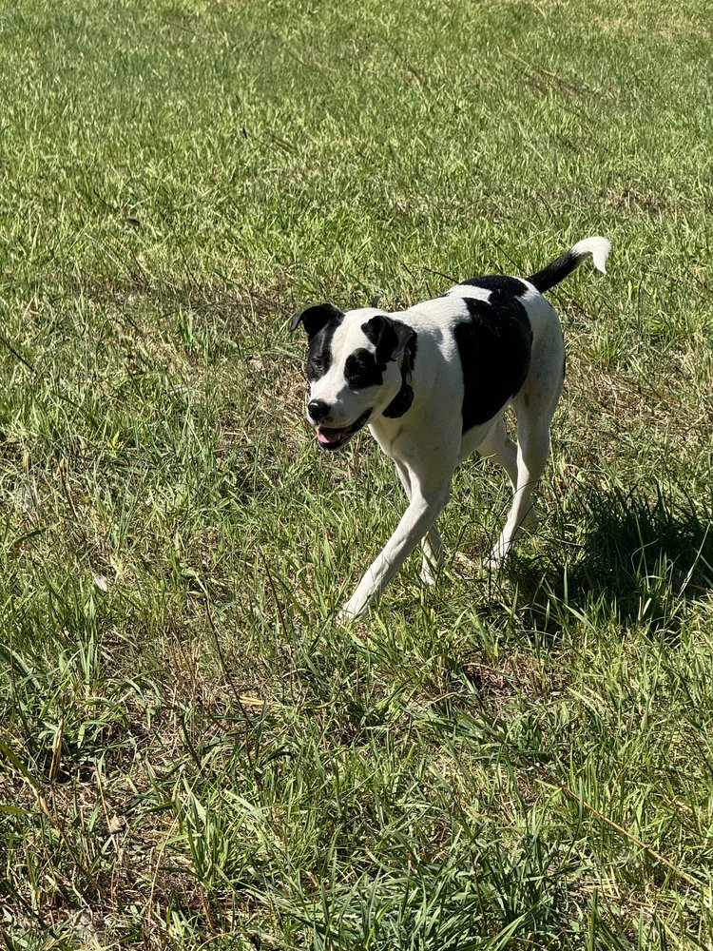
Almost every dog owner starts with a vision.
Sometimes it’s a picture in their head.
Sometimes it’s a memory from childhood.
Sometimes it’s a dog they saw online.
But nearly everyone imagines what life with their future dog is going to look like.
The puppy will be:
well behaved,
easy to train,
great with people,
good with other dogs,
and ready to accompany them on every adventure.
Then reality arrives.
And reality often has different plans.
The puppy chews things.
The adolescent dog ignores instructions.
The rescue dog carries emotional baggage.
The working breed wants a full-time job.
The little dog thinks it’s responsible for national security.
And suddenly the dog in front of you doesn’t look exactly like the dog you imagined.
That’s where many owners face an important choice.
They can spend their energy wishing they had a different dog.
Or they can start learning the dog they actually have.
One path creates frustration.
The other creates understanding.
One thing I’ve learned over the years is that comparison is one of the fastest ways to damage a relationship.
Not just with dogs.
With people too.
The moment we become obsessed with what something “should” be, we often stop appreciating what it actually is.
Dogs are individuals.
Even within the same breed.
Even within the same litter.
Two dogs raised similarly can have completely different personalities.
Different strengths.
Different weaknesses.
Different fears.
Different motivations.
Different challenges.
That’s normal.
One thing I think social media has unintentionally made worse is unrealistic expectations.
Owners see:
perfectly edited training videos,
highly trained dogs,
flawless off-leash adventures,
and carefully selected highlight reels.
What they don’t see is:
the mistakes,
the setbacks,
the repetitions,
the failures,
and the years of work behind those moments.
They compare their everyday reality to someone else’s best fifteen seconds.
That’s not a fair comparison.
For dogs.
Or for people.
One thing I tell owners all the time is:
Train the dog you have.
Not the dog you wish you had.
Not the dog your neighbor has.
Not the dog you saw online.
The dog standing in front of you.
Because that’s where progress happens.
That’s where relationship happens.
That’s where understanding happens.
I’ve seen owners become frustrated because their dog wasn’t:
outgoing enough,
social enough,
athletic enough,
confident enough,
calm enough,
or easy enough.
Meanwhile the dog was doing the best it could with the tools and understanding it possessed at the time.
One thing that changes relationships dramatically is acceptance.
Not lowering standards.
Acceptance.
Those are not the same thing.
Acceptance means recognizing reality clearly.
The dog may always be:
more sensitive,
more cautious,
more energetic,
more independent,
or more intense than you expected.
That’s useful information.
Because once we accept reality, we can work with reality.
And that’s where improvement begins.
One thing I learned from some of the most challenging dogs I’ve ever trained is that growth often starts when owners stop fighting reality.
The fearful dog may never become the life of the party.
The independent dog may never become a clingy shadow.
The high-drive dog may always need more purpose than the average family pet.
That’s okay.
The goal isn’t creating identical dogs.
The goal is helping each dog become the best version of itself.
One thing I love about dog training is that it teaches humility.
Dogs don’t care about our expectations.
They care about clarity.
Communication.
Consistency.
Relationship.
The dog doesn’t wake up every morning thinking:
“How can I disappoint my owner today?”
The dog wakes up trying to navigate life with the knowledge and skills it currently possesses.
And honestly, that’s not so different from people.
One thing I’ve noticed repeatedly is that owners often become happier when they stop chasing perfection and start appreciating progress.
The relationship changes.
The pressure decreases.
The frustration decreases.
The enjoyment increases.
Suddenly they’re seeing the dog for who it is rather than who they hoped it might become.
That’s a powerful shift.
One thing I think about often is how many of my favorite dogs were not easy dogs.
Some were:
stubborn,
sensitive,
intense,
quirky,
challenging,
or downright frustrating at times.
But those same dogs often taught the biggest lessons.
They forced growth.
Patience.
Creativity.
Understanding.
And ultimately they became unforgettable.
Not despite their imperfections.
Partly because of them.
At the end of the day, every owner eventually faces the same question:
Can I appreciate the dog I have while still helping that dog improve?
The answer is yes.
Absolutely yes.
In fact, that’s where the best relationships are built.
Not through denial.
Not through lowered expectations.
But through honest acceptance and thoughtful growth.
Because when we stop comparing our dogs to fantasies and start investing in the dogs standing in front of us, something remarkable happens.
The relationship becomes real.
And honestly, real relationships are always more rewarding than imaginary ones.

Chapter 18
What Dogs Teach Us About Ourselves
Most people think they get a dog because they have something to teach.
And that’s true.
We teach:
obedience,
manners,
boundaries,
recall,
confidence,
and how to live successfully in a human world.
But if you spend enough time around dogs, you eventually realize something.
The teaching goes both ways.
Dogs teach us too.
In fact, some of the most important lessons I’ve learned in life didn’t come from a classroom, a seminar, or a book.
They came from dogs.
Sometimes those lessons were funny.
Sometimes they were frustrating.
And sometimes they were exactly what I needed to hear, even when I didn’t want to hear them.
One thing dogs expose immediately is impatience.
Dogs operate on their own timeline.
Not ours.
They don’t care that we’re:
busy,
stressed,
running late,
tired,
distracted,
or frustrated.
The dog in front of you simply responds to what’s happening in that moment.
And if you’re impatient, the dog often reflects it right back to you.
I’ve seen owners become frustrated because progress wasn’t happening quickly enough.
They wanted:
immediate results,
instant reliability,
overnight transformation.
Who wouldn’t?
But dogs remind us that growth rarely works that way.
Growth is usually slow.
One repetition at a time.
One lesson at a time.
One successful day at a time.
Honestly, most meaningful things in life work the same way.
Dogs also teach humility.
That’s a lesson many of us need from time to time.
Nothing humbles a person quite like spending thirty minutes searching the yard for a dog that somehow stole a sandwich while making direct eye contact the entire time.
Dogs have a remarkable ability to remind us that we don’t control everything.
And honestly, that’s probably healthy.
One thing I’ve noticed over the years is that dogs expose inconsistency faster than almost anyone.
You can tell yourself you’re being consistent.
Your dog will tell you the truth.
The dog knows.
The dog knows when:
rules change,
boundaries shift,
expectations disappear,
and follow-through becomes optional.
Dogs pay attention to patterns.
Sometimes better than people do.
That’s one reason dog training often becomes self-improvement disguised as obedience training.
The dog improves.
But the owner often improves too.
One thing I love about dogs is that they live in the present.
People spend a lot of time:
worrying about tomorrow,
regretting yesterday,
replaying mistakes,
imagining problems.
Dogs don’t.
A dog can have a difficult moment.
A difficult day.
Even a difficult past.
Yet many still approach life with remarkable openness.
That’s something worth paying attention to.
One thing I learned from working with fearful dogs is that courage isn’t the absence of fear.
It’s movement despite fear.
The fearful Maltipoo didn’t become confident because he stopped feeling uncertainty overnight.
He became confident because he learned how to move forward despite it.
One successful experience at a time.
One small victory at a time.
That’s courage.
And honestly, that’s a lesson many humans could benefit from remembering.
Dogs also teach us about forgiveness.
I’ve seen dogs:
neglected,
abandoned,
misunderstood,
and treated unfairly.
Yet many still find ways to trust again.
To connect again.
To love again.
That’s remarkable when you stop and think about it.
It’s one of the reasons rescue dogs have such a profound impact on people.
They remind us that difficult experiences don’t have to define the rest of our lives.
One thing I think dogs teach better than almost anything else is the value of presence.
A dog doesn’t care what kind of day you had at work.
A dog doesn’t care about your job title.
A dog doesn’t care how many followers you have online.
The dog cares that you’re there.
Right now.
In this moment.
Dogs have a way of simplifying life.
Not because life becomes easier.
Because they remind us what actually matters.
Connection.
Trust.
Relationship.
Time together.
One thing I think about often is how many important life lessons are hidden inside good dog training.
We’ve talked throughout this book about:
communication,
consistency,
accountability,
patience,
leadership,
trust,
and clarity.
Those principles don’t just improve relationships with dogs.
They improve relationships with people too.
I’ve found myself becoming:
more patient,
more observant,
more intentional,
and more aware
because of the lessons dogs have taught me over the years.
Not because dogs are magical.
Because they provide honest feedback.
And honest feedback is incredibly valuable.
One thing I learned growing up from Whoop was that consistency matters.
If he said something, he meant it.
If there was a boundary, it remained a boundary.
Dogs appreciate that same steadiness.
And honestly, people do too.
The longer I work with dogs, the more I realize that many of life’s most important lessons aren’t complicated.
They’re simple.
Not easy.
Simple.
Show up.
Be consistent.
Communicate clearly.
Keep your word.
Be patient.
Stay calm.
Those lessons improve almost everything.
One thing I know for certain is that I became a better trainer because of dogs.
But I also became a better person because of them.
And honestly, I think that’s one of the greatest gifts dogs have to offer.
Not just companionship.
Perspective.
Because if we’re paying attention, dogs teach us something every day.
The question is whether we’re willing to learn.
This chapter is one of the emotional pillars of the entire book.
It’s where readers start realizing:
“This book isn’t just about training dogs.”
It’s about growth.
Relationships.
Responsibility.
Patience.
And becoming the kind of person a good dog can trust.

Chapter 19
Choosing the Right Dog for the Life You Actually Live
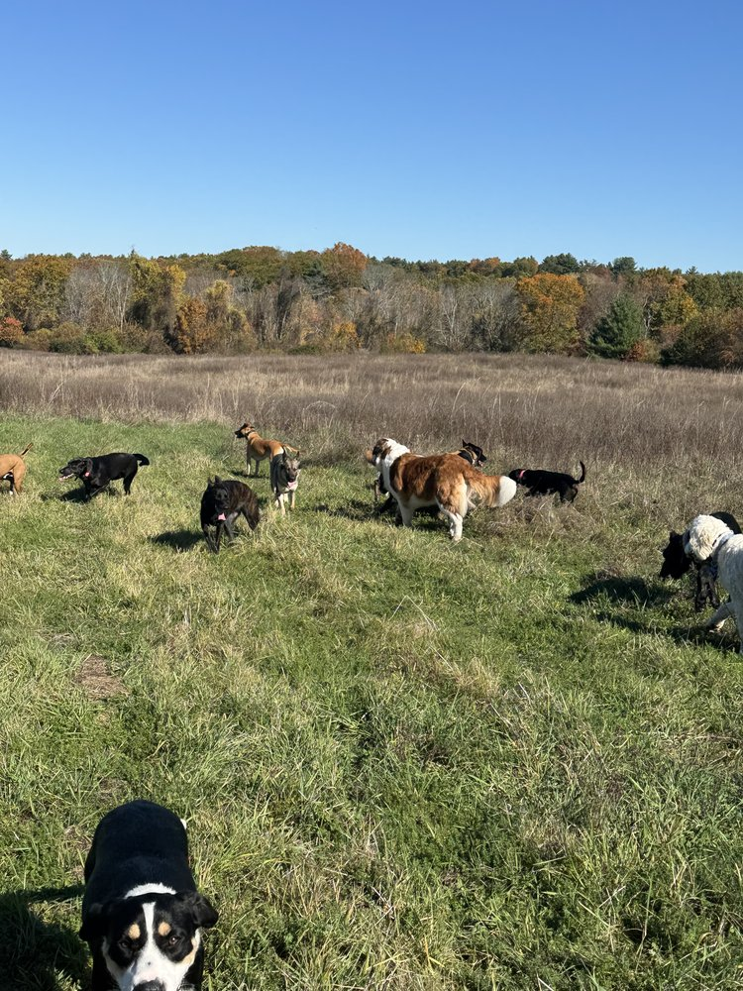
One of the hardest conversations I have with people sometimes happens before they ever get a dog.
Or at least before they get the dog they think they want.
Because while most people spend a lot of time asking:
“What dog do I want?”
A far more important question is:
“What dog fits the life I actually live?”
Those are not always the same thing.
And honestly, a lot of frustration could be avoided if more people asked that second question first.
One thing I’ve learned over the years is that most dog ownership problems don’t begin with bad dogs.
They begin with bad matches.
Good people.
Good dogs.
Wrong fit.
A dog isn’t automatically a good fit because:
it’s beautiful,
popular,
impressive,
trendy,
or looked amazing in a video online.
The dog still has to fit your actual life.
Not your fantasy life.
Your real one.
One thing I see frequently is people choosing dogs based on who they wish they were rather than who they are.
They imagine:
“I’m going to hike every weekend.”
“I’m going to train every day.”
“I’m going to spend hours exercising my dog.”
“I’m going to be outdoors constantly.”
Sometimes that happens.
Often it doesn’t.
Life gets busy.
Work happens.
Kids happen.
Responsibilities happen.
And suddenly the dog is living a very different life than the one originally imagined.
The dog isn’t the problem.
The mismatch is.
One thing I tell people all the time is:
Be honest before you bring the dog home.
Not optimistic.
Honest.
That’s where good decisions begin.
If you prefer quiet evenings at home, that’s okay.
If you love outdoor adventures, that’s okay.
If you travel frequently, that’s okay.
If you have children, that’s okay.
If you’re retired, that’s okay.
If you’re busy running a business, that’s okay too.
None of those lifestyles are wrong.
But different lifestyles often benefit from different dogs.
One thing people sometimes forget is that breed tendencies exist for a reason.
Generations of selective breeding matter.
A Border Collie didn’t accidentally become energetic.
A Labrador didn’t accidentally become social.
A Livestock Guardian Dog didn’t accidentally become independent.
A Terrier didn’t accidentally become persistent.
Those traits were intentionally developed.
That’s part of what makes dogs so incredible.
But it also means we should respect what dogs were bred to do.
One thing I find fascinating is how often owners become frustrated with dogs for displaying the exact characteristics they were bred to possess.
The herding dog wants to herd.
The retriever wants to retrieve.
The guardian wants to guard.
The scent hound wants to follow odors.
The terrier wants to investigate everything.
The dog isn’t broken.
The dog is being a dog.
That’s why understanding breed tendencies matters so much.
Not because every dog follows the same script.
Because tendencies provide useful information.
One thing I think people overlook is the importance of energy matching.
The happiest relationships often happen when the owner’s energy and the dog’s energy complement each other.
Not perfectly.
But reasonably.
A highly driven working dog living with somebody who wants a quiet companion can become frustrating for everyone.
Likewise, somebody seeking a constant adventure partner may become disappointed if they choose a dog better suited for a slower pace.
Again, neither is wrong.
The fit matters.
One thing I appreciate about rescue dogs is that they often force people to embrace reality.
You don’t always get a perfectly predictable package.
You get an individual.
Sometimes with:
fears,
quirks,
habits,
strengths,
and challenges.
Just like people.
The key is understanding what you’re bringing into your life.
Not what you hope you’re bringing into your life.
One thing I’ve learned from years at Campbell K9’s is that owners are often far happier when they choose a dog that fits their lifestyle rather than trying to redesign their entire life around a dog.
Can people adjust?
Absolutely.
Should people be willing to grow and adapt?
Of course.
But compatibility still matters.
A lot.
One thing I often tell clients is:
The best dog isn’t the best breed.
The best dog is the dog that fits your life.
That’s where successful relationships begin.
Not with popularity.
Not with trends.
Not with social media.
With honesty.
One thing I think about often is how much easier life becomes when expectations and reality align.
The dog succeeds more often.
The owner becomes less frustrated.
The relationship becomes more enjoyable.
Everybody wins.
And honestly, that’s what we should be aiming for.
Not finding the most impressive dog.
Finding the right dog.
Because the right dog doesn’t necessarily make the biggest impression on strangers.
The right dog makes the biggest difference in your everyday life.
And when the fit is right, something wonderful happens.
The relationship feels natural.
Not forced.
Not exhausting.
Not like a constant struggle.
Just natural.
And honestly, that’s one of the best gifts a dog can give us.

Chapter 20
The Myth of the Perfect Dog
If you’ve spent any amount of time around dog owners, you’ve probably heard some version of this sentence:
“I just want a good dog.”
It’s a completely reasonable thing to want.
The problem is that many people quietly replace the word good with the word perfect.
And that’s where trouble begins.
Because perfect dogs don’t exist.
Never have.
Never will.
Not at my house.
Not at your house.
Not at Campbell K9’s.
Not anywhere.
Dogs are living creatures.
Not robots.
Not software programs.
Not machines.
They’re individuals.
And individuals come with imperfections.
One thing I think social media has unintentionally done is convince people that perfect dogs are everywhere.
You see:
flawless recalls,
perfect heel work,
calm public behavior,
off-leash adventures,
beautiful training videos,
and dogs that appear incapable of making mistakes.
What you don’t see are the other 23 hours and 55 minutes of the day.
You don’t see:
the setbacks,
the mistakes,
the distractions,
the adolescent phases,
the bad decisions,
and the ordinary moments that make dogs real.
You see the highlight reel.
Not the full story.
And honestly, that’s a dangerous comparison.
One thing I’ve learned after working with thousands of dogs is that every dog has something.
Every single one.
The dog that’s fantastic off leash may struggle around visitors.
The dog that’s amazing with people may struggle with other dogs.
The dog that’s confident outdoors may be sensitive indoors.
The dog that’s calm ninety-nine percent of the time may still occasionally make a terrible decision.
That’s normal.
That’s life.
One thing I tell owners frequently is:
The goal is not perfection.
The goal is reliability.
Those are very different things.
Reliable dogs still make mistakes.
Reliable dogs still have bad days.
Reliable dogs are still dogs.
The difference is that the overall relationship is strong enough to navigate those moments successfully.
One thing I think people forget is that progress is often happening even when perfection isn’t.
A dog may still bark occasionally.
But now recovers faster.
A dog may still get excited.
But now listens sooner.
A dog may still make mistakes.
But now understands how to get back on track.
That’s progress.
And progress matters.
One thing I love about experienced dog owners is that many eventually stop chasing perfection altogether.
They start appreciating things they once overlooked.
A calm walk.
A reliable recall.
A peaceful evening at home.
A dog choosing a good decision without being asked.
Those moments become meaningful because they represent relationship.
Not performance.
Relationship.
One thing I’ve noticed over the years is that the owners who enjoy their dogs the most are rarely the owners with perfect dogs.
They’re the owners with realistic expectations.
They understand:
My dog is going to make mistakes.
My dog is going to have challenges.
My dog is going to keep learning.
And so am I.
That mindset changes everything.
One thing I often think about is how unfair perfection can be.
Not just for dogs.
For people too.
Imagine being judged entirely on your worst day.
Your most embarrassing moment.
Your biggest mistake.
None of us would enjoy that.
Dogs deserve the same grace.
That doesn’t mean we lower standards.
It means we keep perspective.
One thing I learned from Whoop growing up was that accountability and understanding can coexist.
You can expect more while still recognizing reality.
You can hold standards while still being fair.
Dogs deserve that balance.
The truth is that some of my favorite dogs have been wonderfully imperfect.
The fearful dogs.
The stubborn dogs.
The quirky dogs.
The dogs that made me think.
The dogs that challenged me.
The dogs that forced owners to grow.
Those dogs often leave the biggest impact.
Not because they were perfect.
Because they were real.
One thing I think owners need to hear is this:
Your dog does not need to be perfect to be deeply loved.
Your dog does not need to be perfect to be successful.
Your dog does not need to be perfect to live a wonderful life.
The relationship is what matters most.
And relationships are built on:
trust,
communication,
patience,
understanding,
accountability,
and time.
Not perfection.
At the end of the day, the perfect dog is a myth.
And honestly, that’s good news.
Because it means you can stop chasing something that doesn’t exist.
You can stop comparing.
You can stop measuring your dog against impossible standards.
You can focus on what’s actually important.
The dog in front of you.
The relationship you’re building.
The progress you’re making together.
Because the happiest dogs I’ve known were not perfect dogs.
They were understood dogs.
And the happiest owners I’ve known weren’t the ones with flawless dogs.
They were the ones who learned to appreciate the beautifully imperfect dogs they shared their lives with.
And honestly, that’s about as close to perfection as any of us are ever going to get.

Chapter 21
Why Training Never Really Ends
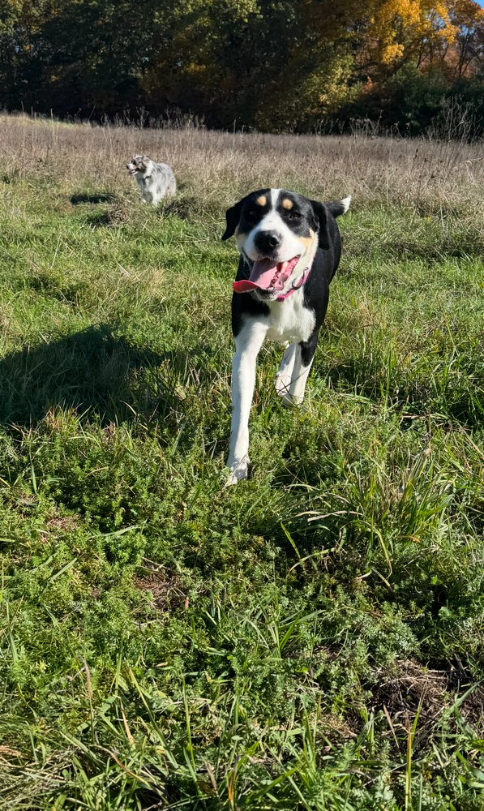
If you’ve made it this far, you may be expecting me to tell you that eventually you’ll reach a point where training is finished.
A point where your dog is fully trained.
A point where all the work is done.
A point where you never have to think about behavior, communication, or learning ever again.
I hate to disappoint you.
But that’s not how relationships work.
And honestly, that’s not how life works either.
Training doesn’t really end.
It evolves.
One of the biggest misconceptions people have about dog training is that it’s a destination.
They imagine a finish line.
A moment where the dog graduates and everything remains perfect forever.
The reality is much different.
Training is not a destination.
It’s a relationship.
And relationships require maintenance.
Not because something is wrong.
Because relationships are living things.
They grow.
They change.
They evolve.
Dogs change.
People change.
Life changes.
And good training adapts right alongside them.
One thing I’ve noticed over the years is that the owners who enjoy the greatest long-term success are rarely the ones who trained the hardest for a short period of time.
They’re the ones who remained consistent over time.
The owners who understood that training isn’t something you do for a few weeks.
It’s something you weave into everyday life.
Not as a burden.
As a habit.
One thing I love about experienced dog owners is that they stop separating training from living.
Everything becomes connected.
The walk is training.
The greeting is training.
The recall is training.
The quiet evening at home is training.
The off-leash hike is training.
The relationship itself becomes training.
Not because the owner is constantly correcting.
Because communication never stops.
Dogs are always learning.
Remember Chapter 1?
That lesson remains true for the rest of your dog’s life.
The question is still:
What is my dog learning?
The answer simply changes over time.
One thing I’ve found fascinating is how many dogs continue growing long after owners believe growth should have stopped.
The fearful dog becomes more confident.
The excitable dog becomes calmer.
The reactive dog becomes more thoughtful.
The owner becomes more skilled.
The relationship becomes deeper.
Growth continues.
Not overnight.
Not dramatically.
But steadily.
One day at a time.
One experience at a time.
One lesson at a time.
One thing I think people sometimes miss is that training is not just about solving problems.
It’s also about maintaining strengths.
A reliable recall stays reliable because it’s practiced.
Good leash manners stay strong because they’re reinforced.
Calm behavior remains calm because it’s valued.
Relationships stay healthy because they’re nurtured.
That’s true for dogs.
It’s true for people too.
One thing I learned from my parents growing up is that consistency matters over the long haul.
Not just when it’s convenient.
Not just when motivation is high.
Real success usually comes from small things repeated consistently over time.
Dog training is no different.
The dogs that thrive are rarely the dogs that received one incredible week of training.
They’re the dogs whose owners continued showing up afterward.
Day after day.
Month after month.
Year after year.
Not perfectly.
Consistently.
One thing I tell clients often is:
Don’t chase perfection.
Chase habits.
Habits create reliability.
Reliability creates trust.
Trust creates freedom.
And freedom creates opportunities.
That’s the cycle we’ve been talking about throughout this book.
One thing I love about dogs is that they give us endless opportunities to improve.
Not because they’re constantly failing.
Because they’re constantly teaching.
A new environment teaches something.
A new challenge teaches something.
A new stage of life teaches something.
The learning never really stops.
For either end of the leash.
One thing I’ve noticed about older dogs is that they often remind us what truly matters.
The puppy chaos fades.
The adolescent craziness settles.
The training goals become less important.
And the relationship becomes everything.
Suddenly you’re less focused on what the dog can do.
And more focused on simply being together.
Those moments matter.
A lot.
Because eventually we all realize something.
We never really trained dogs so they could perform for us.
We trained them so we could share more of life together.
The recall wasn’t about the command.
It was about freedom.
The leash work wasn’t about the leash.
It was about partnership.
The boundaries weren’t about control.
They were about clarity.
The accountability wasn’t about punishment.
It was about understanding.
The training was never the goal.
The relationship was.
And that’s why training never really ends.
Because relationships never really end until the day they’re gone.
They continue growing.
Deepening.
Changing.
Teaching.
One thing I know for certain after all these years is this:
The best dogs I’ve known were not the dogs with the most titles.
Not the dogs with the most ribbons.
Not the dogs with the most impressive resumes.
The best dogs were the ones whose owners built meaningful relationships with them.
Relationships built on:
trust,
clarity,
communication,
accountability,
patience,
leadership,
and love.
Those things last.
Long after the individual lessons have been forgotten.
Long after the training sessions have ended.
Long after anybody remembers exactly how the journey began.
At the end of the day, dog training is not really about creating a better dog.
It’s about creating a better relationship.
And if this book has taught you anything, I hope it’s this:
Dogs don’t need perfect owners.
They don’t need perfect lives.
They don’t need perfect training.
They need people willing to communicate clearly, lead calmly, remain consistent, and continue learning right alongside them.
Because when that happens, something remarkable occurs.
Life becomes clearer.
The relationship becomes stronger.
And both ends of the leash become better because of it.

Chapter 22
The Hardest Dog to Train Is Usually the Human
Over the years, I’ve trained thousands of dogs.
Puppies.
Rescues.
Working dogs.
Fearful dogs.
Aggressive dogs.
Stubborn dogs.
Dogs that pulled on the leash.
Dogs that wouldn’t come when called.
Dogs that barked at everything.
Dogs that seemed completely out of control.
And after all those years, I’ve learned something that surprises a lot of people.
The hardest part of dog training usually isn’t the dog.
It’s the human.
Now before you get offended, stay with me.
I’m not saying dog owners are bad people.
Quite the opposite.
Most of the owners I work with deeply love their dogs.
They spend money on them.
They worry about them.
They buy them toys, treats, beds, birthday cakes, and sometimes wardrobes that cost more than my first car.
The problem isn’t a lack of love.
The problem is that love and leadership are not the same thing.
And many owners accidentally make training harder because they allow emotions to override clarity.
One of the most common things I hear is:
“I know what I’m supposed to do, but I feel bad.”
I understand that.
I really do.
Nobody enjoys telling their dog no.
Nobody enjoys holding a boundary.
Nobody enjoys being consistent when it would be easier to give in.
But dogs don’t become confused because we lack love.
They become confused because we lack consistency.
A dog doesn’t understand that you’re tired from work.
A dog doesn’t understand that today is different because company is coming over.
A dog doesn’t understand that yesterday the rule existed but today it doesn’t.
Dogs understand patterns.
And whatever pattern exists becomes their reality.
That’s why owners often become the biggest obstacle to progress.
Not intentionally.
Emotionally.
One thing I’ve noticed over the years is that many owners become negotiators.
The dog jumps.
The owner asks nicely.
The dog ignores them.
The owner asks again.
The dog ignores them again.
Now we’re entering the fifth round of negotiations and the dog doesn’t even realize a meeting is taking place.
Meanwhile, the dog is learning something important.
The rules are optional.
The owner thinks they’re being patient.
The dog thinks they’re being persuasive.
Neither realizes what’s happening.
Another challenge owners face is guilt.
A lot of guilt.
Modern dog owners carry an enormous amount of it.
They feel guilty for working.
Guilty for using a crate.
Guilty for correcting behavior.
Guilty for leaving the dog home.
Guilty for setting boundaries.
Guilty for not doing enough.
Guilty for doing too much.
At some point, guilt becomes the operating system.
And guilt is a terrible dog trainer.
Because guilt often causes people to make decisions based on emotion instead of what the dog actually needs.
Dogs don’t need guilty owners.
They need clear owners.
They need calm owners.
They need consistent owners.
One thing I’ve learned is that dogs are remarkably forgiving.
They don’t expect perfection.
They don’t need perfection.
They simply need clarity.
Some of the best dog owners I’ve ever worked with made plenty of mistakes.
Just like everyone else.
The difference was that they were willing to improve.
They were willing to become more consistent.
They were willing to hold boundaries.
They were willing to follow through.
And most importantly, they were willing to change their own behavior before expecting the dog to change.
That’s where real progress begins.
Not when the dog changes.
When the owner changes.
I often tell clients that dog training is really two training programs happening at the same time.
One for the dog.
One for the human.
The dog learns:
commands,
boundaries,
accountability,
self-control,
and communication.
The owner learns:
timing,
consistency,
leadership,
patience,
and follow-through.
When both improve together, incredible things happen.
The relationship changes.
The communication improves.
The frustration decreases.
And the dog finally receives the clarity they were looking for all along.
One of the most rewarding parts of my job is watching owners transform.
Not just their dogs.
Them.
The nervous owner becomes confident.
The frustrated owner becomes patient.
The overwhelmed owner becomes capable.
And as that happens, the dog often changes right alongside them.
Because dogs are constantly learning from us.
They’re watching us.
Reading us.
Responding to us.
Whether we realize it or not, we’re teaching them every day.
The truth is that dogs don’t need perfect owners.
They never have.
They simply need owners who are willing to learn.
Owners who are willing to improve.
Owners who are willing to provide clarity.
Because at the end of the day, the goal isn’t to create a perfect dog.
The goal is to create a better relationship.
And relationships are built by two participants.
Not one.
So if you’ve made mistakes with your dog, welcome to the club.
We all have.
I’ve made them too.
The good news is that dogs are incredibly resilient.
They don’t care what happened six months ago.
They care about what happens next.
And that’s one of the greatest gifts dogs give us.
Every day is an opportunity to communicate more clearly.
Lead more calmly.
Love more effectively.
And become the kind of person our dog can confidently follow.
Because sometimes the most important training doesn’t happen on the leash.
It happens at the other end of it.

Conclusion
Clearer Dogs, Better Relationships
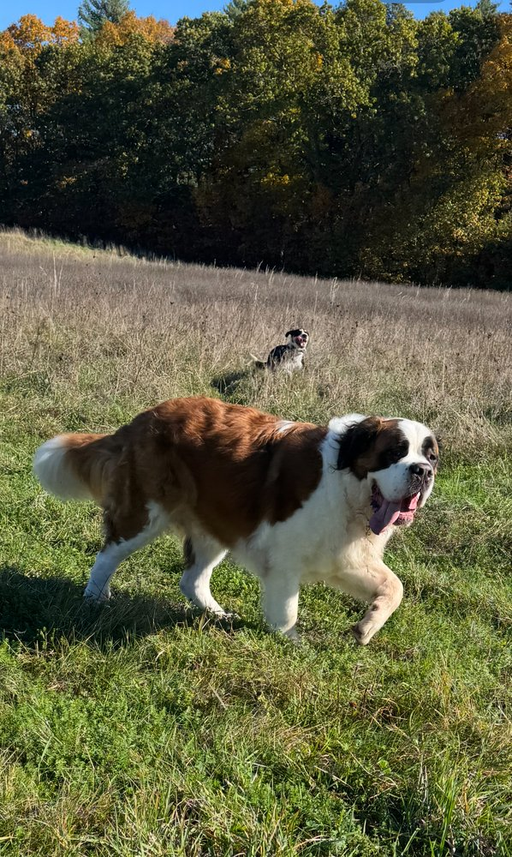
When I first started training dogs, I thought dog training was mostly about behavior.
Fixing problems.
Teaching commands.
Creating reliability.
And while those things certainly matter, I’ve learned something much more important over the years.
The best dog training isn’t really about behavior.
It’s about relationships.
Everything we’ve talked about in this book comes back to that simple truth.
The barking.
The pulling.
The recall.
The fear.
The confidence.
The calmness.
The structure.
The accountability.
The leadership.
The communication.
None of those things exist in a vacuum.
They all serve a larger purpose.
They help dogs and people understand each other better.
Because at the end of the day, that’s what most owners are really looking for.
Not perfection.
Understanding.
Not control.
Trust.
Not a flawless dog.
A meaningful relationship.
One thing I’ve learned through Campbell K9’s is that most dogs are trying much harder than we give them credit for.
They’re navigating a human world that often makes very little sense to them.
They’re trying to understand:
our expectations,
our routines,
our emotions,
our communication,
and the strange rules we create.
Sometimes they succeed.
Sometimes they struggle.
Just like we do.
That’s why I’ve always believed clarity matters so much.
Dogs thrive when life makes sense.
When communication is clear.
When expectations are fair.
When leadership is calm.
When accountability is consistent.
And when relationships are built on trust instead of confusion.
Throughout this book, we’ve talked about structure.
But structure was never the goal.
Freedom was.
We’ve talked about accountability.
But accountability was never the goal.
Understanding was.
We’ve talked about leadership.
But leadership was never the goal.
Confidence was.
Everything leads back to relationship.
One of the greatest lessons dogs teach us is that relationships aren’t built in grand moments.
They’re built in small ones.
The daily walk.
The quiet evening on the couch.
The successful recall.
The shared adventure.
The patient repetition.
The consistent follow-through.
The ordinary moments become extraordinary because they’re shared.
That’s where trust grows.
That’s where connection grows.
That’s where relationships grow.
I think about the dogs that have impacted me most over the years.
The fearful dogs.
The stubborn dogs.
The energetic dogs.
The quirky dogs.
The ones that challenged me.
The ones that made me laugh.
The ones that forced me to grow as a trainer and as a person.
None of them were perfect.
Not one.
And honestly, that’s exactly why I remember them.
Because relationships aren’t built through perfection.
They’re built through shared experiences.
Shared challenges.
Shared growth.
One thing I hope you take away from this book is that your dog does not need you to be perfect.
Your dog doesn’t need the perfect training plan.
The perfect equipment.
The perfect timing every single day.
The perfect life.
Your dog needs you.
Present.
Consistent.
Willing to learn.
Willing to lead.
Willing to communicate.
Willing to grow.
That’s enough.
More than enough.
If you’ve made it this far, then you’re already the kind of owner who cares deeply about your dog.
Otherwise, you wouldn’t be here.
So give yourself some grace.
Your dog is learning.
You’re learning.
And relationships take time.
The goal isn’t perfection.
The goal is progress.
The goal is understanding.
The goal is building a life together that both of you can enjoy.
One of the greatest gifts dogs give us is perspective.
They remind us to slow down.
To be present.
To appreciate simple things.
To enjoy the moment we’re in rather than constantly chasing the next one.
And perhaps that’s why dogs leave such a lasting mark on our lives.
Not because they live with us.
Because they teach us how to live better ourselves.
As you move forward, I hope you remember this:
A clearer dog is not necessarily a dog that knows more commands.
A clearer dog is a dog that better understands the world around them.
And a clearer owner is someone who better understands their dog.
When those two things come together, something remarkable happens.
Communication improves.
Trust grows.
Freedom expands.
Stress decreases.
And the relationship becomes everything it was meant to be.
Thank you for trusting me to be part of your journey.
Now go enjoy your dog.
Not when they’re perfect.
Not when training is finished.
Not when every problem is solved.
Today.
Because the relationship you’re building is the whole point.
And honestly, that’s what makes it all worthwhile.
Matthew Campbell
Campbell K9’s
Clearer Dogs: Balanced Training, Calm Leadership, and Building the Relationship Every Dog Needs

