**Infection with avian malaria of different geographical origin causes different dynamics of resting metabolic rate and innate immune response in infected Eurasian siskins**

Или

**Dynamics of resting metabolic rate and innate immune response in malaria-infected Eurasian siskins: the impact of the parasite’s geographical origin**

*Maria Erokhina1,2, Andrey Bushuev2, Vaidas Palinauskas3, Elena Platonova1, Vadim Khaitov4,5, Alexandr Davydov1, Andrey Mukhin1*

*1 Biological Station Rybachy of Zoological Institute RAS, Rybachy, 238535, Russia*

*2 Department of Vertebrate Zoology, Faculty of Biology, Lomonosov Moscow State University, Moscow, 119991, Russia*

*3 Nature Research Centre, Akademijos 2, Vilnius, 08412, Lithuania*

*4 St. Petersburg State University, St. Petersburg, 199034, Russia*

1. *Kandalaksha State Nature Reserve, Kandalaksha, +++, Russia*

**1. Introduction**

Each year, billions of birds make a tremendous journey from their breeding to their wintering grounds and back. The final destination during autumn for most of the migrating Western Palearctic passerines is Central and Southern Africa (tropical and subtropical regions) (Newton, 2010; Shirihai & Svensson, 2018). While being there, the birds may be attacked by locally spread blood-sucking mosquitoes. As a result of such encounters, birds may become infected with southern species of *Plasmodium* (Plasmodiidae, Haemosporida) parasites which cause avian malaria. Infected birds that survive and return to the breeding grounds in the Northern Palearctic serve as reservoirs for new infections, as malaria parasites can persist in individuals for years (Bensch et al., 2007; Rooyen, Lalubin, Glaizot, & Christe, 2013). This could be a potential threat to resident or short-distance migratory species, since they did not co-evolve with southern malaria parasites that could cause a malaria outbreak in a novel host’s species population. It is a well-known fact that *Plasmodium* parasites can develop a high virulence when they established in naïve populations that have not co-evolved with avian malaria species (Van Riper III, Van Riper, Goff, & Laird, 1986). Besides, avian malaria outbreaks happen regularly in zoos, where captive birds (pinguins particularly) are for the first time exposed to locally transmitting *Plasmodium* parasites (Cocumelli et al., 2021; González-Olvera et al., 2022; Meister, Richard, Hoby, Gurtner, & Basso, 2021).

After invading vertebrate host organism, parasite penetrate into host`s different type tissue cells where it starts to multiplicate. At this period no parasites or very few can be seen in the red blood cells. This process precedes the following stage known as acute phase, which is usually marked by a sharp increase of infected erythrocytes in peripheral blood (Valkiūnas, 2005). As any other infection, avian malaria triggers the process of immune response. Its activation requires energy and affects host metabolism (Eraud, Duriez, Chastel, & Faivre, 2005; Martin, Scheuerlein, & Wikelski, 2003) and energy storages (Bonneaud et al., 2003; Demas, Drazen, & Nelson, 2003). However, immoderate and inappropriate immune response can be harmful causing immunopathology (Graham, Allen, & Read, 2005; Sorci & Faivre, 2009). So, despite its beneficials of controlling the parasite infection, immune defense has high cost and a trade-off should exist between immunity and other energy demanded physiological processes in organism (Norris & Evans, 2000; Owen-Ashley & Wingfield, 2007; Sheldon & Verhulst, 1996; Zuk & Stoehr, 2002).

One of the approaches to assessing the energetic costs of immune response is to measure resting metabolic rate (RMR) which reflect the cost of self-maintenance (Ricklefs, Konarzewski, & Daan, 1996). It is, perhaps, impossible to measure the exact metabolic cost of immunity because it is deeply integrated with other physiological systems of organism (Lochmiller & Deerenberg, 2000). That means that measured in our study RMR reflected not only the immune response per se but also the energetic consequences of malaria collateral damages such as free hemoglobin and heme utilization, replenishment of destroyed RBC and tissue damages and so on.

Successful recovery after primary malaria infection and development of acquired immunity depends on first line of non-specific defense – innate immunity, in particular on activation of multitude of pro- and anti-inflammatory cytokines (Gowda and Wu, 2018). IL-6 is one of the proinflammatory cytokines that trigger the acute phase reaction and is produced soon after infection as part of the induced innate immune response in vertebrates (Owen-Ashley & Wingfield, 2007; Schat, Kaspers, & Kaiser, 2014). While there is almost negligible information about the role of this cytokine in avian malaria models, recent meta-analysis of IL-6 levels in malaria infected human patients and several studies on murine models suggests that IL-6 can be a marker for malaria severity (Carapau et al., 2007; Wilairatana et al., 2022; Wunderlich et al., 2012).

In this study, we compared the impact of malaria infection on physiological parameters of common European passerine migrant – the Eurasian siskin (*Spinus spinus*) with two different species of avian haemosporidian parasites: *Plasmodium relictum* (lineage pSGS1) and *Plasmodium ashfordi* (lineage pGRW2). The first one is a generalist, widespread in Palearctic, with great range of avian hosts` species and with great variance in host susceptibility ranging from absolute resistance to low and high level parasitemia in both species and individual levels (Palinauskas, Valkiūnas, Bolshakov, & Bensch, 2008, 2011). Experiments with juvenile Eurasian siskins demonstrated that during pSGS1 malaria infection they usually have high levels of parasitemia at the acute stage, though they showed great individual variation, with some birds performing very low number of infected erythrocytes (Mukhin et al., 2016; Palinauskas et al., 2008). Overall, this lineage is considered as severe and highly pathogenic, with high possible mortality for susceptible birds (Valkiūnas et al., 2018). *P. ashfordi* (pGRW2) is also a generalist malarial parasite, though transmitting in Africa while in Europe this parasite was detected only in adult birds, mostly warblers, after their returning from their wintering grounds in tropical Africa (Bensch, Hellgren, & Pérez‐Tris, 2009).

Considering the controversial data on metabolic responses of infected birds during parasitic infection, particularly during malaria infection we could expect three possible scenarios for RMR: i) RMR might increase in all infected juvenile Eurasian siskins as a result of immune response against proliferating malaria parasite. Besides, the force of the immune reaction could be higher in those birds which were infected with pGRW2 – evolutionary unfamiliar malarial parasite for European residential birds’ species, like Eurasian siskins and this would result in higher levels of RMR; ii) RMR might decrease, especially during the acute stage when there is an active destruction of erythrocytes and digestion of hemoglobin (Hb) by multiplying parasites. The main function of red blood cells is oxygen transportation to tissues, therefore, progressing anemia leads to a reduction in the oxygen binding capacity of blood and violation of O2 transportation. This view is supported by results of Hayworth (1987) and are provided by general knowledge about *Plasmodium* parasite life cycle (Stager, 2021), though several studies hadn’t confirmed it (Hahn, 2018; Stager, 2021); iii) Changes in RMR should be in association with parasitemia level. This assumption follows directly from the previous one. On the one hand, higher rates of erythrocytes destruction lead to a stronger violation of oxygen transportation, on the other, they should activate the processes of hematopoiesis, which in turn could be energy consuming (but see Sun et al., (2020). To roughly estimate the immune response during the course of the infection we used IL-6 level as the marker. We assume that we will detect the increase of IL-6 during the acute phase of malaria and then its decrease for those birds, which survived through crisis and acquired a chronic infection. Considering the lack of experimental data on both RMR and, especially, IL-6 levels during malaria infection in birds, our minimal expectation was that we will observe different average group reaction for both studied parameters on *P. relictum* SGS1 and *P. ashfordi* GRW2. This assumption was based on different co-evolutional history of host and parasite species.

**2. Materials and methods**

*2.1 Study site, species*

The study was carried out at the Biological Station Rybachy of the Zoological Institute of the Russian Academy of Sciences (55°09’N, 20°51’E) in July – October 2020. For our study the Eurasian siskins were chosen as these Palearctic birds is a short migrating passerine species probably never met with parasites of south African origin. Also, this species is common and abundant at the study area and proved itself as a convenient test subject for experiments with malaria infection. Birds caught on their autumn migration were examined for the absence of haemosporidian parasites using both microscopy and PCR methods of diagnostic (see below).

Sixty juvenile Eurasian siskins were randomly split into three equal groups – one control and two experimental named here and elsewhere as SGS1, GRW2 and Control. Each individual was kept at the individual plastic cages in vector-free room with a constant ambient temperature (+23°C) and light-dark photoperiod (L:D) as 17:7, which reflected the natural photoperiod at 1st July. Water and food were provided *ad libitum*.

*2.2 DNA extraction and PCR-based method*

We followed a standard ammonium-acetate protocol (Sambrook, 1989) to extract total DNA from the collected blood samples. For genetic PCR-based analysis we followed nested-PCR protocol using specific for avian *Plasmodium* primers (Hellgren, Waldenström, & Bensch, 2004). To control for a false amplification, we used two controls: positive (DNA of *P. relictum*) and negative (nuclease-free water). The results of PCR-based amplification of parasite`s DNA was evaluated by running of the final PCR products on a 2% agarose gel.

To check the genetic lineages of used parasites, fragments were sequenced from the from both 5′ and 3′ ends using an ABI PRISM TM 3100 capillary sequencing robot (Applied Biosystems, USA). Obtained sequences were aligned in BioEdit software (Hall, 1999) and identified using BLAST-program of GenBank and MalAvi database (Bensch et al., 2009).

*2.2 Experimental infections of birds and collection of blood*

For experimental infections we used two species of *Plasmodium* parasites: *P.* *relictum* (lineage pSGS1) and *P. ashfordi* (lineage pGRW2). The first one, pSGS1, was initially isolated in 2018 from a naturally infected wild Common Rosefinch (*Carpodacus erythrinus*). From this bird, several juvenile European Siskins were infected and since then they serve as living donors of pSGS1. The southern malaria strain *P. ashfordi* was collected from a wild Wood warbler (*Phylloscopus sibilatrix*) during its spring migration in 2020. Its blood was cryopreserved according to Garnham (1966) and then thawed prior to the start of the experiment.

To multiplicate the parasites, several juvenile birds (2 for pSGS1, 3 for pGRW2) were inoculated with infected blood from donors of pSGS1 and pGRW2 separately. For each experimental groups mixture of infected donors’ blood, 3.7% sodium citrate (anticoagulant) and 0.9% saline (4:1:5) was prepared as described by (Iezhova, Valkiūnas, & Bairlein*, 2005). Experimental birds received the injection of 150 μl of mixture into their pectoral muscle. All control birds undergo the same procedure, except the inoculated blood was from the uninfected donor.

Starting with the inoculation procedure and every sixth day after, from each experimental bird 2 capillaries (about 150 μl) of blood were taken from the wing vein (basilic) – two drops were used to prepare two smears, most amount were centrifuged at 10 000 rpm to separate plasma and red blood cells. Then plasma was sucked out and put into the cryo-tubes and stored at -196º in liquid nitrogen. The remained blood was stored in SET-buffer (0.05 M Tris, 0.15 M NaCl, 0.5 M EDTA, pH 8.0) for molecular analyses as described by Hellgren et al. (2004).

The blood smears were air-dried, fixed in absolute methanol and stained with Giemsa according to the standard protocol (Valkiūnas, 2005). Smears were examined under a light microscope with 1000x magnification using oil immersion. The intensity of parasitemia was estimated as a percentage by actual counting the number of parasites per 1000 erythrocytes or per 10,000 erythrocytes if infections were light, as recommended by Godfrey Jr, Fedynich, and Pence (1987).

*2.3 Measurements of metabolic rate*

Before the inoculation (which is considered as the beginning of the experiment), we measured basal metabolic rate (BMR) – the minimal rate of energy expenditure of healthy birds before the inoculation. After this procedure and further, we will use the term “resting metabolic rate” (RMR), which reflects not only the cost of self-maintenance, but also a shift in resources allocation due to an exogenous stressor, such as inoculation, infection and stress from handling. BMR and then RMR were estimated by flow-through respirometry.

Each day at about 21:00 p.m. we put up to four birds into the individual polypropylene chambers with a volume of 1.3 liters. Chambers with birds were placed into the thermostat to maintain the ambient temperature at 27 °C, which is within the thermoneutral zone of European siskins (V. Gavrilov & Gavrilov, 2019; V. M. Gavrilov, 2014). Four independent membrane air pumps pushed the outside air through the chambers with indicating silica gel to remove water vapor from the incoming air and then further into the chambers with birds at the flow rate about 350-400 ml/min. The air pumps were connected to the uninterruptible power supply system so that possible power outages won`t led to the death of birds in chambers.

To measure the metabolic rate in several birds during one night we used an airflow switching system which automatically alternately directed the air from the chamber with a bird and from the empty reference chamber into respirometer. Each bird was measured for 20 min (10 min for the reference chamber) in each cycle.

After a chamber with a bird in it the air entered the 50 ml tube with a Drierite® desiccant (USA) and then mass flow-meter of the FoxBox respirometer (Sable Systems, USA). Then part of the flow was subsampled through the O2 gas analyzer of the FoxBox respirometer using a Dwyer GFC-1106 flow controller (Dwyer Instruments, USA) at a rate of 120 ml/min. The desiccant was replaced every day, as insufficiently dehumidified air can lead to underestimation of measured oxygen concentration (Melanson et al., 2010). To minimize the system washout time, the volume of all pathways downstream of the animal chambers, including the desiccant chamber, was minimized (Frappell, Blevin, & Baudinette, 1989; Lighton & Halsey, 2011).

The fractional concentrations of O2 were recorded with a sampling interval of 4 sec. We discarded the first five minutes of measurements as a wash-out time. To estimate the BMR and RMR, we used the 5 min minimum running average. Before starting all experiments, the gas analyzer was zero-calibrated with 6.0 nitrogen. Before each measurement session, the gas analyzer was calibrated using atmospheric air. The volume of oxygen consumed by birds was calculated according to Eq. 1a in Koteja (1996) assuming a fixed respiratory quotient (RQ) of 0.8 and converted to energy expenditure (kJ/day) using energetic equivalent of 20.1 kJ per 1 l of oxygen consumed (Table 12-1 in Brody (1945)).

At about 7:00 a.m. birds were released from their chambers and weighted with an accuracy of 0.1 g. We used this morning body mass in the regression analysis, as well as to calculate the mass-specific and mass-independent RMR.

*2.4 Analysis of IL-6 level*

Il-6 levels in birds` blood plasma we determined by enzyme-linked immunosorbent assay using a commercial test system Chicken Interleukin 6, IL-6 ELISA Kit according to the manufacturer’s instructions (Cusabio Biotech Co., Ltd, China). This test system was developed for the quantitative measurement of IL-6 in serum, plasma and tissue homogenates of chickens. This is a “sandwich” type ELISA kit, its detection range is 15.6 pg/ml-1000 pg/ml, and its sensitivity is 3.9 pg/ml. Optical density was measured on a Bio-Rad 680 microplate photometer (USA) at a wavelength of 450 nm.

*2.5 Statistical analysis*

All statistical analyses, data processing and visualizations were performed with functions of statistical programming language R v. 4.2.3 (R Core Team, 2023).

The design of our respirometer allowed us to test simultaneously only four birds per night. This circumstance in couple with our decision to take blood samples each sixth day after the inoculation from the whole experimental or control group at a time led us to challenges in subsequent statistical analysis when combination of RMR and parasitemia level was necessary. In order to estimate the level of parasitemia on the day of RMR measurement, we calculated the dependence of the parasitemia on the date using the assumption that, over relatively short time intervals (six days), the parasitemia development curve can be considered as linear. This equation was derived for each RMR measurement from parasitemia data on the two days closest to it (one day before and one after the metabolic trial).

To describe the dynamics of parasitemia, RMR and IL-6 development we used generalized additive mixed models with bird’s individual ring number (ID) as a random grouping factor (Pederson et al., 2018). Function gam() from the package “mgcv” (Wood, 2017) was used.

For each response variable we fitted two models. The first one included one common smoother for all treatment levels (Control, SGS1 and GRW2) and the second one with three different smoothers for each levels. Both models within each response variable were compared using Akaike information criterion (AIC). The model with minimal AIC value was considered as final one.

For the GAM with RMR as dependent variable the bird’s body mass (log10-transformed Mb) was included as a covariate to take into account possible allometry in dependence.

As parasitemia – our response variable – cannot have negative values, we used negative binomial distribution to model it with GAM. In the case of two other dependent variables GAM’s were based on gaussian distributions (RMR and IL-6 concentration were log10-transformed prior to analysis). The validity of the models was checked by means of residual and quantile-quantile plots. Function appraise() from the package “gratia” (Simpson, 2023) was used for the analysis.

~~The final models had different smoothers for both SGS1 and GRW2 group, which means that they had different course of infection development and impact on birds` physiological traits (see figure 1).~~

We checked the stability of RMR during the development of parasitemia by assessing its repeatability (Lessells & Boag, 1987; Nakagawa & Schielzeth, 2010). We estimated repeatabilities of RMR using linear mixed-effects models (LMM) fitted by the function ‘rpt’ from the ‘rptR’ package (Stoffel et al., 2017). The individual ring number (ID) was set as a random effect and log10(RMR) was a response factor. Since RMR is highly dependent on Mb, we estimated adjusted RMR repeatability (Nakagawa & Schielzeth, 2010) using log10(Mb) as the covariate. Both the number of parametric bootstraps for estimation of standard error (SE) of repeatability (R) and the number of permutations for estimation of the P-value were set to 1e4.

~~Means are given with ±SE.~~

**3. Results**

*3.1 Parasitemia development*

All of the experimental birds were susceptible to the infection. The development of parasitemia in SGS1 group was typical with prepatent period of about 6 days and with a peak occurred on the 18th day post infection with mean parasitemia 50.5% (±7.1%, here and thereafter SE are given). Minimal parasitemia at the acute stage was 0.1% and maximal 90%. By the end of the experiment, all birds had parasitemia less than 1% except one bird with 3.5%. In the GRW2 group the prepatent period was longer and exceeded 6 days with the peak occurred with a slight delay – on 24th day post infection with mean parasitemia 33.2% (±6.7). Acute stage was prolonged and by the end of the experiment in eight birds out of ten survived parasitemia was higher than 1%. The rate of mortality for birds with SGS1 was 50% (10 birds) and 45% (9 birds) for GRW2 group. Mortality in the control group was 25% (5 birds).

GAM fitted with two different smoothers for two species (AIC = 1326) was better in comparison with GAM including one common smoother for both species (AIC = 1362). The model parameters are given in Table ++.

Table ++. GAM parameters characterizing the course of parasetemia after parasite inoculation.

Parametric terms

|term | estimate| std.error| statistic| p.value|

|:---------------|----------:|---------:|----------:|---------:|

|(Intercept) | 0.2603116| 0.3645873| 0.7139897| 0.4752336|

|ExperimentpGRW2 | -0.2207647| 0.5639016| -0.3914951| 0.6954313|

smoothers

|term | edf| ref.df| statistic| p.value|

|:----------------------|---------:|---------:|---------:|-------:|

|s(DPI):pSGS1 | 6.938614| 7.850353| 234.9969| 0|

|s(DPI):pGRW2 | 6.286396| 7.310971| 119.5584| 0|

|s(Ring) | 25.379038| 38.000000| 109.3947| 0|

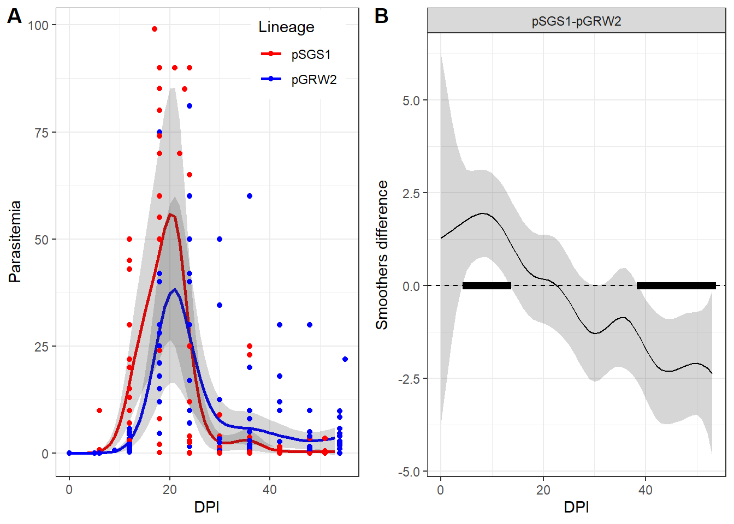

Figure +. Parasitemia at different days after inoculation (DPI) in two Plasmodium species. Panel A represents the observed number of merozoites (dots) and predicted GAM (lines, gray areas around the lines represent 95% CI). Panel B represents the difference between smoothers. Time periods when the difference between smoothers is significantly different from zero are marked by black rectangles.

No significant difference in mean parasetemia level for two species was revealed in the model fitted (Table ++. parametric terms). The general patterns of parasitemia dynamics were similar for both species (Fig. ++, A). Although in the case of pSGS1 the parasitaemia was significantly higher than that of pGRW2 at the beginning of the disease development, at the end of the disease the parasitaemia level of the second species became higher than that of the first (Fig. ++, B).

*.2 Analysis of metabolic rates` dynamics*

The mean value of BMR collected from the siskins after the capture was 22.03 kJ/day with mean body mass 12.87 g. There were no differences in BMR between experimental and control birds (ANOVA: P = 0.065) and between sexes (ANOVA: P = 0.639). Among experimental birds there were no differences in BMR between group-1 and group -2 siskins (ANOVA: P = 0.0614). The average number of days between the capture and inoculation procedure was 31.1 days for all group of birds.

At! Этот кусок про ANOVA надо описать в Материалах и методах .

For description of RMR the best GAM, again, the model with different smoothers (AIC = -753) was better than the model with common for all groups smoother (AIC = -700). This suggests that RMR dynamics were different for each group of siskins (SGS1, GRW2 and Control). The GAM parameters are presented in Table +++. The smoothers for all groups were significantly curved (i.e., differed from the horizontal straight line, Table ++), indicating an unstable RMR level over the observation time within each group. (Fig ++. A-C).

Table +++. GAM parameters characterizing the course of RMR after parasite inoculation.

Parametric terms Control was taken as reference level for the factor “Group”

|term | estimate| std.error| statistic| p.value|

|:---------------|----------:|---------:|---------:|---------:|

|(Intercept) | 0.8667586| 0.1083407| 8.000302| 0.0000000|

|Group(pSGS1) | -0.0210262| 0.0107747| -1.951444| 0.0528774|

|Group(pGRW2) | 0.0069930| 0.0110084| 0.635240| 0.5262450|

|log10(Mass) | 0.4463987| 0.0974461| 4.580982| 0.0000097|

Smoothers

|term | edf| ref.df| statistic| p.value|

|:------------------------|---------:|---------:|---------:|---------:|

|s(DPI):Control | 3.353317| 3.995504| 3.050404| 0.0188474|

|s(DPI):pSGS1 | 3.478809| 4.126216| 12.958613| 0.0000000|

|s(DPI):pGRW2 | 4.745876| 5.501000| 5.796103| 0.0000566|

|s(Ring) | 32.230936| 50.000000| 2.134290| 0.0000000|

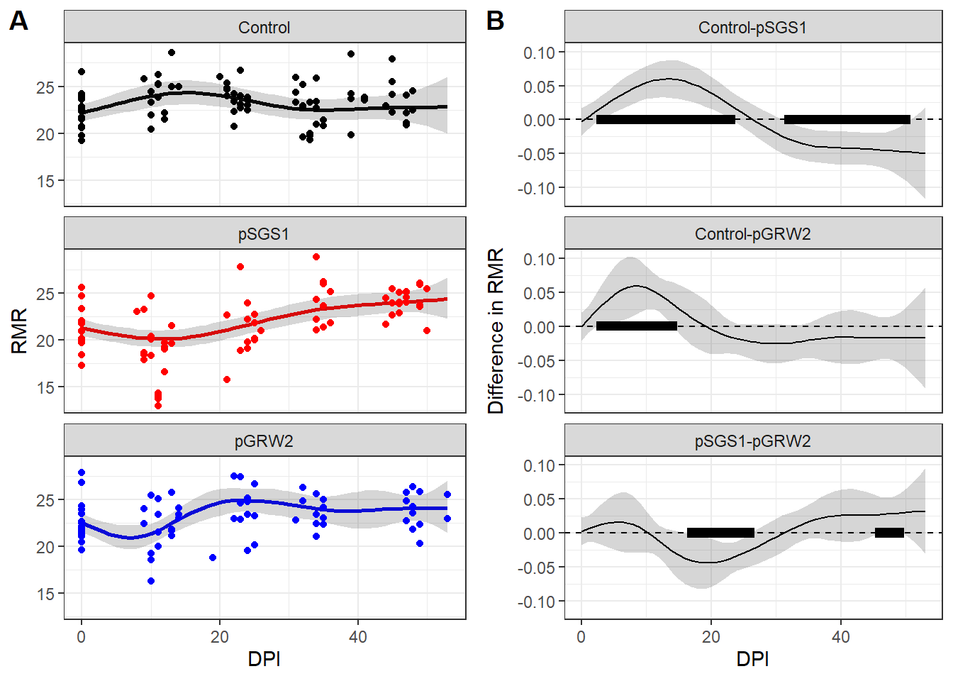

Figure +. RMR at different days after inoculation (DPI) in different birds’ groups. Panel A represents the observed RMR level (dots) and GAM predictions (lines and 95% CI). Panel B represents the difference between smoothers. Time periods when the difference between smoothers is significantly different from zero are marked by black rectangles.

In Control group there was a slight increase in RMR during the first two weeks after the inoculation, whereas in both experimental groups RMR dramaticaly decreased.

In group with SGS1, immediately after the inoculation, there was a drop in RMR, after which it begins to grow and by the end of the experiment, on average, RMR is higher than it was initially (Fig. ++, A). During 3-23 day after parasites inoculation RMR level in pSGS1 group was significantly lower than in Control one but later (32-50 days) RMR level in pSGS1was higher than in Control (Fig. ++, B).

In GRW2 birds RMR at first decreased (Fig ++, A): during 3-14 days it was significantly lower than in Control group (Fig. ++, B). However during the following days there were no significant differences between GRW2 and Control groups (Fig. ++. B).

The comparison of RMR dynamics in two inoculated groups (pSGS1 vs pGRW2, Fig ++, B) reveals significantly higher RMR level in pGRW2 birds during 17-26 days past inoculation. However later in very short period (during 46-49 days) an opposite pattern was revealed.

*3.3* *Analysis of IL-6 level dynamics*

The best GAM for IL-6 changes was, as for parasitemia and RMR, with different smoothers for each group of siskins (AIC = 353, for the model with common smoother AIC = 251).

The parameters of the model are presented in the Table ++.

Table +++. GAM parameters characterizing the course of IL-6 concentration after parasite inoculation.

Parametric terms “Control” was taken as reference level for the factor “Group”

|term | estimate| std.error| statistic| p.value|

|:---------------|----------:|---------:|---------:|---------:|

|(Intercept) | 1.1024811| 0.0178942| 61.610973| 0.0000000|

|Group(pSGS1) | 0.0290625| 0.0254962| 1.139876| 0.2550437|

|Group(pGRW2) | -0.0806343| 0.0258581| -3.118332| 0.0019550|

Smoothers

|term | edf| ref.df| statistic| p.value|

|:------------------------|---------:|---------:|----------:|--------:|

|s(DPI):Control | 3.835704| 3.981939| 25.1384067| 0.00e+00|

|s(DPI):pSGS1 | 3.479888| 3.835300| 23.9773201| 0.00e+00|

|s(DPI):pGRW2 | 3.900352| 3.993298| 15.0194797| 0.00e+00|

|s(Ring) | 25.264011| 57.000000| 0.9289817| 4.56e-05|

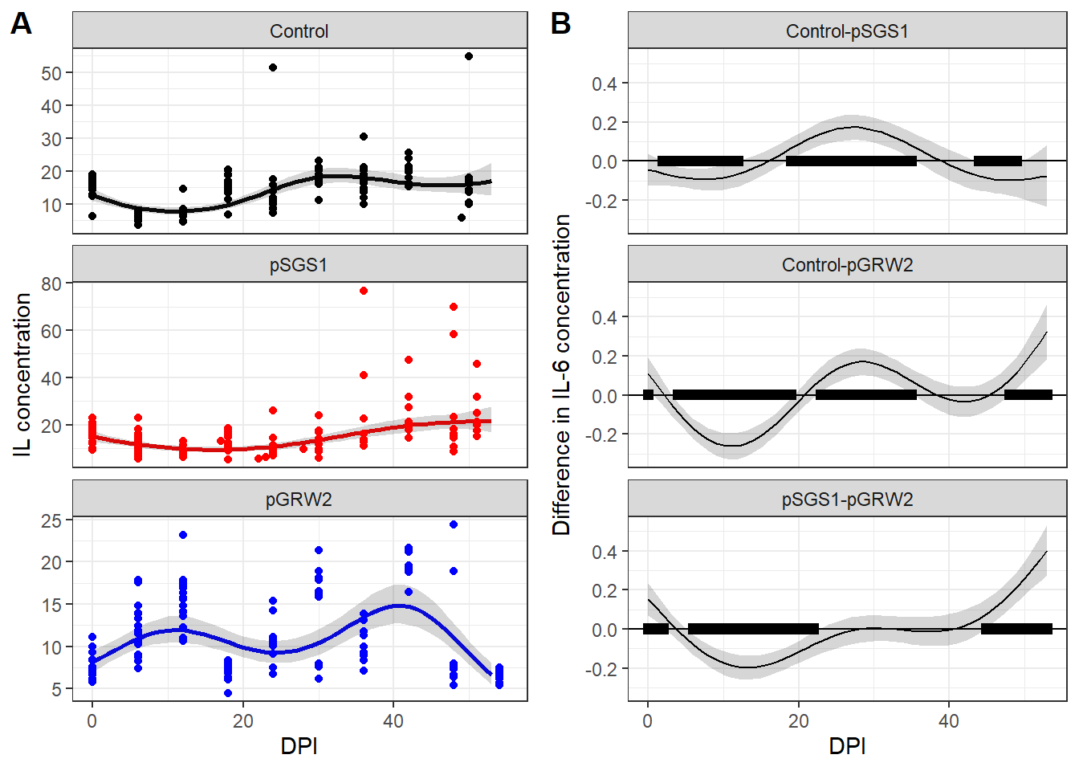

Figure +. IL-6 at different days after inoculation (DPI) in different birds’ groups. Panel A represents the observed IL-6 concentration (dots) and GAM predictions (lines and 95% CI). Panel B represents the difference between smoothers. Time periods when the difference between smoothers is significantly different from zero are marked by black rectangles.

After the inoculation procedure in Control group of birds the level of IL-6 started to fall down from the initial levels. It was the lowest on the 3rd week and then started to rise (Fig. ++, A). Similar pattern was revealed in the IL-6 dynamics between birds from pSGS1 group. Concentration of IL-6 decreased during several days after inoculation. However, at the end of the experiment, on average, it was even higher than initial level, because some birds had several times higher levels of IL-6 from their zero-day values (Fig. +++ A). The IL-6 concentration in pSGS1 group was significantly higher than in Control group in the beginning and close to the end of survey (Fig. ++, B). However in the middle of observation period IL-6 concentration was significantly lower than in Control group (Fig. ++, B).

The dynamics of IL-6 in the pGRW2 group was more complex. It demonstrated two peaks. one in the first half of the observation period and one in the second half (Fig. ++, A). The IL-6 concentration in the pSGS1 group was significantly higher than in the pGRW2 group during a short period at the beginning of the study (0-2 days after inoculation) and during the last days of observations (45-53 DPI). From 6-22 DPI, IL-6 concentrations were significantly higher in the pGRW2 group than in the pSGS1 group, but no significant differences were found between groups in 23-44 DPI.

~~In group-2 group interleukin level fluctuated throughout the experiment, after the inoculation procedure, on 6-12~~~~th~~ ~~days, interleukin in these birds` plasma begin to increase in contrast to the other two groups. Then it dropped again and rise, though by the end it was lower than initially and was the lowest between all three groups. In control siskins IL-6 level decreased right after the inoculation, was lowest on the 2~~~~nd~~ ~~week and after 4th week reached its initial values and remained approximately at the same level until the end of the experiment.~~

*3.4 Analysis of repeatabilities*

The repeatabilities of mass-independent RMR in Control, SGS1 and GRW2 groups were R = 0.207±0.114 (P = 0.009), R = 0.359±0.136 (P = 0.007) and R = 0 (P = 0.997; there was singular fit in the model since the variance of the random effect was close to zero). The repeatabilities of log10(Mb) in Control, *P* SGS1 and GRW2 groups were R = 0.464±0.122 (P < 0.001), R = 0.695±0.102 (P < 0.001) and R = 0.139±0.108 (P = 0.07), correspondingly.

**4. Discussion**

*4.1 Parasitemia development*

Both *P. relictum* SGS1 and *P. ashfordi* GRW2 avian malaria parasite species are considered as generalists with great range of potential host species. According to published papers, both of them demonstrate high levels of parasitemia during primary infections of juvenile siskins (Palinauskas et al., 2008; Videvall et al., 2017). Palinauskas et al. (2011) was the first one who reported susceptibility to infected blood inoculation and formation of gametocytes by *P. ashfordi* in Northern Palearctic bird species (*S. spinus* and *Loxia curvirostra*). The development of *P. relictum* pSGS1 parasite was more rapid than of *P. relictum* pGRW2. The acute stage started and ended earlier and more simultaneously in SGS1 infected birds than in GRW2. Long prepatent period of *P. ashfordi* in our study corresponds with the idea about a longer prepatent period for the most parasites of *Novyella* sudgenus to which *P. ashfordi* belongs to (Garnham, 1966; Palinauskas et al., 2011; Valkiūnas, 2005). Apart from the longer hidden stage in this group, high levels of parasitemia remained up to the end of the experiment. Similar results for the same host-parasite species were observed in other study during the late stages of decreasing parasitemia, though whether it is due to host-parasite interactions or due to peculiarities of parasite species itself is unclear (Videvall et al., 2017).

*4.2 Oxygen consumption during different malaria infection in siskins*

A traditional view is that RMR should be positively linked to parasite loads (Bordes & Morand, 2011). However, this statement still lacks of experimental evidence, and available data contradict each other. A recent meta-analysis of data from researches that focused on the effect of parasitic load on the RMR of various groups of animals showed that in most cases the RMR of hosts increased after parasite infestation (Robar, Murray, & Burness, 2011). Nonetheless, the overall effect of parasites was weak and not statistically significant. As author states the lack of consistent effect of parasites on hosts` energy metabolism in analyzed articles may be explained by different host-parasite systems used in described experiments (Robar et al., 2011)

We are aware of only three works that focuses on the impact of haemosporidian parasites on hosts` metabolic rate and their results contradict each other. The first one was conducted on two years old domestic canaries (*Serinus canaria*) where birds were infected with *Plasmodium relictum* of unknown genetic lineage. It was shown that during the peak of parasitemia the decrease in oxygen consumption occurred in both thermoneutral and low temperature conditions (Hayworth, Charles van Riper, & Weathers, 1987). The study on infected Great Reed warblers (*Acrocephalus arundinaceus*) by Hahn et al. (2018) had not found any difference in RMR and maximal metabolic rate (MMR) between control and experimentally infected with *Plasmodium relictum* birds during both acute and chronical stages. Hahn et al. (2018) concluded that low level parasitemia (less than 1%) during avian malaria does not affect birds` aerobic performance. The recent study by Stager et al. (2021) on the wild Pink-sided Junco *(Junco hyemalis mearnsi*) showed that the presence of haemosporidian parasites (*Haemoproteus* or *Plasmodium*) did not correlate with any of the measured physiological indices, in particular with RMR metabolism of birds. The authors concluded that there was little cost of haemosporidian infection on either junco aerobic performance or energy budgets.

The results of our study show that oxygen consumption after malaria infection in immunologically naïve birds differ depending on the origin of the malaria parasite. In *P. relictum* SGS1 group the decrease of RMR coincided with the acute phase of parasitemia. This is similar to the result of Hayworth et al. (1987). They reported significant decrease in oxygen consumption in canaries during the crisis period of *P. relictum* infection. Since the destruction of erythrocytes at this time is the highest, it is logical to assume that hematological parameters, such as hematocrit and hemoglobin should be negatively affected by proliferating parasite (Hammond, Chappell, Cardullo, Lin, & Johnsen, 2000; Stager et al., 2021). In our study we did not measure hematocrit level or hemoglobin concentration – parameters that reflect blood capacity to carry oxygen, because the amount of blood taken from each of the experimental bird was on its limit. A number of studies have shown a drop in hematocrit in experimentally infected birds during the acute phase of malaria (Ilgūnas, Bukauskaitė, et al., 2019; Ilgūnas, Palinauskas, Platonova, Iezhova, & Valkiūnas, 2019; LaPointe, Atkinson, & Samuel, 2012; Palinauskas et al., 2008; Paulman & McAllister, 2005; Williams, 2005), as well as in hemoglobin concentration (Krams et al., 2013; Palinauskas, Žiegytė, Šengaut, & Bernotienė, 2022). Videvall et al. (2020) reported that in siskins infected with *P. relictum* pSGS1, genes that are involved in oxygen binding and transportation processes were in negative correlation with parasitemia level. Interestingly, that in the earlier work with siskins and *P. ashfordi* pGRW2, Videvall et al. (2015) bserved a significant overrepresentation of genes responsible for metabolic functions and oxidation–reduction processes during both parasitemia stages. Afterwards, during the late stage of malaria, when parasitemia was decreasing, catabolic processes became predominant in comparison with the stage of parasitemia`s peak. Comparing the result of these two works Videvall et al. (2020) noted similarities in genes functions that were expressed in pSGS1-infected (Videvall et al., 2020) and pGRW2-infected siskins (Videvall et al., 2015) and demonstrated that highly-virulent pSGS1 induced strong transcriptome response, while low-virulent pGRW4 – minor. Coupled with the high levels of parasitemia in both *P. relictum* pSGS1 and *P. ashfordi* pGRW2 in our experiment we can accept that both these parasites have strong effect on physiological state of experimental siskins.

The pathological consequences of malaria vary depending on host and parasite species, their interactions, environmental factors, host individual traits and parasite isolates – all of these can affect the disease outcome (Cornet & Sorci, 2014). In Hahn et al. (2018) peak parasitemia was lower than 1% of parasitized erythrocytes, while in Hayworth et. al. it ranged from 1.32% to 50%. It seems evident that the higher the parasitemia, the more detrimental consequences it has on bird`s health in general, and strongly it should affect host metabolic rate in particular. So, Hayworth et al. (1987) found a significant positive correlation between level of parasitemia on the peak and relative decrease in oxygen consumption during low temperature condition though it was not significant in the thermoneutral zone.

In the light of these considerations, it is curious that for siskins from group GRW2 birds our GAMM also showed a period of lowered RMR, though short. At that time period (6-12 DPI) the average level of parasitemia was relatively small i.e., acute phase hasn`t appeared yet. But, starting from day 12 PI both RMR and parasitemia has started to rise. We assume two possible explanations for this: a) the average parasitemia in group GRW2 during the crisis was 33%, which is almost two times less than parasitemia in group SGS1 (50%), possibly because in group-2 the peak parasitemia level didn`t cause enough of erythrocytes destruction to reduce the metabolic rate. However, we cannot state that this is a sufficient difference to claim that one parasitemia is less severe than the other, especially when both are so high; b) an increase in RMR might indicate the activation of immune response or, at least, an increase in energy expenditure during the acute phase of unfamiliar tropical malaria infection since the rise in RMR coincided with the peak parasitemia in group-2 birds on 24th DPI. After 30th day the difference between two experimental group in RMR became statistically insignificant, with the tendency for birds from SGS1 to have higher rate of metabolism. Interestingly, that we observed an increase in oxygen consumption in Control group after the inoculation of uninfected blood. It lasted for about 2 weeks after which RMR decreased and after 5th week became indistinguishable from the initial level. We see a possible reason for this in the: a) stress, because with the beginning of the experiment birds were regularly subjected to handling which may cause a short term stress additional to a chronic stress from captivity (Li et al., 2019; Thompson, Brown, & Downs, 2015); b) immune response due to the inoculation with uninfected blood, since blood itself can cause an inflammatory response (Ellis et al., 2015; Garraud et al., 2016). We cannot exclude the possibility that these factors were acting simultaneously.

Despite the high peak of parasitemia in birds infected with *P. relictum* pSGS1, repeatabilities of both body mass and mass-independent RMR during the course of the disease in this group of siskins were significant and even exceeded the corresponding repeatabilities in the Control group. Both corresponding repeatabilities in birds infected with *P. ashfordi* pGRW2 did not differ significantly from zero, suggesting that pGRW2malaria infection causes more significant changes in bird physiology compared to pSGS1. More detailed analysis of repeatabilities will be presented in another article.

*4.3 Il-6 level in blood of infected siskins*

We found it quite difficult to interpret the IL-6 level graphs. At the first glance for all groups, they look like roller-coasters. It turns out that for group-1 IL-6 level was low during the acute phase – from 12 to 24th DPI. But strangely, for some birds, closer to the end of the experiment, IL-6 started to rise and became several times higher, than it was at the day zero of experiment. The thing that catches the eye is that during the first two weeks after infection of the SGS1-infected siskins had almost uniform decrease of IL-6. It seems like we observed somewhat similar to results gained in the master degree project by Esteban Henao (2019) made also on siskins infected with *P. relictum* pSGS1. She found out that expression level of IL-15 on 8 dpi was negatively related to rapidly growing parasitemia level and highly parasitized birds expressed less IL-15, approaching expression level of uninfected birds. This resembles our results for siskins from SGS1 group, though we had a decrease of interleukin in both Control and SGS1-infected groups. IL-15 is required for type 1 cytokine production, for natural killer cells and dendritic cells responses, and for the synthesis of malaria-specific antibodies (Ing, Gros, & Stevenson, 2005), while IL-6 is the pro-inflammatory cytokine (Clark, Alleva, Budd, & Cowden, 2008). Authors suggested that infected birds had expressed less IL-15 in order to control for hyperreactivity of immune response on growing number of parasitic antigens (Esteban Henao, 2019).

However, despite the different roles of these cytokines in immune response, mechanisms of suppression of their expression and lowered final level in blood can still be the same. In distinction to SGS1, birds with GRW2 parasite tended to increase their IL-6 level in plasma after the infection up to the 12 DPI. As we see on figure 1, the week between 12 DPI and 18 DPI was a period when parasite started to multiplicate rapidly. It coincided with the moment of transition from the increase of IL-6 level to its decrease in GRW2-infected siskins. It seems like birds in both groups tended to decrease IL-6 level in response to rapid multiplication of the parasite. It might be the result of malaria-related immunosuppression or/and activation of tolerogenic way of immune response by the host itself in order to avoid immunopathology (Calle, Mordmüller, & Singh, 2021; Esteban Henao, 2019).

Analysis of birds` transcriptome response to malaria showed that it involved genes of immune system and they are highly active during the peak of parasitemia and less or no active during the malaria late stages (Paxton et al., 2023; Videvall et al., 2020). Paxton et al. (2023) showed that Hawaiʻi ‘amakihi (*Chlorodrepanis virens*) from highly susceptible population that succumbed in experiment to *P. relictum* GRW4 and those who recovered had different gene expression profiles at different stages of malaria. Birds that did not survive the infection had a dysregulation of the innate immune system and thus increased levels of gene expression at middle and late stages of infection, while in survivors the upregulation of genes of both the innate and adaptive immunity appeared at the peak of parasitemia.

We cannot judge about the gene expression as a whole basing only on IL-6 level, however, considering results of Paxton et al. (2023), it is remarkable that by the end of our experiment the majority of birds with GRW2 parasite had very low level of IL-6 and it was the lowest between all the three group of birds. Besides, several birds from SGS1 group that survived to the end of the experiment had several times higher levels of IL6 in blood plasma after they survived through the critical moment of the peak parasitemia.

In control birds there was also a decrease of IL-6 level right after the inoculation – that seems inconsistent with the idea that control birds experience a prolonged immune activation due to single free from malaria bird blood injection. It seems, that it was mainly the chronic stress from captivity and handling, that caused changes in RMR and IL-6 level in control siskins. Chronic stress can have the immunosuppressive effects, contrary to the acute stress, which is usually immunoenhancing (reviewed in Dhabhar and Mcewen (1997)) (but see Martin et al. (2011)).

**Conclusion**

Each group of experimental birds had its own dynamics of physiological parameters, which means that both groups of birds differed from Control one and that they were different between each other too. SGS1 infected siskins had both lowered RMR and IL-6 level at the acute stage of parasitemia development, which is consistent with previously gained results in other studies. Conversely, GRW2 infected birds demonstrated rather erratic and difficult to interpret – in terms of parasitemia development – shifts in both RMR and IL-6 level. At the same time, the repeatability of mass-independent RMR and body mass was lower in GRW2, than in SGS1 infected birds. This indirectly confirms that southern species of malaria had stronger effect on birds` physiology, which, in turn, might reflect in more chaotic changes in RMR and IL-6. In our study we had not evaluate individual changes in siskins physiological traits, though the proportion of individual reaction on parasite might exceeded the modeled group one. Our results showed that all three experimental group of birds statistically differed between each other in terms of studied parameters: parasitemia development.

**Acknowledgments**

We are grateful to the Natalya Gazatova, who did all the immunosorbent assays analysis of blood plasma. We also thank our colleagues from Biological Station “Rybachy” for species identification and bird ringing and students of Baltic Federal University, for helping with keeping of experimental birds. Data collection and analysis were supported by the Russian Scientific Grant (RSF Grant # 20-14-00049).

Bensch, S., Hellgren, O., & Pérez‐Tris, J. (2009). MalAvi: a public database of malaria parasites and related haemosporidians in avian hosts based on mitochondrial cytochrome b lineages. *Molecular ecology resources, 9*(5), 1353-1358.

Bensch, S., Waldenström, J., Jonzán, N., Westerdahl, H., Hansson, B., Sejberg, D., & Hasselquist, D. (2007). Temporal dynamics and diversity of avian malaria parasites in a single host species. *Journal of Animal Ecology*, 112-122.

Bonneaud, C., Mazuc, J., Gonzalez, G., Haussy, C., Chastel, O., Faivre, B., & Sorci, G. (2003). Assessing the cost of mounting an immune response. *The American Naturalist, 161*(3), 367-379.

Bordes, F., & Morand, S. (2011). The impact of multiple infections on wild animal hosts: a review. *Infection ecology & epidemiology, 1*(1), 7346.

Brody, S. (1945). Bioenergetics and growth. Reinhold. *New York, 307*.

Calle, C. L., Mordmüller, B., & Singh, A. (2021). Immunosuppression in malaria: do Plasmodium falciparum parasites hijack the host? *Pathogens, 10*(10), 1277.

Carapau, D., Kruhofer, M., Chatalbash, A., Orengo, J. M., Mota, M. M., & Rodriguez, A. (2007). Transcriptome profile of dendritic cells during malaria: cAMP regulation of IL‐6. *Cellular microbiology, 9*(7), 1738-1752.

Clark, I. A., Alleva, L. M., Budd, A. C., & Cowden, W. B. (2008). Understanding the role of inflammatory cytokines in malaria and related diseases. *Travel medicine and infectious disease, 6*(1-2), 67-81.

Cocumelli, C., Iurescia, M., Diaconu, E. L., Galietta, V., Raso, C., Buccella, C., . . . De Liberato, C. (2021). Plasmodium matutinum causing avian malaria in lovebirds (Agapornis roseicollis) hosted in an Italian zoo. *Microorganisms, 9*(7), 1356.

Cornet, S., & Sorci, G. (2014). Avian malaria models of disease. *Encyclopedia of malaria, M. Hommel and PG Kremsner (eds.). Springer New York, New York City, New York*, 1-11.

Demas, G. E., Drazen, D. L., & Nelson, R. J. (2003). Reductions in total body fat decrease humoral immunity. *Proceedings of the Royal Society of London. Series B: Biological Sciences, 270*(1518), 905-911.

Dhabhar, F. S., & Mcewen, B. S. (1997). Acute stress enhances while chronic stress suppresses cell-mediated immunityin vivo: A potential role for leukocyte trafficking. *Brain, behavior, and immunity, 11*(4), 286-306.

Ellis, V. A., Cornet, S., Merrill, L., Kunkel, M. R., Tsunekage, T., & Ricklefs, R. E. (2015). Host immune responses to experimental infection of Plasmodium relictum (lineage SGS1) in domestic canaries (Serinus canaria). *Parasitology Research, 114*(10), 3627-3636.

Eraud, C., Duriez, O., Chastel, O., & Faivre, B. (2005). The energetic cost of humoral immunity in the Collared Dove, Streptopelia decaocto: is the magnitude sufficient to force energy‐based trade‐offs? *Functional Ecology, 19*(1), 110-118.

Esteban Henao, M. C. (2019). Analysis of cytokine expression in avian peripheral blood in response to malaria infections.

Frappell, P., Blevin, H., & Baudinette, R. (1989). Understanding respirometry chambers: what goes in must come out. *Journal of Theoretical Biology, 138*(4), 479-494.

Garnham, P. C. C. (1966). Malaria parasites and other Haemosporidia. *Malaria Parasites and other Haemosporidia.*

Garraud, O., Tariket, S., Sut, C., Haddad, A., Aloui, C., Chakroun, T., . . . Cognasse, F. (2016). Transfusion as an inflammation hit: knowns and unknowns. *Frontiers in Immunology, 7*, 534.

Gavrilov, V., & Gavrilov, V. (2019). Scaling of total evaporative water loss and evaporative heat loss in birds at different ambient temperatures and seasons. *Int J Avian & Wildlife Biol, 4*(2), 40-53.

Gavrilov, V. M. (2014). Ecological and scaling analysis of the energy expenditure of rest, activity, flight, and evaporative water loss in Passeriformes and non-Passeriformes in relation to seasonal migrations and to the occupation of boreal stations in high and moderate latitudes. *The Quarterly Review of Biology, 89*(2), 107-150.

Godfrey Jr, R. D., Fedynich, A. M., & Pence, D. B. (1987). Quantification of hematozoa in blood smears. *Journal of Wildlife Diseases, 23*(4), 558-565.

González-Olvera, M., Hernandez-Colina, A., Himmel, T., Eckley, L., Lopez, J., Chantrey, J., . . . Jackson, A. P. (2022). Molecular and epidemiological surveillance of Plasmodium spp. during a mortality event affecting Humboldt penguins (Spheniscus humboldti) at a zoo in the UK. *International Journal for Parasitology: Parasites and Wildlife, 19*, 26-37.

Graham, A. L., Allen, J. E., & Read, A. F. (2005). Evolutionary causes and consequences of immunopathology. *Annu. Rev. Ecol. Evol. Syst., 36*, 373-397.

Hahn, S., Bauer, S., Dimitrov, D., Emmenegger, T., Ivanova, K., Zehtindjiev, P., & Buttemer, W. A. (2018). Low intensity blood parasite infections do not reduce the aerobic performance of migratory birds. *Proceedings of the Royal Society B: Biological Sciences, 285*(1871), 20172307.

Hall, T. A. (1999). *BioEdit: a user-friendly biological sequence alignment editor and analysis program for Windows 95/98/NT.* Paper presented at the Nucleic acids symposium series.

Hammond, K. A., Chappell, M. A., Cardullo, R. A., Lin, R.-S., & Johnsen, T. S. (2000). The mechanistic basis of aerobic performance variation in red junglefowl. *Journal of experimental Biology, 203*(13), 2053-2064.

Hayworth, A. M., Charles van Riper, I., & Weathers, W. W. (1987). Effects of Plasmodium relictum on the metabolic rate and body temperature in canaries (Serinus canarius). *The Journal of Parasitology*, 850-853.

Hellgren, O., Waldenström, J., & Bensch, S. (2004). A new PCR assay for simultaneous studies of Leucocytozoon, Plasmodium, and Haemoproteus from avian blood. *Journal of parasitology, 90*(4), 797-802.

Iezhova, T. A., Valkiūnas, G., & Bairlein*, F. (2005). Vertebrate host specificity of two avian malaria parasites of the subgenus Novyella: Plasmodium nucleophilum and Plasmodium vaughani. *Journal of parasitology, 91*(2), 472-474.

Ilgūnas, M., Bukauskaitė, D., Palinauskas, V., Iezhova, T., Fragner, K., Platonova, E., . . . Valkiūnas, G. (2019). Patterns of Plasmodium homocircumflexum virulence in experimentally infected passerine birds. *Malaria Journal, 18*(1), 1-14.

Ilgūnas, M., Palinauskas, V., Platonova, E., Iezhova, T., & Valkiūnas, G. (2019). The experimental study on susceptibility of common European songbirds to Plasmodium elongatum (lineage pGRW6), a widespread avian malaria parasite. *Malaria Journal, 18*, 1-11.

Ing, R., Gros, P., & Stevenson, M. M. (2005). Interleukin-15 enhances innate and adaptive immune responses to blood-stage malaria infection in mice. *Infection and immunity, 73*(5), 3172-3177.

Koteja, P. (1996). Measuring energy metabolism with open-flow respirometric systems: which design to choose? *Functional Ecology*, 675-677.

Krams, I., Suraka, V., Rantala, M., Sepp, T., Mierauskas, P., Vrublevska, J., & Krama, T. (2013). Acute infection of avian malaria impairs concentration of haemoglobin and survival in juvenile altricial birds. *Journal of Zoology, 291*(1), 34-41.

LaPointe, D. A., Atkinson, C. T., & Samuel, M. D. (2012). Ecology and conservation biology of avian malaria. *Annals of the New York Academy of Sciences, 1249*(1), 211-226.

Lessells, C., & Boag, P. T. (1987). Unrepeatable repeatabilities: a common mistake. *The Auk, 104*(1), 116-121.

Li, M., Zhu, W., Wang, Y., Sun, Y., Li, J., Liu, X., . . . Li, D. (2019). Effects of capture and captivity on plasma corticosterone and metabolite levels in breeding Eurasian Tree Sparrows. *Avian Research, 10*, 1-10.

Lighton, J., & Halsey, L. (2011). Flow-through respirometry applied to chamber systems: pros and cons, hints and tips. *Comparative Biochemistry and Physiology Part A: Molecular & Integrative Physiology, 158*(3), 265-275.

Lochmiller, R. L., & Deerenberg, C. (2000). Trade‐offs in evolutionary immunology: just what is the cost of immunity? *Oikos, 88*(1), 87-98.

Martin, L. B., Kidd, L., Liebl, A. L., & Coon, C. A. (2011). Captivity induces hyper-inflammation in the house sparrow (Passer domesticus). *Journal of experimental Biology, 214*(15), 2579-2585.

Martin, L. B., Scheuerlein, A., & Wikelski, M. (2003). Immune activity elevates energy expenditure of house sparrows: a link between direct and indirect costs? *Proceedings of the Royal Society of London. Series B: Biological Sciences, 270*(1511), 153-158.

Meister, S. L., Richard, O. K., Hoby, S., Gurtner, C., & Basso, W. U. (2021). Fatal avian malaria in captive Atlantic puffins (Fratercula arctica) in Switzerland. *International Journal for Parasitology: Parasites and Wildlife, 14*, 97-106.

Melanson, E. L., Ingebrigtsen, J. P., Bergouignan, A., Ohkawara, K., Kohrt, W. M., & Lighton, J. R. (2010). A new approach for flow-through respirometry measurements in humans. *American Journal of Physiology-Regulatory, Integrative and Comparative Physiology, 298*(6), R1571-R1579.

Mukhin, A., Palinauskas, V., Platonova, E., Kobylkov, D., Vakoliuk, I., & Valkiūnas, G. (2016). The strategy to survive primary malaria infection: an experimental study on behavioural changes in parasitized birds. *PLoS One, 11*(7), e0159216.

Nakagawa, S., & Schielzeth, H. (2010). Repeatability for Gaussian and non‐Gaussian data: a practical guide for biologists. *Biological Reviews, 85*(4), 935-956.

Newton, I. (2010). *The migration ecology of birds*: Elsevier.

Norris, K., & Evans, M. R. (2000). Ecological immunology: life history trade-offs and immune defense in birds. *Behavioral Ecology, 11*(1), 19-26.

Owen-Ashley, N. T., & Wingfield, J. C. (2007). Acute phase responses of passerine birds: characterization and seasonal variation. *Journal of Ornithology, 148*, 583-591.

Palinauskas, V., Valkiūnas, G., Bolshakov, C. V., & Bensch, S. (2008). Plasmodium relictum (lineage P-SGS1): effects on experimentally infected passerine birds. *Experimental parasitology, 120*(4), 372-380.

Palinauskas, V., Valkiūnas, G., Bolshakov, C. V., & Bensch, S. (2011). Plasmodium relictum (lineage SGS1) and Plasmodium ashfordi (lineage GRW2): the effects of the co-infection on experimentally infected passerine birds. *Experimental parasitology, 127*(2), 527-533.

Palinauskas, V., Žiegytė, R., Šengaut, J., & Bernotienė, R. (2022). Experimental study on primary bird co-infection with two Plasmodium relictum lineages—pSGS1 and pGRW11. *Animals, 12*(15), 1879.

Paulman, A., & McAllister, M. M. (2005). Plasmodium gallinaceum: clinical progression, recovery, and resistance to disease in chickens infected via mosquito bite. *The American journal of tropical medicine and hygiene, 73*(6), 1104-1107.

Paxton, K. L., Cassin-Sackett, L., Atkinson, C. T., Videvall, E., Campana, M. G., & Fleischer, R. C. (2023). Gene expression reveals immune response strategies of naïve Hawaiian honeycreepers experimentally infected with introduced avian malaria. *Journal of Heredity*, esad017.

Ricklefs, R. E., Konarzewski, M., & Daan, S. (1996). The relationship between basal metabolic rate and daily energy expenditure in birds and mammals. *The American Naturalist, 147*(6), 1047-1071.

Robar, N., Murray, D. L., & Burness, G. (2011). Effects of parasites on host energy expenditure: the resting metabolic rate stalemate. *Canadian Journal of Zoology, 89*(11), 1146-1155.

Rooyen, J. v., Lalubin, F., Glaizot, O., & Christe, P. (2013). Avian haemosporidian persistence and co-infection in great tits at the individual level. *Malaria Journal, 12*(1), 1-8.

Sambrook, J. (1989). Molecular colning. *A laboratory manual*, 1.82-81.89.

Schat, K. A., Kaspers, B., & Kaiser, P. (2014). *Avian immunology*: Elsevier Philadelphia, USA:.

Sheldon, B. C., & Verhulst, S. (1996). Ecological immunology: costly parasite defences and trade-offs in evolutionary ecology. *Trends in ecology & evolution, 11*(8), 317-321.

Shirihai, H., & Svensson, L. (2018). *Handbook of Western Palearctic Birds, Volume 1: Passerines: Larks to Warblers*: Bloomsbury Publishing.

Sorci, G., & Faivre, B. (2009). Inflammation and oxidative stress in vertebrate host–parasite systems. *Philosophical Transactions of the Royal Society B: Biological Sciences, 364*(1513), 71-83.

Stager, M., Eddy, D. K., Cheviron, Z. A., & Carling, M. D. (2021). Haemosporidian infection does not alter aerobic performance in the Pink-sided Junco (Junco hyemalis mearnsi). *bioRxiv*, 2021.2009. 2020.460914.

Sun, N. W., Goodwin, S. E., Griego, M. S., Gerson, A. R., & Clotfelter, E. D. (2020). Does blood loss explain higher resting metabolic rates in nestling birds with hematophagous ectoparasites? *Journal of Avian Biology, 51*(2).

Thompson, L. J., Brown, M., & Downs, C. T. (2015). The effects of long-term captivity on the metabolic parameters of a small Afrotropical bird. *Journal of Comparative Physiology B, 185*, 343-354.

Valkiūnas, G. (2005). *Avian malaria parasites and other haemosporidia*: CRC press.

Valkiūnas, G., Ilgūnas, M., Bukauskaitė, D., Fragner, K., Weissenböck, H., Atkinson, C. T., & Iezhova, T. A. (2018). Characterization of Plasmodium relictum, a cosmopolitan agent of avian malaria. *Malaria Journal, 17*(1), 1-21.

Van Riper III, C., Van Riper, S. G., Goff, M. L., & Laird, M. (1986). The epizootiology and ecological significance of malaria in Hawaiian land birds. *Ecological monographs, 56*(4), 327-344.

Videvall, E., Cornwallis, C. K., Ahrén, D., Palinauskas, V., Valkiūnas, G., & Hellgren, O. (2017). The transcriptome of the avian malaria parasite Plasmodium ashfordi displays host‐specific gene expression. *Molecular ecology, 26*(11), 2939-2958.

Videvall, E., Cornwallis, C. K., Palinauskas, V., Valkiūnas, G., & Hellgren, O. (2015). The avian transcriptome response to malaria infection. *Molecular biology and evolution, 32*(5), 1255-1267.

Videvall, E., Palinauskas, V., Valkiūnas, G., & Hellgren, O. (2020). Host transcriptional responses to high-and low-virulent avian malaria parasites. *The American Naturalist, 195*(6), 1070-1084.

Wilairatana, P., Mala, W., Milanez, G. D. J., Masangkay, F. R., Kotepui, K. U., & Kotepui, M. (2022). Increased interleukin-6 levels associated with malaria infection and disease severity: a systematic review and meta-analysis. *Scientific Reports, 12*(1), 5982.

Williams, R. (2005). Avian malaria: clinical and chemical pathology of Plasmodium gallinaceum in the domesticated fowl Gallus gallus. *Avian Pathology, 34*(1), 29-47.

Wunderlich, C. M., Delić, D., Behnke, K., Meryk, A., Ströhle, P., Chaurasia, B., . . . Wunderlich, F. T. (2012). Cutting edge: Inhibition of IL-6 trans-signaling protects from malaria-induced lethality in mice. *The Journal of Immunology, 188*(9), 4141-4144.

Zuk, M., & Stoehr, A. M. (2002). Immune defense and host life history. *The American Naturalist, 160*(S4), S9-S22.