**Dynamics of resting metabolic rate and innate immune response in malaria-infected Eurasian siskins**

*Maria Erokhina1,2, Andrey Bushuev2, Vaidas Palinauskas3, Elena Platonova1, Vadim Khaitov4,5, Alexandr Davydov1, Andrey Mukhin1*

*1 Biological Station Rybachy of Zoological Institute RAS, Rybachy, 238535, Russia*

*2 Department of Vertebrate Zoology, Faculty of Biology, Lomonosov Moscow State University, Moscow, 119991, Russia*

*3 Nature Research Centre, Vilnius, 08412, Lithuania*

*4 St. Petersburg State University, St. Petersburg, 199034, Russia*

1. *Kandalaksha State Nature Reserve, Kandalaksha, 184042, Russia*

**Abstract**

In our experiment, we studied the course of the disease in two groups of juvenile siskins (*Spinus spinus*) infected with two different species of malaria parasites originating from distinct geographical regions. The first group received an infection with *Plasmodium relictum* (SGS1 lineage), a parasite with established transmission in the Northern Palearctic region. The second group was exposed to *Plasmodium ashfordi* (GRW2 lineage), a parasite with documented transmission in Central and Southern Africa but not yet confirmed in the Northern Palearctic. To assess the impact of these diverse malarial species on the physiological well-being of siskins, we employed two key physiological parameters: resting metabolic rate (RMR) and interleukin-6 (IL-6) levels. RMR measurement offers insights into the energetic cost associated with disease, while IL-6 serves as a crucial pro-inflammatory cytokine that triggers the acute phase response during infection within the context of the innate immune system. Our experimental findings reveal distinct outcomes during the acute phase of SGS1 infection, characterized by a reduction in resting metabolic rate and decreased IL-6 levels in siskins. A partially similar pattern for IL-6 was observed in the GRW2-infected group during the acute phase, although this effect was not sustained during the later stages of chronic infection. Furthermore, the dynamics of resting metabolic rate in siskins from the GRW2-infected group exhibited significant differences from those observed in the SGS1 group. In summary, our study did not provide conclusive evidence that tropical malaria has more severe consequences for infected siskins. However, we did observe notable variations in the disease progression between the two groups, highlighting the complexity of host-parasite interactions in the context of avian malaria infections.

**1. Introduction**

Each year, billions of birds undertake a remarkable journey from their breeding to wintering areas and back. The final autumn destination for most migrating Western Palearctic passerines is Central and Southern Africa, encompassing tropical and subtropical regions (Newton, 2010; Shirihai and Svensson, 2018). Due to their movement across various geographic areas during migration, migratory birds encounter a diverse range of blood-sucking insects along their routes. These insects may serve as vectors and can carry different species and strains of haemosporidian parasites, with transmission restricted to the distribution range of their competent vector. Specifically, migrating birds may become infected with malaria parasites of the *Plasmodium* genus (Plasmodiidae, Haemosporida), which are prevalent in the African region. Infected birds that manage to survive and return to their breeding grounds in the Northern Palearctic serve as reservoirs for new infections, as malaria parasites can persist in individuals for years (Bensch et al., 2007; Rooyen et al., 2013). This scenario presents a potential threat to birds belonging to resident or short-distance migratory species that have not co-evolved with malaria parasite species whose transmission extends beyond their habitats. It is well-known that *Plasmodium* parasites can be of high virulence when introduced to naïve populations that have not co-evolved with avian malaria species (Van Riper III et al., 1986). Furthermore, avian malaria outbreaks happen regularly in zoos, where captive birds (penguins particularly) are for the first time exposed to locally transmitting *Plasmodium* parasites (Cocumelli et al., 2021; Meister et al., 2021; González-Olvera et al., 2022).

Upon invading a vertebrate host organism, the parasite penetrates tissue cells of various organs, initiating multiplication. No parasites can be seen in the red blood cells during this period (so-called pre-patent period). This process precedes the subsequent stage, known as the acute phase, which is usually marked by a sharp increase of infected erythrocytes in the peripheral blood (Valkiūnas, 2005). Similar to any other infection, avian malaria triggers the process of an immune response, which demands energy, affects host metabolism (Martin et al., 2003; Eraud et al., 2005) and energy reserves (Bonneaud et al., 2003; Demas et al., 2003). Excessive and inappropriate immune response can be detrimental, leading to immunopathology (Graham et al., 2005; Sorci and Faivre, 2009). Hence, despite its benefits of controlling parasite infections, immune defense comes at a high cost and a trade-off should exist between immunity and other energy-demanded physiological processes in the organism (Sheldon and Verhulst, 1996; Norris and Evans, 2000; Zuk and Stoehr, 2002; Owen-Ashley and Wingfield, 2007).

One approach for assessing the energetic costs of immune response is to measure the resting metabolic rate (RMR), which reflects the expense of the self-maintenance (Ricklefs et al., 1996). However, measuring the precise metabolic cost of immunity is challenging due to its intricate integration with other physiological systems within the organism (Lochmiller and Deerenberg, 2000). That implies that RMR measured in our study reflected not only the immune response itself but also the energetic consequences of collateral damages caused by malaria, such as free hemoglobin and heme utilization, replenishment of destroyed red blood cells (RBCs) and tissue damages, and other related factors.

Successful recovery following primary malaria infection and the development of acquired immunity depends on the first line of non-specific defense: innate immunity, specifically the activation of many pro- and anti-inflammatory cytokines (Gowda and Wu, 2018). IL-6 is one of the proinflammatory cytokines that triggers the acute phase reaction and is produced shortly after infection as part of the induced innate immune response in vertebrates (Owen-Ashley and Wingfield, 2007; Schat et al., 2014). While there is scarce information about the role of this cytokine in avian malaria models, a recent meta-analysis of IL-6 levels in malaria infected human patients and several studies on murine models suggest that IL-6 serves as a marker for malaria severity (Carapau et al., 2007; Wunderlich et al., 2012; Wilairatana et al., 2022).

In this study, we compared the impact of malaria infection on the physiological parameters of a common European passerine short-distance migrant – the Eurasian siskin (*Spinus spinus*) infected with two different avian haemosporidian parasites: *Plasmodium relictum* (lineage SGS1) and *Plasmodium ashfordi* (lineage GRW2). The first one is widespread in the Palearctic region, a generalist with a broad range of avian host species and high variability in developed levels of parasitemia depending both on host species and on host individuals (Palinauskas et al., 2008, 2011; Martínez-de la Puente et al., 2021). Experiments conducted with juvenile siskins revealed that during SGS1 malaria infection, they usually exhibit high levels of parasitemia (i.e., the quantity of infected erythrocytes) during the acute stage. However, considerable individual variation was observed, with some birds displaying a deficient number of infected erythrocytes (Palinauskas et al., 2008; Mukhin et al., 2016). Overall, this lineage is considered as severe and highly pathogenic, with a high potential for mortality in susceptible birds (Valkiūnas et al., 2018). *Plasmodium ashfordi* (GRW2) is also a generalist malarial parasite primarily transmitted in Africa. In Europe, this parasite has only been detected in adults of long-distance migrating birds after their return from wintering grounds in tropical Africa (Bensch et al., 2009). Experimental infections with *P. ashfordi* demonstrated its ability to develop high levels of parasitemia and lethality of its natural host great reed warbler (*Acrocephalus arundinaceus*)(Asghar et al., 2012), as well as in siskins (Asghar et al., 2016).

Given the contradictory data on metabolic responses in birds during parasitic infection (Robar et al., 2011), particularly during malaria infection, we can anticipate three possible scenarios for RMR changes during infection: i) RMR might increase in all infected juvenile siskins due to immune response against proliferating malaria parasites. Moreover, the intensity of the immune reaction could be higher in birds infected with GRW2 – an evolutionary unfamiliar malarial parasite for European resident bird species like siskins. Consequently, this could lead to elevated RMR levels; ii) RMR might decrease, especially during the acute stage when there is active destruction of erythrocytes and digestion of hemoglobin (Hb) by multiplying parasites. Red blood cells primarily serve to transport oxygen to tissues; thus, progressing anemia could reduce the blood's oxygen-binding capacity, disrupting oxygen transportation. This view is supported by the results of Hayworth (1987) and aligns with general knowledge of the *Plasmodium* parasite life cycle (Stager, 2021), although several studies have not confirmed it (Hahn, 2018; Stager, 2021); iii) Changes in RMR should correlate with parasitemia levels. This assumption directly follows from the previous scenario. On one hand, increased erythrocyte destruction leads to a more pronounced disruption of oxygen transportation. On the other, this should activate the processes of hematopoiesis, which is potentially energy consuming (but see Sun et al., (2020). To provide a rough estimation of the immune response during infection, we used IL-6 level as the marker. We assume that an increase of IL-6 will be detected during the acute phase of malaria, followed by a decrease in birds that survive the crisis and acquire chronic infection.

Considering the lack of experimental data on both RMR and, especially, IL-6 levels during malaria infection in birds, our minimum expectation was to observe different average group reactions for the studied parameters in response to *P. relictum* SGS1 and *P. ashfordi* GRW2. This assumption is based on the distinct co-evolutionary backgrounds of the host and two parasite species.

**2. Materials and methods**

*2.1 Study site, host species*

The study was conducted at the Biological Station Rybachy of the Zoological Institute of the Russian Academy of Sciences (located at 55°09’N, 20°51’E), from July to October 2020. For our study, we selected siskins due to their status as a Palearctic bird species with a limited migratory range, which likely has not come into contact with parasites of African origin. Additionally, this species is common and abundant in the study area and proved itself a convenient candidate for experiments with malaria infection. Birds captured on their autumn migration were examined for the presence of haemosporidian parasites using microscopy and PCR-based diagnostic methods (see below).

Sixty juvenile siskins were randomly divided into three equal groups: one control and two experimental groups, referred to as SGS1, GRW2 and Control. Each bird was housed in an individual plastic cage within a vector-free room with a constant ambient temperature (+23°C) and light-dark photoperiod (L:D) as 17:7, mimicking the natural photoperiod on 1st July. Water and food were provided *ad libitum*.

*2.2 DNA extraction and PCR-based method*

We followed a standard ammonium-acetate protocol (Sambrook, 1989) to extract total DNA from the collected blood samples. For PCR-based analysis, we followed nested-PCR protocol using primers specific to avian *Plasmodium* and *Haemoproteus* parasites (Hellgren et al., 2004). To control for false amplification, we used positive (DNA of *P. relictum*) and negative (nuclease-free water) controls. The parasite DNA amplification outcomes were assessed by running electrophoresis on a 2% agarose gel.

To determine the genetic lineages of used parasites, we sequenced fragments from both 5′ and 3′ ends using an ABI PRISM TM 3100 capillary sequencing robot (Applied Biosystems, USA). Obtained sequences were aligned using BioEdit software (Hall, 1999) and identified using the BLAST-program in GenBank and the MalAvi database (Bensch et al., 2009).

*2.2 Experimental infections of birds and collection of blood*

We used two species of *Plasmodium* parasites for experimental infections: *P.* *relictum* (lineage SGS1) and *P. ashfordi* (lineage GRW2). The first one, SGS1, was initially isolated in 2018 from a naturally infected wild common rosefinch (*Carpodacus erythrinus*). Several juvenile siskins were infected from this bird, and since then they served as living donors of SGS1. The southern malaria strain, *P. ashfordi,* was collected from a wild wood warbler (*Phylloscopus sibilatrix*) during its spring migration in 2020. Its blood was cryopreserved according to Garnham (1966) and then thawed prior to the start of the experiment.

To multiply the parasites, a number of juvenile siskins (2 for SGS1, 3 for GRW2) were inoculated with infected blood obtained from SGS1 and GRW2 donors. For each experimental group, a mixture of infected donor blood, 3.7% sodium citrate (used as an anticoagulant) and 0.9% saline (all at a ratio of 4:1:5) was prepared as described by (Iezhova et al., 2005). Experimental birds received an injection of 150 μl of this mixture into their pectoral muscle. All control birds underwent the same procedure, with the exception that the inoculated blood originated from an uninfected donor.

Starting with the inoculation procedure and continuing every sixth day after, two capillaries (approximately 150 μl) of blood were collected from the wing vein (ulnar) of each experimental bird. Two drops of this blood were used to prepare two smears, a fraction of blood was centrifuged at 10,000 rpm to separate plasma and red blood cells. Subsequently, plasma was aspirated and transferred into cryo-tubes, then stored at -196º in liquid nitrogen. The remained blood was stored in SET-buffer (0.05 M Tris, 0.15 M NaCl, 0.5 M EDTA, pH 8.0) for molecular analyses, as described by Hellgren et al. (2004).

The blood smears were air-dried, fixed in absolute methanol, and stained with Giemsa according to the standard protocol (Valkiūnas, 2005). These smears were then examined under a light microscope at 1000x magnification using oil immersion. The intensity of parasitemia was determined as a percentage by directly counting the number of parasites per 1000 erythrocytes, or per 10,000 erythrocytes if infections were light, as recommended by Godfrey Jr. et al. (1987).

Care and handling of animals was under current laws of Russia. All culling of experimental birds was permitted by the Forest and Nature Protection Agency of Kaliningrad Region, Russia (№ 26 of 13/06/2018), whose permits were based on the decisions made by the Specialized Committee of the Scientific Council of the Zoological Institute RAS and Russian Foundation for Basic Research. Experimental procedures were approved by the Scientific Council of the Zoological Institute RAS.

*2.3 Measurements of metabolic rate*

Before the inoculation (which is considered as the beginning of the experiment), we measured the basal metabolic rate (BMR). BMR represents the minimal metabolic activity required to maintain a normothermic resting endotherm and is taken at thermoneutral environmental temperatures and excludes any factors such as thermoregulation, digestion, or other metabolic heat-producing processes (McNab, 1997). In our study BMR represents the minimal rate of energy expenditure exhibited by healthy birds prior to inoculation. After this procedure and further, we will use the term “resting metabolic rate” (RMR) to describe the metabolic rate from this point onward. RMR reflects not only the cost of self-maintenance but also the reallocation of resources due to exogenous stressors, including inoculation, infection, and stress from handling. Both BMR and RMR were estimated by flow-through respirometry. The average duration between the capture of all birds and the initial measurement of BMR was 25 days. The average number of days between the capture and inoculation procedure was 31.1 days for all birds.

Each day, at about 21:00, we placed up to four birds into the individual polypropylene chambers with a volume of 1.3 liters. These chambers, with birds inside them, were then placed within a thermostat to maintain the ambient temperature of 27 °C, which is within the thermoneutral zone of siskins (Gavrilov, 2014; Gavrilov and Gavrilov, 2019). Four separate membrane air pumps pushed the outside air through the chambers containing indicating silica gel, facilitating the removal of water vapor from the incoming air. The treated air was subsequently directed into the chambers with the birds, achieving a flow rate of approximately 350-400 ml/min. The air pumps were connected to the uninterruptible power supply system so that possible power outages wouldn`t suffocate birds in chambers.

To measure the metabolic rate of several birds throughout one night, we used an airflow-switching system that automatically alternated between the chamber containing a bird and the empty reference chamber into the respirometer. Each bird was measured for 20 min (10 min for the reference chamber) in each cycle.

After the chamber with a bird, the air entered a 50 ml tube containing Drierite® desiccant (USA), then passed through the mass flow-meter of the FoxBox respirometer (Sable Systems, USA). A portion of the airflow was subsampled through the O2 gas analyzer of the FoxBox respirometer, using a Dwyer GFC-1106 flow controller (Dwyer Instruments, USA) operating at a rate of 120 ml/min. The desiccant was replaced daily, as insufficiently dehumidified air can result in an underestimation of measured oxygen concentration (Melanson et al., 2010). To minimize the system`s washout time, the volume of all pathways downstream of the animal chambers, including the desiccant chamber, was minimized (Frappell et al., 1989; Lighton and Halsey, 2011).

The fractional concentrations of O2 were recorded with a sampling interval of 4 seconds. We discarded the first five minutes of measurements as a washout time. To estimate the BMR and RMR, we used a 5-minute minimum running average. Before starting all experiments, the gas analyzer was zero-calibrated with 6.0 nitrogen. Before each measurement session, the gas analyzer was calibrated using atmospheric air. The volume of oxygen consumed by the birds was calculated according to Eq. 1a in Koteja (1996), assuming a fixed respiratory quotient (RQ) of 0.8. This value was then converted into energy expenditure (kJ/day) using the energetic equivalent of 20.1 kJ per 1 L of oxygen consumed (Table 12-1 in Brody (1945)). At about 7:00, birds were released from their chambers and weighed with an accuracy of 0.1 g. We used this morning’s body mass in the regression analysis, as well as to calculate the mass-specific and mass-independent RMR.

The mean value of BMR collected from the siskins after the capture was 22.03 kJ/day with a mean body mass of 12.87 g. There were no differences in BMR between experimental and control birds (ANOVA: P = 0.065) and between sexes (ANOVA: P = 0.639). Among experimental birds there were no differences in BMR between SGS1 and GRW2 infected siskins (ANOVA: P = 0.0614).

*2.4 Analysis of IL-6 level*

We determined IL-6 levels in birds` blood plasma by enzyme-linked immunosorbent assay using a commercial test system Chicken Interleukin 6, IL-6 ELISA Kit according to the manufacturer’s instructions (Cusabio Biotech Co., Ltd, China). This test system was developed for the quantitative measurement of IL-6 in serum, plasma and tissue homogenates of chickens. This is a “sandwich” type ELISA kit, its detection range is 15.6 pg/ml-1000 pg/ml, and its sensitivity is 3.9 pg/ml. Optical density was measured on a Bio-Rad 680 microplate photometer (USA) at a wavelength of 450 nm.

*2.5 Statistical analysis*

All statistical analyses, data processing and visualizations were performed with functions of the statistical programming language R v. 4.2.3 (R Core Team, 2023).

Our respirometer's design allowed us to simultaneously test only four birds per night. This circumstance, coupled with our decision to collect blood samples every sixth day after the inoculation from the entire experimental or control group at once, posed challenges for subsequent statistical analysis when a combination of RMR and parasitemia level was necessary. To estimate the level of parasitemia on the day of RMR measurement, we calculated the parasitemia's dependence on the date, assuming that over relatively short time intervals (six days), the parasitemia development curve could be approximated as linear. This equation was derived for each RMR measurement from parasitemia data on the two days closest to it (one day before and one after the metabolic trial).

To describe the dynamics of parasitemia, RMR, and IL-6 development, we used generalized additive mixed models with a bird’s individual ring number (ID) as a random grouping factor (Pederson et al., 2018). Function gam() from the package “mgcv” (Wood, 2017) was used.

For each response variable, we fitted two models. The first one included one common smoother for all treatment levels (Control, SGS1 and GRW2), while the second model incorporated three distinct smoothers, each corresponding to a different treatment level. Both models within each response variable were compared using the Akaike information criterion (AIC). The model with the lowest AIC value was considered the final one.

In the GAMMwith RMR as the dependent variable, the bird’s body mass (log10-transformed Mb) was included as a covariate for potential allometric relationships.

Since parasitemia, our response variable, cannot have negative values, we used a negative binomial distribution to model it using GAM. Regarding the other two dependent variables, GAMs were constructed based on Gaussian distributions (RMR and IL-6 concentration were log10-transformed prior to analysis). The models` validity was assessed using residual and quantile-quantile plots. Function appraise() from the package “gratia” (Simpson, 2023) was used for the analysis.

We checked the stability of RMR during the development of parasitemia by assessing its repeatability (Lessells and Boag, 1987; Nakagawa and Schielzeth, 2010). We estimated repeatability of RMR using linear mixed-effects models (LMM), fitted by the function ‘rpt’ from the ‘rptR’ package (Stoffel et al., 2017). The individual ring number (ID) was set as a random effect and log10 (RMR) as a response factor. Since RMR highly depends on body mass (Mb), we estimated adjusted RMR repeatability (Nakagawa and Schielzeth, 2010) using log10(Mb) as the covariate. Both the number of parametric bootstraps for estimation of standard error (SE) of repeatability (R) and the number of permutations for estimation of the P-value were set to 1e4.

**3. Results**

*3.1 Parasitemia development*

All experimental birds were susceptible to the infections. The development of parasitemia in the SGS1 group was typical, with a prepatent period of about 6 days post inoculation (DPI) and a peak occurring on the 18th DPI, with a mean parasitemia 50.5% (±7.1%, here and thereafter SE are given). Minimal parasitemia during the acute stage was 0.1% and the maximum reached 90%. By the end of the experiment, all birds had less than 1% parasitemia except one bird with 3.5%. In the GRW2 group, the prepatent period exceeded 6 DPI, with the peak occurring with a slight delay on the 24th DPI with a mean parasitemia of 33.2% (±6.7). The acute stage was prolonged and by the end of the experiment eight birds out of ten survived acute parasitemia remained above 1%. The mortality rate for birds with the SGS1 was 50% (10 birds) and 45% (9 birds) for the GRW2 group. The control group experienced a mortality rate of 25% (5 birds).

GAMMfitted with two different smoothers for two species (AIC = 1326) was better in comparison with GAMMincluding one common smoother for both species (AIC = 1362). The model parameters are given in Table 1.

Table 1. GAMMparameters characterizing the course of parasitemia after parasite inoculation.

| Parametric terms | | | | |
| --- | --- | --- | --- | --- |
| Term | Value | Std.Error | t | p |
| (Intercept) | 0.260 | 0.365 | 0.714 | 0.475 |
| Lineage (GRW2) | -0.221 | 0.564 | -0.391 | 0.695 |
| Smooth terms | | | |
| Term | edf | F | p |
| s(DPI):SGS1 | 6.939 | 234.997 | 0.000 |
| s(DPI):GRW2 | 6.286 | 119.558 | 0.000 |
| Random factor | 25.379 | 109.395 | 0.000 |

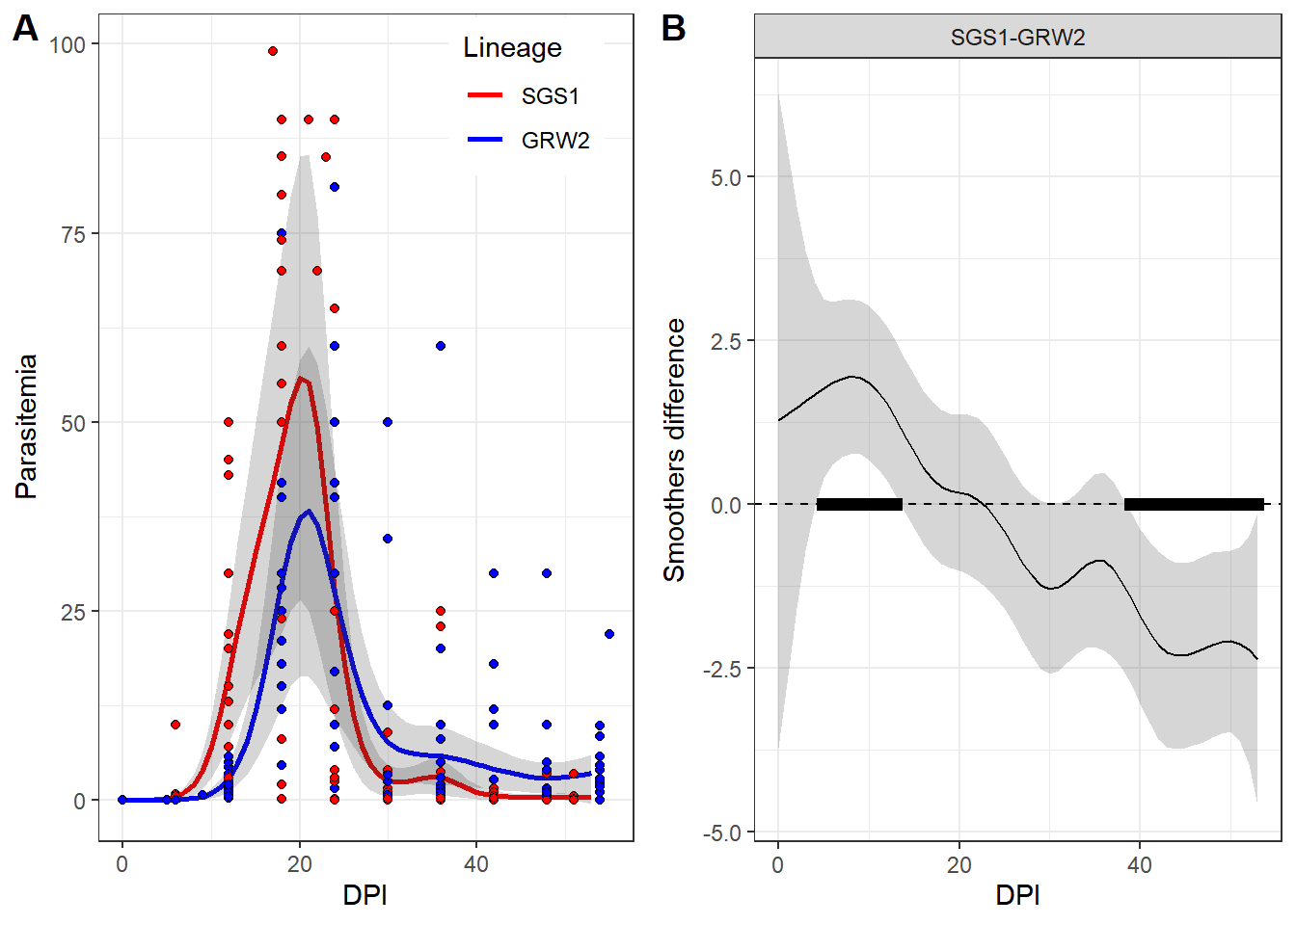

Figure 1. Parasitemia (%) on different days post inoculation (DPI) of two *Plasmodium* species. Panel A represents the observed level of parasitemia (given in %) (dots) and predicted GAMM(lines, gray areas around the lines represent 95% CI). Panel B represents the difference between smoothers. Time periods when the difference between smoothers is significantly different from zero are marked by black rectangles.

No significant difference in the mean parasitemia level between the two parasite species was revealed in the fitted model (Table 1. parametric terms). The general patterns of parasitemia dynamics were similar for both species (Fig. 1, A). Although, in the case of SGS1, the parasitemia was significantly higher than that of GRW2 at the beginning of the disease development, at the end of the experiment, the parasitemia level of the second species became significantly higher than that of the first (Fig. 1, B).

*3.2 Analysis of metabolic rates` dynamics*

For the description of RMR the best GAMM, the model with different smoothers (AIC = -753) was better than the model with common for all groups smoother (AIC = -700). This suggests that RMR dynamics differed for each siskin group (SGS1, GRW2 and Control). ~~The GAMMparameters are presented in Table 2.~~ The smoothers for all groups were significantly curved (i.e., differed from the horizontal straight line, Table ++), indicating an unstable RMR level over the observation time within each group. (Fig 2. A-C).

Table 2. GAMM parameters characterizing the course of RMR after parasite inoculation.

| Parametric terms | | | | |
| --- | --- | --- | --- | --- |
| Term | Value | Std.Error | t | p |
| (Intercept) | 0.867 | 0.108 | 8.000 | <0.001 |
| Lineage (SGS1) | -0.021 | 0.011 | -1.951 | 0.053 |
| Lineage (GRW2) | 0.007 | 0.011 | 0.635 | 0.526 |
| log10(Mass) | 0.446 | 0.097 | 4.581 | <0.001 |
| Smooth terms | | | |
| Term | edf | F | p |
| s(DPI):Control | 3.353 | 3.050 | 0.019 |
| s(DPI):SGS1 | 3.479 | 12.959 | <0.001 |
| s(DPI):GRW2 | 4.746 | 5.796 | <0.001 |
| Random factor | 32.231 | 2.134 | <0.001 |

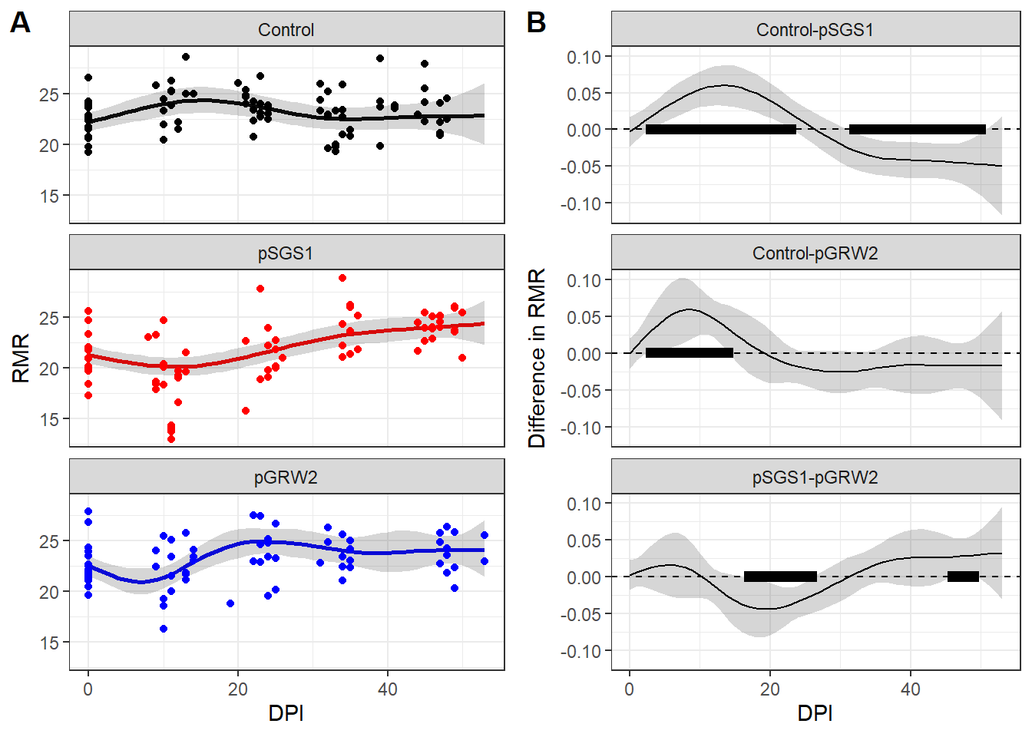

Figure 2. RMR at different days post inoculation (DPI) in different birds’ groups. Panel A represents the observed RMR level (dots) and GAMMpredictions (lines and 95% CI). Panel B represents the difference between smoothers. Time periods when the difference between smoothers is significantly different from zero are marked by black rectangles.

In the Control group, there was a slight increase in RMR during the first two weeks after the inoculation, whereas in both experimental groups, RMR exhibited a dramatic decrease.

In the SGS1 group, immediately after the inoculation, a decline in RMR was observed, followed by subsequent growth. By the end of the experiment, on average, RMR was higher than it was initially (Fig. 2, A). The RMR level in the SGS1 group was significantly lower than in the Control one during the period of 3-23 DPI, but later (32-50 DPI) the RMR level in the SGS1 group was higher than in the Control (Fig. 2, B).

In GRW2 birds, RMR at first decreased (Fig 2, A): during 3-14 DPI it was significantly lower than in the Control group (Fig. 2, B). However, during the following days there were no significant differences between GRW2 and Control groups (Fig. 2. B).

The comparison of RMR dynamics in two inoculated groups (SGS1 vs GRW2, Fig 2, B) reveals significantly higher RMR levels in GRW2 birds during 17-26 DPI. However, later for a short period (during 46-49 DPI) an opposite pattern was recorded.

*3.3* *Analysis of IL-6 level dynamics*

The best GAMMfor IL-6 changes was, as for parasitemia and RMR, with different smoothers for each group of siskins (AIC = -353, for the model with common smoother AIC = -251).

The parameters of the model are presented in Table 3.

Table 3. GAMMparameters characterizing the course of IL-6 concentration after parasite inoculation.

| Parametric terms | | | | |
| --- | --- | --- | --- | --- |
| Term | Value | Std.Error | t | p |
| (Intercept) | 1.102 | 0.018 | 61.611 | <0.001 |
| Lineage (SGS1) | 0.029 | 0.025 | 1.140 | 0.255 |
| Lineage (GRW2) | -0.081 | 0.026 | -3.118 | 0.002 |
| Smooth terms | | | |
| Term | edf | F | p |
| s(DPI):Control | 3.836 | 25.138 | <0.001 |
| s(DPI):SGS1 | 3.480 | 23.977 | <0.001 |
| s(DPI):GRW2 | 3.900 | 15.019 | <0.001 |
| Random factor | 25.264 | 0.929 | <0.001 |

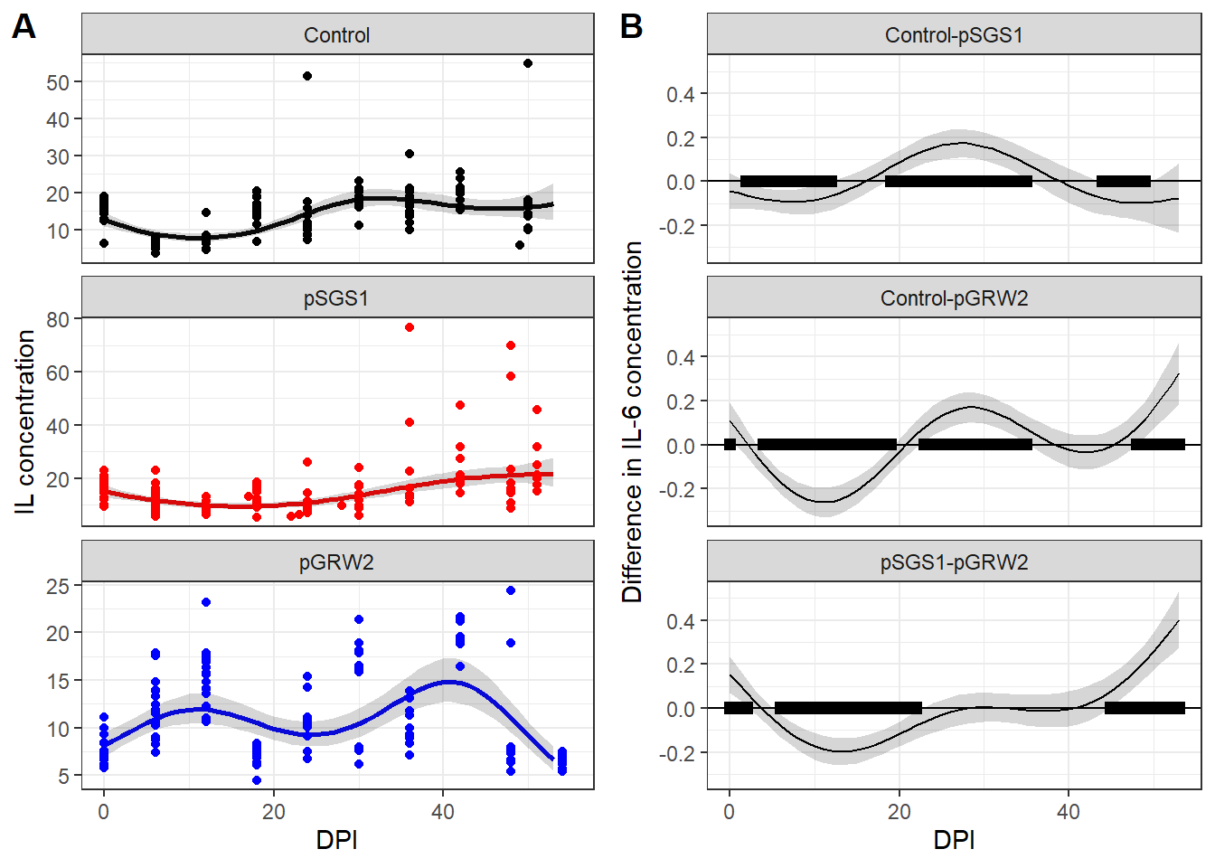

Figure 3. IL-6 at different days post inoculation (DPI) in different birds’ groups. Panel A represents the observed IL-6 concentration (dots) and GAMMpredictions (lines and 95% CI). Panel B represents the difference between smoothers. Time periods when the difference between smoothers is significantly different from zero are marked by black rectangles.

After the inoculation procedure in the Control group of birds, the level of IL-6 began to decrease from its initial levels. It was the lowest on the 3rd week, after which it began to rise (Fig. 3, A). A similar pattern was revealed in the IL-6 dynamics between birds from the SGS1 group. The concentration of IL-6 decreased during several days after inoculation. However, at the end of the experiment, the average concentration was even higher than the initial level, due to some birds exhibiting several times higher levels of IL-6 from their zero-day values (Fig. 3, A). The IL-6 concentration in the SGS1 group was significantly higher than in the Control group at the beginning and near the end of the survey (Fig. 3, B). Nonetheless, during the middle of the observation period, the IL-6 concentration was significantly lower than in the Control group (Fig. 3, B).

The dynamics of IL-6 in the GRW2 group were more complex. It displayed two peaks: one during the first half of the observation period and another in the second half (Fig. 3, A). The IL-6 concentration in the SGS1 group was significantly higher than in the GRW2 group for a brief period at the beginning of the study (0-2 DPI) and during the last days of observations (45-53 DPI). From 6 to 22 DPI, IL-6 concentrations were significantly higher in the GRW2 group than in the SGS1 group, but no significant differences were found between groups 23-44 DPI.

*3.4 Analysis of repeatabilities*

The repeatabilities of mass-independent RMR in Control, SGS1 and GRW2 groups were R = 0.207±0.114 (P = 0.009), R = 0.359±0.136 (P = 0.007) and R = 0 (P = 0.997; there was singular fit in the model since the variance of the random effect was close to zero). The repeatabilities of log10(Mb) in Control, SGS1 and GRW2 groups were R = 0.464±0.122 (P < 0.001), R = 0.695±0.102 (P < 0.001) and R = 0.139±0.108 (P = 0.07), respectively.

**4. Discussion**

*4.1 Parasitemia development*

Both *P. relictum* SGS1 and *P. ashfordi* GRW2 avian malaria parasite species are considered generalists with a wide range of potential host species. According to published papers, both exhibit high levels of parasitemia during primary infections of juvenile siskins (Palinauskas et al., 2008; Videvall et al., 2017). Palinauskas et al. (2011) was the first to report susceptibility to infected blood inoculation and the formation of gametocytes of *P. ashfordi* in Northern Palearctic bird species, including *S. spinus* and *Loxia curvirostra*. The development of the *P. relictum* SGS1 parasite was more rapid than that of *P. relictum* GRW2. The acute stage started and ended earlier and more simultaneously in SGS1-infected birds than in GRW2. The long prepatent period of *P. ashfordi* in our study corresponds to the idea of a more extended prepatent period for most parasites of *Novyella* subgenus, to which *P. ashfordi* belongs (Garnham, 1966; Valkiūnas, 2005; Palinauskas et al., 2011). Apart from the longer hidden stage in this group, high levels of parasitemia remained until the end of the experiment. Similar results for the same host-parasite species were observed in another study during the late stages of decreasing parasitemia. However, whether this was due to host-parasite interactions or the peculiarities of parasite species remain unclear (Videvall et al., 2017).

*4.2 Oxygen consumption during different malaria infections in siskins*

A traditional view suggests that RMR should be positively linked to parasite loads (Bordes and Morand, 2011). However, this statement still lacks experimental evidence, and available data contradict each other. A recent meta-analysis of research data that investigated the impact of parasitic load on the RMR of various animal groups indicated that, in most cases, the RMR of hosts increased after parasite infestation (Robar et al., 2011). Nonetheless, the overall effect of parasites was weak and not statistically significant. As the author suggests, the lack of consistent effect of parasites on hosts` energy metabolism in analyzed articles may be explained by different host-parasite systems used in described experiments (Robar et al., 2011)

We are aware of only three studies that focus on the impact of haemosporidian parasites on hosts` metabolic rates, and their results contradict each other. The first was conducted on two-year-old domestic canaries (*Serinus canaria*), where birds were infected with *Plasmodium relictum* of unknown genetic lineage. It was shown that during the peak of parasitemia, oxygen consumption decreased under both thermoneutral and low-temperature conditions (Hayworth et al., 1987). The study by Hahn et al. (2018) on infected great reed warblers (*Acrocephalus arundinaceus*) did not find any difference in RMR and maximal metabolic rate (MMR) between non-infected and experimentally infected birds with *Plasmodium relictum*  (lineage GRW4), during both acute and chronic stages.

Hahn et al. (2018) concluded that low-level parasitemia (less than 1%) during avian malaria did not affect the aerobic performance of birds. A recent study by Stager et al. (2021) on the wild pink-sided junco *(Junco hyemalis mearnsi*) demonstrated that the presence of haemosporidian parasites (*Haemoproteus* or *Plasmodium*) did not correlate with any of the measured physiological indices, particularly with the RMR of the birds. The authors concluded that there was a minor cost of haemosporidian infection on either junco aerobic performance or energy budgets.

The results of our study reveal that oxygen consumption in immunologically naïve birds after malaria infection differs depending on the malaria parasite. In the *P. relictum* SGS1 group, the decrease of RMR coincided with the acute phase of parasitemia. This is similar to the result reported by Hayworth et al. (1987), who observed a significant decrease in oxygen consumption in canaries during the crisis period of *P. relictum* infection. Since the destruction of erythrocytes at this time is most pronounced, it is reasonable to assume that hematological parameters, such as hematocrit and hemoglobin, should be negatively affected by proliferating parasite (Hammond et al., 2000; Stager et al., 2021). Our study did not measure hematocrit level or hemoglobin concentration – parameters that reflect blood`s capacity to carry oxygen, because the amount of blood collected from each experimental bird was constrained. Several studies indicated a decrease in hematocrit in experimentally infected birds during the acute phase of the *Plasmodium* infection (Paulman and McAllister, 2005; Williams, 2005; Palinauskas et al., 2008; LaPointe et al., 2012; Ilgūnas et al., 2019a; Ilgūnas et al., 2019b), as well as in hemoglobin concentration (Krams et al., 2013; Palinauskas et al., 2022). Videvall et al. (2020) reported a negative correlation between parasitemia levels and the expression of genes involved in oxygen binding and transportation processes in siskins infected with *P. relictum* SGS1. Interestingly, in the earlier study with siskins and *P. ashfordi* GRW2, Videvall et al. (2015) observed a significant expression of genes responsible for metabolic functions and oxidation-reduction processes during both peak and decreasing parasitemia stages. Afterwards, during the late stage of malaria, when parasitemia decreased, catabolic processes became predominant compared to the peak of parasitemia. Comparing the result of these two studies, Videvall et al. (2020) noted similarities in functions of expressed genes in SGS1-infected (Videvall et al., 2020) and GRW2-infected siskins (Videvall et al., 2015). They also demonstrated that highly-virulent SGS1 induced a strong transcriptome response, while the low-virulent GRW4 – minor. Given the high levels of parasitemia observed in both *P. relictum* SGS1 and *P. ashfordi* GRW2 in our experiment, we can conclude that both parasites substantially affect the physiological state of experimental siskins.

The pathological consequences of malaria vary depending on host and parasite species, their interactions, environmental factors, host individual traits, and parasite isolates – all of which can affect the disease outcome (Cornet and Sorci, 2014). In the study by Hahn et al. (2018), peak parasitemia was lower than 1% of parasitized erythrocytes, while in Hayworth et. al. (1987) it ranged from 1.32% to 50%. It appears evident that the higher the parasitemia, the more detrimental consequences it has on bird`s health in general, and consequently, strongly it should affect host metabolic rate in particular. Hayworth et. al. (1987) found a significant positive correlation between level of parasitemia at the peak and the relative decrease in oxygen consumption during low temperature conditions, though it was not significant in the thermoneutral zone.

In the light of these considerations, it is curious that for siskins from the GRW2 group, our GAMMalso showed a period of lowered RMR, albeit short. During that time period (6-12 DPI) the average level of parasitemia was relatively small, indicating that acute phase had not appeared yet. But, starting on day 12 DPI, both RMR and parasitemia began to rise. We assume two possible explanations for this: a) the average parasitemia in the GRW2 group during the crisis was 33%, which is almost two times less than parasitemia in the SGS1 group (50%). This lower parasitemia level in group GRW2 may not have caused sufficient erythrocyte destruction to reduce the metabolic rate. However, we cannot definitively claim that one parasitemia is less severe than the other, especially when both are so high. Additionally, it is noteworthy that relying solely on parasitemia levels within the bloodstream may not consistently offer an accurate assessment of malaria severity. For example, in the case of *P. elongatum* (subgenus Huffia), characterized by typically low-level parasitemia (generally below 1%), it can induce significant pathology (Valkiūnas et al., 2008). This arises from its impact on the erythropoietic system within the bone marrow, a consequence of the destruction of stem cells by exoerythrocytic stages (Palinauskas et al., 2016). b) the increase in RMR might indicate the activation of immune response or, at least, an increase in energy expenditure during the acute phase of an unfamiliar tropical malaria infection. This is suggested by the rise in RMR coincided with the peak parasitemia in birds GRW2 birds 24 DPI. After 30 DPI, the difference between the two experimental groups in RMR became statistically insignificant, with the tendency for birds from the SGS1 group to have a higher rate of metabolism. Interestingly, we observed an increase in oxygen consumption in the Control group after the inoculation of uninfected blood. This increase lasted for about 2 weeks, after which RMR decreased and, by the 5th week, became indistinguishable from the initial level. We see a possible reason for this in: a) stress, because with the beginning of the experiment, birds were regularly subjected to handling, which may have caused a short term stress additional to chronic stress from captivity (Thompson et al., 2015; Li et al., 2019); b) immune response due to the inoculation with uninfected blood, since blood itself can cause an inflammatory response (Ellis et al., 2015; Garraud et al., 2016). We cannot exclude the possibility that these factors were acting simultaneously.

Despite the high peak of parasitemia in birds infected with *P. relictum* SGS1, repeatabilities of both body mass and mass-independent RMR during the course of the disease in this group were significant and even exceeded the corresponding repeatabilities in the Control group. However, both corresponding repeatabilities in birds infected with *P. ashfordi* GRW2 did not differ significantly from zero, suggesting that GRW2malaria infection causes more significant changes in bird physiology compared to SGS1. A more detailed analysis of repeatabilities will be presented in another study.

*4.3 Il-6 level in the blood of infected siskins*

We found it quite difficult to interpret the IL-6 level graphs. At first glance, they appear to resemble roller coasters for all groups. It turns out that the IL-6 level for the SGS1 group was low during the acute phase – from 12 to 24 DPI. But strangely, for some birds, closer to the end of the experiment, IL-6 started to rise and became several times higher than it was at day zero of the experiment. One noticeable pattern is that during the first two weeks after the infection, the SGS1-infected siskins showed an almost uniform decrease in IL-6. It seems like we observed somewhat similar to results obtained in the master`s degree project by Esteban Henao (2019) conducted on siskins also infected with *P. relictum* SGS1. The author showed that the expression level of IL-15 on 8 DPI is negatively correlated with the rapidly growing parasitemia level, and highly parasitized birds express less IL-15, approaching the expression level of uninfected birds. This resemblance to our results for siskins from the SGS1 group is notable, although we observed a decrease in interleukin levels in both the Control and SGS1-infected groups. IL-15 is required for type 1 cytokine production, natural killer cells and dendritic cells responses, and for the synthesis of malaria-specific antibodies (Ing et al., 2005), while IL-6 is the pro-inflammatory cytokine (Clark et al., 2008). The authors suggested that infected birds may express less IL-15 in order to control for hyperreactivity of immune response to the growing number of parasitic antigens (Esteban Henao, 2019).

However, despite the different roles of these cytokines in immune response, mechanisms of suppressing their expression and lowering the final level in the blood may still be the same. In contrast to SGS1, birds infected with GRW2 parasite tended to increase their IL-6 level in plasma after the infection up to 12 DPI. As shown in figure 1, the week between 12 DPI and 18 DPI was a period when parasites began to multiplicate rapidly. This coincided with the transition from the increase of IL-6 levels to its decrease in GRW2-infected siskins. It seems like birds in both groups tended to decrease IL-6 level in response to the rapid multiplication of the parasite. This might be the result of malaria-related immunosuppression and/or activation of a tolerogenic way of immune response by the host itself in order to avoid immunopathology (Esteban Henao, 2019; Calle et al., 2021).

Analysis of birds` transcriptome response to malaria showed that expressed genes were associated with innate and adaptive immunity and their expression was active during the peak of parasitemia and less or not active during the malaria late stages (Videvall et al., 2020; Paxton et al., 2023). Paxton et al. (2023) showed that Hawaiʻi ‘amakihi (*Chlorodrepanis virens*) from a highly susceptible population that succumbed to *P. relictum* GRW4 in experiment, as well as those that recovered, exhibited different gene expression profiles at different stages of malaria. Birds that did not survive the infection had a dysregulation of the innate immune system, resulting in increased levels of gene expression at the middle and late stages of infection. In contrast, survivors showed the upregulation of genes of both innate and adaptive immunity at the peak of parasitemia.

We cannot make a comprehensive assessment of gene expression solely based on IL-6 levels. However, in light of the findings by Paxton et al. (2023), it is remarkable that by the end of our experiment, a majority of birds infected with the GRW2 parasite had very low levels of IL-6, the lowest among all three groups of birds. Besides, several birds from the SGS1 group that survived until the end of the experiment had several times higher levels of IL-6 in their blood plasma after they survived the critical moment at the peak parasitemia.

In the control birds, there was also a decrease of IL-6 levels right after the inoculation. This appears inconsistent with the idea that control birds experience prolonged immune activation due to a single injection of birds` blood free from malaria. Instead, it seems that the primary factor influencing changes in RMR and IL-6 levels in control siskins was the chronic stress arising from captivity and handling. Chronic stress can have immunosuppressive effects, contrary to the acute stress, which typically has immunoenhancing properties (reviewed in Dhabhar and Mcewen (1997)), (but see Martin et al. (2011)).

**Conclusion**

Experimental birds infected with avian malaria parasites exhibited distinct dynamics of physiological parameters not only compared with control birds, but also between experimental birds where birds were infected with parasites of different *Plasmodium* species. SGS1 infected siskins had both reduced RMR and IL-6 levels during the acute stage of parasitemia, which is consistent with previous findings in other studies. Conversely, GRW2 infected birds demonstrated rather erratic shifts in both RMR and IL-6 levels, which were challenging to interpret in the context of parasitemia development. At the same time, the repeatability of mass-independent RMR and body mass was lower in GRW2 infected birds, than in SGS1 infected birds. We can confidently assert that different avian *Plasmodium* parasites can exert varying effects on the health parameters of their avian hosts. These disparities may also arise from the intricate co-evolutionary dynamics between the host and the parasite. Specifically, in the case of siskins, it's important to consider that they have likely co-evolved with the SGS1 parasite, which has adapted to their local environment. On the other hand, the GRW2 parasite originates from Africa and can be considered exotic for siskins. This difference in evolutionary history and geographic origin may contribute to the varying impacts of these parasites on the health of siskin hosts. This dynamic interplay between host and parasite becomes especially noteworthy when considering the potential introduction of exotic parasites to regions outside their natural range. In the context of climate change and anthropological impacts, the transmission of tropical-origin parasites to northern latitudes has become a matter of concern. Should such transmission occur, it could lead to unpredictable outcomes for local bird populations.

**Acknowledgments**

We are grateful to Natalya Gazatova, who conducted all the immunoassays on blood plasma. We also extend our thanks to our colleagues at the Biological Station "Rybachy" for their assistance with species identification and bird ringing, as well as to the students of Immanuel Kant Baltic Federal University for their help in caring for the experimental birds. Data collection and analysis were supported by the Russian Scientific Grant (RSF Grant # 20-14-00049).

Asghar, M., Palinauskas, V., Zaghdoudi-Allan, N., Valkiūnas, G., Mukhin, A., Platonova, E., Färnert, A., Bensch, S., Hasselquist, D., 2016. Parallel telomere shortening in multiple body tissues owing to malaria infection. Proceedings of the Royal Society B: Biological Sciences 283, 20161184. doi:

Asghar, M., Westerdahl, H., Zehtindjiev, P., Ilieva, M., Hasselquist, D., Bensch, S., 2012. Primary peak and chronic malaria infection levels are correlated in experimentally infected great reed warblers. Parasitology 139, 1246-1252. doi:

Bensch, S., Hellgren, O., Pérez‐Tris, J., 2009. MalAvi: a public database of malaria parasites and related haemosporidians in avian hosts based on mitochondrial cytochrome b lineages. Molecular ecology resources 9, 1353-1358. doi:

Bensch, S., Waldenström, J., Jonzán, N., Westerdahl, H., Hansson, B., Sejberg, D., Hasselquist, D., 2007. Temporal dynamics and diversity of avian malaria parasites in a single host species. Journal of Animal Ecology, 112-122. doi:

Bonneaud, C., Mazuc, J., Gonzalez, G., Haussy, C., Chastel, O., Faivre, B., Sorci, G., 2003. Assessing the cost of mounting an immune response. The American Naturalist 161, 367-379. doi:

Bordes, F., Morand, S., 2011. The impact of multiple infections on wild animal hosts: a review. Infection ecology & epidemiology 1, 7346. doi:

Brody, S., 1945. Bioenergetics and growth. Reinhold. New York 307. doi:

Calle, C.L., Mordmüller, B., Singh, A., 2021. Immunosuppression in malaria: do Plasmodium falciparum parasites hijack the host? Pathogens 10, 1277. doi:

Carapau, D., Kruhofer, M., Chatalbash, A., Orengo, J.M., Mota, M.M., Rodriguez, A., 2007. Transcriptome profile of dendritic cells during malaria: cAMP regulation of IL‐6. Cellular microbiology 9, 1738-1752. doi:

Clark, I.A., Alleva, L.M., Budd, A.C., Cowden, W.B., 2008. Understanding the role of inflammatory cytokines in malaria and related diseases. Travel medicine and infectious disease 6, 67-81. doi:

Cocumelli, C., Iurescia, M., Diaconu, E.L., Galietta, V., Raso, C., Buccella, C., Stravino, F., Grande, F., Fiorucci, L., De Liberato, C., 2021. Plasmodium matutinum causing avian malaria in lovebirds (Agapornis roseicollis) hosted in an Italian zoo. Microorganisms 9, 1356. doi:

Cornet, S., Sorci, G., 2014. Avian malaria models of disease. Encyclopedia of malaria, M. Hommel and PG Kremsner (eds.). Springer New York, New York City, New York, 1-11. doi:

Demas, G.E., Drazen, D.L., Nelson, R.J., 2003. Reductions in total body fat decrease humoral immunity. Proceedings of the Royal Society of London. Series B: Biological Sciences 270, 905-911. doi:

Dhabhar, F.S., Mcewen, B.S., 1997. Acute stress enhances while chronic stress suppresses cell-mediated immunityin vivo: A potential role for leukocyte trafficking. Brain, behavior, and immunity 11, 286-306. doi:

Ellis, V.A., Cornet, S., Merrill, L., Kunkel, M.R., Tsunekage, T., Ricklefs, R.E., 2015. Host immune responses to experimental infection of Plasmodium relictum (lineage SGS1) in domestic canaries (Serinus canaria). Parasitology Research 114, 3627-3636. doi:

Eraud, C., Duriez, O., Chastel, O., Faivre, B., 2005. The energetic cost of humoral immunity in the Collared Dove, Streptopelia decaocto: is the magnitude sufficient to force energy‐based trade‐offs? Functional Ecology 19, 110-118. doi:

Esteban Henao, M.C., 2019. Analysis of cytokine expression in avian peripheral blood in response to malaria infections. doi:

Frappell, P., Blevin, H., Baudinette, R., 1989. Understanding respirometry chambers: what goes in must come out. Journal of Theoretical Biology 138, 479-494. doi:

Garnham, P.C.C., 1966. Malaria parasites and other Haemosporidia. Malaria Parasites and other Haemosporidia. doi:

Garraud, O., Tariket, S., Sut, C., Haddad, A., Aloui, C., Chakroun, T., Laradi, S., Cognasse, F., 2016. Transfusion as an inflammation hit: knowns and unknowns. Frontiers in Immunology 7, 534. doi:

Gavrilov, V., Gavrilov, V., 2019. Scaling of total evaporative water loss and evaporative heat loss in birds at different ambient temperatures and seasons. Int J Avian & Wildlife Biol 4, 40-53. doi:

Gavrilov, V.M., 2014. Ecological and scaling analysis of the energy expenditure of rest, activity, flight, and evaporative water loss in Passeriformes and non-Passeriformes in relation to seasonal migrations and to the occupation of boreal stations in high and moderate latitudes. The Quarterly Review of Biology 89, 107-150. doi:

Godfrey Jr., R.D., Fedynich, A.M., Pence, D.B., 1987. Quantification of hematozoa in blood smears. Journal of wildlife diseases 23, 558-565. doi:

González-Olvera, M., Hernandez-Colina, A., Himmel, T., Eckley, L., Lopez, J., Chantrey, J., Baylis, M., Jackson, A.P., 2022. Molecular and epidemiological surveillance of Plasmodium spp. during a mortality event affecting Humboldt penguins (Spheniscus humboldti) at a zoo in the UK. International Journal for Parasitology: Parasites and Wildlife 19, 26-37. doi:

Graham, A.L., Allen, J.E., Read, A.F., 2005. Evolutionary causes and consequences of immunopathology. Annu. Rev. Ecol. Evol. Syst. 36, 373-397. doi:

Hahn, S., Bauer, S., Dimitrov, D., Emmenegger, T., Ivanova, K., Zehtindjiev, P., Buttemer, W.A., 2018. Low intensity blood parasite infections do not reduce the aerobic performance of migratory birds. Proceedings of the Royal Society B: Biological Sciences 285, 20172307. doi:

Hall, T.A., 1999. BioEdit: a user-friendly biological sequence alignment editor and analysis program for Windows 95/98/NT, Nucleic acids symposium series. [London]: Information Retrieval Ltd., c1979-c2000., pp. 95-98.

Hammond, K.A., Chappell, M.A., Cardullo, R.A., Lin, R.-S., Johnsen, T.S., 2000. The mechanistic basis of aerobic performance variation in red junglefowl. Journal of experimental Biology 203, 2053-2064. doi:

Hayworth, A.M., Charles van Riper, I., Weathers, W.W., 1987. Effects of Plasmodium relictum on the metabolic rate and body temperature in canaries (Serinus canarius). The Journal of Parasitology, 850-853. doi:

Hellgren, O., Waldenström, J., Bensch, S., 2004. A new PCR assay for simultaneous studies of Leucocytozoon, Plasmodium, and Haemoproteus from avian blood. Journal of parasitology 90, 797-802. doi:

Iezhova, T.A., Valkiūnas, G., Bairlein*, F., 2005. Vertebrate host specificity of two avian malaria parasites of the subgenus Novyella: Plasmodium nucleophilum and Plasmodium vaughani. Journal of Parasitology 91, 472-474. doi:

Ilgūnas, M., Bukauskaitė, D., Palinauskas, V., Iezhova, T., Fragner, K., Platonova, E., Weissenböck, H., Valkiūnas, G., 2019a. Patterns of Plasmodium homocircumflexum virulence in experimentally infected passerine birds. Malaria journal 18, 1-14. doi:

Ilgūnas, M., Palinauskas, V., Platonova, E., Iezhova, T., Valkiūnas, G., 2019b. The experimental study on susceptibility of common European songbirds to Plasmodium elongatum (lineage pGRW6), a widespread avian malaria parasite. Malaria journal 18, 1-11. doi:

Ing, R., Gros, P., Stevenson, M.M., 2005. Interleukin-15 enhances innate and adaptive immune responses to blood-stage malaria infection in mice. Infection and immunity 73, 3172-3177. doi:

Koteja, P., 1996. Measuring energy metabolism with open-flow respirometric systems: which design to choose? Functional Ecology, 675-677. doi:

Krams, I., Suraka, V., Rantala, M., Sepp, T., Mierauskas, P., Vrublevska, J., Krama, T., 2013. Acute infection of avian malaria impairs concentration of haemoglobin and survival in juvenile altricial birds. Journal of Zoology 291, 34-41. doi:

LaPointe, D.A., Atkinson, C.T., Samuel, M.D., 2012. Ecology and conservation biology of avian malaria. Annals of the New York Academy of Sciences 1249, 211-226. doi:

Lessells, C., Boag, P.T., 1987. Unrepeatable repeatabilities: a common mistake. The Auk 104, 116-121. doi:

Li, M., Zhu, W., Wang, Y., Sun, Y., Li, J., Liu, X., Wu, Y., Gao, X., Li, D., 2019. Effects of capture and captivity on plasma corticosterone and metabolite levels in breeding Eurasian Tree Sparrows. Avian Research 10, 1-10. doi:

Lighton, J., Halsey, L., 2011. Flow-through respirometry applied to chamber systems: pros and cons, hints and tips. Comparative Biochemistry and Physiology Part A: Molecular & Integrative Physiology 158, 265-275. doi:

Lochmiller, R.L., Deerenberg, C., 2000. Trade‐offs in evolutionary immunology: just what is the cost of immunity? Oikos 88, 87-98. doi:

Martin, L.B., Kidd, L., Liebl, A.L., Coon, C.A., 2011. Captivity induces hyper-inflammation in the house sparrow (Passer domesticus). Journal of Experimental Biology 214, 2579-2585. doi:

Martin, L.B., Scheuerlein, A., Wikelski, M., 2003. Immune activity elevates energy expenditure of house sparrows: a link between direct and indirect costs? Proceedings of the Royal Society of London. Series B: Biological Sciences 270, 153-158. doi:

Martínez-de la Puente, J., Santiago-Alarcon, D., Palinauskas, V., Bensch, S., 2021. Plasmodium relictum. Trends in Parasitology 37, 355-356. doi:

McNab, B.K., 1997. On the utility of uniformity in the definition of basal rate of metabolism. Physiological Zoology 70, 718-720. doi:

Meister, S.L., Richard, O.K., Hoby, S., Gurtner, C., Basso, W.U., 2021. Fatal avian malaria in captive Atlantic puffins (Fratercula arctica) in Switzerland. International Journal for Parasitology: Parasites and Wildlife 14, 97-106. doi:

Melanson, E.L., Ingebrigtsen, J.P., Bergouignan, A., Ohkawara, K., Kohrt, W.M., Lighton, J.R., 2010. A new approach for flow-through respirometry measurements in humans. American Journal of Physiology-Regulatory, Integrative and Comparative Physiology 298, R1571-R1579. doi:

Mukhin, A., Palinauskas, V., Platonova, E., Kobylkov, D., Vakoliuk, I., Valkiūnas, G., 2016. The strategy to survive primary malaria infection: an experimental study on behavioural changes in parasitized birds. PLoS One 11, e0159216. doi:

Nakagawa, S., Schielzeth, H., 2010. Repeatability for Gaussian and non‐Gaussian data: a practical guide for biologists. Biological Reviews 85, 935-956. doi:

Newton, I., 2010. The migration ecology of birds. Elsevier.

Norris, K., Evans, M.R., 2000. Ecological immunology: life history trade-offs and immune defense in birds. Behavioral Ecology 11, 19-26. doi:

Owen-Ashley, N.T., Wingfield, J.C., 2007. Acute phase responses of passerine birds: characterization and seasonal variation. Journal of Ornithology 148, 583-591. doi:

Palinauskas, V., Valkiūnas, G., Bolshakov, C.V., Bensch, S., 2008. Plasmodium relictum (lineage P-SGS1): effects on experimentally infected passerine birds. Experimental parasitology 120, 372-380. doi:

Palinauskas, V., Valkiūnas, G., Bolshakov, C.V., Bensch, S., 2011. Plasmodium relictum (lineage SGS1) and Plasmodium ashfordi (lineage GRW2): the effects of the co-infection on experimentally infected passerine birds. Experimental Parasitology 127, 527-533. doi:

Palinauskas, V., Žiegytė, R., Iezhova, T.A., Ilgūnas, M., Bernotienė, R., Valkiūnas, G., 2016. Description, molecular characterisation, diagnostics and life cycle of Plasmodium elongatum (lineage pERIRUB01), the virulent avian malaria parasite. International Journal for Parasitology 46, 697-707. doi:

Palinauskas, V., Žiegytė, R., Šengaut, J., Bernotienė, R., 2022. Experimental study on primary bird co-infection with two Plasmodium relictum lineages—pSGS1 and pGRW11. Animals 12, 1879. doi:

Paulman, A., McAllister, M.M., 2005. Plasmodium gallinaceum: clinical progression, recovery, and resistance to disease in chickens infected via mosquito bite. The American journal of tropical medicine and hygiene 73, 1104-1107. doi:

Paxton, K.L., Cassin-Sackett, L., Atkinson, C.T., Videvall, E., Campana, M.G., Fleischer, R.C., 2023. Gene expression reveals immune response strategies of naïve Hawaiian honeycreepers experimentally infected with introduced avian malaria. Journal of Heredity, esad017. doi:

Ricklefs, R.E., Konarzewski, M., Daan, S., 1996. The relationship between basal metabolic rate and daily energy expenditure in birds and mammals. The American Naturalist 147, 1047-1071. doi:

Robar, N., Murray, D.L., Burness, G., 2011. Effects of parasites on host energy expenditure: the resting metabolic rate stalemate. Canadian Journal of Zoology 89, 1146-1155. doi:

Rooyen, J.v., Lalubin, F., Glaizot, O., Christe, P., 2013. Avian haemosporidian persistence and co-infection in great tits at the individual level. Malaria Journal 12, 1-8. doi:

Sambrook, J., 1989. Molecular colning. A laboratory manual, 1.82-81.89. doi:

Schat, K.A., Kaspers, B., Kaiser, P., 2014. Avian immunology. Elsevier Philadelphia, USA:.

Sheldon, B.C., Verhulst, S., 1996. Ecological immunology: costly parasite defences and trade-offs in evolutionary ecology. Trends in ecology & evolution 11, 317-321. doi:

Shirihai, H., Svensson, L., 2018. Handbook of Western Palearctic Birds, Volume 1: Passerines: Larks to Warblers. Bloomsbury Publishing.

Simpson, G.L., 2023. Graceful 'ggplot'-Based Graphics and Other Functions for GAMs

Fitted Using 'mgcv'. Ggplotbased graphics and other useful functions for GAMs fitted using Mgcv, 0.1-0 (Ggplot-based graphics and utility functions for working with GAMs fitted using the mgcv package). doi:

Sorci, G., Faivre, B., 2009. Inflammation and oxidative stress in vertebrate host–parasite systems. Philosophical Transactions of the Royal Society B: Biological Sciences 364, 71-83. doi:

Stager, M., Eddy, D.K., Cheviron, Z.A., Carling, M.D., 2021. Haemosporidian infection does not alter aerobic performance in the Pink-sided Junco (Junco hyemalis mearnsi). bioRxiv, 2021.2009. 2020.460914. doi:

Sun, N.W., Goodwin, S.E., Griego, M.S., Gerson, A.R., Clotfelter, E.D., 2020. Does blood loss explain higher resting metabolic rates in nestling birds with hematophagous ectoparasites? Journal of Avian biology 51. doi:

Thompson, L.J., Brown, M., Downs, C.T., 2015. The effects of long-term captivity on the metabolic parameters of a small Afrotropical bird. Journal of Comparative Physiology B 185, 343-354. doi:

Valkiūnas, G., 2005. Avian malaria parasites and other haemosporidia. CRC press.

Valkiūnas, G., Ilgūnas, M., Bukauskaitė, D., Fragner, K., Weissenböck, H., Atkinson, C.T., Iezhova, T.A., 2018. Characterization of Plasmodium relictum, a cosmopolitan agent of avian malaria. Malaria journal 17, 1-21. doi:

Valkiūnas, G., Zehtindjiev, P., Dimitrov, D., Križanauskienė, A., Iezhova, T.A., Bensch, S., 2008. Polymerase chain reaction-based identification of Plasmodium (Huffia) elongatum, with remarks on species identity of haemosporidian lineages deposited in GenBank. Parasitology Research 102, 1185-1193. doi:

Van Riper III, C., Van Riper, S.G., Goff, M.L., Laird, M., 1986. The epizootiology and ecological significance of malaria in Hawaiian land birds. Ecological monographs 56, 327-344. doi:

Videvall, E., Cornwallis, C.K., Ahrén, D., Palinauskas, V., Valkiūnas, G., Hellgren, O., 2017. The transcriptome of the avian malaria parasite Plasmodium ashfordi displays host‐specific gene expression. Molecular Ecology 26, 2939-2958. doi:

Videvall, E., Cornwallis, C.K., Palinauskas, V., Valkiūnas, G., Hellgren, O., 2015. The avian transcriptome response to malaria infection. Molecular biology and evolution 32, 1255-1267. doi:

Videvall, E., Palinauskas, V., Valkiūnas, G., Hellgren, O., 2020. Host transcriptional responses to high-and low-virulent avian malaria parasites. The American Naturalist 195, 1070-1084. doi:

Wilairatana, P., Mala, W., Milanez, G.D.J., Masangkay, F.R., Kotepui, K.U., Kotepui, M., 2022. Increased interleukin-6 levels associated with malaria infection and disease severity: a systematic review and meta-analysis. Scientific Reports 12, 5982. doi:

Williams, R., 2005. Avian malaria: clinical and chemical pathology of Plasmodium gallinaceum in the domesticated fowl Gallus gallus. Avian Pathology 34, 29-47. doi:

Wood, S.N., 2017. Generalized additive models: an introduction with R. CRC press.

Wunderlich, C.M., Delić, D., Behnke, K., Meryk, A., Ströhle, P., Chaurasia, B., Al-Quraishy, S., Wunderlich, F., Brüning, J.C., Wunderlich, F.T., 2012. Cutting edge: Inhibition of IL-6 trans-signaling protects from malaria-induced lethality in mice. The Journal of Immunology 188, 4141-4144. doi:

Zuk, M., Stoehr, A.M., 2002. Immune defense and host life history. the american naturalist 160, S9-S22. doi: