Таблица 1. Length of *Platichthys flesus* morphs of different sexes from 4 sample sites (Mean ± SE and range (min – max))

|  |  |  |  |  |
| --- | --- | --- | --- | --- |
| Bay | Female Left | Female Right | Male Left | Male Right |
| Kandalaksha Bay | 27.6 ± 1.03  16.0 – 38.2 | 26.3 ± 0.60  16.6 – 42.5 | 23.0 ± 0.44  14.3 – 32.4 | 22.5 ± 0.37  13.0 – 34.1 |
| Onega Bay | 20.4 ± 0.26  7.0 – 41.1 | 19.5 ± 0.15  7.1 – 44 | 17.3 ± 0.23  6.9 – 33.6 | 16.4 ± 0.13  6.6 – 34.2 |
| Dvina Bay | 21.3 ± 0.37  9.4 – 35.1 | 21.9 ± 0.10  5.1 – 48.3 | 18.5 ± 0.39  9.3 – 28.2 | 18.1 ± 0.07  7.5 – 36.7 |
| Mezen Bay | 20.2 ± 0.97  10.8 – 34.0 | 18.7 ± 0.17  7.2 – 41.2 | 16.7 ± 0.52  10.6 – 25.0 | 16.9 ± 0.11  9.1 – 30.4 |

Рисунок 2. Geographical variation in the proportion of left-sided morphs of *Platichthys flesus* across its range. Размер точки пропорционален частоте. Источники данных приведены в табл.2

|  |  |  |  |  |
| --- | --- | --- | --- | --- |
| № | **Locality** | **Sample size** | **Left, %** | **Author** |
| 1 | Chupa Inlet, Kandalaksha Bay, White Sea, Russia | 484 | 28,3 | Present study |
| 2 | Onega Bay, White Sea, Russia | 4758 | 26 | Present study |
| 3 | Mezen Bay, White Sea, Russia | 2272 | 5,2 | Present study |
| 4 | Delta of the Northern Dvina river, Dvina Bay, White Sea, Russia | 4760 | 3,3 | Present study |
| 5 | Velikaya Salma Strait, Kandalaksha Bay, White Sea, Russia | 957 | 37,1 | Shatunovsky 1964; Dietrich 2009 |
| 6 | Eckernforde Bay; Laboe (Kiel), Baltic Sea, Germany | 3331 | 42,7 | Apstein 1905 |
| 7 | Neustadt Bay, Baltic Sea, Germany | 90 | 34,4 | Duncker 1900 |
| 8 | Zuiderzee, North Sea, Netherlands | 50 | 44 | Redeke 1915 |
| 9 | Den Helder, North Sea, Netherlands | 75 | 48 | Redeke 1915 |
| 10 | Rostock, Baltic Sea, Germany | 15 | 26,7 | Momigliano et al. 2018 |
| 11 | Loughor estuary, South Wales, UK | 64 | 4,7 | Galleguillos and Ward 1982 |
| 12 | Sorve peninsula, Saaremaa, Baltic Sea, Estonia | 200 | 39,5 | Mikelsaar 1958 |
| 13 | Mandjala, Saaremaa, Baltic Sea, Estonia | 200 | 22,5 | Mikelsaar 1958 |
| 14 | Murman coast, Barents Sea, Russia | 475 | 44,5 | Sych 1930 |
| 15 | North Bull Island, Dublin Bay, Irish Sea | 590 | 5,6 | Russo et al. 2012 |
| 16 | Murman coast, Barents Sea, Russia | no data | 39,6 | Suvorov 1926 |
| 17 | English Channel, Plymouth, UK | 1120 | 5,4 | Duncker 1900 |
| 18 | Elbe river mouth, North Sea, Germany | 225 | 23,6 | Duncker 1900 |
| 19 | Mevagissey harbour, UK | 192 | 5,7 | Duncker 1900 |
| 20 | Langeoog, Wadden Sea, North Sea, Germany | 26 | 35 | Voronina 1999 |
| 21 | Murman coast, Barents Sea, Russia | 25 | 40 | Voronina 1999 |
| 22 | English Channel, Plymouth, UK | 40 | 7,5 | Galleguillos and Ward 1982 |
| 23 | Thames estuary, London, UK | 50 | 18 | Galleguillos and Ward 1982 |
| 24 | Mezen Bay, White Sea, Russia | 1367 | 3,1 | Semushin et al, 2015 |
| 25 | Danish Belt Sea | 49 | 25,4 | Galleguillos and Ward 1982 |
| 26 | Stromstad, Skagerrak, Sweden | 455 | 27,5 | Fornbacke et al. 2002 |
| 27 | Lysekil, Skagerrak, Sweden | 653 | 27 | Fornbacke et al. 2002 |
| 28 | Karlskrona, Baltic Sea, Sweden | 631 | 22,4 | Fornbacke et al. 2002 |
| 29 | Oland, Baltic Sea, Sweden | 1673 | 21,1 | Fornbacke et al. 2002 |
| 30 | Vastervik, Baltic Sea, Sweden | 193 | 21,2 | Fornbacke et al. 2002 |
| 31 | Nynashamn, Baltic Sea, Sweden | 186 | 20,1 | Fornbacke et al. 2002 |
| 32 | Kuz Inlet, Onega Bay, White Sea, Russia | 187 | 31,3 | Nikolaev 1949 |
| 33 | Kolezhma river, Onega Bay, White Sea, Russia | 358 | 28,5 | Mikelsaar 1958 |
| 34 | Delta of the Northern Dvina river, White Sea, Russia | 897 | 4 | Dietrich 2009 |
| 35 | Delta of the Northern Dvina river, White Sea, Russia | 2394 | 4,7 | Semushin et al. 2015 |
| 36 | Trondheimsfjord, Norway | 269 | 32,3 | Nordgaard, 1915 |
| 37 | Millport, Cumbrae, Scottish coast, UK | no data | 6,7 | Elmhirst 1911 |
| 38 | Pudisoo, Baltic Sea, Estonia | 1271 | 33,1 | Mikelsaar 1958 |
| 39 | Hiiumaa, Baltic Sea, Estonia | 800 | 35 | Mikelsaar 1958 |

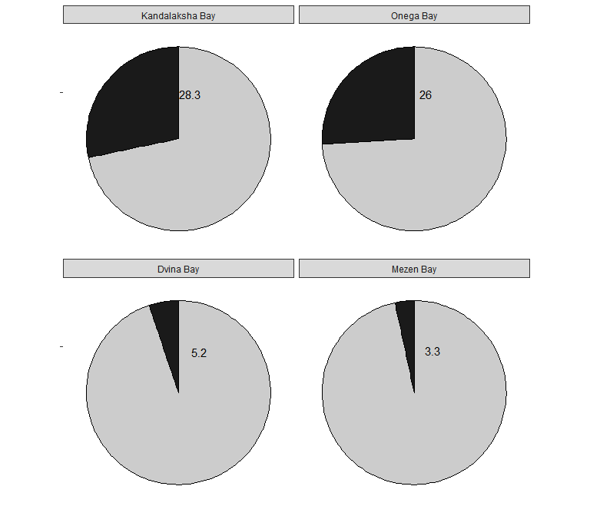

Рисунок 1. Frequency of left-sided *Platichthys flesus* (%, black sectors) from 4 sample sites

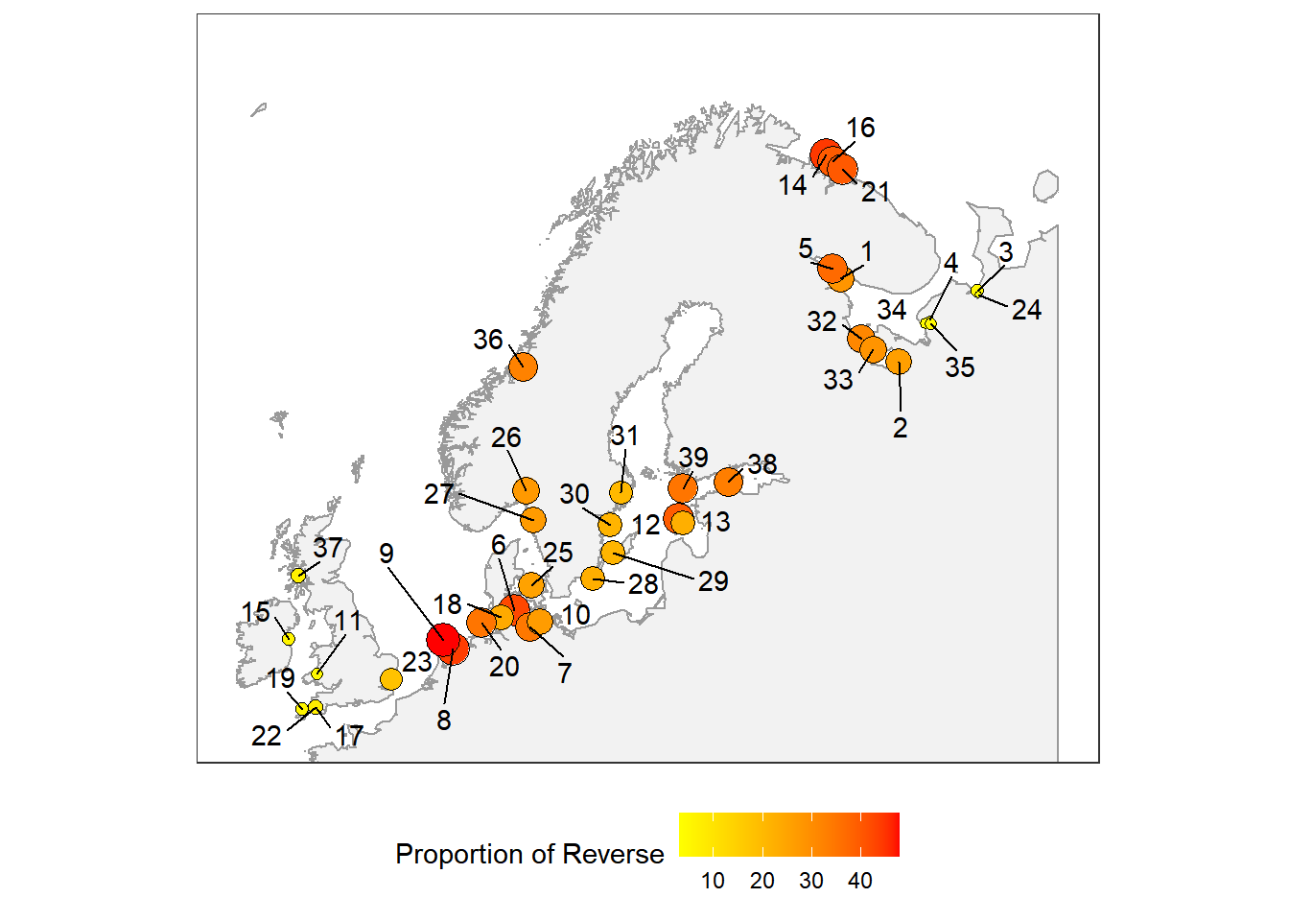

Рисунок 2. Geographical variation in the proportion of left-sided morphs of *Platichthys flesus* across its range. Размер точки пропорционален частоте. Источники данных приведены в табл.2