Divergence in the ecological space between cryptic blue mussel species in the White Sea: towards to species distribution modelling

**V. M. Khaitov, A. A. Zaychikova, P. Y. Safonov, M. V. Katolikova, M. V. Ivanov, P. P. Strelkov**

Table ++. Environmental parameters used for the analysis

| Environmental parameter/ model predictor | Type | Explanation | Range (median) in the data |
| --- | --- | --- | --- |
| *Influence of substrate* | | | |
| Substrate | Categorical | Algal and Bottom samples for each site are treated separately | Algae VS Bottom |
| *Influence of rivers* | | | |
| Salinity | Continuous | Surface salinity (ppm) at the time of sampling, i.e. at low tide. | 2-30 (19) |
| DistRiver | Continuous | The straight line distance (km) between the site and the nearest river mouth by map. The values were log-transformed when used for model fitting. | 0-18.5 (4.9) |
| RiverSize | Categorical | Rivers are categorized according to whether their catchment area is larger or smaller than the median area of all rivers in the region. | Small VS Large |
| *Influence of ports* | | | |
| DistPort | Continuous | The straight line distance (km) between the site and the nearest port by map. Log-transformed values were used. | 0.1-82.2 (18.7) |
| PortStatus | Categorical | Ports are categorized according whether they are active or abandoned | Active VS Abandoned |
| *Influence of surf* | | | |
| Fetch | Continuous | Unobstructed length of water surface (km) over which wind from a certain direction can blow over. Log-transformed values were used. | 0.2-28.8 (3.3) |

Table 1 . Parameters of smoothers and coefficients of parametric terms for the Model describing dependency of Ptros on predictors.

| Smoother terms | edf | ref.edf | Chi.sq | p-value |
| --- | --- | --- | --- | --- |
| s(Salinity) | 2.4 | 9 | 396.7 | 0.0033 |
| s(DistRiver) | 0.0 | 9 | 0.0 | 0.6724 |
| s(Fetch) | 0.9 | 9 | 88.2 | 0.0417 |
| s(DistPort) | 1.0 | 9 | 276.2 | 0.0016 |
| Random effect s(Site) | 74.4 | 92 | 453.6 | 0.0000 |

| Parametric terms | Parameter estimate | SE | z-statistic | p-value |
| --- | --- | --- | --- | --- |
| (Intercept) | -1.7 | 0.1 | -11.8 | 0.0000 |
| Substrate(Algae) | 0.9 | 0.1 | 14.6 | 0.0000 |
| RiverSize(Large) | 0.4 | 0.2 | 2.6 | 0.0091 |
| PortStatus(Active) | 1.0 | 0.2 | 5.7 | 0.0000 |

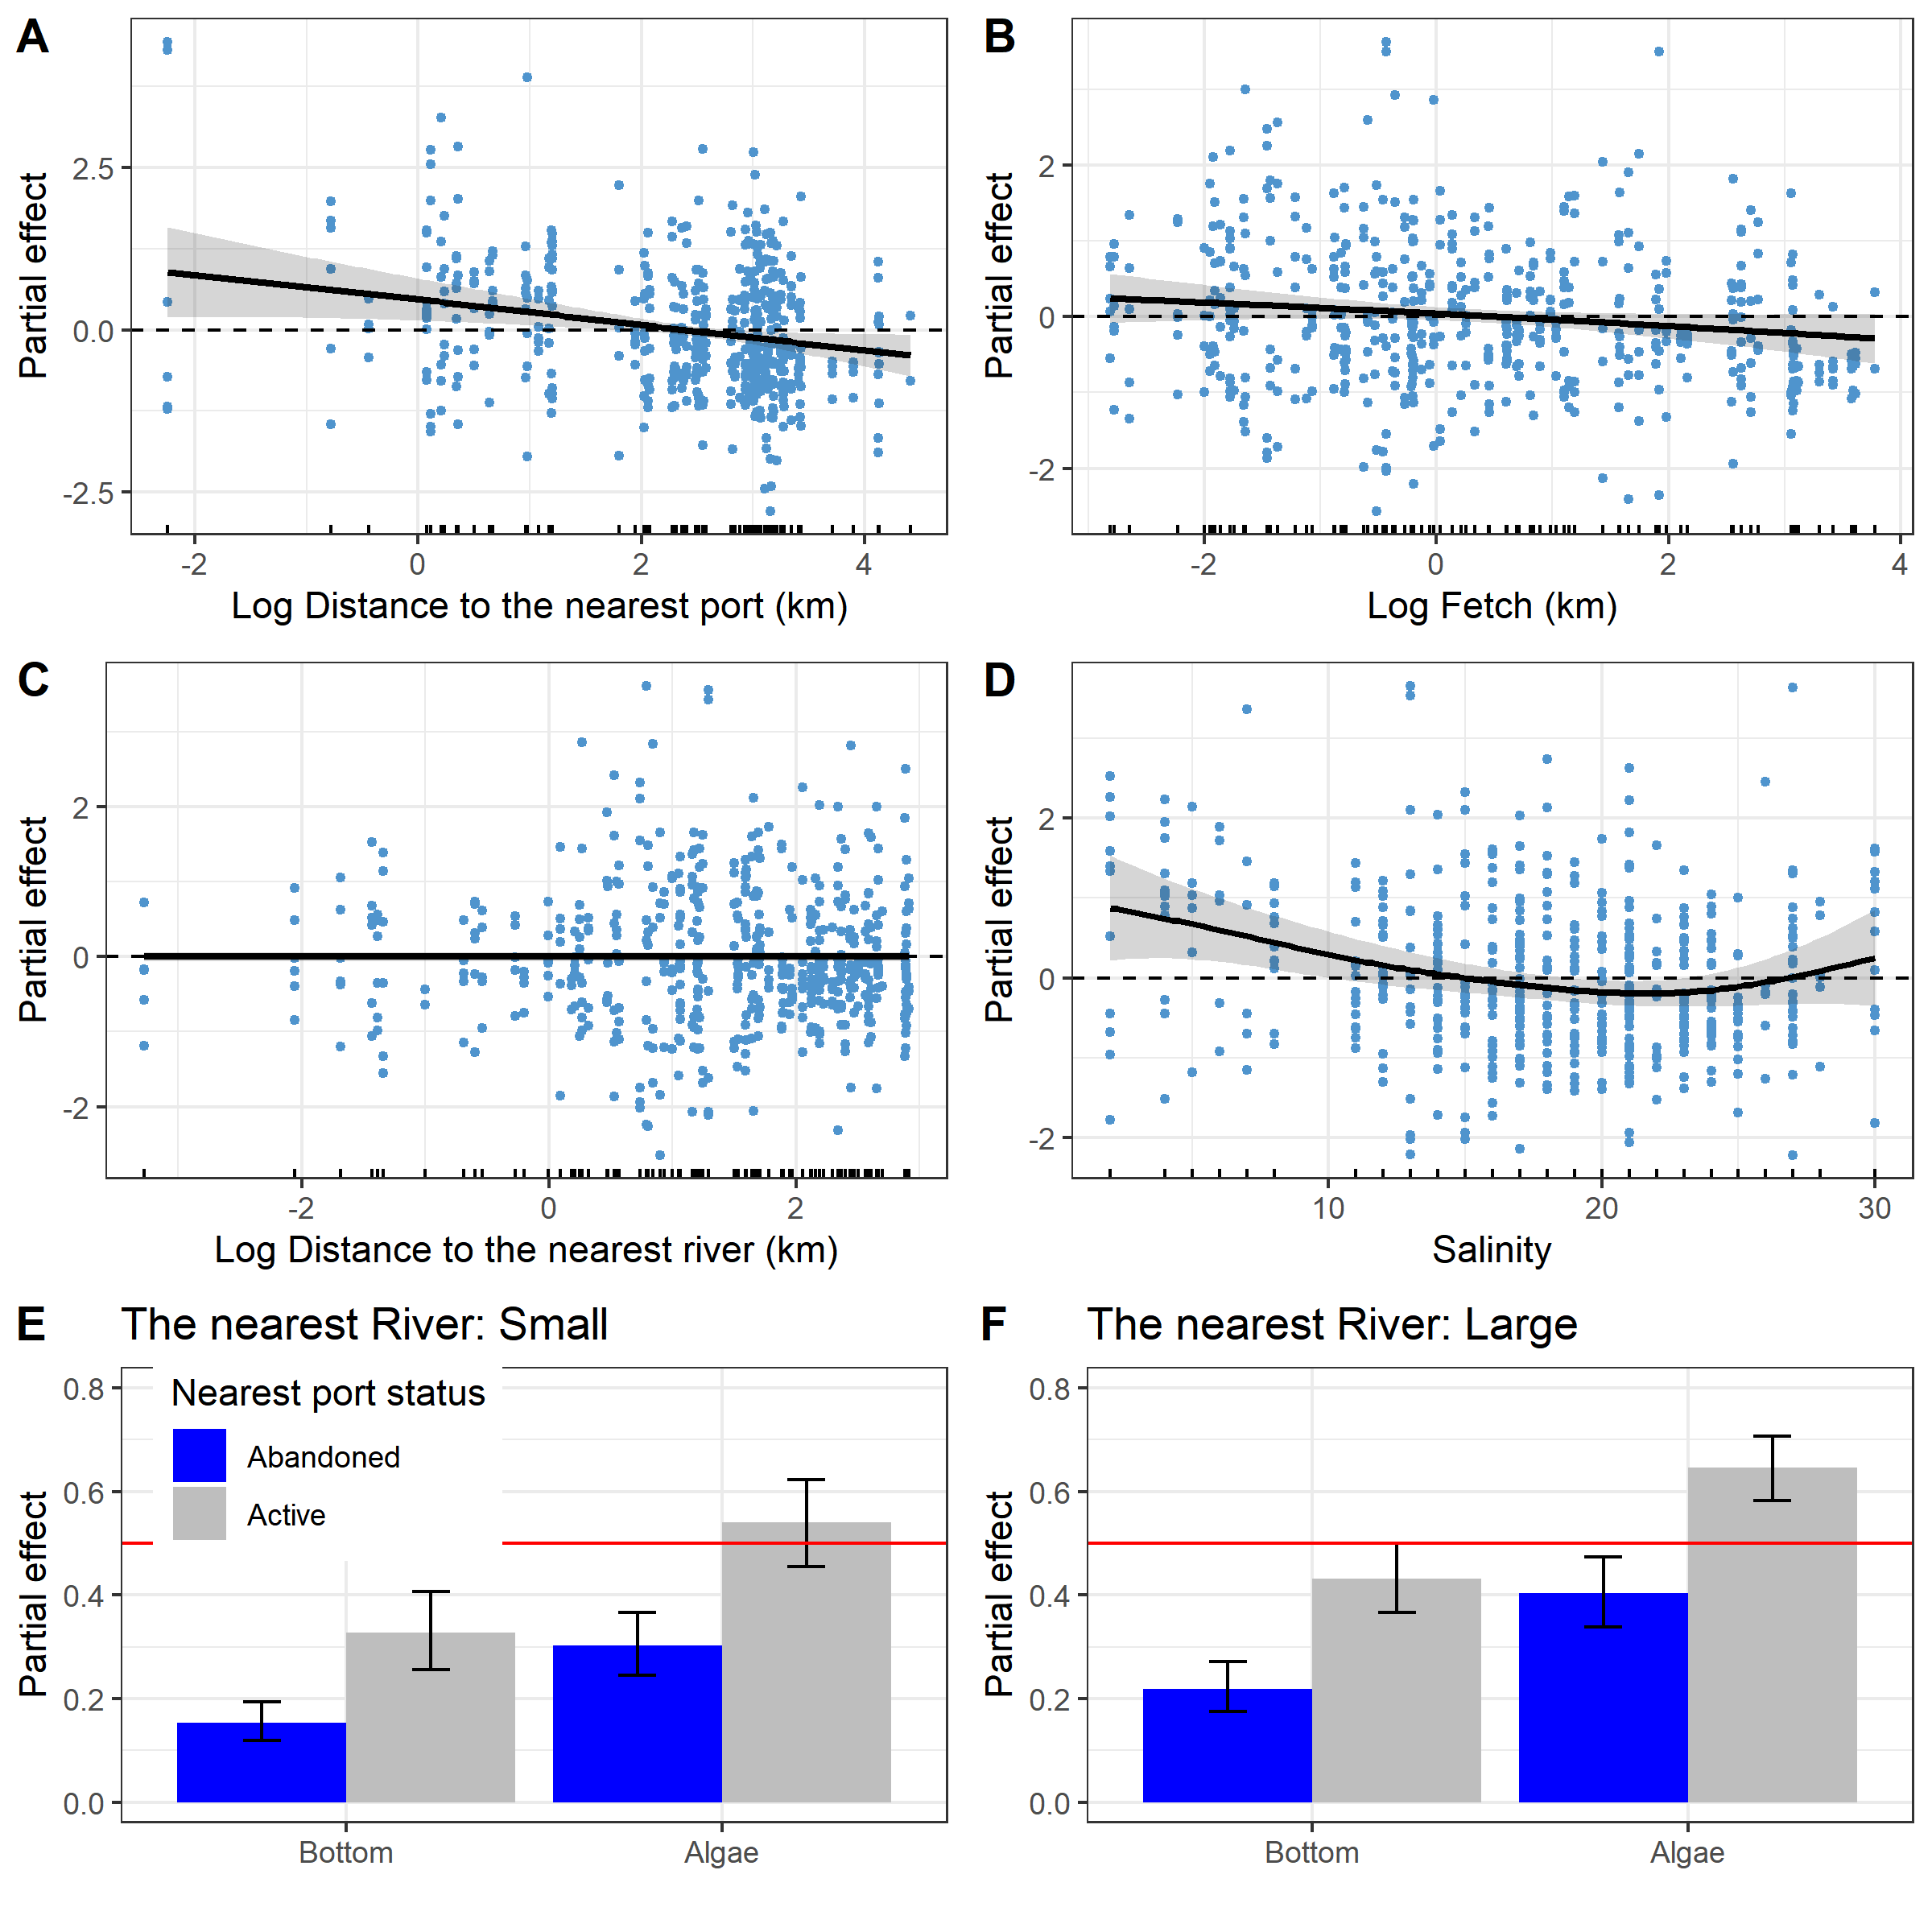

Fig. 3. Predictions of the *Model 1* describing the dependency of *Ptros* on distance to the nearest port (A), average fetch (B), distance to the nearest river (C), salinity (E) and substrate type, nearest port status and size of the largest river (E, F). The gray ribbons and wiskers demonstrate 95% confidence interval. The dotted lines in panels A-D represent the median predicted value, this value is given to track the trend in the change in model predictions. Points on panels A-D reflect partial residuals but not raw data for each sample.

# Supplementary electronic materials (SEM)

### Associations between environmental parameters

Pearson correlation between environmental parameters

| Predictor | Min_dist_river | Min_dist_port | Fetch |
| --- | --- | --- | --- |
| Salinity | 0.368 | 0.049 | 0.250 |
| Min_dist_river | 1.000 | 0.153 | 0.341 |
| Min_dist_port |  | 1.000 | 0.525 |

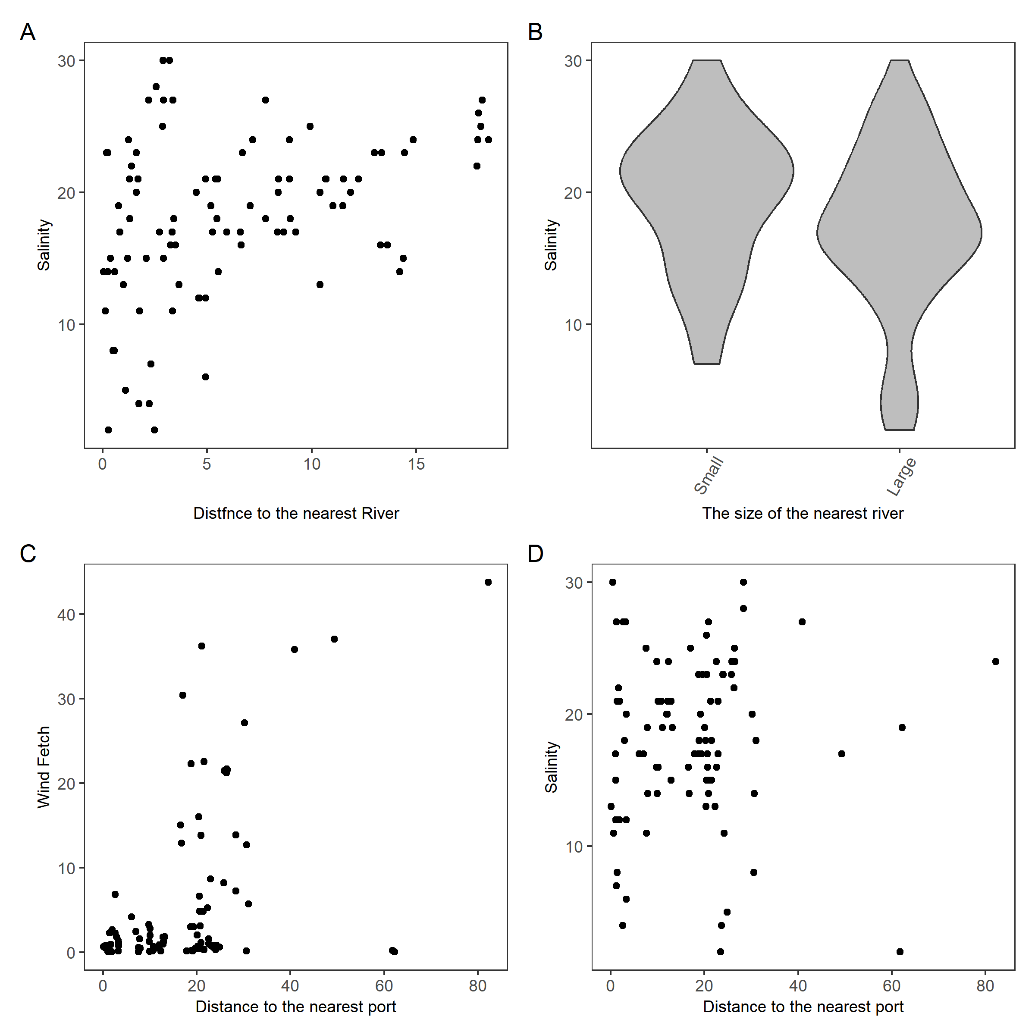

SFigure +. Associations between environmental parameters used. (A) The association of salinity with distance to the mouth of the nearest river. (B) The kernel density violin-plots showing salinity variation for sites near Small and Large rivers. (C) The association between wind fetch and distance to the nearest port. (D) The association of salinity with distance to the nearest port.