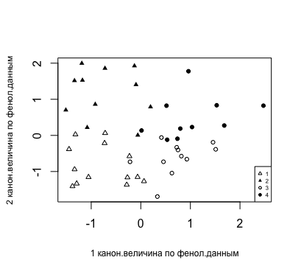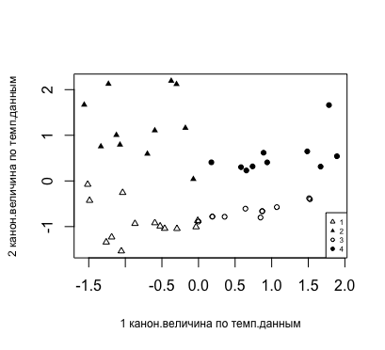**Spring-summer transition and zooplankton phenology in the White Sea coastal zone: is the "paradox of plankton" resolved?** 

# Abstract

Climatic changes manifest themselves, among other, through temporal shifts of seasonal events in environment, which can be critical for planktonic organisms. Long-term observations of the zooplankton organisms and water temperature has been conducted in the Sub-Arctic White Sea (Russian North-West) near the White Sea biological station of Zoological Institute (RAS). These observations allowed to reveal significant correlation between timing of phenological events in the seasonal cycle of planktonic copepods and dynamics of spring-summer temperature dynamics (spring-summer transition). 2 types of seasonal abundance dynamics of copepod juveniles and 4 types of the spring-summer transition were revealed. Each species demonstrated specific dynamics type in response to the specific spring-summer transition type. As a rule, species with close ecological traits differed in their response to changes of temperature dynamics. This phenomenon was explained from the point of view of ecological niche partitioning. In such a way ecologically similar species separate their temporal niches, shifting in time their phenological events, according to spring-summer transition type in this specific year. This separation may be one of the solutions of the Paradox of plankton, and allows high latitude ecosystems to support relatively species-rich planktonic communities.

# Introduction

Temperature is among the primary factors (together with the solar cycle), driving seasonal cycle of high latitude marine ecosystems. Not only variations of absolute temperatures are the signs of climatic fluctuations – climate change manifests itself often through temporal shifts of seasonal temperature cycle – early/late seasonal warming or cooling (Stine et al., 2009; Dwyer et al., 2012; Mackas et al., 2012; Descamps et al., 2019). Such temporal shifts in environment inevitably leads to shifts of major phenological events in populations of marine organisms (Bertram et al., 2001; Ji et al., 2010; Mackas et al., 2012; Usov et al., 2013; Friedland et al., 2015).

Phenological changes in biological systems, which can be connected to the recent climate change, are documented all over the world, both on land and in the oceans and lakes (Parmesan, 2006; Thackeray et al., 2012; Staudinger et al., 2019; Descamps et al., 2019). Marine zooplankton is particularly sensitive to climate changes due to relatively short life cycles of planktonic organisms (Mackas, Beaugrand, 2010; Lombard et al., 2019). Phenological changes in zooplankton populations are interconnected between different trophic levels and populations of competing species (Aebischer et al., 1990; Edwards, Richardson, 2004; Miller-Rushing et al., 2010; Pau et al., 2011; Atkinson et al., 2015). The competition is one of the factors constraining diversity and species abundance in biological communities in general and in planktonic communities in particular (Hardin, 1960; Hutchinson, 1961; DeMott, 1989; Lindegren et al., 2020). However, diversity and abundance of these communities, which inhabit relatively homogeneous medium and consist of species exploiting the same restricted resources, is surprisingly high. This was called "paradox of the plankton" (Hutchinson, 1961). One of the mechanisms of supporting such diversity is separation of temporal niches during seasonal cycle (DeMott, 1989), which is driven by changing environmental conditions during a year. This appears, among other, as differences of species phenology. Therefore, with changing phenological timing, temporal niches of competing species may overlap, causing strengthening of competition, which may have negative implications for planktonic populations and even whole ecosystems (Bertram et al., 2001; Miller-Rushing et al., 2010; Nakazawa, Doi, 2012), because of importance of the plankton as the base of aquatic trophic pyramid.

The importance of problem described above demonstrates the need for thorough long-term investigations of climatic influence on the zooplankton. There are some specific requirements to such work. First, the longer is the period of observations, the greater is probability of revealing long-term patterns (e.g., cyclicity or trends) in seasonal dynamics of temperature and planktonic abundance. According to some works, observations should be 6 times as long as length of period of interest to reveal it reliably (Granger, Hatanaka, 1971). Second, the more often we measure temperature and sample plankton, the subtler shifts in their seasonal cycles and shorter life-cycle phases we can discern. This points out to the importance of long-term high-frequency observations of marine ecosystems. Among studies meeting these requirements is the long-term monitoring of zooplankton and environment near the White Sea Biological station Kartesh of the Zoological institute of the Russian Academy of Sciences (COPEPOD. Interactive Time-series Explorer METABASE, 2018). Present paper is based on this multivariate time series.

In the present study, we performed the detailed analysis of the long-term phenological changes of the following Copepoda species: arctic *Calanus glacialis*, boreal-arctic *Pseudocalanus* spp., boreal *Acartia* spp., *Centropages hamatus,* and *Temora longicornis,* and ubiquitous *Oithona similis* and *Microsetella norvegica*. Arctic *C. glacialis* prefers low temperatures from –0.39 to 4.86 °C (Prygunkova 1974; Zubakha and Usov 2004), living for 2 or 3 years (Prygunkova 1974; Kosobokova 1999). Genus *Pseudocalanus* is presented by two species, *P. acuspes* and *P. minutus* (Markhaseva et al. 2012), which have not been distinguished historically until the last years. These species are characterized by quite similar temperature optima, according to the narrow seasonal peak of their combined abundance, the calculated temperature optimum for the pooled data is 3.5 °C (Zubakha and Usov 2004). In the White Sea, *Calanus* and *Pseudocalanus* reproduce in the end of winter–beginning of spring (in March–May). Boreal *C. hamatus* and *T. longicornis* have similar temperature optima at the study area: 10.3 and 9.9 °C, respectively (Zubakha and Usov 2004); they produce 2–3 generations per year (Prygunkova 1974; Pertsova 1990). The genus *Acartia* is presented in the White Sea by two boreal species, *A. longiremis* and *A. bifilosa,* which were not distinguished historically. They differ slightly by salinity and temperature preferences: *A. bifilosa* withstands freshening and inhabits estuarine regions of the White Sea with lower salinity and higher temperature compared to the open sea (Prudkovsky 2003). According to our observations, this species appears a little later during the season than *A. longiremis*, when water became warmer. Peaks of both species coincide with the warmest period of year (June–September). All the studied boreal species overwinter as dormant eggs, which hatch in the late spring–beginning of summer (June–July; original data). Only single specimens of *Acartia* spp. are found from time to time during winter (December–March), while *Centropages* and *Temora* are totally absent from November to May. Both *Oithona similis* and *Microsetella norvegica* are present in the plankton during the whole year and both have the same optima in the study area, about 9 °C (Zubakha and Usov 2004). The listed species are the most abundant in terms of biomass and numbers in the local zooplankton community and in the entire White Sea. These species represent also the ecological and biogeographical spectra of the local zooplankton. Moreover, *Calanus glacialis*, *Pseudocalanus* spp. and *Oithona similis* are among the most abundant species in the North Atlantic and Arctic oceans (Cornils et al. 2017; Weydmann et al. 2013).

We have already correlated significant shift of the developmental season beginning of several planktonic Copepods inhabiting the White Sea with the substantial shift of spring and summer beginning (Usov et al., 2013). However, that approach, which considered only discrete events in the seasonal temperature dynamics, did not explain how the change of the whole course of the seasonal warming/cooling may influence dynamics of planktonic animals. The latter, obviously, react to temperature continuously, not only at specific temperature thresholds. E.g. early start of summer but slow summer warming or late summer beginning but quick temperature increase during summer, theretically, may have different consequences for planktonic animals. So, another approach may be the analysis of the seasonal temperature curve, or some parts of it, as a whole, with maximal possible resolution. Thus, one of the objectives of this study is revealing the response of copepod phenological timing to changes in the spring-summer transition curve as a whole.

It was shown that in high latitudes the role of interspecific interactions increases during warm season, while the influence of abiotic factors at the edges of vegetation season is rather strong (Pau et al., 2011). Therefore, the phenological changes in population of any species must inevitably result in changes in populations of connected species. So, the second objective of this study is to analyze consequences of phenological changes for interactions in planktonic community.

# Materials and methods

***Sampling site and the period of observations***. Water temperature, water salinity, and the zooplankton abundance have been monitored in Chupa Inlet (Kandalaksha Bay, the White Sea), at the standard station D-1 (depth of 65 m; 66°19′50″N; 33°40′06″E) since 1961 (Fig. 1). Data from this monitoring site are recorded in the database "White Sea Hydrology and Zooplankton Time-Series: Kartesh D1" (COPEPOD. Interactive Time-series Explorer METABASE, 2018); this dataset was used as the data source in this study. The period from 1961 to 2018 was analyzed.

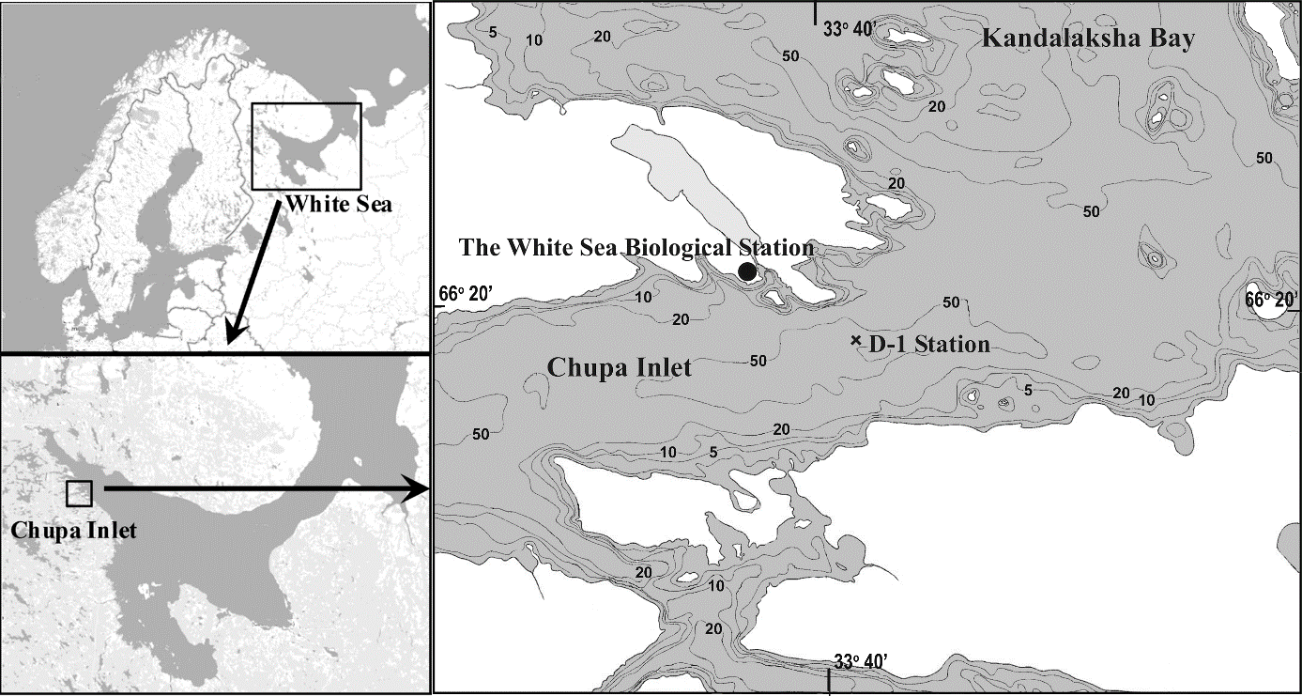

Fig. 1. Location of the study site (D-1 Station) in Chupa Inlet.

***Sampling scheme and methods***. Monitoring was conducted from research vessel during ice-free period and from the ice in winter. Zooplankton was sampled every ten days during the ice-free period and monthly from the ice, except for the period of 1962–1969, when the sampling was performed every ten days all the year round. Zooplankton was sampled from standard water layers (0–10 m, 10–25 m, and 25–65 m) by vertical tows with Juday plankton net (mesh size 200 μm; mouth diameter 37 cm, mouth area 0.1 m2). The samples were immediately preserved with formaldehyde (final concentration 2–4%). In total, more than 3,400 samples have been collected and processed since 1961. The sample processing was performed by the standard methods (Harris et al. 2000). Briefly, the samples were brought to 100 mL or 200 mL volume according to the organisms' concentration assessed visually. The abundant species and their stages (exceeding 10 ind. mL-1) were counted in the Bogorov counting chamber in each of three 1-mL aliquots taken using the Hensen stempel from the total sample. Other species (stages) were counted in the whole sample. Developmental stages of *Calanus glacialis* and *Pseudocalanus* spp. were determined to nauplii, immature copepodites CI–CV (each stage separately), and mature specimens CVI (males and females separately). Copepodite stages of smaller species were combined at counting as juvenile copepodites ["juveniles", CI+CII+CIII] and immature copepodites ["copepodites", CIV+CV]. The abundance was expressed as the number of specimens per one cubic meter (ind. m-3).

Temperature was measured simultaneously with the zooplankton sampling During the period of 1961–2006, the water temperature was measured by reversing thermometers mounted on the Nansen bottle (BM-48) at 0-, 5-, 10-, 15-, 25-, 50-m depths and near the bottom (63–65 m) or by bathythermograph GM7-III. Since 2006, the water temperature has been measured by CTD probe MIDAS 500 (Valeport Ltd.) on continuous profiles from surface to bottom. Prior to active application of the new equipment, CTD was intercalibrated with reversing thermometers and bathythermograph. No significant discrepancies were found within the limits of accuracy of the previously used equipment.

The temperature and juvenile copepods abundance in the layer 0-25 m were used in analysis. It is the upper 25-m layer, where the major part of organic carbon is produced in the White Sea (Prygunkova, 1974; Pertsova, 1980). The reproduction and early development of the studied species also take place in this water layer (Pertsova, 1971, 1974; Prygunkova, 1974; Pertzova, Kosobokova, 2010; Martynova et al., 2011).

***Studied species***. The phenology of six species/genera of planktonic Copepoda were analyzed: cold-water arctic *Calanus glacialis* Jaschnov, 1955 and boreal-arctic *Pseudocalanus* spp., warm-water boreal species *Acartia* spp., *Centropages hamatus* (Lilljeborg, 1853), and *Temora longicornis* (Müller, 1792), and ubiquitous *Oithona similis* Claus, 1866 and *Microsetella norvegica* (Boeck, 1864). Average total abundance of each species (all developmental stages) from May through October (period of reproduction and active development of each studied species) was used in analysis of long-term dynamics.

***Defining the phenological events.*** We analyzed seasonal dynamics of juveniles of the studied species. For each species, the earliest possible stage(s) that could be reliably sampled by 200-µm mesh was (were) analyzed; these stages were considered as indicating the reproductive season of the species. First copepodites (CI) of *Calanus* and *Pseudocalanus* spp., combined CIII–CV of smaller *Acartia* spp., *Centropages*, *Temora*, *Oithona* and *Microsetella* were considered. Four key dates based on the cumulative seasonal abundance (Batten, Mackas, 2009, with modifications) were identified: beginning-of-season, middle-of-season, end-of-season and timing of peak abundance. They were determined in a following way (reference to last article instead of the following text?). Cumulative abundances of mentioned developmental stages of each species, were calculated for each sampling date, starting from January 1 of the calendar year. These cumulative abundances were approximated using a logistic curve that described their dependence on the number of Julian days from January 1 of a given year.

The fitting of the logistic model was performed using the least squares method using the *nls()* function (Bates, Chambers, 1992) from the Stats package (R Core Team, 2019). After estimation of the logistic model parameters, we calculated three of four values, mentioned above:

1. Julian day which corresponded to 15% of the asymptote value of the logistic curve fitted for this species' abundance in a given year. This value was considered as the *Beginning-of-season (BS)*.

2. Julian day at which the inflection point was observed on the logistic curve. This value was considered as the *Middle-of-season (MS)*.

3. Julian day which corresponded to 85% of the asymptote value. This value was considered as the *End-of-season (ES)*.

4. The date of direct observation of the maximum species abundance for the given year was considered as the date of the peak of the species abundance (*Peak*).

Since standard methods of goodness of fit assessment are not appropriate for nonlinear estimations (Spiess, Neumeyer, 2010) the quality of fitted logistic curves was evaluated by visual inspection of correspondence between observed cumulative curve and fitted regression line (ES 1.1). Additionally, we inspected the level of similarity between observed date of Peak and predicted Middle-of-Season date (ES 1.1), which expected to be close to each other. Both methods gave acceptable results.

The long-term average values of the timing of analyzed events are presented in Table 1.

In some years for some species the proposed algorithm for searching phenological events gave improbable results (the end date of the season was not reached until 365-th day, i.e., the logistic curve did not reach the plateau, so it was impossible to calculate the asymptote value of the logistic curve). It was found in *Oithona similis* and *Microsetella norvegica* dynamics (6 years and 1 year, respectively). In 1963, 1972 and 1990, a very short period of *C. glacialis* presence in the plankton fell on the intervals between observations, therefore, the observations could not have been described adequately by the logistic model. These values were considered as missing. These and other missing values were replaced using Singular Spectral Analysis (SSA), proposed as a tool for filling gaps in time series (Golyandina, Osipov, 2007; Golyandina, Korobeynikov, 2014). For this analysis, the *gapfill()* function from the *Rssa* package was used (Golyandina, Korobeynikov, 2014).

***Temperature***. Several seasonal events in temperature dynamics were defined and calculated. For this purpose, the hydrological seasons in 0–25 m depth layer were defined according to methodology offered by A.I. Babkov (Babkov, 1985) with modifications. According to this scheme, the hydrological winter in a specific water layer is a season with water temperatures in this layer (0-25 m in our case) below 0 °C. Hydrological spring and autumn are the periods of the highest rate of the temperature change (increase or decrease, respectively); they correspond to the intervals between the dates of 0 °C and +5 °C thresholds. Hydrological summer is the period when the average water temperature of the layer 0-25 m exceeds +5 °C. This value corresponds also to the upper limit of the optimal temperature range of cold-water zooplankton species (Zubakha, Usov, 2004). The date when average water temperature in layer 0–25 m reached 3 °C was accepted as the beginning of hydrological spring, because period between 0 and 3 °C thresholds coincides with the period of ice melting, when the work was technically impossible neither from ice nor from boat or ship. So, the date of 3°C threshold was the first which could be detected reliably. Other thresholds analyzed are: 4, 5 and 8°C on ascending part of the seasonal curve and timing of the seasonal temperature peak (Table 1). 8°C threshold was the lowest value of the latter since the beginning of monitoring (in 1969). 6- and 7-degree thresholds were not considered, because they correlated strongly (Pearson r = 0.88), and increased unreasonably number of degrees of freedom when included in the canonical correlation analysis. Thus, also, we avoided effect of multicollinearity, when predictors mask effects of each other. Thus, we considered the period from the spring beginning to the temperature peak, the *spring-summer transition* period, when the reproduction and early development of studied species took place.

The dates throughout the paper were expressed as Julian days.

Table 1. Average timing of spring-summer transition and phenological phases in the study region. Values are shown, which were used in analysis. In the column "Species", in brackets, the duration of developmental season (from beginning to end) is shown for each species.

|  |  |  |  |  |
| --- | --- | --- | --- | --- |
| **Temperature** | | **Animals** | | |
| Threshold | Day ± st. error | Species | Phase | Day ± st. error |
| 3°C | 160 ± 1.4 | Calanus  (15 days) | beginning | 154 ± 1.3 |
| 4°C | 169 ± 1.8 | middle | 161 ± 1.2 |
| 5°C | 172 ± 1.9 | end | 169 ± 1.3 |
| 8°C | 191 ± 2.2 | peak | 167 ± 2 |
| t peak | 215 ± 1.9 | Pseudocalanus  (37 days) | beginning | 141 ± 2.5 |
|  |  | middle | 159 ± 2.6 |
|  |  | end | 178 ± 3.1 |
|  |  | peak | 161 ± 2.7 |
|  |  | Acartia  (67 days) | beginning | 203 ± 3.6 |
|  |  | middle | 237 ± 3.6 |
|  |  | end | 270 ± 4.8 |
|  |  | peak | 243 ± 4.1 |
|  |  | Centropages  (36 days) | beginning | 204 ± 2.1 |
|  |  | middle | 222 ± 1.7 |
|  |  | end | 240 ± 1.9 |
|  |  | peak | 229 ± 2.2 |
|  |  | Temora  (39 days) | beginning | 217 ± 1.8 |
|  |  | middle | 237 ± 1.4 |
|  |  | end | 256 ± 1.7 |
|  |  | peak | 241 ± 2.3 |
|  |  | Microsetella  (75 days) | beginning | 158 ± 3.9 |
|  |  | middle | 195 ± 3.7 |
|  |  | end | 233 ± 5.2 |
|  |  | peak | 202 ± 5.1 |
|  |  | Oithona  (122 days) | beginning | 170 ± 4.9 |
|  |  | middle | 231 ± 3.6 |
|  |  | end | 292 ± 4.7 |
|  |  | peak | 230 ± 7.3 |

***Statistical analysis***.

Two arrays of data were used in analysis: biological - timing of phenological events in the seasonal dynamics of studied species and species abundance; abiotic - timing of temperature thresholds. Variables had been previously standardized to zero mean and unit variance prior to analysis. During canonical correlation analysis for each year we obtained several pairs (orthogonal to each other) of canonical scores in the form of linear combinations separately of abiotic and biological variables. They were calculated in such a way as to maximize the correlation (canonical correlation) between biological and abiotic canonical variables. Only the first two pairs of canonical variables and, respectively, two first canonical correlations were significant. Significance of the canonical correlations was assessed by Bartlett criterion (Kendall, Stuart, 1966). For visualization of results of canonical analysis, a scatterplot was built, where the first and second canonical scores of each year were indicated on x and y axes, respectively. Calculations were made in R (R Core Team, 2019), package *CCA* (González, Déjean, 2012).

The signs of the first and second canonical scores indicated different gradation of two factors, which determine the shape and shift of the seasonal temperature curves. The ANOVA repeated measures analysis was used to assess the significance of influence of revealed factors on the timing of thresholds 3, 4, 5 and 8°C. The estimates of the parameters of this model were used to build curves of temperature spring-summer dynamics (spring-summer transition), corresponding to contrasting types of the latter. To take into account all the data in ANOVA Repeated Measures, including incomplete ones, the ergodic method was used (Alexeyeva, 2017), which allowed us to assess model parameters without removing incomplete data and without artificial filling of missing values. In the ANOVA Repeated Measures model, the missing data leads to a bias that can be estimated using the ergodic method, so an appropriate correction is applied to the data, and then statistics are calculated from the already centralized model. For ANOVA Repeated Measures R packages *MASS* (Ripley et al., 2020), *pracma* (Borchers, 2019), *magic* (Hankin, 2018) and *corpcor* (Schafer, 2017) were used.

All the estimates were considered statistically significant at a critical level of significance p = 0.05.

# Results

***Types of the spring-summer transition.*** Canonical correlations between phenological indices of studied species and timing of the spring-summer transition are shown in the Table 2. The first and second canonical correlations exceeded 0.9. However, despite p2 = 0.072 the second canonical correlation and corresponding canonical variates reflected important patterns in temperature dynamics and species phenology (see below) and was considered in further analysis.

Canonical variables (C.V.) for temperature data characterized specific transition regimes. The latter in a specific year were expressed through the signs (and values?) of canonical scores for this year. First C.V.: positive values of canonical scores indicated early spring-summer transition (negative coefficients at 4, 5 and 8°C thresholds; coefficient for 3°C is low) with late seasonal temperature peak (Fig. 2). Second C.V.: positive values of canonical scores indicated early spring beginning (negative coefficient at 3°C threshold), but slow spring transition (positive coefficient at 4°C, which means large interval between 3°C and 4°C), earlier timing of 5 and 8°C thresholds and later timing of peak (Fig. 2). In brief, first C.V. characterized shift of transition from year to year (early, when C.V.1 is positive, but late, when it is negative), the second C.V. – the rate of spring transition: slow (C.V.2 is positive) and fast (C.V.2 negative).

Thus, all the years, depending on the combination of signs of the canonical scores for the first and second canonical variables for each specific year, may be divided into four groups, which are characterized by four variants of the spring-summer transition (Fig. 2; Table 3): 1) late and fast transition; 2) late and slow transition (the variant, when the second canonical variable has positive sign, so the spring beginning (3°C) is relatively early); 3) early and fast transition; 4) early and slow transition. Definitions "slow" and "fast" refer here mostly to the part of curve between 3 and 4°C or period of spring transition. So, each year may be characterized by the form (slow – fast) and shift (early – late) of transition. These groups separate well in the space of the first two canonical axes, calculated either on the temperature or phenological data (Fig. 3). Note that the grouping is very similar in both cases (abiotic and biological data). Respective grouping of years is presented in Table 3.

Table 2. Canonical correlation results. A – significant canonical correlations and Bartlett test results (Chi-square, degrees of freedom and p-value). B – canonical coefficients for temperature threshold dates, phenological indices and abundance of studied species. C.V.1, C.V.2 – first and second canonical variates. Species are grouped according to type of response to temperature dynamics changes (see below).

|  |  |  |  |
| --- | --- | --- | --- |
| **A** | χ2 | df | p value |
| r1 = 0.96 | 221.12 | 175 | 0.010 |
| r2 = 0.95 | 160.84 | 136 | 0.072 |

|  |  |  |  |
| --- | --- | --- | --- |
| **B** | t-threshold or phenological event | C.V.1 | C.V.2 |
| Temperature | 3°C | 0.044 | -0.660 |
| thresholds | 4°C | -0.266 | 0.737 |
|  | 5°C | -0.394 | -0.108 |
|  | 8°C | -0.604 | -0.093 |
|  | Peak | 0.638 | 0.026 |
| Calanus | beginning | 0.133 | 0.041 |
| Calanus | middle | -0.204 | -0.066 |
| Calanus | end | 0.125 | 0.044 |
| Calanus | peak | -0.053 | -0.019 |
| Centropages | beginning | 0.390 | 0.100 |
| Centropages | middle | -0.590 | -0.158 |
| Centropages | end | 0.350 | 0.095 |
| Centropages | peak | -0.011 | 0.001 |
| Temora | beginning | -0.003 | -0.019 |
| Temora | middle | 0.028 | 0.050 |
| Temora | end | -0.010 | -0.026 |
| Temora | peak | -0.017 | -0.008 |
| Oithona | beginning | -0.228 | -0.381 |
| Oithona | middle | 0.320 | 0.565 |
| Oithona | end | -0.214 | -0.378 |
| Oithona | peak | 0.033 | 0.008 |
| Acartia | beginning | -0.003 | -0.073 |
| Acartia | middle | -0.021 | 0.134 |
| Acartia | end | 0.033 | -0.085 |
| Acartia | peak | -0.030 | -0.003 |
| Microsetella | beginning | 0.110 | -0.070 |
| Microsetella | middle | -0.228 | 0.105 |
| Microsetella | end | 0.146 | -0.076 |
| Microsetella | peak | 0.008 | 0.011 |
| Pseudocalanus | beginning | -0.014 | 0.254 |
| Pseudocalanus | middle | 0.064 | -0.399 |
| Pseudocalanus | end | -0.042 | 0.244 |
| Pseudocalanus | peak | -0.021 | -0.010 |
| Calanus | number | 0.027 | 0.009 |
| Pseudocalanus | number | 0.003 | -0.001 |
| Acartia | number | 0.024 | 0.001 |
| Centropages | number | -0.013 | 0.001 |
| Oithona | number | -0.033 | -0.008 |
| Temora | number | 0.021 | 0.000 |
| Microsetella | number | -0.009 | -0.006 |

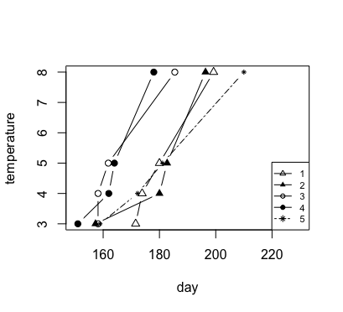

Fig. 2. Graphs of the four types of spring-summer temperature dynamics. Legend: 1 – late and fast, 2 – late and slow, 3 – early and fast, 4 – early and slow, 5 – years with incomplete data.

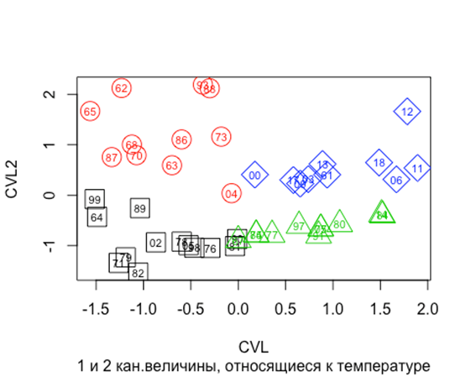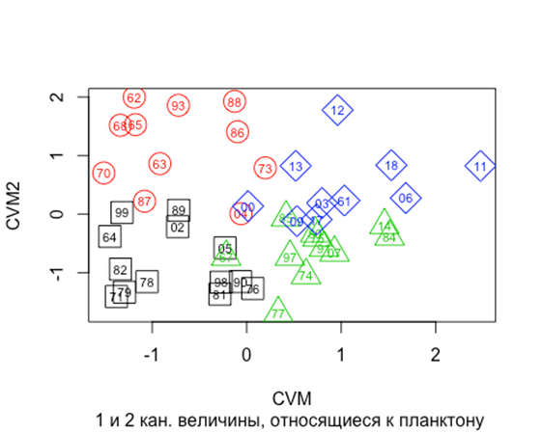

Fig. 3. Ordination of years in the space of canonical variates (axes), based on timing of the spring-summer transition (A) and phenological data (B). Numbers in figures – years (61-99 – 1961-1999; 00-18 – 2000-2018). Rectangles – late and fast, circles – late and slow, triangles – early and fast, diamonds – early and slow.

Table 3. Years with different types of spring-summer transition.

|  |  |
| --- | --- |
| Group (as on Fig. 4 and 5) | Years |
| 1 | 1964, 1971, 1976, 1978, 1979, 1981, 1982, 1989, 1990, 1998, 1999, 2002, 2005 |
| 2 | 1962, 1963, 1965, 1968, 1970, 1973, 1986, 1987, 1988, 1993, 2004 |
| 3 | 1967, 1974, 1975, 1977, 1980, 1984, 1985, 1991, 1997, 2007, 2014 |
| 4 | 1961, 2000, 2003, 2006, 2009, 2011, 2012, 2013, 2017, 2018 |
| 5 | 1966, 1969, 1983, 1992, 1994, 1995, 1996, 2001, 2008, 2010, 2015, 2016 |

***Phenological response of the abundant species to changes in spring-summer transition.*** Analogous to the temperature dynamics, canonical analysis revealed two principal schemes of seasonal dynamics of the juveniles of the studied species, which could be discerned from the values of canonical coefficients for studied phenological variables. These schemes are illustrated in Figure 4. 1-st type of phenology: late beginning and end of the season with the middle of season shifted towards the beginning (signs "+" – "-" – "+" at the respective canonical coefficients for each species). 2-nd type of phenology: early beginning and end of the season with the middle of season shifted towards the end of season (signs "-" – "+" – "-" at the canonical coefficients). This pattern was broken in the case of *Acartia* spp., which demonstrated early beginning of season, early middle of season and late end of season. However, taking into account that canonical coefficient for the beginning of season was very low, dynamics of these species can be considered as the 1-st type of phenology. Specific phenology type of a species depended on the combination of the first and second canonical variables determined by the temperature ("form" and "shift" of spring-summer transition).

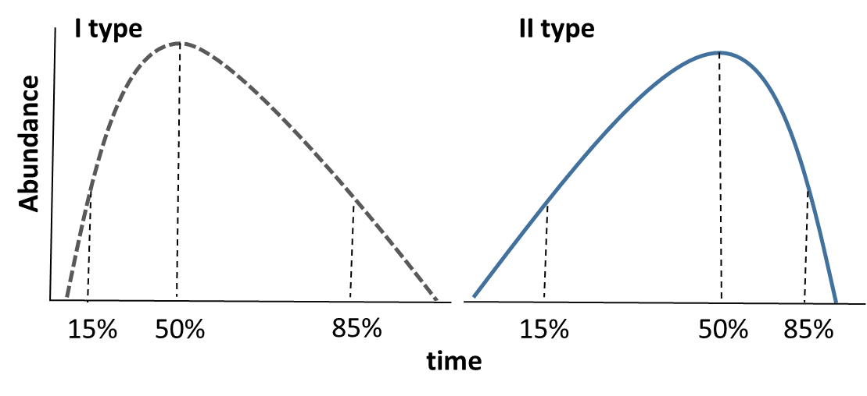

Fig. 4. Schematic view of two types of animal seasonal dynamics, described in the text. 15%, 50% and 85% - percentiles of the cumulative abundance (beginning, middle and end of season, respectively). Timing of the middle of season almost coincides with the timing of abundance peak (see Table 1).

Canonical coefficients at the seasonal abundance peak timing were relatively low, except *Acartia* and *Temora*, so we will not pay special attention to these phenological indices. Moreover, this timing was close to the middle of season in most cases (see Table 1).

Temperature thresholds and timing of species phenology demonstrated different contribution to the values of canonical variables and eventually to canonical correlations. The first canonical correlation was determined mostly by the "shift" of spring transition and by the phenology of two species – *Oithona similis* and *Centropages hamatus* (Table 2). *Calanus glacialis* and *Microsetella norvegica* also demonstrated significant contribution. The second correlation was determined primarily by the timing of spring and summer beginning and rate of the temperature increase from 3 to 4°С (i.e. "form" of spring-summer transition), and also by phenology of *Oithona similis* and *Pseudocalanus* spp. For all studied species the middle of season had greater weight than its beginning and end.

Two phenology schemes, described above, corresponded to four types of spring-summer temperature dynamics, revealed earlier (Table 4). For juveniles of *Calanus* and *Centropages* 1-st type of phenology (late beginning and end of the season with early middle of season) was characteristic in years, when the transition was early and slow, and opposite phenology (2-nd type - early beginning and end of the season with late middle of season) – when transition was late and fast. *Temora* and *Oithona* demonstrated opposite response: 1-st type of phenology in years, when transition was late and fast, and 2-nd type of phenology, when the transition was early and slow. *Microsetella* and *Acartia* (with admission for the latter, made above) demonstrated 1-st type of phenology in years, when the transition was early and fast, and 2-nd type, when that was late and slow. *Pseudocalanus*, on the contrary, demonstrated 2-nd type of phenology in years, when transition was early and fast, and 1-st type, when the transition was late and slow.

Abundance of juveniles responded only to the shift of spring-summer transition (coefficients for the 2-st canonical variate are very low). Abundance of *Calanus*, *Acartia* and *Temora* tended to be high, and abundance of *Oithona* и *Centropages* – low, in years with early spring-summer transition (Table 2).

Table 4. Types of the seasonal dynamics of copepod juveniles (types of phenology) at different regimes of spring-summer transition.

|  |  |  |  |  |
| --- | --- | --- | --- | --- |
| Type of transition  Species | Early slow | Early fast | Late slow | Late fast |
| Calanus glacialis | 1 |  |  | 2 |
| Centropages hamatus | 1 |  |  | 2 |
| Oithona similis | 2 |  |  | 1 |
| Temora longicornis | 2 |  |  | 1 |
| Acartia spp. |  | 1 | 2 |  |
| Microsetella norvegica |  | 1 | 2 |  |
| Pseudocalanus spp. |  | 2 | 1 |  |

***Trends in the long-term dynamics of the studied parameters (1961-2018).*** The years with different types of spring-summer transition demonstrated some pattern in their distribution in time (Fig. 5). General tendency was observed from late and slow towards early and slow transition. The years characterized by early slow transition were all but one (1961) concentrated after 2000. Years with fast transition were mostly concentrated in the first half of the studied period. Thus, there existed tendency towards early spring and summer and relatively prolonged spring.



Fig. 5. Temporal distribution of years with different types of spring-summer transition.

Long-term trends were revealed in the dynamics of some phenological indices, despite large interannual fluctuations (Fig. 6). *Calanus glacialis* and *Pseudocalanus* spp. demonstrated significant tendency towards earlier developmental season: R2 for different phenological phases of these species was within the range from 0.13 to 0.23 (b from -0.23 to -0.68; p < 0.05). Significant shift towards earlier time was found for *Centropages* beginning and middle of season (R2 = 0.10 and 0.12, respectively; b = -0.31 and -0.26; p = 0.01) and *Temora* beginning and middle of season (R2 = 0.23 and 0.19; b = -0.40 and -0.28; p = 0.0001 and 0.0006).

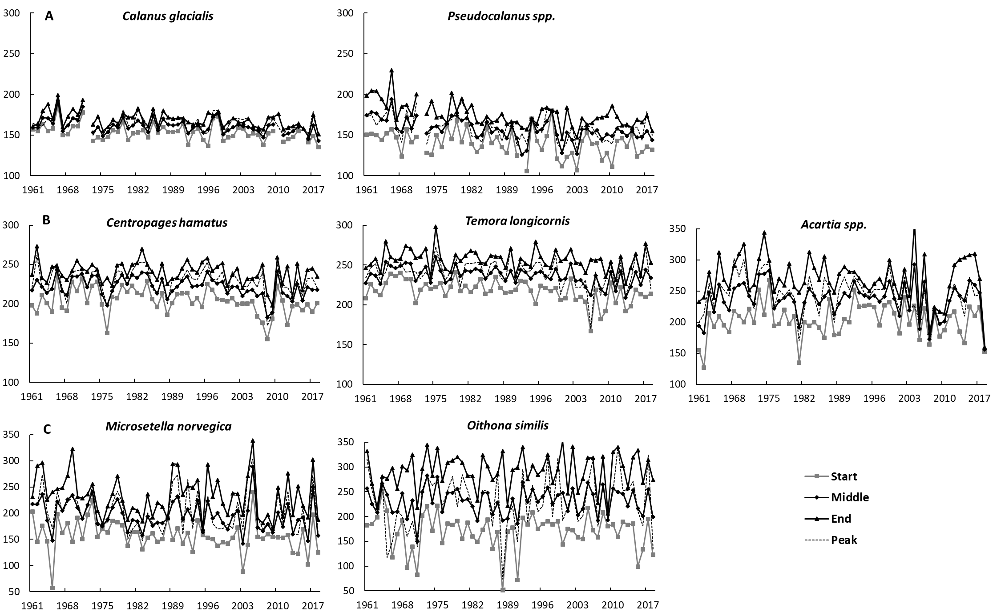

Fig. 6. Long-term dynamics of timing of the beginning, middle, end of the developmental season and abundance peak of abundant copepods. A – Arctic species, B – boreal species, C – eurybiont species.

Предлагаю вот такую визуализацию. Можно доработать, например, описав двумерными GAMи, как я делал для оитоны и микросетеллы и нанести линию тренда для даты пика, например. Ну там, еще раскраску додумать и перегруппировать виды.

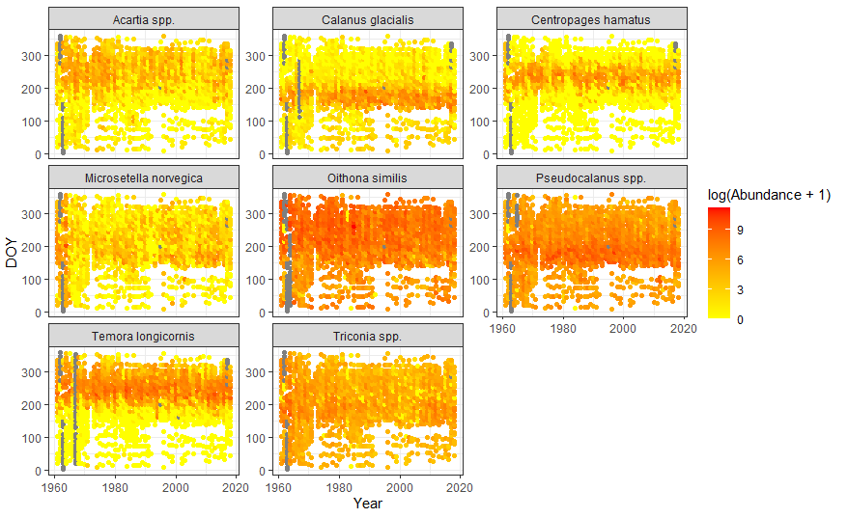

# Discussion

Our results revealed a phenological response of copepod juveniles to the changes of timing of the spring-summer transition in the studied region of the White Sea. The response of species with different temperature preferences (Zubakha, Usov, 2004) could be similar and, on the contrary, the response of similar species could be different. For example, similar reaction of arctic cold-water *Calanus glacialis* and boreal warm-water *Centropages hamatus* was connected to the same type of spring-summer transition.

How such similarity could be explained? *Calanus* is a typical arctic species. Its middle of season, on average, coincided with the 3°С threshold, and the end of season – with the 4°С threshold. Therefore, early middle and late end of season of *Calanus* would correspond to early slow transition, and vice-versa, just what was shown in our work. This corresponds to the data, that early development of *C. glacialis* depends on water temperature – the higher the temperature, the faster development from the first naupliar stage to the first copepodite stage (Corkett et al., 1986; McLaren et al., 1988; Daase et al., 2011). *Centropages* is a warm-water boreal species with one of the highest temperature optimums in the White Sea (Zubakha, Usov, 2004). The beginning of season of *Centropages* took place just after the 8°С threshold, however negative tie was revealed between timings of those two events (opposite signs of canonical coefficients). Probably, spring transition (between 3°С and 4°С) was more important for the beginning of *Centropages* season. Indeed, fast increase of *Centropages* nauplii abundance was observed normally on the 180-th day, about 10 days after 4°С threshold (original data). Middle of season of *Centropages* was observed after seasonal peak of temperature (more, than 2 months later, than *Calanus*). The development of *Centropages* juveniles after the middle of season continued, when the water started to cool down. Hence, some factors other than temperature might influence *Centropages* and other boreal animals in that part of season (see below).

Early development of the cold-water species of the genus *Pseudocalanus* is very similar to the development of *Calanus glacialis* (Prygunkova, 1974; Usov et al., 2013). Nevertheless, response of this species to the spring-summer transition differed from the response of *Calanus* (see Table 4). It is worth noting in this regard that the first nauplii of *Pseudocalanus* spp. appeared about two months earlier than nauplii of *Calanus*, and peak of abundance of *Pseudocalanus* nauplii also was observed earlier (original data). Therefore, large part of development of *Pseudocalanus* juveniles took place under the ice, long before transition of the water above 0°С. This may be the cause that *Pseudocalanus* is less dependent on the temperature, than *Calanus*. Lower dependence of *Pseudocalanus* on the temperature in the White Sea was revealed in modelling study of Persson et al. (2012). Besides that, interpretation of the results is complicated by the existence of two species of *Pseudocalanus* in the White Sea (*P. acuspes* and *P. minutus*), which have not been distinguished since the beginning of observations (Markhaseva et al., 2012).

Phenological phases of juveniles of the boreal species *Acartia* spp. и *Temora longicornis* were very close to phenological timing of *Centropages* (Table 1). Development of all studied boreal species (*Acartia* spp., *Temora* and *Centropages*) took place after 8°С threshold and beginning of the seasonal cooling. When the peak of temperature was shifted to a later time ("early" transition), the beginning of season of *Acartia*, like in the case of *Centropages*, also was shifted forward. However, the responses of these species to the rate of transition ("slow" - "fast") were different (see Table 4). *Temora*, the most probably, was influenced by the shift of 8°С threshold: the earlier it was, the earlier development of this species began. The response of *Temora* to the rate of transition was similar to that of *Acartia* spp. Thus, despite similarity of temperature preferences of these boreal species, their responses to the dynamics of spring-summer transition differ. The development of these species (as already was mentioned regarding *Centropages* phenology) mostly took place after seasonal peak of temperature. So, the temperature must not be of primary importance for this period of the life cycle. Indeed, it was shown, that after beginning of seasonal cooling boreal species in this part of the White Sea depended mostly on the availability of food resources (Martynova et al., 2011).

*Oithona similis* responded to the dynamics of the seasonal transition in the same way as *Temora longicornis*, however these two species differed substantially in their biology. Despite the fact that the middle of season of *Oithona* is close to that of boreal species, *Oithona* is the most eurybiont among species inhabiting the White Sea (Prygunkova, 1974). It reproduces all the year round even in Arctic (Dvoretsky, Dvoretsky, 2009). The developmental season (defined by the appearance of the first copepodite stages) of *Oithona* in the study region began only 16 days later than season of *Calanus*, but ended later than season of any other species, after 290-th day, near mid-October. The development of *Oithona* after the middle of season, which took place after peak of temperature, like in the case of boreal species, hardly depended on the temperature.

The response of *Microsetella norvegica* to the changes of seasonal transition was the same as *Acartia* spp., however, the developmental season of *Microsetella* passed much earlier. Therefore, juveniles of these two species was exposed to temperature fluctuations in different periods of year. Temperature optimum of *Microsetella* is negligibly lower, than optimum of *Acartia*: 8.1°С и 8.3°С, respectively (Zubakha, Usov, 2004). However, the biology of *Microsetella* differs substantially from other planktonic Copepoda. It is one of very few true planktonic Harpacticoida in the World Ocean (Boxshall, 1979; Huys, Boxshall, 1991) and the only – in the White Sea (Kornev, Chertoprud, 2008). There are data on connection of Microsetella with benthic biotopes (Zhang et al., 2004; Kornev, Chertoprud, 2008). Besides that, trophic preferences and trophic behaviour of this species distinguish *Microsetella* from other copepods found in the White Sea – in other parts of the World Ocean this species is found often on detrital aggregates and abandoned houses of Appendicularia (Green, Dagg, 1997; Koski et al., 2005; Maar et al., 2006). Abundance outbursts of *Microsetella* in the White Sea in the recent years were connected with anomalous blooms of *Phaeocystis* (original observations).

Phenology of a specific organism is a result of combined effect of environmental factors and competitive interactions between community members (Pau et al., 2011). It is especially apparent in plankton, where competition for the same resource is observed in relatively homogeneous environment. Despite that, relatively high diversity is maintained in planktonic communities – this phenomenon was called "the paradox of plankton" (Hutchinson, 1961). One of the explanations of it is that temporal change of environmental conditions and accessibility of resources lead to change in competitive abilities of species (Hutchinson, 1961; DeMott, 1989). As a result, in a seasonal climate in each specific period of year, the species get advantage, which are the most adapted to this very conditions. Basically, it is expressed in the difference of the seasonal dynamics of various species. This helps to separate in time key events in life cycles of different community members, or, in other words, separate their temporal niches (Gotelli, Graves, 1996). However, the seasonal dynamics of some species is very close to each other, as in the case of boreal species in the White Sea. Nevertheless, these species demonstrated differences in their responses to the year-to-year changes of temperature dynamics (spring-summer transition). As a result, phenological events of boreal species shifted relative to each other from year to year, thus separating temporal niches.

However, seasonal dynamics of the boreal species *Acartia*, *Centropages* and *Temora* is so similar, that they could not escape competition without turning on additional mechanisms of niche separation. Here, temporal separation is enforced by differences in the feeding preferences of these species (Martynova et al., 2011). Trophic differences seem to weaken competition of the boreal species with *Oithona similis*, seasonal peak of which is close in time to abundance peak of those, but trophic spectra differ substantially (Marshall, Orr, 1966; Kattner et al., 2003).

We have found that different types of spring-summer transition were distributed unevenly during the period of investigations (Fig. 5), with tendency towards early and slow transition. This trend corresponds well to the global warming trend, and explains, at least partly, tendecies in phenology towards earlier developmental season of studied species (Mackas et al., 2012; Atkinson et al., 2015). It was hypothesized earlier, that high-latitude species with early reproductive season are most sensitive to climate change (Pau et al., 2011), which is confirmed in our study by stronger trends in phenology of arctic species *Calanus* and *Pseudocalanus*. On the other hand, hatching of the resting eggs of boreal species depends to a large extent on the water temperature (Katajisto, 2003; Boyer, Bonnet, 2013; Holm et al., 2018). So, earlier beginning of season of boreal warm-water *Centropages* and *Temora*, which spend winter in the White Sea in the diapausing eggs, can be attributed to earlier summer warming (Pertzova, 1990).

Analysis of the reaction of planktonic copepods to long-term trends in seasonal temperature timing indicated that it differs from response to changes of the same sign at the year-to-year scale. E.g., *Calanus* and *Pseudocalanus* phenological response to the same seasonal transition regime differed substantially, but was similar in response to long-term shifts of the seasonal transition timing. The same can be said about boreal species. We can suppose that different factors may be of different significance at different time scales. Short-term (mostly local) fluctuations of environment and biological (competitive) interactions play important role in driving year-to-year changes of phenology. Long-term trends in dynamics of phenological variables must be determined to a larger extent by climatic, global-scale processes, expressed at the local scale through long-term changes in environment.

# Conclusion

Long-term temporal shifts of phenological processes in the seasonal cycles of planktonic copepods are connected to changes in the spring-summer temperature dynamics, as revealed by canonical correlation analysis. 4 types of seasonal temperature dynamics and 2 types of seasonal dynamics of copepod juveniles were revealed. Each species demonstrated specific type of seasonal dynamics in response to specific type of temperature dynamics. As a rule, species with similar temperature preferences demonstrated different responses to the same changes in temperature dynamics.

This may have an explanation from the point of view of the theory of ecological niche. Different reaction on the changes in environment (the temperature dynamics in our case) allows to separate temporal niches of two ecologically similar species, e.g. boreal species. This difference leads to relative shifts of their phenological phases in time, and, therefore, to separation of their temporal niches, according to spring-summer transition type in this specific year. This separation may be one of the mechanisms which facilitate competition between species, having close feeding preferences and inhabiting homogeneous medium with limited resources. Owing to this temporal niche separation high abundance and production of zooplankton is supported in high latitudes, despite relatively short vegetation season.

Response of animals to the long-term trends in environment may differ from their reaction at the scale of year-to-year fluctuations. This, probably, arises from the different mechanisms determining dynamics at different scales: biological interactions must have more contribution at the year-to-year scale, and large-scale climatic forcing – at the scale of decades.

Of course, the mechanisms of niche separation are not limited to those mentioned in our work. Spatial dimension of multidimensional Hutchinson's niche also deserves attention. It is especially important for plankton, whose habitat is three-dimensional and offer more opportunities for coexistence of ecologically similar species. This is subject for special study.

# References

Aebischer, N., Coulson, J. & Colebrook, J. (1990) Parallel long-term trends across four marine trophic levels and weather. Nature 347, 753–755. <https://doi.org/10.1038/347753a0>

Alexeyeva N. (2017) Dual balance correction in repeated measures ANOVA with missing data. Electronic Journal of Applied Statistical Analysis. 10(1): 146-159. https://doi.org/10.1285/i20705948v10n1p146

Atkinson, A., Harmer, R. A., Widdicombe, C. E., McEvoy, A. J., Smyth, T. J., Cummings, D. G., Somerfield PJ., Maud JL., McConville, K. (2015). Questioning the role of phenology shifts and trophic mismatching in a planktonic food web. Progress in Oceanography, 137, 498–512. <https://doi.org/10.1016/j.pocean.2015.04.023>

Babkov AI (1985) About the principles of determination of hydrological seasons (by the example of Chupa inlet, the White Sea. Explorations of the fauna of the seas 31(39): 84–88. [in Russian]

Bates DM, Chambers JM (1992) Nonlinear models. In: Chambers SJM and Hastie TJ (eds) Statistical Models. Wadsworth & Brooks/Cole.

Bertram, D. F., Mackas, D. L., & McKinnell, S. M. (2001). The seasonal cycle revisited: Interannual variation and ecosystem consequences. Progress in Oceanography, 49(1–4), 283–307. <https://doi.org/10.1016/S0079-6611(01)00027-1>

Borchers HW (2019) pracma: Practical Numerical Math Functions. R package. Version 2.2.9. Available from https://cran.r-project.org/package=pracma.

Boyer S., Bonnet D. (2013) Triggers for hatching of Paracartia grani (Copepoda: Calanoida) resting eggs: an experimental approach. J. Plankton Res., 35, 668–676. https://doi.org/10.1093/plankt/fbt020

Boxshall, G.A. (1979). The planktonic copepods of the northeastern Atlantic Ocean: Harpacticoida, Siphonostomatoida and Mormonilloida. Bulletin of the British Museum of Natural History (Bul. Br. Mus. Nat. Hist.), Zoology. 35(3): 201-264.

COPEPOD. Interactive Time-series Explorer METABASE (2018): [https://www.st.nmfs.noaa.gov/ copepod/time-series/ru-10101/](https://www.st.nmfs.noaa.gov/%20copepod/%20copepod/time-series/ru-10101/)

Corkett, C. J., I. A. McLaren & J.M. Sevigny, 1986. The rearing of the marine calanoid copepods *Calanus finmarchicus* (Gunnerus), *C. glacialis* Jaschnov and *C. hyperboreus* Kroyer with comment on the equiproportional rule. In Schriever, G., H. K. Schminke & C. T. Shih (eds), Syllogeus 58. Proceedings of 2nd International Conference on Copepoda, 13–17 August, Ottawa. The National Museum of Canada, Ottawa, 539–546.

Daase M., Søreide J. & Martynova D., 2011. Effects of food quality and food concentration on naupliar development of Calanus glacialis at sub-zero temperatures. Marine Ecology Progress Series 429: 111–124.

DeMott W.R. (1989) The Role of Competition in Zooplankton Succession. In: Sommer U. (eds) Plankton Ecology. Brock/Springer Series in Contemporary Bioscience. Springer, Berlin, Heidelberg. <https://doi.org/10.1007/978-3-642-74890-5_6>

Descamps S., Ramírez F., Benjaminsen S., Anker-Nilssen T., Barrett R. T., Burr Z., Christensen‐Dalsgaard S, Erikstad K‐E, Irons DB, Lorentsen S‐H, Mallory ML, Robertson GJ, Reiertsen TK, Strøm H, Varpe Ø, Lavergne S. (2019). Diverging phenological responses of Arctic seabirds to an earlier spring. Global Change Biology, 25(12), 4081–4091. <https://doi.org/10.1111/gcb.14780>

Dvoretsky V.G., Dvoretsky A.G. (2009). Life cycle of Oithona similis (Copepoda: Cyclopoida) in Kola Bay (Barents Sea). Mar. Biol. 156, 1433–1446. https://doi.org/10.1007/s00227-009-1183-4

Dwyer, J.G., M. Biasutti, and A.H. Sobel (2012). Projected Changes in the Seasonal Cycle of Surface Temperature. J. Climate, 25, 6359–6374, <https://doi.org/10.1175/JCLI-D-11-00741.1>

Edwards, M., & Richardson, A. J. (2004). Impact of climate change on marine pelagic phenology and trophic mismatch. Nature, 430(7002): 881–884. https://doi.org/10.1038/nature02808

Golyandina N, Korobeynikov A (2014) Basic Singular Spectrum Analysis and Forecasting with R. Computational Statistics and Data Analysis 71: 934–954. https://doi.org/10.1016/j.csda.2013.04.009

Golyandina N, Osipov E (2007) The “Caterpillar” – SSA method for analysis of time series with missing values. Journal of Statistical Planning and Inference 137: 2642–2653. <https://doi.org/10.1016/j.jspi.2006.05.014>

González I, Déjean S (2012) CCA: Canonical Correlation Analysis. R package. Version 1.2. Available at https://cran.r-project.org/package=CCA.

Gotelli NJ, Graves GR (1996). The temporal niche. In: Null Models in Ecology (eds Gotelli NJ, Graves GR), pp. 95–111. Smithsonian Institution, Washington, DC.

Granger C., Hatanaka M. (1971). Spectral analysis of economic time series. (PSME-1. Princeton, NJ: Princeton University Press. 299 p.

Green E.P., Dagg M.J. (1997) Mesozooplankton associations with medium to large marine snow aggregates in the northern Gulf of Mexico. J. Plankton Res., 19(4): 435–447.

Hankin RKS (2018) magic: Create and Investigate Magic Squares. R package. Version 1.5-9. Available at https://cran.r-project.org/package=magic.

Hardin, G. 1960. The competitive exclusion principle. Science 131: 1292–1297. doi:10.1126/science.131.3409.1292

Holm M. W., Kiørboe T., Brun P., Licandro P., Almeda R., Hansen B. W. (2018). Resting eggs in free living marine and estuarine copepods. Journal of Plankton Research, 40(1), 2–15. https://doi.org/10.1093/plankt/fbx062

Hutchinson G.E. (1961) The Paradox of the Plankton. The American Naturalist, Vol. 95, No. 882., 137-145.

Huys R., Boxshall G. A., 1991. Copepod Evolution. Ray Society Monographs 159: 1-468.

Ji R., Edwards, M., MacKas, D. L., Runge, J. A., & Thomas, A. C. (2010). Marine plankton phenology and life history in a changing climate: Current research and future directions. Journal of Plankton Research, 32(10), 1355–1368. <https://doi.org/10.1093/plankt/fbq062>

Katajisto T. (2003) Development of *Acartia bifilosa* (Copepoda, Calanoida) eggs in the northern Baltic Sea with special reference to dormancy. J. Plankton Res. 25: 357–364. https://doi.org/10.1093/plankt/25.4.357

Kattner G., Albers C., Graeve M., Schnack-Schiel S.B. (2003) Fatty acid and alcohol composition of the small polar copepods, Oithona and Oncaea: indication on feeding modes. Polar Biol 26, 666–671. <https://doi.org/10.1007/s00300-003-0540-x>

Kendall, M. G. & A. Stuart. 1966. The advanced theory of statistics. Vol. 3. Hafner Publ. Co.,

New York. ix + 552 pp.

Kornev P.N., Chertoprud E.S. (2008) Copepods of the order Harpacticoida of the White Sea: morphology, systematics, ecology. KMK Publishing House, Moscow. 1–379. (in Russian)

Koski, M., Kiørboe, T., Takahashi, K. (2005). Benthic life in the pelagic: Aggregate encounter and degradation rates by pelagic harpacticoid copepods. Limnology and Oceanography, 50(4), 1254–1263. <https://doi.org/10.4319/lo.2005.50.4.1254>

Lindegren, M., Thomas, M.K., Jónasdóttir, S.H., Nielsen, T.G. and Munk, P. (2020), Environmental niche separation promotes coexistence among ecologically similar zooplankton species—North Sea copepods as a case study. Limnol Oceanogr, 65: 545-556. https://doi.org/10.1002/lno.11322

Lombard F, Boss E, Waite AM, Vogt M, Uitz J, Stemmann L, Sosik HM, Schulz J, Romagnan J-B, Picheral M, Pearlman J, Ohman MD, Niehoff B, Möller KO, Miloslavich P, Lara-Lpez A, Kudela R, Lopes RM, Kiko R, Karp-Boss L, Jaffe JS, Iversen MH, Irisson J-O, Fennel K, Hauss H, Guidi L, Gorsky G, Giering SLC, Gaube P, Gallager S, Dubelaar G, Cowen RK, Carlotti F, Briseño-Avena C, Berline L, Benoit-Bird K, Bax N, Batten S, Ayata SD, Artigas LF and Appeltans W (2019) Globally Consistent Quantitative Observations of Planktonic Ecosystems. Front. Mar. Sci. 6:196. <https://doi.org/10.3389/fmars.2019.00196>

Maar, M., Visser, A. W., Nielsen, T. G., Stips, A., & Saito, H. (2006). Turbulence and feeding behaviour affect the vertical distributions of *Oithona similis* and *Microsetella norwegica*. Marine Ecology Progress Series, 313, 157–172. https://doi.org/10.3354/meps313157

Mackas D. L., Beaugrand G. (2010). Comparisons of zooplankton time series. Journal of Marine Systems, 79(3–4), 286–304. <https://doi.org/10.1016/j.jmarsys.2008.11.030>

Mackas D. L., Greve W., Edwards M., Chiba S., Tadokoro K., Eloire D., Mazzocchi M.G., Batten S., Richardson A.J., Johnson C., Head E., Conversi A., Peluso T. (2012). Changing zooplankton seasonality in a changing ocean: Comparing time series of zooplankton phenology. Progress in Oceanography, 97–100, 31–62. https://doi.org/10.1016/j.pocean.2011.11.005

Marshall S.M., Orr A.P. (1966). Respiration and feeding in some small copepods. Journal of the Marine Biological Association of the United Kingdom, 46(3), 513–530. <https://doi.org/10.1017/S0025315400033312>

Markhaseva EL, Abramova AA, Mingazov ND (2012) Pseudocalanus acuspes (Crustacea, Copepoda) from the White Sea. Proceedings of the Zoological Institute RAS 316 (1): 57–70.

Martynova DM, Kazus NA, Bathmann UV, Graeve M, Sukhotin AA (2011) Seasonal abundance and feeding patterns of copepods *Temora longicornis*, *Centropages hamatus* and *Acartia* spp. in the White Sea (66°N). Polar Biol 34: 1175–1195. https://doi.org/ 10.1007/s00300-011-0980-7

McLaren, I. A., J. M. Sevigny & C. J. Corkett, 1988. Body sizes, development rates, and genome sizes among *Calanus* species. Hydrobiologia 167–168: 275–284.

Miller-Rushing A. J., Høye T. T., Inouye D. W., Post E. (2010). The effects of phenological mismatches on demography. Philosophical Transactions of the Royal Society B: Biological Sciences, 365(1555), 3177–3186. <https://doi.org/10.1098/rstb.2010.0148>

Nakazawa T., Doi H. (2012), A perspective on match/mismatch of phenology in community contexts. Oikos, 121: 489-495. <https://doi.org/10.1111/j.1600-0706.2011.20171.x>

Parmesan C (2006) Ecological and evolutionary responses to recent climate change. Annu. Rev. Ecol. Evol. Syst. 37: 637–669. <https://doi.org/10.1146/annurev.ecolsys.37.091305.110100>

Pau, S., Wolkovich, E. M., Cook, B. I., Davies, T. J., Kraft, N. J. B., Bolmgren, K., Betancourt J.L., Cleland, E. E. (2011). Predicting phenology by integrating ecology, evolution and climate science. Global Change Biology, 17(12), 3633–3643. https://doi.org/10.1111/j.1365-2486.2011.02515.x

Persson J., Stige L.C., Stenseth N.C., Usov N., Martynova D. (2012) Scale-dependent effects of climate on two copepod species, *Calanus glacialis* and *Pseudocalanus minutus*, in an Arctic-boreal sea. // Marine Ecology Progress Series. 2012. Vol. 468. Pp. 71-83. https://doi.org/10.3354/meps09944

Pertzova NM (1971) On the quantitative vertical distribution of the zooplankton in Kandalaksha Bay of the White Sea. Integrated investigations of the ocean resources. 2-nd issue. Moscow University Publ., Moscow, pp 153–162. [in Russian]

Pertzova NM (1974) Life cycle and ecology of warm-water copepod *Centropages hamatus* in the White Sea. Zoologicheskii Zhurnal 53: 1013–1022. (in Russian).

Pertzova NM (1990) On ecology of the boreal copepods *Centropages hamatus* Lilljeborg and *Temora longicornis* Müller in the White Sea and their areals. In: Matekin PV (ed) Biological resources of the White Sea. Moscow University Publ., Moscow, pp 80–92. [in Russian]

Pertzova NM, Kosobokova KN (2010) Interannual and seasonal variation of the population structure, abundance, and biomass of the arctic copepod *Calanus glacialis* in the White Sea. Oceanology 50: 531−541. <https://doi.org/10.1134/S0001437010040090>

Prudkovsky A (2003) Life cycle of *Acartia bifilosa* (Copepoda, Calanoida) in the White Sea (Chernorechenskaya Inlet, Kandalaksha Bay). Proc. of the White Sea Biological Station of the Moscow State University, 9: 164–168. [in Russian]

Prygunkova RV (1974) Some peculiarities of seasonal development of zooplankton in Chupa Inlet of the White Sea. Explorations of the fauna of the seas 13(21): 4–55. [in Russian]

R Core Team (2019) R: A language and environment for statistical computing. R Foundation for Statistical Computing, Vienna, Austria. URL <https://www.R-project.org/>.

Ripley B, Venables B, Bates DM, Hornik K, Gebhardt A, Firth D (2020) MASS: Support Functions and Datasets for Venables and Ripley's MASS. R package. Version 7.3-53. Available from <https://cran.r-project.org/package=MASS>.

Schafer J, Opgen-Rhein R, Zuber V, Ahdesmaki M, Silva APD, Strimmer K (2017) corpcor: Efficient Estimation of Covariance and (Partial) Correlation. R package. Version 1.6.9. Available from <https://cran.r-project.org/package=corpcor>.

Søreide J. E., Leu E. V. A., Berge J, Graeve M., Falk-Petersen S. (2010). Timing of blooms, algal food quality and *Calanus glacialis* reproduction and growth in a changing Arctic. Global Change Biology, 16(11), 3154–3163. <https://doi.org/10.1111/j.1365-2486.2010.02175.x>

Staudinger, M. D., Mills, K. E., Stamieszkin, K., Record, N. R., Hudak, C. A., Allyn, A., Diamond A, Friedland KD, Golet W, Henderson ME, Hernandez CM, Huntington TG, Ji R, Johnson CL, Johnson DS, Jordaan A, Kocik J, Yun Li, Liebman M, Nichols O.C., Pendleton D, Richards RA, Robben T, Thomas AC, Walsh HJ, Yakola K (2019). It’s about time: A synthesis of changing phenology in the Gulf of Maine ecosystem. Fisheries Oceanography, 28(5), 532–566. <https://doi.org/10.1111/fog.12429>

Thackeray, S. J., Henrys, P. A., Hemming, D. et al. (2016). Phenological sensitivity to climate across taxa and trophic levels. Nature, 535(7611), 241–245. <https://doi.org/10.1038/nature18608>

Usov N, Kutcheva I, Primakov I, Martynova D (2013) Every species is good in its season: Do the shifts in the annual temperature dynamics affect the phenology of the zooplankton species in the White Sea? Hydrobiologia 706: 11–33. https://doi.org/10.1007/s10750-012-1435-z

Wernberg, T., Smale, D. A. and Thomsen, M. S. (2012), A decade of climate change experiments on marine organisms: procedures, patterns and problems. Global Change Biology, 18: 1491–1498. <https://doi.org/10.1111/j.1365-2486.2012.02656.x>

Zhang F, Zhang Y, Zhang X, Guo X, Liang Z, Chen H (2004) Species and abundance of the benthic boundary layer fauna of the Yellow sea in summer. Marine Fisheries Research. 25(3): 1-9.

Zubakha, M. A. & N. V. Usov, 2004. Optimum temperatures for common zooplankton species in the White Sea. Russian Journal of Marine Biology 30: 293–297.