**Phenological Responses of the Arctic, Ubiquitous and Boreal Copepod Species to the Long-Term Changes in the Annual Seasonality of the Water Temperature in the White Sea**

***Nikolay V. Usov1*, Vadim Khaitov2,3, Inna P. Kutcheva1, and Daria M. Martynova1*\*\***

1 *White Sea Biological Station, Zoological Institute, Russian Academy of Sciences, St.Petersburg, Russia*

2 *Saint Petersburg State University, St. Petersburg, Russia*

3 *Kandalaksha State Nature Reserve, Kandalaksha, Russia*

*Corresponding author: [nikolay.usov@gmail.com](mailto:nikolay.usov@gmail.com); tel. +7 921 9785522; ORCID ID: https://orcid.org/0000-0001-5093-5603

** ORCID ID: https://orcid.org/0000-0001-8279-9896

# Abstract

Climate change-derived temperature rise has been proved the most intensive in the high latitudes. However, absolute temperature increase is not the only sign of changing climate, which can manifest itself also through temporal shifts of seasonal temperature dynamics, which, in turn, causes temporal shifts of phenological processes in zooplankton. Long-term shift of the timing of seasonal water warming was registered in the north-western White Sea (Chupa Inlet, Kandalaksha Bay). ...

**Key words**: zooplankton, Copepoda, White Sea, phenology, long-term changes, water temperature.

# Introduction

Recent climate change, manifested through the temperature rise, has been proved the most intensive in high latitudes, especially in the Northern Hemisphere (IPCC, 2007, 2013). High latitudes are also characterized by the pronounced seasonality of solar energy supply and, as a result, seasonality of temperature, which governs the annual cycle of the phyto- and zooplankton production. Two main factors influencing marine ecosystems can be distinguished: the temperature fluctuations and the timing of seasonal warming/cooling. Thus, one can expect that the climate change influences not only absolute values of temperature and other registered environmental parameters but also timing of different events during seasonal cycle. Populations of planktonic organisms respond rather quickly to climatic fluctuations because of short life cycles. Besides that, many planktonic organisms inhabit the upper water layer of the Ocean, which is the most sensitive to the climatic fluctuations. Indeed, climatic changes in the Arctic affect planktonic organisms significantly (Richardson, 2008; Wassmann et al., 2011). It was found all round the world, that planktonic animals respond to long-term trends and year-to-year fluctuations of environmental parameters by temporal shifts of key events in their seasonal cycles (Mackas et al., 2012). Seasonal ice retreat occurs earlier in the Arctic, which causes respective shifts of the timing of phytoplankton bloom (Ji et al., 2012). It is known that each species must be synchronized normally with its food, for successful reproduction and development (Post, Forchhammer, 2008). This is especially important in Arctic, where period of rich food is very short (Falk-Petersen et al., 2009; Ji et al., 2012). Temporal shifts in seasonal cycles of environmental parameters and trophic objects may lead to the trophic mismatch between consumers and food objects, e.g. zoo- and phytoplankton (Edwards and Richardson, 2004; Søreide et al., 2010; Atkinson et al., 2015) ), because rate of phenological changes at different trophic levels may differ (Thackeray, 2012). This may negatively affect zooplankton community, which inevitably translates to the next trophic level (Edwards, Richardson, 2004; Ji et al., 2012). Planktonic organisms are indispensable component of marine trophic webs, so, any changes in phyto- and zooplankton abundance or in the timing of phenological events in plankton may lead to the changes along the entire food chain and food web. This stresses the importance of observations of quantitative and phenological changes in plankton.

Вот здесь просится обзор (на 1-1.5 стр.) о том, как другие коллеги исследовали фенологию в других морях и (вероятно) – какими методами.

Чтобы уловить изменения в сообществах, которые происходят в течение многих лет, необходимо наблюдения вести также в течение длительного времени. Важной характеристикой таких наблюдений является их непрерывность, так как в природе велики межгодовые флуктуации различных параметров, как биологических, так и абиотических (средовых). Чтобы выделить "сигнал" в этом "шуме", необходимо регистрировать parameters of interest из года в год. Таких временных серий в мире не так много. Среди них – мониторинг зоопланктона в Белом море, на Беломорской биостанции (COPEPOD. Interactive Time-series Explorer METABASE, 2018).

The White Sea is a semi-enclosed sub-Arctic basin, so the intensive climatic changes, observed in high latitudes of the Northern Hemisphere, influence this sea inevitably. The White Sea has pronounced continental features, which manifest themselves among other in the long cold winter (surface layer cools down to -1.5 °C) and short, relatively warm summer with surface temperature up to 20 °C (Berger et al., 2001; Filatov et al., 2005; Usov et al., 2013). The sea is covered with ice for 4–6 months (Babkov, 1982; original data). В связи с этим в Белом море ярко выражена сезонность всех процессов, как абиотических, так и биологических, поэтому любые смещения сроков событий в течение года могут привести к нарушению связей между трофическими уровнями в биоценозе. Это, в свою очередь, может иметь негативные последствия для пелагических сообществ. В Белом море, у Беломорской биологической станции Зоологического ин-та РАН уже более 50 лет ведется непрерывный мониторинг зоопланктона и параметров среды (COPEPOD. Interactive Time-series Explorer METABASE, 2018), что позволяет уловить изменения в сезонном ходе как средовых параметров, так и количественных характеристик планктонных сообществ.

The long-term changes of the temperature seasonal cycle in the White Sea has been reported earlier for the period of 1961–2010 (Usov et al., 2013). However, the detailed analysis of the phenology of the arctic (*Calanus glacialis*), boreal-arctic (*Pseudocalanus* spp.), boreal (Acartia spp., *Centropages hamatus* and *Temora longicornis*) and eurybiont (*Oithona similis*, *Microsetella norvegica*) organisms in the coastal region of the White Sea was not performed yet. Though some preliminary analysis was done in the work, mentioned above (Usov et al., 2013). We hypothesize that the shifts in the temperature seasonal cycle may inevitably influences seasonal cycle of planktonic organisms with different temperature preferences, which, in turn, may potentially lead to the changes in the species abundance.

# Materials and methods

***Sampling site and the period of observations***. Water temperature, water salinity, and the zooplankton abundance have been monitored in Chupa Inlet (Kandalaksha Bay, the White Sea), at the standard station D-1 (65 m depth; 66°19′50″N; 33°40′06″E) since 1961 (Fig. 1). Data from this monitoring site are recorded in the database "White Sea Hydrology and Zooplankton Time-Series: Kartesh D1" (https://www.st.nmfs.noaa.gov/copepod/time-series/ru-10101); this dataset was used as the data source in this study. The period from 1961 to 2018 was used for the data analyses. Some gaps in the observations occurred during the periods of the ice formation and melting, because of dangerous ice conditions. However, they did not influence the analysis because we chose seasons less affected by these gaps – spring and summer – to calculate average abundances of animals.

***Sampling scheme and methods***. Monitoring was conducted from research vessel during ice-free period and from the ice in winter. Zooplankton sampling was performed every ten days during the ice-free period and monthly from the ice, except for the period of 1962–1969, when the sampling was performed every ten days all the year round. The zooplankton were sampled from standard water layers (0–10 m, 10–25 m, and 25–65 m) by vertical hauls by closing Juday net (mesh size 200 μm; mouth diameter 37 cm, mouth area 0.1 m2). The samples have been immediately preserved with formaldehyde (final concentration 2–4%). In total, more than 3400 samples have been collected and processed since 1961. The sample processing was performed by the standard methods (Harris et al., 2000). Briefly, the samples were concentrated to 100-mL or 200-mL volume according to the organisms' concentration assessed visually, and three 1-mL aliquots were taken using a Hensen stempel pipette from concentrated sample to count the abundant species and their stages (whose numbers in an aliquot exceeded 10 ind.); less abundant and large species were counted individually for the whole sample. The counting was performed in the Bogorov’s counting chamber. Animals were identified down to the species or genus levelDevelopmental stages of the copepod species *Calanus glacialis* and *Pseudocalanus* spp. were determined to nauplii, CI–CV copepodites, and mature specimens of CVI, i.e. males and females. Copepodite stages of the other, smaller copepod species were combined at counting in a following way: CI–CII ("juveniles") and CIII–CV ("copepodites"). The abundance was expressed as a number of individuals per one cubic meter (ind. m-3).

Temperature was measured in parallel to the zooplankton sampling. During the period of 1961–2006, the water temperature was measured by reversing thermometers mounted on a bathometer BM-48 at 0-m, 5-m, 10-m, 15-m, 25-m, 50-m depths and near the bottom (63–65 m) or by bathythermograph GM7-III. Since 2006, the water temperature has been measured by CTD probe MIDAS 500 (Valeport Ltd.) on continuous profiles from surface to bottom. Prior to active application of the new equipment, we intercalibrated CTD with reversing thermometers and bathythermograph. No significant discrepancies were found.

***Studied species***. The phenology of the six species/genera of planktonic Copepoda were analyzed: cold-water (arctic) *Calanus glacialis* Jaschnov, 1955 and *Pseudocalanus* spp., warm-water (boreal) species *Acartia* spp., *Centropages hamatus* (Lilljeborg, 1853), and *Temora longicornis* (Müller, 1792), and ubiquitous eurybiont *Oithona similis* Claus, 1866 and *Microsetella norvegica* (Boeck, 1864). Arctic *C. glacialis* has temperature optimum at 3.1 °C (Zubakha and Usov, 2004) ranging from –0.39 to 4.86 °C (Prygunkova, 1974) and 2- to 3-year life cycle (Prygunkova, 1974; Kosobokova, 1999). This species reproduces at the study site in the end of winter–beginning of spring (in March–May). *Pseudocalanus* genus is presented by two species, *P. acuspes* and *P. minutus* (Markhaseva et al., 2012), which were not distinguished historically until the last years. These species are characterized by close temperature optima, according to the narrow seasonal peak of their combined abundance, the calculated temperature optimum for the pooled data is 3.5 °C (Zubakha and Usov, 2004). Boreal *C. hamatus* and *T. longicornis* have similar temperature optima at the study area: 10.3 and 9.9 °C, respectively; they produce 2–3 generations during a year (Prygunkova, 1974; Pertzova, 1990). Genus *Acartia* is presented in the White Sea by two boreal species, which were not distinguished during monitoring: *A. longiremis* and *A. bifilosa*. They differ slightly in salinity and temperature preferences: *A. bifilosa* inhabits estuarine regions of the White Sea with low salinity (Prudkovsky, 2003). According to our observations, this species appear a little later during the season, when water is warmer. Thus, speaking about timing of appearance of these species, we mean first of all *A. longiremis*. Season of high abundance of these species takes place in warm period of year (June-September). All studied boreal species overwinter as the dormant eggs, which hatch in the late spring–beginning of summer (June–July; original data). Only single individuals of *Acartia* spp. were encountered during winter (December-March), while *Centropages* and *Temora* were totally absent in that period. Both *Oithona similis* and *Microsetella norvegica* are present in the plankton during the whole year and both have the same optima: 8.7 °C.

***Data processing***. The values on each sampling day (every 10-th day) and seasonal averages of the water temperature and zooplankton/species/stage abundance in 0–25 m depth layer were used in analysis. This layer lies above seasonal thermocline (10–25 m), and the major part of organic carbon is produced here in the White Sea (Prygunkova, 1974; Pertsova, 1980). The reproduction and early development of the studied species take place here also (Bogorov, 1941; Pertsova, 1971, 1974; Prygunkova, 1974; Pertsova and Kosobokova, 2010; Martynova et al, 2011). The dates were expressed as Julian days.

Several seasonal events in temperature dynamics and phenological indices were defined and calculated. For this purpose the hydrological seasons were defined according to methodology offered by Babkov (1985) for 0–25 m depth layer. According to this scheme, the hydrological winter is a season with water temperatures below 0 °C. Hydrological spring and autumn are the periods of the highest rate of the temperature change (increase or decrease, respectively); they correspond to the intervals between the dates of 0 °C and +5 °C thresholds. Hydrological summer is the period when the average temperature of the layer 0-25 m exceeds +5 °C. This value corresponds also to the upper limit of the optimal temperature range of cold-water zooplankton species (Zubakha and Usov, 2004). The date when average temperature in layer 0–25 m reached 3 °C was accepted as the threshold of spring beginning, because period between 0 and 3 °C thresholds corresponds to the period of ice melting, when the work was technically impossible neither from ice nor from boat or ship. Other thresholds used in analysis are: 4 °C, 5 °C on ascending part of the seasonal curve and 5 °C on descending part (summer end). Summer duration was the period between these two 5 °C thresholds.

**Detection of phenological events in populations of particular species**

We identified four key events based on the available observations, the dates of these events were: the beginning of the species presence in plankton (Beginning-of-season), the middle of the time interval when the species is presented in plankton (Middle-of-season), the date of peak species abundance (Peak) and end date of the species in the plankton (End-of-season) (after Batten and Mackas, 2009).

Since we had seasonal observations organized according to a decade scheme, the dates of key events could fall on the intervals between observations and, therefore, were missed. In this regard, we used the following method for constructing the dates of key events. We used the abundance of copepodites as the most abundant and, therefore, the most representative stage as markers of the species presence in plankton. (For Calanus glacialis, the total number of copepodites I, II and III was considered). The abundance of individuals of these stages was considered as a measure of the general abundance of the population.

A cumulative abundance was calculated for each species in each of the calendar years; this cumulate was a numerical series reflecting the accumulated number of individuals noted in the samples at the moment of observation. This cumulative was approximated using a logistic curve that described the dependence of cumulatives on the number of Julian days since January 1 of a given year (this date was taken as a reference point for each year).

The selection of the parameters of the logistic model was performed using the least squares method using the nls() function (Bates, Chambers, 1992) from the Stats package (R Core Team, 2019). After selecting the parameters of the model linking cumulate and the time elapsed since the beginning of the year, we estimated three values:

1. Date (the number of Julian days that have passed since the beginning of the year), which accounted for 15% of the asymptote value of the logistic curve chosen for this species in a given year. This value was considered as the date of the beginning of the presence of the species in the plankton community (Beginning-of-season).

2. The date at which the inflection point was observed on the logistic curve. This value was considered as a characteristic of the “middle point” of the species presence in the plankton community (Middle- of-season).

3. The date on which 85% of the value of the asymptote was observed. This value was considered as a characteristic of the end of the stay of the species in the plankton (End-of-season). The date of direct observation (without taking into account the approximating logistic curve), when the maximum species abundance for the entire observation period in a given year was noted, was considered as the date of the peak of the species abundance (Peak).

In the case of Oithona (6 cases) and Microsetella (1 case), when the proposed algorithm for searching phenological events gave improbable results (the end date of the season exceeded 365 days, i.e., the logistic curve did not reach the plateau and it was not possible to calculate the asymptote value of the logistic curve), these values were considered as missing and their replacement was performed using SSA.

Average values of temperature and species abundance in spring (May and June) and summer (July-September) periods have been considered in analysis of long-term dynamics, these are the periods when the reproduction and active development of studied species take place.

Climatic index of North Atlantic Oscillations (NAO) represents winter (December through March) index of the NAO based on the difference of normalized sea level pressure (SLP) between Lisbon, Portugal and Stykkisholmur/Reykjavik, Iceland (Hurrell, 1995; retrieved from https://climatedataguide.ucar.edu/climate-data/hurrell-north-atlantic-oscillation-nao-index-station-based). Arctic Oscillations Index (AOI) data were taken from https://www.cpc.ncep.noaa.gov/products/precip/CWlink/daily_ao_index/ao.shtml. The latter is determined by the difference between sea-level pressure anomalies of one sign in the Arctic and anomalies of opposite sign centered at about 37–45°N.

***Abbreviations of the tested parameters***

Main phenological events mentioned above: ‘Begin’ – start of season; ‘Middle’ – middle of season ; ‘Peak’ – seasonal peak of abundance; ‘End’ – end of season. Species abbreviations: Pseudocalanus - *Pseudocalanus* spp.; Calanus - *Calanus glacialis*; Microsetella - *Microsetella norvegica*; Oithona - *Oithona similis*; Acartia - *Acartia* spp.; Temora - *Temora longicornis*; Centropages – *Centropages hamatus*. The combination of each two abbreviations is used below for indicating the phenological event for a given species (e.g. Calanus_Peak).

Environmental parameters: TPD – Julian day when temperature maximum was observed; SpSD – Julian day when hydrological spring started (water temperature reached 3 °C); SuSD – Julian day when hydrological summer started (water temperature reached 3 °C); SuFD – Julian day when hydrological summer ends; SuDur – summer duration, Julian days; ICD – Julian day when ice clearing was observed; SpT – Mean spring temperature; SuT – Mean summer temperature; NAO – North Atlantic oscillation index; AOI – Arctic oscillation index.

The state of plankton copepod populations in the current year may depend on the events that occurred in the previous year. In this regard, the values of indicators marked in the previous year were considered as the individual factors involved in the further analysis.

***Statistics***

Где-то надо сказать, что в анализах мы не учитываем данные 1961 и 1962 года.

### All material processing was carried out using the functions of the statistical programming language R 3.5.3 (R Core Team, 2019).

***Filling in missing values***

In 1963, 1972 and 1990, the observations did not adequately describe the cumulative for *C. glacialis* (a very short species presence in plankton fell on the intervals between observations). In these cases, it was not possible to find a logistic curve. In this regard, the missing values of key events were reconstructed using a singular spectral analysis of time series, proposed as a tool for filling gaps in time series (Golyadina, Osipov, 2007; Golyadina, Korobeynikov, 2013). For this analysis, the *gapfill()* function from the *Rssa* package was used (Golyadina, Korobeynikov, 2014).

A similar approach was applied to fill in missing values in a time series of environmental factors (see below).

In 1961 and 1962 …

***Analysis of the long-term dynamics of the studied parameters***

The linear models that relate the value of a particular parameter to time (years of observation) were ~~selected~~ fitted to identify long-term linear trends in the dynamics of phenological indicators of species and their abundance, as well as environmental factors for each of them. The ~~selection~~ calculation of linear model parameters was carried out by the least squares method using the *lm()* function from the *stats* package (R Core Team, 2019).

However, due to the very high probability of the presence of temporal autocorrelations in the data, we did not use the standard estimates of the statistical significance of model parameters that require independent observations. Instead, we used the permutation approach based on the “model matrix” approach (Clarke & Gorley, 2006; Legendre & Legendre, 2012). To do this, we calculated the matrix of pairwise Euclidean distances between years, based on a time series representing the long-term changes of a given value. The second so-called “gradient” model matrix reflected the pairwise Euclidean distances between the numbers of the natural series from 1963 to 2018. Next, the Mantel correlation between the two matrices was calculated. The assessment of statistical significance was carried out by the permutation method (here and in further cases of permutational significance estimates, 9999 permutations were used). Later we used the significance levels obtained in this analysis. Since in all cases we had to deal with multiple hypotheses (~~several types~~  several plancton species included in one analyses or numerous environmental parameters), all permutational p-values were adjusted in accordance with the FDR (False Discovery Rate) monitoring procedure (Benjamini, Hochberg, 1995).

If the corrected level of significance was below the critical level (in this analysis, the value p = 0.05 was set as the critical level), this was considered as evidence of the presence of a certain directional (upward or downward) trend in the long-term dynamics. The trend directionality was estimated by the value of the slope coefficient of the selected linear model. The magnitude of the change in the variable over the observation period was estimated by the multiplication of slope coefficient by the longivity of observation (57 years). Величину изменения переменной за период наблюдений оценивали по модулю углового коэффициента, умноженному на количество лет (57).

***Phenological events and its analysis***

To identify the factors that influence the phenological events in the seasonal dynamics of the species, canonical correspondent analysis, CCA was applied (Ter Braak, 1986; Legendre, Legendre, 2012). The “phenological matrix” was used as a dependent matrix, 28 columns (4 key events of 7 species) of which were formed by key events of each type, and the rows were the years of observation. The dates of key events (the numbers of Julian days) were given in the cells of the phenological matrix.

The matrix in which the rows were years and the parameters of the environment were columns (see above) acted as the predictor matrix. However, since phenological events in the life of plankton can be regulated not only by abiotic environmental parameters, but also by biotic interactions with other members of the plankton community, we also included abundance of species in the predictor matrix (values were transformed using log(x+1)). The analysis was performed using the *cca()* function from the *vegan* package (Oksanen et al., 2019).

After the complete model, including all possible variables from the predictor matrix, was constructed, the optimal model was selected according to the stepwise forward selection performed using the *ordistep()* function from the *vegan* package.

The permutation method was used to assess the statistical significance of the final model as a whole, the individual constrained axes and the predictor variables remaining in the model. The estimates were considered statistically significant at a critical level of significance *p* = 0.05.

***Relationship of the abundance of the species and its phenological indicators***

The assessment of the correlation between population time series and environmental parameters requare some precautions: high correlations may appear even in the absence of significant assoiation between two time series (Royama, 1981). In this regard, the dichotomous nominal scale correlation method (Royama, 1981; 1992) was used to identify the correlation between the abundance of species and their phenological characteristics (the date of Beginning-of-season was considered as a phenological marker in the analysis)

Since the ananlysis requare the stationarity of time series included we applied the detrnding procedure. Thus the first stage of the analysis was to remove from the time series (a series of logarithms of the abundance {X} = {log (N+1)} and a series dates of Begin-of-season {u}) their linear trends. For this we used not raw data but the residuals from the linear models describing the relations of values with time (see [link to the section for linear selection])..

The second stage is the analysis of the sign of the second derivative at each time point of the two time series. Both time series were divided into sliding local segments consisting of the three observation points Xt−1, Xt, Xt+1 for a time series of abundances and ut−1, ut, ut+1 for the dates of the beginning of the season. If both segments at the points Xt and ut were concave or both were convex (the sign of the second derivative is positive or negative, respectively), then this was considered to be a coincidence of trends in two time series. If the signs of the second derivatives were different, then it was considered a mismatch. Next, the number of matches (p) and the number of mismatches (q) were calculated when the segments were shifted along the time series. After that, the correlation coefficient was calculated by the following formula:

δ=(p−q)/(p+q)

The third stage is the evaluation of the statistical significance of the obtained value. To estimate the statistical significance of the obtained correlation coefficients, a permutation approach was used (Quinn and Keough, 2002). Random permutations of values in the row {X} and in the row {u} were made. After each act of permutation, the correlation coefficient was calculated. A total of 9999 permutations were performed. The significance level was calculated as the ratio of the number of correlation coefficients obtained with random permutations greater than or equal to the coefficient obtained when comparing the actually observed data to the total number of permutations plus 1. Further, since there were multiple testing of hypotheses (the analysis was applied for seven species), the p-value obtined was adjusted in accordance with the False Discovery Rate control procedure (Benjamini, Hochberg, 1995).

# Results

***Seasonal dynamics: temperature and zooplankton species abundance***

Average temperature of the 0–25 m depth layer at the study site changed during year from –0.8 °C in February – April to 10.7 °C in the beginning of August (Fig. 2). The winter lasted on average from the second 10-day period of December until the first week of May, when the temperature of this layer rose above zero, thus indicating the beginning of a spring period. Timing of other events in temperature dynamics will be considered later.

The peak of *Calanus glacialis* abundance was usually observed in the end of May, in the beginning of the spring period (Fig. 2). The nauplii were the absolute dominants in the population at this moment. Juveniles of *C. glacialis* (this year’s generation) peaked in the middle of June and disappeared from the 0–25 m depth layer by the end of July. Peak of *Pseudocalanus* spp. abundance was rather prolonged, with “plateau” from the middle of May until the end of June. These species were present during the whole year. *Oithona similis* was registered year round and demonstrated several peaks in July – September. Narrow peak in the middle of June was characteristic for *Microsetella norvegica*, which was also present during the whole year. The first individuals of *Centropages hamatus* appeared normally in early June; the maximum abundance of this species was observed usually in the end of August. *Temora longicornis* developed synchronously to *Centropages*: the timing of their appearance and the abundance peaks coincided. They were first found in the plankton in the first 10 days of June; the peaks of their abundances were observed in the last 10 days of August. These two boreal species disappeared totally by the beginning of December. *Acartia* spp. had prolonged development season with several peaks in August and September, and was totally absent only in February.

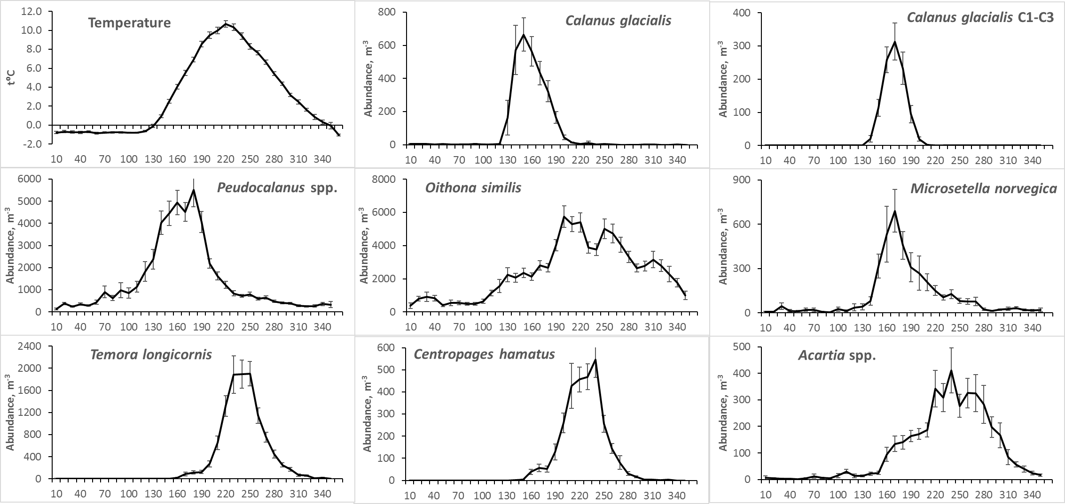

Fig. 2 Seasonal dynamics of temperature and species abundance at the D-1 station (data for the period 1961–2018). X-axis – number of Julian day. Long-term means of total numbers for each 10-day period are shown. Error bars indicate standard errors of means.

Average dates of the key temperature thresholds and phenological events are present on the Fig. 3. The earliest of registered events in environment (Fig. 3B) was the timing of ice melt – it took place on average in the beginning of May (day 141). As it was mentioned before, spring normally started in the beginning of May according to temperature curve. However, the first key date in the seasonal temperature dynamics, that we could reliably register almost every year, was 3 °C threshold (arbitrary spring beginning). The latter was normally registered a month later, normally in the beginning of June (160-th day). Summer began only 2 weeks later, on 173-th day, and finished in the middle of October (day 287).

**A**

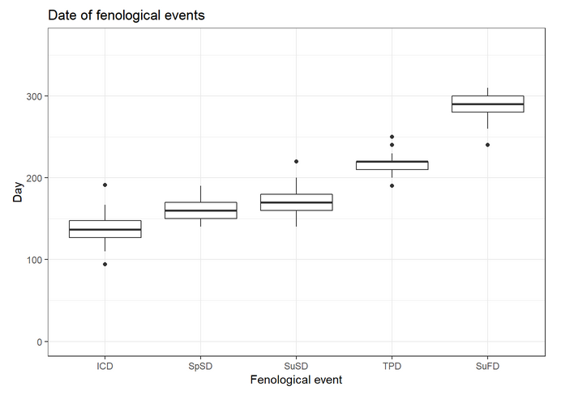

**B**

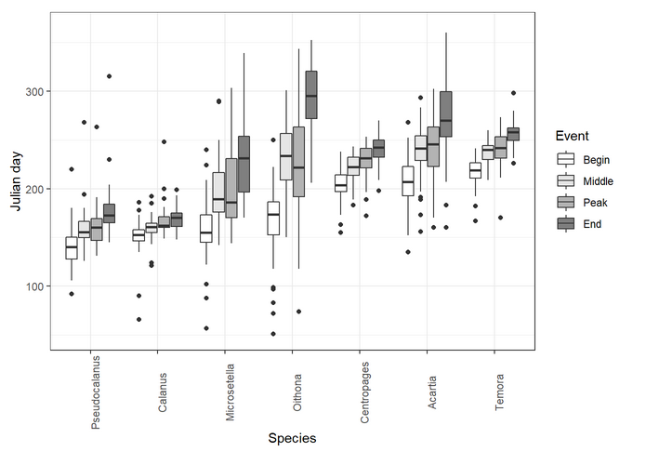

Fig. 3. Median values of the key events taking place in the environment (A) and in the life cycles of the studied species (B). ICD – Ice clear date; SpSD – Spring start date (the day when the water temperature overcomes 3°C); SuSD – Summer start date (the day when the water temperature overcomes 5 Celsium degrees); TPD – The date when the highest water temperature was observed; SuFD – The date of summer end. Horizontal line refers to median. The box margin refers to the first quartile (lower) and third quartile (upper), i.e. the 25th and 75th percentiles. Vertical lines refer to 1.5 IQR (IQR is the inter-quartile range, or distance between the first and third quartiles).

Species were ranged according to the timing of developmental season beginning. The season of *Pseudocalanus* spp. development started the earliest (middle of May, day 140). Then followed *Calanus glacialis* that had the narrowest developmental season (period between appearance of CI and disappearance of CIII from upper 25-meter layer). The latest season beginning was demonstrated by *Temora longicornis* (beginning of August, day 217). Narrow developmental seasons were characteristic for boreal species *T. longicornis* and *Centropages hamatus* (39 and 36 days, respectively). The longest season was observed for ubiquitous (eurybiont) *Oithona similis* (133 days).

***Long-term dynamics: phenology timing and species abundance***

Long-term changes in phenology of the studied copepods demonstrated negative trends or were insignificant (Fig. 4). Only end of season of *Oithona similis* tended to be later, but this trend was not significant. Start of season of four species has shifted to earlier time: *Calanus glacialis* (by 26 days), *Centropages hamatus* (23 days), *Temora longicornis* (25 days) and *Microsetella norvegica* (21 days). End of season of the following species shifted to an earlier time *C. glacialis* (18 days), *Pseudocalanus* spp. (38 days) and *Acartia* spp. (30 days). Thus, developmental season of *C*. *glacialis* shifted wholly to an earlier time. Seasons of *Pseudocalanus* and *Acartia* shortened, seasons of *Microsetella*, *Centropages* and *Temora* became longer.

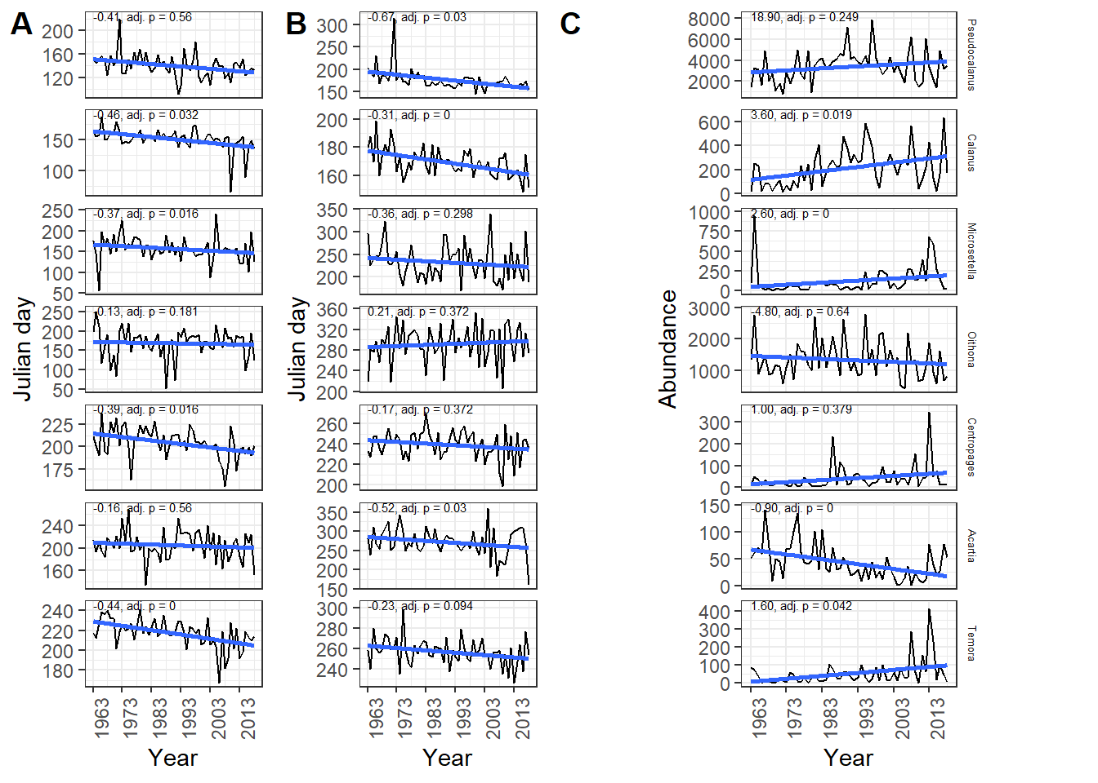

Fig. 4. Long-term changes in the timing of phenological events ( beginning-of-season (A) and end-of-season (B)) in the seasonal dynamics of the studied species, and the dynamics of the total number of their populations (C). Abundance is given as ind./m3. The straight line represents the linear model connecting the value plotted along the ordinate axis with time. Numbers above the regression line are the slope coefficient of the model and the level of significance for the Mantel correlation (see Materials and Methods for details).

The significant interannual fluctuations were the feature of the long-term dynamics of abundance of all the studied species (Fig. 4). The minimal and maximal values differed in an order of magnitude, which was characteristic for almost all species. Substantial increase of abundance of *Calanus glacialis*, *Microsetella norvegica* and *Temora longicornis* after 1961 was revealed, in spite of large interannual fluctuations. Only numbers of *Acartia* spp. decreased significantly. No significant trends were found in the abundance dynamics of *Pseudocalanus* spp., *Centropages hamatus* and *Oithona similis*.

***Long-term dynamics: factors influencing phenology timing***

Distinct long-term tendencies were revealed in the timing of the seasonal temperature dynamics (Fig. 5). Thus, dates of spring and summer beginning demonstrated tendency to the shift to earlier time (b=-0.39 and -0.50, respectively; p<0.05). This shift amounted to about 23 for spring and 29 days for summer beginning since 1961. Another threshold, summer end date has not changed significantly. However, hydrological summer duration increased by 39 days. Timing of the seasonal temperature peak has not changed at all, in spite of pronounced fluctuations. Ice melted significantly earlier, by about 26 days towards the end of the study period. Absolute values of temperature in “spring” (May-June) increased significantly during study period by about 3°C. Increase of “summer” (July-September) temperature was insignificant (ca. 1.7°C). Climatic index NAO also demonstrated significant tendency towards increase. Trend in the dynamics of AOI was not significant.

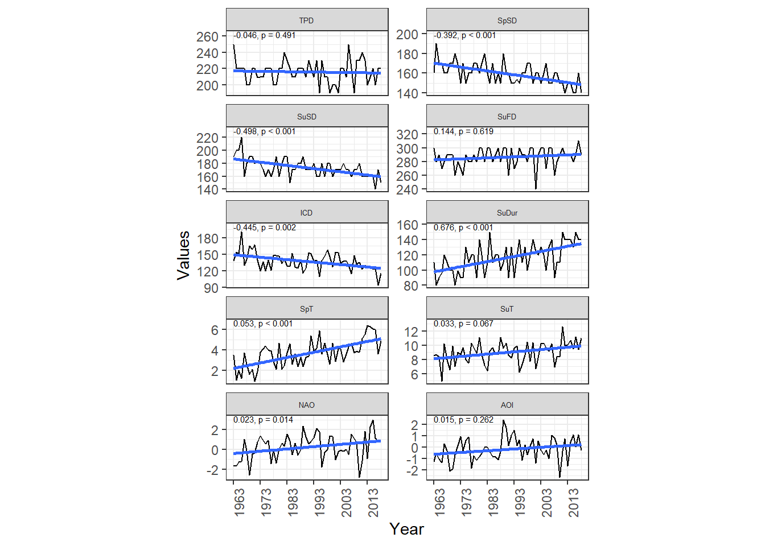

Fig. 5. Long-term changes in the timing of seasonal events in the external environment and some abiotic variables. TPD – Julian day when temperature maximum was observed; SpSD – Julian day when hydrological spring started (water temperature reached 3°C); SuSD – Julian day when hydrological summer started (water temperature reached 5°C); SuFD – Julian day when hydrological summer ends; SuDur – summer duration; ICD – Julian day when ice clearing was observed; SpT – Mean spring temperature; SuT – Mean summer temperature; NAO – North Atlantic oscillation index; AOI – Arctic oscillation index. Slope coeficient fkr the linear model and p-values for Mantel correlation are given.

All the hydrological and climatic factors described above, as well as biotic characteristics (abundance of species) were included in the full model of canonical correspondent analysis as predicors. After the procedure of simplifying the complete model, only three predictors that characterize the hydrological and climatic conditions were taken into the final model: the beginning of spring in a given year (SpSD), the date of the ice release in a given year (ICD), and the end of summer in the previous year (SuFDPY). Only two of biotic predictors where kept in the final model: the abundance of Acartia and Microsetella. No statistically significant differences between the full and simplified models were identified (*F* = 1.12, *pperm* = 0.221).

The final model was statistically significant (Table 1a) and explained 23.5% of total inertia ~~taking into account all canonical correspondent axes~~. At the same time, only the first and second axes were statistically significant out of the five possible canonical axes (Table 1b). They accounted for 12 and 5.4% of total inertia, respectively. The presence of all the predictors remaining in the model was statistically significant (Table 1c).

Table 1. Estimation of the significance of the CCA model.

|  |  |  |  |  |
| --- | --- | --- | --- | --- |
| 1. Permutation significance test of the final CCA model | | | | |
| Term | *df* | *ChiSquare* | pseudo-F | *p*-value |
| Model | 5 | 0.0029733 | 3.070672 | 1e-04 |
| Residual | 50 | 0.0096830 |  |  |
| 1. Permutation significance test of CCA constrained axis | | | | |
| term | *df* | *ChiSquare* | pseudo-F | *p*-value |
| CCA1 | 1 | 0.0015219 | 7.8585931 | 0.0001 |
| CCA2 | 1 | 0.0006818 | 3.5207171 | 0.0383 |
| CCA3 | 1 | 0.0004448 | 2.2966440 | 0.1714 |
| CCA4 | 1 | 0.0002075 | 1.0715697 | 0.7107 |
| CCA5 | 1 | 0.0001173 | 0.6058361 | 0.7962 |
| Residual | 50 | 0.0096830 |  |  |
| c) Permutation significance test of each terms included in the CCA model | | | | |
| term | *df* | *ChiSquare* | pseudo-F | *p*-value |
| Microsetella_N | 1 | 0.0010319 | 5.328538 | 0.0001 |
| SuFDPY | 1 | 0.0006538 | 3.375766 | 0.0017 |
| SpSD | 1 | 0.0005805 | 2.997564 | 0.0051 |
| Acartia_N | 1 | 0.0005305 | 2.739234 | 0.0090 |
| ICD | 1 | 0.0004821 | 2.489406 | 0.0169 |
| Residual | 50 | 0.0096830 |  |  |

Figure 6 shows the ordination of the phenological characteristics of species in the space of the first and second canonical axes. The maximum values on the first axis fall on the date of the peak (Microsetella_Peak), the date of the middle (Microsetella_Middle), and the date of the end of the season (Microsetella_End) for *Microsetella*. All hydrologic and climatic factors remaining in the model are positively correlated with the first canonical axis (CCA1). The strongest correlation is observed for the date of the disappearance of ice and the date of the end of the summer last year. The beginning of spring also is correlated to this axis. This means that the later the ice disappears, the later the spring comes and the later the summer ended in a previous year, the later the mentioned above phenological events take place.

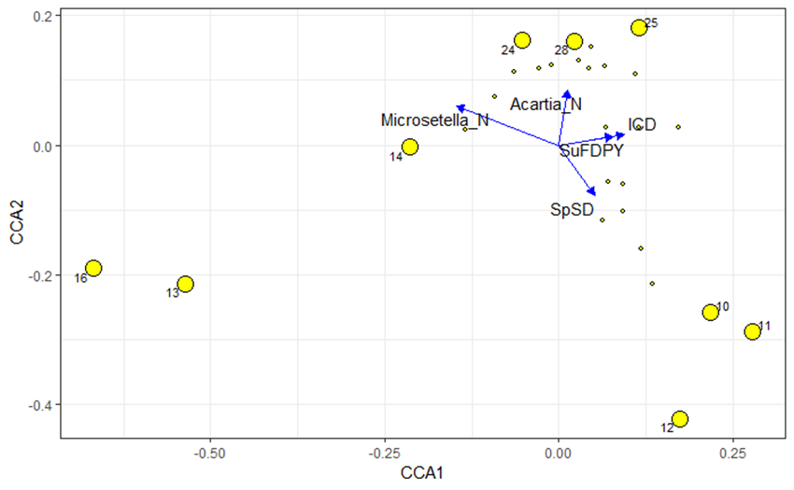

Fig. 6. Ordination of phenological characteristics of species in constrained axes of CCA. Large numbered points correspond to the phenological indicators that have own values on the first and / or second bounded axis (without a sign) outside the 10th or 90th percentiles. The arrows indicate the predictors included in the final model.

Табл. 3. Обозначения фенологических характеристик.

| Phenological Event | Label | Phenological Event | Label |
| --- | --- | --- | --- |
| Microsetella_Middle | 10 | Oithona_Peak | 16 |
| Microsetella_End | 11 | Acartia_Peak | 24 |
| Microsetella_Peak | 12 | Temora_Begin | 25 |
| Oithona_Begin | 13 | Temora_Peak | 28 |
| Oithona_Middle | 14 |  |  |

At the same time, there are a number of phenological events, which, on the contrary, occur earlier if the indicated hydrological-climatic events occur later. Thus, the dates of the beginning of the season, the date of the midpoint, and the date of the peak in *Oithona* (Oithona_Begin, Oithona_Middle, Oithona_Peak) tend to start earlier in case when the mentioned earlier hydrological and climatic events have occurred later. This is true for a later ice retreat, a later arrival of spring and a later end of summer last year. It is important to note that negative values along the first canonical axis also positively correlate with the abundance of *Microsetella*. Particularly, in the years when the abundance of *Microsetella* is high, the events in the *Oithona* seasonal cycle tend to occur later.

It is important to emphasize that the phenological events in *Oithona* and the phenological events in *Microsetella* occupy opposite positions along the CCA1, that is, the earlier the events in one species, the later the events in another.

Taking into account low informational content of the second canonical axis, it makes sense to discuss only those characteristics that have maximum values along this axis, but close to zero in the CCA1. The start date of the season (Temora_Begin) and the peak date of *Temora* (Temora_Peak), as well as the peak date of *Acartia* (Acartia_Peak) are the highest values for the CCA2. High abundance of *Acartia* in a given year correlates most strongly with the positive values of this canonical axis, i.e. in the years when the abundance of *Acartia* is high, these phenological events occur later.

***Relationship of the abundance of the species and its phenological indicators***

Analysis of correlation between the dynamics of abundance and the season start date, allows us to speak of only two cases of a statistically significant relationship: the abundances of *Centropages* and *Temora* were lower when the season started later (Fig. 7; Table 4).

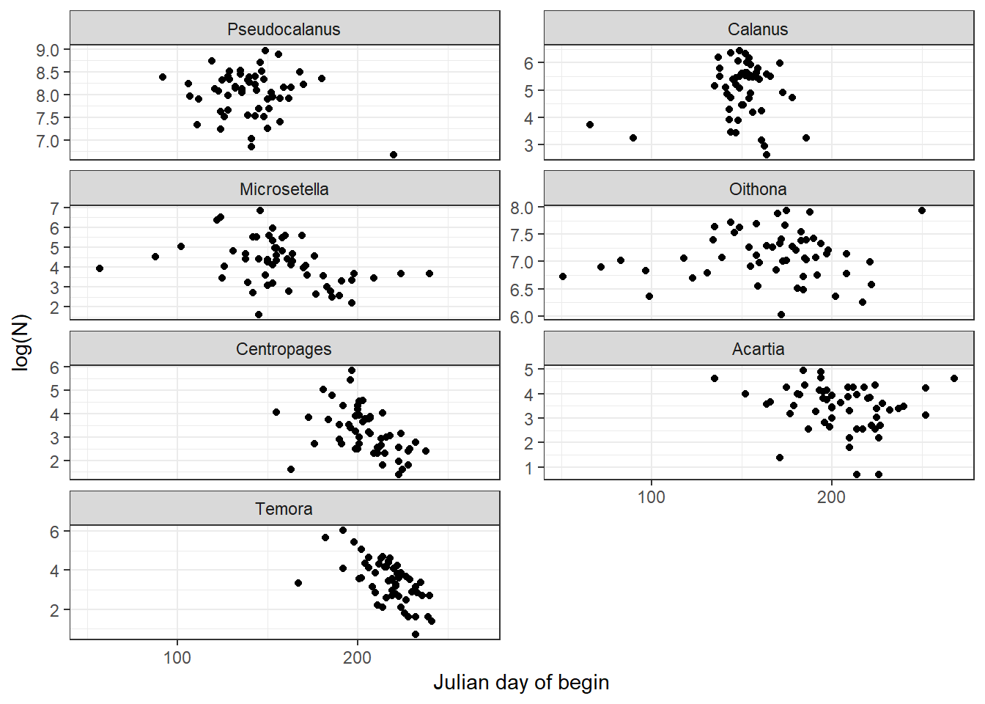

Fig. 7. The relationship between the abundance of the species in a given year and the start of the season. Each point corresponds to a separate year of observations. The X-axis shows the difference between the start date in a given year *t* and in the previous year *t−1*. The Y-axis shows a similar difference between the logarithms of the abundance of species.

Table 4. Correlation between year changes in abundance and between year changes in appearance begin. Permutation p-level adjusted accordingly to Benjamini-Hochberg procedure are provided. Correlation calculation – see Methods section.

Species Correlation Adjusted p-value

Pseudocalanus -0.15 0.8467

Calanus -0.19 0.8467

Microsetella -0.41 0.4319

Oithona -0.33 0.5905

Centropages -0.67 0.0192

Acartia -0.56 0.1003

Temora -0.74 0.0070

# Discussion

Significant trend in the spring dynamics of the water temperature was detected at the study site, while summer temperature changed insignificantly, though slight tendency existed (~0.03 °C per year). These changes correlated with the global trend towards warmer Arctic, when pronounced changes of temperature have been reported for many Arctic areas (ACIA, 2004; IPСС, 2012), and were higher than average for the Northern Hemisphere (Davy et al., 2018). Changes of the temperature may well be the consequence of the earlier seasonal spring warming of water: beginning of the spring and summer moved to an earlier time by about 3–4 weeks at the study site. Similar trend during the last three decades was documented in different areas over the Arctic for the timing of the ice retreat (Ji et al., 2012).

Considerable change in seasonal temperature dynamics influences seasonal cycles of planktonic animals. There were phenological shifts detected in dynamics of studied species, which coincided with the timing of the life-cycle events of Arctic, boreal and ubiquitous species advanced by up to a month and even more. The first copepodite stage of *Calanus glacialis* appeared 26 days earlier in the end of the study period in the White Sea. It is reasonable to connect this shift to the advance of the seasonal water warming. However, it was shown that the start of *C. glacialis* reproduction depends more on the food availability than on the temperature (Ringuette et al., 2002). On the other hand, it is the temperature that governs the ice melting and, therefore, the timing of the phytoplankton bloom allowing more light penetrating through the ice and thus accelerating the production of ice and planktonic algae. Moreover, temperature influence phytoplankton photosynthetic activity later in the year, after light saturation of the upper water layer (Tilzer et al., 1986). Thus, the timing of the reproduction of *C. glacialis* depends on both food availability and temperature. The timing of *Calanus* juveniles’ disappearance also has shifted to an earlier time, but by 18 days only (compared to 26 days for appearance timing). Thus, season of active early development of *C. glacialis* has shifted to an earlier time and increased. One may expect that with earlier appearance and faster development *Calanus* juveniles must leave upper layer much earlier. However, *Calanus* CIII remains in the depth layer 0–25 m, but stay below 10 m depth by the end of spring (our observations), thus escaping unfavorable thermal conditions. High concentrations of chlorophyll *a* are observed only to 10 m depth by this time (Usov et al., 2013). So, feeding conditions below this depth are not favorable by the time CIII leave surface layer. Thus, until *Calanus* copepodites finally leave 0–25 m layer, they experience the deficit of food. This may be the cause of observed development prolongation. It was shown that starvation increases the developmental time of *Calanus glacialis* nauplii and may even terminate it (Daase et al., 2011). It is reasonable to expect similar effect of the food shortage on the copepodite stages.

It was reported about the possible mismatch between the ice melt and *Calanus glacialis* reproduction in the Beaufort Sea and Svalbard, which may have a negative effect on the success of this species (Søreide et al., 2010; Daase et al., 2013). In high Arctic, an early ice melting and intensive warming of upper water layer may cause shortening of period between ice-algae and phytoplankton blooms (Søreide et al., 2010). The complete disappearance of ice in the study area also is registered almost a month earlier than in 1960-ies. It may lead to discrepancy between *Calanus* juveniles' development and the spring peak of the phytoplankton abundance, because reaching the first feeding naupliar stage (NIII) requires certain time to develop, this process may take longer than the period between the two blooms (Søreide et al., 2010). Unfortunately, we cannot either prove, or refute this for the White Sea population, since no long-term data on phytoplankton abundance are available by now. However, long-term positive trend of *Calanus glacialis* abundance points out that at least at this temporal scale there is no tendency to mismatch. Our findings are also supported by the results of modeling temperature increase in Arctic (Feng et al., 2017). The authors argue that rising temperature leads to prolongation of the period of abundant phytoplankton, which leads towards increasing success of *Calanus glacialis* in Arctic Ocean. This can also be reasonable explanation of *Calanus* success in the White Sea, as well as relative success of Pseudocalanus populations (see beneath).

Terms of appearance of young *Pseudocalanus* spp. shifted slightly less than the timing of the appearance of *Calanus*, i.e. about 23 days. However, due to sharp fluctuations in the indicator in the early 1970s and in the early 1990s, the changes were insignificant (Fig. 5). The end of the developmental season of *Pseudocalanus* spp. has shifted by almost six weeks (38 days), therefore, we can talk about the reduction of the season of active development of *Pseudocalanus* spp. Shrinkage of the *Pseudocalanus* spp. developmental season may be also consequence of the reduction of spring and early summer beginning. Population of *Pseudocalanus* spp. increased since 1961 (by 30% of the average long-term abundance), however, this change was also not significant, but comparable , to *Calanus glacialis* population rise, abundance of which has almost doubled. However, taking into account the ecological similarity of these two species (breeding dates and food preferences during the breeding season and early development; see: Lischka, Hagen, 2007; Falk-Petersen et al., 2009), the same conclusions can be drawn: a huge shift in the timing of the development of these species does not lead to a noticeable trophic mismatch and population depression. The negative shift of the center-of-gravity timing for species of the genus *Pseudocalanus* was noted in the central part of the North Sea, which coincided with a positive trend in the dynamics of the average annual water temperature at the sea surface (Mackas et al., 2012 and references therein).

As one of the mechanisms of the resilience of the populations of planktonic copepods to phenological shifts may serve a synchronization of the timing of the main events in the life cycles of cold-water species with changes in the environment. Such synchronization was reported for phytoplankton in Arctic (Ji et al., 2012): planktonic algae develop earlier with earlier ice retreat.

Omnivory may be the alternative mechanism of resilience. Planktonic Copepoda consume heterotrophic plankton (microzooplankton) actively when suitable phytoplankton becomes deficient, which was found in other regions, in experiments and for related species ( Levinsen et al., 2000; Lischka, Hagen, 2007; Fileman et al., 2010). The ability of many animals to switch to other food objects in conditions of the food shortage, or to be potentially omnivorous, is widely reported (Saiz, Calbet, 2010; Kiørboe, 2011; Benedetti et al., 2016; Brun et al., 2017). This ability may support *Calanus* and *Pseudocalanus* population success in the changing environment of the White Sea.

These hypotheses may well apply to other species, demonstrating resilience to phenological changes, which will be discussed further.

The trends of phenology of the boreal *Centropages hamatus* and *Temora longicornis* are consistent with the changes of the seasonal cycle of temperature. Particularly, the latter is one of the main triggers of their hatching in the White Sea (Pertzova, 1990) and other areas, such as the northern Baltic Sea (Katajisto et al., 1998). The temperature increase either induces hatching (Pertzova, 1990) or shortens egg developmental time (Katajisto et al., 1998). Thus, shift of spring warming may influence the timing of hatching of these species in the White Sea. Other boreal species, *Acartia* spp., have no shifts of the beginning of the developmental season. According to our observations (Fig. 2), adults of *Acartia[1]* are found in the plankton all year round, and the increase in their abundance begins in March, under the ice. This suggests that *Acartia* depends on temperature to a lesser extent than *Temora* and *Centropages*. Tendency for the earlier development of boreal species was observed in other areas of the World Ocean. Thus, the timing of the appearance of the thermophilic *Acartia tonsa* in Narragansett Bay (West Coast of USA) in plankton shifted to an earlier time during period from 1972 to 1990, which coincided with a significant increase in spring temperature (Borkman et al., 2018). Approximately in the same period (from 1974 to 2004), the periods of the middle of the season (time of the 50% of the annual cumulative abundance threshold) of *Temora longicornis*, *Acartia* spp., and *Temora* spp. (nauplii) near the Helgoland Island in the North Sea has shifted to an earlier dates, 2.5 to 4 weeks (Mackas et al., 2012). In this case, changes in phenology coincided with an increase in average annual and summer (June-August) temperatures.

Of the two studied species of eurybionts, only the trend of the season beginning dynamics of *Microsetella norvegica* was significant. The phenology of *Oithona similis* did not show significant changes. The described differences can be explained by the fact that the reproduction of *M. norvegica* begins only in June (own data), despite its presence all year round in the plankton community. At the same time, the nauplii of *O. similis* are found in plankton throughout the year. Probably, the temperature is not the first trigger of the beginning of the active development of this species. This is indirectly confirmed by its cosmopolitan distribution (OBIS, 2019). Meantime, a significant shift of the middle-of-season (50% of the cumulative abundance)to an earlier dates in the seasonal dynamics of *Microsetella* spp. (15 weeks!) and *Oithona* spp. (~4 weeks) has been reported near Helgoland Island, and these changes coincided with an increase in average annual and summer temperatures (Mackas et al., 2012). The same trend, when the season advances, was traced in the dynamics of *Oithona* spp. in the English Channel (Mackas et al., 2012). A similar dependence was observed in the northern part of the Pacific Ocean, where the seasonal peak of the biomass of the interzonal copepod *Neocalanus plumchrus* has shifted since the early 1970s by more than a month earlier, which coincided with an increase in spring temperature (Mackas et al., 2012). The timing of the abundance peak of *Calanus finmarchicus* CI in the Norwegian Sea is negatively associated with the temperature in April, but the trend is not traced, despite its presence in the dynamics of the water temperature in April (Mackas et al., 2012). In the same study, there is a lot of evidence of the negative connection of spring temperature with the phenological events of different species in the North Atlantic and the North Pacific. As can be seen, the pattern “the warmer the earlier” is traced in different regions of the World Ocean and for species with different temperature preferences. This is consistent with the trends observed in the study area in the White Sea.

Abundance of studied species either has not changed significantly (*Pseudocalanus* spp., *Oithona* and *Centropages*), or increased (*Calanus*, *Microsetella* and *Temora*). Only abundance of *Acartia* spp. decreased which coincided with significant reduction of their developmental season duration. The season of *Pseudocalanus* spp. has also shortened, which, however, has not affected negatively the trend of their abundance. Thus, the majority of studied species are resilient to revealed phenological changes at the long-term temporal scale.

Besides long-term trends large interannual fluctuations were observed of both phenological metrics and abundance of zooplankton, which demonstrate connection with fluctuatons in environment. Such relationships in our work manifested themselves in the results of canonical correspondent analysis. The final model includes three abiotic factors, the most significant of which are the dates of the ice retreat and the beginning of spring. There are serious doubts about the reality of the positive relationship between timing of the end of summer in the previous year and the timing of the ice retreat in the next year. However, we may speculate that the late end of summer will lead to a greater accumulation of heat in the sea and to a warmer winter and the formation of a thinner ice. The latter, respectively, would have melted earlier. The CCA results evidenced that the phenological phases of *Microsetella* season are positively associated with the ice dynamics. Earlier processes in the pelagic zone can explain the behavior of the young Microsetella during the years characterized by the early collapse of ice. It was shown that ice retreat and phytoplankton bloom timing positively correlate in the Arctic (Ji et al., 2012). Therefore, probably, not only early warming favors *Microsetella*, but also earlier phytoplankton bloom.

It seems to be more difficult to find any temperature influence on the ubiquitous eurybiont organisms *Oithona similis* and *Microsetella norvegica* (Castellani et al., 2005; Arendt et al., 2012). Other factors seems to influence their dynamics. We found that the timing of events in the *Oithona* and *Microsetella* seasonal cycles changes in the opposite directions: the earlier phenological events of one species, the later events of another. This relationship is consistent with the fact that these two species have similar food preferences (González, Smetacek 1994; Maar et al., 2006) and may compete for food. Bothspecies, *Oithona similis* (Cyclopoida) and *Microsetella norvegica* (Harpacticoida), are omnivorous: they feed on detritus aggregates; *O. similis* also consumes microzooplankton (Paffenhöfer, 1993; Green and Dagg, 1997; Maar et al., 2006). Normal course of seasonal succession allows co-occuring species to reduce competition by partitioning resources through time, when they occupy different *temporal* niches (Pau et al., 2011). Phenological shifts may result in temporal overlaps between species with similar trophic preferences and affect competitive relationships (Nakazawa, Doi, 2012; Borkman et al., 2018). The overlapping of the trophic niches is aggravated by the high abundances of *MIcrosetella* and *Oithona* in the study area and the significant intersection of the temporal niches (Fig. 2). It appears that interspecific interactions play an important role in the seasonal dynamics of these two species. It should also be noted that the timing of phenological events in the *Microsetella* seasonal cycle is negatively related to its population size in a same year. In other words, the later the developmental season of his species begins, the lower its abundance. Probably, when *Microsetella* appears late, it does not have time to achieve high abundance before the mass development of the competitor, *Oithona similis*. However, the earlier *Microsetella* appears in the plankton, the greater the abundance it reaches, gaining a competitive advantage over *Oithona*, which in such years develops later than usual.

Interspecific interactions can also explain the relationship between the abundance of *Acartia* spp. and the timing of the start of the season and the peak abundance of *Temora longicornis*. The higher the abundance of the first species, the later the timing of events in *Temora* dynamics. At the same time, the dates of the peak abundance of *Acartia* shift in line with that of *Temora*. It turns out that the greater the abundance of *Acartia* and the later it reaches the peak of abundance, the later *Temora* develops. This also can be explained by overlap of trophic niches, since both species have similar food preferences: they are omnivorous, but prefer phytoplankton, at least in the White Sea (Martynova et al., 2009; Martynova et al., 2011). Besides that, their temporal and spatial niches also overlap. Though described relationships are well explicable, we cannot speak about any strong connections because resulting variation accounts for only a small part of total variance (about 5%). Meantime, it is proposed that boreal species *Acartia*, *Centropages* and *Temora* depend primarily on the temperature, because their hatching from the dormant eggs is triggered by the temperature change (Pertzova, 1990; Engel, 2005; Katajisto, 2006). Thus, the interannual variations in the timing of phenological events of boreal and eurybiont species are determined by timing of the ice retreat, early spring warming and interspecific interactions.

# Conclusions

The global climate change is manifested in the White Sea through temporal shift of the seasonal temperature cycle. The spring water heating has shifted since 1961 towards an earlier time: spring beginning shifted by 23 and summer beginning – by 29 days. This shift influences seasonal cycle of planktonic organisms. Key events of the life cycles of both cold- and warm-water copepods in the coastal area of Kandalaksha Bay of the White Sea have moved to an earlier time by up to a month. Main factors, which drive these shifts, are advance of ice melt and advance of spring water heating. For ubiquitous and boreal species, interspecific competition for resources plays an important role: in the years when the abundance of *Microsetella* is high, the key events in the *Oithona* seasonal cycle tend to occur later. The same relationship was revealed between *Acartia* spp. abundance and timing of *Temora longicornis* development. Period of active development of some of them (*Pseudocalanus* and *Acartia*) has shortened as well, but only for *Acartia* spp. abundance this change had negative consequences. Revealed temporal shifts of phenological events had almost no effect on the abundance of the most studied species (except *Acartia* spp.). This point out to resilience of planktonic organisms to changes in seasonal cycles of environmental variables. Several mechanisms may underlie this resilience. First, organisms may synchronize key events in their life cycles with dynamics of environmental parameters. Second, to overcome temporal mismatch with feeding objects, planktonic copepods may switch their food preferences form herbivory to carnivory according to situation in plankton (presence/absence of suitable food), because the majority of Copepoda, at least at the study site, are potentially omnivorous. Third, the success of the spring cold-water species depends to a some extent on the duration of the period of ample phytoplankton, because these species are predominantly herbivorous. These conclusions were made based on the long-term observational data, and need to be verified experimentally, where possible. We suppose this to be the focus of our further scientific efforts.

# Acknowledgments

We would like to express our gratitude to all the colleagues and vessel staff who took part in monitoring since 1957, especially to Dr. Regina V. Prygunkova, who kept running this program for almost 30 years and summarized the plankton data from 1960 to 1995. We are also grateful to oceanologist Alexey I. Babkov (worked in 1973–1995), who summarized the hydrological data of monitoring. Our thanks go to other participants of the program and to the captains and crews of the research vessels. This research is supported by the ongoing Basic Research Program of the Russian Academy of Sciences "The fauna of the White Sea and adjacent basins: adaptive traits of organisms and populations under the influence of the climate change" (reg. No АААА-А17-117021300219-7).

# References

ACIA (2004) Impacts of a Warming Arctic: Arctic Climate Impact Assessment. ACIA Overview report. Cambridge University Press.

Arendt KE, Juul-Pedersen T, Mortensen J, Blicher ME, Rysgaard S (2012) A 5-year study of seasonal patterns in mesozooplankton community structure in a sub-Arctic fjord reveals dominance of Microsetella norvegica (Crustacea, Copepoda), J Plankton Res 35: 105–120, https://doi.org/10.1093/plankt/fbs087

Atkinson A, Harmer RA, Widdicombe CE, McEvoy AJ, Smyth TJ, Cummings DG, Somerfield PJ, Maud JL, McConville K (2015) Questioning the role of phenology shifts and trophic mismatching in a planktonic food web. Prog Oceanogr 137: 498–512. https://doi.org/10.1016/j.pocean.2015.04.023

Babkov AI (1982) The brief hydrological characteristic of Chupa inlet, the White Sea. Explorations of the fauna of the seas 27(35): 3–16. [in Russian]

Babkov AI (1985) About the principles of determination of hydrological seasons (by the example of Chupa inlet, the White Sea. Explorations of the fauna of the seas 31(39): 84–88. [in Russian]

Bates DM, Chambers JM (1992) Nonlinear models. Chapter 10 of: Statistical Models. S. J. M. Chambers and T. J. Hastie, Eds., Wadsworth & Brooks/Cole.

Batten SD, Mackas DL (2009) Shortened duration of the annual *Neocalanus plumchrus* biomass peak in the Northeast Pacific. Mar Ecol Prog Ser 393: 189–198.

Beaugrand G, Kirby RR (2018) How Do Marine Pelagic Species Respond to Climate Change? Theories and Observations. Annu Rev Mar Sci 10: 15.1–15.29. <https://doi.org/10.1146/annurev-marine-121916-063304>

Benjamini Y, Hochberg Y (1995) Controlling the false discovery rate: a practical and powerful approach to multiple testing. Journal of the Royal statistical society: series B (Methodological) 57: 289–300.

Berger V, Dahle S, Galaktionov K, Kosobokova X, Naumov A, Rat'kova T, Savinov V, Savinova T (2001) White Sea. Ecology and Environment. Derzavets Publisher, St.-Petersburg, Tromsø.

Bogorov VG (1941) Diel vertical distribution of zooplankton in the polar conditions (in the White Sea). Transactions of The Polar Institute of Marine Fisheries and Oceanography, Murmansk 7: 287–311.

Bonnet D, Harris RP, Yebra L, Guilhaumon F, Conway DVP, Hirst AG (2009) Temperature effects on *Calanus helgolandicus* (Copepoda: Calanoida) development time and egg production. J Plankton Res 31: 31–44. <https://doi.org/10.1093/plankt/fbn099>

Borkman DG, Fofonoff P, Smayda TJ, Turner JT (2018) Changing *Acartia* spp. phenology and abundance during a warming period in Narragansett Bay, Rhode Island, USA: 1972–1990. J Plankton Res 40: 580–594. https://doi.org/10.1093/plankt/fby029

Box GEP, Jenkins GW (1976) Time Series Analysis: Forecasting and Control. CA: Holden-Day, San Francisco.

Carton JA*,* Ding Y*,* ArrigoKR(2015)The seasonal cycle of the Arctic Ocean under climate change. Geophys Res Lett 42:7681*–*7686. <https://doi.org/10.1002/2015GL064514>

Castellani C, Robinson C, Smith T, Lampitt RS (2005) Temperature affects respiration rate of Oithona similis. Mar Ecol Prog Ser 285: 129–135. <https://doi.org/10.3354/meps285129>

Clarke KR, Gorley RN (2006) PRIMER v6: User Manual/Tutorial. Primer-E Ltd., Plymouth.

Corkett CJ, McLaren IA, Sevigny JM (1986) The rearing of the marine calanoid copepods *Calanus finmarchicus* (Gunnerus), *C. glacialis* Jaschnov and *C. hyperboreus* Kroyer with comment on the equiproportional rule. Syllogeus 58, The National Museum of Natural Sciences, Ottawa: 539–546.

Daase M, Søreide J, Martynova D (2011) Effects of food quality and food concentration on naupliar development of *Calanus glacialis* at sub-zero temperatures. Mar Ecol Prog Ser 429: 111–124. https://doi.org/10.3354/meps09075

Daase M, Falk-Petersen S, Varpe Ø, Darnis G, Søreide JE, Wold A, Leu E, Berge J, Philippe B, Fortierc L (2013) Timing of reproductive events in the marine copepod *Calanus glacialis*: a pan-Arctic perspective. Can J Fish Aquat Sci 70: 871–884. https://doi.org/10.1139/cjfas-2012-0401

Danielsdottir MG, Brett MT, Arhonditsis GB (2007) Phytoplankton food quality control of planktonic food web processes. Hydrobiologia 589: 29–41. <https://doi.org/10.1007/s10750-007-0714-6>

Davy R, Chen L, Hanna E (2018) Arctic amplification metrics. Int J Climatol 38: 4384–4394. https://doi.org/10.1002/joc.5675

Devreker D, Souissi S, Forget-Leray J, Leboulenger F (2007) Effects of salinity and temperature on the post-embryonic development of *Eurytemora affinis* (Copepoda; Calanoida) from the Seine estuary: a laboratory study. J Plankton Res 29 (suppl 1): i117–i133. https://doi.org/10.1093/plankt/fbl071

Edwards M, Richardson AJ (2004) Impact of climate change on marine pelagic phenology and trophic mismatch. Nature 430: 881–884. https:// doi.org/10.1038/nature02808

Eilertsen HC, Sandberg S, Tøllefsen H (1995) Photoperiodic control of diatom spore growth; a theory to explain the onset of phytoplankton blooms. Mar Ecol Prog Ser 116: 303–307.

Engel M (2005) Calanoid copepod resting eggs – a safeguard against adverse environmental conditions in the German Bight and the Kara Sea? Berichte zur Polar- und Meeresforschung 508: 1–108.

Falk-Petersen, S., Mayzaud, P., Kattner, G., & Sargent, J. R. (2009). Lipids and life strategy of Arctic *Calanus*. Mar Biol Res 5: 18–39. https://doi.org/10.1080/ 17451000802512267

Feng Z, Ji R, Ashjian C, Campbell R, Zhang J. (2018) Biogeographic responses of the copepod *Calanus glacialis* to a changing Arctic marine environment. Glob Change Biol 24: e159–e170. https://doi.org/10.1111/gcb.13890

Filatov NN, Pozdnyakov DV, Johannessen OM, Petterson LH, Bobylev LP (2005) White Sea. Its Marine Environment and Ecosystem Dynamics Influenced by Global Change. Springer-Praxis Publishing, Chichester.

Fileman E, Petropavlovsky A, Harris R (2010). Grazing by the copepods Calanus helgolandicus and Acartia clausi on the protozooplankton community at station L4 in the Western English Channel. J Plankton Res (32): 709–724. https://doi.org/10.1093/plankt/fbp142

Gillooly JF (2000) Effect of body size and temperature on generation time in zooplankton. J Plankton Res 22: 241–251. <https://doi.org/10.1093/plankt/22.2.241>

Golyandina N, Osipov E (2007) The “Caterpillar” – SSA method for analysis of time series with missing values. Journal of Statistical Planning and Inference 137: 2642–2653. https://doi.org/10.1016/j.jspi.2006.05.014

Golyandina N, Zhigljavsky A (2013) Singular Spectrum Analysis for time series. Springer Science & Business Media.

Golyandina N, Korobeynikov A (2014) Basic Singular Spectrum Analysis and Forecasting with R. Computational Statistics and Data Analysis 71: 934-954. <https://doi.org/10.1016/j.csda.2013.04.009>

Gonzalez HE, Smetacek М (1994) The possible role of the cyclopoid copepod Oithona in retarding vertical flux of zooplankton faecal material. Mar Ecol Prog Ser 113: 233-246.

Green, E. P. Dagg, M. J. (1997). Mesozooplankton associations with medium to large marine snow aggregates in the northern Gulf of Mexico. J Plankton Res 19: 435–447.

Greve W, Reiners F, Nast J, Hoffmann S (2004) Helgoland Roads meso- and macrozooplankton time-series 1974 to 2004: lessons from 30 years of single spot, high frequency sampling at the only off-shore island of the North Sea. Helgol Mar Res 58: 274–288. https://doi.org/10.1007/s10152-004-0191-5

Harris RP, Wiebe PH, Lenz J, Skjoldal H-R, Huntley M (eds) (2000) ICES Zooplankton Methodology Manual. Academic Press, London.

Hays GC, Carr MR, Taylor AH (1993) The relationship between Gulf Stream position and copepod abundance derived from the Continuous Plankton Recorder Survey: separating biological signal from sampling noise. J Plankton Res 15: 1359–1373. https://doi.org/ 10.1093/plankt/15.12.1359

Hirche H-J (1987) Temperature and plankton. II. Effect on respiration and swimming activity in copepods from the Greenland Sea. Mar Biol 94: 347–356. https://doi.org/ 10.1007/BF00428240

Hunt GL Jr, Stabeno P, Walters G, Sinclair E, Brodeur RD, Napp JM, Bond NA (2002) Climate change and control of the southeastern Bering Sea pelagic ecosystem. Deep Sea Research Part II: Topical Studies in Oceanography 49: 5821–5853. https://doi.org/10.1016/S0967-0645(02)00321-1

Hurrell JW (1995) Decadal trends in the North Atlantic Oscillation and relationships to regional temperature and precipitation. Science, 269: 676–679.

COPEPOD. Interactive Time-series Explorer METABASE (2018): [https://www.st.nmfs.noaa.gov/ copepod/time-series/ru-10101/](https://www.st.nmfs.noaa.gov/%20copepod/time-series/ru-10101/).

IPCC (2007) Climate Change 2007. The Physical Science Basis. Working Group I, Contribution to the Fourth Assessment Report of the IPCC Intergovernmental Panel on Climate Change. Cambridge University Press, Cambridge.

IPCC (2013): Climate Change 2013: The Physical Science Basis. Contribution of Working Group I to the Fifth Assessment Report of the Intergovernmental Panel on Climate Change. Cambridge University Press, Cambridge.

Ji R, Edwards M, Mackas DL, Runge JA, Thomas AC (2010) Marine plankton phenology and life history in a changing climate: current research and future directions. J Plankton Res 32: 1355–1368. <https://doi.org/10.1093/plankt/fbq062>

Ji R, Jin M, Varpe Ø (2012) Sea ice phenology and timing of primary production pulses in the Arctic Ocean. Glob Change Biol 19: 734–741. https://doi.org/10.1111/gcb.12074

Katajisto T, Viitasalo M, Koski M (1998) Seasonal occurrence and hatching of calanoid eggs in sediments of the northern Baltic Sea. Mar Ecol Prog Ser 163: 133–143.

Katajisto T (2006) Benthic resting eggs in the life cycles of calanoid copepods in the northern Baltic Sea. W. & A. de Nottbeck Foundation Science Report 29: 1–46.

Koski M, Kuosa H (1999) The effect of temperature, food concentration and female size on the egg production of the planktonic copepod *Acartia bifilosa*. J Plankton Res 21: 1779–1789. <https://doi.org/10.1093/plankt/21.9.1779>

Koski M, Kiørboe T, Takahashi K (2005) Benthic life in the pelagic: Aggregate encounter and degradation rates by pelagic harpacticoid copepods. Limnol Oceanogr 50: 1254–1263. https://doi.org/10.4319/lo.2005.50.4.1254

Kosobokova KN (1999) The reproductive cycle and life history of the Arctic copepod *Calanus glacialis* in the White Sea. Polar Biol 22: 254–263. https://doi.org/10.1007/ s003000050418

Kosobokova KN, Rat’kova TN, Sazhin AF (2003) Zooplankton in the ice-covered Chupa Inlet (White Sea) in the early spring of 2002. Oceanology 43: 694–703.

Kwasniewski S, Walkusz W, Cottier FR, Leu E (2013) Mesozooplankton dynamics in relation to food availability during spring and early summer in a high latitude glaciated fjord (Kongsfjorden), with focus on *Calanus*. J Mar Syst 111: 83–96. <https://doi.org/10.1016/j.jmarsys.2012.09.012>

Legendre P, Legendre L (2012) Numerical Ecology. Elsevier, Third English edition.

Levinsen H, Turner JT, Nielsen TG, Hansen BW (2000) On the trophic coupling between protists and copepods in arctic marine ecosystems. Mar Ecol Prog Ser 204: 65–77. https://doi.org/10.3354/meps204065

Light B, Grenfell TC, Perovich DK (2008) Transmission and absorption of solar radiation by Arctic sea ice during the melt season. J Geophys Res 113: C03023. <http://dx.doi.org/10.1029/2006JC003977>

Lischka S, Hagen W (2007) Seasonal lipid dynamics of the copepods Pseudocalanus minutus (Calanoida) and Oithona similis (Cyclopoida) in the Arctic Kongsfjorden (Svalbard). Mar Biol 150: 443–454. https://doi.org/10.1007/s00227-006-0359-4

Maar M., Visser A.W., Nielsen T.G., Stips A., Saito H. (2006). Turbulence and feeding behaviour affect the vertical distributions of *Oithona similis* and *Microsetella norwegica*. Mar Ecol Prog Ser 313, 157–172.

Mackas DL, Goldblatt R, Lewis AG (1998) Interdecadal variation in developmental timing of *Neocalanus plumchrus* populations at Ocean Station P in the subarctic North Pacific. Can J Fish Aquat Sci 55: 1878-1893. <https://doi.org/10.1139/f98-080>

D.L. Mackas a,⇑, W. Greve b, M. Edwards c, S. Chiba d, K. Tadokoro e, D. Eloire f, M.G. Mazzocchi g, S. Batten h, A.J. Richardson i,j, C. Johnson k, E. Head k, A. Conversi l, T. Peluso Changing zooplankton seasonality in a changing ocean: Comparing time series of zooplankton phenology. Progress in Oceanography 97–100: 31–62. https://doi.org/ 10.1016/j.pocean.2011.11.005

Markhaseva EL, Abramova AA, Mingazov ND (2012) *Pseudocalanus acuspes* (Crustacea, Copepoda) from the White Sea. Proceedings of the Zoological Institute RAS 316 (1): 57–70.

Martynova DM, Graeve M, Bathmann UV (2009) Adaptation strategies of copepods (superfamily Centropagoidea) in the White Sea (66°N). Polar Biol 32: 133–146. https://doi.org/10.1007/s00300-008-0513-1

Martynova DM, Kazus NA, Bathmann UV, Graeve M, Sukhotin AA (2011) Seasonal abundance and feeding patterns of copepods *Temora longicornis*, *Centropages hamatus* and *Acartia* spp. in the White Sea (66°N). Polar Biol 34: 1175–1195. https://doi.org/ 10.1007/s00300-011-0980-7

McLaren, I. A., Sevigny, J. M., & Corkett, C. J. (1988). Body sizes, development rates, and genome sizes among *Calanus* species. Hydrobiologia 167: 275–284. <https://doi.org/10.1007/BF00026315>

Nakazawa T, Doi H (2012) A perspective on match/mismatch of phenology in community contexts. Oikos 121: 489–495. doi:10.1111/j.1600-0706.2011.20171.x

Norrbin F (1991) Gonad maturation as an indication of seasonal cycles for several species of small copepods in the Barents Sea. Polar Res 10: 421–432. https://doi.org/10.1111/ j.1751-8369.1991.tb00663.x

OBIS (2019) Ocean Biogeographic Information System. Intergovernmental Oceanographic Commission of UNESCO. www.iobis.org.

Oksanen J, Guillaume Blanchet F., Friendly M, Kindt R, Legendre P, McGlinn D, Minchin PR, O’Hara RB, Simpson GL, Solymos P, Stevens MHH, Szoecs E Wagner H (2019) Vegan: Community Ecology Package. R package version 2.5-4. <https://CRAN.R-project.org/package=vegan>

Pau S., Wolkovich EM, Cook BI, Davies TJ, Kraft NJB, Bolmgren K, Betancourt JL, Cleland EE (2011) Predicting phenology by integrating ecology, evolution and climate science. Global Change Biology17: 3633–3643. https://doi.org/10.1111/j.1365-2486.2011.02515.x

Paffenhöfer GA (1993) On the ecology of marine cyclopoid copepods (Crustacea, Copepoda). J Plankton Res 15: 37–55. https://doi.org/10.1093/plankt/15.1.37

Pertzova, NM (1971) On the quantitative vertical distribution of the zooplankton in Kandalaksha Bay of the White Sea. Integrated investigations of the ocean resources. 2-nd issue. Moscow University Publ., Moscow, pp 153–162.

Pertzova, NM (1974) Life cycle and ecology of warm-water copepod Centropages hamatus in the White Sea. Zoologicheskii Zhurnal 53: 1013–1022. (in Russian).Pertsova NM (1980) Distribution of the zooplankton in the Basin and Kandalaksha Bay of the White Sea. Transactions of the White Sea Biological Station of the Moscow University 5: 49–68. [in Russian]

Pertzova NM (1990) Ecology of the boreal copepods *Centropages hamatus* Lilljeborg and *Temora longicornis* Müller in the White Sea and within the range. In Matekin PV (ed), Biological resources of the White Sea. Moscow University Publ., Moscow, pp 80–92. [in Russian]

Pertsova NM, Kosobokova KN (2010) Interannual and seasonal variation of the population structure, abundance, and biomass of the arctic copepod *Calanus glacialis* in the White Sea. Oceanology 50: 531−541.

Post E, Forchhammer MC (2008) Climate change reduces reproductive success of an Arctic herbivore through trophic mismatch. Philos. Trans. R. Soc. B Biol. Sci. 363: 2367–2373.

Primakov IM (2005) The impact of hydro-meteorological conditions on primary production. Zoological Sessions. Annual Reports 308: 83–90.

Prudkovsky A (2003) Life cycle of *Acartia bifilosa* (Copepoda, Calanoida) in the White Sea (Chernorechenskaya Inlet, Kandalaksha Bay). Proc. of the White Sea Biological Station of the Moscow State University, 9: 164–168. [in Russian]

Prygunkova RV (1974) Some peculiarities of seasonal development of zooplankton in Chupa Inlet of the White Sea. Explorations of the fauna of the seas 13(21): 4–55. [in Russian]

Pyper BJ, Peterman RM (1998) Comparison of methods to account for autocorrelation in correlation analyses of fish data. Can J Fish Aquat Sci 55, 2127–2140. https://doi.org/ 10.1139/f98-104

Quenouille NH (1952) Associated Measurements. Butterworths, London. (есть ли в новом варианте?)

Quinn GP, Keough MJ (2002) Experimental design and data analysis for biologists. Cambridge University Press.

R Core Team (2019) R: A language and environment for statistical computing. R Foundation for Statistical Computing, Vienna, Austria. URL https://www.R-project.org/.

Richardson AJ (2008) In hot water: zooplankton and climate change. ICES J Mar Sci 65: 279–295. https://doi.org/10.1093/icesjms/fsn028

Ringuette M, Fortiera L, Fortier M, Runge JA, Bélanger S, Larouche P, Weslawski J-M, Kwasniewski S (2002) Advanced recruitment and accelerated population development in Arctic calanoid copepods of the North Water. Deep-Sea Res II 49: 5081–5099. <https://doi.org/10.1016/S0967-0645(02)00179-0>

Royama T (1981) Fundamental concepts and methodology for the analysis of animal population dynamics, with particular reference to univoltine species. Ecological Monographs, 51(4), 473-493.

Royama T (1992) Analytical Population Dynamics. Chapman & Hall, London.

Rusanova MN, Khlebovich VV (1967) About the influence of anomalous conditions in 1965 – 1966 on the fauna of the White Sea. Oceanology, 7: 164–167. [in Russian]

Saiz E, Calbet A (2011) Copepod feeding in the ocean: scaling patterns, composition of their diet and the bias of estimates due to microzooplankton grazing during incubations. Hydrobiologia 666: 181–196. https://doi.org/10.1007/s10750-010-0421-6

Sokal RR, Rohlf FJ (1995) Biometry. The principles and practice of statistics in biological research, 3-rd ed. W. H. Freeman, New-York.

Søreide JE, Leu E, Berge J, Graeve M, Falk-Petersen S (2010) Timing of blooms, algal food quality and *Calanus glacialis* reproduction and growth in a changing Arctic. Global Change Biol 16: 3154–3163. <https://doi.org/10.1111/j.1365-2486.2010.02175.x>

Tenth report of the joint panel on oceanographic tables and standards. UNESCO Technical Papers in Marine Science 36 (1981).

Ter Braak CJF (1986) Canonical Correspondence Analysis: a new eigenvector technique for multivariate direct gradient analysis. Ecology 67: 1167–1179. https://doi.org/10.2307/1938672

Thackeray SJ (2012). Mismatch revisited: What is trophic mismatching from the perspective of the plankton? J Plankton Res 34: 1001–1010. https://doi.org/10.1093/plankt/fbs066

Thompson DWJ, Wallace JM (1998). The Arctic oscillations signature in the wintertime geopotential height and temperature fields. Geophysical Research Letters 25: 1297–1300. https://doi.org/10.1029/98GL00950

Tilzer MM, Elbrachter M, Gieskes WW, Beese B (1986) Light-temperature interactions in the control of photosynthesis in Antarctic phytoplankton. Polar Biol 5: 105–111. <https://doi.org/10.1007/BF00443382>

Tourangeau S, Runge JA (1991). Reproduction of *Calanus glacialis* under ice in spring in southeastern Hudson Bay, Canada. Mar Biol 108: 227–233. https://doi.org/ 10.1007/BF01344337

Troshkov VA, Slonova SA (2000) Zooplankton of the White Sea and its role in the feeding of the White Sea herring. Biological resources of the coastal area of Russian Arctic*.* Symposium materials. VNIRO Publishers, Moscow: 150–164. [in Russian]

Turner JT, Levinsen H, Nielsen TG, Hansen BW (2001) Zooplankton feeding ecology: grazing on phytoplankton and predation on protozoans by copepod and barnacle nauplii in Disko Bay, West Greenland. Mar Ecol Prog Ser 221: 209–219. https://doi.org/ 10.3354/meps221209

Usov NV (2011) Zooplankton dynamics during winter in ice-covered sea by the example of coastal zone of the White Sea. Bulletin of Saint-Petersburg University (Series 3, Biology) 3: 3−14. [in Russian]

Usov N, Kutcheva I, Primakov I, Martynova D (2013) Every species is good in its season: Do the shifts in the annual temperature dynamics affect the phenology of the zooplankton species in the White Sea? Hydrobiologia 706: 11–33. https://doi.org/10.1007/s10750-012-1435-z

Wassmann P, Duarte CM, Agusti S, Sejr MK (2011) Footprints of climate change in the Arctic marine ecosystem. Global Change Biol 17: 1235–1249. <https://doi.org/10.1111/j.1365-2486.2010.02311.x>

Weijerman M, Lindeboom H, Zuur AF (2005). Regime shifts in marine ecosystems of the North Sea and Wadden Sea. Mar. Ecol. Prog. Ser. 298: 21–39. https://doi.org/10.3354/meps298021

Zubakha MA, Usov NV (2004) Optimum temperatures for common zooplankton species in the White Sea. Russian Journal of Marine Biology 30: 293–297. https://doi.org/ 10.1023/B:RUMB.0000046547.26708.3e

Zhang J, Ashjian C, Campbell R, Spitz YH, Steele M, Hill V (2015) The influence of sea ice and snow cover and nutrient availability on the formation of massive under-ice phytoplankton blooms in the Chukchi Sea. Deep Sea Res II 118: 122–135. https://doi.org/10.1016/ j.dsr2.2015.02.008

1. Most likely, this is *A. longiremis*, one of the two species inhabiting the study area, which differs by its neritic distribution from *A. bifilosa* characterized by living in the coastal and estuarine areas (Prudkovsky, 2003).